For ODP Recommendation

1. Click On Odp
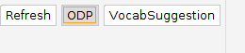
2. Enter description through terminal
3. Get Recommendation.
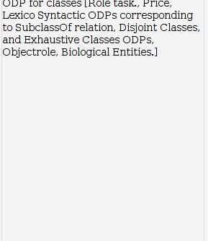

For Vocabularies and Alternate Names:

1. Build Classes and properties.

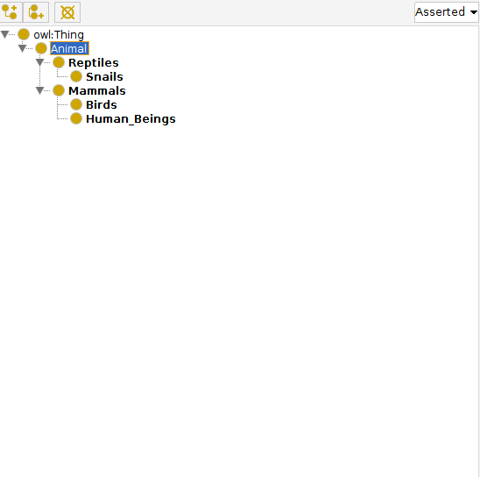
2. Click on VocabSuggestion

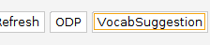

3. Get Recommendation.

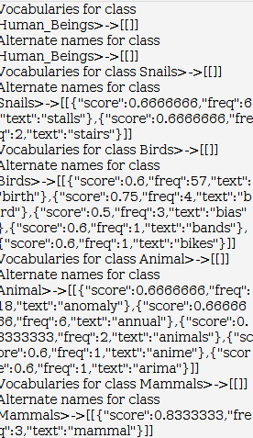

For Naming Convention :

1.Click on Refresh .
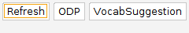

2.Get Recommendations.

