On-Premises Databases migrations

Overview of scenarios of database on cloud.

- Azure SQL Database(PaaS)
- SQL Server on Azure Vms(IaaS) (Good option for migrations from on-premises)

Choose a cloud SQL Server option (Azure SQL Database or SQL Server on Azure VMs):
Azure SQL Database is optimized to reduce overall costs to the minimum for provisioning and managing many databases. It reduces ongoing administration costs because you do not have to manage any virtual machines, operating system or database software. You do not have to manage upgrades, high availability, or backups.
SQL Server running on Azure VMs is optimized for migrating existing applications to Azure or extending existing on-premises applications to the cloud in hybrid deployments. In addition, you can use SQL Server in a virtual machine to develop and test traditional SQL Server applications. With SQL Server on Azure VMs, you have the full administrative rights over a dedicated SQL Server instance and a cloud-based VM. It is a perfect choice when an organization already has IT resources available to maintain the virtual machines.

Migrate a SQL Server database to SQL Server in an Azure VM

Below mentioned methods are describing about to migrate an on-premises SQL Server user database to SQL Server in an Azure VM.

 | Method | Source database version | Destination database version | Source database backup size constraint | Notes
1 | Perform on-premises backup using compression and manually copy the backup file into the Azure virtual machine | SQL Server 2005 or greater | SQL Server 2005 or greater | Have to view Azure VM storage limit details | This is a very simple and well-tested technique for moving databases across machines.
2 | Perform a backup to URL and restore into the Azure virtual machine from the URL | SQL Server 2012 SP1 CU2 or greater | SQL Server 2012 SP1 CU2 or greater | < 12.8 TB for SQL Server 2016, otherwise < 1 TB | This method is just another way to move the backup file to the VM using Azure storage.
3 | Detach and then copy the data and log files to Azure blob storage and then attach to SQL Server in Azure virtual machine from URL | SQL Server 2005 or greater | SQL Server 2014 or greater | Have to view Azure VM storage limit details | Use this method when you plan to store these files using the Azure Blob storage service and attach them to SQL Server running in an Azure VM, particularly with very large databases
4 | Convert on-premises machine to Hyper-V VHDs, upload to Azure Blob storage, and then deploy a new virtual machine using uploaded VHD | SQL Server 2005 or greater | SQL Server 2005 or greater | Have to view Azure VM storage limit details | Use when bringing your own SQL Server license, when migrating a database that you will run on an older version of SQL Server, or when migrating system and user databases together as part of the migration of database dependent on other user databases and/or system databases.
5 | Ship hard drive using Windows Import/Export Service | SQL Server 2005 or greater | SQL Server 2005 or greater | Azure VM storage limit | Use the Windows Import/Export Service when manual copy method is too slow, such as with very large databases
6 | Use the Add Azure Replica Wizard | SQL Server 2012 or greater | SQL Server 2012 or greater | Azure VM storage limit | Minimizes downtime, use when you have an AlwaysOn on-premises deployment
7 | Use SQL Server transactional replication | SQL Server 2005 or greater | SQL Server 2005 or greater | Azure VM storage limit | Use when you need to minimize downtime and do not have an AlwaysOn on-premises deployment

We can also use these same techniques to move databases between SQL Server VMs in Azure. For example, there is no supported way to upgrade a SQL Server gallery-image VM from one version/edition to another. In this case, you should create a new SQL Server VM with the new version/edition, and then use one of the migration techniques in above table.

Method 1 steps:
- Perform a full database backup to an on-premises location.
- Create or upload a virtual machine with the version of SQL Server desired.
- Setup connectivity based on your requirements. See Connect to a SQL Server Virtual Machine on Azure (Resource Manager).
- Copy your backup file(s) to your VM using remote desktop, Windows Explorer or the copy command from a command prompt.

Method 2 steps:
Instead of backing up to a local file, you can use the backup to URL and then restore from URL to the VM. With SQL Server 2016, striped backup sets are supported, are recommended for performance, and required to exceed the size limits per blob. For very large databases, the use of the Windows Import/Export Service is recommended.

Method 3 steps:
- Detach the database files from the on-premises database instance.
- Copy the detached database files into Azure blob storage using the AZCopy command-line utility.
- Attach the database files from the Azure URL to the SQL Server instance in the Azure VM.

Method 4 steps:
- Convert physical or virtual machines to Hyper-V VHDs by using Microsoft Virtual Machine Converter.
- Upload VHD files to Azure Storage by using the Add-AzureVHD cmdlet.
- Deploy a new virtual machine by using the uploaded VHD.

Method 5 steps:
Use the Windows Import/Export Service method to transfer large amounts of file data to Azure Blob storage in situations where uploading over the network is prohibitively expensive or not feasible. With this service, you send one or more hard drives containing that data to an Azure data center, where your data will be uploaded to your storage account.

SQL Server database migration to SQL Database in the cloud

There are 2 primary methods for migrating a SQL Server 2005 or later database to Azure SQL Database.

Method 1: Migration with downtime during the migration:
Use this method if you can afford some downtime or you are performing a test migration of a production database for later migration. This is simpler but requires some, possibly substantial, downtime during the migration.

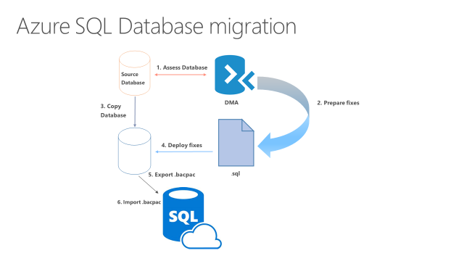

Steps contain the general workflow for a SQL Server database migration using this method:
- Assess the database for compatibility using the latest version of Data Migration Assistant (DMA).
- Prepare any necessary fixes as Transact-SQL scripts.
- Make a transactionally consistent copy of the source database being migrated - and ensure no further changes are being made to the source database (or you can manually apply any such changes after the migration completes). There are many methods to quiesce a database, from disabling client connectivity to creating a database snapshot.
- Deploy the Transact-SQL scripts to apply the fixes to the database copy.
- Export the database copy to a .BACPAC file on a local drive.
- Import the .BACPAC file as a new Azure SQL database using any of several BACPAC import tools, with SQLPackage.exe being the recommended tool for best performance.

The following list contains recommendations for best performance during the import process.
- Choose the highest service level and performance tier that your budget allows to maximize the transfer performance. You can scale down after the migration completes to save money.
- Minimize the distance between your .BACPAC file and the destination data center.
- Disable auto-statistics during migration
- Partition tables and indexes
- Drop indexed views, and recreate them once finished
- Remove rarely queried historical data to another database and migrate this historical data to a separate Azure SQL database. You can then query this historical data using elastic queries.

Method 2: Use Transactional Replication:
This method is more complex, but substantially eliminates downtime during the migration.
When you cannot afford to remove your SQL Server database from production while the migration is occurring, you can use SQL Server transactional replication as your migration solution. To use this method, the source database must meet the requirements for transactional replication and be compatible for Azure SQL Database.
To use this solution, you configure your Azure SQL Database as a subscriber to the SQL Server instance that you wish to migrate. The transactional replication distributor synchronizes data from the database to be synchronized (the publisher) while new transactions continue occur.
With transactional replication, all changes to your data or schema show up in your Azure SQL Database. Once the synchronization is complete and you are ready to migrate, change the connection string of your applications to point them to your Azure SQL Database. Once transactional replication drains any changes left on your source database and all your applications point to Azure DB, you can uninstall transactional replication. Your Azure SQL Database is now your production system.

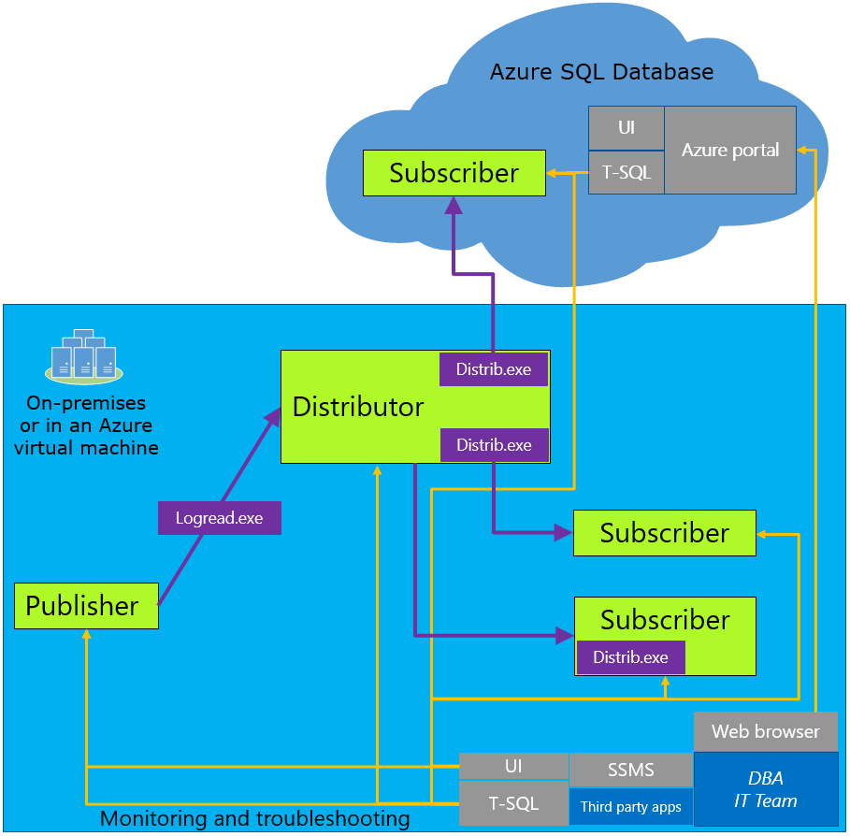

Migration to SQL Database using Transaction Replication workflow
- Set up Distribution
- Using SQL Server Management Studio (SSMS)
- Using Transact-SQL
- Create Publication
- Using SQL Server Management Studio (SSMS)
- Using Transact-SQL
- Create Subscription
- Using SQL Server Management Studio (SSMS)
- Using Transact-SQL

Some tips and differences for migrating to SQL Database:
- Use a local distributor
  - This causes a performance impact on the server.
  - If the performance impact is unacceptable, you can use another server but it adds complexity in management and administration.
- When selecting a snapshot folder, make sure the folder you select is large enough to hold a BCP of every table you want to replicate.
- Snapshot creation locks the associated tables until it is complete, so schedule your snapshot appropriately.
- Only push subscriptions are supported in Azure SQL Database. You can only add subscribers from the source database.

Resolving database migration compatibility issues:
There are a wide variety of compatibility issues that you might encounter, depending both on the version of SQL Server in the source database and the complexity of the database you are migrating. Older versions of SQL Server have more compatibility issues. Use the following resources, in addition to a targeted Internet search using your search engine of choices:
SQL Server database features not supported in Azure SQL Database
Discontinued Database Engine Functionality in SQL Server 2016
Discontinued Database Engine Functionality in SQL Server 2014
Discontinued Database Engine Functionality in SQL Server 2012
Discontinued Database Engine Functionality in SQL Server 2008 R2
Discontinued Database Engine Functionality in SQL Server 2005

Move data from an on-premises SQL server to SQL Azure with Azure Data Factory

Azure Data Factory:
It is a fully managed cloud-based data integration service that orchestrates and automates the movement and transformation of data. The key concept in the ADF model is pipeline. A pipeline is a logical grouping of Activities, each of which defines the actions to perform on the data contained in Datasets. Linked services are used to define the information needed for Data Factory to connect to the data resources.

Conditions when we have to use ADF:
- when data needs to be continually migrated in a hybrid scenario that accesses both on-premises and cloud resources
- when the data is transacted or needs to be modified or have business logic added to it when being migrated.

