**PROJECT BENEFICIARY**

Charles & Charlie Food Products

Mr. Herminigildo E. Acuesta

**PROJECT SITE**

Brgy. Kimos, Siay, Zamboanga Sibugay

**COST OF TECHNOLOGY INTEVENTIONS**

DOST SET-UP P 639,700.00

**PROJECT DURATION**

2016-2017

**Refund Period**

March 2017 – February 2020 + Tech. Transfer Fee

**NATURE OF PROJECT/ INDUSTRY SECTOR**

Food Processing

**PROJECT DESCRIPTION**

Charles & Charlie Food Products is a DTI registered and single proprietorship type of business established in 2005. The enterprise has steadily grown through the years and was able to corner a sizeable market for calamansi products in the Cities of Zamboanga City, Cebu City, Cagayan City and Dipolog City; and the Province of Zamboanga del Sur and Zamboanga Sibugay. The firm has been into production and selling of ready-to-drink and concentrated calamnsi juice, using the traditional or manual production operation and processes. With this, the owner intends to expand the business by mechanizing the operations and processes through upgrading the equipment, enabled to full scale the operation and supply of the growing number of customers in the market. Furthermore, the project is expected to create employment opportunities for the people in the community.

Upgrading the Calamansi Juice Production from

**Manual to Mechanized of Charles & Charlie Food Products**



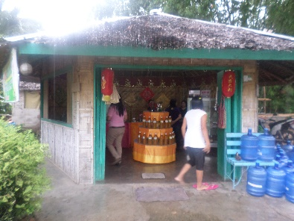

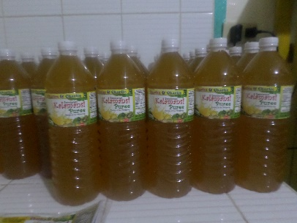

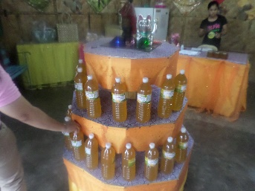

**PROJECT STATUS/OUTPUT/IMPACT**

* Established and completed the construction of new production building for the operation and house of the equipment as part of the beneficiary’s counterpart to the project;
* Mechanized the juice extraction process resulted to reduction of processing time from 4 hours to 1 hour with 200kgs capacity extracted per hour;
* Attained product consistency thru mechanization of the process;
* Provide the appropriate and customized packaging materials that is suitable for juice preservation and more attractive to the customers;
* Increased volume of production by 48%, from 86,000 bottles of ready-to-drink juice to 128,00 bottles); and
* Created an additional of 5 employments, a total of 14 job opportunities for the people in the community.

**TECHNOLOGY INTERVENTIONS**

* System improvement - upgrade business operation thru acquisition and utilization of calamansi processing facility.
* Process improvement - improvement of overall production operations which include production process and technical consultancy on proper plant lay-outing
* Manpower development - productivity improvement of workers through provision of trainings GMP, BSH and the operation and maintenance of the new equipment.

**LIST OF EQUIPMENTS PROVIDED**

|  |  |  |
| --- | --- | --- |
| **Qty** | **Equipment/Packaging** | **Specification** |
| 1 unit | Calamansi Extractor | 200kgs capacity; stainless steel separator |
| 85,000 pcs | Pet bottles | 350ml content |
| 10,000 pcs | Pet bottles | 500ml content |
| 17,000 pcs | Pet bottles | 1000ml content |

**Volume and Value of Production Including Sales Generated**

**As of 2019 2nd Semester**

|  |  |  |  |
| --- | --- | --- | --- |
| **Name of Product** | **Volume of Production** | **Quarter** | **Gross Sales** |
| Calamansi Juice  - Ready to drink  - Concentrated | RTD: 64,000 bottles of  350ml  Concentrated: 3,500 bottles of 1000ml | 3rd Quarter | PhP1,200,000 |
| RTD: 64,000 bottles of  350ml  Concentrated: 3,500 bottles of 1000ml | 4th Quarter | PhP1,200,000 |

**For the period 01-31 March 2020**

|  |  |  |  |
| --- | --- | --- | --- |
| **Name of Product** | **Volume of Production** | **Month Covered** | **Gross Sales** |
| Calamansi Juice  - Ready to drink  - Concentrated | RTD: 36,000 bottles of  350ml  Concentrated: 2,200 bottles of 1000ml | March 2020 | PhP870,000 |

**Percentage Increase (Monthly Basis)**

|  |  |  |  |  |
| --- | --- | --- | --- | --- |
| **Name of Product** | **Before EQC** (2019 2ns Sem Monthly Ave.) | **During EQC**  (March 2020) | **Total**  **Increase** | **Percentage Increase** |
| Calamansi Juice  - Ready to drink | 21,333 bottles of 350ml | 36,000 bottles of  350ml | 14,667 bottles of  350ml | **69%** |
| Calamansi Juice  - Concentrated | 1,166 bottles of 1000ml | 2,200 bottles of 1000ml | 1,034 bottles of 1000ml | **89%** |
| Gross Sales | PhP400,000 | PhP870,000 | PhP470,000 | **118%** |

*Market outlet during EQC****:*** *Bulk delivery in Pagadian and Cebu City and walk in customers with in Zamboanga Sibugay.*

Prepared by: Noted by:

**JEYZEL P. APARRI JENNIFER A. PIDOR**

PDO II Provincial S&T Director