

Upgrading of

**Palay Harvesting Process from Manual to Mechanized of VMD Rice Mill through Acquisition of Rice Combine Harvester**

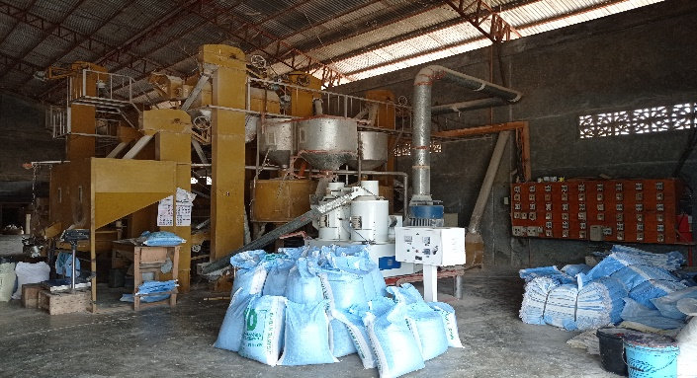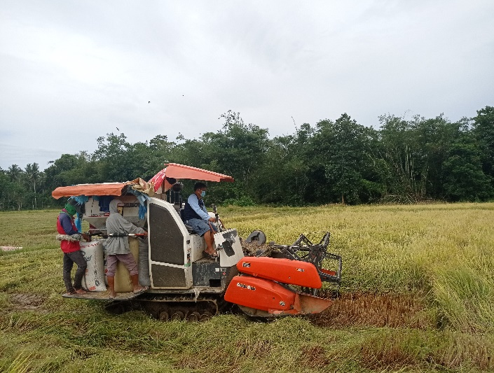

**TECHNOLOGY INTERVENTIONS**

* **System and Process Improvement** – Improvement of the firm’s harvesting process from manual to mechanized;
* **Human Resource Development** – Provision of training on basic equipment operation and maintenance; and
* **Equipment Acquisition –**

1-unit Rice Combine Harvester DC-70 with complete accessories

**PROJECT STATUS/OUTPUT/IMPACT**

The assistance of 1-unit DC-70HP Kubota Combine Rice Harvester has remarkably improve their operation including:

* Enhanced harvesting capability from manual to mechanized
* Expanded area of coverage from 50 to 100 hectares of rice farm
* Increased of number of employees directly involved in the project from 39 workers to 51 workers.

**PROJECT BENEFICIARY**

VMD Rice Mill

**PROJECT SITE**

Poblacion, Tampilisan, Zamboanga del Norte

**COST OF TECHNOLOGY INTEVENTIONS**

₱1,580,000.00

**PROJECT DURATION**

July 2017 – December 2020

**NATURE OF PROJECT/ INDUSTRY SECTOR**

Argicultures

**PROJECT DESCRIPTION**

The owners, Mr. & Mrs. Dalogdog, hav been in agri-business for more than a decade already. The couple both came from a family of farmers and landowners. Mr. Virgilio Dalogdog previously worked as an OFW in Saudi Arabia for few years and Mrs. Dalogdog is a secondary school teacher. Having a background in agriculture and with few savings in hand, they decide to put up a palay trading business in 2004. In 2011, they expanded the business and established a rice milling facility based in Poblacion, Tampilisan.

This year 2020, they now own 70 hectares of rice field and support more or less 30 hectares from farmers located in the municipalities of Tampilisan, Titay and Kalawit. Its total serviceable area is 100 hectares.

The business gradually grows over the years. The couple continuously expands their farm coverage and collaborates with more famers. They are providing the farm inputs and exchange the farmers sell the harvest to them.