**Modelling and predicting the origins of dengue importations into Europe**

Simon Busch-Moreno1*, Cedric Marsboom2, G.R. William Wint1,3,

Moritz U.G. Kraemer1,4*

**Affiliations**

1. Department of Biology, University of Oxford, Oxford, UK
2. Avia-GIS, Zoersel, Belgium
3. Environmental Research Group Oxford (ERGO), Department of Biology, University of Oxford, Oxford, UK
4. Pandemic Sciences Institute, University of Oxford, Oxford, UK

**\*Corresponding author:** [simon.buschmoreno@biology.ox.ac.uk](mailto:simon.buschmoreno@biology.ox.ac.uk), [moritz.kraemer@biology.ox.ac.uk](mailto:moritz.kraemer@biology.ox.ac.uk)

**Abstract**

Reported dengue cases have increased tenfold over the past two decades leading to a growing number of international exportations between endemic and non-endemic regions. The expanding range of the mosquito vectors which are affected by climate change and urbanisation increase the risk of outbreaks in currently non-endemic areas. Here we leverage country level time series data of dengue importations into Europe between 2012 and 2021 and combined with a Bayesian modelling approach reconstruct and predict dengue importations specific to origin and destination locations. Our model can accurately estimate the time-varying risk of importation. In addition, our model, fitted to dengue importations by quarter from 2012 to 2021 for 22 European countries, shows good inferential capacity and in-sample predictions via posterior and posterior predictive assessment. The model predicts out-of-sample moderately well (similarity indices between aggregated observations and predictions > 0.8). We discuss the model’s implementation, extendibility, and scalability and how it can be deployment in real-time assessing and predicting dengue disease risk in Europe.

**Keywords**: *Dengue; importation risk; importation forecast; Bayesian modelling; Gaussian process.*

**Acknowledgements**

We thank the E4Warning team and special thanks to all members of the modelling team for their valuable suggestions and comments.

**Authors Contributions**

Contributions to the study were as follows. S.B.M.: conceptualisation, software, statistical methodology, analysis, writing. C.M.: conceptualisation, data, revision. W.W.: conceptualisation, data, revision. M.U.G.K.: conceptualization, administration, revision.

**Data and Code Availability**

Code scripts available at: <https://github.com/kraemer-lab/Dengue_Europe_Import>. Dengue importation data cannot be re-shared but are available for research purposes from the European Centre for Disease Prevention and Control. Requests to access these data can be made via https://www.ecdc.europa.eu/en/publications-data/request-tessy-data-research .

**Funding Sources**

M.U.G.K., S.B.M., C.M., G.R.W.W. acknowledge funding from European Union’s Horizon Europe programme (E4Warning under Grant Agreement 101086640). M.U.G.K. acknowledges funding from The Rockefeller Foundation, Google.org, the Oxford Martin School Pandemic Genomics programme, European Union's Horizon Europe programme projects MOOD (#874850, also C.M. and G.R.W.W.), the John Fell Fund, a Branco Weiss Fellowship and Wellcome Trust grants 225288/Z/22/Z, 226052/Z/22/Z & 228186/Z/23/Z, United Kingdom Research and Innovation (#APP8583) and the Medical Research Foundation (MRF-RG-ICCH-2022-100069). The contents of this publication are the sole responsibility of the authors and do not necessarily reflect the views of the European Commission or the other funders.

**Declaration of interests**

The authors declare no conflicts of interest.

**Introduction**

Dengue is a systematic viral infection that is endemic in over 100 countries, many of them in tropical and sub-tropical regions, and has substantially expanded in geographical reach and intensity over the past decades (European Centre for Disease Prevention and Control, 2024). Dengue outbreaks have also been recorded in Europe, the USA and China, with a notable increase in the frequency and intensity of outbreaks (De Carli, 2023). Outbreaks in Europe for example are limited to periods when local temperatures reach the threshold for viral replication in the vector species *Ae. albopictus*. Currently the main hypothesis is that outbreaks in Europe follow the arrival of infected travellers coming from endemic regions (Branda et al., 2023). To prepare and respond to the risk of local outbreaks it is critical for local authorities to know about the potential arrival of infected travellers.

Countries with known endemic dengue circulation such as Brazil, Thailand, Cambodia and others have established dengue surveillance systems. This data has been used to for example map the local outbreak dynamics, vector distribution and abundance, and understand the impact of climate and demographic factors driving outbreak risk (e.g. Bett et al., 2012; Cuong et al., 2013; Romero et al., 2019; Andrioli et al., 2020; Kiang et al., 2021). To aid public health decision making short- and medium-term predictions of dengue cases and burden in endemic areas have recently been developed (Colón-González et al., 2021).

Although Europe was considered a low-risk region (Schaffner and Mathis, 2014), the current assessment of the European Centre for Disease Prevention and Control (2024) indicates moderate likelihood of local transmission of dengue in Europe. The widespread global distribution of *Ae. albopictus*, changes in temperatures, and rising dengue importation imply an increased risk of local outbreaks in Europe (Ahmed et al., 2019; Brem et al., 2024). Hence, inferring and predicting the importation patterns of dengue into Europe is critical to anticipate local outbreaks. Prior work indicates a progressive increase of dengue importation into Europe from the end of the 20th century (Ahmed et al., 2019) and more recent work indicates that almost three dengue cases are imported into Europe per 100,000 air passengers in the period from 2015-2019 (Gossner et al., 2022).

We implement a principled Bayesian model to make inferences and short-term forecasts of dengue importations into Europe at the country level. We develop this model prioritising computational efficiency and reduced model complexity. A travel-related case (imported case) was defined as an individual with a dengue virus infection acquired in a country other than the country of diagnosis (and outside of Europe). The more specific aim of our study was to estimate the importation rate of dengue into Europe by country of origin and provide distributions of observed and unobserved cases for 2022 – 2024, as well as a forecast of dengue cases into 2025. We thereby provide insights into the recent dengue importation dynamics in Europe influenced by the drop in global commercial air travel during the height of the COVID-19 pandemic. We test our models’ robustness and describe extensions to enable updates of dengue importation estimates into Europe as dengue incidence is rising globally.

**Materials and Methods**

*Epidemiological and air transportation data*

We used travel-related cases reported through The European Surveillance System (TESSy) of the European Centre of Disease Prevention and Control (ECDC). Data were extracted on 6 October 2020, and corresponds to detected cases of Dengue, Chikungunya, and Zika viruses in Europe by reporting country and place where the case was registered inside this country (if available), date of report (day-month-year), and country of origin (where the person reported to be positive with dengue was infected).

We aggregated data by reporting country (22 European countries for dengue, 16 for chikungunya and zika), exporting country (140, 94, and 74 countries where the passenger was infected with dengue, chikungunya and zika respectively), and quarter (40 terms 2012-2021); Zika data was only available from 2015’s 4th quarter. We use data reported on a previous study (Gossner et al., 2022), consisting of the aggregated number of travellers from 93 exporting countries to Europe between 2015 and 2019. The previous study used 6 more exporters consisting of smaller countries aggregated into sub-regions, we have no manner of matching these aggregates, so we perform analyses with the 93 matching countries (71 and 47 matching countries for chikungunya and zika respectively). To roughly approximate the average yearly number of travellers from exporting countries into Europe, we divide the 2015-2019 aggregate by 5 (years) and 4 (terms), which applies to pre-pandemic years. For pandemic and post pandemic years we adjust the number of travellers by the reported decreases/increases in passenger volume (percentage) between 2020 and 2024 (drops of 66% for 2020, 58% for 2021, 23% for 2022 and 6% for 2023 compared to 2019, with total recovery expected for 2024), as reported by the International Air Transport Association (IATA, 2024). World maps for plotting where obtained from the World Food Programme (UN agency) (2022).

*Software*

For the completion of this study all the following software packages were essential: for Bayesian sampling and statistics we used PyMC (Abril-Pla et al., 2023), and ArviZ (Kumar et al., 2019), for numerical calculation support we used NumPy (Harris et al., 2020), for data wrangling we used pandas (The pandas development team, 2024), and for plots we used Matplotlib (Hunter, 2007) and Geopandas (Jordahl et al., 2020).

*Model Design*

Our main statistical model is a hierarchical Bayesian model based on a Negative Binomial (*NB*) sampling distribution, for our observed count data, with a Gaussian process (*GP*) prior for the temporal variable (terms), and normal priors for other parameters. The use of a temporal *GP* as prior for count distributions can be an efficient way for capturing information on the influence of past observations on future ones, and it is a reliable choice for epidemiological data (e.g. Guzmán-Rincón et al., 2023). With this in mind, we design the following model:

Where is the temporal length-scale,is a maximum covariance parameter, is the exponential-quadratic kernel over *t…T* terms (quarters from 2012 to 2021) informing Gaussian process ; and and are non-centred parametrisations with base distributions and , raging through exporting-reporting country dyads and exporting countries, locations and , and scales and respectively; is a covariate corresponding to the standardised yearly number of passengers from exporting country to Europe; is a shape parameter; and is the mean of the sampling distribution over imported cases. Note that when a *NB* is parametrised via mean and shape, its standard deviation is .

*Model Assessment*

Before sampling our main model, we carried on a calibration step to ensure appropriate out-of-sample predictions and that priors are appropriate. To this aim, we fit the main model to data segmented from 2012 to 2018, thus leaving three years (2019, 2021 and 2022) to fall within the predicted window (out-of-sample period). To forecast imported cases on the 2019-2021 windows we extrapolate from the posterior predictive distribution obtained from the model fitted to the 2012-2018 period. The posterior predictive distribution can be defined (see Schad et al., 2020) as , where is the posterior over model parameters and the likelihood function, used to simulate new data .

We can use these simulations as posterior predictive checks to assess how well the model can predict observed data and with what degree of uncertainty (McElreath, 2020, Martin et al 2021), and we can also predict values of unobserved (out-of-sample) data, i.e. on the 2019-2021 window for calibration, on the 2022-2024 window for extrapolation/imputation, and on the 2025 window for forecast. To assess the similarity between predicted distributions and target simulations we use the Jaccard, Sorensen-Dice, or similarity index (SI) (see Costa, 2021): SI = , where is the observed data and is the model prediction on the unobserved data.

Finally, we use predictions from the posterior to assess the risk of each country proportional to the total risk. We use a risk measure bases on previous research (Lee et al., 2021) as , where is the number of infected people traveling into a country and is the total number of travellers. As mentioned before, using previously published data (Gossner et al., 2022), we have roughly approximated the quarterly travellers over the 2012-2025 period, so we define as the aggregated travellers over the 2012-2025 period (2015-2025 for zika data) and as the aggregated predictions over the same period. We define proportional risk as .

We sampled all models, for calibration and otherwise, using HMC NUTS as provided by PyMC (Abril-Pla et al., 2023), using 3000 samples, 3000 tuning steps and 4 chains. Models sampled well, with all ESS > 1000, , and BFMIs > 0.75. For more details, like full summaries and convergence plots see our online repository (link in Data Availability Statement).

**Results**

The average number of travellers based on our approximation shows a coherent average trend, whit most travellers coming from Asian countries, Mexico and Brazil (see Figure 1A). Additionally, averaged arbovirus importations indicate a higher trend of dengue importation from south-east Asia, followed by south Asia and the Americas (Figure 1B), while chikungunya is mainly imported from the Caribbean (Figure 1C) and zika is mainly imported from the Americas (Figure 1D).

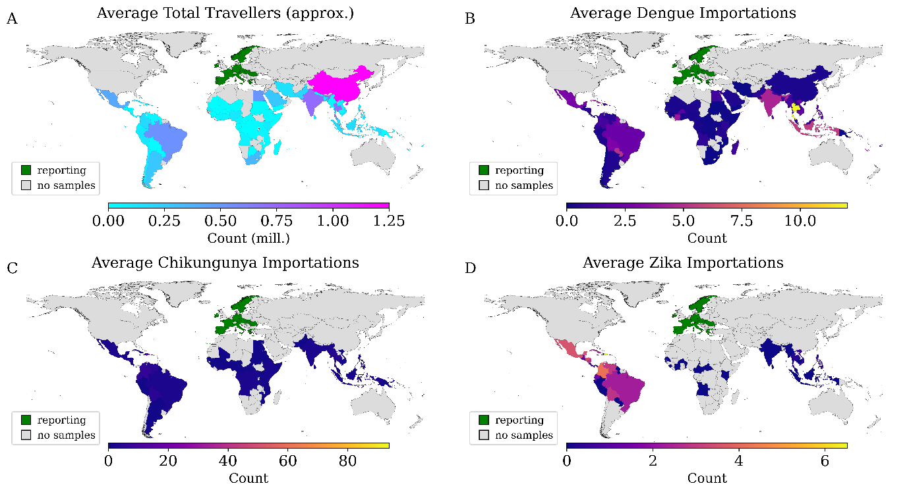

**Figure 1**. Travellers and arboviruses descriptive plots. **A**: average number of travellers from country of origin to Europe (green) as per our estimation and averaged between 2012-2021. **B**: dengue importations from country of origin averaged between 2012-2021. **C**: chikungunya importations from country of origin averaged between 2012-2021 (note that most come from small islands in the Caribbean such as Guadeloupe). **D**: zika importations from country of origin averaged between 2015-2021.

We fit our model on data from 2012 to 2018 for dengue and chikungunya and from 2015 to 2018 for zika, from that fit we predict the 2019-2021 period. Dengue predictions aggregated by time (Figure 2A) indicate good predictive capacity (SI = 0.9) with reasonable uncertainty but slightly low accuracy. Aggregating predictions by reporting country (Figure 2B) also indicates a good approximation (SI = 0.87), but the model underpredicts for major importers France (FR) and Germany (DE). This is similar for aggregated predictions by exporting country (Figure 2C), with high general predictive capacity (SI = 0.82), but underprediction of major importers Thailand (TH), India (IN), Indonesia (ID), and Cuba (CU). Similarity per country (see FigureB-C) indicates SIs > 0.6 for most countries.

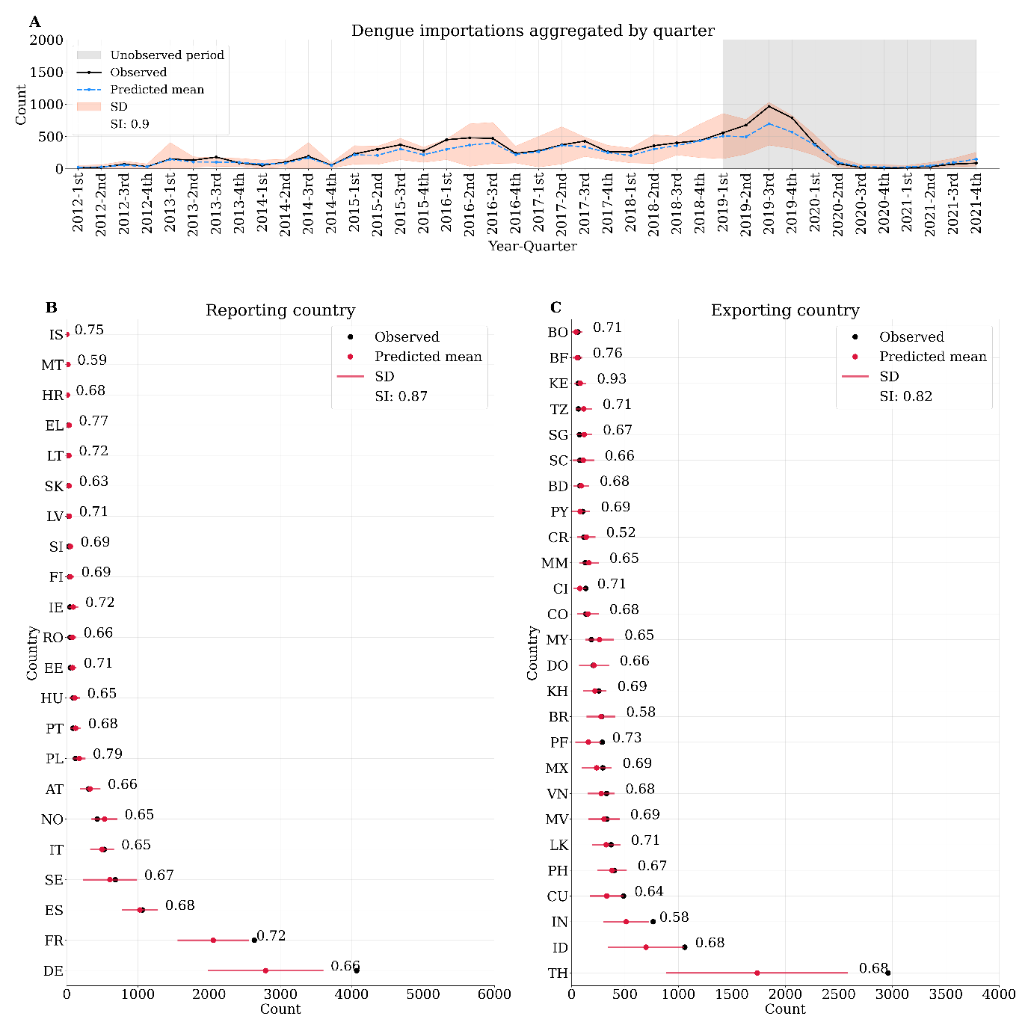

**Figure 2**. Dengue Predictions 2012-2021. **A**: predictions aggregated by quarter (time), grey shadow indicates the unobserved period (held-out data or testing set), red shadows indicate the negative binomial (NB) standard deviation (SD), SI is the similarity index. **B**: predictions aggregated by reporting country, red bars indicate NB SD, red dots indicate aggregated predictions including unobserved period, numbers beside dots are individual country SI across time. **C**: predictions aggregated by exporting country, red bars indicate NB SD, red dots indicate aggregated predictions including unobserved period, numbers beside dots are individual country SI across time. Country names correspond to ISO labels.

Chikungunya predictions aggregated by time (Figure 3A) indicate a lower predictive capacity (SI=0.75), but underpredictions concentrate early in time (2014). Predictions aggregated by reporting country (Figure 3B) are overall reasonable (SI = 0.84), but individual countries show mostly SIs < 0.6. Predictions aggregated by exporting country show somewhat lower predictive capacity (SI = 0.71), but with most individual countries showing SIs > 0.6.

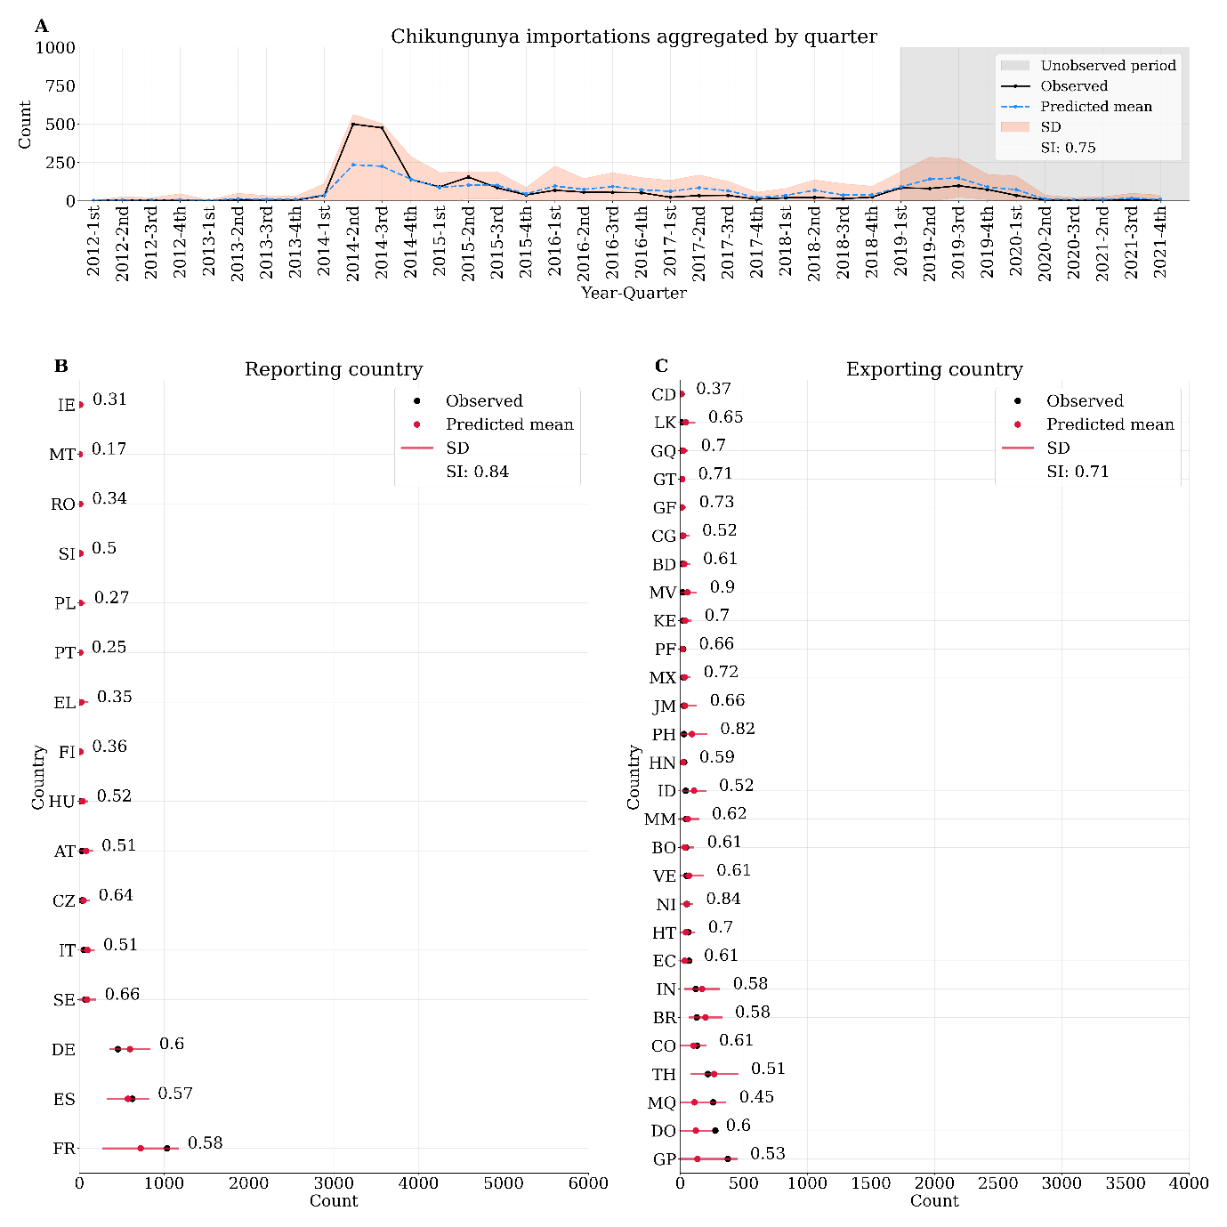

**Figure 3**. Chikungunya Predictions 2012-2021. **A**: predictions aggregated by quarter (time), grey shadow indicates the unobserved period (held-out data or testing set), red shadows indicate the negative binomial (NB) standard deviation (SD), SI is the similarity index. **B**: predictions aggregated by reporting country, red bars indicate NB SD, red dots indicate aggregated predictions including unobserved period, numbers beside dots are individual country SI across time. **C**: predictions aggregated by exporting country, red bars indicate NB SD, red dots indicate aggregated predictions including unobserved period, numbers beside dots are individual country SI across time. Country names correspond to ISO labels.

Zika predictions aggregated over time (Figure 4A) indicate somewhat unstable predictions across the timeline with reasonable predictive capacity (SI = 0.77). Predictions aggregated by reporting country also show good general predictive capacity (SI = 0.84), with most individual countries showing moderate SIs > 0.5. Predictions aggregated by exporting country are similar (SI = 0.84), showing many SIs > 0.6 for individual countries.

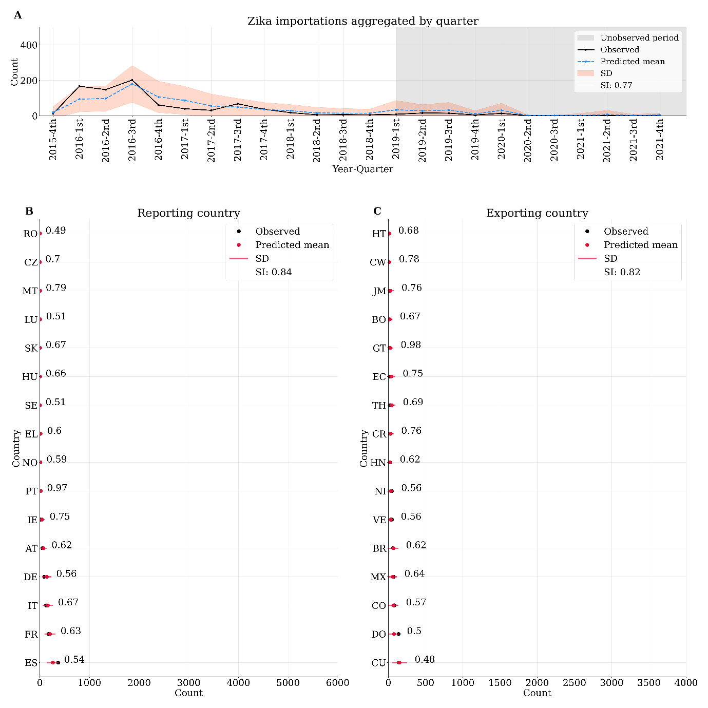

**Figure 4**. Zika Predictions 2012-2021. **A**: predictions aggregated by quarter (time), grey shadow indicates the unobserved period (held-out data or testing set), red shadows indicate the negative binomial (NB) standard deviation (SD), SI is the similarity index. **B**: predictions aggregated by reporting country, red bars indicate NB SD, red dots indicate aggregated predictions including unobserved period, numbers beside dots are individual country SI across time. **C**: predictions aggregated by exporting country, red bars indicate NB SD, red dots indicate aggregated predictions including unobserved period, numbers beside dots are individual country SI across time. Country names correspond to ISO labels.

Next, we fit models to the full dataset (up to 2021) and forecast importations from 2022 to 2025. Dengue results indicate a rapid recovery of importations from 2022 onwards (Figure 5). Results from Chikungunya and Zika seem to predict the same fast recovery, though this may be a statistical artefact induced by the COVID-19 pandemic drop in travelling, given that both Zika and Chikungunya presented low importation rates right before the COVID-19 pandemic, as opposed to dengue.

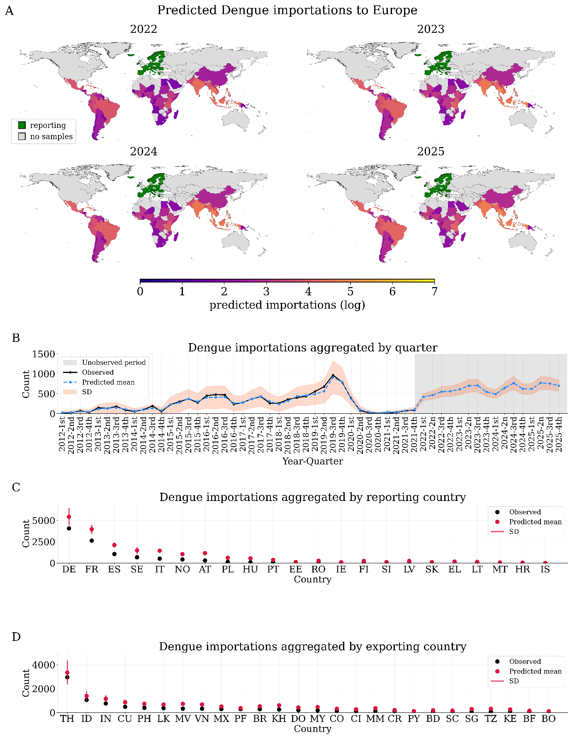

**Figure 5**. Dengue forecast. **A**: predicted importations of dengue into Europe from 2022 to 2025 in natural log scale, countries in green are reporting countries. **B**: Predicted timeline, shadows indicate negative binomial (NB) standard deviation (SD), grey shadow indicates precited period after 2021’s 4th quarter. **C**: predictions aggregated by reporting country (entire timeline), red bars indicate NB SD. **D**: predictions aggregated by exporting country (entire timeline), red bars indicate NB SD. Country names correspond to ISO labels.

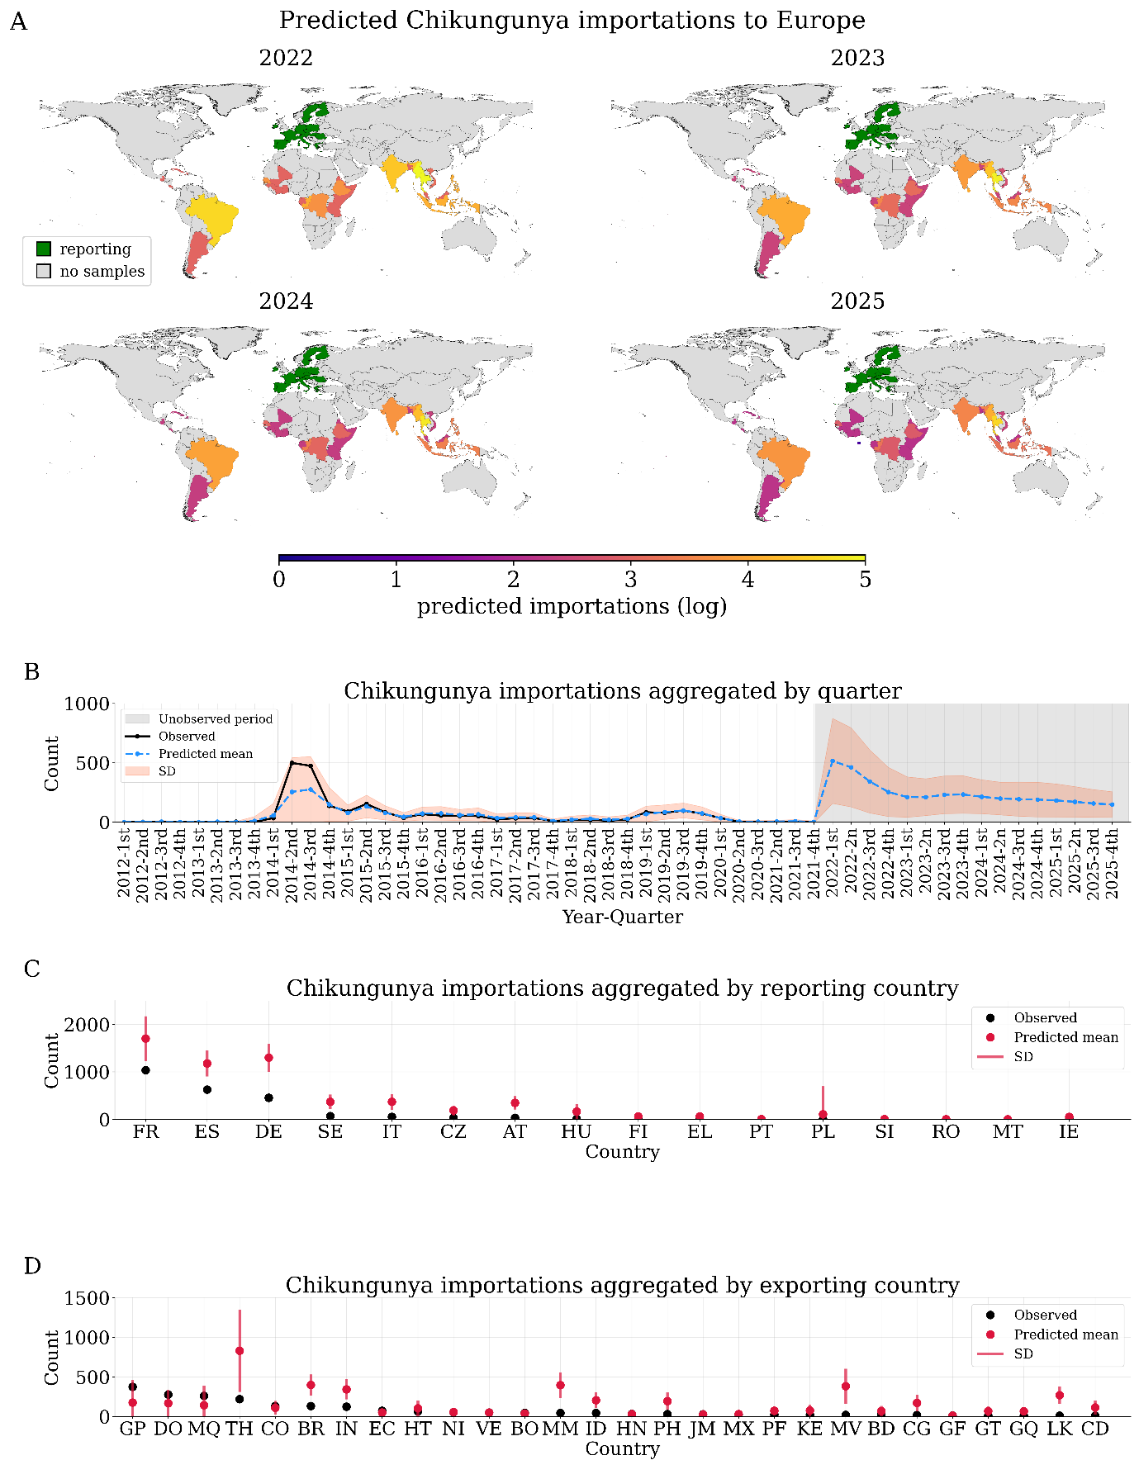

**Figure 6**. Chikungunya forecast. **A**: predicted importations of dengue into Europe from 2022 to 2025 in natural log scale, countries in green are reporting countries. **B**: Predicted timeline, shadows indicate negative binomial (NB) standard deviation (SD), grey shadow indicates precited period after 2021’s 4th quarter. **C**: predictions aggregated by reporting country (entire timeline), red bars indicate NB SD. **D**: predictions aggregated by exporting country (entire timeline), red bars indicate NB SD. Country names correspond to ISO labels.

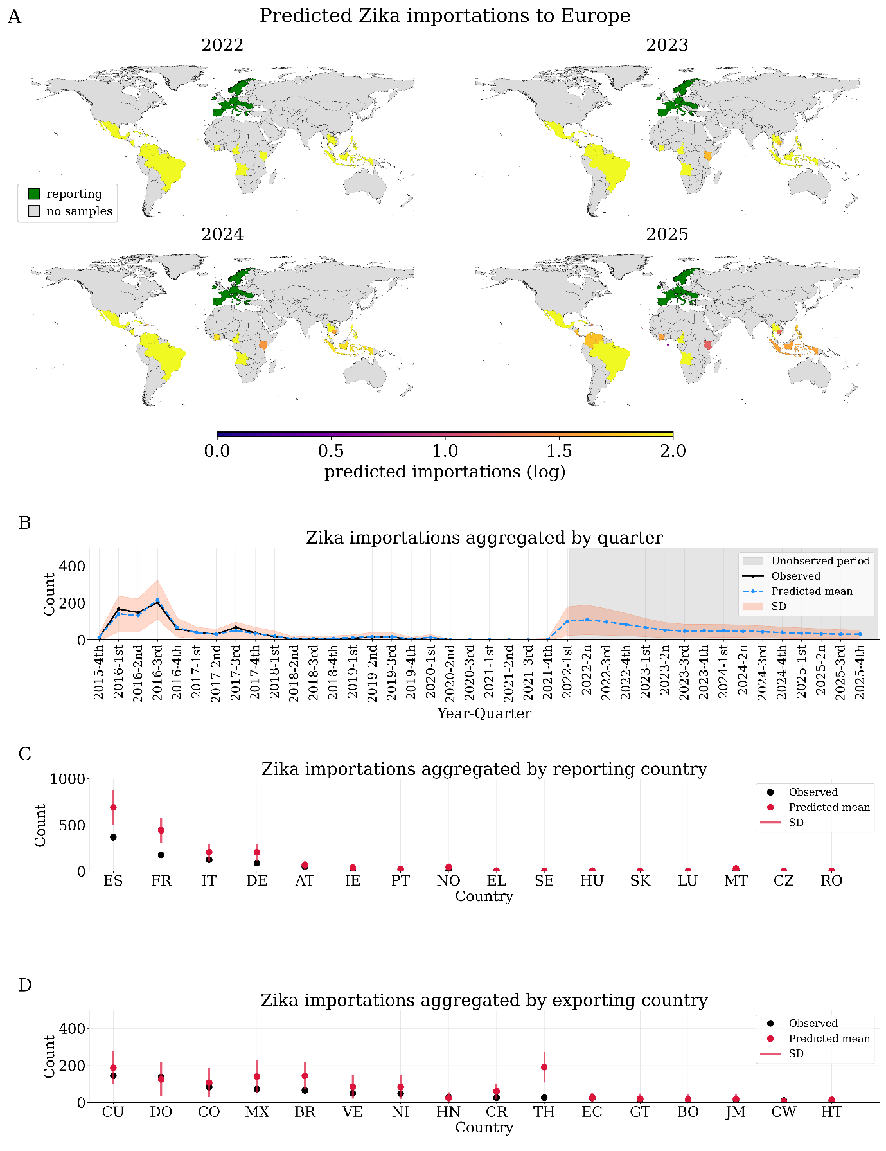

**Figure 7**. Zika forecast. **A**: predicted importations of dengue into Europe from 2022 to 2025 in natural log scale, countries in green are reporting countries. **B**: Predicted timeline, shadows indicate negative binomial (NB) standard deviation (SD), grey shadow indicates precited period after 2021’s 4th quarter. **C**: predictions aggregated by reporting country (entire timeline), red bars indicate NB SD. **D**: predictions aggregated by exporting country (entire timeline), red bars indicate NB SD. Country names correspond to ISO labels.

**Discussion**

Our results indicate that our main model has good inferential capacity in terms of providing informative estimates of importation/exportation rates by country. Additionally, the model predicts well at aggregated levels (by quarter and country), although it may benefit from increased precision and accuracy, especially at the single country level (exporting and reporting). This may require more detailed covariates, such as time-varying air passenger data and unbiased dengue case data from reporting countries. The predicted dengue patterns are, however, consistent with observed data (Ahmed et al., 2019; Gossner et al., 2022) and other modelling frameworks (Salami et al., 2020a, 2020b;). indicating that our simple model can be a useful complement to other more long-term efforts aiming to model dengue importations to Europe accounting for additional complexity such as incidence in origin countries and reporting biases.

Predicted patterns of importation are within reasonable expectations given the current global dengue epidemiology, namely the post-pandemic recovery of international air travel and dengue outbreaks in Argentina, Brazil, and Peru (European Centre for Disease Prevention and Control, 2024; De Ambrosio, 2024; Munyaco et al., 2024).

Our results need to be viewed in light of several limitations: Firstly, the lack of more accurate information for covariates, may be a factor contributing to reduced accuracy. There is no openly available data on number of passengers arriving in at European airports stratified by origin country and time. This can have a negative impact on models when researchers have no access to these data (as in our case). Previous research has shown how this detailed travel information can be important for improving predictive accuracy (Salami, 2020b). Even so, our model proves sufficiently capable when accessing this detailed information is not possible, which was one of the goals of present study (i.e. provide sufficiently good evidence and predictions when information and computational capacity may be limited). Secondly, additional calibration, model comparison and model averaging could help to improve the predictive capacity of our model. We believe our model calibration already provides a good benchmark for assessing our approach, but this does not exclude further exploration on variations of our model structure (e.g. different parametrisation, or additional parameters).

Our model provides good inference on importation and exportation uncertainty, and on the temporal scale of dengue importation into Europe, with good description of importation peaks and highest/lowest importers and exporter-reporter scales. Although our analysis has focused on air-traffic, it is possible to extend our approach, or similar ones, to cross border and land-based mobility. This may help to increase accuracy on local estimates, but also to capture patterns of local transmission in Europe and elsewhere.

An important aspect of present model/approach simplicity and flexibility is that it can be integrated into or paired with models assessing the spread and establishment of dengue vectors, such as *Aedes aegypti* (e.g. Kraemer et al., 2019; Barradas Mores et al., 2020). Although there are a variety of models, both statistical and mechanistic, for the study of *Ae. aegypti* and *Ae. albopictus* spread into Europe (e.g. Liu-Helmersson et al., 2019; Kraemer et al., 2019; Wint et al., 2020), few attempts have been made to integrate these with dengue exportation/importation dynamics. That is, a comprehensive model to estimate local outbreaks risk given both vector spread and dengue importation. Future work integrating the model presented here with vector models can improve predictions of local arbovirus outbreaks (e.g. non-linear models with *GP* priors).

**Conclusion**

In conclusion, our approach presents an easy to apply model which can provide fast results for generating short-term predictions for countries where both, historic importation rates and flight data are available. Our approach provides estimates consistent with recent literature (Ahmed et al., 2019; Salami et al., 2020a, 2020b; Gossner et al., 2022) and provides predictions of dengue importations into Europe for unobserved data from recent and present years and a forecast for the upcoming calendar year (2025). Predicted seasonality patterns are consistent with dengue’s seasonality, and they provide information which could be used in tandem with vector spread and establishment models. Although our modelling approach can coherently characterise importation patterns, it requires further work, especially regarding the addition of more detailed covariates (e.g. predicted monthly air travel data).

**References**

Abril-Pla, O., Andreani, V., Carroll, C., Dong, L. Y., Fonnesbeck, C., Kochurov, M., Kumar, R., Lao, J., Luhmann, C. C., Martin, O. A., Osthege, M., Vieira, R., Wiecki, T. V., & Zinkov, R. (2023). PyMC: a modern, and comprehensive probabilistic programming framework in Python. *PeerJ*, *9*, e1516–e1516. <https://doi.org/10.7717/peerj-cs.1516>

Ahmed, A. M., Mohammed, A. T., Vu, T. T., Khattab, M., Doheim, M. F., Ashraf Mohamed, A., Abdelhamed, M. M., Shamandy, B. E., Dawod, M. T., Alesaei, W. A., Kassem, M. A., Mattar, O. M., Smith, C., Hirayama, K., & Huy, N. T. (2019). Prevalence and burden of dengue infection in Europe: A systematic review and meta‐analysis. *Reviews in Medical Virology*, *30*(2). <https://doi.org/10.1002/rmv.2093>

Andrioli, D. C., Busato, M. A., & Lutinski, J. A. (2020). Spatial and temporal distribution of dengue in Brazil, 1990 - 2017. *PLOS ONE*, *15*(2), e0228346. <https://doi.org/10.1371/journal.pone.0228346>

Barradas Mores, G., Schuler-Faccini, L., Hasenack, H., Oliveira Fetzer, L., Dornelles Souza, G., & Ferraz, G. (2020). Site Occupancy by Aedes aegypti in a Subtropical City is Most Sensitive to Control during Autumn and Winter Months. *American Journal of Tropical Medicine and Hygiene*, *103*(1), 445–454. <https://doi.org/10.4269/ajtmh.19-0366>

Bett, B., Grace, D., Lee, H. S., Lindahl, J., Nguyen-Viet, H., Phuc, P.-D., Quyen, N. H., Tu, T. A., Phu, T. D., Tan, D. Q., & Nam, V. S. (2019). Spatiotemporal analysis of historical records (2001–2012) on dengue fever in Vietnam and development of a statistical model for forecasting risk. *PLOS ONE*, *14*(11), e0224353. <https://doi.org/10.1371/journal.pone.0224353>

Bouzid, M., Colón-González, F. J., Lung, T., Lake, I. R., & Hunter, P. R. (2014). Climate change and the emergence of vector-borne diseases in Europe: case study of dengue fever. *BMC Public Health*, *14*(1). <https://doi.org/10.1186/1471-2458-14-781>

Colón-González, F. J., Soares Bastos, L., Hofmann, B., Hopkin, A., Harpham, Q., Crocker, T., Amato, R., Ferrario, I., Moschini, F., James, S., Malde, S., Ainscoe, E., Sinh Nam, V., Quang Tan, D., Duc Khoa, N., Harrison, M., Tsarouchi, G., Lumbroso, D., Brady, O. J., & Lowe, R. (2021). Probabilistic seasonal dengue forecasting in Vietnam: A modelling study using superensembles. *PLOS Medicine*, *18*(3), e1003542. <https://doi.org/10.1371/journal.pmed.1003542>

Costa, L. J. (2021). *Further Generalizations of the Jaccard Index*. <https://doi.org/10.48550/arxiv.2110.09619>

Cuong, H. Q., Vu, N. T., Cazelles, B., Boni, M. F., Thai, K. T. D., Rabaa, M. A., Quang, L. C., Simmons, C. P., Huu, T. N., & Anders, K. L. (2013). Spatiotemporal Dynamics of Dengue Epidemics, Southern Vietnam. *Emerging Infectious Diseases*, *19*(6), 945–953. <https://doi.org/10.3201/eid1906.121323>

Eritja, R., Palmer, J. R. B., Roiz, D., Sanpera-Calbet, I., & Bartumeus, F. (2017). Direct Evidence of Adult Aedes albopictus Dispersal by Car. *Scientific Reports*, *7*(1). <https://doi.org/10.1038/s41598-017-12652-5>

European Centre for Disease Prevention and Control. (2024, April 22). *Dengue worldwide overview*. European Centre for Disease Prevention and Control. <https://www.ecdc.europa.eu/en/dengue-monthly>

Gossner, C. M., Fournet, N., Frank, C., Fernández-Martínez, B., Del Manso, M., Gomes Dias, J., & de Valk, H. (2022). Dengue virus infections among European travellers, 2015 to 2019. *Euro Surveillance: Bulletin Europeen Sur Les Maladies Transmissibles = European Communicable Disease Bulletin*, *27*(2). <https://doi.org/10.2807/1560-7917.ES.2022.27.2.2001937>

Guzmán-Rincón, L. M., Hill, E. M., Dyson, L., Tildesley, M. J., & Matthew James Keeling. (2023). Bayesian estimation of real-time epidemic growth rates using Gaussian processes: local dynamics of SARS-CoV-2 in England. *Applied Statistics*, *72*. <https://doi.org/10.1093/jrsssc/qlad056>

Harris, C. R., Millman, K. J., van der Walt, S. J., Gommers, R., Virtanen, P., Cournapeau, D., Wieser, E., Taylor, J., Berg, S., Smith, N. J., Kern, R., Picus, M., Hoyer, S., van Kerkwijk, M. H., Brett, M., Haldane, A., del Río, J. F., Wiebe, M., Peterson, P., & Gérard-Marchant, P. (2020). Array Programming with NumPy. *Nature*, *585*(7825), 357–362. <https://doi.org/10.1038/s41586-020-2649-2>

Hunter, J. D. (2007). Matplotlib: A 2D Graphics Environment. *Computing in Science & Engineering*, *9*(3), 90–95. <https://doi.org/10.1109/mcse.2007.55>

International Air Transport Association. (2024). *Economics Report Library*. Www.iata.org. https://www.iata.org/en/publications/economics/economics-library/?Search=Air%20Passenger%20Market%20Analysis&Ordering=DateDesc

Jordahl, K., Van, Fleischmann, M., Wasserman, J. L., McBride, J. R., Gerard, J., Tratner, J., Perry, M., Garcia Badaracco, A., Farmer, C., Arne Hjelle, G., Snow, A. D., Cochran, M., Gillies, S., Culbertson, L., Bartos, M., Eubank, N., maxalbert, Bilogur, A., & Rey, S. J. (2020). *geopandas/geopandas: v0.8.1*. https://doi.org/10.5281/zenodo.3946761

Kiang, M. V., Santillana, M., Chen, J. T., Onnela, J.-P., Krieger, N., Engø-Monsen, K., Ekapirat, N., Areechokchai, D., Prempree, P., Maude, R. J., & Buckee, C. O. (2021). Incorporating human mobility data improves forecasts of Dengue fever in Thailand. *Scientific Reports*, *11*(1). <https://doi.org/10.1038/s41598-020-79438-0>

Kraemer, M. U. G., Reiner, R. C., Brady, O. J., Messina, J. P., Gilbert, M., Pigott, D. M., Yi, D., Johnson, K., Earl, L., Marczak, L. B., Shirude, S., Davis Weaver, N., Bisanzio, D., Perkins, T. A., Lai, S., Lu, X., Jones, P., Coelho, G. E., Carvalho, R. G., & Van Bortel, W. (2019). Past and future spread of the arbovirus vectors Aedes aegypti and Aedes albopictus. *Nature Microbiology*, *4*(5), 854–863. <https://doi.org/10.1038/s41564-019-0376-y>

Kumar, R., Carroll, C., Hartikainen, A., & Martin, O. (2019). ArviZ a unified library for exploratory analysis of Bayesian models in Python. *Journal of Open Source Software*, *4*(33), 1143. <https://doi.org/10.21105/joss.01143>

Lee, H., Kim, Y., Kim, E., & Lee, S. (2021). Risk Assessment of Importation and Local Transmission of COVID-19 in South Korea: Statistical Modeling Approach. *JMIR Public Health and Surveillance*, *7*(6), e26784. <https://doi.org/10.2196/26784>

Liu-Helmersson, J., Quam, M., Wilder-Smith, A., Stenlund, H., Ebi, K., Massad, E., & Rocklöv, J. (2016). Climate Change and Aedes Vectors: 21st Century Projections for Dengue Transmission in Europe. *EBioMedicine*, *7*, 267–277. <https://doi.org/10.1016/j.ebiom.2016.03.046>

Liu-Helmersson, J., Rocklöv, J., Sewe, M., & Brännström, Å. (2019). Climate change may enable Aedes aegypti infestation in major European cities by 2100. *Environmental Research*, *172*, 693–699. <https://doi.org/10.1016/j.envres.2019.02.026>

Martín De Ambrosio. (2024). Argentina’s healthcare is crumbling under its worst ever dengue epidemic and Milei’s presidency. *BMJ*, q896–q896. <https://doi.org/10.1136/bmj.q896>

Martin, O. A., Kumar, R., & Lao, J. (2021). *Bayesian Modeling and Computation in Python*. CRC Press.

McElreath, R. (2020). *Statistical Rethinking, 2nd Edition*. Chapman and Hall/CRC.

Munayco, C. V., Valderrama Rosales, B. Y., Mateo Lizarbe, S. Y., & et al. (2024). Notes from the Field: Dengue Outbreak — Peru, 2023. *MMWR. Morbidity and Mortality Weekly Report*, *73*. <https://doi.org/10.15585/mmwr.mm7304a4>

Racloz, V., Ramsey, R., Tong, S., & Hu, W. (2012). Surveillance of Dengue Fever Virus: A Review of Epidemiological Models and Early Warning Systems. *PLoS Neglected Tropical Diseases*, *6*(5), e1648. <https://doi.org/10.1371/journal.pntd.0001648>

Rogers, D. J., Suk, J. E., & Semenza, J. C. (2014). Using global maps to predict the risk of dengue in Europe. *Acta Tropica*, *129*, 1–14. <https://doi.org/10.1016/j.actatropica.2013.08.008>

Romero, D., Olivero, J., Real, R., & Guerrero, J. C. (2019). Applying fuzzy logic to assess the biogeographical risk of dengue in South America. *Parasites & Vectors*, *12*(1). <https://doi.org/10.1186/s13071-019-3691-5>

Salami, D., Capinha, C., Martins, M. do R. O., & Sousa, C. A. (2020a). Dengue importation into Europe: A network connectivity-based approach. *PLOS ONE*, *15*(3), e0230274. <https://doi.org/10.1371/journal.pone.0230274>

Salami, D., Sousa, C. A., Martins, M. do R. O., & Capinha, C. (2020b). Predicting dengue importation into Europe, using machine learning and model-agnostic methods. *Scientific Reports*, *10*(1). <https://doi.org/10.1038/s41598-020-66650-1>

Schad, D. J., Betancourt, M., & Vasishth, S. (2020). Toward a principled Bayesian workflow in cognitive science. *Psychological Methods*. <https://doi.org/10.1037/met0000275>

Schaffner, F., & Mathis, A. (2014). Dengue and dengue vectors in the WHO European region: past, present, and scenarios for the future. *The Lancet Infectious Diseases*, *14*(12), 1271–1280. <https://doi.org/10.1016/s1473-3099(14)70834-5>

The pandas development team. (2024, April 10). *pandas-dev/pandas: Pandas*. Zenodo. <https://zenodo.org/records/10957263>

Wint, W., Van Bortel, W., & Schaffner, F. (2020). RVF vector spatial distribution models: Probability of presence. *EFSA Supporting Publications*, *17*(2). <https://doi.org/10.2903/sp.efsa.2020.en-1800>