**First Year(Fall 2022)**

**Assignment No:1**

**Programming Fundamentals (Python)**

**Software Engineering Dept**

**CLO-1(C2)**

**Apply** the devised solutions into computer programs and test the programs on a computer.

**It should be clear that your assignment will not get any credit if:**

1. The assignment is submitted after due date.
2. The assignment is submitted via email.
3. The assignment is copied from Internet or from any other student.

___________________________________________________________________________________________

1.**By using for loop, generate the following series**

1. **11 16 21 26 31 36 41**
2. **3 8 13 18 23 28 33**
3. **20 20 17 17 14 14 11**

**2.** **Write a Python program to print alphabet pattern 'A'.**

***

* *

* *

****

* *

* *

* *

3**. Write a Python program to check a triangle is equilateral, isosceles or scalene.**    
Note :  
An equilateral triangle is a triangle in which all three sides are equal.  
A scalene triangle is a triangle that has three unequal sides.  
An isosceles triangle is a triangle with (at least) two equal sides.

**Expected Output:**

Input lengths of the triangle sides:

x: 12

y: 12

z: 12

Equilateral triangle

4. Write a function stats() that takes one input argument: the name of a text file. The function should print, on the screen, the number of lines, words, and characters in the file; your function should open the file only once. >>> stats('example.txt') File: example.txt line count: 3 word count: 20 character count: 98

5. **Create a Python program that includes an array holding elements**

37, 2, 6,4,90,45,67,21

And sort all the array elements in ascending order.

6. Implement a program that requests four numbers (integer or floating-point) from the user. Your program should compute the average of the first three numbers and compare the average to the fourth number. If they are equal, your program should print 'Equal' on the screen. >>> Enter first number: 4.5 Enter second number: 3 Enter third number: 3 Enter last number: 3.5 Equal

7. 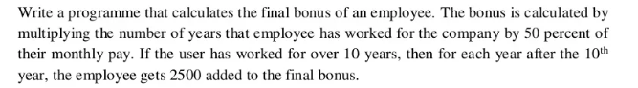

8. Write a Python program to count the number of strings where the string length is 2 or more and the first and last character are same from a given list of strings.

9. Write a Python function that takes two lists and returns True if they have at least one common member.

10. 