Chapter 9
Input and Sensors
Touch is clearly one of the most exciting means of interacting with a computer that has finally come of age. Sure, we’ve had touch-sensitive devices for many years: I remember working with a touch-enabled screen in my college days, which I have to admit is almost an embarrassingly long time ago now! In that case, the touch sensor was a series of transparent wires embedded in a plastic sheet over the screen, with an overall touch resolution of around 60 wide by 40 high…and, to really date myself, the monitor itself was only a text terminal!
Fortunately, touch screens have progressed tremendously in recent years. They are responsive enough for general purpose use (that is, you don’t have to stab them to register a point), are built into high-resolution displays, are relatively inexpensive, and are capable of doing something more than replicating the mouse—namely, supporting multitouch and sophisticated gestures.
Great touch interaction is thus now a fundamental feature of great apps, and designing for touch means in many ways thinking through UI concerns anew. In your layout, for example, it means making hit targets a size that’s suitable for a variety of fingers. In your content navigation, it means utilizing direct gestures such as swipes and pinches rather than relying on only item selection and navigation controls. Similarly, designing for touch means thinking though how gestures might enrich the user experience—and also how to provide for discoverability and user feedback that has generally relied on mouse-only events like hover.
All in all, approach your design as if touch was the only means of interaction that your users might have. At the same time, it’s very important to remember that new methods of input seldom obsolete existing ones. Sure, punch cards did eventually disappear, but the introduction of the mouse did not obsolete keyboards. The availability of speech recognition or handwriting has obsoleted neither mouse nor keyboard. I think the same is true for touch: it’s really a complementary input method that has its own particular virtues but is unlikely to wholly supplant the others. As Bill Buxton of Microsoft Research has said, “Every modality, including touch, is best for something and worst for something else.” I expect, in time, we’ll see ourselves using keyboard, mouse, and touch together, just as we learned to integrate the mouse in what was once a keyboard-only reality.
Windows is designed to work well with all forms of input—to work great with touch, to work great with mice, to work great with keyboards, and, well, to just work great on diverse hardware! (And Windows Store certification requires this for apps as well.) For this reason, Windows provides a unified pointer-based input model wherein you can differentiate the different inputs if you really need to but can otherwise treat them equally. You can also focus more on higher-level gestures as well, which can arise from any input source, and not worry about raw pointer events at all. Indeed, the very fact that we haven’t even brought this subject up until now, midway through this book, gives testimony to just how natural it is to work with all kinds of pointer input without having to think about it: the controls and other UI elements we’ve been using have done all that work for us. Handling such events ourselves thus arises primarily when creating your own controls or otherwise doing direct manipulation of noncontrol objects.
The keyboard also remains an important consideration, and this means both hardware keyboards and the on-screen “soft” keyboard. The latter has gotten more attention in recent years for touch-only devices but actually has been around for some time for accessibility purposes. In Windows, too, the soft keyboard includes a handwriting recognizer—something apps just get for free. And when an app wants to work more closely with raw handwriting input—known as ink—those capabilities are present as well.
The other topic we’ll cover in this chapter is sensors. It might seem an incongruous subject to place alongside input until you come to see that sensors, like touch screens themselves, are another form of input! Sensors tell an app what’s happening to the device in its relationship to the physical world: how its positioned in space (relative to a number of reference points), how it’s moving through space, how it’s being held relative to its “normal” orientation, and even how much light is shining on it. Thinking of sensors in this light (pun intended), we begin to see opportunities for apps to directly integrate with the world around a device rather than requiring users to tell the app about those relationships in some more abstract way. And just to warn you, once you see just how easy it is to use the WinRT APIs for sensors, you might be shopping for a new piece of well-equipped hardware!

Touch, Mouse, and Stylus Input
Where pointer-based input is concerned—which includes touch, mouse, and pen/stylus input—the singular message from Microsoft has been and remains, “Design for touch and get mouse and stylus for free.” This is very much the case, as we shall see, but we’ve also found that a phrase like “touch-first design” that sounds great to a consumer can be a terrifying proposition for developers! With all the attention around touch, consumer expectations are often very demanding, and meeting such expectations seems like it will take a lot of work.
Fortunately, Windows 8 provides a unified framework for handling pointer input—from all sources—such that you don’t actually need to think about the differences until there’s a specific reason to do so. In this way, touch-first design really is a design issue more than an implementation issue.
We’ll talk more about designing for touch in the next section. What I wanted to discuss first is how you as a developer should approach implementing those designs once you have them so that you don’t make any distinctions between the types of pointer input until it’s necessary:
- First, use templates and standard controls and you get lots of touch support for free, along with mouse, pen, stylus, and keyboard support. If you build up your UI with standard controls, set appropriate tabindex attributes for keyboard users, and handle standard DOM events like click, you’re pretty much covered. Controls like semantic zoom already handle different kinds of input (as we saw in Chapter 5, “Collections and Collection Controls”), and other CSS styles like snap points and content zooming automatically handle various interaction gestures.
- Second, when you need to handle gestures yourself, as with custom controls or other elements with which the user will interact directly, use the gesture events like MSGestureTap and MSGestureHold along with event sequences for inertial gestures (MSGestureStart, MSGestureChange, and MSGestureEnd). The benefit here is that gestures are essentially higher-order interpretations of lower-level pointer events, meaning that you don’t have to do such interpretation yourself. For example, a pointer down followed by a pointer up within a certain movement threshold (to account for wiggling fingers) becomes a single tap gesture. A pointer down followed by a short drag followed by a pointer up becomes a swipe that triggers a series of events, possibly including inertial events (ones that continue to fire even after the pointer, like a touch point, is physically released). Note that if you want to capture and save pointer input directly without concern for gestures, there is also built-in support for inking, as we’ll see later on.
- Third, if you need to handle pointer events directly, use the unified pointer events like MSPointerDown, MSPointerMove, and so forth. These are lower-level events than gestures, and they are primarily appropriate for apps that don’t necessarily need gesture interpretation. For example, a drawing app simply needs to trace different pointers with on-screen feedback, where concepts like swipe and inertia aren’t meaningful. Pointer events also provide more specialized device data such as pressure, rotation, and tilt, which is surfaced through the pointer events. Still, it is possible to implement gestures directly with pointer events, as a number of the built-in controls do.
- Finally, an app can work directly with the gesture recognizer to provide its own interpretations of pointer events into gestures.
So, what about legacy DOM events that we already know and love, beyond click? Can you still work with the likes of mousedown, mouseup, mouseover, mousemove, mouseout, and mousewheel? The answer is yes, because pointer events from all input sources will be automatically translated into these legacy events. This can be useful when you’re porting code from a web app into a Windows Store app, for example. This translation takes a little extra processing time, however, so for new code you’ll generally realize better responsiveness by using the gesture and pointer events directly. Legacy mouse events also assume a single pointer and will be generated only for the primary touch point (the one with the isPrimary property). As much as possible, use the gesture and pointer events in your code.
Note Visual feedback for touch input is one of the Windows 8 app certification requirements (section 3.5) and applies to everything in your app as well as any web content you might display in an iframe element. Providing feedback means executing small animations that acknowledge the touch. For this you can use the WinJS animations library or straight CSS animations and transitions, as discussed in Chapter 11, “Purposeful Animations.”

The Touch Language, Its Translations, and Mouse/Keyboard Equivalents
On the Windows Developer Center, the rather extensive article on Touch interaction design is helpful for designers and developers alike. It discusses various ergonomic considerations, has some great diagrams on the sizes of human fingers, provides clear guidance on the proper size for touch targets given that human reality, and outlines key design principles such as providing direct feedback for touch interaction (animation) and having content follow your finger.
Most importantly, the design guidance also describes the Windows 8 Touch Language, which contains the eight core gestures that are baked into the system and the controls. The table below shows and describes the gestures and indicates what events appear in the app for them.

Gesture | Meaning and Gesture Events | Description
One finger touches the screen and lifts up.  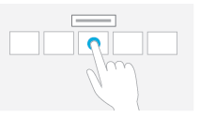 | Tap for primary action (commanding); appears as click and MSGestureTap events on the element. | Tapping on an element invokes its primary action, typically executing a command, checking a box, setting a rating, positioning a cursor, etc.
One finger touches the screen and stays in place.  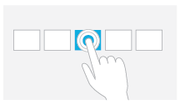 | Press and hold to learn; appears as contextmenu and MSGestureHold events on the element. | This touch interaction displays detailed information or teaching visuals (for example, a tooltip or context menu) without a commitment to an action. Anything displayed this way should not prevent users from panning if they begin sliding their finger.
One or more fingers touch the screen and move in the same direction.  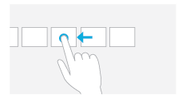 | Slide to pan (can be horizontal or vertical); appears as scrolling events as well as a gesture series (MSGestureStart, MSGestureChange, MSGestureEnd, possibly with inertial gesture events signaled by MSInertiaStart, plus MSPointer* events). | Slide is used primarily for panning interactions but can also be used for moving, drawing, or writing. Slide can also be used to target small, densely packed elements by scrubbing (sliding the finger over related objects such as radio buttons).

One or more fingers touch the screen and move a short distance in the same direction.  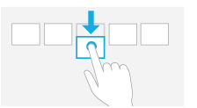 | Swipe to select, command, and move (can be horizontal or vertical)—also called cross-slide; appears as a gesture series (MSGestureStart, MSGestureChange, MSGestureEnd, as well as MSPointer* events). The gesture recognizer doesn’t distinguish this from vertical panning, however, so an app or control needs to implement that interpretation directly (a good reason to use controls like the ListView!). | Sliding the finger a short distance, perpendicular to the panning direction, selects objects in a list or grid; also implies displaying commands in an app bar relevant to the selection.
Two or more fingers touch the screen and move closer together or farther apart.  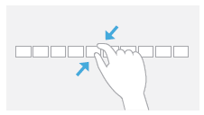 | Pinch and stretch to zoom; appears as a gesture series (MSGestureStart, MSGestureChange, MSGestureEnd), but apps can use the -ms-content-zooming: zoom and -ms-touch-action: pinch-zoom CSS styles to enable touch zooming automatically. | Can be used for optical zoom or resizing, as well as for semantic zoom where applicable.
Two or more fingers touch the screen and move in a clockwise or counter-clockwise arc.  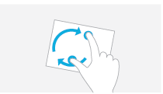 | Turn to rotate; appears as a gesture series (MSGestureStart, MSGestureChange, MSGestureEnd). | Rotates an object or a view.
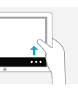 | Swipe from top or bottom edge for app commands; handled automatically through the AppBar control, though an app can also detect these events directly through Windows.UI.Input.EdgeGesture. | The bottom app bar contains app commands for the current page context; the top app bar provides for navigation, if applicable.
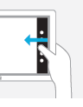 | Swipe from edge for system commands; handled automatically by the system with the app receiving events related to the selected charm, when applicable, as well as focus and blur events if the foreground app is changed when swiping from the left edge. | Swiping from the right displays the Charms bar; swiping from the left cycles through currently running apps; swiping from the top edge to the bottom closes the current app; swiping from the top edge to the left or right snaps the current app to one side of the screen.
Additional details and guidelines for designing around this touch language can be found on the Gestures, manipulations, and interactions topic.
You might notice in the table above that many of the gestures in the touch language don’t actually have a single event associated with them (like pinch or rotate) but are instead represented by a series of gesture or pointer events. The reason for this is that these gestures, when used with touch, typically involve animation of the affected content while the gesture is happening. Swipes, for example, show linear movement of the object being panned or selected. A pinch or stretch movement will often be actively zooming the content. (Semantic Zoom is an exception, but then you just let the control handle the details.) And a rotate gesture should definitely give visual feedback. In short, handling these gestures with touch, in particular, means dealing with a series of events rather than just a single one.
This is one reason that it’s so helpful (and time-saving!) to use the built-in controls as much as possible, because they already handle all the gesture details for you. The ListView control, for example, contains all the pointer/gesture logic to handling pans and swipes, along with taps. The Semantic Zoom control, like I said, implements pinch and stretch by watching MSPointer* events. If you look at the source code for these controls within WinJS, you’ll start to appreciate just how much they do for you (and what it will look like to implement a rich custom control of your own, using the gesture recognizer!).
You can also save yourself a lot of trouble with the -ms-touch-action CSS properties described under “CSS Styles That Affect Input.” Using this has the added benefit of processing the touch input on a non-UI thread, thereby providing much smoother manipulation than could be achieved by handling pointer or gesture events.
On the theme of “write for touch and get other input for free,” all of these gestures also have mouse and keyboard equivalents, which the built-in controls also implement for you. It’s also helpful to know what those equivalents are, as shown in the table below. The “Standard Keystrokes” section later in this chapter also lists many other command-related keystrokes.
Touch | Keyboard | Mouse | Pen/Stylus
Press and hold (or tap on text selection) | Right-click button | Right button click | Press and hold
Tap | Enter | Left button click | Tap
Slide (short distance) | Arrow keys | Left button click and drag, click on scrollbar arrows, drag the scrollbar thumb, use the mouse wheel | Tap on scrollbar arrows, drag scrollbar thumb, tap and drag
Slide + inertia  (long distance) | Page Up/Page Down | Left button click and drag, click on scrollbar track, drag the scrollbar thumb, use the mouse wheel | Tap on scrollbar track, drag scrollbar thumb, tap and drag
Swipe to select | Right-click button or spacebar | Right button click | Tap and drag
Pinch/Stretch | Ctrl+ and Ctrl- | Ctrl+mouse wheel or UI command | UI command or other hardware feature
Swipe from edge | Win+Z, Win+Tab, Win+C or Win+Shift+C | Clicking on corners of the screen; right-click shows app bar | Drag in from edge
Rotate | Ctrl+, and Ctrl+. | Ctrl+Shift+mouse wheel | UI command or other hardware feature

You might notice a conspicuous absence of double-click and/or double-tap gestures in this list. Does that surprise you? In early builds of Windows 8 we actually did have a double-tap gesture, but it turned out to not be all that useful, conflicted with the zoom gesture, and sometimes very difficult for users to perform. I can say from watching friends over the years that double-clicking with the mouse isn’t even all it’s cracked up to be. People with not-entirely-stable hands will often move the mouse quite a ways between clicks, just as they might move their finger between taps. As a result, the reliability of a double-tap ends up being pretty low, and since it wasn’t really needed in the touch language, it was simply dropped altogether.
Sidebar: Creating Completely New Gestures?
While the Windows 8 touch language provides a simple yet fairly comprehensive set of gestures, it’s not too hard to imagine other possibilities. The question is, when is it appropriate to introduce a new kind of gesture or manipulation?
First, it makes sense that apps don’t generally introduce new ways to do the same things, such as additional gestures that just swipe, zoom, etc. It’s better to simply get more creative in how the app interprets an existing gesture. For example, a swipe gesture might pan a scrollable region but can also just move an object on the screen—no need to invent a new gesture.
Second, if you have controls placed on the screen where you want the user to give input, there’s no need to think in terms of gestures at all: just apply the input from those controls appropriately.
Third, even when you do think a custom gesture is needed, the bottom-line recommendation is to make those interactions feel natural, rather than something you just invent for the sake of invention. We also recommend that gestures behave consistently with the number of pointers, velocity/time, and so on. For example, separating an element into three pieces with a three-finger stretch and into two pieces with a two-finger stretch is fine; having a three-finger stretch enlarge an element while a two-finger stretch zooms the canvas is a bad idea, because it’s not very discoverable. Similarly, the speed of a horizontal or vertical flick can affect the velocity of an element’s movement, but having a fast flick switch to another page while a slow flick highlights text is a bad idea. In this case, having different functions based on speed creates a difficult UI for your customers because they’ll all have different ideas about what “fast” and “slow” mean and might be limited by their physical abilities.
Finally, with any custom gesture, recognize that you are potentially introducing an inconsistency between apps. When a user starts interacting with a certain kind of app in a new way, he or she might start to expect that of other apps and might become confused (or upset) when those apps don’t behave in the same way, especially if those apps use a similar gesture for a completely different purpose! Complex gestures, too, might be difficult for some, if not many, people to perform; might be limited by the kind of hardware in the device (number of touch points, responsiveness, etc.); and are generally not very discoverable. In most cases it’s probably simpler to add an appbar command on a button on your app canvas to achieve the same goal.

Edge Gestures
As we saw in Chapter 7, “Commanding UI,” you don’t need to do anything special for commands on the app bar or navigation bar to appear: Windows automatically handles the edge swipe from the top and bottom of your app, along with right-click, Win+Z, and the context menu key on the keyboard. That said, you can detect when these events happen directly by listening for the starting, completed, and canceled events on the Windows.UI.Input.EdgeGesture object:
var edgeGesture = Windows.UI.Input.EdgeGesture.getForCurrentView();
edgeGesture.addEventListener("starting", onStarting);
edgeGesture.addEventListener("completed", onCompleted);
edgeGesture.addEventListener("canceled", onCanceled);
With these, completed fires for all input types; the starting and canceled events occur only for touch. Within these events, the eventArgs.kind property contains a value from the EdgeGesture-Kind enumeration that indicates the kind of input that invoked the event. The starting and canceled events will always have the kind of touch, obviously, whereas completed can be any touch, keyboard, or mouse:
function onCompleted(e) {
// Determine whether it was touch or keyboard invocation
if (e.kind === Windows.UI.Input.EdgeGestureKind.touch) {
id("ScenarioOutput").innerText = "Invoked with touch.";
}
else if (e.kind === Windows.UI.Input.EdgeGestureKind.mouse) {
id("ScenarioOutput").innerText = "Invoked with right-click.";
}
else if (e.kind === Windows.UI.Input.EdgeGestureKind.keyboard) {
id("ScenarioOutput").innerText = "Invoked with keyboard.";
}
}
The code above is taken from Scenario 1 of the Edge gesture invocation sample. In Scenario 2, the sample also shows that you can prevent the edge gesture event from occurring for a particular element if you handle the contextmenu event for that element and call eventArgs.preventDefault in your handler. It does this for one element on the screen, such that right-clicking that element with the mouse or pressing the context menu key when that element has the focus will prevent the edge gesture events:
document.getElementById("handleContextMenuDiv").addEventListener("contextmenu", onContextMenu);
function onContextMenu(e) {
e.preventDefault();
id("ScenarioOutput").innerText =
"The ContextMenu event was handled. The EdgeGesture event will not fire.";
}
Note that this method has no effect on edge gestures via touch and does not affect the Win+Z key combination that normally invokes the app bar. It’s primarily to show that if you need to handle the contextmenu event specifically, you usually want to prevent the edge gesture.

CSS Styles That Affect Input
While we’re on the subject of input, it’s a good time to mention a number of CSS styles that affect the input an app might receive.
One style is –ms-user-select, which we’ve encountered a few times already in Chapter 3, “App Anatomy and Page Navigation,” and Chapter 4, “Controls, Control Styling, and Data Binding.” This style can be set to one of the following:
- none disables direct selection, though the element as a whole can be selected if it’s parent is selectable.
- inherit sets the selection behavior of an element to match its parent.
- text will enable selection for text even if the parent is set to none.
- element enables selection for an arbitrary element.
- auto (the default) may or may not enable selection depending on the control type and the styling of the parent. For an element that is not a text control and does not have contenteditable="true", it won’t be selectable unless it’s contained within a selectable parent.
If you want to play around with the variations, refer to the Unselectable content areas with -ms-user-select CSS attribute sample, which wins the prize for the longest JavaScript sample name in the entire Windows SDK!
A related style, but one not shown in the sample, is -ms-touch-select, which can be either none or grippers, the latter being the style that enables the selection control circles for touch:
Selectable text elements automatically get this style, as do other textual elements with contenteditable = "true"—you can thus use -ms-touch-select to turn them off. To see the effect, try this with some of the elements in Scenario 1 of the aforementioned sample with the really long name!
In Chapter 6, “Layout,” we introduced the idea of snap points for panning, with the -ms-scroll-snap* styles. Along these same lines, listed on the Touch: Zooming and Panning styles reference, are others for content zooming, such as -ms-content-zooming and the -ms-content-zoom* styles that provide snap points for zoom operations as well. The important thing is that -ms-content-zooming: zoom (as opposed to the default, none) enables automatic zooming with touch and the mouse wheel, provided that the element in question allows for overflow in both x and y dimensions. There are quite a number of variations here for panning and zooming, and how those gestures interact with WinJS controls. I’ll leave it to the HTML scrolling, panning, and zooming sample to explain the details.
Finally, the -ms-touch-action style provides for a number of options on an element:
- none Disables touch on the element.
- auto Enables usual touch behaviors.
- pan-x/pan-y The element permits horizontal/vertical touch panning, which is performed on the nearest ancestor that is horizontally/vertically scrollable, such as a parent div.
- pinch-zoom Enables pinch-zoom on the element, performed on the nearest ancestor that has -ms-content-zooming: zoom and overflow capability. For example, an img element by itself won’t respond to the gesture with this style, but if you place it in a parent div with overflow set, it will.
- manipulation Shorthand equivalent of pan-x pan-y pinch-zoom.
For an example of panning and zooming, try creating a simple app with markup like this (use whatever image you’d like):
<div id="imageContainer">
<img id="image1" src="/images/flowers.jpg" />
</div>
and style the container as follows:
#imageContainer {
overflow: auto;
-ms-content-zooming:zoom;
-ms-touch-action: manipulation;
}

What Input Capabilities Are Present?
The WinRT API in the Windows.Devices.Input namespace provides all the information you need about the input capabilities that are available on the current device, specifically through these three objects:
- MouseCapabilities Properties are mousePresent (0 or 1), horizontalWheelPresent (0 or 1), verticalWheelPresent (0 or 1), numberOfButtons (a number), and swapButtons (0 or 1).
- KeyboardCapabilities Contains only a single property: keyboardPresent (0 or 1). Note that this does not indicate the presence of the on-screen keyboard, which is always available; keyboardPresent specifically indicates a physical keyboard device.
- TouchCapabilities Properties are touchPresent (0 or 1) and contacts (a number). Note that where touch is concerned, you might also be interested in the Windows.UI.-ViewManagement.UISettings.handPreference property, which indicates the user’s right- or left-handedness.
To check whether touch is available, then, you can use a bit of code like this:
var tc = new Windows.Devices.Input.TouchCapabilities();
var touchPoints = 0;
if (tc.touchPresent) {
touchPoints = tc.contacts;
}
Note In the web context where WinRT is not available, some information about capabilities can be obtained through the msPointerEnabled, msManipulationViewsEnabled, and msMax-TouchPoints properties that are hanging off DOM elements. These also work in the local context.
You’ll notice that the capabilities above don’t say anything about a stylus or pen. For these and for more extensive information about all pointer devices, including touch and mouse, we have the Windows.Devices.Input.PointerDevice.getPointerDevices method. This returns an array of PointerDevice objects, each of which has these properties:
- pointerDeviceType A value from Windows.Devices.Input.PointerDeviceType that can be touch, pen, or mouse.
- maxContacts The maximum number of contact points that the device can support—typically 1 for mouse and stylus and any other number for touch.
- isIntegrated true indicates that the device is built into the machine so that its presence can be depended upon; false indicates a peripheral that the user could disconnect.
- physicalDeviceRect This Windows.Foundation.Rect object provides the bounding rectangle as the device sees itself. Oftentimes, a touch screen’s input resolution won’t actually match the screen pixels, meaning that the input device isn’t capable of hitting exactly one pixel. On one of my touch-capable laptops, for example, this resolution is reported as 968x548 for a 1366x768 pixel screen (as reported in screenRect below). A mouse, on the other hand, typically does match screen pixels one-for-one. This could be important for a drawing app that works with a stylus, where an input resolution smaller than the screen would mean there will be some inaccuracy when translating input coordinates to screen pixels.
- screenRect This Windows.Foundation.Rect object provides the bounding rectangle for the device on the screen, which is to say, the minimum and maximum coordinates that you should encounter with events from the device. This rectangle will take multimonitor systems into account, and it’s adjusted for resolution scaling.
- supportedUsages An array of Windows.Devices.Input.PointerDeviceUsage structures that supply what’s called HID (human interface device) usage information. This subject is beyond the scope of this book, so I’ll refer you to the HID Usages page on MSDN for starters.
The Input Device capabilities sample in the Windows SDK retrieves this information and displays it to the screen through the code in js/pointer.js. I won’t show that code here because it’s just a matter of iterating through the array and building a big HTML string to dump into the DOM. In the simulator, the output appears as follows—notice that the simulator reports the presence of touch and mouse both in this case.
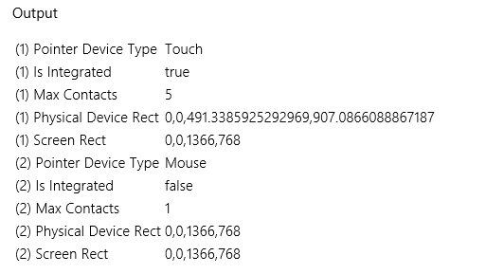
Curious Forge? Interestingly, I ran this same sample in Visual Studio’s Local Machine debugger on a laptop that is definitely not touch-enabled, and yet a touch device was still reported as in the image above! Why was that? It’s because I still had the Visual Studio simulator running, which adds a virtual touch device to the hardware profile. After closing the simulator completely (not just minimizing it), I got an accurate report for my laptop’s capabilities. So be mindful of this if you’re writing code to test for specific capabilities.
Tried remote debugging yet? Speaking of debugging, as mentioned in a sidebar in Chapter 6, “Layout,” testing an app against different device capabilities is a great opportunity to use remote debugging in Visual Studio. If you haven’t done so already, it takes only a few minutes to set up and makes it far easier to test apps on multiple machines. For details, see Running Windows 8 apps on a remote machine.

Unified Pointer Events
For any situation where you want to directly work with touch, mouse, and stylus input, perhaps to implement parts of the touch language in this way, use the MSPointer* events. Most art/drawing apps, for example, will use these events to track and respond to screen interaction. Remember again that pointers are a lower-level way of looking at input than gestures, which we’ll see in the next section. Which input model you use depends on the kind of events you’re really looking to work with.
Tip Pointer events won’t fire if the system is trying to do a manipulation like panning or zooming. To disable manipulations on an element, set the -ms-content-zooming: none or -ms-touch-action: none, and avoid using -ms-touch-action styles of pan-x, pan-y, pinch-zoom, and manipulation.
As with other events, you can listen to MSPointer* events on whatever elements are relevant to you, remembering again that these are translated into legacy mouse events, so you should not listen to both. The specific events are described as follows, given in the order of their typical sequencing:
- MSPointerOver Pointer moved into the bounds of the element from outside.
- MSPointerHover A pointer is hovering over the element (generally only for pen or mouse).
- MSPointerDown Pointer down occurred on the element.
- MSPointerMove Pointer moved across the element.
- MSPointerUp Pointer was released over the element. (If an element previously captured the touch, msReleasePointerCapture is called automatically.) Note that if a pointer is moved outside of an element and released, it will receive MSPointerOut but not MSPointerUp.
- MSPointerCancel The system canceled a pointer event.
- MSPointerOut Pointer moved out of the bounds of the element, which also occurs with an up event. This is the last pointer event an element will receive.
- MSGotPointerCapture The pointer is captured by the element.
- MSLostPointerCapture The pointer capture has been lost for the element.
These are the names you use with addEventListener; the equivalent property names are of the form onmspointerdown, as usual. It should be obvious that some of these events might not occur with all pointer types—touch screens, for instance, generally don’t provide hover events, though some that can detect the proximity of a finger are so capable.
Tip If for some reason you want to prevent the translation of an MSPointer* event into a legacy mouse event, call the eventArgs.preventDefault method within the appropriate event handler.
The PointerEvents example provided with this chapter’s companion content and shown in Figure 9-1 lets you see what’s going on with all the mouse, pointer, and gesture events, selectively showing groups of events in the display.
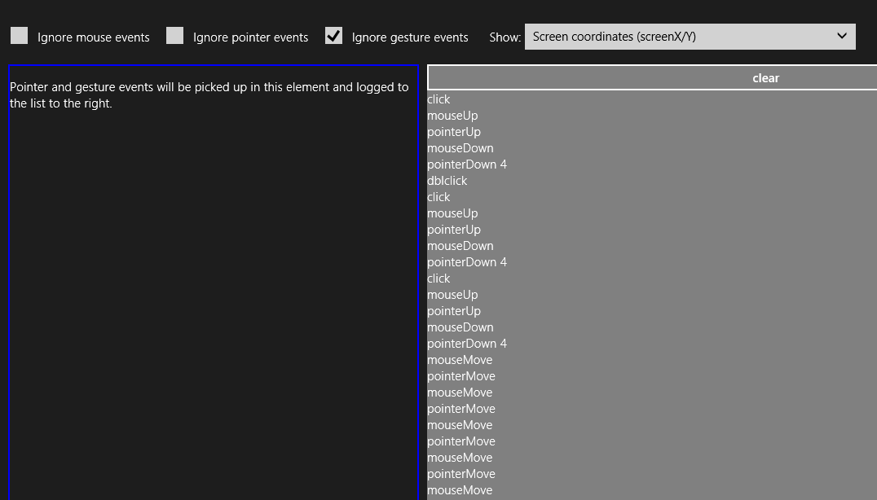
Figure 9-1 The PointerEvents example display (screen shot cropped a bit to show detail).
Within the handlers for all of the MSPointer* events, the eventArgs object contains a whole roster of properties. One of them, pointerType, identifies the type of input: touch (2), pen (3), and mouse (4). This property lets you implement different behaviors for different input methods, if desired. Each event object also contains a unique pointerId value that identifies a stroke or a path for a specific contact point, allowing you to correlate an initial MSPointerDown event with subsequent events. When we look at gestures in the next section, we’ll also see how we use the pointerId of MSPointerDown to associate a gesture with a pointer.
The complete roster of properties that come with the event is actually far too much to show here, as it contains many of the usual DOM properties along with many pointer-related ones from an object type called MSPointerEvent. The best way to see what shows up is to run some code like the Input DOM pointer event handling sample (a canvas drawing app), set a breakpoint within a handler for one of the events, and examine the event object. The table on the following page describes some of the properties (and a few methods) relevant to our discussion here.

Properties | Description
currentPoint | A Windows.UI.Input.PointerPoint object. This contains many other properties such as pointerDevice (a Windows.Input.Device.PointerDevice object, as described in “What Input Capabilities Are Present” earlier in this chapter) and one just called properties, which is a Windows.UI.Input.PointerPointProperties.
pointerType | The source of the event could be touch or pen or mouse: MSPOINTER_TYPE_TOUCH (2), MSPOINTER_TYPE_PEN (3), and MSPOINTER_TYPE_MOUSE (4). You can use this to make adjustments according to input type, if necessary.
pointerId | The unique identifier of the contact. This remains the same throughout the lifetime of the pointer. If desired, you can call Windows.Devices.Input.getPointerDevice with this id to obtain a PointerDevice that describes the input device’s capabilities, as described earlier in “What Input Capabilities are Present?”
type | The name of the event, as in "MSPointerDown".
x, screenX, y, screenY | The x- and y-coordinates of the pointer’s center point position relative to the screen.
clientX, clientY | The x- and y-coordinates of the pointer’s center point position relative to the client area of the app.
offsetX, offsetY | The x- and y-coordinates of the pointer’s center point position relative to the element.
button | Determines the button pressed by the user (on mice and other input devices with buttons). The left is 0, middle is 1, and right is 2; these values can be combined with bitwise the OR operator for chord presses (multiple buttons).
ctrlKey, altKey, shiftKey | Indicates whether certain keys were depressed when the pointer event occurred.
hwTimestamp | The timestamp (in microseconds) at which the event was received from the hardware.
relatedTarget | Provides the element related to the current event, e.g., the MSPointerOut event will provide the element to which the touch is moving. This can be null.
isPrimary | Indicates if this pointer is the primary one in a multitouch scenario (such as the pointer that the mouse would control).
Properties surfaced depending on hardware support (if not supported, these values will be 0)
width, height | The contact width and height of the touch point specified by pointerId.
pressure | Pen pressure normalized in a range of 0 to 255.
rotation | Clockwise rotation of the cursor around its own major axis in a range of 0 to 359.
tiltX | The left-right tilt away from the normal of a transducer (typically perpendicular to the surface) in a range of -90 (left) to 90 (right).
tiltY | The forward-back tilt away from the normal of a transducer (typically perpendicular to the surface) in a range of -90 (forward/away from user) to 90 (back/toward user).
Methods
currentPoint  getCurrentPoint | Providers the Windows.UI.Input.PointerPoint object for the current pointer relevant to the target element (currentPoint) or a given element (getCurrentPoint)
intermediatePoints  getIntermediatPoints | Provides the PointerPoint history for the current pointer relative to the target element (intermediatePoint) or a given element (getIntermediatePoints)

It’s very instructive to run the Input DOM pointer event handling sample on a multitouch device, because it tracks each pointerId separately allowing you to draw with multiple fingers simultaneously.

Pointer Capture
It’s common with down and up events for an element to set and release a capture on the pointer. To support these operations, the following methods are available on each element in the DOM and apply to each pointerId separately:
Method | Description
msSetPointerCapture | Captures the pointerId for the element so that pointer events come to it and are not raised for other elements (even if you move outside the first element and into another). MSGotPointerCapture will be fired on the element as well.
msReleasePointerCapture | Ends capture, triggering an MSLostPointerCapture event.
msGetPointerCapture | Returns the element with the capture, if any (otherwise null).
We see this in the Input DOM pointer event handling sample, where it sets capture within its MSPointerDown handler and releases it in MSPointerUp:
this.MSPointerDown = function (evt) {
canvas.msSetPointerCapture(evt.pointerId);
// ...
};
this.MSPointerUp = function (evt) {
canvas.msReleasePointerCapture(evt.pointerId);
// ...
};

Gesture Events
The first thing to know about all MSGesture* events is that they don’t just fire automatically like click and MSPointer* events, and you don’t just add a listener and be done with it (that’s what click is for!). Instead, you need to do a little bit of configuration first to tell the system how exactly you want gestures to occur, and you need to use MSPointerDown to associate the gesture configurations with a particular pointerId. This small added bit of complexity makes it possible for apps to work with multiple concurrent gestures and keep them all independent just as you can do with pointer events. Imagine, for example, a jigsaw puzzle app (as presented in a small way in one of the samples in “The Gesture Samples” below) that allows multiple people sitting around a table-size touch screen to work with individual pieces as they will. Using gestures, each person can be manipu-lating an individual piece (or two!), moving it around, rotating it, perhaps zooming in to see a larger view, and, of course, testing out placement. For Windows Store apps written in JavaScript, it’s also helpful that manipulation deltas for configured elements—which include translation, rotation, and scaling—are given in the coordinate space of the parent element, meaning that it’s fairly straightforward to translate the manipulation into CSS transforms and such to make the manipulation visible. In short, there is a great deal of flexibility here when you need it; if you don’t, you can use gestures in a simple manner as well. Let’s see how it all works.
Tip If you’re observant, you’ll notice that everything in this section has no dependency on WinRT APIs. As a result, the gesture events described here work in both the local and web contexts.
The first step to receiving gesture events is to create an MSGesture object and associate it with the element for which you’re interested in receiving events. In the PointerEvents example, that element is named divElement; you need to store that element in the gesture’s target property and store the gesture object in the element’s gestureObject property for use by MSPointerDown:
var gestureObject = new MSGesture();
gestureObject.target = divElement;
divElement.gestureObject = gestureObject;
With this association, you can then just add event listeners as usual. The example shows the full roster of the six gesture events:
divElement.addEventListener("MSGestureTap", gestureTap);
divElement.addEventListener("MSGestureHold", gestureHold);
divElement.addEventListener("MSGestureStart", gestureStart);
divElement.addEventListener("MSGestureChange", gestureChange);
divElement.addEventListener("MSGestureEnd", gestureEnd);
divElement.addEventListener("MSInertiaStart", inertiaStart);
We’re not quite done yet, however. If this is all you do in your code, you still won’t receive any of the events because each gesture has to be associated with a pointer. You do this within the MSPointerDown event handler:

function pointerDown(e) {
//Associate this pointer with the target's gesture
e.target.gestureObject.addPointer(e.pointerId);
}
To enable rotation and pinch-stretch gestures with the mouse wheel (which you should do), add an event handler for the wheel event, set the pointerId for that event to 1 (a fixed value for the mouse wheel), and send it on to your MSPointerDown handler:
divElement.addEventListener("wheel", function (e) {
e.pointerId = 1; // Fixed pointerId for MouseWheel
pointerDown(e);
});
Now gesture events will start to come in for that element. (Remember that mouse wheel by itself is translate, Ctrl+wheel is zoom, and Shift+Ctrl+wheel is rotate.) What’s more, if additional MSPointerDown events occur for the same element with different pointerId values, the addPointer method will include that new pointer in the gesture. This automatically enables pinch-stretch and rotation gestures that rely on multiple points.
If you run the PointerEvents example (checking Ignore Mouse Events and Ignore Pointer Events) and start doing taps, tap-holds, and short drags (with touch or mouse), you’ll see output like that shown in Figure 9-2.
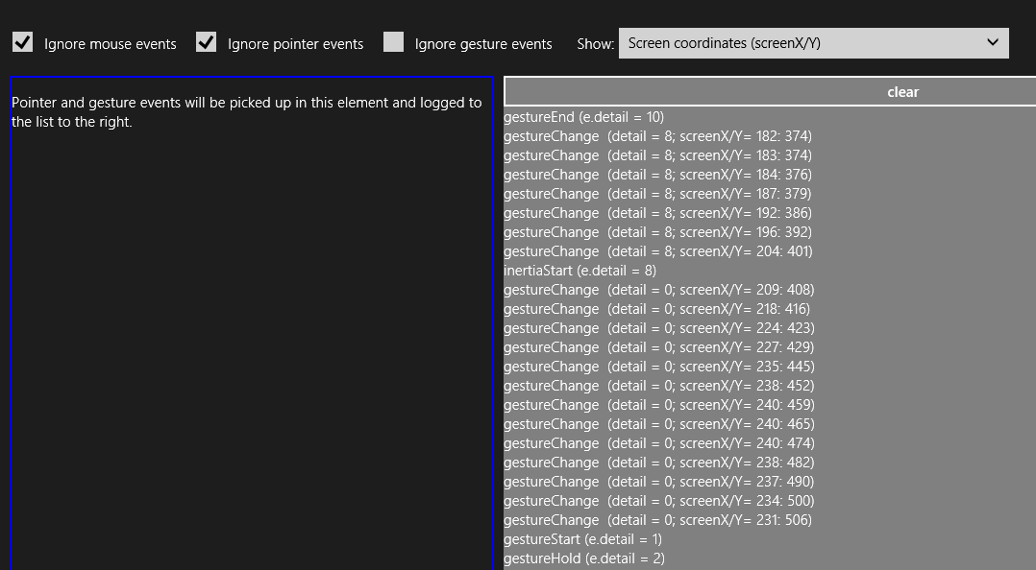
Figure 9-2 The PointerEvents example output for gesture events (screen shot cropped a bit to emphasize detail).
Again, gesture events are fired in response to a series of pointer events, offering higher-level interpretations of the lower-level pointer events. It’s the process of interpretation that differentiates the tap/hold events from the start/change/end events, how and when the MSInertiaStart event kicks off, and what the gesture recognizer does when the MSGesture object is given multiple points.
Starting with a single pointer gesture, the first aspect of differentiation is a pointer movement threshold. When the gesture recognizer sees an MSPointerDown event, it starts to watch the MSPointerMove events to see whether they stay inside that threshold, which is the effective boundary for tap and hold events. This accounts for and effectively ignores small amounts of jiggle in a mouse or a touch point as illustrated (or shall I say, exaggerated!) below, where a pointer down, a little movement, and a pointer up generates an MSGestureTap:
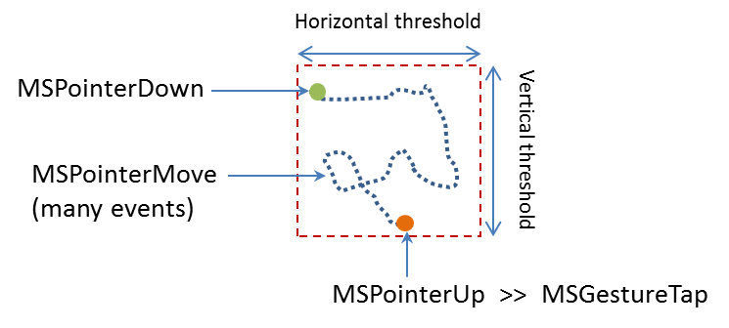
What then differentiates MSGestureTap and MSGestureHold is a time threshold:
- MSGestureTap occurs when MSPointerDown is followed by MSPointerUp within the time threshold.
- MSGestureHold occurs when MSPointerDown is followed by MSPointerUp outside the time threshold. MSGestureHold then fires once when the time threshold is passed with eventArgs.detail set to 1 (MSGESTURE_FLAG_BEGIN). Provided that the pointer is still within the movement threshold, MSGestureHold fires then again when MSPointerUp occurs, with eventArgs.detail set to 2 (MSGESTURE_FLAG_END). You can see this detail included in the first two events of Figure 9-2 above.
The gesture flags in eventArgs.detail value is accompanied by many other positional and movement properties in the eventArgs object as shown in the following table:
Properties | Description
screenX, screenY | The x- and y-coordinates of the gesture center point relative to the screen.
clientX, clientY | The x- and y-coordinates of the gesture center point relative to the client area of the app.
offsetX, offsetY | The x- and y-coordinates of the gesture center point relative to the element.
translationX, translationY | Translation along the x- and y-axes.
velocityX, velocityY | Velocity of movement along x- and y-axes.
scale | Scale factor for zoom (percentage change in the scale).
expansion | Diameter of the manipulation area (absolute change in size, in pixels).
velocityExpansion | Velocity of expanding manipulation area.
rotation | Rotation angle in radians.
velocityAngular | Angular velocity in radians.
detail | Contains the gesture flags that describe the gesture state of the event; these flags are defined as values in eventArgs itself:  eventArgs.MSGESTURE_FLAG_NONE (0): Indicates ongoing gesture such as MSGestureChange where there is change in the coordinates.  eventArgs.MSGESTURE_FLAG_BEGIN (1): The beginning of the gesture sequence. If the interaction contains single event such as MSGestureTap, both MSGESTURE_FLAG_BEGIN and MSGESTURE_FLAG_END flags will be set (detail will be 3).  eventArgs.MSGESTURE_FLAG_END (2): The end of the gesture sequence. Again, if the interaction contains single event such as MSGestureTap, both MSGESTURE_FLAG_BEGIN and MSGESTURE_FLAG_END flags will be set (detail will be 3).  eventArgs.MSGESTURE_FLAG_CANCEL (4): The gesture was cancelled. Always comes paired with MSGESTURE_FLAG_END, (detail will be 6).  eventArgs.MSGESTURE_FLAG_INERTIA (8): The gesture is in an inertia state. The MSGestureChange event can be distinguished from direct interaction and timer driven inertia through this flag.
hwTimestamp | The timestamp of the pointer assigned by the system when the input was received from the hardware.

Many of these properties become much more interesting when a pointer moves outside the movement threshold, after which time you’ll no longer see the tap or hold events. Instead, as soon as the pointer leaves the threshold area, MSGestureStart is fired, followed by zero or more MSGestureChange events (typically many more!), and completed with a single MSGestureEnd event:
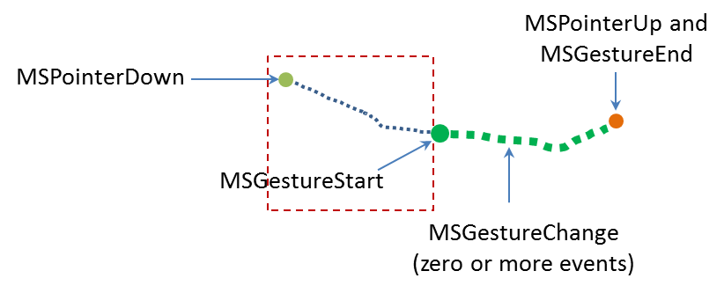
Note that if a pointer has been held within the movement threshold long enough for the first MSGestureHold to fire with MSGESTURE_FLAG_BEGIN, but then the pointer is moved out of the threshold area, MSGestureHold will be fired a second time with MSGESTURE_FLAG_CANCEL | MSGESTURE_FLAG_END in eventArgs.detail (a value of 6), followed by MSGestureStart with MSGESTURE_FLAG_BEGIN. This series is how you differentiate a hold from a slide or drag gesture even if the user holds the item in place for a while.
Together, the MSGestureStart, MSGestureChange, and MSGestureEnd events define a manipulation of the element to which the gesture is attached, where the pointer remains in contact with the element throughout the manipulation. Technically this means that the pointer was no longer moving when it was released.
If the pointer was moving when released, then we switch from a manipulation to an inertial motion. In this case, an MSInertiaStart event gets fired in to indicate that the pointer effectively continues to move even though contact was released or lifted. That is, you’ll continue to receive MSGestureChange events until the movement is complete:
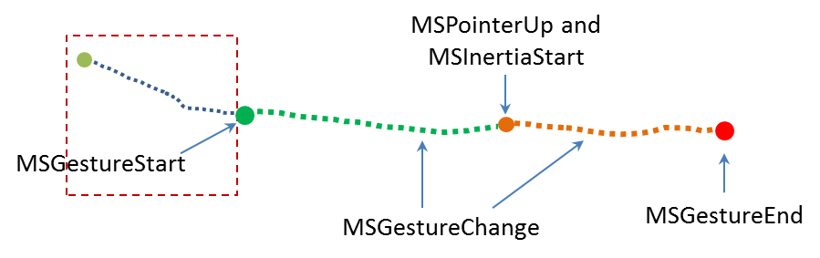
Conceptually, you can see the difference between a manipulation and an inertial motion as illustrated in Figure 9-3; the curves shown here are not necessarily representative of actual changes between messages. If the pointer is moved along the green line such that it’s no longer moving when released, we see the series of gesture that define a manipulation. If the pointer is released while moving, we see MSInertiaStart in the midst of MSGestureChange events and the event sequence follows the orange line.
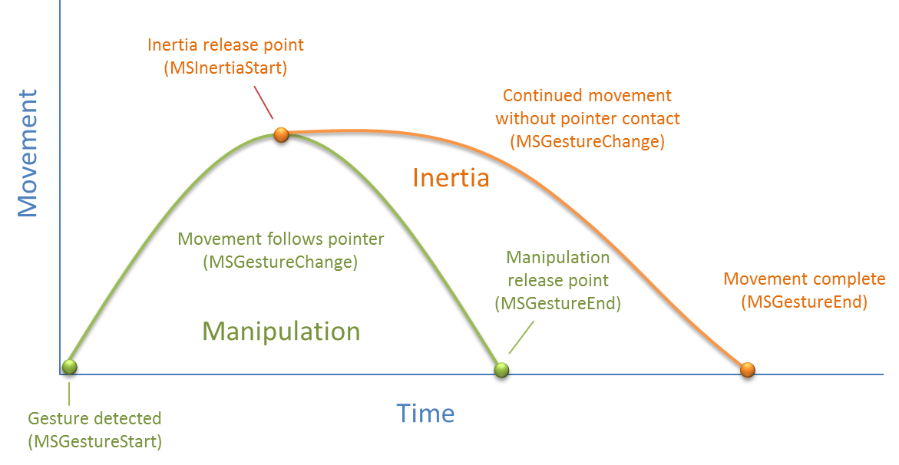
Figure 9-3 A conceptual representation of manipulation (green) and inertial (orange) motions.
Referring back to Figure 9-2, when the Show drop-down list (as shown!) is set to Velocity, the output for MSGestureChange events includes the eventArgs.velocity* values. During a manipulation, the velocity can change at any rate depending on how the pointer is moving. Once an inertial motion begins, however, the velocity will gradually diminish down to zero at which point MSGestureEnd occurs. The number of change events depends on how long it takes for the movement to slow down and come to a stop, of course, but if you’re just moving an element on the display with these change events, the user will see a nice fluid animation. You can play with this in the PointerEvents example, using the Show drop-down list to also look at how the other positional properties are affected by different manipulations and inertial gestures.

Multipoint Gestures
What we’ve discussed so far has focused on a single point gesture, but the same is also true for multi-point gestures. When an MSGesture object is given multiple pointers through its addPointer event, it will also fire MSGestureStart, MSGestureChange, MSGestureEnd for rotations and pinch-stretch gestures, along with MSInertiaStart. In these cases, the scale, rotation, velocityAngular, expansion, and velocity-Expansion properties in the eventArgs object become meaningful.
You can selectively view these properties for MSGestureChange events through the upper-right drop-down list in the PointerEvents example. One thing you might notice is that if you do multipoint gestures in the Visual Studio simulator, you’ll never see MSGestureTap events for the individual points. This is because the gesture recognizer can see that multiple MSPointerDown events are happening
almost simultaneously (which is where the hwTimestamp property comes into play) and combines them into an MSGestureStart right away (for example, starting a pinch-stretch or rotation gesture).
Now I’m sure you’re asking some important questions. While I’ve been speaking of pinch-stretch, rotation, and translation gestures as different things, how does one, in fact, differentiate these gestures when they’re all coming into the app through the same MSGestureChange event? Doesn’t that just make everything confusing? What’s the strategy for translation, rotation, and scaling gestures?
Well, the answer is—you don’t have to separate them! If you think about it for a moment, how you handle MSGestureChange events and the data each one contains depends on the kinds of manipulations you actually support in your UI:
- If you’re supporting only translation of an element, you’ll simply never pay any attention to properties like scale and rotation and apply only those like translationX and translationY. This would be the expected behavior for selecting an item in a collection control, for example (or a control that allowed drag-and-drop of items to rearrange them).
- If you support only zooming, you’ll ignore all the positional properties and work with scale, expansion, and/or velocityExpansion. This would be the sort of behavior you’d expect for a control that supported optical or semantic zoom.
- If you’re interested in only rotation, the rotation and velocityAngular properties are your friends.
Of course, if you want to support multiple kinds of manipulations, you can simply apply all of these properties together, feeding them into CSS transforms, for instance. This would be expected of an app that allowed arbitrary manipulation of on-screen objects, and it’s exactly what one of the gesture samples of the Windows SDK demonstrates.

The Input Instantiable Gesture Sample
While the PointerEvents example included with this chapter gives us a raw view of pointer and gesture events, what really matters to apps is how to apply these events to real manipulation of on-screen objects, which is to say, implementing parts of touch language such as pinch/stretch and rotation. For these we can turn to the Input Instantiable gestures sample.
This sample primarily demonstrates how to use gesture events on multiple elements simultaneously. In Scenarios 1 and 2, the app simulates a simple example of a puzzle app, as mentioned earlier. Each colored box can be manipulated separately, using drag to move (with or without inertia), pinch-stretch gestures to zoom, and rotation gestures to rotate, as shown in Figure 9-4.
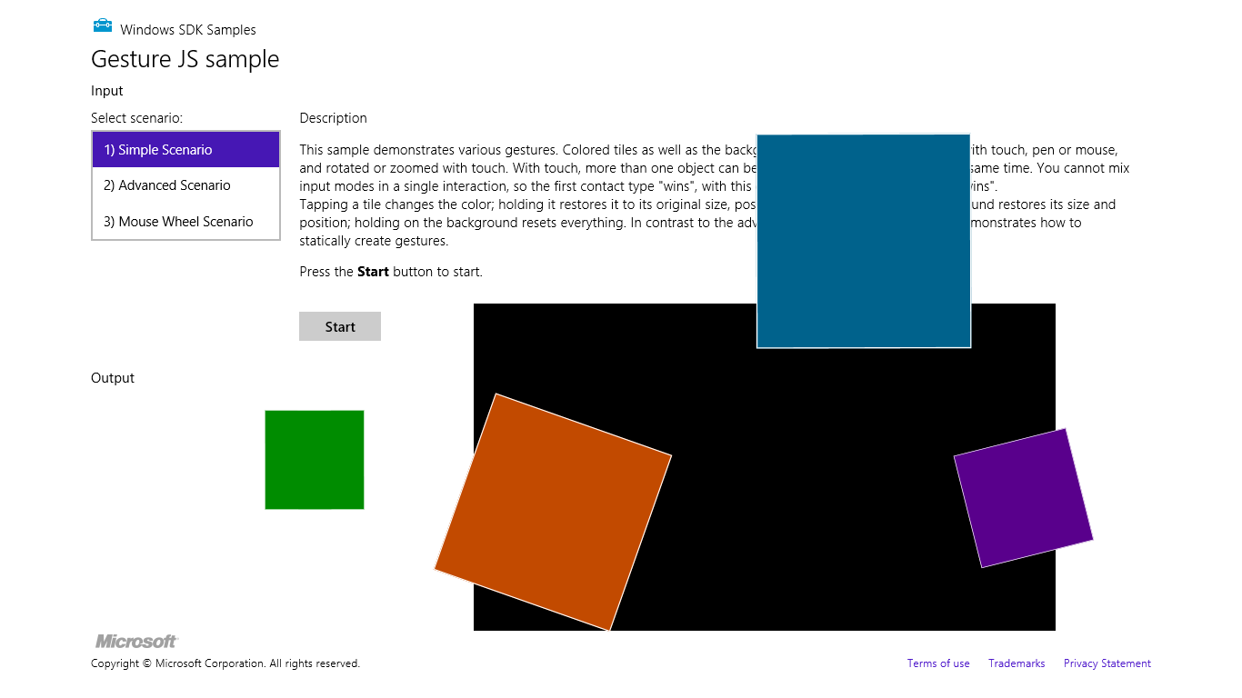
Figure 9-4 The Input Instantiable Gestures Sample after playing around a bit. The “instantiable” word comes from the need to instantiate an MSGesture object to receive gesture events.
In Scenario 1 (js/instantiableGesture.js), an MSGesture object is created for each screen element along with one for the black background “table top” element during initialization (the initialize function). This is the same as we’ve already seen. Similarly, the MSPointerDown handler (onPointerDown) adds pointers to the gesture object for each element, adding a little more processing to manage z-index. This avoids having simultaneous touch, mouse and stylus pointers working on the same element (which would be odd!):
function onPointerDown(e) {
if (e.target.gesture.pointerType === null) { // First contact
e.target.gesture.addPointer(e.pointerId); // Attaches pointer to element
e.target.gesture.pointerType = e.pointerType;
}
else if (e.target.gesture.pointerType === e.pointerType) { // Contacts of similar type
e.target.gesture.addPointer(e.pointerId); // Attaches pointer to element
}
// ZIndex Changes on pointer down. Element on which pointer comes down becomes topmost
var zOrderCurr = e.target.style.zIndex;
var elts = document.getElementsByClassName("GestureElement");
for (var i = 0; i < elts.length; i++) {
if (elts[i].style.zIndex === 3) {
elts[i].style.zIndex = zOrderCurr;
}
e.target.style.zIndex = 3;
}
}
The MSGestureChange handler for each individual piece (onGestureChange) then takes all the translation, rotation, and scaling data in the eventArgs object and applies them with CSS. This shows how convenient it is that all those properties are already reported in the coordinate space we need:
function onGestureChange(e) {
var elt = e.target;
var m = new MSCSSMatrix(elt.style.msTransform);
elt.style.msTransform = m.
translate(e.offsetX, e.offsetY).
translate(e.translationX, e.translationY).
rotate(e.rotation * 180 / Math.PI).
scale(e.scale).
translate(-e.offsetX, -e.offsetY);
}
There’s a little more going on in the sample, but what we’ve shown here are the important parts. Clearly, if you didn’t want to support certain kinds of manipulations, you’d again simply ignore certain properties in the event args object.
Scenario 2 of this sample has the same output but is implemented a little differently. As you can see in its initialize function (js/gesture.js), the only events that are initially registered apply to the entire “table top” that contains the black background and a surrounding border. Gesture objects for the individual pieces are created and attached to a pointer within the MSPointerDown event (onTableTopPointerDown). This approach is much more efficient and scalable to a puzzle app that has hundreds or even thousands of pieces, as gesture objects are held only for as long as a particular piece is being manipulated. Those manipulations are also like those of Scenario 1, where all the MSGestureChange properties are applied through a CSS transform. For further details, refer to the code comments in js/gesture.js, as they are quite extensive.
Scenario 3 of this sample provides another demonstration of performing translate, pinch-stretch, and rotate gestures using the mouse wheel. As shown in the PointerEvents example, the only thing you need to do here is process the wheel event, set eventArgs.pointerId to 1, and pass that onto your MSPointerDown handler that then adds the pointer to the gesture object:
elt.addEventListener("wheel", onMouseWheel, false);
function onMouseWheel(e) {
e.pointerId = 1; // Fixed pointerId for MouseWheel
onPointerDown(e);
}
Again, that’s all there is to it. (I love it when it’s so simple!) As an exercise, you might try adding this little bit of code to Scenarios 1 and 2 as well.

The Gesture Recognizer
With inertial gestures, which continue to send some number of MSGestureChange events after pointers are released, you might be asking this question: What, exactly, controls those events? That is, there is obviously a specific deceleration model built into those events, namely the one around which the Windows look and feel is built. But what if you want a different behavior? And what if you want to interpret pointer events in different way altogether?
The agent that interprets pointer events into gesture events is called the gesture recognizer, which you can get to directly through the Windows.UI.Input.GestureRecognizer object. After instantiating this object with new, you then set its gestureSettings properties for the kinds of manipulations and gestures you’re interested in. The documentation for Windows.UI.Input.-GestureSettings gives all the options here, which include tap, doubleTap, hold, holdWithMouse, rightTap, drag, translations, rotations, scaling, inertia motions, and crossSlide (swipe). For example, in the Input manipulations and gestures sample (ballineight.js) we can see how it configures a recognizer for tap, rotate, translate, and scale (with inertia):
gr = new Windows.UI.Input.GestureRecognizer();
// Configuring GestureRecognizer to detect manipulation rotation, translation, scaling,
// + inertia for those three components of manipulation + the tap gesture
gr.gestureSettings =
Windows.UI.Input.GestureSettings.manipulationRotate |
Windows.UI.Input.GestureSettings.manipulationTranslateX |
Windows.UI.Input.GestureSettings.manipulationTranslateY |
Windows.UI.Input.GestureSettings.manipulationScale |
Windows.UI.Input.GestureSettings.manipulationRotateInertia |
Windows.UI.Input.GestureSettings.manipulationScaleInertia |
Windows.UI.Input.GestureSettings.manipulationTranslateInertia |
Windows.UI.Input.GestureSettings.tap;
// Turn off UI feedback for gestures (we'll still see UI feedback for PointerPoints)
gr.showGestureFeedback = false;
The GestureRecognizer also has a number of properties to configure those specific events. With cross-slides, for example, you can set the crossSlideThresholds, crossSlideExact, and crossSlideHorizontally properties. You can set the deceleration rates (in pixels/ms²) through inertiaExpansionDeceleration, inertiaRotationDeceleration, and inertiaTranslation-Deceleration.
Once configured, you then start passing MSPointer* events to the recognizer object, specific to its methods named processDownEvent, processMoveEvents, and processUpEvent (also processMouseWheelEvent, and processInertia, if needed). In response, depending on the configuration, the recognizer will then fire a number of its own events. First, there are discrete events like crossSliding, dragging, holding, rightTapped, and tapped. For all others it will fire a series of manipuationStarted, manipulationUpdated, manipulationInertiaStarting, and manipulationCompleted events. Note that all of these come from WinRT to be sure to call removeEventListener as needed.
When you’re using the recognizer directly, in other words, you’ll be listening for MSPointer* events, feeding them to the recognizer, and then listening for and acting on the recognizer’s specific events as above rather than the MSGesture* events that come out of the default recognizer configured by the MSGesture object.
Again, refer to the documentation on Windows.UI.Input.GestureRecognizer for all the details and refer to the sample for some bits of code. As one extra example, here’s a snippet to capture a small horizontal motion using the manipuationTranslateX setting:
var recognizer = new Windows.UI.Input.GestureRecognizer();
recognizer.gestureSettings = Windows.UI.Input.GestureSettings.manipulationTranslateX;
var DELTA = 10;
myElement.addEventListener('MSPointerDown', function (e) {
recognizer.processDownEvent(e.getCurrentPoint(e.pointerId));
});
myElement.addEventListener('MSPointerUp', function (e) {
recognizer.processUpEvent(e.getCurrentPoint(e.pointerId));
});
myElement.addEventListener('MSPointerMove', function (e) {
recognizer.processMoveEvents(e.getIntermediatePoints(e.pointerId));
});
// Remember removeEventListener as needed for this event
recognizer.addEventListener('manipulationcompleted', function (args) {
var pt = args.cumulative.translation;
if (pt.x < -DELTA) {
// move right
}
else if (pt.x > DELTA) {
// move left
}
});
Beyond the recognizer, do note that you can always go the low-level route and do your own processing of MSPointer* events however you want, completely bypassing the gesture recognizer. This would be necessary if the configurations allowed by the recognizer object don’t accommodate your specific need. At the same time, now is a good opportunity to re-read “Sidebar: Creating Completely New Gesture?” at the end of the earlier section on the touch language. It addresses a few of the questions about when and if custom gestures are really needed.

Keyboard Input and the Soft Keyboard
After everything to do with touch and other forms of input, it seems almost anticlimactic to consider the humble keyboard. Yet of course the keyboard remains utterly important for textual input, whether it’s a physical key-board or the on-screen “soft” keyboard. It is especially important for accessibility as well, as some users are physically unable to use a mouse or other devices. In fact, the Windows 8 app certification requirements (section 3.5) make keyboard input mandatory.
Fortunately, there is nothing special about handling keyboard input in a Windows Store app, but a little goes a long way. Drawing from Implementing keyboard accessibility, here’s a summary:
- Process keydown, keyup, and keypress events as you already know how to do, especially for imple-menting special key combinations. See “Standard Keystrokes” later in this section for a quick run-down of typical mappings.
- Have tabindex attributes on interactive elements that should be tab stops. Avoid adding tabindex to noninteractive elements as this will interfere with screen readers.
- Have accesskey attributes on those elements that should have keyboard shortcuts.
- Call the DOM focus API on whatever element should be the default.
- Take advantage of the keyboard support that already exists in built-in controls, such as the App Bar.
As an example, the Here My Am! we’ve been working with in this book has been updated in this chapter’s companion content with full keyboard support. This was mostly a matter of adding tabindex to a few elements, setting focus to the image area, and picking up keydown events on the img elements for the Enter key and spacebar where we’ve already been handling click. Within those keydown events, note that it’s helpful to use the WinJS.Utilities.Key enumeration for comparing key codes:
var Key = WinJS.Utilities.Key;
var image = document.getElementById("photo");
image.addEventListener("keydown", function (e) {
if (e.keyCode == Key.enter || e.keyCode==Key.space) {
image.click();
}
});
All this works for both the physical keyboard as well as the soft keyboard. Case closed? Well, not entirely. There are two special concerns with the soft keyboard: how to make it appear, and the effect of its appearance on app layout. At the end of this section I’ll also provide a quick run-down of standard keystrokes for app commands.

Soft Keyboard Appearance and Configuration
The appearance of the soft keyboard happens for one reason and one reason only: the user touches a text input element or an element with the contenteditable="true" attribute (such as a div or canvas). There isn’t an API to make the keyboard appear, nor will it appear when you click in such an element with the mouse or a stylus, or tab to it with a physical keyboard.
The configuration of the keyboard is also sensitive to the type of input control. We can see this through Scenario 2 of the Input Touch keyboard text input sample, where html/ScopedViews.html contains a bunch of input controls (surrounding table markup omitted), which appear as shown in Figure 9-5:
<input type="url" name="url" id="url" size="50" />
<input type="email" name="email" id="email" size="50" />
<input type="password" name="password" id="password" size="50" />
<input type="text" name="text" id="text" size="50" />
<input type="number" name="number" id="number" />
<input type="search" name="search" id="search" size="50" />
<input type="tel" name="tel" id="tel" size="50" />
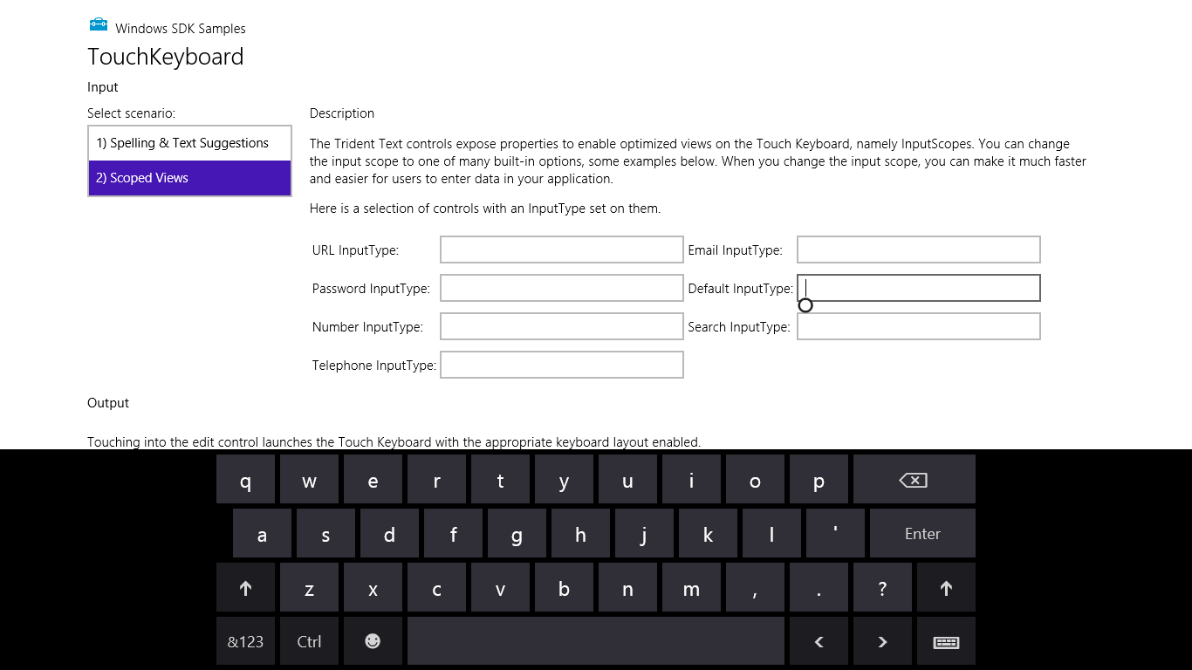
Figure 9-5 The soft keyboard appears when you touch an input field, as shown in the Input Touch keyboard text input sample.
What’s shown in Figure 9-5 is the default keyboard. If you tap in the Search field, you get pretty much the same view except the Enter key turns into Search. For the Email field, it’s much like the default view except you get @ and .com keys to either side of the spacebar:

The URL keyboard is the same except the @ key is dropped and Enter turns into Go:

For passwords you get a key to hide keypresses, which prevents a visible animation from happening on the screen—a very important feature if you’re recording videos!

And finally, the Number and Telephone fields bring up a number-oriented view:

In all of these cases, the key on the lower right (whose icon looks a bit like a keyboard), lets you switch to other keyboard layouts:
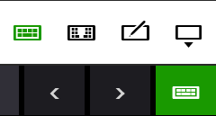
The options here are the normal (wide) keyboard, the split keyboard, a handwriting recognition panel, and a key to dismiss the soft keyboard entirely. Here’s what the default split keyboard and handwriting panels look like:
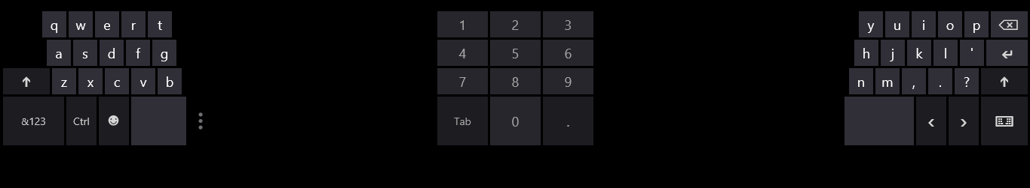
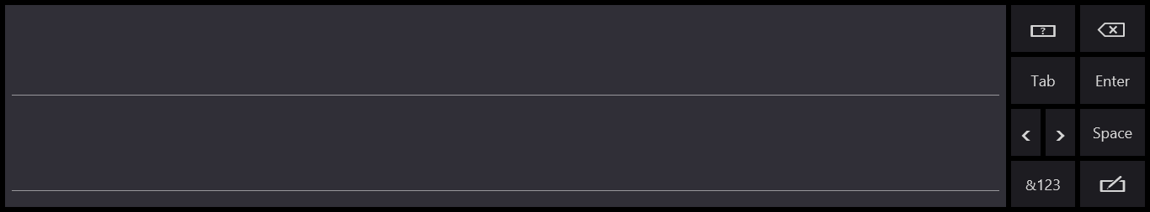
This handwriting panel for input is simply another mode of the soft keyboard: you can switch between the two, and your selection sticks across invocations. (For this reason, Windows does not automatically invoke the handwriting panel for a pen pointer, because the user may prefer to use the soft keyboard even with the stylus.)
The keyboard will also adjust its appearance with text input controls to provide text suggestions; specifically, a highlighted Insert key appears. This is demonstrated in Scenario 1 of the sample and shown below:
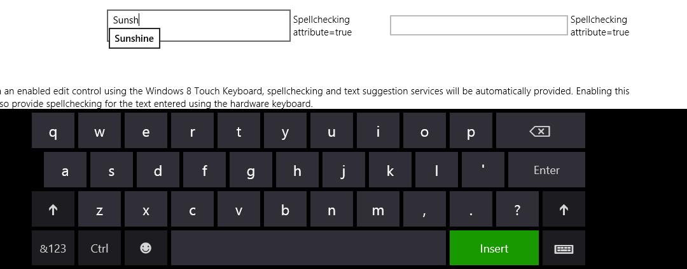

Adjusting Layout for the Soft Keyboard
The second concern with the soft keyboard (no, I didn’t forget!) is handling layout when the keyboard might obscure the input field with the focus.
When the soft keyboard or handwriting panel appears, the system will try to make sure the input field is visible by scrolling the page content if it can. This means that it just sets a negative vertical offset to your entire page equal to the height of the soft keyboard. For example, if I add (as a total hack!) a bunch of <br/> elements at the top of html/ScopedView.html in the sample, such that the input controls are at the bottom of the page, and then I touch one of them, the whole page is slid up, as shown in Figure 9-6.
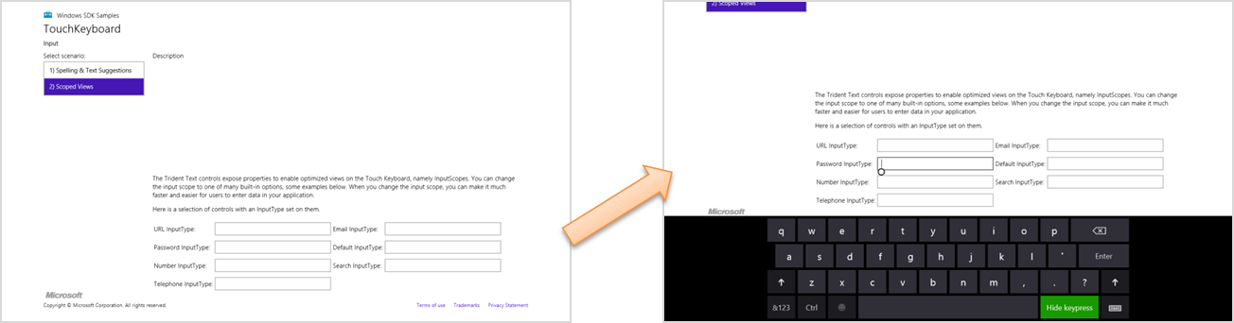
Figure 9-6 When the soft keyboard appears, Windows will automatically slide the app page up to make sure the input field isn’t obscured.
Although this can be the easiest solution to this particular concern, it’s not always ideal. Fortunately, you can do something more intelligent if you’d like by listening to the hiding and showing events of the Windows.UI.ViewManagement.InputPane object and adjust your layout directly. Code for doing this can be found in the—are you ready for this one?—Responding to the appearance of the on-screen keyboard sample. Adding listeners for these events is simple (see the bottom of js/keyboardPage.js, which also removes the listeners properly):
var inputPane = Windows.UI.ViewManagement.InputPane.getForCurrentView();
inputPane.addEventListener("showing", showingHandler, false);
inputPane.addEventListener("hiding", hidingHandler, false);
Within the showing event handler, the eventArgs.occludedRect object (a Windows.-Foundation.Rect) gives you the coordinates and dimensions of the area that the soft keyboard is covering. In response, you can adjust whatever layout properties are applicable and set the eventArgs.ensuredFocusedElementInView property to true. This tells Windows to bypass its automatic offset behavior:
function showingHandler(e) {
if (document.activeElement.id === "customHandling") {
keyboardShowing(e.occludedRect);
// Be careful with this property. Once it has been set, the framework will
// do nothing to help you keep the focused element in view.
e.ensuredFocusedElementInView = true;
}
}
The sample shows both cases. If you tap on the aqua-colored defaultHandling element on the bottom left of the app, as shown in Figure 9-7, this showingHandler does nothing, so the default behavior occurs.
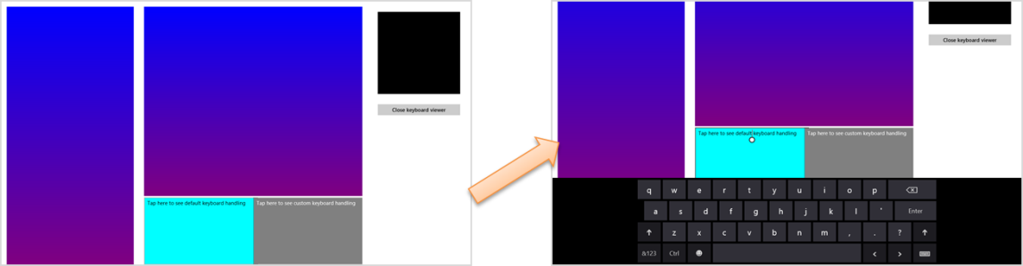
Figure 9-7 Tapping on the left defaultHanding element at the bottom shows the default behavior when the keyboard appears, which offsets other page content vertically.
If you tap the customHandling element (on the right), it calls its keyboardShowing routine to do layout adjustment:
function keyboardShowing(keyboardRect) {
// Some code omitted...
var elementToAnimate = document.getElementById("middleContainer");
var elementToResize = document.getElementById("appView");
var elementToScroll = document.getElementById("middleList");
// Cache the amount things are moved by. It makes the math easier
displacement = keyboardRect.height;
var displacementString = -displacement + "px";
// Figure out what the last visible things in the list are
var bottomOfList = elementToScroll.scrollTop + elementToScroll.clientHeight;
// Animate
showingAnimation = KeyboardEventsSample.Animations.inputPaneShowing(elementToAnimate,
{ top: displacementString, left: "0px" }).then(function () {
// After animation, layout in a smaller viewport above the keyboard
elementToResize.style.height = keyboardRect.y + "px";
// Scroll the list into the right spot so that the list does not appear to scroll
elementToScroll.scrollTop = bottomOfList - elementToScroll.clientHeight;
showingAnimation = null;
});
}
The code here is a little involved because it’s animating the movement of the various page elements. The short of it is that the layout of affected elements—namely the one that is tapped—is adjusted to make space for the keyboard. Other elements on the page are otherwise unaffected. The result is shown in Figure 9-8.
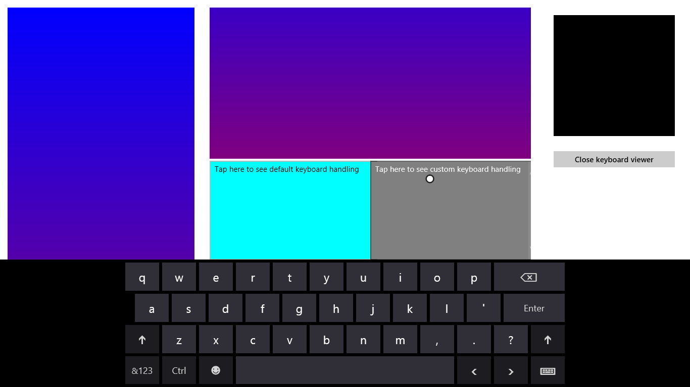
Figure 9-8 Tapping the gray customHanding element on the right shows custom handling for the keyboard’s appearance.

Standard Keystrokes
The last piece I wanted to include on the subject of the keyboard is a table of command keystrokes you might support in your app. These are in addition to the touch language equivalents, and you’re probably accustomed to using many of them already. They’re good to review because again, apps should be fully usable with just the keyboard, and implementing keystrokes like these goes a long way toward fulfilling that requirement and enabling more efficient use of your app by keyboard users.
Action or Command | Keystroke
Move focus | Tab
Back (navigation) | Back button on special keyboards; backspace if not in a text field; Alt+left arrow
Forward (navigation | Alt+right arrow
Up | Alt+up arrow
Cancel/Escape from mode | ESC
Walk through items in a list | Arrow keys (plus Tab)
Jump through items in a list to next group if selection doesn’t automatically follow focus | Ctrl+arrow keys
Zoom (semantic and optical) | Ctrl+ and Ctrl-
Jump to something in a named collection | Start typing
Jump far | Page up/down (should work in panning UI, in either horizontal or vertical directions)
Next tab or group | Ctrl+Tab
Previous tab or group | Ctrl+Shift+Tab
Nth tab or group | Ctrl+N (1-9)
Open app bar (Windows handles this automatically) | Win+Z
Context menu | Context menu key
Open additional flyout/select menu item | Enter
Navigate into/activate | Enter (on a selection)
Select | Space
Select contiguous | Shift+arrow keys
Pin this | Ctrl+Shift+!
Save | Ctrl+S
Find | Ctrl+F
Print | Ctrl+P (call Windows.Graphics.Printing.PrintManager.showPrintUIAsync)
Copy | Ctrl+C
Cut | Ctrl+X
Paste | Ctrl+V
New Item | Ctrl+N
Open address | Ctrl+L or Alt+D
Rotate | Ctrl+, and Ctrl+.
Play/Pause | Ctrl+P (media apps only)
Next item | Ctrl+F (conflict with Find)
Previous item | Ctrl+B
Rewind | Ctrl+Shift+B
Fast forward | Ctrl+Shift+F

Inking
Beyond the built-in soft keyboard/handwriting pane, an app might also want to provide a surface on which it can directly accept pointer input as ink. By this I mean more than just having a canvas element and processing MSPointer* events to draw on it to produce a raster bitmap. Ink is a data structure that maintains the actual input data (including pressure, angle, and velocity if the hardware supports it) which allows for handwriting recognition and other higher-level processing that isn’t possible with raster data. Ink, in other words, remembers how an image was drawn, not just the final image itself, and it works with all types of pointer input.
Ink support in WinRT is found in the Windows.UI.Input.Inking namespace. This API doesn’t depend on any particular presentation framework, nor does it provide for rendering: it deals only with the managing data structures that an app can then render itself to a drawing surface such as a canvas. Here’s its basic function:
- Create an instance of the manager object with new Windows.UI.Input.Inking.-InkManager().
- Assign any drawing attributes by creating a Windows.UI.Input.Inking.InkDrawing-Attributes object and settings attributes like the ink color, fitToCurve (as opposed to the default straight lines), ignorePressure, penTip (Windows.UI.Input.Inking.-PenTipShape.circle or rectangle), and size (a Windows.Foundation.Size object with height and width).
- For the input element, listen for the MSPointerDown, MSPointerMove, and MSPointerUp events, which you generally need to handle for display purposes already. The eventArgs.-currentPoint is a Windows.UI.Input.PointerPoint object that contains a pointer id, point coordinates, and properties like pressure, tilt, and twist.
- Pass that PointerPoint object to the ink manager’s processPointerDown, process-PointerUpdate, and processPointerUp methods, respectively.
- After processPointerUp, the ink manager will create a Windows.UI.Input.Inking.-InkStroke object for that path. Those strokes can then be obtained through the ink manager’s getStrokes method and rendered as desired.
- Higher-order gestures can be also converted into InkStroke objects directly and given to the manager through its addStroke method. Stroke objects can also be deleted with deleteStroke.
The ink manager also provides methods for performing handwriting recognition with its contained strokes, saving and loading the data, and handling different modes like draw and erase. For a complete demonstration, check out the Input Ink sample that is shown in Figure 9-9. This sample lets you see the full extent of inking capabilities, including handwriting recognition.
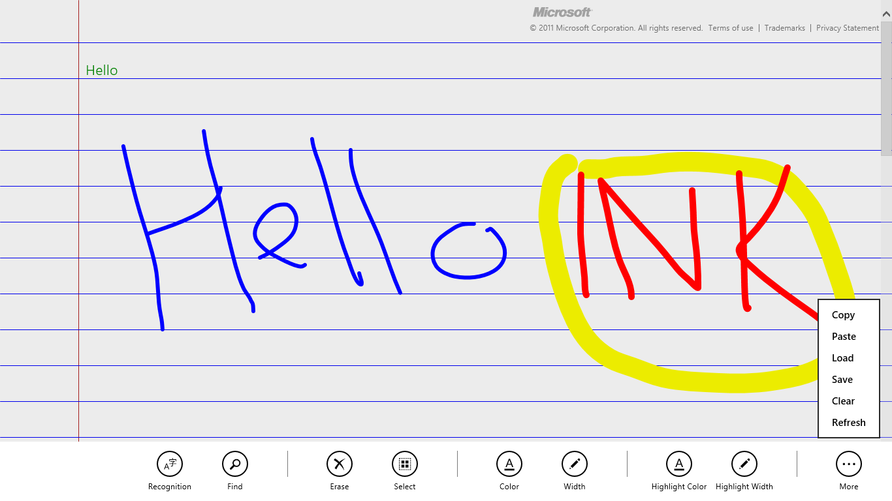
Figure 9-9 The Input Ink sample with many commands on its app bar. The green “Hello” text in the upper left was generated by selecting the Hello ink and tapping the Recognition command.
The SDK also includes the Input Simplified ink sample to demonstrate a more focused handwriting recognition scenario, as shown in Figure 9-10. You should know that this is one sample that doesn’t support touch at all—it’s strictly mouse and stylus and uses keystrokes for various commands instead of an app bar. Look at the keydown function in simpleink.js for a list of the Ctrl+key commands; the spacebar performs recognition of your strokes and the backspace key clears the canvas. As you can see in the figure, I think the handwriting recognition is quite good! (It tells me that the handwriting samples I gave to an engineering team at Microsoft somewhere in the mid-1990s must have made a valuable contribution.)
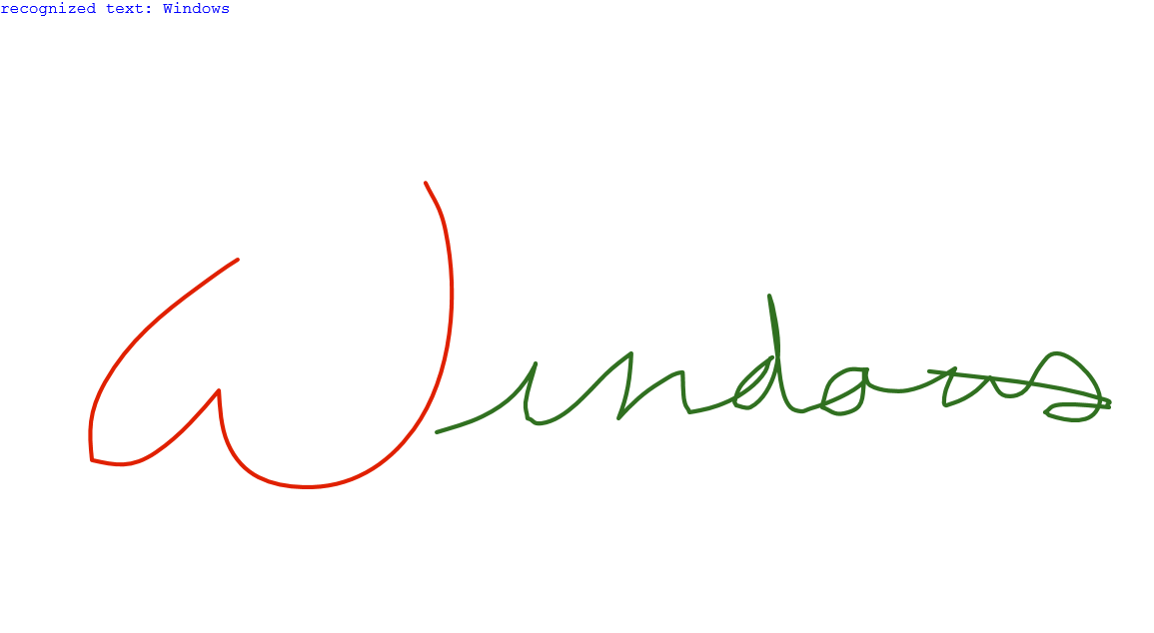
Figure 9-10 The Input Simplified Ink sample doing a great job recognizing my sloppy mouse-based handwriting.

Geolocation
Before we explore sensors more generally, I’ll call out the geolocation capabilities for Windows Store apps separately because its API is structured differently from other sensors. We’ve already used this since Chapter 2, “Quickstart” in the Here My Am! app, but we need the more complete story of this highly useful capability.
Unlike all other sensors, in fact, geolocation is the only one that has an associated capability you must declare in the manifest. Where you are on the earth is an absolute measure, if you will, and is therefore classified as a piece of personal information. So, users must give their consent before an app can obtain that information, and your app must also provide a Privacy Statement in the Windows Store. Other sensor data, in contrast, is relative—you cannot, for example, really know anything about a person from how a device is tilted, how it’s moving, or how much light is shining on it. Accordingly, you can use those others sensors without declaring any specific capabilities.
As you might know, geolocation can be obtained in two different ways. The primary and most precise way, of course, is to get a reading from an actual GPS radio that is talking to geosynchronous satellites some hundreds of miles up in orbit. The other reasonably useful means, though not always accurate, is to attempt to find one’s position through the IP address of a wired network connection or to triangulate from the position of available WiFi hotspots. Whatever the case, WinRT will do its best to give you a decent reading.
To access geolocation readings, you must first create an instance of the WinRT geolocator, Windows.Devices.Geolocation.Geolocator. With that in hand, you can then call its getGeopositionAsync method, whose results (delivered to your completed handler) is a Geoposition object (in the same Windows.Devices.Geolocation namespace, as everything here is unless noted). Here’s the code as it appears in Here My Am!:
var gl = new Windows.Devices.Geolocation.Geolocator();
gl.getGeopositionAsync().done(function (position) {
//Save for share
lastPosition = { latitude: position.coordinate.latitude,
longitude: position.coordinate.longitude };
}
The getGeopositionAsync method also has a variation where you can specify two parameters: a maximum age for a cached reading (which is to say, how stale you can allow a reading to be) and a timeout value for how long you’re willing to wait for a response. Both values are in milliseconds.
A Geoposition contains two properties. First, its coordinate property is a Geocoodinate object that provides accuracy (meters), altitude (meters), altitudeAccuracy (meters), heading (degrees relative to true north), latitude (degrees), longitude (degrees), speed (meters/sec), and a timestamp (Date). The second part of a Geoposition is a CivicAddress object named—what else!—civicAddress, which might contain city (string), country (string, a two-letter ISO-3166 country code), postalCode (string), state (string), and timestamp (Date) properties, if the geolocation provider supplies such data.
You can indicate the accuracy you’re looking for through the Geolocator’s desiredAccuracy property, which is either PositionAccuracy.default or PositionAccuracy.high. The latter, mind you, will be much more radio or network intensive. This might incur higher costs on metered broadband connections and can shorten battery life, so set this to high only if it’s essential to your user experience.
The Geolocator also provides a locationStatus property, which is a PositionStatus object containing ready, initializing, noData, disabled, notInitialized, and notAvailable. It should be obvious that you can’t get data from a Geolocator that’s in any state other than ready. To track this, you can listen to the Geolocator’s statusChanged event, where eventArgs.status property in your handler will contain a PositionStatus; this is helpful when you find that a GPS device might take a couple seconds to provide a reading. For an example of using this event, see Scenario 1 of the Geolocation sample in the Windows SDK:
geolocator = new Windows.Devices.Geolocation.Geolocator();
geolocator.addEventListener("statuschanged", onStatusChanged); //Remember to remove later
function onStatusChanged(e) {
switch (e.status) {
// ...
}
}
Note that PositionStatus and statusChanged reflect the readiness of the GPS device, and that readiness is not affected by the Location permission in the app’s Settings pane. As demonstrated in Here My Am!, an app needs to check permissions by trying to obtain a setting, which is a different concern from device readiness.
The other two interesting properties of the Geolocator are movementThreshold, a distance in meters that the device can move before another reading is triggered (which can be used for geo-fencing scenarios), and reportInterval, which is the number of milliseconds between attempted readings. Be conservative with the latter, setting it to what you really need, because you again want to minimize network or radio activity. In any case, when the Geolocator takes and other reading and finds that the device has moved beyond the movement-Threshold, it will fire a positionChanged event, where the eventArgs.position property is a new Geoposition object. This is also shown in Scenario 1 of the Geolocation sample:
geolocator.addEventListener("positionchanged", onPositionChanged);
function onPositionChanged(e) {
var coord = e.position.coordinate;
document.getElementById("latitude").innerHTML = coord.latitude;
document.getElementById("longitude").innerHTML = coord.longitude;
document.getElementById("accuracy").innerHTML = coord.accuracy;
}
With movementThreadhold and reportInterval, really think through what your app needs based on the accuracy and/or refresh intervals of the data you’re using in relation to the location. For example, weather data is regional and might be updated only hourly. Therefore, movementThreshold might be set on the scale of miles or kilometers and reportInterval at 15, 30, 60 minutes, or longer. A mapping or real-time traffic app, on the other hand, works with data that is very location-sensitive and will thus have a much smaller threshold and a much shorter interval.
Where battery life is concerned, it’s best to simply take a reading when the user wants one, rather than following the position at regular intervals. But this again depends on the app scenario, and you could also provide a setting that lets the user control geolocation activity.
It’s also very important to note that apps won’t get positionChanged or statusChanged events while suspended unless you register a time trigger background task for this purpose and the user adds the app to the lock screen. We’ll talk more of this in Chapter 13, “Tiles, Notifications, the Lock Screen, and Background Tasks,” and you can also see how this works in Scenario 3 of the Geolocation sample. If, however, you don’t use a background task or the user doesn’t place you on the lock screen and you still want to track the user’s position, be sure to handle the resuming event and refresh the position there.
On the flip side, some geolocation scenarios, such as providing navigation, need to also keep the display active (preventing automatic screen shutoff) even when there’s no user activity. For this purpose you can use the Windows.System.Display.DisplayRequest class, namely its requestActive and releaseRelease methods that you would call when starting and ending a navigation session. Of course, since keeping the display active consumes more battery power, only use this capability when necessary—as when specifically providing navigation—and avoid simply making the request when your app starts. Otherwise your app will probably gain a reputation in the Windows Store as being power hungry!
Sidebar: HTML5 Geolocation
An experienced HTML/JavaScript developer might wonder why WinRT provides a Geolocation API when HTML5 already has one: window.navigator.geolocation and its getCurrent-Position method that returns an object with coordinates. The reason for the overlap is that other languages like C#, Visual Basic, and C++ don’t have another API to draw from, which leaves HTML/JavaScript developers a choice. Under the covers, the HTML5 API hooks into the same data as the WinRT API, requires the same manifest capability, Location, and is subject to the same user consent, so for the most part the two APIs are almost equivalent. I would give WinRT a slight edge due to the movementThreshold option, which helps an app cooperate with power management and enables easier geo-fencing. Doing the same with the HTML5 API would require more frequent polling and battery consumption. For many scenarios, however, you can use either one with equal results.
Like all other WinRT APIs, however, Windows.Devices.Geolocation is available only in local context pages in a Windows Store app. In web context pages you can use the HTML5 API.

Sensors
As I wrote in the chapter’s introduction, I like to think of sensors as another form of input. It makes a lot of sense because every device that is now wholly integrated into our computer systems—such that we take them for granted—was at one point a kind of human-interface peripheral. In time, I suspect that many of the sensors that are new to us today will be standard equipment just about everywhere.
Sensors, again, are a way of understanding the relationship of a device to the physical world around it, and this constitutes input because you, as a human being, can affect that relationship primarily by moving the device around in physical space or otherwise changing its environment. Sensors can also be used as direct input to cause motion on the screen rather than relying on some form of abstract input like the keyboard or mouse. For example, instead of using keystrokes to abstractly tilt a game board, you can, with sensors, just tilt the device. Shaking, in fact, is becoming a well-known physical gesture that can be wired to a command of some kind like Retry Now, darn you! Why aren’t you doing what I want? Haven’t we for years been shaking or smacking our computers when they aren’t behaving properly? Well, with sensors the computer can now actually respond!
Here, then, is what the various sensors tell us:
- Location The device’s position on the earth (as we covered in the previous section).
- Compass and orientation The direction the device is pointing, relative to the earth’s magnetic poles or relative to the device’s inherent sense of position (both simple and complex orientation).
- Inclinometer The static pitch, roll, and yaw of the device in 3D space.
- Gyrometer The angular velocity/rotational motion of the device in 3D space.
- Accelerometer The linear G-force acceleration of the device within 3D space (x, y, z).
- Ambient light The amount of light surrounding the device.
These are the sensors that are represented in the WinRT API, some of which are created in software through sensor fusion. This means taking raw data from one or more hardware sensors and combining, interpreting, and presenting it all in a form that’s more directly useful to apps. Just as with pointers, you can still get to raw data if you want it, but oftentimes it’s unnecessary. For example, the Simple Orientation sensor provides a simple interpretation of how the device is oriented in relation to its default position, rounding everything off, as it were, to the nearest 90-degree quadrant. The full Orientation sensor, on the other hand, combines gyrometer, accelerometer, and compass data to provide an exact 3D orientation matrix that is much more precise but much more oriented (if I might make the pun!) to advanced scenarios than simply needing to know whether the device is upside-down or rightside-up.
Because all of these sensors are very similar in how they work (which is intentional, with the exception of the Simple Orientation sensor, which is intentionally dissimilar!), I want to show the general pattern of the sensor APIs rather than explicit examples for each. Such examples are readily available in these SDK samples: Accelerometer, Compass, Gyrometer, Inclinometer, Light Sensor, and OrientationSensor.
The usage pattern is as follows, with the particulars summarized in the table that follows:
- Obtain a sensor object via Windows.Devices.Sensors.<sensor>.getDefault().
- Call that object’s getCurrentReading to obtain a one-time reading.
- For ongoing readings, configure the object’s minimumReportInterval and reportInterval properties (both in milliseconds) and listen to the object’s readingchanged event. Your handler will receive a reading object of an appropriate type in response. As with geolocation, setting these values wisely will help optimize battery life by avoiding excess electrons flying through the sensors!
Sensor Name (Windows.Devices.Sensors.) | Added Members | Reading Type (Windows.Devices.Sensors) | Reading Properties (timestamp is a Date; all others are Numbers unless noted)
Accelerometer | Event: shaken (event args contains only a timestamp property) | AccelerometerReading | accelerationX (G’s), accelerationY, accelerationZ, timestamp
Compass | n/a | CompassReading | headingMagneticNorth (degrees), headingTrueNorth, timestamp
Gyrometer | n/a | GyrometerReading | angularVelocityX (degrees/sec), angularVelocityY, angularVelocityZ, timestamp
Inclinometer | n/a | InclinometerReading | pitchDegrees (degrees), rollDegrees (degrees), yawDegrees (degrees), timestamp
LightSensor | n/a | LightSensorReading | illuminenceInLux (lux), timestamp
OrientationSensor | n/a | OrientationSensorReading | quaternion, (SensorQuaternion containing w, x, y, and z properties) rotationMatrix (Sensor-RotationMatrix containing m11, m12, m13, m21, m22, m23, m31, m32, m33 properties), timestamp

Here’s an example of such code from the Gyrometer sample (js/scenario1.js):
gyrometer = Windows.Devices.Sensors.Gyrometer.getDefault();
var minimumReportInterval = gyrometer.minimumReportInterval;
var reportInterval = minimumReportInterval > 16 ? minimumReportInterval : 16;
gyrometer.reportInterval = reportInterval;
gyrometer.addEventListener("readingchanged", onDataChanged); // Remember to remove as needed
function onDataChanged(e) {
var reading = e.reading;
document.getElementById("eventOutputX").innerHTML = reading.angularVelocityX.toFixed(2);
document.getElementById("eventOutputY").innerHTML = reading.angularVelocityY.toFixed(2);
document.getElementById("eventOutputZ").innerHTML = reading.angularVelocityZ.toFixed(2);
}
With the Orientation Sensor, a quaternion can be most easily understood as a rotation of a point [x,y,z] about a single arbitrary axis. This is different from a rotation matrix, which represents rotations around three axes. The mathematics behind quaternions is fairly exotic because it involves the geometric properties of complex numbers and mathematical properties of imaginary numbers, but working with them is simple and frameworks like DirectX support them. See the OrientationSensor sample for more.
Speaking of orientation, I mentioned that the SimpleOrientationSensor works a little differently. Its purpose is to supply quadrant orientation rather than exact orientation, which is perhaps all you need. For example, a star chart app would need to know if a slate device is upside-down so that it can adjust its display (along with a compass reading) to match the sky itself.
To summarize this sensor’s usage:
- Call Windows.Devices.Sensors.SimpleOrientation.getDefault to obtain the object.
- Call the getCurrentOrientation to obtain a reading.
- The orientationChanged event provides for ongoing readings, where eventArgs contains orientation (a reading) and timestamp properties.
- The reading is a SimpleOrientation object that contains these properties:
  - notRotated (“portrait up”), rotated90DegreesCounterclockwise (“portrait left”), rotated90DegreesCounterclockwise (“portrait down”), rotated270Degrees-Counterclockwise (“landscape right”) Note that these are entirely different from view states like fullscreen-landscape and fullscreen-portrait.
  - faceup, facedown (slate devices only).
For a demonstration, see the SimpleOrientationSensor sample.

What We’ve Just Learned
- “Design for touch, get mouse and stylus for free” is a message that holds true, because working with pointer and gesture input from a variety of input devices doesn’t require you to differentiate between the forms of input.
- Using built-in controls is the easiest way to handle input, but you can also handle MSPointer* events and MSGesture* events directly, when needed. You can also feed MSPointer* events into a custom gesture recognizer (that issues its own events).
- The Windows 8 touch language includes tap, press and hold, slide/pan, cross-slide (to select), pinch-stretch, rotate, and edge gestures (from top/bottom and from the sides). A tap is typically handled with a click event, whereas the others require the creation of an MSGesture object, association of that object with a pointer, and handling of MSGesture* event sequences which provide for maniplations and inertial motions together.
- The touch language also has mouse, stylus, and keyboard equivalents. For mouse and stylus, there is very little work an app needs to do (such as sending mouse wheel events to the gesture object). Keyboard support must be implemented separately, but simply uses the standard HTML/JavaScript events.
- Keyboard support also includes accommodating the soft (on-screen) keyboard, which appears automatically for text input fields and other content-editable elements. It automatically adjusts its appearance according to input type, and will slide the app contents up if necessary to avoid having the keyboard overlap the input control. An app can also handle visibility events directly to provide a better experience than the default.
- The Inking API provides apps with the means to record, save, and render an entire series of pointer activities, where the strokes can also be fed into a handwriting recognizer.
- The Geolocation API in WinRT, similar to the HTML5 geolocation API, provides apps with access to GPS data as well as events when the device has moved past a specified threshold.
- The WinRT API represents a number of sensors that can also be used as input to an app. In addition to geolocation, the sensors are compass, orientation, simple orientation (quadrant-based), inclinometer, gyrometer, accelerometer, and ambient light.
- Most sensors follow the same usage pattern: acquire the sensor object, get a current reading, and possibly listen to the readingchanged event. They are very easy to work with, leaving much of your energy to apply them creatively!

As WinRT object events, these are subject to the considerations in “WinRT Events and removeEventListener” in Chapter 3.
double-tap-zoom is not supported for Windows Store apps.
And while you might think this is the second longest JavaScript sample name in the Windows SDK, it actually gets only the bronze medal. The Unselectable content areas with -ms-user-select CSS attribute sample, as we’ve seen, gets the gold by seven characters. Using requestAnimationFrame for power efficient animations sample wins the silver by 4. I don’t mind such long names, however—I’m delighted that there we have such an extensive set of great samples to draw from!
That is, the civicAddress property might not be available or might be empty. An alternate means to obtain it is to use the Bing Maps API, specifically the MapAddress class, to convert coordinates into an address.
There is also the proximity sensor for near-field communications (NFC) that tells us when devices are near one another or make contact, but this is more a networking handshake than a sensor like the others. We’ll see this in Chapter 15, “Devices and Printing.”

