About the Author

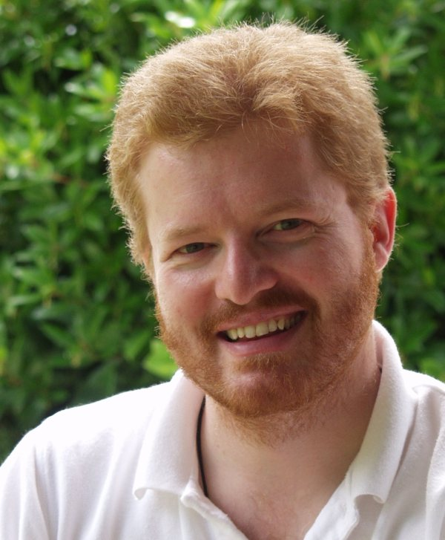Kraig Brockschmidt has worked with Microsoft since 1988, focusing primarily on helping developers through writing, education, public speaking, and direct engagement. Kraig is currently a Senior Program Manager in the Windows Ecosystem team working directly with key partners on building apps for Windows 8 and bringing knowledge gained in that experience to the wider developer community. His other books include *Inside OLE* (two editions), *Mystic Microsoft*, *The Harmonium Handbook,* and *Finding Focus.* His website is [www.kraigbrockschmidt.com](http://www.kraigbrockschmidt.com).