# 801063

# PSEUDOSPIN HAMILTONIAN TENSORS

|  |  |  |
| --- | --- | --- |
| g_x | g_y | g_z |
| 0.0053144092219 | 0.00721203917857 | 19.4155573818947 |
| 0.11259253016551 | 0.195148948805 | 15.75673876504341 |
| 0.83950997073714 | 1.17314980583586 | 12.57946866533274 |
| 3.6160720502804 | 4.84522868016503 | 8.85769983321889 |
| 3.69641021200688 | 3.81666768044428 | 11.17873918288857 |
| 0.7011392607966 | 1.04743310356265 | 18.14204098026023 |
| 0.01553348538964 | 0.08732625331102 | 18.60178057010413 |
| 0.00691755364634 | 0.01389558983587 | 19.51730889098264 |

# AB INITIO BLOCKING BARRIER

|  |  |  |  |
| --- | --- | --- | --- |
| KD | l+, muB | l-, muB | E, cm-1 |
| 1.0 | -9.7077787 | 9.7077787 | 0.0 |
| 2.0 | -7.4528232 | 7.4528232 | 124.5245516 |
| 3.0 | -6.1648494 | 6.1648494 | 190.6090469 |
| 4.0 | -4.3657723 | 4.3657723 | 238.6856689 |
| 5.0 | -2.1113693 | 2.1113693 | 279.1291479 |
| 6.0 | -2.7333274 | 2.7333274 | 328.906469 |
| 7.0 | -0.102922 | 0.102922 | 411.8996188 |
| 8.0 | -5.8931698 | 5.8931698 | 512.9721209 |

# QTM, ORBACH, MATRIX ELEMENTS

|  |  |  |  |  |  |  |  |
| --- | --- | --- | --- | --- | --- | --- | --- |
| 0 | 1 | 2 | 3 | 4 | 5 | 6 | 7 |
| 0.00208774139862 | 0.0119408268476 | 0.034277709171 | 0.0521598603085 | 0.0542813482584 | 0.049717754258 | 0.0221634514241 | 0.00364415803514 |
| 0.0 | 0.0545016595292 | 0.13619954325 | 0.301256188112 | 0.200687085068 | 0.130660925073 | 0.122714409007 | 0.0268537850209 |
| 0.0 | 0.0 | 0.341871818456 | 0.557921406687 | 0.81653916695 | 0.331690979794 | 0.232778755338 | 0.0816534237426 |
| 0.0 | 0.0 | 0.0 | 1.42858793106 | 1.21789226232 | 0.725621822821 | 0.458706550704 | 0.198308385956 |
| 0.0 | 0.0 | 0.0 | 0.0 | 2.45451498896 | 1.15238138578 | 0.884211101367 | 0.143515213576 |
| 0.0 | 0.0 | 0.0 | 0.0 | 0.0 | 0.571897677207 | 0.290256757606 | 0.394188560875 |
| 0.0 | 0.0 | 0.0 | 0.0 | 0.0 | 0.0 | 0.446480021472 | 0.0863729305685 |
| 0.0 | 0.0 | 0.0 | 0.0 | 0.0 | 0.0 | 0.0 | 0.00428626616482 |

# DIRECT MATRIX ELEMENTS

|  |  |  |  |  |  |  |  |
| --- | --- | --- | --- | --- | --- | --- | --- |
| 0 | 1 | 2 | 3 | 4 | 5 | 6 | 7 |
| 3.23592623032 | 2.0159677894 | 0.683695237969 | 0.302128276725 | 0.24915821466 | 0.115444028361 | 0.171282174283 | 0.395332733856 |
| 0.0 | 3.64445517387 | 2.82022816549 | 0.737077005782 | 0.51835989688 | 0.186454308542 | 0.305256660857 | 0.691063283082 |
| 0.0 | 0.0 | 2.63771637116 | 3.02594497611 | 0.68952773377 | 0.498907330103 | 0.405989184032 | 0.874956259409 |
| 0.0 | 0.0 | 0.0 | 1.71304869402 | 3.0049756165 | 1.08486086303 | 0.648148919684 | 0.916257276257 |
| 0.0 | 0.0 | 0.0 | 0.0 | 1.82341371709 | 1.8782160582 | 1.45620592078 | 0.760290629073 |
| 0.0 | 0.0 | 0.0 | 0.0 | 0.0 | 4.3421729442 | 0.968429274195 | 0.225826358176 |
| 0.0 | 0.0 | 0.0 | 0.0 | 0.0 | 0.0 | 3.64359846326 | 1.57720982182 |
| 0.0 | 0.0 | 0.0 | 0.0 | 0.0 | 0.0 | 0.0 | 5.57640834722 |

# Diagram

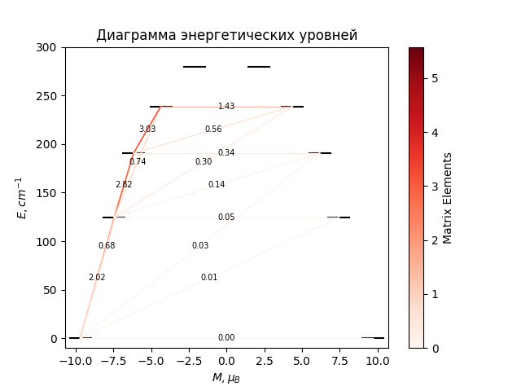

# CF_parameters

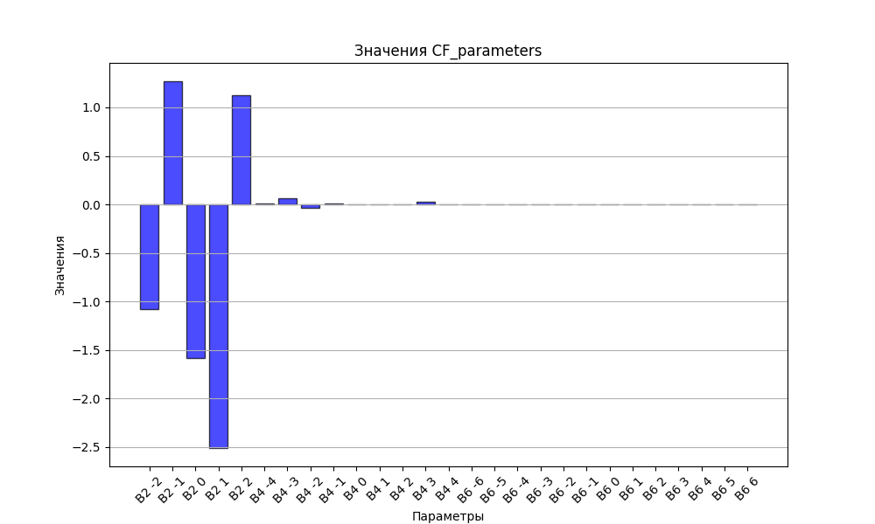

# CHI * T

|  |  |
| --- | --- |
| T | CHI * T |
| 1.0 | 4.561679 |
| 2.0 | 7.6602277 |
| 3.0 | 9.3710969 |
| 4.0 | 10.291602 |
| 5.0 | 10.8203044 |
| 6.0 | 11.1491462 |
| 7.0 | 11.3691519 |
| 8.0 | 11.5259073 |
| 9.0 | 11.6437589 |
| 10.0 | 11.7365067 |
| 11.0 | 11.8123893 |
| 12.0 | 11.8765484 |
| 13.0 | 11.9323178 |
| 14.0 | 11.9819302 |
| 15.0 | 12.026923 |
| 16.0 | 12.0683805 |
| 17.0 | 12.1070827 |
| 18.0 | 12.1436004 |
| 19.0 | 12.178357 |
| 20.0 | 12.2116706 |
| 21.0 | 12.2437821 |
| 22.0 | 12.2748754 |
| 23.0 | 12.3050922 |
| 24.0 | 12.3345415 |
| 25.0 | 12.3633084 |
| 26.0 | 12.3914588 |
| 27.0 | 12.4190444 |
| 28.0 | 12.4461058 |
| 29.0 | 12.472675 |
| 30.0 | 12.4987774 |
| 31.0 | 12.5244333 |
| 32.0 | 12.549659 |
| 33.0 | 12.5744676 |
| 34.0 | 12.5988701 |
| 35.0 | 12.6228757 |
| 36.0 | 12.6464921 |
| 37.0 | 12.669726 |
| 38.0 | 12.6925833 |
| 39.0 | 12.7150696 |
| 40.0 | 12.7371897 |
| 41.0 | 12.7589485 |
| 42.0 | 12.7803502 |
| 43.0 | 12.8013994 |
| 44.0 | 12.8221003 |
| 45.0 | 12.8424572 |
| 46.0 | 12.8624741 |
| 47.0 | 12.8821555 |
| 48.0 | 12.9015054 |
| 49.0 | 12.9205281 |
| 50.0 | 12.939228 |
| 51.0 | 12.9576093 |
| 52.0 | 12.9756763 |
| 53.0 | 12.9934334 |
| 54.0 | 13.0108851 |
| 55.0 | 13.0280356 |
| 56.0 | 13.0448894 |
| 57.0 | 13.061451 |
| 58.0 | 13.0777248 |
| 59.0 | 13.0937152 |
| 60.0 | 13.1094266 |
| 61.0 | 13.1248635 |
| 62.0 | 13.1400304 |
| 63.0 | 13.1549315 |
| 64.0 | 13.1695713 |
| 65.0 | 13.1839542 |
| 66.0 | 13.1980844 |
| 67.0 | 13.2119663 |
| 68.0 | 13.2256042 |
| 69.0 | 13.2390023 |
| 70.0 | 13.2521647 |
| 71.0 | 13.2650957 |
| 72.0 | 13.2777994 |
| 73.0 | 13.2902798 |
| 74.0 | 13.302541 |
| 75.0 | 13.3145869 |
| 76.0 | 13.3264215 |
| 77.0 | 13.3380487 |
| 78.0 | 13.3494723 |
| 79.0 | 13.360696 |
| 80.0 | 13.3717236 |
| 81.0 | 13.3825588 |
| 82.0 | 13.3932051 |
| 83.0 | 13.4036662 |
| 84.0 | 13.4139456 |
| 85.0 | 13.4240466 |
| 86.0 | 13.4339728 |
| 87.0 | 13.4437274 |
| 88.0 | 13.4533137 |
| 89.0 | 13.462735 |
| 90.0 | 13.4719944 |
| 91.0 | 13.4810951 |
| 92.0 | 13.4900401 |
| 93.0 | 13.4988325 |
| 94.0 | 13.5074751 |
| 95.0 | 13.515971 |
| 96.0 | 13.5243229 |
| 97.0 | 13.5325336 |
| 98.0 | 13.5406059 |
| 99.0 | 13.5485426 |
| 100.0 | 13.5563461 |
| 101.0 | 13.5640191 |
| 102.0 | 13.5715642 |
| 103.0 | 13.5789839 |
| 104.0 | 13.5862805 |
| 105.0 | 13.5934565 |
| 106.0 | 13.6005143 |
| 107.0 | 13.6074561 |
| 108.0 | 13.6142841 |
| 109.0 | 13.6210007 |
| 110.0 | 13.6276079 |
| 111.0 | 13.6341079 |
| 112.0 | 13.6405027 |
| 113.0 | 13.6467945 |
| 114.0 | 13.6529851 |
| 115.0 | 13.6590765 |
| 116.0 | 13.6650708 |
| 117.0 | 13.6709696 |
| 118.0 | 13.6767749 |
| 119.0 | 13.6824884 |
| 120.0 | 13.688112 |
| 121.0 | 13.6936473 |
| 122.0 | 13.699096 |
| 123.0 | 13.7044598 |
| 124.0 | 13.7097403 |
| 125.0 | 13.714939 |
| 126.0 | 13.7200576 |
| 127.0 | 13.7250975 |
| 128.0 | 13.7300603 |
| 129.0 | 13.7349473 |
| 130.0 | 13.7397601 |
| 131.0 | 13.7444999 |
| 132.0 | 13.7491682 |
| 133.0 | 13.7537664 |
| 134.0 | 13.7582956 |
| 135.0 | 13.7627573 |
| 136.0 | 13.7671526 |
| 137.0 | 13.7714827 |
| 138.0 | 13.775749 |
| 139.0 | 13.7799525 |
| 140.0 | 13.7840945 |
| 141.0 | 13.788176 |
| 142.0 | 13.7921981 |
| 143.0 | 13.796162 |
| 144.0 | 13.8000686 |
| 145.0 | 13.8039191 |
| 146.0 | 13.8077145 |
| 147.0 | 13.8114557 |
| 148.0 | 13.8151437 |
| 149.0 | 13.8187795 |
| 150.0 | 13.822364 |
| 151.0 | 13.8258982 |
| 152.0 | 13.8293829 |
| 153.0 | 13.8328189 |
| 154.0 | 13.8362073 |
| 155.0 | 13.8395487 |
| 156.0 | 13.8428441 |
| 157.0 | 13.8460942 |
| 158.0 | 13.8492999 |
| 159.0 | 13.8524619 |
| 160.0 | 13.8555809 |
| 161.0 | 13.8586578 |
| 162.0 | 13.8616933 |
| 163.0 | 13.864688 |
| 164.0 | 13.8676426 |
| 165.0 | 13.870558 |
| 166.0 | 13.8734346 |
| 167.0 | 13.8762733 |
| 168.0 | 13.8790746 |
| 169.0 | 13.8818391 |
| 170.0 | 13.8845676 |
| 171.0 | 13.8872605 |
| 172.0 | 13.8899186 |
| 173.0 | 13.8925423 |
| 174.0 | 13.8951323 |
| 175.0 | 13.8976892 |
| 176.0 | 13.9002134 |
| 177.0 | 13.9027055 |
| 178.0 | 13.9051661 |
| 179.0 | 13.9075956 |
| 180.0 | 13.9099946 |
| 181.0 | 13.9123636 |
| 182.0 | 13.914703 |
| 183.0 | 13.9170134 |
| 184.0 | 13.9192953 |
| 185.0 | 13.921549 |
| 186.0 | 13.923775 |
| 187.0 | 13.9259738 |
| 188.0 | 13.9281459 |
| 189.0 | 13.9302915 |
| 190.0 | 13.9324113 |
| 191.0 | 13.9345055 |
| 192.0 | 13.9365747 |
| 193.0 | 13.9386191 |
| 194.0 | 13.9406391 |
| 195.0 | 13.9426353 |
| 196.0 | 13.9446078 |
| 197.0 | 13.9465572 |
| 198.0 | 13.9484837 |
| 199.0 | 13.9503877 |
| 200.0 | 13.9522696 |
| 201.0 | 13.9541297 |
| 202.0 | 13.9559683 |
| 203.0 | 13.9577858 |
| 204.0 | 13.9595825 |
| 205.0 | 13.9613587 |
| 206.0 | 13.9631148 |
| 207.0 | 13.9648509 |
| 208.0 | 13.9665675 |
| 209.0 | 13.9682648 |
| 210.0 | 13.9699431 |
| 211.0 | 13.9716027 |
| 212.0 | 13.9732439 |
| 213.0 | 13.974867 |
| 214.0 | 13.9764722 |
| 215.0 | 13.9780597 |
| 216.0 | 13.9796299 |
| 217.0 | 13.9811831 |
| 218.0 | 13.9827193 |
| 219.0 | 13.984239 |
| 220.0 | 13.9857423 |
| 221.0 | 13.9872295 |
| 222.0 | 13.9887008 |
| 223.0 | 13.9901565 |
| 224.0 | 13.9915967 |
| 225.0 | 13.9930217 |
| 226.0 | 13.9944317 |
| 227.0 | 13.995827 |
| 228.0 | 13.9972077 |
| 229.0 | 13.998574 |
| 230.0 | 13.9999262 |
| 231.0 | 14.0012645 |
| 232.0 | 14.002589 |
| 233.0 | 14.0038999 |
| 234.0 | 14.0051974 |
| 235.0 | 14.0064818 |
| 236.0 | 14.0077532 |
| 237.0 | 14.0090118 |
| 238.0 | 14.0102577 |
| 239.0 | 14.0114911 |
| 240.0 | 14.0127123 |
| 241.0 | 14.0139213 |
| 242.0 | 14.0151184 |
| 243.0 | 14.0163037 |
| 244.0 | 14.0174773 |
| 245.0 | 14.0186395 |
| 246.0 | 14.0197903 |
| 247.0 | 14.02093 |
| 248.0 | 14.0220587 |
| 249.0 | 14.0231765 |
| 250.0 | 14.0242835 |
| 251.0 | 14.02538 |
| 252.0 | 14.0264661 |
| 253.0 | 14.0275418 |
| 254.0 | 14.0286074 |
| 255.0 | 14.029663 |
| 256.0 | 14.0307087 |
| 257.0 | 14.0317446 |
| 258.0 | 14.0327709 |
| 259.0 | 14.0337876 |
| 260.0 | 14.034795 |
| 261.0 | 14.0357931 |
| 262.0 | 14.0367821 |
| 263.0 | 14.037762 |
| 264.0 | 14.038733 |
| 265.0 | 14.0396953 |
| 266.0 | 14.0406488 |
| 267.0 | 14.0415938 |
| 268.0 | 14.0425303 |
| 269.0 | 14.0434585 |
| 270.0 | 14.0443784 |
| 271.0 | 14.0452902 |
| 272.0 | 14.0461939 |
| 273.0 | 14.0470897 |
| 274.0 | 14.0479777 |
| 275.0 | 14.0488579 |
| 276.0 | 14.0497305 |
| 277.0 | 14.0505955 |
| 278.0 | 14.0514531 |
| 279.0 | 14.0523033 |
| 280.0 | 14.0531462 |
| 281.0 | 14.053982 |
| 282.0 | 14.0548106 |
| 283.0 | 14.0556323 |
| 284.0 | 14.056447 |
| 285.0 | 14.0572549 |
| 286.0 | 14.0580561 |
| 287.0 | 14.0588505 |

# H_B_df

|  |  |  |  |
| --- | --- | --- | --- |
| H(T) | B(T_1) | B(T_2) | B(T_3) |
| 0.0001 | 0.0010595651 | 0.000532041 | 0.0003561997 |

# WAVE FUNCTIONS

|  |  |  |  |  |  |  |  |  |
| --- | --- | --- | --- | --- | --- | --- | --- | --- |
| Label | +-15/2> | +-13/2> | +-11/2> | +-9/2> | +-7/2> | +-5/2> | +-3/2> | +-1/2> |
| KD1 | 90 | 0 | 8 | 1 | 0 | 0 | 0 | 0 |
| KD2 | 1 | 62 | 4 | 23 | 4 | 4 | 2 | 0 |
| KD3 | 4 | 14 | 39 | 6 | 24 | 4 | 7 | 2 |
| KD4 | 1 | 4 | 17 | 27 | 10 | 20 | 4 | 16 |
| KD5 | 0 | 3 | 1 | 10 | 26 | 17 | 26 | 16 |
| KD6 | 0 | 0 | 3 | 5 | 15 | 35 | 28 | 15 |
| KD7 | 0 | 2 | 3 | 4 | 4 | 10 | 29 | 48 |
| KD8 | 3 | 14 | 25 | 24 | 17 | 10 | 5 | 2 |