# 806774.log

# PSEUDOSPIN HAMILTONIAN TENSORS

|  |  |  |  |
| --- | --- | --- | --- |
| KD | g_x | g_y | g_z |
| 1.0 | 0.0064069376321 | 0.01859687823972 | 19.29947055259497 |
| 2.0 | 0.38952149079277 | 0.50196591161672 | 15.72544075350537 |
| 3.0 | 2.67218255387661 | 4.25850609041781 | 11.60046051156936 |
| 4.0 | 7.8570293675869 | 5.75789262072859 | 2.5883904484122 |
| 5.0 | 0.22140443782697 | 3.12801050246995 | 10.56830356385965 |
| 6.0 | 1.00617945025662 | 2.9967258031265 | 16.54834019593892 |
| 7.0 | 0.01268635989472 | 0.02784490741496 | 19.49849402715207 |
| 8.0 | 0.00184575138667 | 0.00592241784997 | 19.86993973412827 |

# AB INITIO BLOCKING BARRIER

|  |  |  |  |
| --- | --- | --- | --- |
| KD | l+, muB | l-, muB | E, cm-1 |
| 1.0 | -9.6497353 | 9.6497353 | 0.0 |
| 2.0 | -7.8030651 | 7.8030651 | 116.1153615 |
| 3.0 | -5.3387441 | 5.3387441 | 177.8400125 |
| 4.0 | -2.8669349 | 2.8669349 | 212.9962337 |
| 5.0 | -2.1316301 | 2.1316301 | 254.1996374 |
| 6.0 | -2.1477572 | 2.1477572 | 280.6966715 |
| 7.0 | -1.368918 | 1.368918 | 387.6587372 |
| 8.0 | -6.1889173 | 6.1889173 | 537.4852827 |

# QTM, ORBACH, MTRIX ELEMENTS

|  |  |  |  |  |  |  |  |
| --- | --- | --- | --- | --- | --- | --- | --- |
| 1+ | 2+ | 3+ | 4+ | 5+ | 6+ | 7+ | 8+ |
| 0.00416730264521 | 0.0283757831359 | 0.155257187324 | 0.158981607681 | 0.101226905266 | 0.0951712254733 | 0.10786616098 | 0.00668830376733 |
| 0.0 | 0.149310411872 | 0.370795051763 | 0.584427249955 | 0.241283995726 | 0.234626203654 | 0.181270413483 | 0.0146689950962 |
| 0.0 | 0.0 | 1.21007097134 | 1.4554317225 | 0.717954470489 | 0.279691711526 | 0.231387728353 | 0.21564101102 |
| 0.0 | 0.0 | 0.0 | 1.94587068356 | 1.62485324949 | 0.835754036622 | 0.400149785824 | 0.370084156376 |
| 0.0 | 0.0 | 0.0 | 0.0 | 1.77220588253 | 1.41482487336 | 1.35531665106 | 0.169525218992 |
| 0.0 | 0.0 | 0.0 | 0.0 | 0.0 | 1.19224652192 | 0.884424079612 | 0.449967664949 |
| 0.0 | 0.0 | 0.0 | 0.0 | 0.0 | 0.0 | 0.0267076479707 | 0.897319388699 |
| 0.0 | 0.0 | 0.0 | 0.0 | 0.0 | 0.0 | 0.0 | 0.00168409242715 |

# DIRECT MTRIX ELEMENTS

|  |  |  |  |  |  |  |  |
| --- | --- | --- | --- | --- | --- | --- | --- |
| 0 | 1 | 2 | 3 | 4 | 5 | 6 | 7 |
| 3.21657842543 | 2.02305702311 | 0.475846882246 | 0.459649652117 | 0.3229313018 | 0.136268638348 | 0.0868222571182 | 0.360431231168 |
| 0.0 | 3.04191359488 | 2.47814305576 | 0.846389121614 | 0.892255003349 | 0.310454410117 | 0.238912033178 | 0.594889983411 |
| 0.0 | 0.0 | 2.75264294356 | 2.90851978315 | 0.898010544979 | 0.807529748461 | 0.488466157836 | 0.661579166318 |
| 0.0 | 0.0 | 0.0 | 1.08248281075 | 2.80736577089 | 1.02511399525 | 0.550609140645 | 0.90813014197 |
| 0.0 | 0.0 | 0.0 | 0.0 | 2.21627958518 | 2.41926098941 | 0.685639643722 | 1.11394769086 |
| 0.0 | 0.0 | 0.0 | 0.0 | 0.0 | 3.42592300804 | 0.36881480839 | 0.477178949892 |
| 0.0 | 0.0 | 0.0 | 0.0 | 0.0 | 0.0 | 4.47234150216 | 0.0173722508636 |
| 0.0 | 0.0 | 0.0 | 0.0 | 0.0 | 0.0 | 0.0 | 5.5070074948 |

# Energy_diagram

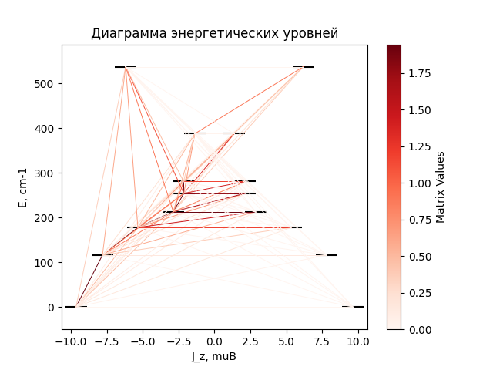

# CF_parameters

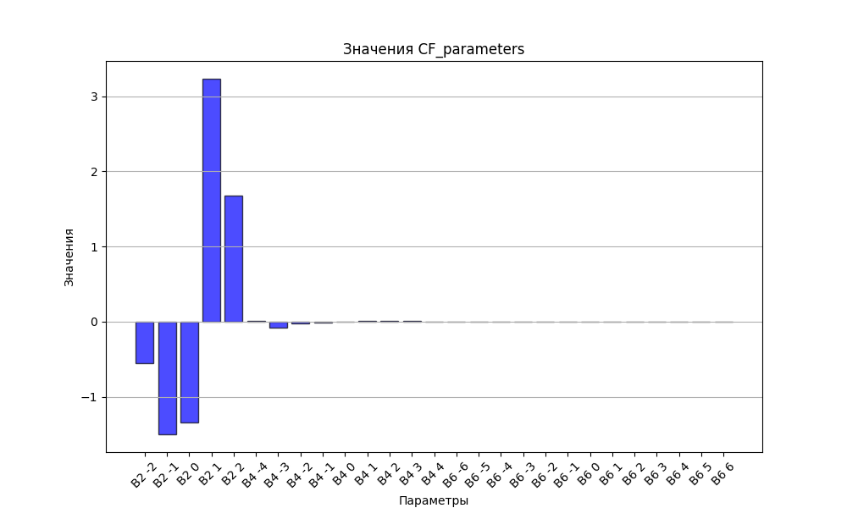

# CHI * T

|  |  |
| --- | --- |
| T | CHI * T |
| 1.0 | 4.4439629 |
| 2.0 | 7.4123581 |
| 3.0 | 9.1380991 |
| 4.0 | 10.0881971 |
| 5.0 | 10.6406139 |
| 6.0 | 10.9869893 |
| 7.0 | 11.2202099 |
| 8.0 | 11.3873342 |
| 9.0 | 11.5136695 |
| 10.0 | 11.6136247 |
| 11.0 | 11.695828 |
| 12.0 | 11.7656762 |
| 13.0 | 11.8266731 |
| 14.0 | 11.8811672 |
| 15.0 | 11.9307758 |
| 16.0 | 11.9766388 |
| 17.0 | 12.0195747 |
| 18.0 | 12.0601812 |
| 19.0 | 12.0989003 |
| 20.0 | 12.1360623 |
| 21.0 | 12.1719166 |
| 22.0 | 12.2066526 |
| 23.0 | 12.2404152 |
| 24.0 | 12.2733157 |
| 25.0 | 12.3054402 |
| 26.0 | 12.3368558 |
| 27.0 | 12.3676148 |
| 28.0 | 12.3977583 |
| 29.0 | 12.427319 |
| 30.0 | 12.4563232 |
| 31.0 | 12.484792 |
| 32.0 | 12.5127429 |
| 33.0 | 12.5401905 |
| 34.0 | 12.5671471 |
| 35.0 | 12.5936237 |
| 36.0 | 12.6196297 |
| 37.0 | 12.6451738 |
| 38.0 | 12.6702638 |
| 39.0 | 12.6949072 |
| 40.0 | 12.7191111 |
| 41.0 | 12.7428823 |
| 42.0 | 12.7662272 |
| 43.0 | 12.7891523 |
| 44.0 | 12.8116638 |
| 45.0 | 12.8337681 |
| 46.0 | 12.8554712 |
| 47.0 | 12.8767792 |
| 48.0 | 12.8976982 |
| 49.0 | 12.9182341 |
| 50.0 | 12.938393 |
| 51.0 | 12.9581806 |
| 52.0 | 12.977603 |
| 53.0 | 12.996666 |
| 54.0 | 13.0153753 |
| 55.0 | 13.0337367 |
| 56.0 | 13.0517559 |
| 57.0 | 13.0694387 |
| 58.0 | 13.0867906 |
| 59.0 | 13.1038172 |
| 60.0 | 13.1205241 |
| 61.0 | 13.1369167 |
| 62.0 | 13.1530006 |
| 63.0 | 13.168781 |
| 64.0 | 13.1842633 |
| 65.0 | 13.1994528 |
| 66.0 | 13.2143547 |
| 67.0 | 13.2289743 |
| 68.0 | 13.2433166 |
| 69.0 | 13.2573866 |
| 70.0 | 13.2711895 |
| 71.0 | 13.2847302 |
| 72.0 | 13.2980135 |
| 73.0 | 13.3110444 |
| 74.0 | 13.3238275 |
| 75.0 | 13.3363676 |
| 76.0 | 13.3486694 |
| 77.0 | 13.3607375 |
| 78.0 | 13.3725765 |
| 79.0 | 13.3841907 |
| 80.0 | 13.3955847 |
| 81.0 | 13.4067627 |
| 82.0 | 13.4177291 |
| 83.0 | 13.4284881 |
| 84.0 | 13.4390439 |
| 85.0 | 13.4494005 |
| 86.0 | 13.4595621 |
| 87.0 | 13.4695325 |
| 88.0 | 13.4793157 |
| 89.0 | 13.4889156 |
| 90.0 | 13.4983358 |
| 91.0 | 13.5075802 |
| 92.0 | 13.5166523 |
| 93.0 | 13.5255558 |
| 94.0 | 13.5342942 |
| 95.0 | 13.5428708 |
| 96.0 | 13.5512892 |
| 97.0 | 13.5595527 |
| 98.0 | 13.5676644 |
| 99.0 | 13.5756276 |
| 100.0 | 13.5834455 |
| 101.0 | 13.5911211 |
| 102.0 | 13.5986574 |
| 103.0 | 13.6060574 |
| 104.0 | 13.613324 |
| 105.0 | 13.62046 |
| 106.0 | 13.6274682 |
| 107.0 | 13.6343513 |
| 108.0 | 13.641112 |
| 109.0 | 13.6477528 |
| 110.0 | 13.6542764 |
| 111.0 | 13.6606852 |
| 112.0 | 13.6669817 |
| 113.0 | 13.6731682 |
| 114.0 | 13.6792471 |
| 115.0 | 13.6852207 |
| 116.0 | 13.6910912 |
| 117.0 | 13.6968607 |
| 118.0 | 13.7025315 |
| 119.0 | 13.7081056 |
| 120.0 | 13.7135851 |
| 121.0 | 13.7189719 |
| 122.0 | 13.724268 |
| 123.0 | 13.7294753 |
| 124.0 | 13.7345957 |
| 125.0 | 13.7396309 |
| 126.0 | 13.7445828 |
| 127.0 | 13.7494531 |
| 128.0 | 13.7542436 |
| 129.0 | 13.7589557 |
| 130.0 | 13.7635913 |
| 131.0 | 13.7681518 |
| 132.0 | 13.7726388 |
| 133.0 | 13.7770538 |
| 134.0 | 13.7813984 |
| 135.0 | 13.7856738 |
| 136.0 | 13.7898817 |
| 137.0 | 13.7940232 |
| 138.0 | 13.7980998 |
| 139.0 | 13.8021128 |
| 140.0 | 13.8060634 |
| 141.0 | 13.809953 |
| 142.0 | 13.8137827 |
| 143.0 | 13.8175537 |
| 144.0 | 13.8212673 |
| 145.0 | 13.8249245 |
| 146.0 | 13.8285265 |
| 147.0 | 13.8320743 |
| 148.0 | 13.835569 |
| 149.0 | 13.8390117 |
| 150.0 | 13.8424034 |
| 151.0 | 13.845745 |
| 152.0 | 13.8490376 |
| 153.0 | 13.8522821 |
| 154.0 | 13.8554794 |
| 155.0 | 13.8586304 |
| 156.0 | 13.861736 |
| 157.0 | 13.8647971 |
| 158.0 | 13.8678146 |
| 159.0 | 13.8707891 |
| 160.0 | 13.8737217 |
| 161.0 | 13.8766129 |
| 162.0 | 13.8794637 |
| 163.0 | 13.8822748 |
| 164.0 | 13.8850469 |
| 165.0 | 13.8877807 |
| 166.0 | 13.890477 |
| 167.0 | 13.8931364 |
| 168.0 | 13.8957596 |
| 169.0 | 13.8983472 |
| 170.0 | 13.9009 |
| 171.0 | 13.9034186 |
| 172.0 | 13.9059035 |
| 173.0 | 13.9083554 |
| 174.0 | 13.9107748 |
| 175.0 | 13.9131624 |
| 176.0 | 13.9155187 |
| 177.0 | 13.9178442 |
| 178.0 | 13.9201396 |
| 179.0 | 13.9224052 |
| 180.0 | 13.9246418 |
| 181.0 | 13.9268497 |
| 182.0 | 13.9290295 |
| 183.0 | 13.9311816 |
| 184.0 | 13.9333065 |
| 185.0 | 13.9354047 |
| 186.0 | 13.9374767 |
| 187.0 | 13.9395229 |
| 188.0 | 13.9415437 |
| 189.0 | 13.9435396 |
| 190.0 | 13.945511 |
| 191.0 | 13.9474583 |
| 192.0 | 13.9493818 |
| 193.0 | 13.9512821 |
| 194.0 | 13.9531594 |
| 195.0 | 13.9550142 |
| 196.0 | 13.9568469 |
| 197.0 | 13.9586577 |
| 198.0 | 13.9604471 |
| 199.0 | 13.9622154 |
| 200.0 | 13.963963 |
| 201.0 | 13.9656901 |
| 202.0 | 13.9673972 |
| 203.0 | 13.9690845 |
| 204.0 | 13.9707523 |
| 205.0 | 13.972401 |
| 206.0 | 13.9740309 |
| 207.0 | 13.9756422 |
| 208.0 | 13.9772353 |
| 209.0 | 13.9788104 |
| 210.0 | 13.9803679 |
| 211.0 | 13.9819079 |
| 212.0 | 13.9834309 |
| 213.0 | 13.9849369 |
| 214.0 | 13.9864264 |
| 215.0 | 13.9878995 |
| 216.0 | 13.9893565 |
| 217.0 | 13.9907977 |
| 218.0 | 13.9922232 |
| 219.0 | 13.9936334 |
| 220.0 | 13.9950284 |
| 221.0 | 13.9964085 |
| 222.0 | 13.997774 |
| 223.0 | 13.9991249 |
| 224.0 | 14.0004616 |
| 225.0 | 14.0017843 |
| 226.0 | 14.0030931 |
| 227.0 | 14.0043883 |
| 228.0 | 14.00567 |
| 229.0 | 14.0069386 |
| 230.0 | 14.008194 |
| 231.0 | 14.0094367 |
| 232.0 | 14.0106666 |
| 233.0 | 14.0118841 |
| 234.0 | 14.0130893 |
| 235.0 | 14.0142823 |
| 236.0 | 14.0154634 |
| 237.0 | 14.0166327 |
| 238.0 | 14.0177904 |
| 239.0 | 14.0189366 |
| 240.0 | 14.0200715 |
| 241.0 | 14.0211953 |
| 242.0 | 14.0223082 |
| 243.0 | 14.0234102 |
| 244.0 | 14.0245015 |
| 245.0 | 14.0255823 |
| 246.0 | 14.0266527 |
| 247.0 | 14.0277129 |
| 248.0 | 14.028763 |
| 249.0 | 14.0298031 |
| 250.0 | 14.0308334 |
| 251.0 | 14.031854 |
| 252.0 | 14.0328651 |
| 253.0 | 14.0338667 |
| 254.0 | 14.034859 |
| 255.0 | 14.0358422 |
| 256.0 | 14.0368163 |
| 257.0 | 14.0377814 |
| 258.0 | 14.0387378 |
| 259.0 | 14.0396854 |
| 260.0 | 14.0406245 |
| 261.0 | 14.0415551 |
| 262.0 | 14.0424773 |
| 263.0 | 14.0433913 |
| 264.0 | 14.0442971 |
| 265.0 | 14.0451949 |
| 266.0 | 14.0460848 |
| 267.0 | 14.0469668 |
| 268.0 | 14.0478411 |
| 269.0 | 14.0487078 |
| 270.0 | 14.049567 |
| 271.0 | 14.0504187 |
| 272.0 | 14.051263 |
| 273.0 | 14.0521001 |
| 274.0 | 14.0529301 |
| 275.0 | 14.053753 |
| 276.0 | 14.0545689 |
| 277.0 | 14.0553779 |
| 278.0 | 14.0561802 |
| 279.0 | 14.0569756 |
| 280.0 | 14.0577645 |
| 281.0 | 14.0585468 |
| 282.0 | 14.0593226 |
| 283.0 | 14.0600921 |
| 284.0 | 14.0608552 |
| 285.0 | 14.0616121 |
| 286.0 | 14.0623628 |
| 287.0 | 14.0631074 |

# H_B_df

|  |  |  |  |
| --- | --- | --- | --- |
| H(T) | B(T_1) | B(T_2) | B(T_3) |
| 0.0001 | 0.0010476118 | 0.0005263767 | 0.0003526316 |
| 0.1 | 1.0263479406 | 0.5236592611 | 0.3518229914 |
| 0.2 | 1.9386111199 | 1.0314873707 | 0.6988579495 |
| 0.3 | 2.6749765169 | 1.5098566999 | 1.0366254177 |
| 0.4 | 3.2320804646 | 1.9488784365 | 1.3612183631 |
| 0.5 | 3.6390681183 | 2.342941129 | 1.6694878519 |
| 0.6 | 3.9326779806 | 2.6903526951 | 1.9591353812 |
| 0.7 | 4.1449912885 | 2.9924474241 | 2.2287155898 |
| 0.8 | 4.3002958668 | 3.25254367 | 2.4775672123 |
| 0.9 | 4.4158231852 | 3.475015866 | 2.7056970069 |
| 1.0 | 4.5034561561 | 3.6645965485 | 2.9136414463 |
| 1.1 | 4.5713150785 | 3.8259180094 | 3.1023264716 |
| 1.2 | 4.624958567 | 3.9632508749 | 3.2729392207 |
| 1.3 | 4.668222106 | 4.0803831254 | 3.4268193929 |
| 1.4 | 4.7037830541 | 4.1805889822 | 3.5653729314 |
| 1.5 | 4.7335359544 | 4.2666495635 | 3.6900073449 |
| 1.6 | 4.758841151 | 4.3408995388 | 3.8020860884 |
| 1.7 | 4.780690116 | 4.40528375 | 3.9028986282 |
| 1.8 | 4.7998162518 | 4.461414588 | 3.9936427395 |
| 1.9 | 4.8167699179 | 4.5106253402 | 4.0754159102 |
| 2.0 | 4.8319698295 | 4.5540174124 | 4.1492132253 |
| 2.1 | 4.8457387151 | 4.592500869 | 4.2159296412 |
| 2.2 | 4.8583283728 | 4.6268285484 | 4.2763650585 |
| 2.3 | 4.8699375084 | 4.657624393 | 4.3312310197 |
| 2.4 | 4.8807245963 | 4.6854067683 | 4.3811582006 |
| 2.5 | 4.8908172697 | 4.7106075468 | 4.4267041231 |
| 2.6 | 4.9003192578 | 4.7335876703 | 4.4683607163 |
| 2.7 | 4.9093155718 | 4.754649817 | 4.5065614912 |
| 2.8 | 4.9178764238 | 4.7740487036 | 4.5416881987 |
| 2.9 | 4.9260602188 | 4.7919994674 | 4.5740769074 |
| 3.0 | 4.9339158625 | 4.8086844908 | 4.6040234857 |
| 3.1 | 4.9414845581 | 4.8242589679 | 4.6317885009 |
| 3.2 | 4.948801216 | 4.8388554518 | 4.6576015678 |
| 3.3 | 4.9558955716 | 4.8525875802 | 4.6816651879 |
| 3.4 | 4.9627930762 | 4.8655531329 | 4.7041581251 |
| 3.5 | 4.9695156136 | 4.87783655 | 4.7252383652 |
| 3.6 | 4.9760820807 | 4.8895110112 | 4.7450457036 |
| 3.7 | 4.9825088594 | 4.9006401572 | 4.7637040061 |
| 3.8 | 4.9888102048 | 4.911279521 | 4.7813231795 |
| 3.9 | 4.9949985643 | 4.92147772 | 4.7980008901 |
| 4.0 | 5.0010848429 | 4.931277453 | 4.813824061 |
| 4.1 | 5.0070786237 | 4.940716337 | 4.8288701759 |
| 4.2 | 5.0129883528 | 4.9498276108 | 4.8432084162 |
| 4.3 | 5.0188214953 | 4.9586407293 | 4.8569006518 |
| 4.4 | 5.024584666 | 4.9671818674 | 4.870002305 |
| 4.5 | 5.0302837416 | 4.9754743471 | 4.8825631057 |
| 4.6 | 5.0359239549 | 4.9835390027 | 4.8946277499 |
| 4.7 | 5.0415099767 | 4.9913944922 | 4.9062364764 |
| 4.8 | 5.047045985 | 4.9990575646 | 4.9174255713 |
| 4.9 | 5.0525357248 | 5.0065432901 | 4.9282278102 |
| 5.0 | 5.05798256 | 5.0138652582 | 4.9386728461 |

# WAVE FUNCTIONS

|  |  |  |  |  |  |  |  |  |
| --- | --- | --- | --- | --- | --- | --- | --- | --- |
| Label | +-15/2> | +-13/2> | +-11/2> | +-9/2> | +-7/2> | +-5/2> | +-3/2> | +-1/2> |
| KD1 | 88 | 0 | 11 | 0 | 1 | 0 | 0 | 0 |
| KD2 | 0 | 72 | 5 | 17 | 1 | 4 | 0 | 0 |
| KD3 | 4 | 4 | 36 | 24 | 8 | 6 | 14 | 4 |
| KD4 | 2 | 3 | 10 | 16 | 32 | 7 | 6 | 24 |
| KD5 | 1 | 4 | 5 | 7 | 26 | 28 | 11 | 17 |
| KD6 | 0 | 2 | 2 | 3 | 5 | 32 | 38 | 18 |
| KD7 | 0 | 1 | 3 | 6 | 10 | 17 | 28 | 35 |
| KD8 | 3 | 14 | 27 | 27 | 16 | 8 | 3 | 1 |