# ./logs/DyCl3finil2sq.log

# PSEUDOSPIN HAMILTONIAN TENSORS

|  |  |  |  |
| --- | --- | --- | --- |
| KD | g_x | g_y | g_z |
| 1.0 | 0.05196600943217 | 0.06272307754809 | 19.6430576296533 |
| 2.0 | 1.34658955946944 | 2.255853887193 | 15.09208151893178 |
| 3.0 | 0.6651671032717 | 1.50078745959255 | 18.19293509599284 |
| 4.0 | 1.93105359886981 | 4.73095951755983 | 11.1487900355879 |
| 5.0 | 0.50912223957602 | 1.38882462372751 | 15.72457527998459 |
| 6.0 | 2.09719659644847 | 2.91406617232308 | 14.22516905943104 |
| 7.0 | 0.67176681340225 | 0.95434430358294 | 14.93866608657164 |
| 8.0 | 0.06553283742567 | 0.10279386081826 | 18.31958006516271 |

# AB INITIO BLOCKING BARRIER

|  |  |  |  |
| --- | --- | --- | --- |
| KD | l+, muB | l-, muB | E, cm-1 |
| 1.0 | -9.8215288 | 9.8215288 | 0.0 |
| 2.0 | -7.5370877 | 7.5370877 | 129.6716885 |
| 3.0 | -0.5121755 | 0.5121755 | 175.1342646 |
| 4.0 | -1.0253822 | 1.0253822 | 194.9136511 |
| 5.0 | -3.4537907 | 3.4537907 | 233.941885 |
| 6.0 | -3.091675 | 3.091675 | 251.7721504 |
| 7.0 | -1.1362619 | 1.1362619 | 305.2771831 |
| 8.0 | -1.1578149 | 1.1578149 | 367.140344 |

# QTM, ORBACH, MTRIX ELEMENTS

|  |  |  |  |  |  |  |  |
| --- | --- | --- | --- | --- | --- | --- | --- |
| 1+ | 2+ | 3+ | 4+ | 5+ | 6+ | 7+ | 8+ |
| 0.0191148478299 | 0.0547197601331 | 0.192633806692 | 0.302327990623 | 0.168931170643 | 0.14848619993 | 0.215970403959 | 0.113745901828 |
| 0.0 | 0.617250613304 | 0.581895196013 | 0.949573220351 | 0.426274726731 | 0.416870727198 | 0.490561020376 | 0.22208598048 |
| 0.0 | 0.0 | 2.24160325053 | 1.27226800123 | 0.816958259985 | 0.897062995599 | 0.216590625414 | 0.625958720257 |
| 0.0 | 0.0 | 0.0 | 2.78202726179 | 1.53774459625 | 1.64948286848 | 0.682075502497 | 0.439981289488 |
| 0.0 | 0.0 | 0.0 | 0.0 | 0.601418435931 | 1.31905509545 | 1.59484750705 | 0.14460905675 |
| 0.0 | 0.0 | 0.0 | 0.0 | 0.0 | 1.38640872924 | 0.993045796277 | 0.532857251374 |
| 0.0 | 0.0 | 0.0 | 0.0 | 0.0 | 0.0 | 1.08009823116 | 2.13479499338 |
| 0.0 | 0.0 | 0.0 | 0.0 | 0.0 | 0.0 | 0.0 | 0.17283626986 |

# DIRECT MTRIX ELEMENTS

|  |  |  |  |  |  |  |  |
| --- | --- | --- | --- | --- | --- | --- | --- |
| 0 | 1 | 2 | 3 | 4 | 5 | 6 | 7 |
| 3.27384293828 | 1.8338232394 | 0.102359455988 | 0.285538970589 | 0.213639053444 | 0.228696287113 | 0.291011793537 | 0.162229656367 |
| 0.0 | 2.65497781852 | 1.18791622973 | 1.96121350177 | 1.17887961787 | 0.852950330672 | 0.477709327793 | 0.328250417344 |
| 0.0 | 0.0 | 2.48202526028 | 1.34491817151 | 0.631180775766 | 0.486347719665 | 0.73690273674 | 0.288548490521 |
| 0.0 | 0.0 | 0.0 | 0.832989152173 | 1.58516376593 | 1.99879859464 | 0.663875011795 | 0.383729545474 |
| 0.0 | 0.0 | 0.0 | 0.0 | 3.7919209389 | 1.41513007519 | 0.624558076 | 0.405533440408 |
| 0.0 | 0.0 | 0.0 | 0.0 | 0.0 | 3.63068318415 | 1.92815057496 | 0.421786293221 |
| 0.0 | 0.0 | 0.0 | 0.0 | 0.0 | 0.0 | 3.69700269327 | 0.394528356859 |
| 0.0 | 0.0 | 0.0 | 0.0 | 0.0 | 0.0 | 0.0 | 4.66450777867 |

# Energy_diagram

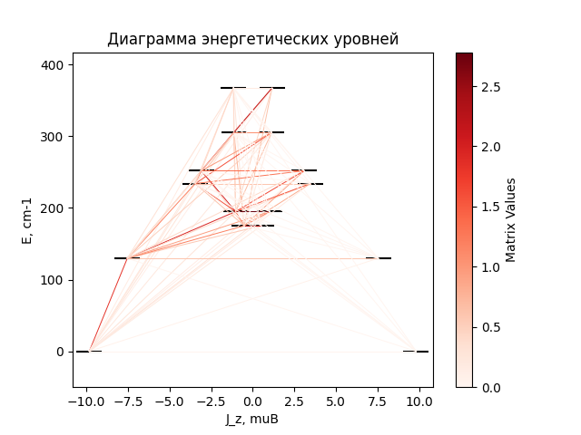

# CF_parameters

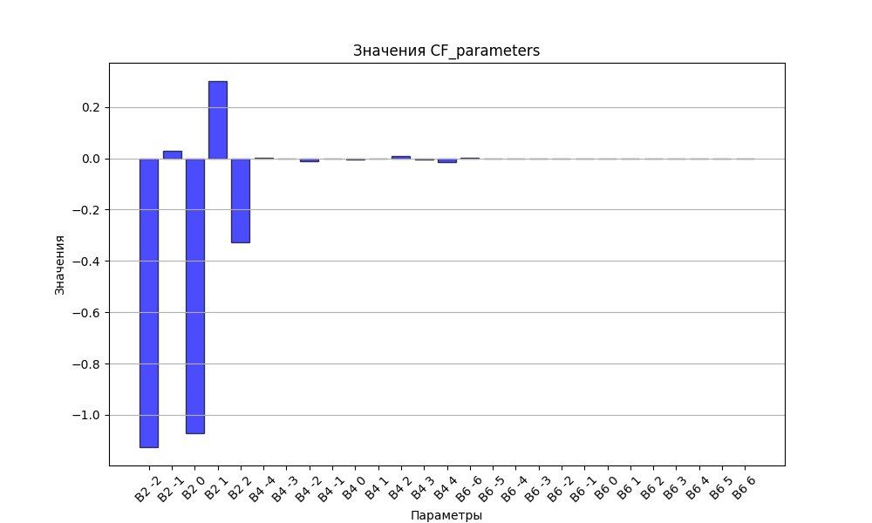

# CHI * T

|  |  |
| --- | --- |
| T | CHI * T |
| 1.0 | 5.1340994 |
| 2.0 | 8.4342704 |
| 3.0 | 10.0433658 |
| 4.0 | 10.8482988 |
| 5.0 | 11.293648 |
| 6.0 | 11.5652969 |
| 7.0 | 11.7452574 |
| 8.0 | 11.8729496 |
| 9.0 | 11.9688974 |
| 10.0 | 12.0445398 |
| 11.0 | 12.1066263 |
| 12.0 | 12.1593339 |
| 13.0 | 12.2053535 |
| 14.0 | 12.2464788 |
| 15.0 | 12.2839403 |
| 16.0 | 12.318603 |
| 17.0 | 12.3510878 |
| 18.0 | 12.3818479 |
| 19.0 | 12.4112187 |
| 20.0 | 12.4394514 |
| 21.0 | 12.4667358 |
| 22.0 | 12.4932164 |
| 23.0 | 12.5190039 |
| 24.0 | 12.5441834 |
| 25.0 | 12.5688206 |
| 26.0 | 12.5929667 |
| 27.0 | 12.6166616 |
| 28.0 | 12.6399365 |
| 29.0 | 12.6628163 |
| 30.0 | 12.6853205 |
| 31.0 | 12.7074654 |
| 32.0 | 12.7292638 |
| 33.0 | 12.7507269 |
| 34.0 | 12.771864 |
| 35.0 | 12.792683 |
| 36.0 | 12.8131913 |
| 37.0 | 12.8333953 |
| 38.0 | 12.8533009 |
| 39.0 | 12.8729139 |
| 40.0 | 12.8922395 |
| 41.0 | 12.9112828 |
| 42.0 | 12.9300486 |
| 43.0 | 12.9485417 |
| 44.0 | 12.9667665 |
| 45.0 | 12.9847275 |
| 46.0 | 13.002429 |
| 47.0 | 13.019875 |
| 48.0 | 13.0370697 |
| 49.0 | 13.0540169 |
| 50.0 | 13.0707203 |
| 51.0 | 13.0871836 |
| 52.0 | 13.1034102 |
| 53.0 | 13.1194035 |
| 54.0 | 13.1351668 |
| 55.0 | 13.150703 |
| 56.0 | 13.1660153 |
| 57.0 | 13.1811064 |
| 58.0 | 13.1959792 |
| 59.0 | 13.2106362 |
| 60.0 | 13.2250801 |
| 61.0 | 13.2393134 |
| 62.0 | 13.2533384 |
| 63.0 | 13.2671574 |
| 64.0 | 13.2807727 |
| 65.0 | 13.2941866 |
| 66.0 | 13.307401 |
| 67.0 | 13.3204182 |
| 68.0 | 13.3332402 |
| 69.0 | 13.345869 |
| 70.0 | 13.3583066 |
| 71.0 | 13.370555 |
| 72.0 | 13.3826161 |
| 73.0 | 13.3944919 |
| 74.0 | 13.4061843 |
| 75.0 | 13.4176953 |
| 76.0 | 13.4290267 |
| 77.0 | 13.4401805 |
| 78.0 | 13.4511587 |
| 79.0 | 13.4619632 |
| 80.0 | 13.4725959 |
| 81.0 | 13.4830588 |
| 82.0 | 13.4933538 |
| 83.0 | 13.5034829 |
| 84.0 | 13.5134481 |
| 85.0 | 13.5232514 |
| 86.0 | 13.5328947 |
| 87.0 | 13.5423802 |
| 88.0 | 13.5517097 |
| 89.0 | 13.5608854 |
| 90.0 | 13.5699092 |
| 91.0 | 13.5787833 |
| 92.0 | 13.5875095 |
| 93.0 | 13.5960901 |
| 94.0 | 13.604527 |
| 95.0 | 13.6128223 |
| 96.0 | 13.620978 |
| 97.0 | 13.6289962 |
| 98.0 | 13.6368789 |
| 99.0 | 13.6446282 |
| 100.0 | 13.6522462 |
| 101.0 | 13.6597347 |
| 102.0 | 13.667096 |
| 103.0 | 13.6743319 |
| 104.0 | 13.6814445 |
| 105.0 | 13.6884358 |
| 106.0 | 13.6953077 |
| 107.0 | 13.7020623 |
| 108.0 | 13.7087015 |
| 109.0 | 13.7152271 |
| 110.0 | 13.7216413 |
| 111.0 | 13.7279457 |
| 112.0 | 13.7341424 |
| 113.0 | 13.7402332 |
| 114.0 | 13.7462199 |
| 115.0 | 13.7521043 |
| 116.0 | 13.7578884 |
| 117.0 | 13.7635738 |
| 118.0 | 13.7691623 |
| 119.0 | 13.7746557 |
| 120.0 | 13.7800556 |
| 121.0 | 13.7853638 |
| 122.0 | 13.790582 |
| 123.0 | 13.7957117 |
| 124.0 | 13.8007547 |
| 125.0 | 13.8057125 |
| 126.0 | 13.8105866 |
| 127.0 | 13.8153787 |
| 128.0 | 13.8200903 |
| 129.0 | 13.8247228 |
| 130.0 | 13.8292778 |
| 131.0 | 13.8337567 |
| 132.0 | 13.8381609 |
| 133.0 | 13.8424919 |
| 134.0 | 13.846751 |
| 135.0 | 13.8509396 |
| 136.0 | 13.855059 |
| 137.0 | 13.8591106 |
| 138.0 | 13.8630956 |
| 139.0 | 13.8670152 |
| 140.0 | 13.8708708 |
| 141.0 | 13.8746635 |
| 142.0 | 13.8783946 |
| 143.0 | 13.8820652 |
| 144.0 | 13.8856765 |
| 145.0 | 13.8892296 |
| 146.0 | 13.8927255 |
| 147.0 | 13.8961655 |
| 148.0 | 13.8995506 |
| 149.0 | 13.9028818 |
| 150.0 | 13.9061601 |
| 151.0 | 13.9093865 |
| 152.0 | 13.9125621 |
| 153.0 | 13.9156879 |
| 154.0 | 13.9187646 |
| 155.0 | 13.9217933 |
| 156.0 | 13.924775 |
| 157.0 | 13.9277104 |
| 158.0 | 13.9306005 |
| 159.0 | 13.9334461 |
| 160.0 | 13.936248 |
| 161.0 | 13.9390071 |
| 162.0 | 13.9417242 |
| 163.0 | 13.9444001 |
| 164.0 | 13.9470356 |
| 165.0 | 13.9496313 |
| 166.0 | 13.9521882 |
| 167.0 | 13.9547068 |
| 168.0 | 13.9571878 |
| 169.0 | 13.9596321 |
| 170.0 | 13.9620403 |
| 171.0 | 13.964413 |
| 172.0 | 13.9667509 |
| 173.0 | 13.9690547 |
| 174.0 | 13.971325 |
| 175.0 | 13.9735623 |
| 176.0 | 13.9757674 |
| 177.0 | 13.9779407 |
| 178.0 | 13.9800829 |
| 179.0 | 13.9821946 |
| 180.0 | 13.9842763 |
| 181.0 | 13.9863285 |
| 182.0 | 13.9883518 |
| 183.0 | 13.9903467 |
| 184.0 | 13.9923137 |
| 185.0 | 13.9942533 |
| 186.0 | 13.9961661 |
| 187.0 | 13.9980524 |
| 188.0 | 13.9999128 |
| 189.0 | 14.0017477 |
| 190.0 | 14.0035576 |
| 191.0 | 14.005343 |
| 192.0 | 14.0071042 |
| 193.0 | 14.0088416 |
| 194.0 | 14.0105558 |
| 195.0 | 14.0122471 |
| 196.0 | 14.0139159 |
| 197.0 | 14.0155627 |
| 198.0 | 14.0171877 |
| 199.0 | 14.0187913 |
| 200.0 | 14.0203741 |
| 201.0 | 14.0219362 |
| 202.0 | 14.0234781 |
| 203.0 | 14.025 |
| 204.0 | 14.0265025 |
| 205.0 | 14.0279857 |
| 206.0 | 14.02945 |
| 207.0 | 14.0308957 |
| 208.0 | 14.0323232 |
| 209.0 | 14.0337327 |
| 210.0 | 14.0351246 |
| 211.0 | 14.0364992 |
| 212.0 | 14.0378567 |
| 213.0 | 14.0391974 |
| 214.0 | 14.0405216 |
| 215.0 | 14.0418296 |
| 216.0 | 14.0431217 |
| 217.0 | 14.044398 |
| 218.0 | 14.045659 |
| 219.0 | 14.0469047 |
| 220.0 | 14.0481356 |
| 221.0 | 14.0493517 |
| 222.0 | 14.0505534 |
| 223.0 | 14.0517409 |
| 224.0 | 14.0529144 |
| 225.0 | 14.0540742 |
| 226.0 | 14.0552205 |
| 227.0 | 14.0563534 |
| 228.0 | 14.0574732 |
| 229.0 | 14.0585801 |
| 230.0 | 14.0596744 |
| 231.0 | 14.0607561 |
| 232.0 | 14.0618256 |
| 233.0 | 14.062883 |
| 234.0 | 14.0639285 |
| 235.0 | 14.0649622 |
| 236.0 | 14.0659844 |
| 237.0 | 14.0669953 |
| 238.0 | 14.067995 |
| 239.0 | 14.0689837 |
| 240.0 | 14.0699615 |
| 241.0 | 14.0709287 |
| 242.0 | 14.0718854 |
| 243.0 | 14.0728317 |
| 244.0 | 14.0737679 |
| 245.0 | 14.074694 |
| 246.0 | 14.0756102 |
| 247.0 | 14.0765167 |
| 248.0 | 14.0774137 |
| 249.0 | 14.0783011 |
| 250.0 | 14.0791793 |
| 251.0 | 14.0800484 |
| 252.0 | 14.0809084 |
| 253.0 | 14.0817595 |
| 254.0 | 14.0826019 |
| 255.0 | 14.0834356 |
| 256.0 | 14.0842609 |
| 257.0 | 14.0850777 |
| 258.0 | 14.0858864 |
| 259.0 | 14.0866868 |
| 260.0 | 14.0874793 |
| 261.0 | 14.0882639 |
| 262.0 | 14.0890407 |
| 263.0 | 14.0898098 |
| 264.0 | 14.0905714 |
| 265.0 | 14.0913255 |
| 266.0 | 14.0920723 |
| 267.0 | 14.0928118 |
| 268.0 | 14.0935442 |
| 269.0 | 14.0942696 |
| 270.0 | 14.094988 |
| 271.0 | 14.0956996 |
| 272.0 | 14.0964044 |
| 273.0 | 14.0971026 |
| 274.0 | 14.0977943 |
| 275.0 | 14.0984795 |
| 276.0 | 14.0991583 |
| 277.0 | 14.0998308 |
| 278.0 | 14.1004971 |
| 279.0 | 14.1011573 |
| 280.0 | 14.1018115 |
| 281.0 | 14.1024598 |
| 282.0 | 14.1031021 |
| 283.0 | 14.1037387 |
| 284.0 | 14.1043696 |
| 285.0 | 14.1049949 |
| 286.0 | 14.1056145 |
| 287.0 | 14.1062288 |

# H_B_df

|  |  |  |  |
| --- | --- | --- | --- |
| H(T) | B(T_1) | B(T_2) | B(T_3) |
| 0.0001 | 0.0010838535 | 0.0005438855 | 0.0003638961 |
| 0.1 | 1.061058302 | 0.5409702244 | 0.3630285375 |
| 0.2 | 2.0002721802 | 1.0649743086 | 0.7209224268 |
| 0.3 | 2.753146319 | 1.5574861489 | 1.0688894204 |
| 0.4 | 3.3181675089 | 2.0080966356 | 1.4027707664 |
| 0.5 | 3.7276498521 | 2.4110636199 | 1.7192430642 |
| 0.6 | 4.0208800482 | 2.7648669195 | 2.015914416 |
| 0.7 | 4.2315024899 | 3.0711909385 | 2.2913203243 |
| 0.8 | 4.3846324315 | 3.3337703515 | 2.5448407659 |
| 0.9 | 4.4978946149 | 3.5573851061 | 2.776567163 |
| 1.0 | 4.5833376975 | 3.7471212552 | 2.9871473526 |
| 1.1 | 4.649137733 | 3.9078979456 | 3.1776309981 |
| 1.2 | 4.7008600776 | 4.0442071374 | 3.3493303231 |
| 1.3 | 4.7423277123 | 4.1600012794 | 3.5037039138 |
| 1.4 | 4.7761999574 | 4.2586731809 | 3.6422658347 |
| 1.5 | 4.8043535977 | 4.3430872594 | 3.7665187179 |
| 1.6 | 4.8281335935 | 4.4156352434 | 3.8779075701 |
| 1.7 | 4.8485188414 | 4.4783000124 | 3.977790337 |
| 1.8 | 4.8662327427 | 4.5327184898 | 4.06742132 |
| 1.9 | 4.8818177826 | 4.5802390818 | 4.1479439925 |
| 2.0 | 4.8956864683 | 4.6219718703 | 4.2203903744 |
| 2.1 | 4.9081565849 | 4.6588312725 | 4.2856847448 |
| 2.2 | 4.9194759323 | 4.6915716493 | 4.3446500262 |
| 2.3 | 4.9298399181 | 4.7208166706 | 4.3980156358 |
| 2.4 | 4.9394042383 | 4.7470833451 | 4.4464259658 |
| 2.5 | 4.9482941366 | 4.7708015826 | 4.4904489271 |
| 2.6 | 4.9566112498 | 4.7923300739 | 4.5305841972 |
| 2.7 | 4.9644387287 | 4.8119691628 | 4.5672709581 |
| 2.8 | 4.9718451115 | 4.8299712762 | 4.6008950091 |
| 2.9 | 4.9788872855 | 4.8465493809 | 4.6317952112 |
| 3.0 | 4.9856127726 | 4.8618838495 | 4.6602692607 |
| 3.1 | 4.9920615108 | 4.8761280431 | 4.68657882 |
| 3.2 | 4.9982672538 | 4.8894128625 | 4.7109540487 |
| 3.3 | 5.0042586793 | 4.9018504665 | 4.7335975858 |
| 3.4 | 5.0100602741 | 4.9135373182 | 4.7546880365 |
| 3.5 | 5.0156930446 | 4.924556689 | 4.7743830182 |
| 3.6 | 5.0211750926 | 4.9349807225 | 4.7928218145 |
| 3.7 | 5.0265220825 | 4.9448721415 | 4.810127686 |
| 3.8 | 5.0317476246 | 4.9542856642 | 4.8264098801 |
| 3.9 | 5.0368635903 | 4.9632691836 | 4.8417653769 |
| 4.0 | 5.0418803723 | 4.9718647527 | 4.8562804082 |
| 4.1 | 5.0468071012 | 4.9801094101 | 4.8700317759 |
| 4.2 | 5.0516518265 | 4.9880358747 | 4.8830880001 |
| 4.3 | 5.0564216673 | 4.995673132 | 4.8955103168 |
| 4.4 | 5.0611229401 | 5.0030469303 | 4.9073535467 |
| 4.5 | 5.0657612664 | 5.0101802025 | 4.9186668522 |
| 4.6 | 5.0703416637 | 5.0170934259 | 4.9294943977 |
| 4.7 | 5.0748686232 | 5.023804929 | 4.9398759263 |
| 4.8 | 5.0793461761 | 5.0303311555 | 4.9498472629 |
| 4.9 | 5.08377795 | 5.0366868913 | 4.9594407559 |
| 5.0 | 5.0881672178 | 5.0428854597 | 4.9686856629 |

# WAVE FUNCTIONS

|  |  |  |  |  |  |  |  |  |
| --- | --- | --- | --- | --- | --- | --- | --- | --- |
| Label | +-15/2> | +-13/2> | +-11/2> | +-9/2> | +-7/2> | +-5/2> | +-3/2> | +-1/2> |
| KD1 | 95 | 0 | 5 | 0 | 0 | 0 | 0 | 0 |
| KD2 | 0 | 79 | 0 | 10 | 0 | 7 | 3 | 1 |
| KD3 | 0 | 2 | 2 | 1 | 7 | 8 | 29 | 51 |
| KD4 | 2 | 9 | 17 | 1 | 8 | 11 | 24 | 29 |
| KD5 | 0 | 1 | 24 | 13 | 22 | 15 | 21 | 4 |
| KD6 | 1 | 1 | 25 | 14 | 10 | 36 | 8 | 5 |
| KD7 | 2 | 6 | 18 | 41 | 28 | 5 | 0 | 0 |
| KD8 | 1 | 3 | 10 | 20 | 23 | 19 | 14 | 11 |