# Dyhf4

# PSEUDOSPIN HAMILTONIAN TENSORS

|  |  |  |
| --- | --- | --- |
| g_x | g_y | g_z |
| 0.13547913163539 | 0.41036380283288 | 18.19245705897356 |
| 0.26224219885023 | 0.45949687001232 | 17.22422002731891 |
| 0.04885770497066 | 1.0054522678392 | 13.88974618736729 |
| 2.75120124985447 | 5.52700427104001 | 9.98436373529846 |
| 1.49412366999079 | 2.21612091478032 | 13.36963470862359 |
| 7.23806592618195 | 4.73567083226612 | 1.39405541590227 |
| 1.51034167423298 | 4.14738562684503 | 15.56132269442902 |
| 0.00053327527635 | 0.00133256028084 | 19.9047448445006 |

# AB INITIO BLOCKING BARRIER

|  |  |  |  |
| --- | --- | --- | --- |
| KD | l+, muB | l-, muB | E, cm-1 |
| 1.0 | -9.0962285 | 9.0962285 | 0.0 |
| 2.0 | -4.4712338 | 4.4712338 | 21.6327028 |
| 3.0 | -6.8597338 | 6.8597338 | 44.6257941 |
| 4.0 | -1.6678827 | 1.6678827 | 98.2046534 |
| 5.0 | -1.2958449 | 1.2958449 | 123.8797888 |
| 6.0 | -2.8161128 | 2.8161128 | 143.9834052 |
| 7.0 | -2.8788517 | 2.8788517 | 172.7857772 |
| 8.0 | -4.009327 | 4.009327 | 488.5238281 |

# QTM, ORBACH, MATRIX ELEMENTS

|  |  |  |  |  |  |  |  |
| --- | --- | --- | --- | --- | --- | --- | --- |
| 0 | 1 | 2 | 3 | 4 | 5 | 6 | 7 |
| 0.0909738224114 | 0.621259811293 | 0.217926467065 | 0.322301540341 | 0.492876341762 | 0.400029453823 | 0.118496287934 | 0.0135267215418 |
| 0.0 | 0.182541220626 | 0.654182791068 | 0.54131507588 | 0.399769476342 | 0.313570038412 | 0.716167624183 | 0.0384881341896 |
| 0.0 | 0.0 | 0.191632357142 | 0.610935288119 | 1.11066992667 | 0.415744480676 | 0.453314474612 | 0.0392354981475 |
| 0.0 | 0.0 | 0.0 | 2.35471381955 | 1.59165729779 | 1.86830329125 | 1.00480934141 | 0.105413030912 |
| 0.0 | 0.0 | 0.0 | 0.0 | 2.52936578532 | 1.79709565453 | 0.798641135636 | 1.15330281692 |
| 0.0 | 0.0 | 0.0 | 0.0 | 0.0 | 1.46854431742 | 1.90878891041 | 0.768472313765 |
| 0.0 | 0.0 | 0.0 | 0.0 | 0.0 | 0.0 | 1.4827194616 | 0.529084132053 |
| 0.0 | 0.0 | 0.0 | 0.0 | 0.0 | 0.0 | 0.0 | 0.000689449501145 |

# DIRECT MATRIX ELEMENTS

|  |  |  |  |  |  |  |  |
| --- | --- | --- | --- | --- | --- | --- | --- |
| 0 | 1 | 2 | 3 | 4 | 5 | 6 | 7 |
| 3.0320761765 | 1.71451482568 | 1.78251351168 | 0.549478840757 | 0.315721421217 | 0.317508497313 | 0.420925963006 | 0.290922381909 |
| 0.0 | 4.28928743717 | 2.07204732838 | 1.20719567701 | 0.823099196946 | 0.695473257493 | 0.511894369392 | 0.0798209997003 |
| 0.0 | 0.0 | 2.67353890936 | 2.34692054457 | 0.96482890878 | 1.10359333943 | 0.410475185944 | 0.373250187356 |
| 0.0 | 0.0 | 0.0 | 1.4761617322 | 1.68764190261 | 2.21826364552 | 0.686075214853 | 0.347565870751 |
| 0.0 | 0.0 | 0.0 | 0.0 | 2.15160046985 | 1.85554238424 | 1.01182629359 | 0.809433850587 |
| 0.0 | 0.0 | 0.0 | 0.0 | 0.0 | 1.52095426757 | 1.87990190527 | 0.842680738767 |
| 0.0 | 0.0 | 0.0 | 0.0 | 0.0 | 0.0 | 4.04206320625 | 0.335236212726 |
| 0.0 | 0.0 | 0.0 | 0.0 | 0.0 | 0.0 | 0.0 | 5.11978185674 |

# Diagram

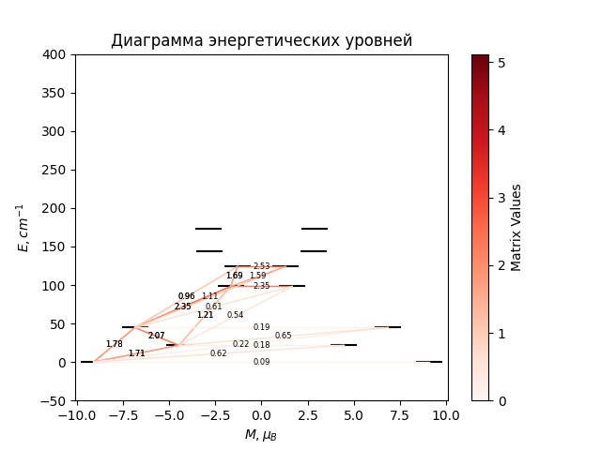

# CF_parameters

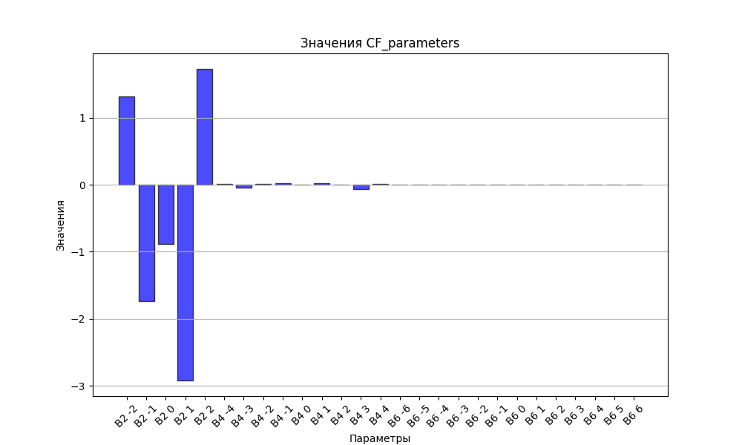

# CHI * T

|  |  |
| --- | --- |
| T | CHI * T |
| 1.0 | 4.1037337 |
| 2.0 | 6.9336547 |
| 3.0 | 8.5928213 |
| 4.0 | 9.5465964 |
| 5.0 | 10.1485971 |
| 6.0 | 10.5688972 |
| 7.0 | 10.8867827 |
| 8.0 | 11.1413182 |
| 9.0 | 11.3532066 |
| 10.0 | 11.5342595 |
| 11.0 | 11.6917171 |
| 12.0 | 11.8303351 |
| 13.0 | 11.9534476 |
| 14.0 | 12.0635296 |
| 15.0 | 12.1625067 |
| 16.0 | 12.2519309 |
| 17.0 | 12.3330847 |
| 18.0 | 12.4070456 |
| 19.0 | 12.4747282 |
| 20.0 | 12.5369145 |
| 21.0 | 12.5942752 |
| 22.0 | 12.6473875 |
| 23.0 | 12.6967486 |
| 24.0 | 12.7427874 |
| 25.0 | 12.7858744 |
| 26.0 | 12.8263297 |
| 27.0 | 12.8644305 |
| 28.0 | 12.900417 |
| 29.0 | 12.9344975 |
| 30.0 | 12.9668531 |
| 31.0 | 12.9976417 |
| 32.0 | 13.0270007 |
| 33.0 | 13.0550508 |
| 34.0 | 13.0818973 |
| 35.0 | 13.1076332 |
| 36.0 | 13.1323402 |
| 37.0 | 13.1560907 |
| 38.0 | 13.178949 |
| 39.0 | 13.2009723 |
| 40.0 | 13.2222117 |
| 41.0 | 13.242713 |
| 42.0 | 13.2625176 |
| 43.0 | 13.2816629 |
| 44.0 | 13.3001827 |
| 45.0 | 13.318108 |
| 46.0 | 13.3354671 |
| 47.0 | 13.352286 |
| 48.0 | 13.3685888 |
| 49.0 | 13.3843975 |
| 50.0 | 13.3997329 |
| 51.0 | 13.4146142 |
| 52.0 | 13.4290595 |
| 53.0 | 13.4430857 |
| 54.0 | 13.4567087 |
| 55.0 | 13.4699435 |
| 56.0 | 13.4828044 |
| 57.0 | 13.4953048 |
| 58.0 | 13.5074576 |
| 59.0 | 13.519275 |
| 60.0 | 13.5307686 |
| 61.0 | 13.5419495 |
| 62.0 | 13.5528285 |
| 63.0 | 13.5634155 |
| 64.0 | 13.5737205 |
| 65.0 | 13.5837528 |
| 66.0 | 13.5935215 |
| 67.0 | 13.603035 |
| 68.0 | 13.6123019 |
| 69.0 | 13.62133 |
| 70.0 | 13.6301271 |
| 71.0 | 13.6387007 |
| 72.0 | 13.6470578 |
| 73.0 | 13.6552054 |
| 74.0 | 13.6631501 |
| 75.0 | 13.6708983 |
| 76.0 | 13.6784563 |
| 77.0 | 13.68583 |
| 78.0 | 13.6930251 |
| 79.0 | 13.7000472 |
| 80.0 | 13.7069017 |
| 81.0 | 13.7135937 |
| 82.0 | 13.7201283 |
| 83.0 | 13.7265103 |
| 84.0 | 13.7327443 |
| 85.0 | 13.7388348 |
| 86.0 | 13.7447862 |
| 87.0 | 13.7506027 |
| 88.0 | 13.7562883 |
| 89.0 | 13.761847 |
| 90.0 | 13.7672825 |
| 91.0 | 13.7725985 |
| 92.0 | 13.7777985 |
| 93.0 | 13.7828859 |
| 94.0 | 13.7878641 |
| 95.0 | 13.7927361 |
| 96.0 | 13.7975051 |
| 97.0 | 13.8021741 |
| 98.0 | 13.8067458 |
| 99.0 | 13.8112232 |
| 100.0 | 13.8156088 |
| 101.0 | 13.8199053 |
| 102.0 | 13.8241152 |
| 103.0 | 13.8282409 |
| 104.0 | 13.8322847 |
| 105.0 | 13.8362489 |
| 106.0 | 13.8401357 |
| 107.0 | 13.8439473 |
| 108.0 | 13.8476856 |
| 109.0 | 13.8513527 |
| 110.0 | 13.8549504 |
| 111.0 | 13.8584807 |
| 112.0 | 13.8619453 |
| 113.0 | 13.865346 |
| 114.0 | 13.8686844 |
| 115.0 | 13.8719622 |
| 116.0 | 13.875181 |
| 117.0 | 13.8783422 |
| 118.0 | 13.8814474 |
| 119.0 | 13.8844979 |
| 120.0 | 13.8874953 |
| 121.0 | 13.8904408 |
| 122.0 | 13.8933356 |
| 123.0 | 13.8961812 |
| 124.0 | 13.8989787 |
| 125.0 | 13.9017292 |
| 126.0 | 13.904434 |
| 127.0 | 13.9070942 |
| 128.0 | 13.9097107 |
| 129.0 | 13.9122848 |
| 130.0 | 13.9148173 |
| 131.0 | 13.9173093 |
| 132.0 | 13.9197618 |
| 133.0 | 13.9221756 |
| 134.0 | 13.9245516 |
| 135.0 | 13.9268908 |
| 136.0 | 13.9291939 |
| 137.0 | 13.9314619 |
| 138.0 | 13.9336954 |
| 139.0 | 13.9358953 |
| 140.0 | 13.9380623 |
| 141.0 | 13.9401972 |
| 142.0 | 13.9423007 |
| 143.0 | 13.9443734 |
| 144.0 | 13.9464161 |
| 145.0 | 13.9484293 |
| 146.0 | 13.9504137 |
| 147.0 | 13.95237 |
| 148.0 | 13.9542987 |
| 149.0 | 13.9562004 |
| 150.0 | 13.9580757 |
| 151.0 | 13.9599252 |
| 152.0 | 13.9617493 |
| 153.0 | 13.9635486 |
| 154.0 | 13.9653236 |
| 155.0 | 13.9670748 |
| 156.0 | 13.9688027 |
| 157.0 | 13.9705077 |
| 158.0 | 13.9721904 |
| 159.0 | 13.9738511 |
| 160.0 | 13.9754903 |
| 161.0 | 13.9771083 |
| 162.0 | 13.9787057 |
| 163.0 | 13.9802828 |
| 164.0 | 13.9818401 |
| 165.0 | 13.9833778 |
| 166.0 | 13.9848964 |
| 167.0 | 13.9863962 |
| 168.0 | 13.9878775 |
| 169.0 | 13.9893408 |
| 170.0 | 13.9907864 |
| 171.0 | 13.9922145 |
| 172.0 | 13.9936256 |
| 173.0 | 13.9950199 |
| 174.0 | 13.9963976 |
| 175.0 | 13.9977592 |
| 176.0 | 13.999105 |
| 177.0 | 14.0004351 |
| 178.0 | 14.0017498 |
| 179.0 | 14.0030495 |
| 180.0 | 14.0043345 |
| 181.0 | 14.0056048 |
| 182.0 | 14.0068609 |
| 183.0 | 14.008103 |
| 184.0 | 14.0093312 |
| 185.0 | 14.0105459 |
| 186.0 | 14.0117472 |
| 187.0 | 14.0129355 |
| 188.0 | 14.0141108 |
| 189.0 | 14.0152735 |
| 190.0 | 14.0164237 |
| 191.0 | 14.0175616 |
| 192.0 | 14.0186875 |
| 193.0 | 14.0198015 |
| 194.0 | 14.0209039 |
| 195.0 | 14.0219947 |
| 196.0 | 14.0230743 |
| 197.0 | 14.0241428 |
| 198.0 | 14.0252003 |
| 199.0 | 14.026247 |
| 200.0 | 14.0272831 |
| 201.0 | 14.0283089 |
| 202.0 | 14.0293243 |
| 203.0 | 14.0303296 |
| 204.0 | 14.031325 |
| 205.0 | 14.0323105 |
| 206.0 | 14.0332864 |
| 207.0 | 14.0342528 |
| 208.0 | 14.0352099 |
| 209.0 | 14.0361577 |
| 210.0 | 14.0370964 |
| 211.0 | 14.0380262 |
| 212.0 | 14.0389471 |
| 213.0 | 14.0398594 |
| 214.0 | 14.0407631 |
| 215.0 | 14.0416583 |
| 216.0 | 14.0425453 |
| 217.0 | 14.043424 |
| 218.0 | 14.0442947 |
| 219.0 | 14.0451574 |
| 220.0 | 14.0460123 |
| 221.0 | 14.0468594 |
| 222.0 | 14.0476989 |
| 223.0 | 14.0485309 |
| 224.0 | 14.0493555 |
| 225.0 | 14.0501727 |
| 226.0 | 14.0509828 |
| 227.0 | 14.0517857 |
| 228.0 | 14.0525816 |
| 229.0 | 14.0533706 |
| 230.0 | 14.0541528 |
| 231.0 | 14.0549283 |
| 232.0 | 14.0556971 |
| 233.0 | 14.0564594 |
| 234.0 | 14.0572152 |
| 235.0 | 14.0579646 |
| 236.0 | 14.0587077 |
| 237.0 | 14.0594446 |
| 238.0 | 14.0601754 |
| 239.0 | 14.0609002 |
| 240.0 | 14.061619 |
| 241.0 | 14.0623319 |
| 242.0 | 14.063039 |
| 243.0 | 14.0637403 |
| 244.0 | 14.064436 |
| 245.0 | 14.0651261 |
| 246.0 | 14.0658106 |
| 247.0 | 14.0664898 |
| 248.0 | 14.0671635 |
| 249.0 | 14.0678319 |
| 250.0 | 14.0684951 |
| 251.0 | 14.0691531 |
| 252.0 | 14.0698059 |
| 253.0 | 14.0704537 |
| 254.0 | 14.0710966 |
| 255.0 | 14.0717345 |
| 256.0 | 14.0723675 |
| 257.0 | 14.0729957 |
| 258.0 | 14.0736192 |
| 259.0 | 14.0742379 |
| 260.0 | 14.0748521 |
| 261.0 | 14.0754616 |
| 262.0 | 14.0760666 |
| 263.0 | 14.0766672 |
| 264.0 | 14.0772633 |
| 265.0 | 14.0778551 |
| 266.0 | 14.0784425 |
| 267.0 | 14.0790257 |
| 268.0 | 14.0796046 |
| 269.0 | 14.0801794 |
| 270.0 | 14.0807501 |
| 271.0 | 14.0813167 |
| 272.0 | 14.0818793 |
| 273.0 | 14.0824379 |
| 274.0 | 14.0829926 |
| 275.0 | 14.0835434 |
| 276.0 | 14.0840904 |
| 277.0 | 14.0846335 |
| 278.0 | 14.0851729 |
| 279.0 | 14.0857086 |
| 280.0 | 14.0862406 |
| 281.0 | 14.086769 |
| 282.0 | 14.0872938 |
| 283.0 | 14.0878151 |
| 284.0 | 14.0883328 |
| 285.0 | 14.0888471 |
| 286.0 | 14.0893579 |
| 287.0 | 14.0898654 |

# H_B_df

|  |  |  |  |
| --- | --- | --- | --- |
| H(T) | B(T_1) | B(T_2) | B(T_3) |
| 0.0001 | 0.0009544487 | 0.0004910055 | 0.0003362715 |

# WAVE FUNCTIONS

|  |  |  |  |  |  |  |  |  |
| --- | --- | --- | --- | --- | --- | --- | --- | --- |
| Label | +-15/2> | +-13/2> | +-11/2> | +-9/2> | +-7/2> | +-5/2> | +-3/2> | +-1/2> |
| KD1 | 72 | 7 | 16 | 0 | 2 | 1 | 0 | 1 |
| KD2 | 8 | 13 | 2 | 15 | 17 | 18 | 17 | 10 |
| KD3 | 3 | 61 | 10 | 4 | 3 | 10 | 3 | 6 |
| KD4 | 7 | 2 | 14 | 4 | 14 | 10 | 25 | 25 |
| KD5 | 4 | 9 | 12 | 26 | 4 | 5 | 15 | 24 |
| KD6 | 6 | 4 | 35 | 14 | 6 | 11 | 5 | 18 |
| KD7 | 1 | 2 | 2 | 17 | 29 | 23 | 20 | 7 |
| KD8 | 0 | 2 | 8 | 18 | 25 | 23 | 15 | 9 |