# FBut

# PSEUDOSPIN HAMILTONIAN TENSORS

|  |  |  |
| --- | --- | --- |
| g_x | g_y | g_z |
| 0.01302603927257 | 0.02603543688577 | 19.56082888760472 |
| 10.29335937756441 | 7.36443266147228 | 0.78671514810572 |
| 10.02281103364787 | 6.74737758795651 | 0.26581867361914 |
| 3.81593133016135 | 4.87672590601538 | 10.38970923937088 |
| 1.64616018071937 | 3.19715091446743 | 11.28099782633557 |
| 0.57540106783994 | 1.17871169835271 | 17.2057999947895 |
| 0.26103660403121 | 0.31021913302297 | 19.23227177965436 |
| 0.02974231704188 | 0.06657947763272 | 19.7480174674916 |

# AB INITIO BLOCKING BARRIER

|  |  |  |  |
| --- | --- | --- | --- |
| KD | l+, muB | l-, muB | E, cm-1 |
| 1.0 | -9.7804144 | 9.7804144 | 0.0 |
| 2.0 | -4.9869526 | 4.9869526 | 95.0824445 |
| 3.0 | -3.1988282 | 3.1988282 | 110.8927127 |
| 4.0 | -3.2891094 | 3.2891094 | 147.2105278 |
| 5.0 | -1.6301349 | 1.6301349 | 182.6588001 |
| 6.0 | -2.5893055 | 2.5893055 | 208.7309781 |
| 7.0 | -0.5858942 | 0.5858942 | 297.4762175 |
| 8.0 | -6.2319802 | 6.2319802 | 439.9102218 |

# QTM, ORBACH, MATRIX ELEMENTS

|  |  |  |  |  |  |  |  |
| --- | --- | --- | --- | --- | --- | --- | --- |
| 0 | 1 | 2 | 3 | 4 | 5 | 6 | 7 |
| 0.00651024602597 | 0.243496788239 | 0.256964620716 | 0.17162793383 | 0.202469966545 | 0.110772130337 | 0.0783289175862 | 0.00316953748335 |
| 0.0 | 1.67501168253 | 2.18159609374 | 0.715634198534 | 0.648420314818 | 0.214197062745 | 0.121346776448 | 0.255259467339 |
| 0.0 | 0.0 | 2.11928023856 | 1.14263719406 | 0.707727783564 | 0.19599718148 | 0.21128533269 | 0.34691885994 |
| 0.0 | 0.0 | 0.0 | 1.90929227725 | 1.65717353051 | 0.604278997748 | 0.472029986678 | 0.501850509015 |
| 0.0 | 0.0 | 0.0 | 0.0 | 2.00102362168 | 1.49450171604 | 0.767765840018 | 0.455532325471 |
| 0.0 | 0.0 | 0.0 | 0.0 | 0.0 | 0.643618432755 | 0.252984508975 | 0.161451684982 |
| 0.0 | 0.0 | 0.0 | 0.0 | 0.0 | 0.0 | 1.1565288819 | 0.163152828245 |
| 0.0 | 0.0 | 0.0 | 0.0 | 0.0 | 0.0 | 0.0 | 0.0197659044823 |

# DIRECT MATRIX ELEMENTS

|  |  |  |  |  |  |  |  |
| --- | --- | --- | --- | --- | --- | --- | --- |
| 0 | 1 | 2 | 3 | 4 | 5 | 6 | 7 |
| 3.26013814793 | 1.55111318781 | 1.08105277532 | 0.575290160156 | 0.360988284521 | 0.158757611013 | 0.138536744364 | 0.420719428483 |
| 0.0 | 2.11662468189 | 1.83261115471 | 2.049040927 | 0.789872433555 | 0.390824566913 | 0.2739287388 | 0.430804381378 |
| 0.0 | 0.0 | 1.46627161592 | 1.92236105491 | 1.75426675646 | 0.584195085365 | 0.261619604346 | 0.898224734318 |
| 0.0 | 0.0 | 0.0 | 2.43822960837 | 2.30656619393 | 1.30197929585 | 0.377056479009 | 0.871524292076 |
| 0.0 | 0.0 | 0.0 | 0.0 | 1.64850355392 | 2.01562407754 | 1.43560045284 | 0.860618840104 |
| 0.0 | 0.0 | 0.0 | 0.0 | 0.0 | 3.79099858019 | 1.37376297677 | 0.399036263524 |
| 0.0 | 0.0 | 0.0 | 0.0 | 0.0 | 0.0 | 4.55709074936 | 0.932565489233 |
| 0.0 | 0.0 | 0.0 | 0.0 | 0.0 | 0.0 | 0.0 | 5.23877512715 |

# Diagram

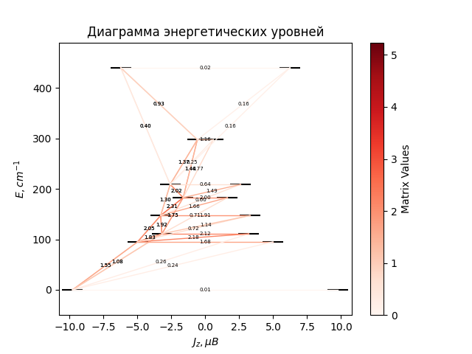

# CF_parameters

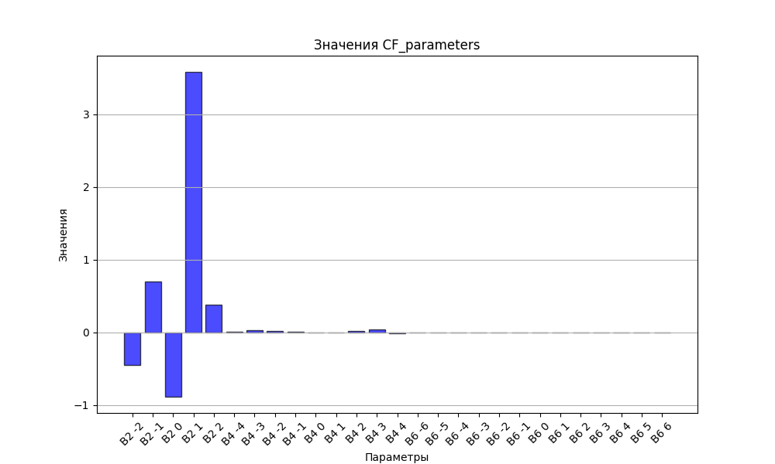

# CHI * T

|  |  |
| --- | --- |
| T | CHI * T |
| 1.0 | 5.2721754 |
| 2.0 | 8.4805196 |
| 3.0 | 10.0369012 |
| 4.0 | 10.8200224 |
| 5.0 | 11.2571399 |
| 6.0 | 11.526912 |
| 7.0 | 11.7082749 |
| 8.0 | 11.83921 |
| 9.0 | 11.9395063 |
| 10.0 | 12.0201972 |
| 11.0 | 12.0877925 |
| 12.0 | 12.1463173 |
| 13.0 | 12.1983589 |
| 14.0 | 12.2456348 |
| 15.0 | 12.2893155 |
| 16.0 | 12.3302164 |
| 17.0 | 12.3689163 |
| 18.0 | 12.4058322 |
| 19.0 | 12.4412691 |
| 20.0 | 12.4754528 |
| 21.0 | 12.5085521 |
| 22.0 | 12.5406951 |
| 23.0 | 12.5719799 |
| 24.0 | 12.6024825 |
| 25.0 | 12.6322625 |
| 26.0 | 12.6613673 |
| 27.0 | 12.6898349 |
| 28.0 | 12.7176961 |
| 29.0 | 12.7449764 |
| 30.0 | 12.7716969 |
| 31.0 | 12.7978755 |
| 32.0 | 12.8235275 |
| 33.0 | 12.8486661 |
| 34.0 | 12.8733028 |
| 35.0 | 12.8974479 |
| 36.0 | 12.9211106 |
| 37.0 | 12.9442992 |
| 38.0 | 12.9670215 |
| 39.0 | 12.9892847 |
| 40.0 | 13.0110957 |
| 41.0 | 13.0324609 |
| 42.0 | 13.0533868 |
| 43.0 | 13.0738794 |
| 44.0 | 13.093945 |
| 45.0 | 13.1135895 |
| 46.0 | 13.132819 |
| 47.0 | 13.1516396 |
| 48.0 | 13.1700574 |
| 49.0 | 13.1880786 |
| 50.0 | 13.2057094 |
| 51.0 | 13.2229561 |
| 52.0 | 13.239825 |
| 53.0 | 13.2563227 |
| 54.0 | 13.2724556 |
| 55.0 | 13.2882303 |
| 56.0 | 13.3036535 |
| 57.0 | 13.3187318 |
| 58.0 | 13.3334719 |
| 59.0 | 13.3478806 |
| 60.0 | 13.3619647 |
| 61.0 | 13.3757308 |
| 62.0 | 13.3891858 |
| 63.0 | 13.4023365 |
| 64.0 | 13.4151894 |
| 65.0 | 13.4277512 |
| 66.0 | 13.4400287 |
| 67.0 | 13.4520283 |
| 68.0 | 13.4637566 |
| 69.0 | 13.47522 |
| 70.0 | 13.4864249 |
| 71.0 | 13.4973774 |
| 72.0 | 13.5080838 |
| 73.0 | 13.5185502 |
| 74.0 | 13.5287825 |
| 75.0 | 13.5387866 |
| 76.0 | 13.5485683 |
| 77.0 | 13.5581332 |
| 78.0 | 13.5674868 |
| 79.0 | 13.5766346 |
| 80.0 | 13.5855818 |
| 81.0 | 13.5943337 |
| 82.0 | 13.6028953 |
| 83.0 | 13.6112715 |
| 84.0 | 13.6194672 |
| 85.0 | 13.6274871 |
| 86.0 | 13.6353358 |
| 87.0 | 13.6430178 |
| 88.0 | 13.6505374 |
| 89.0 | 13.6578988 |
| 90.0 | 13.6651063 |
| 91.0 | 13.6721638 |
| 92.0 | 13.6790753 |
| 93.0 | 13.6858445 |
| 94.0 | 13.6924752 |
| 95.0 | 13.6989709 |
| 96.0 | 13.7053353 |
| 97.0 | 13.7115716 |
| 98.0 | 13.7176831 |
| 99.0 | 13.7236732 |
| 100.0 | 13.7295449 |
| 101.0 | 13.7353013 |
| 102.0 | 13.7409453 |
| 103.0 | 13.7464797 |
| 104.0 | 13.7519074 |
| 105.0 | 13.757231 |
| 106.0 | 13.7624532 |
| 107.0 | 13.7675764 |
| 108.0 | 13.7726033 |
| 109.0 | 13.7775361 |
| 110.0 | 13.7823773 |
| 111.0 | 13.787129 |
| 112.0 | 13.7917935 |
| 113.0 | 13.7963729 |
| 114.0 | 13.8008693 |
| 115.0 | 13.8052846 |
| 116.0 | 13.809621 |
| 117.0 | 13.8138801 |
| 118.0 | 13.8180639 |
| 119.0 | 13.8221743 |
| 120.0 | 13.8262128 |
| 121.0 | 13.8301812 |
| 122.0 | 13.8340812 |
| 123.0 | 13.8379143 |
| 124.0 | 13.8416822 |
| 125.0 | 13.8453862 |
| 126.0 | 13.8490279 |
| 127.0 | 13.8526087 |
| 128.0 | 13.85613 |
| 129.0 | 13.8595931 |
| 130.0 | 13.8629993 |
| 131.0 | 13.8663499 |
| 132.0 | 13.8696462 |
| 133.0 | 13.8728893 |
| 134.0 | 13.8760804 |
| 135.0 | 13.8792207 |
| 136.0 | 13.8823113 |
| 137.0 | 13.8853531 |
| 138.0 | 13.8883474 |
| 139.0 | 13.8912951 |
| 140.0 | 13.8941972 |
| 141.0 | 13.8970546 |
| 142.0 | 13.8998684 |
| 143.0 | 13.9026394 |
| 144.0 | 13.9053685 |
| 145.0 | 13.9080566 |
| 146.0 | 13.9107046 |
| 147.0 | 13.9133133 |
| 148.0 | 13.9158834 |
| 149.0 | 13.9184157 |
| 150.0 | 13.9209111 |
| 151.0 | 13.9233703 |
| 152.0 | 13.925794 |
| 153.0 | 13.9281828 |
| 154.0 | 13.9305376 |
| 155.0 | 13.9328589 |
| 156.0 | 13.9351475 |
| 157.0 | 13.9374039 |
| 158.0 | 13.9396288 |
| 159.0 | 13.9418228 |
| 160.0 | 13.9439865 |
| 161.0 | 13.9461205 |
| 162.0 | 13.9482253 |
| 163.0 | 13.9503015 |
| 164.0 | 13.9523496 |
| 165.0 | 13.9543702 |
| 166.0 | 13.9563638 |
| 167.0 | 13.9583309 |
| 168.0 | 13.9602719 |
| 169.0 | 13.9621874 |
| 170.0 | 13.9640778 |
| 171.0 | 13.9659436 |
| 172.0 | 13.9677852 |
| 173.0 | 13.9696031 |
| 174.0 | 13.9713976 |
| 175.0 | 13.9731693 |
| 176.0 | 13.9749184 |
| 177.0 | 13.9766455 |
| 178.0 | 13.9783509 |
| 179.0 | 13.980035 |
| 180.0 | 13.9816981 |
| 181.0 | 13.9833407 |
| 182.0 | 13.984963 |
| 183.0 | 13.9865654 |
| 184.0 | 13.9881484 |
| 185.0 | 13.9897121 |
| 186.0 | 13.991257 |
| 187.0 | 13.9927833 |
| 188.0 | 13.9942914 |
| 189.0 | 13.9957815 |
| 190.0 | 13.9972541 |
| 191.0 | 13.9987092 |
| 192.0 | 14.0001474 |
| 193.0 | 14.0015688 |
| 194.0 | 14.0029737 |
| 195.0 | 14.0043623 |
| 196.0 | 14.0057351 |
| 197.0 | 14.0070921 |
| 198.0 | 14.0084337 |
| 199.0 | 14.0097601 |
| 200.0 | 14.0110715 |
| 201.0 | 14.0123683 |
| 202.0 | 14.0136505 |
| 203.0 | 14.0149185 |
| 204.0 | 14.0161725 |
| 205.0 | 14.0174127 |
| 206.0 | 14.0186394 |
| 207.0 | 14.0198526 |
| 208.0 | 14.0210527 |
| 209.0 | 14.0222398 |
| 210.0 | 14.0234142 |
| 211.0 | 14.024576 |
| 212.0 | 14.0257254 |
| 213.0 | 14.0268627 |
| 214.0 | 14.0279879 |
| 215.0 | 14.0291014 |
| 216.0 | 14.0302032 |
| 217.0 | 14.0312935 |
| 218.0 | 14.0323726 |
| 219.0 | 14.0334405 |
| 220.0 | 14.0344975 |
| 221.0 | 14.0355436 |
| 222.0 | 14.0365792 |
| 223.0 | 14.0376042 |
| 224.0 | 14.0386189 |
| 225.0 | 14.0396235 |
| 226.0 | 14.040618 |
| 227.0 | 14.0416027 |
| 228.0 | 14.0425776 |
| 229.0 | 14.0435428 |
| 230.0 | 14.0444987 |
| 231.0 | 14.0454452 |
| 232.0 | 14.0463825 |
| 233.0 | 14.0473107 |
| 234.0 | 14.04823 |
| 235.0 | 14.0491405 |
| 236.0 | 14.0500423 |
| 237.0 | 14.0509356 |
| 238.0 | 14.0518203 |
| 239.0 | 14.0526968 |
| 240.0 | 14.053565 |
| 241.0 | 14.0544252 |
| 242.0 | 14.0552773 |
| 243.0 | 14.0561216 |
| 244.0 | 14.0569581 |
| 245.0 | 14.0577869 |
| 246.0 | 14.0586081 |
| 247.0 | 14.0594219 |
| 248.0 | 14.0602284 |
| 249.0 | 14.0610275 |
| 250.0 | 14.0618195 |
| 251.0 | 14.0626044 |
| 252.0 | 14.0633824 |
| 253.0 | 14.0641535 |
| 254.0 | 14.0649177 |
| 255.0 | 14.0656753 |
| 256.0 | 14.0664262 |
| 257.0 | 14.0671707 |
| 258.0 | 14.0679086 |
| 259.0 | 14.0686402 |
| 260.0 | 14.0693656 |
| 261.0 | 14.0700847 |
| 262.0 | 14.0707977 |
| 263.0 | 14.0715047 |
| 264.0 | 14.0722057 |
| 265.0 | 14.0729009 |
| 266.0 | 14.0735902 |
| 267.0 | 14.0742737 |
| 268.0 | 14.0749517 |
| 269.0 | 14.075624 |
| 270.0 | 14.0762908 |
| 271.0 | 14.0769521 |
| 272.0 | 14.0776081 |
| 273.0 | 14.0782587 |
| 274.0 | 14.0789041 |
| 275.0 | 14.0795442 |
| 276.0 | 14.0801793 |
| 277.0 | 14.0808093 |
| 278.0 | 14.0814343 |
| 279.0 | 14.0820544 |
| 280.0 | 14.0826695 |
| 281.0 | 14.0832799 |
| 282.0 | 14.0838855 |
| 283.0 | 14.0844864 |
| 284.0 | 14.0850826 |
| 285.0 | 14.0856743 |
| 286.0 | 14.0862614 |
| 287.0 | 14.086844 |

# H_B_df

|  |  |  |  |
| --- | --- | --- | --- |
| H(T) | B(T_1) | B(T_2) | B(T_3) |
| 0.0001 | 0.0010760472 | 0.0005405985 | 0.0003621156 |

# WAVE FUNCTIONS

|  |  |  |  |  |  |  |  |  |
| --- | --- | --- | --- | --- | --- | --- | --- | --- |
| Label | +-15/2> | +-13/2> | +-11/2> | +-9/2> | +-7/2> | +-5/2> | +-3/2> | +-1/2> |
| KD0 | 94 | 0 | 4 | 1 | 0 | 0 | 0 | 0 |
| KD1 | 0 | 48 | 7 | 4 | 2 | 5 | 14 | 19 |
| KD1 | 0 | 35 | 4 | 4 | 6 | 5 | 17 | 28 |
| KD2 | 2 | 1 | 31 | 24 | 7 | 17 | 9 | 10 |
| KD2 | 1 | 2 | 23 | 18 | 24 | 14 | 17 | 2 |
| KD3 | 0 | 0 | 1 | 14 | 34 | 30 | 12 | 8 |
| KD3 | 0 | 1 | 3 | 4 | 7 | 22 | 30 | 33 |
| KD4 | 3 | 12 | 26 | 31 | 20 | 7 | 1 | 0 |