# LEZLUA

# PSEUDOSPIN HAMILTONIAN TENSORS

|  |  |  |
| --- | --- | --- |
| g_x | g_y | g_z |
| 0.02225120563697 | 0.03718997569113 | 19.53696690405538 |
| 0.13269910590041 | 0.25670416662061 | 16.13435962886756 |
| 2.14755895044521 | 2.76539962026049 | 12.58589471813854 |
| 8.23332802238801 | 6.10702238873038 | 2.8599798680754 |
| 9.48454696032527 | 4.80037579490876 | 0.06346261046915 |
| 1.96591380675345 | 4.69469530685653 | 13.04719388874546 |
| 0.07985899879603 | 0.11553308398102 | 17.10997824478926 |
| 0.00149580861298 | 0.01529081237295 | 19.2102054497412 |

# AB INITIO BLOCKING BARRIER

|  |  |  |  |
| --- | --- | --- | --- |
| KD | l+, muB | l-, muB | E, cm-1 |
| 1.0 | -9.7684835 | 9.7684835 | 0.0 |
| 2.0 | -7.6548493 | 7.6548493 | 134.0453083 |
| 3.0 | -5.8988959 | 5.8988959 | 205.2523262 |
| 4.0 | -3.9574564 | 3.9574564 | 287.7106312 |
| 5.0 | -2.4001731 | 2.4001731 | 389.306418 |
| 6.0 | -1.0220849 | 1.0220849 | 454.0518883 |
| 7.0 | -0.2293772 | 0.2293772 | 620.5833734 |
| 8.0 | -2.1118855 | 2.1118855 | 689.0403838 |

# QTM, ORBACH, MATRIX ELEMENTS

|  |  |  |  |  |  |  |  |
| --- | --- | --- | --- | --- | --- | --- | --- |
| 0 | 1 | 2 | 3 | 4 | 5 | 6 | 7 |
| 0.00990686355469 | 0.0231820176924 | 0.0603619609593 | 0.19609208508 | 0.0933361446342 | 0.113426381872 | 0.133858223921 | 0.0286214316215 |
| 0.0 | 0.0671180927555 | 0.176177761214 | 0.378029031753 | 0.212959550794 | 0.196361480934 | 0.246144205095 | 0.0443573020528 |
| 0.0 | 0.0 | 0.858701547587 | 0.77872937063 | 0.527850481667 | 0.415797097225 | 0.310448317142 | 0.0607917542767 |
| 0.0 | 0.0 | 0.0 | 1.55221564554 | 1.04921479149 | 0.993836574943 | 0.37048755733 | 0.345431272155 |
| 0.0 | 0.0 | 0.0 | 0.0 | 2.1740908868 | 0.855215282538 | 0.940249981874 | 0.208758472256 |
| 0.0 | 0.0 | 0.0 | 0.0 | 0.0 | 2.93341914496 | 1.5424349314 | 0.37939470258 |
| 0.0 | 0.0 | 0.0 | 0.0 | 0.0 | 0.0 | 0.714826506674 | 2.05305728323 |
| 0.0 | 0.0 | 0.0 | 0.0 | 0.0 | 0.0 | 0.0 | 0.00525396837763 |

# DIRECT MATRIX ELEMENTS

|  |  |  |  |  |  |  |  |
| --- | --- | --- | --- | --- | --- | --- | --- |
| 0 | 1 | 2 | 3 | 4 | 5 | 6 | 7 |
| 3.25616115068 | 1.82868433108 | 0.754438304675 | 0.388360825433 | 0.239818663738 | 0.141795731147 | 0.0706212629516 | 0.125799293805 |
| 0.0 | 3.60657449221 | 2.66705362362 | 0.803094194462 | 0.500024753456 | 0.352724552667 | 0.122276365371 | 0.236100857548 |
| 0.0 | 0.0 | 2.97089048534 | 2.97505910133 | 0.47407237198 | 0.45965481573 | 0.20814541964 | 0.314495493206 |
| 0.0 | 0.0 | 0.0 | 1.73354368873 | 2.83306551228 | 0.657333252179 | 0.222056314602 | 0.492613033329 |
| 0.0 | 0.0 | 0.0 | 0.0 | 0.988004929471 | 2.87218605597 | 0.879739469312 | 0.38385864039 |
| 0.0 | 0.0 | 0.0 | 0.0 | 0.0 | 0.704577784685 | 1.60326566959 | 0.503751608934 |
| 0.0 | 0.0 | 0.0 | 0.0 | 0.0 | 0.0 | 3.84862691671 | 0.196014980844 |
| 0.0 | 0.0 | 0.0 | 0.0 | 0.0 | 0.0 | 0.0 | 4.83569956842 |

# Diagram

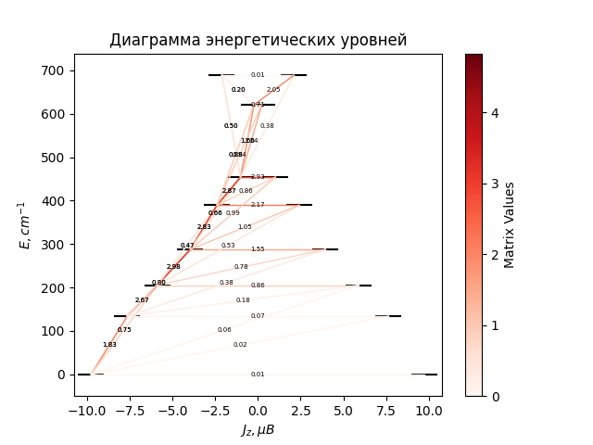

# CF_parameters

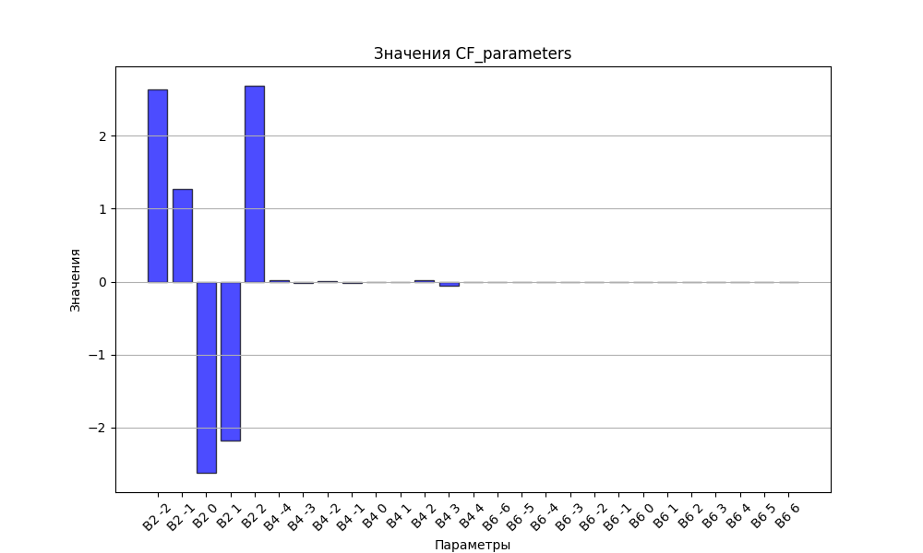

# CHI * T

|  |  |
| --- | --- |
| T | CHI * T |
| 1.0 | 4.2975401 |
| 2.0 | 7.3713645 |
| 3.0 | 9.1915119 |
| 4.0 | 10.2022442 |
| 5.0 | 10.7902761 |
| 6.0 | 11.1570232 |
| 7.0 | 11.4014931 |
| 8.0 | 11.5742597 |
| 9.0 | 11.7026616 |
| 10.0 | 11.802319 |
| 11.0 | 11.8826085 |
| 12.0 | 11.949406 |
| 13.0 | 12.006533 |
| 14.0 | 12.0565554 |
| 15.0 | 12.1012449 |
| 16.0 | 12.1418541 |
| 17.0 | 12.1792873 |
| 18.0 | 12.2142089 |
| 19.0 | 12.2471147 |
| 20.0 | 12.2783792 |
| 21.0 | 12.3082888 |
| 22.0 | 12.3370639 |
| 23.0 | 12.3648761 |
| 24.0 | 12.3918592 |
| 25.0 | 12.4181186 |
| 26.0 | 12.4437373 |
| 27.0 | 12.4687812 |
| 28.0 | 12.4933026 |
| 29.0 | 12.5173434 |
| 30.0 | 12.5409368 |
| 31.0 | 12.5641097 |
| 32.0 | 12.5868836 |
| 33.0 | 12.6092762 |
| 34.0 | 12.6313015 |
| 35.0 | 12.6529713 |
| 36.0 | 12.6742952 |
| 37.0 | 12.6952812 |
| 38.0 | 12.7159363 |
| 39.0 | 12.7362662 |
| 40.0 | 12.7562762 |
| 41.0 | 12.7759707 |
| 42.0 | 12.795354 |
| 43.0 | 12.8144299 |
| 44.0 | 12.8332021 |
| 45.0 | 12.8516739 |
| 46.0 | 12.8698487 |
| 47.0 | 12.88773 |
| 48.0 | 12.9053209 |
| 49.0 | 12.9226247 |
| 50.0 | 12.9396449 |
| 51.0 | 12.9563845 |
| 52.0 | 12.9728472 |
| 53.0 | 12.9890361 |
| 54.0 | 13.0049549 |
| 55.0 | 13.020607 |
| 56.0 | 13.0359959 |
| 57.0 | 13.0511252 |
| 58.0 | 13.0659985 |
| 59.0 | 13.0806194 |
| 60.0 | 13.0949918 |
| 61.0 | 13.1091191 |
| 62.0 | 13.1230053 |
| 63.0 | 13.136654 |
| 64.0 | 13.1500689 |
| 65.0 | 13.1632539 |
| 66.0 | 13.1762126 |
| 67.0 | 13.1889489 |
| 68.0 | 13.2014665 |
| 69.0 | 13.2137691 |
| 70.0 | 13.2258605 |
| 71.0 | 13.2377443 |
| 72.0 | 13.2494242 |
| 73.0 | 13.260904 |
| 74.0 | 13.2721871 |
| 75.0 | 13.2832772 |
| 76.0 | 13.2941779 |
| 77.0 | 13.3048927 |
| 78.0 | 13.315425 |
| 79.0 | 13.3257784 |
| 80.0 | 13.3359561 |
| 81.0 | 13.3459616 |
| 82.0 | 13.3557981 |
| 83.0 | 13.365469 |
| 84.0 | 13.3749775 |
| 85.0 | 13.3843266 |
| 86.0 | 13.3935196 |
| 87.0 | 13.4025594 |
| 88.0 | 13.4114492 |
| 89.0 | 13.4201918 |
| 90.0 | 13.4287902 |
| 91.0 | 13.4372473 |
| 92.0 | 13.4455658 |
| 93.0 | 13.4537485 |
| 94.0 | 13.4617982 |
| 95.0 | 13.4697174 |
| 96.0 | 13.4775088 |
| 97.0 | 13.485175 |
| 98.0 | 13.4927184 |
| 99.0 | 13.5001416 |
| 100.0 | 13.5074468 |
| 101.0 | 13.5146365 |
| 102.0 | 13.521713 |
| 103.0 | 13.5286786 |
| 104.0 | 13.5355354 |
| 105.0 | 13.5422856 |
| 106.0 | 13.5489313 |
| 107.0 | 13.5554747 |
| 108.0 | 13.5619178 |
| 109.0 | 13.5682624 |
| 110.0 | 13.5745107 |
| 111.0 | 13.5806645 |
| 112.0 | 13.5867256 |
| 113.0 | 13.592696 |
| 114.0 | 13.5985773 |
| 115.0 | 13.6043713 |
| 116.0 | 13.6100797 |
| 117.0 | 13.6157042 |
| 118.0 | 13.6212464 |
| 119.0 | 13.6267079 |
| 120.0 | 13.6320903 |
| 121.0 | 13.637395 |
| 122.0 | 13.6426236 |
| 123.0 | 13.6477776 |
| 124.0 | 13.6528583 |
| 125.0 | 13.6578672 |
| 126.0 | 13.6628056 |
| 127.0 | 13.6676748 |
| 128.0 | 13.6724762 |
| 129.0 | 13.677211 |
| 130.0 | 13.6818804 |
| 131.0 | 13.6864857 |
| 132.0 | 13.6910281 |
| 133.0 | 13.6955087 |
| 134.0 | 13.6999286 |
| 135.0 | 13.7042891 |
| 136.0 | 13.708591 |
| 137.0 | 13.7128356 |
| 138.0 | 13.7170239 |
| 139.0 | 13.7211568 |
| 140.0 | 13.7252354 |
| 141.0 | 13.7292607 |
| 142.0 | 13.7332335 |
| 143.0 | 13.7371549 |
| 144.0 | 13.7410256 |
| 145.0 | 13.7448467 |
| 146.0 | 13.748619 |
| 147.0 | 13.7523433 |
| 148.0 | 13.7560205 |
| 149.0 | 13.7596514 |
| 150.0 | 13.7632367 |
| 151.0 | 13.7667773 |
| 152.0 | 13.770274 |
| 153.0 | 13.7737274 |
| 154.0 | 13.7771383 |
| 155.0 | 13.7805074 |
| 156.0 | 13.7838355 |
| 157.0 | 13.7871231 |
| 158.0 | 13.7903711 |
| 159.0 | 13.7935799 |
| 160.0 | 13.7967504 |
| 161.0 | 13.799883 |
| 162.0 | 13.8029785 |
| 163.0 | 13.8060374 |
| 164.0 | 13.8090603 |
| 165.0 | 13.8120478 |
| 166.0 | 13.8150005 |
| 167.0 | 13.8179189 |
| 168.0 | 13.8208036 |
| 169.0 | 13.823655 |
| 170.0 | 13.8264738 |
| 171.0 | 13.8292605 |
| 172.0 | 13.8320155 |
| 173.0 | 13.8347393 |
| 174.0 | 13.8374324 |
| 175.0 | 13.8400954 |
| 176.0 | 13.8427286 |
| 177.0 | 13.8453325 |
| 178.0 | 13.8479075 |
| 179.0 | 13.8504542 |
| 180.0 | 13.8529728 |
| 181.0 | 13.8554639 |
| 182.0 | 13.8579279 |
| 183.0 | 13.8603652 |
| 184.0 | 13.862776 |
| 185.0 | 13.865161 |
| 186.0 | 13.8675204 |
| 187.0 | 13.8698546 |
| 188.0 | 13.8721639 |
| 189.0 | 13.8744488 |
| 190.0 | 13.8767096 |
| 191.0 | 13.8789466 |
| 192.0 | 13.8811602 |
| 193.0 | 13.8833507 |
| 194.0 | 13.8855185 |
| 195.0 | 13.8876638 |
| 196.0 | 13.8897871 |
| 197.0 | 13.8918885 |
| 198.0 | 13.8939684 |
| 199.0 | 13.8960271 |
| 200.0 | 13.898065 |
| 201.0 | 13.9000822 |
| 202.0 | 13.9020791 |
| 203.0 | 13.9040559 |
| 204.0 | 13.906013 |
| 205.0 | 13.9079506 |
| 206.0 | 13.9098689 |
| 207.0 | 13.9117683 |
| 208.0 | 13.913649 |
| 209.0 | 13.9155112 |
| 210.0 | 13.9173552 |
| 211.0 | 13.9191812 |
| 212.0 | 13.9209895 |
| 213.0 | 13.9227803 |
| 214.0 | 13.9245538 |
| 215.0 | 13.9263103 |
| 216.0 | 13.9280499 |
| 217.0 | 13.929773 |
| 218.0 | 13.9314797 |
| 219.0 | 13.9331703 |
| 220.0 | 13.9348449 |
| 221.0 | 13.9365037 |
| 222.0 | 13.938147 |
| 223.0 | 13.939775 |
| 224.0 | 13.9413878 |
| 225.0 | 13.9429856 |
| 226.0 | 13.9445687 |
| 227.0 | 13.9461372 |
| 228.0 | 13.9476913 |
| 229.0 | 13.9492312 |
| 230.0 | 13.9507571 |
| 231.0 | 13.9522691 |
| 232.0 | 13.9537674 |
| 233.0 | 13.9552522 |
| 234.0 | 13.9567237 |
| 235.0 | 13.9581819 |
| 236.0 | 13.9596272 |
| 237.0 | 13.9610595 |
| 238.0 | 13.9624792 |
| 239.0 | 13.9638863 |
| 240.0 | 13.9652811 |
| 241.0 | 13.9666635 |
| 242.0 | 13.9680339 |
| 243.0 | 13.9693924 |
| 244.0 | 13.970739 |
| 245.0 | 13.9720739 |
| 246.0 | 13.9733973 |
| 247.0 | 13.9747094 |
| 248.0 | 13.9760101 |
| 249.0 | 13.9772998 |
| 250.0 | 13.9785784 |
| 251.0 | 13.9798462 |
| 252.0 | 13.9811033 |
| 253.0 | 13.9823497 |
| 254.0 | 13.9835857 |
| 255.0 | 13.9848112 |
| 256.0 | 13.9860266 |
| 257.0 | 13.9872318 |
| 258.0 | 13.988427 |
| 259.0 | 13.9896123 |
| 260.0 | 13.9907879 |
| 261.0 | 13.9919538 |
| 262.0 | 13.9931101 |
| 263.0 | 13.9942569 |
| 264.0 | 13.9953944 |
| 265.0 | 13.9965227 |
| 266.0 | 13.9976419 |
| 267.0 | 13.998752 |
| 268.0 | 13.9998532 |
| 269.0 | 14.0009456 |
| 270.0 | 14.0020292 |
| 271.0 | 14.0031042 |
| 272.0 | 14.0041707 |
| 273.0 | 14.0052287 |
| 274.0 | 14.0062784 |
| 275.0 | 14.0073198 |
| 276.0 | 14.0083531 |
| 277.0 | 14.0093783 |
| 278.0 | 14.0103955 |
| 279.0 | 14.0114048 |
| 280.0 | 14.0124062 |
| 281.0 | 14.0134 |
| 282.0 | 14.0143861 |
| 283.0 | 14.0153646 |
| 284.0 | 14.0163357 |
| 285.0 | 14.0172994 |
| 286.0 | 14.0182557 |
| 287.0 | 14.0192048 |

# H_B_df

|  |  |  |  |
| --- | --- | --- | --- |
| H(T) | B(T_1) | B(T_2) | B(T_3) |
| 0.0001 | 0.0010721881 | 0.0005380435 | 0.0003599953 |

# WAVE FUNCTIONS

|  |  |  |  |  |  |  |  |  |
| --- | --- | --- | --- | --- | --- | --- | --- | --- |
| Label | +-15/2> | +-13/2> | +-11/2> | +-9/2> | +-7/2> | +-5/2> | +-3/2> | +-1/2> |
| KD0 | 93 | 0 | 6 | 0 | 0 | 0 | 0 | 0 |
| KD1 | 0 | 66 | 4 | 26 | 2 | 1 | 0 | 1 |
| KD1 | 3 | 12 | 37 | 3 | 35 | 6 | 2 | 1 |
| KD2 | 2 | 6 | 23 | 19 | 3 | 36 | 10 | 2 |
| KD2 | 0 | 7 | 4 | 16 | 12 | 7 | 40 | 14 |
| KD3 | 1 | 3 | 10 | 7 | 8 | 7 | 10 | 55 |
| KD3 | 1 | 4 | 9 | 16 | 22 | 23 | 17 | 8 |
| KD4 | 0 | 3 | 8 | 12 | 17 | 20 | 21 | 19 |