# PIYXED_new

# PSEUDOSPIN HAMILTONIAN TENSORS

|  |  |  |
| --- | --- | --- |
| g_x | g_y | g_z |
| 0.00732147723351 | 0.01479824416706 | 19.40246085292635 |
| 0.40502505911493 | 0.63748834079715 | 15.48633087801523 |
| 1.19742419310256 | 1.82797079402475 | 12.50272093502296 |
| 2.45996544165427 | 5.12042332886537 | 9.32896484601542 |
| 3.3941761856581 | 4.46478990234701 | 9.93016392420898 |
| 1.05883058735422 | 1.99742752104535 | 17.35001607416272 |
| 0.03886444873244 | 0.11465198500333 | 18.83320588543488 |
| 0.01367769518513 | 0.02931803468585 | 19.64047043748303 |

# AB INITIO BLOCKING BARRIER

|  |  |  |  |
| --- | --- | --- | --- |
| KD | l+, muB | l-, muB | E, cm-1 |
| 1.0 | -9.7012304 | 9.7012304 | 0.0 |
| 2.0 | -7.3979496 | 7.3979496 | 121.74834 |
| 3.0 | -5.4175247 | 5.4175247 | 181.1798901 |
| 4.0 | -4.408849 | 4.408849 | 229.6876629 |
| 5.0 | -2.3391025 | 2.3391025 | 270.105142 |
| 6.0 | -2.8333509 | 2.8333509 | 310.460036 |
| 7.0 | -0.2265274 | 0.2265274 | 407.4288512 |
| 8.0 | -5.9371865 | 5.9371865 | 522.1205394 |

# QTM, ORBACH, MATRIX ELEMENTS

|  |  |  |  |  |  |  |  |
| --- | --- | --- | --- | --- | --- | --- | --- |
| 0 | 1 | 2 | 3 | 4 | 5 | 6 | 7 |
| 0.00368662023406 | 0.0243948339439 | 0.104401984066 | 0.0347366052558 | 0.095973746602 | 0.0613884198999 | 0.0431121780105 | 0.00503877347357 |
| 0.0 | 0.178693639563 | 0.249759431728 | 0.247264869874 | 0.242471088267 | 0.24427042343 | 0.121628870918 | 0.0172282198258 |
| 0.0 | 0.0 | 0.537693367697 | 0.802394483276 | 0.704012504623 | 0.323530210757 | 0.272127929022 | 0.137290780016 |
| 0.0 | 0.0 | 0.0 | 1.3425268179 | 1.26771001467 | 0.739295224431 | 0.484892372983 | 0.100982362381 |
| 0.0 | 0.0 | 0.0 | 0.0 | 2.24832206264 | 1.35072965542 | 0.88029738747 | 0.172032004602 |
| 0.0 | 0.0 | 0.0 | 0.0 | 0.0 | 0.883830315611 | 0.412938847593 | 0.343871989819 |
| 0.0 | 0.0 | 0.0 | 0.0 | 0.0 | 0.0 | 0.511695934563 | 0.0924917605778 |
| 0.0 | 0.0 | 0.0 | 0.0 | 0.0 | 0.0 | 0.0 | 0.0091204998685 |

# DIRECT MATRIX ELEMENTS

|  |  |  |  |  |  |  |  |
| --- | --- | --- | --- | --- | --- | --- | --- |
| 0 | 1 | 2 | 3 | 4 | 5 | 6 | 7 |
| 3.23374347549 | 2.00003765149 | 0.611967962242 | 0.419084235381 | 0.260523577638 | 0.114372866516 | 0.169974883907 | 0.386948695369 |
| 0.0 | 3.48716224877 | 2.83755143375 | 0.807074190192 | 0.724499652391 | 0.267877966957 | 0.298123279433 | 0.660190712016 |
| 0.0 | 0.0 | 3.15516055342 | 3.08503377897 | 0.7159002739 | 0.545543386151 | 0.35654469611 | 0.812663965063 |
| 0.0 | 0.0 | 0.0 | 2.04609667698 | 3.0375910897 | 0.986425333519 | 0.516289894539 | 0.861346730951 |
| 0.0 | 0.0 | 0.0 | 0.0 | 1.41387914698 | 2.11094918994 | 1.42061612212 | 0.880706460307 |
| 0.0 | 0.0 | 0.0 | 0.0 | 0.0 | 4.02350830329 | 0.919090698138 | 0.277385822634 |
| 0.0 | 0.0 | 0.0 | 0.0 | 0.0 | 0.0 | 3.72440535783 | 1.47206101527 |
| 0.0 | 0.0 | 0.0 | 0.0 | 0.0 | 0.0 | 0.0 | 5.56369064042 |

# Diagram

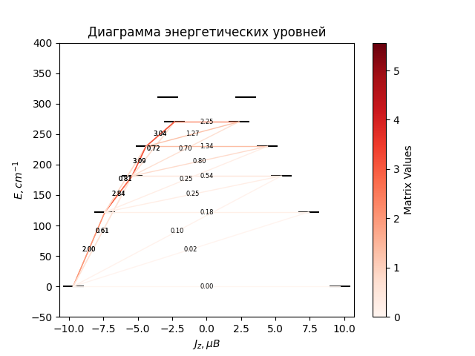

# CF_parameters

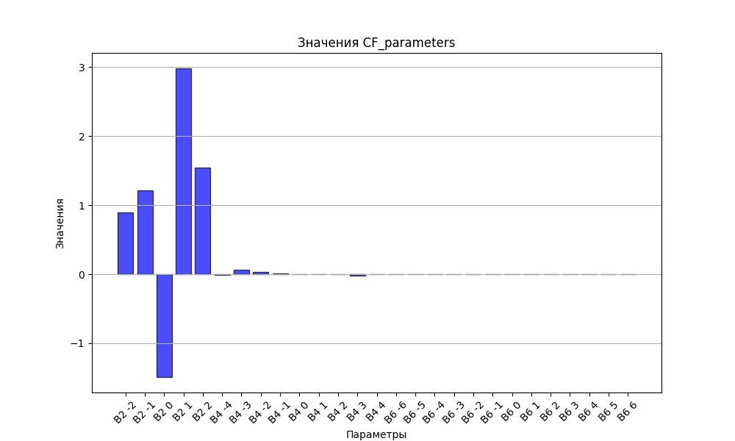

# CHI * T

|  |  |
| --- | --- |
| T | CHI * T |
| 1.0 | 4.6387714 |
| 2.0 | 7.6695329 |
| 3.0 | 9.3634807 |
| 4.0 | 10.280113 |
| 5.0 | 10.808192 |
| 6.0 | 11.1373421 |
| 7.0 | 11.3579557 |
| 8.0 | 11.5154222 |
| 9.0 | 11.6340202 |
| 10.0 | 11.727525 |
| 11.0 | 11.8041656 |
| 12.0 | 11.8690805 |
| 13.0 | 11.9256018 |
| 14.0 | 11.9759617 |
| 15.0 | 12.0216969 |
| 16.0 | 12.063891 |
| 17.0 | 12.103323 |
| 18.0 | 12.1405621 |
| 19.0 | 12.1760307 |
| 20.0 | 12.2100449 |
| 21.0 | 12.2428444 |
| 22.0 | 12.2746117 |
| 23.0 | 12.3054868 |
| 24.0 | 12.3355779 |
| 25.0 | 12.3649688 |
| 26.0 | 12.3937248 |
| 27.0 | 12.421897 |
| 28.0 | 12.4495254 |
| 29.0 | 12.4766419 |
| 30.0 | 12.5032717 |
| 31.0 | 12.5294351 |
| 32.0 | 12.5551484 |
| 33.0 | 12.5804253 |
| 34.0 | 12.6052768 |
| 35.0 | 12.6297124 |
| 36.0 | 12.6537405 |
| 37.0 | 12.6773681 |
| 38.0 | 12.7006017 |
| 39.0 | 12.7234473 |
| 40.0 | 12.7459103 |
| 41.0 | 12.767996 |
| 42.0 | 12.7897094 |
| 43.0 | 12.8110554 |
| 44.0 | 12.8320388 |
| 45.0 | 12.8526644 |
| 46.0 | 12.8729367 |
| 47.0 | 12.8928605 |
| 48.0 | 12.9124406 |
| 49.0 | 12.9316815 |
| 50.0 | 12.950588 |
| 51.0 | 12.9691648 |
| 52.0 | 12.9874166 |
| 53.0 | 13.0053481 |
| 54.0 | 13.022964 |
| 55.0 | 13.0402691 |
| 56.0 | 13.0572682 |
| 57.0 | 13.0739658 |
| 58.0 | 13.0903668 |
| 59.0 | 13.1064759 |
| 60.0 | 13.1222976 |
| 61.0 | 13.1378369 |
| 62.0 | 13.1530981 |
| 63.0 | 13.1680861 |
| 64.0 | 13.1828053 |
| 65.0 | 13.1972604 |
| 66.0 | 13.2114558 |
| 67.0 | 13.2253961 |
| 68.0 | 13.2390858 |
| 69.0 | 13.2525291 |
| 70.0 | 13.2657307 |
| 71.0 | 13.2786946 |
| 72.0 | 13.2914253 |
| 73.0 | 13.3039269 |
| 74.0 | 13.3162037 |
| 75.0 | 13.3282598 |
| 76.0 | 13.3400993 |
| 77.0 | 13.3517262 |
| 78.0 | 13.3631444 |
| 79.0 | 13.374358 |
| 80.0 | 13.3853708 |
| 81.0 | 13.3961866 |
| 82.0 | 13.4068091 |
| 83.0 | 13.4172422 |
| 84.0 | 13.4274893 |
| 85.0 | 13.4375542 |
| 86.0 | 13.4474403 |
| 87.0 | 13.4571511 |
| 88.0 | 13.4666901 |
| 89.0 | 13.4760606 |
| 90.0 | 13.485266 |
| 91.0 | 13.4943093 |
| 92.0 | 13.503194 |
| 93.0 | 13.511923 |
| 94.0 | 13.5204996 |
| 95.0 | 13.5289266 |
| 96.0 | 13.5372071 |
| 97.0 | 13.545344 |
| 98.0 | 13.5533401 |
| 99.0 | 13.5611983 |
| 100.0 | 13.5689213 |
| 101.0 | 13.5765118 |
| 102.0 | 13.5839724 |
| 103.0 | 13.5913058 |
| 104.0 | 13.5985145 |
| 105.0 | 13.605601 |
| 106.0 | 13.6125677 |
| 107.0 | 13.619417 |
| 108.0 | 13.6261513 |
| 109.0 | 13.6327728 |
| 110.0 | 13.6392839 |
| 111.0 | 13.6456866 |
| 112.0 | 13.6519833 |
| 113.0 | 13.658176 |
| 114.0 | 13.6642667 |
| 115.0 | 13.6702576 |
| 116.0 | 13.6761505 |
| 117.0 | 13.6819474 |
| 118.0 | 13.6876503 |
| 119.0 | 13.6932609 |
| 120.0 | 13.6987812 |
| 121.0 | 13.7042128 |
| 122.0 | 13.7095576 |
| 123.0 | 13.7148173 |
| 124.0 | 13.7199934 |
| 125.0 | 13.7250878 |
| 126.0 | 13.7301018 |
| 127.0 | 13.7350372 |
| 128.0 | 13.7398955 |
| 129.0 | 13.7446781 |
| 130.0 | 13.7493866 |
| 131.0 | 13.7540223 |
| 132.0 | 13.7585866 |
| 133.0 | 13.763081 |
| 134.0 | 13.7675068 |
| 135.0 | 13.7718653 |
| 136.0 | 13.7761578 |
| 137.0 | 13.7803855 |
| 138.0 | 13.7845497 |
| 139.0 | 13.7886516 |
| 140.0 | 13.7926923 |
| 141.0 | 13.7966731 |
| 142.0 | 13.800595 |
| 143.0 | 13.8044592 |
| 144.0 | 13.8082667 |
| 145.0 | 13.8120187 |
| 146.0 | 13.815716 |
| 147.0 | 13.8193598 |
| 148.0 | 13.822951 |
| 149.0 | 13.8264906 |
| 150.0 | 13.8299796 |
| 151.0 | 13.8334189 |
| 152.0 | 13.8368094 |
| 153.0 | 13.8401519 |
| 154.0 | 13.8434475 |
| 155.0 | 13.8466968 |
| 156.0 | 13.8499008 |
| 157.0 | 13.8530602 |
| 158.0 | 13.8561759 |
| 159.0 | 13.8592487 |
| 160.0 | 13.8622793 |
| 161.0 | 13.8652684 |
| 162.0 | 13.8682169 |
| 163.0 | 13.8711254 |
| 164.0 | 13.8739946 |
| 165.0 | 13.8768252 |
| 166.0 | 13.8796179 |
| 167.0 | 13.8823734 |
| 168.0 | 13.8850923 |
| 169.0 | 13.8877752 |
| 170.0 | 13.8904228 |
| 171.0 | 13.8930357 |
| 172.0 | 13.8956145 |
| 173.0 | 13.8981597 |
| 174.0 | 13.9006719 |
| 175.0 | 13.9031517 |
| 176.0 | 13.9055997 |
| 177.0 | 13.9080163 |
| 178.0 | 13.9104022 |
| 179.0 | 13.9127578 |
| 180.0 | 13.9150836 |
| 181.0 | 13.9173802 |
| 182.0 | 13.9196479 |
| 183.0 | 13.9218874 |
| 184.0 | 13.924099 |
| 185.0 | 13.9262833 |
| 186.0 | 13.9284406 |
| 187.0 | 13.9305715 |
| 188.0 | 13.9326763 |
| 189.0 | 13.9347554 |
| 190.0 | 13.9368094 |
| 191.0 | 13.9388385 |
| 192.0 | 13.9408433 |
| 193.0 | 13.942824 |
| 194.0 | 13.9447811 |
| 195.0 | 13.946715 |
| 196.0 | 13.9486259 |
| 197.0 | 13.9505144 |
| 198.0 | 13.9523807 |
| 199.0 | 13.9542252 |
| 200.0 | 13.9560482 |
| 201.0 | 13.95785 |
| 202.0 | 13.9596311 |
| 203.0 | 13.9613917 |
| 204.0 | 13.9631321 |
| 205.0 | 13.9648527 |
| 206.0 | 13.9665537 |
| 207.0 | 13.9682355 |
| 208.0 | 13.9698984 |
| 209.0 | 13.9715425 |
| 210.0 | 13.9731683 |
| 211.0 | 13.974776 |
| 212.0 | 13.9763659 |
| 213.0 | 13.9779382 |
| 214.0 | 13.9794932 |
| 215.0 | 13.9810312 |
| 216.0 | 13.9825524 |
| 217.0 | 13.9840571 |
| 218.0 | 13.9855455 |
| 219.0 | 13.9870179 |
| 220.0 | 13.9884744 |
| 221.0 | 13.9899154 |
| 222.0 | 13.991341 |
| 223.0 | 13.9927515 |
| 224.0 | 13.9941471 |
| 225.0 | 13.995528 |
| 226.0 | 13.9968945 |
| 227.0 | 13.9982466 |
| 228.0 | 13.9995848 |
| 229.0 | 14.000909 |
| 230.0 | 14.0022196 |
| 231.0 | 14.0035168 |
| 232.0 | 14.0048006 |
| 233.0 | 14.0060714 |
| 234.0 | 14.0073293 |
| 235.0 | 14.0085745 |
| 236.0 | 14.0098071 |
| 237.0 | 14.0110273 |
| 238.0 | 14.0122354 |
| 239.0 | 14.0134315 |
| 240.0 | 14.0146156 |
| 241.0 | 14.0157881 |
| 242.0 | 14.0169491 |
| 243.0 | 14.0180987 |
| 244.0 | 14.0192371 |
| 245.0 | 14.0203644 |
| 246.0 | 14.0214808 |
| 247.0 | 14.0225864 |
| 248.0 | 14.0236814 |
| 249.0 | 14.024766 |
| 250.0 | 14.0258402 |
| 251.0 | 14.0269042 |
| 252.0 | 14.0279582 |
| 253.0 | 14.0290022 |
| 254.0 | 14.0300365 |
| 255.0 | 14.031061 |
| 256.0 | 14.0320761 |
| 257.0 | 14.0330817 |
| 258.0 | 14.0340781 |
| 259.0 | 14.0350653 |
| 260.0 | 14.0360434 |
| 261.0 | 14.0370127 |
| 262.0 | 14.0379731 |
| 263.0 | 14.0389248 |
| 264.0 | 14.0398679 |
| 265.0 | 14.0408026 |
| 266.0 | 14.0417289 |
| 267.0 | 14.042647 |
| 268.0 | 14.0435569 |
| 269.0 | 14.0444587 |
| 270.0 | 14.0453526 |
| 271.0 | 14.0462387 |
| 272.0 | 14.047117 |
| 273.0 | 14.0479877 |
| 274.0 | 14.0488508 |
| 275.0 | 14.0497065 |
| 276.0 | 14.0505548 |
| 277.0 | 14.0513959 |
| 278.0 | 14.0522297 |
| 279.0 | 14.0530565 |
| 280.0 | 14.0538763 |
| 281.0 | 14.0546891 |
| 282.0 | 14.0554951 |
| 283.0 | 14.0562944 |
| 284.0 | 14.057087 |
| 285.0 | 14.057873 |
| 286.0 | 14.0586526 |
| 287.0 | 14.0594256 |

# H_B_df

|  |  |  |  |
| --- | --- | --- | --- |
| H(T) | B(T_1) | B(T_2) | B(T_3) |
| 0.0001 | 0.0010582729 | 0.00053146 | 0.0003558557 |

# WAVE FUNCTIONS

|  |  |  |  |  |  |  |  |  |
| --- | --- | --- | --- | --- | --- | --- | --- | --- |
| Label | +-15/2> | +-13/2> | +-11/2> | +-9/2> | +-7/2> | +-5/2> | +-3/2> | +-1/2> |
| KD1 | 90 | 0 | 8 | 0 | 0 | 0 | 0 | 0 |
| KD2 | 0 | 64 | 4 | 19 | 5 | 5 | 2 | 1 |
| KD3 | 4 | 15 | 29 | 6 | 18 | 10 | 13 | 6 |
| KD4 | 2 | 2 | 26 | 28 | 4 | 11 | 5 | 23 |
| KD5 | 0 | 3 | 3 | 13 | 33 | 7 | 22 | 17 |
| KD6 | 0 | 1 | 1 | 4 | 17 | 43 | 23 | 12 |
| KD7 | 0 | 2 | 4 | 5 | 5 | 14 | 30 | 40 |
| KD8 | 3 | 12 | 25 | 26 | 18 | 10 | 4 | 1 |