# UMITOB

# PSEUDOSPIN HAMILTONIAN TENSORS

|  |  |  |
| --- | --- | --- |
| g_x | g_y | g_z |
| 0.0084455521812 | 0.01601470105392 | 19.51315233451524 |
| 0.679876690284 | 1.10069434313144 | 16.01285128441747 |
| 1.67043408854772 | 3.16684402789387 | 13.78389101754806 |
| 1.10232209072262 | 4.18854460346772 | 11.84153910036723 |
| 3.95800797717855 | 4.41881079342647 | 12.51297334732932 |
| 0.94237616265471 | 1.70110269202421 | 15.08357629231255 |
| 0.62687141612146 | 2.92986644928882 | 15.50120823876709 |
| 0.10722120770009 | 0.21892486792947 | 19.26052349107114 |

# AB INITIO BLOCKING BARRIER

|  |  |  |  |
| --- | --- | --- | --- |
| KD | l+, muB | l-, muB | E, cm-1 |
| 1.0 | -9.7565762 | 9.7565762 | 0.0 |
| 2.0 | -6.9537171 | 6.9537171 | 126.0960413 |
| 3.0 | -4.2549219 | 4.2549219 | 179.0258832 |
| 4.0 | -4.1267895 | 4.1267895 | 229.4049867 |
| 5.0 | -2.239492 | 2.239492 | 278.4071682 |
| 6.0 | -3.4980488 | 3.4980488 | 383.5876041 |
| 7.0 | -2.3317075 | 2.3317075 | 420.8822814 |
| 8.0 | -5.2074347 | 5.2074347 | 498.060991 |

# QTM, ORBACH, MATRIX ELEMENTS

|  |  |  |  |  |  |  |  |
| --- | --- | --- | --- | --- | --- | --- | --- |
| 0 | 1 | 2 | 3 | 4 | 5 | 6 | 7 |
| 0.00407670887252 | 0.0520958840495 | 0.132727957603 | 0.139860974671 | 0.213075015272 | 0.095530489642 | 0.0350169999223 | 0.00896595172352 |
| 0.0 | 0.33264776393 | 0.630520829607 | 0.418507012579 | 0.362302369213 | 0.313766562449 | 0.0762001211214 | 0.0336777404533 |
| 0.0 | 0.0 | 0.981679414822 | 1.16919137707 | 0.803459371438 | 0.419937461836 | 0.383974110112 | 0.208512590462 |
| 0.0 | 0.0 | 0.0 | 1.06779461349 | 1.00274963835 | 0.824107078989 | 0.838661276668 | 0.23235480733 |
| 0.0 | 0.0 | 0.0 | 0.0 | 2.60492750507 | 1.16097961724 | 1.03182962569 | 0.610275215669 |
| 0.0 | 0.0 | 0.0 | 0.0 | 0.0 | 0.695924429612 | 1.08957150236 | 0.438892187446 |
| 0.0 | 0.0 | 0.0 | 0.0 | 0.0 | 0.0 | 1.37272498185 | 0.358985595929 |
| 0.0 | 0.0 | 0.0 | 0.0 | 0.0 | 0.0 | 0.0 | 0.0698373097602 |

# DIRECT MATRIX ELEMENTS

|  |  |  |  |  |  |  |  |
| --- | --- | --- | --- | --- | --- | --- | --- |
| 0 | 1 | 2 | 3 | 4 | 5 | 6 | 7 |
| 3.25219205575 | 1.83561866245 | 0.701725931382 | 0.559881215745 | 0.352968029288 | 0.2369927428 | 0.133103518811 | 0.339323117139 |
| 0.0 | 4.00608372239 | 2.74176714725 | 1.09282828759 | 0.64384517087 | 0.446568483908 | 0.292359873086 | 0.5811755903 |
| 0.0 | 0.0 | 3.51073118909 | 2.73741582583 | 0.858658409307 | 0.350544887521 | 0.391048631888 | 0.625403106807 |
| 0.0 | 0.0 | 0.0 | 3.24939575165 | 2.88232931608 | 0.77194687319 | 0.688779178688 | 0.633893586332 |
| 0.0 | 0.0 | 0.0 | 0.0 | 1.67885914393 | 1.97310785808 | 0.980685929188 | 0.63847494876 |
| 0.0 | 0.0 | 0.0 | 0.0 | 0.0 | 4.23537326609 | 2.07945752812 | 0.6594807197 |
| 0.0 | 0.0 | 0.0 | 0.0 | 0.0 | 0.0 | 3.92452203349 | 1.64634602914 |
| 0.0 | 0.0 | 0.0 | 0.0 | 0.0 | 0.0 | 0.0 | 4.80785270787 |

# Diagram

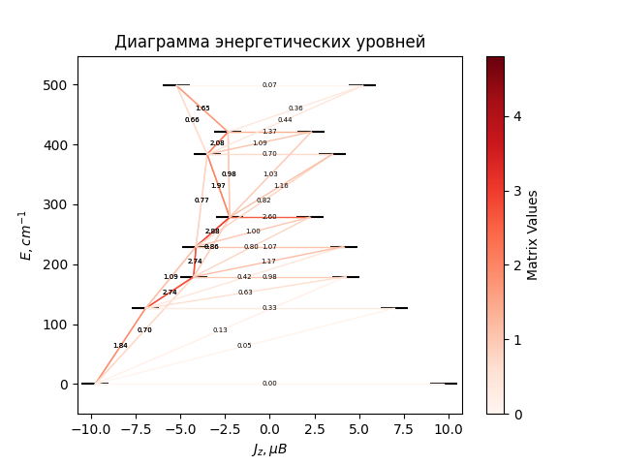

# CF_parameters

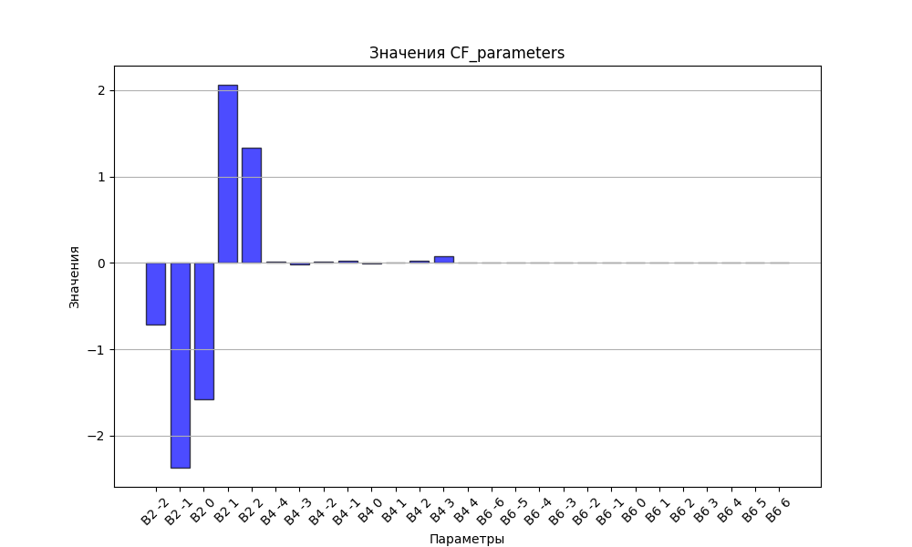

# CHI * T

|  |  |
| --- | --- |
| T | CHI * T |
| 1.0 | 3.6529815 |
| 2.0 | 6.7883977 |
| 3.0 | 8.7660121 |
| 4.0 | 9.8970544 |
| 5.0 | 10.5649213 |
| 6.0 | 10.9844713 |
| 7.0 | 11.2649136 |
| 8.0 | 11.4630833 |
| 9.0 | 11.6100605 |
| 10.0 | 11.7237385 |
| 11.0 | 11.8149161 |
| 12.0 | 11.8903862 |
| 13.0 | 11.9545791 |
| 14.0 | 12.0104763 |
| 15.0 | 12.0601391 |
| 16.0 | 12.1050267 |
| 17.0 | 12.1461933 |
| 18.0 | 12.1844139 |
| 19.0 | 12.2202668 |
| 20.0 | 12.2541895 |
| 21.0 | 12.2865163 |
| 22.0 | 12.3175054 |
| 23.0 | 12.3473579 |
| 24.0 | 12.3762314 |
| 25.0 | 12.4042504 |
| 26.0 | 12.431514 |
| 27.0 | 12.458101 |
| 28.0 | 12.4840752 |
| 29.0 | 12.5094877 |
| 30.0 | 12.5343804 |
| 31.0 | 12.5587873 |
| 32.0 | 12.5827364 |
| 33.0 | 12.606251 |
| 34.0 | 12.6293504 |
| 35.0 | 12.6520509 |
| 36.0 | 12.6743662 |
| 37.0 | 12.696308 |
| 38.0 | 12.7178867 |
| 39.0 | 12.739111 |
| 40.0 | 12.7599888 |
| 41.0 | 12.7805271 |
| 42.0 | 12.8007321 |
| 43.0 | 12.8206098 |
| 44.0 | 12.8401654 |
| 45.0 | 12.8594038 |
| 46.0 | 12.8783299 |
| 47.0 | 12.896948 |
| 48.0 | 12.9152626 |
| 49.0 | 12.9332776 |
| 50.0 | 12.9509973 |
| 51.0 | 12.9684255 |
| 52.0 | 12.9855662 |
| 53.0 | 13.0024232 |
| 54.0 | 13.0190005 |
| 55.0 | 13.0353017 |
| 56.0 | 13.0513307 |
| 57.0 | 13.0670913 |
| 58.0 | 13.0825872 |
| 59.0 | 13.0978222 |
| 60.0 | 13.1128001 |
| 61.0 | 13.1275247 |
| 62.0 | 13.1419998 |
| 63.0 | 13.156229 |
| 64.0 | 13.1702162 |
| 65.0 | 13.1839652 |
| 66.0 | 13.1974797 |
| 67.0 | 13.2107634 |
| 68.0 | 13.2238201 |
| 69.0 | 13.2366535 |
| 70.0 | 13.2492673 |
| 71.0 | 13.2616652 |
| 72.0 | 13.273851 |
| 73.0 | 13.2858282 |
| 74.0 | 13.2976004 |
| 75.0 | 13.3091713 |
| 76.0 | 13.3205444 |
| 77.0 | 13.3317233 |
| 78.0 | 13.3427114 |
| 79.0 | 13.3535122 |
| 80.0 | 13.3641292 |
| 81.0 | 13.3745657 |
| 82.0 | 13.384825 |
| 83.0 | 13.3949105 |
| 84.0 | 13.4048255 |
| 85.0 | 13.414573 |
| 86.0 | 13.4241564 |
| 87.0 | 13.4335786 |
| 88.0 | 13.4428429 |
| 89.0 | 13.4519521 |
| 90.0 | 13.4609093 |
| 91.0 | 13.4697174 |
| 92.0 | 13.4783793 |
| 93.0 | 13.4868977 |
| 94.0 | 13.4952756 |
| 95.0 | 13.5035155 |
| 96.0 | 13.5116202 |
| 97.0 | 13.5195923 |
| 98.0 | 13.5274344 |
| 99.0 | 13.5351489 |
| 100.0 | 13.5427384 |
| 101.0 | 13.5502054 |
| 102.0 | 13.5575521 |
| 103.0 | 13.564781 |
| 104.0 | 13.5718942 |
| 105.0 | 13.5788941 |
| 106.0 | 13.5857829 |
| 107.0 | 13.5925627 |
| 108.0 | 13.5992356 |
| 109.0 | 13.6058036 |
| 110.0 | 13.6122689 |
| 111.0 | 13.6186333 |
| 112.0 | 13.6248988 |
| 113.0 | 13.6310674 |
| 114.0 | 13.6371408 |
| 115.0 | 13.6431208 |
| 116.0 | 13.6490094 |
| 117.0 | 13.6548081 |
| 118.0 | 13.6605187 |
| 119.0 | 13.6661429 |
| 120.0 | 13.6716823 |
| 121.0 | 13.6771385 |
| 122.0 | 13.6825131 |
| 123.0 | 13.6878075 |
| 124.0 | 13.6930233 |
| 125.0 | 13.6981619 |
| 126.0 | 13.7032249 |
| 127.0 | 13.7082134 |
| 128.0 | 13.7131291 |
| 129.0 | 13.7179731 |
| 130.0 | 13.7227468 |
| 131.0 | 13.7274516 |
| 132.0 | 13.7320885 |
| 133.0 | 13.736659 |
| 134.0 | 13.7411641 |
| 135.0 | 13.7456051 |
| 136.0 | 13.7499831 |
| 137.0 | 13.7542992 |
| 138.0 | 13.7585546 |
| 139.0 | 13.7627503 |
| 140.0 | 13.7668874 |
| 141.0 | 13.770967 |
| 142.0 | 13.77499 |
| 143.0 | 13.7789574 |
| 144.0 | 13.7828703 |
| 145.0 | 13.7867295 |
| 146.0 | 13.7905361 |
| 147.0 | 13.7942909 |
| 148.0 | 13.7979947 |
| 149.0 | 13.8016486 |
| 150.0 | 13.8052534 |
| 151.0 | 13.8088098 |
| 152.0 | 13.8123188 |
| 153.0 | 13.8157811 |
| 154.0 | 13.8191975 |
| 155.0 | 13.8225689 |
| 156.0 | 13.8258959 |
| 157.0 | 13.8291793 |
| 158.0 | 13.8324198 |
| 159.0 | 13.8356183 |
| 160.0 | 13.8387752 |
| 161.0 | 13.8418914 |
| 162.0 | 13.8449676 |
| 163.0 | 13.8480043 |
| 164.0 | 13.8510022 |
| 165.0 | 13.8539621 |
| 166.0 | 13.8568844 |
| 167.0 | 13.8597698 |
| 168.0 | 13.8626189 |
| 169.0 | 13.8654323 |
| 170.0 | 13.8682105 |
| 171.0 | 13.8709542 |
| 172.0 | 13.8736639 |
| 173.0 | 13.87634 |
| 174.0 | 13.8789833 |
| 175.0 | 13.8815941 |
| 176.0 | 13.8841731 |
| 177.0 | 13.8867206 |
| 178.0 | 13.8892372 |
| 179.0 | 13.8917235 |
| 180.0 | 13.8941797 |
| 181.0 | 13.8966065 |
| 182.0 | 13.8990043 |
| 183.0 | 13.9013735 |
| 184.0 | 13.9037146 |
| 185.0 | 13.906028 |
| 186.0 | 13.9083141 |
| 187.0 | 13.9105734 |
| 188.0 | 13.9128063 |
| 189.0 | 13.9150131 |
| 190.0 | 13.9171943 |
| 191.0 | 13.9193502 |
| 192.0 | 13.9214813 |
| 193.0 | 13.9235878 |
| 194.0 | 13.9256703 |
| 195.0 | 13.9277289 |
| 196.0 | 13.9297642 |
| 197.0 | 13.9317764 |
| 198.0 | 13.9337659 |
| 199.0 | 13.935733 |
| 200.0 | 13.937678 |
| 201.0 | 13.9396013 |
| 202.0 | 13.9415033 |
| 203.0 | 13.9433841 |
| 204.0 | 13.9452441 |
| 205.0 | 13.9470837 |
| 206.0 | 13.948903 |
| 207.0 | 13.9507025 |
| 208.0 | 13.9524824 |
| 209.0 | 13.9542429 |
| 210.0 | 13.9559844 |
| 211.0 | 13.9577071 |
| 212.0 | 13.9594113 |
| 213.0 | 13.9610973 |
| 214.0 | 13.9627653 |
| 215.0 | 13.9644155 |
| 216.0 | 13.9660483 |
| 217.0 | 13.9676638 |
| 218.0 | 13.9692624 |
| 219.0 | 13.9708442 |
| 220.0 | 13.9724095 |
| 221.0 | 13.9739585 |
| 222.0 | 13.9754914 |
| 223.0 | 13.9770085 |
| 224.0 | 13.97851 |
| 225.0 | 13.979996 |
| 226.0 | 13.9814669 |
| 227.0 | 13.9829228 |
| 228.0 | 13.9843639 |
| 229.0 | 13.9857905 |
| 230.0 | 13.9872026 |
| 231.0 | 13.9886006 |
| 232.0 | 13.9899846 |
| 233.0 | 13.9913548 |
| 234.0 | 13.9927113 |
| 235.0 | 13.9940545 |
| 236.0 | 13.9953843 |
| 237.0 | 13.9967011 |
| 238.0 | 13.998005 |
| 239.0 | 13.9992962 |
| 240.0 | 14.0005748 |
| 241.0 | 14.001841 |
| 242.0 | 14.003095 |
| 243.0 | 14.0043369 |
| 244.0 | 14.0055669 |
| 245.0 | 14.0067851 |
| 246.0 | 14.0079917 |
| 247.0 | 14.0091869 |
| 248.0 | 14.0103708 |
| 249.0 | 14.0115435 |
| 250.0 | 14.0127052 |
| 251.0 | 14.013856 |
| 252.0 | 14.0149961 |
| 253.0 | 14.0161256 |
| 254.0 | 14.0172446 |
| 255.0 | 14.0183533 |
| 256.0 | 14.0194519 |
| 257.0 | 14.0205403 |
| 258.0 | 14.0216188 |
| 259.0 | 14.0226875 |
| 260.0 | 14.0237466 |
| 261.0 | 14.024796 |
| 262.0 | 14.025836 |
| 263.0 | 14.0268667 |
| 264.0 | 14.0278882 |
| 265.0 | 14.0289006 |
| 266.0 | 14.029904 |
| 267.0 | 14.0308985 |
| 268.0 | 14.0318842 |
| 269.0 | 14.0328613 |
| 270.0 | 14.0338299 |
| 271.0 | 14.03479 |
| 272.0 | 14.0357418 |
| 273.0 | 14.0366853 |
| 274.0 | 14.0376207 |
| 275.0 | 14.038548 |
| 276.0 | 14.0394675 |
| 277.0 | 14.040379 |
| 278.0 | 14.0412828 |
| 279.0 | 14.042179 |
| 280.0 | 14.0430676 |
| 281.0 | 14.0439487 |
| 282.0 | 14.0448224 |
| 283.0 | 14.0456889 |
| 284.0 | 14.0465481 |
| 285.0 | 14.0474002 |
| 286.0 | 14.0482452 |
| 287.0 | 14.0490833 |

# H_B_df

|  |  |  |  |
| --- | --- | --- | --- |
| H(T) | B(T_1) | B(T_2) | B(T_3) |
| 0.0001 | 0.0010697663 | 0.0005369253 | 0.0003593116 |

# WAVE FUNCTIONS

|  |  |  |  |  |  |  |  |  |
| --- | --- | --- | --- | --- | --- | --- | --- | --- |
| Label | +-15/2> | +-13/2> | +-11/2> | +-9/2> | +-7/2> | +-5/2> | +-3/2> | +-1/2> |
| KD1 | 93 | 0 | 5 | 1 | 0 | 0 | 0 | 0 |
| KD2 | 1 | 57 | 6 | 16 | 9 | 5 | 5 | 3 |
| KD3 | 1 | 24 | 9 | 4 | 16 | 16 | 14 | 17 |
| KD4 | 2 | 5 | 32 | 14 | 14 | 12 | 11 | 11 |
| KD5 | 1 | 2 | 17 | 11 | 5 | 18 | 22 | 24 |
| KD6 | 0 | 1 | 13 | 18 | 21 | 14 | 18 | 15 |
| KD7 | 1 | 3 | 2 | 15 | 11 | 18 | 22 | 28 |
| KD8 | 2 | 8 | 17 | 21 | 25 | 18 | 7 | 2 |