# UMITOB_d4d

# PSEUDOSPIN HAMILTONIAN TENSORS

|  |  |  |
| --- | --- | --- |
| g_x | g_y | g_z |
| 0.00403936385402 | 0.00517745442891 | 19.63167880819327 |
| 0.04727229024611 | 0.09068751308493 | 15.97606842040525 |
| 0.80859446759643 | 0.95557212569145 | 13.54678797862457 |
| 2.37288062429347 | 3.98719568578849 | 9.24687150068099 |
| 3.15290992482824 | 5.28067059859103 | 12.83288919221292 |
| 0.18065062785755 | 0.2047483774225 | 19.36972840309954 |
| 0.0613448946482 | 0.1299919126958 | 17.44650950218715 |
| 0.02091827805395 | 0.0553625249101 | 19.07784887964389 |

# AB INITIO BLOCKING BARRIER

|  |  |  |  |
| --- | --- | --- | --- |
| KD | l+, muB | l-, muB | E, cm-1 |
| 1.0 | -9.8158394 | 9.8158394 | 0.0 |
| 2.0 | -7.9358693 | 7.9358693 | 163.8865735 |
| 3.0 | -5.6421818 | 5.6421818 | 235.4936511 |
| 4.0 | -3.6608772 | 3.6608772 | 279.3396949 |
| 5.0 | -2.1557458 | 2.1557458 | 311.3928144 |
| 6.0 | -4.0167381 | 4.0167381 | 398.1707356 |
| 7.0 | -1.9744068 | 1.9744068 | 433.756496 |
| 8.0 | -5.4267823 | 5.4267823 | 535.0941191 |

# QTM, ORBACH, MATRIX ELEMENTS

|  |  |  |  |  |  |  |  |
| --- | --- | --- | --- | --- | --- | --- | --- |
| 0 | 1 | 2 | 3 | 4 | 5 | 6 | 7 |
| 0.00153613638049 | 0.00607885309968 | 0.0174290458353 | 0.0755671098171 | 0.08268527415 | 0.0394784965192 | 0.0140339443869 | 0.00526268843472 |
| 0.0 | 0.02419107986 | 0.0791445629366 | 0.289163170932 | 0.255042756819 | 0.0870975205637 | 0.136839477244 | 0.0341343396764 |
| 0.0 | 0.0 | 0.32386039737 | 0.723187315038 | 0.461303605282 | 0.0760322311089 | 0.534648153152 | 0.133258101171 |
| 0.0 | 0.0 | 0.0 | 1.16841106088 | 1.38598375295 | 0.298404257978 | 1.01015438581 | 0.20769830214 |
| 0.0 | 0.0 | 0.0 | 0.0 | 2.51808442588 | 0.719533284259 | 0.948987712501 | 0.475877640304 |
| 0.0 | 0.0 | 0.0 | 0.0 | 0.0 | 0.112793149674 | 0.19359615083 | 0.463986425314 |
| 0.0 | 0.0 | 0.0 | 0.0 | 0.0 | 0.0 | 0.0718368310997 | 0.044672791895 |
| 0.0 | 0.0 | 0.0 | 0.0 | 0.0 | 0.0 | 0.0 | 0.0164556928475 |

# DIRECT MATRIX ELEMENTS

|  |  |  |  |  |  |  |  |
| --- | --- | --- | --- | --- | --- | --- | --- |
| 0 | 1 | 2 | 3 | 4 | 5 | 6 | 7 |
| 3.27194646803 | 1.90409912163 | 0.406856429023 | 0.282231489062 | 0.184930255115 | 0.133334476756 | 0.210526036685 | 0.331596955666 |
| 0.0 | 3.06581738037 | 2.50784298343 | 1.06949133253 | 0.604876889035 | 0.33305980614 | 0.502737948237 | 0.597076193651 |
| 0.0 | 0.0 | 3.57074069612 | 2.91542365493 | 1.0464440803 | 0.569463196403 | 0.654143243427 | 0.622085928384 |
| 0.0 | 0.0 | 0.0 | 2.40012926499 | 2.89115417386 | 0.811219263098 | 1.25575478832 | 0.768737131922 |
| 0.0 | 0.0 | 0.0 | 0.0 | 2.38179579926 | 1.89129138781 | 1.15810891456 | 0.446858468758 |
| 0.0 | 0.0 | 0.0 | 0.0 | 0.0 | 5.42250878179 | 0.546643889609 | 0.127397770223 |
| 0.0 | 0.0 | 0.0 | 0.0 | 0.0 | 0.0 | 4.02140430865 | 2.07576509091 |
| 0.0 | 0.0 | 0.0 | 0.0 | 0.0 | 0.0 | 0.0 | 5.35186638229 |

# Diagram

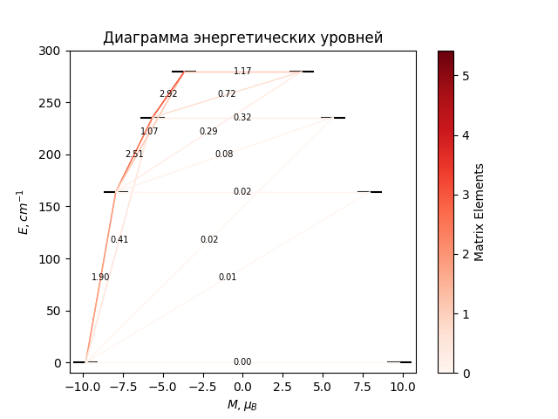

# CF_parameters

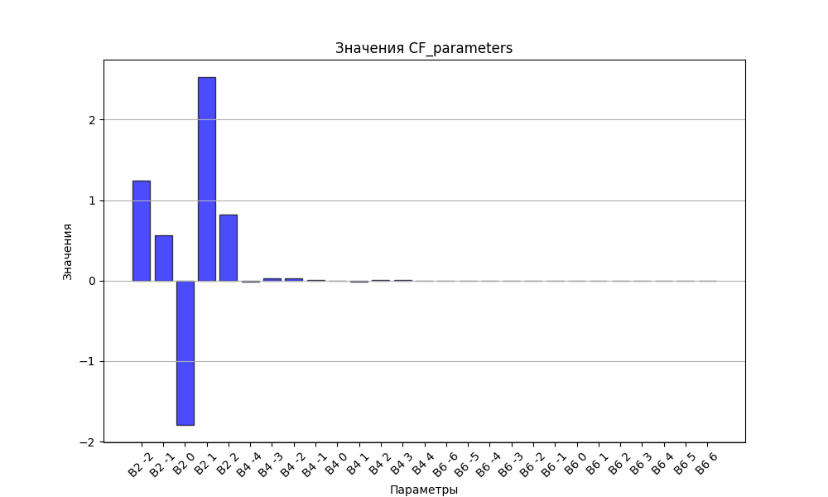

# CHI * T

|  |  |
| --- | --- |
| T | CHI * T |
| 1.0 | 3.6678252 |
| 2.0 | 6.8271608 |
| 3.0 | 8.8281587 |
| 4.0 | 9.974256 |
| 5.0 | 10.6500962 |
| 6.0 | 11.0730496 |
| 7.0 | 11.3540749 |
| 8.0 | 11.5510617 |
| 9.0 | 11.6957161 |
| 10.0 | 11.8063113 |
| 11.0 | 11.8938836 |
| 12.0 | 11.9653793 |
| 13.0 | 12.0253309 |
| 14.0 | 12.0767907 |
| 15.0 | 12.1218708 |
| 16.0 | 12.1620686 |
| 17.0 | 12.1984682 |
| 18.0 | 12.2318695 |
| 19.0 | 12.2628723 |
| 20.0 | 12.2919328 |
| 21.0 | 12.3194028 |
| 22.0 | 12.3455561 |
| 23.0 | 12.3706083 |
| 24.0 | 12.3947304 |
| 25.0 | 12.4180589 |
| 26.0 | 12.4407036 |
| 27.0 | 12.4627532 |
| 28.0 | 12.4842797 |
| 29.0 | 12.5053416 |
| 30.0 | 12.5259869 |
| 31.0 | 12.5462547 |
| 32.0 | 12.5661773 |
| 33.0 | 12.5857811 |
| 34.0 | 12.6050879 |
| 35.0 | 12.6241158 |
| 36.0 | 12.6428798 |
| 37.0 | 12.6613921 |
| 38.0 | 12.6796632 |
| 39.0 | 12.6977017 |
| 40.0 | 12.7155146 |
| 41.0 | 12.7331082 |
| 42.0 | 12.7504876 |
| 43.0 | 12.7676571 |
| 44.0 | 12.7846206 |
| 45.0 | 12.8013814 |
| 46.0 | 12.8179423 |
| 47.0 | 12.8343059 |
| 48.0 | 12.8504746 |
| 49.0 | 12.8664505 |
| 50.0 | 12.8822355 |
| 51.0 | 12.8978315 |
| 52.0 | 12.9132402 |
| 53.0 | 12.9284632 |
| 54.0 | 12.9435023 |
| 55.0 | 12.9583589 |
| 56.0 | 12.9730347 |
| 57.0 | 12.9875311 |
| 58.0 | 13.0018497 |
| 59.0 | 13.015992 |
| 60.0 | 13.0299596 |
| 61.0 | 13.0437539 |
| 62.0 | 13.0573765 |
| 63.0 | 13.0708289 |
| 64.0 | 13.0841127 |
| 65.0 | 13.0972293 |
| 66.0 | 13.1101805 |
| 67.0 | 13.1229676 |
| 68.0 | 13.1355924 |
| 69.0 | 13.1480563 |
| 70.0 | 13.160361 |
| 71.0 | 13.172508 |
| 72.0 | 13.1844989 |
| 73.0 | 13.1963354 |
| 74.0 | 13.208019 |
| 75.0 | 13.2195512 |
| 76.0 | 13.2309339 |
| 77.0 | 13.2421684 |
| 78.0 | 13.2532564 |
| 79.0 | 13.2641995 |
| 80.0 | 13.2749993 |
| 81.0 | 13.2856574 |
| 82.0 | 13.2961753 |
| 83.0 | 13.3065547 |
| 84.0 | 13.3167971 |
| 85.0 | 13.3269041 |
| 86.0 | 13.3368772 |
| 87.0 | 13.346718 |
| 88.0 | 13.3564281 |
| 89.0 | 13.366009 |
| 90.0 | 13.3754622 |
| 91.0 | 13.3847893 |
| 92.0 | 13.3939918 |
| 93.0 | 13.4030712 |
| 94.0 | 13.4120289 |
| 95.0 | 13.4208666 |
| 96.0 | 13.4295856 |
| 97.0 | 13.4381874 |
| 98.0 | 13.4466736 |
| 99.0 | 13.4550455 |
| 100.0 | 13.4633047 |
| 101.0 | 13.4714524 |
| 102.0 | 13.4794903 |
| 103.0 | 13.4874196 |
| 104.0 | 13.4952418 |
| 105.0 | 13.5029582 |
| 106.0 | 13.5105703 |
| 107.0 | 13.5180794 |
| 108.0 | 13.5254869 |
| 109.0 | 13.532794 |
| 110.0 | 13.5400023 |
| 111.0 | 13.5471128 |
| 112.0 | 13.5541271 |
| 113.0 | 13.5610463 |
| 114.0 | 13.5678718 |
| 115.0 | 13.5746048 |
| 116.0 | 13.5812465 |
| 117.0 | 13.5877983 |
| 118.0 | 13.5942614 |
| 119.0 | 13.600637 |
| 120.0 | 13.6069262 |
| 121.0 | 13.6131304 |
| 122.0 | 13.6192507 |
| 123.0 | 13.6252882 |
| 124.0 | 13.6312441 |
| 125.0 | 13.6371196 |
| 126.0 | 13.6429158 |
| 127.0 | 13.6486338 |
| 128.0 | 13.6542747 |
| 129.0 | 13.6598397 |
| 130.0 | 13.6653298 |
| 131.0 | 13.670746 |
| 132.0 | 13.6760895 |
| 133.0 | 13.6813613 |
| 134.0 | 13.6865624 |
| 135.0 | 13.6916939 |
| 136.0 | 13.6967567 |
| 137.0 | 13.7017518 |
| 138.0 | 13.7066803 |
| 139.0 | 13.7115431 |
| 140.0 | 13.7163411 |
| 141.0 | 13.7210753 |
| 142.0 | 13.7257467 |
| 143.0 | 13.7303562 |
| 144.0 | 13.7349046 |
| 145.0 | 13.7393928 |
| 146.0 | 13.7438219 |
| 147.0 | 13.7481925 |
| 148.0 | 13.7525057 |
| 149.0 | 13.7567621 |
| 150.0 | 13.7609628 |
| 151.0 | 13.7651084 |
| 152.0 | 13.7691999 |
| 153.0 | 13.773238 |
| 154.0 | 13.7772235 |
| 155.0 | 13.7811572 |
| 156.0 | 13.7850398 |
| 157.0 | 13.7888722 |
| 158.0 | 13.7926551 |
| 159.0 | 13.7963891 |
| 160.0 | 13.8000751 |
| 161.0 | 13.8037138 |
| 162.0 | 13.8073058 |
| 163.0 | 13.8108519 |
| 164.0 | 13.8143527 |
| 165.0 | 13.8178089 |
| 166.0 | 13.8212212 |
| 167.0 | 13.8245902 |
| 168.0 | 13.8279166 |
| 169.0 | 13.831201 |
| 170.0 | 13.834444 |
| 171.0 | 13.8376463 |
| 172.0 | 13.8408085 |
| 173.0 | 13.8439311 |
| 174.0 | 13.8470148 |
| 175.0 | 13.8500601 |
| 176.0 | 13.8530676 |
| 177.0 | 13.8560378 |
| 178.0 | 13.8589714 |
| 179.0 | 13.8618688 |
| 180.0 | 13.8647307 |
| 181.0 | 13.8675574 |
| 182.0 | 13.8703496 |
| 183.0 | 13.8731077 |
| 184.0 | 13.8758323 |
| 185.0 | 13.8785239 |
| 186.0 | 13.8811829 |
| 187.0 | 13.8838098 |
| 188.0 | 13.8864051 |
| 189.0 | 13.8889692 |
| 190.0 | 13.8915027 |
| 191.0 | 13.894006 |
| 192.0 | 13.8964794 |
| 193.0 | 13.8989236 |
| 194.0 | 13.9013387 |
| 195.0 | 13.9037254 |
| 196.0 | 13.9060841 |
| 197.0 | 13.908415 |
| 198.0 | 13.9107187 |
| 199.0 | 13.9129955 |
| 200.0 | 13.9152458 |
| 201.0 | 13.91747 |
| 202.0 | 13.9196685 |
| 203.0 | 13.9218417 |
| 204.0 | 13.9239899 |
| 205.0 | 13.9261135 |
| 206.0 | 13.9282128 |
| 207.0 | 13.9302882 |
| 208.0 | 13.93234 |
| 209.0 | 13.9343686 |
| 210.0 | 13.9363743 |
| 211.0 | 13.9383574 |
| 212.0 | 13.9403182 |
| 213.0 | 13.9422572 |
| 214.0 | 13.9441745 |
| 215.0 | 13.9460705 |
| 216.0 | 13.9479455 |
| 217.0 | 13.9497998 |
| 218.0 | 13.9516336 |
| 219.0 | 13.9534474 |
| 220.0 | 13.9552413 |
| 221.0 | 13.9570156 |
| 222.0 | 13.9587706 |
| 223.0 | 13.9605066 |
| 224.0 | 13.9622238 |
| 225.0 | 13.9639226 |
| 226.0 | 13.9656031 |
| 227.0 | 13.9672656 |
| 228.0 | 13.9689104 |
| 229.0 | 13.9705377 |
| 230.0 | 13.9721477 |
| 231.0 | 13.9737408 |
| 232.0 | 13.975317 |
| 233.0 | 13.9768768 |
| 234.0 | 13.9784202 |
| 235.0 | 13.9799475 |
| 236.0 | 13.9814589 |
| 237.0 | 13.9829547 |
| 238.0 | 13.9844351 |
| 239.0 | 13.9859002 |
| 240.0 | 13.9873503 |
| 241.0 | 13.9887855 |
| 242.0 | 13.9902062 |
| 243.0 | 13.9916124 |
| 244.0 | 13.9930044 |
| 245.0 | 13.9943823 |
| 246.0 | 13.9957464 |
| 247.0 | 13.9970968 |
| 248.0 | 13.9984338 |
| 249.0 | 13.9997574 |
| 250.0 | 14.0010679 |
| 251.0 | 14.0023655 |
| 252.0 | 14.0036503 |
| 253.0 | 14.0049224 |
| 254.0 | 14.0061822 |
| 255.0 | 14.0074296 |
| 256.0 | 14.0086649 |
| 257.0 | 14.0098882 |
| 258.0 | 14.0110998 |
| 259.0 | 14.0122997 |
| 260.0 | 14.013488 |
| 261.0 | 14.0146651 |
| 262.0 | 14.0158309 |
| 263.0 | 14.0169857 |
| 264.0 | 14.0181295 |
| 265.0 | 14.0192626 |
| 266.0 | 14.020385 |
| 267.0 | 14.0214969 |
| 268.0 | 14.0225985 |
| 269.0 | 14.0236898 |
| 270.0 | 14.024771 |
| 271.0 | 14.0258423 |
| 272.0 | 14.0269037 |
| 273.0 | 14.0279553 |
| 274.0 | 14.0289974 |
| 275.0 | 14.03003 |
| 276.0 | 14.0310532 |
| 277.0 | 14.0320671 |
| 278.0 | 14.033072 |
| 279.0 | 14.0340678 |
| 280.0 | 14.0350547 |
| 281.0 | 14.0360328 |
| 282.0 | 14.0370022 |
| 283.0 | 14.0379631 |
| 284.0 | 14.0389155 |
| 285.0 | 14.0398595 |
| 286.0 | 14.0407952 |
| 287.0 | 14.0417228 |

# H_B_df

|  |  |  |  |
| --- | --- | --- | --- |
| H(T) | B(T_1) | B(T_2) | B(T_3) |
| 0.0001 | 0.0010818112 | 0.0005424778 | 0.0003626999 |

# WAVE FUNCTIONS

|  |  |  |  |  |  |  |  |  |
| --- | --- | --- | --- | --- | --- | --- | --- | --- |
| Label | +-15/2> | +-13/2> | +-11/2> | +-9/2> | +-7/2> | +-5/2> | +-3/2> | +-1/2> |
| KD1 | 94 | 0 | 6 | 0 | 0 | 0 | 0 | 0 |
| KD2 | 0 | 76 | 1 | 22 | 1 | 0 | 0 | 0 |
| KD3 | 2 | 4 | 36 | 7 | 37 | 10 | 1 | 3 |
| KD4 | 1 | 1 | 20 | 8 | 5 | 34 | 26 | 5 |
| KD5 | 0 | 5 | 5 | 14 | 7 | 5 | 21 | 43 |
| KD6 | 0 | 2 | 7 | 18 | 25 | 25 | 13 | 10 |
| KD7 | 1 | 3 | 8 | 5 | 0 | 12 | 33 | 38 |
| KD8 | 2 | 8 | 19 | 26 | 24 | 14 | 5 | 2 |