# XOPLIA

# PSEUDOSPIN HAMILTONIAN TENSORS

|  |  |  |
| --- | --- | --- |
| g_x | g_y | g_z |
| 0.01117071380455 | 0.02941407866541 | 19.41699983329308 |
| 0.40959437340853 | 0.68512251700795 | 16.34194796692324 |
| 1.76452777557497 | 2.26898906359817 | 14.13971383377413 |
| 3.81919213284965 | 5.33691183356422 | 7.51473773726948 |
| 2.10208497623655 | 3.51210809722968 | 11.86878923982526 |
| 0.17676837162751 | 0.20646214232525 | 17.01601519181167 |
| 0.00235715580937 | 0.11122958192932 | 17.81710477462789 |
| 0.01311259836965 | 0.03284103849635 | 19.23587143055086 |

# AB INITIO BLOCKING BARRIER

|  |  |  |  |
| --- | --- | --- | --- |
| KD | l+, muB | l-, muB | E, cm-1 |
| 1.0 | -9.7084999 | 9.7084999 | 0.0 |
| 2.0 | -7.7283229 | 7.7283229 | 106.2432277 |
| 3.0 | -5.7468243 | 5.7468243 | 148.150419 |
| 4.0 | -3.693041 | 3.693041 | 191.6494097 |
| 5.0 | -2.0360915 | 2.0360915 | 235.2944731 |
| 6.0 | -1.5757851 | 1.5757851 | 318.6923634 |
| 7.0 | -0.355924 | 0.355924 | 392.7463338 |
| 8.0 | -5.7886907 | 5.7886907 | 482.6833531 |

# QTM, ORBACH, MATRIX ELEMENTS

|  |  |  |  |  |  |  |  |
| --- | --- | --- | --- | --- | --- | --- | --- |
| 0 | 1 | 2 | 3 | 4 | 5 | 6 | 7 |
| 0.006764132078 | 0.049397096975 | 0.168344769822 | 0.13208184009 | 0.0640275086315 | 0.0458139092342 | 0.0304579199206 | 0.00798089618811 |
| 0.0 | 0.190980506221 | 0.590274918914 | 0.604557888458 | 0.47867860287 | 0.180792814277 | 0.13738702781 | 0.0284280036477 |
| 0.0 | 0.0 | 0.754517277102 | 1.13385703001 | 0.978046558565 | 0.275669072527 | 0.300198316879 | 0.264293421352 |
| 0.0 | 0.0 | 0.0 | 1.55589594588 | 1.51485967698 | 0.722779365564 | 0.439036071925 | 0.240725520279 |
| 0.0 | 0.0 | 0.0 | 0.0 | 1.62682890872 | 0.735078057605 | 0.312871196898 | 0.165230826316 |
| 0.0 | 0.0 | 0.0 | 0.0 | 0.0 | 0.201236023231 | 0.0781572714018 | 0.0954784042593 |
| 0.0 | 0.0 | 0.0 | 0.0 | 0.0 | 0.0 | 0.268366364023 | 0.0669018638014 |
| 0.0 | 0.0 | 0.0 | 0.0 | 0.0 | 0.0 | 0.0 | 0.00943161237942 |

# DIRECT MATRIX ELEMENTS

|  |  |  |  |  |  |  |  |
| --- | --- | --- | --- | --- | --- | --- | --- |
| 0 | 1 | 2 | 3 | 4 | 5 | 6 | 7 |
| 3.23616663888 | 1.87251772918 | 0.773250096609 | 0.550351727209 | 0.327196453736 | 0.177372693647 | 0.214942125222 | 0.428859225529 |
| 0.0 | 3.81827974908 | 2.25904762574 | 1.2459991951 | 0.476067402012 | 0.232796141166 | 0.346758491076 | 0.639582200599 |
| 0.0 | 0.0 | 3.47220999187 | 2.81923852563 | 0.768379387647 | 0.145967508082 | 0.317258332917 | 0.658467249125 |
| 0.0 | 0.0 | 0.0 | 1.45309563204 | 3.05483818841 | 0.814658801362 | 0.745026624607 | 1.01019148932 |
| 0.0 | 0.0 | 0.0 | 0.0 | 2.68717970907 | 2.3531508271 | 1.1917818826 | 0.745934438278 |
| 0.0 | 0.0 | 0.0 | 0.0 | 0.0 | 3.74971497598 | 2.04660649942 | 0.620616575059 |
| 0.0 | 0.0 | 0.0 | 0.0 | 0.0 | 0.0 | 4.2407543719 | 1.68825260264 |
| 0.0 | 0.0 | 0.0 | 0.0 | 0.0 | 0.0 | 0.0 | 5.13331242757 |

# Diagram

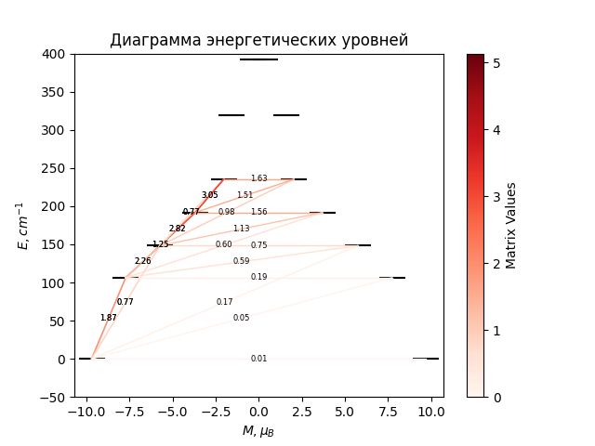

# CF_parameters

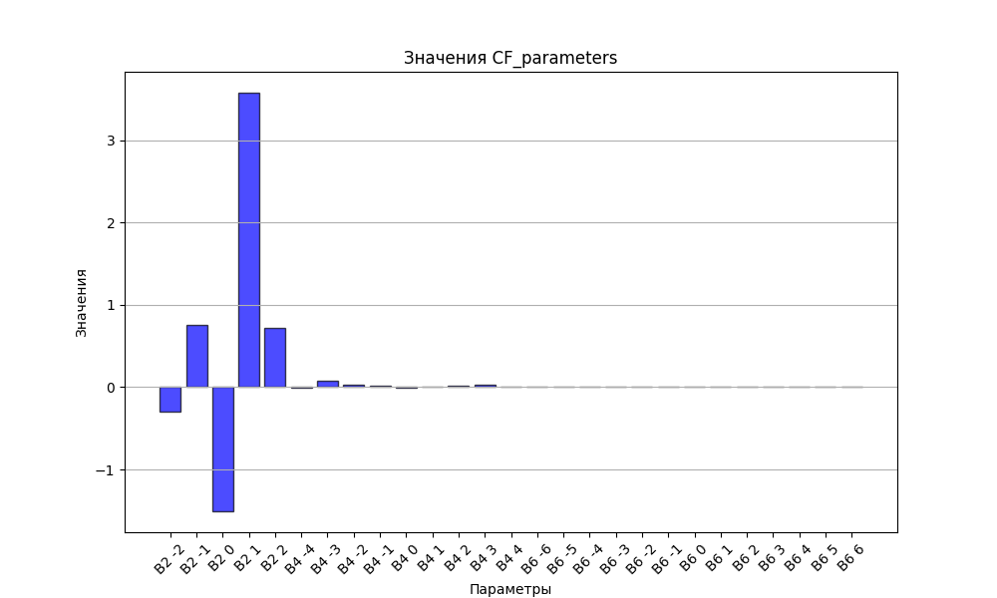

# CHI * T

|  |  |
| --- | --- |
| T | CHI * T |
| 1.0 | 5.1038065 |
| 2.0 | 8.1843707 |
| 3.0 | 9.7500238 |
| 4.0 | 10.5606138 |
| 5.0 | 11.0192116 |
| 6.0 | 11.3038025 |
| 7.0 | 11.4953076 |
| 8.0 | 11.633306 |
| 9.0 | 11.7386299 |
| 10.0 | 11.8229741 |
| 11.0 | 11.8932732 |
| 12.0 | 11.9538329 |
| 13.0 | 12.0074327 |
| 14.0 | 12.0559261 |
| 15.0 | 12.1005834 |
| 16.0 | 12.1422949 |
| 17.0 | 12.1816966 |
| 18.0 | 12.2192497 |
| 19.0 | 12.2552931 |
| 20.0 | 12.2900781 |
| 21.0 | 12.3237929 |
| 22.0 | 12.3565793 |
| 23.0 | 12.3885447 |
| 24.0 | 12.4197712 |
| 25.0 | 12.4503216 |
| 26.0 | 12.4802442 |
| 27.0 | 12.5095766 |
| 28.0 | 12.538348 |
| 29.0 | 12.5665813 |
| 30.0 | 12.5942948 |
| 31.0 | 12.6215029 |
| 32.0 | 12.6482176 |
| 33.0 | 12.6744486 |
| 34.0 | 12.7002044 |
| 35.0 | 12.725492 |
| 36.0 | 12.7503177 |
| 37.0 | 12.7746874 |
| 38.0 | 12.7986063 |
| 39.0 | 12.8220796 |
| 40.0 | 12.8451121 |
| 41.0 | 12.8677087 |
| 42.0 | 12.8898743 |
| 43.0 | 12.9116137 |
| 44.0 | 12.9329318 |
| 45.0 | 12.9538338 |
| 46.0 | 12.9743246 |
| 47.0 | 12.9944095 |
| 48.0 | 13.0140941 |
| 49.0 | 13.0333836 |
| 50.0 | 13.0522838 |
| 51.0 | 13.0708004 |
| 52.0 | 13.0889392 |
| 53.0 | 13.1067062 |
| 54.0 | 13.1241074 |
| 55.0 | 13.141149 |
| 56.0 | 13.1578371 |
| 57.0 | 13.1741779 |
| 58.0 | 13.1901779 |
| 59.0 | 13.2058432 |
| 60.0 | 13.2211804 |
| 61.0 | 13.2361956 |
| 62.0 | 13.2508954 |
| 63.0 | 13.2652861 |
| 64.0 | 13.2793741 |
| 65.0 | 13.2931656 |
| 66.0 | 13.306667 |
| 67.0 | 13.3198844 |
| 68.0 | 13.3328242 |
| 69.0 | 13.3454924 |
| 70.0 | 13.3578951 |
| 71.0 | 13.3700384 |
| 72.0 | 13.381928 |
| 73.0 | 13.3935699 |
| 74.0 | 13.4049698 |
| 75.0 | 13.4161334 |
| 76.0 | 13.4270662 |
| 77.0 | 13.4377737 |
| 78.0 | 13.4482613 |
| 79.0 | 13.4585342 |
| 80.0 | 13.4685976 |
| 81.0 | 13.4784566 |
| 82.0 | 13.4881162 |
| 83.0 | 13.497581 |
| 84.0 | 13.506856 |
| 85.0 | 13.5159458 |
| 86.0 | 13.5248548 |
| 87.0 | 13.5335875 |
| 88.0 | 13.5421483 |
| 89.0 | 13.5505412 |
| 90.0 | 13.5587705 |
| 91.0 | 13.5668402 |
| 92.0 | 13.5747542 |
| 93.0 | 13.5825162 |
| 94.0 | 13.59013 |
| 95.0 | 13.5975992 |
| 96.0 | 13.6049273 |
| 97.0 | 13.6121178 |
| 98.0 | 13.619174 |
| 99.0 | 13.6260992 |
| 100.0 | 13.6328964 |
| 101.0 | 13.6395689 |
| 102.0 | 13.6461195 |
| 103.0 | 13.6525512 |
| 104.0 | 13.6588669 |
| 105.0 | 13.6650693 |
| 106.0 | 13.671161 |
| 107.0 | 13.6771447 |
| 108.0 | 13.6830229 |
| 109.0 | 13.6887982 |
| 110.0 | 13.6944728 |
| 111.0 | 13.7000491 |
| 112.0 | 13.7055294 |
| 113.0 | 13.7109159 |
| 114.0 | 13.7162108 |
| 115.0 | 13.7214161 |
| 116.0 | 13.7265339 |
| 117.0 | 13.7315661 |
| 118.0 | 13.7365147 |
| 119.0 | 13.7413815 |
| 120.0 | 13.7461684 |
| 121.0 | 13.7508771 |
| 122.0 | 13.7555093 |
| 123.0 | 13.7600668 |
| 124.0 | 13.7645511 |
| 125.0 | 13.7689638 |
| 126.0 | 13.7733065 |
| 127.0 | 13.7775807 |
| 128.0 | 13.7817879 |
| 129.0 | 13.7859294 |
| 130.0 | 13.7900067 |
| 131.0 | 13.794021 |
| 132.0 | 13.7979738 |
| 133.0 | 13.8018663 |
| 134.0 | 13.8056998 |
| 135.0 | 13.8094754 |
| 136.0 | 13.8131944 |
| 137.0 | 13.8168578 |
| 138.0 | 13.8204669 |
| 139.0 | 13.8240227 |
| 140.0 | 13.8275263 |
| 141.0 | 13.8309788 |
| 142.0 | 13.834381 |
| 143.0 | 13.8377342 |
| 144.0 | 13.8410391 |
| 145.0 | 13.8442967 |
| 146.0 | 13.847508 |
| 147.0 | 13.8506739 |
| 148.0 | 13.8537952 |
| 149.0 | 13.8568728 |
| 150.0 | 13.8599075 |
| 151.0 | 13.8629001 |
| 152.0 | 13.8658514 |
| 153.0 | 13.8687623 |
| 154.0 | 13.8716333 |
| 155.0 | 13.8744654 |
| 156.0 | 13.8772592 |
| 157.0 | 13.8800153 |
| 158.0 | 13.8827346 |
| 159.0 | 13.8854177 |
| 160.0 | 13.8880651 |
| 161.0 | 13.8906777 |
| 162.0 | 13.8932559 |
| 163.0 | 13.8958005 |
| 164.0 | 13.8983119 |
| 165.0 | 13.9007908 |
| 166.0 | 13.9032378 |
| 167.0 | 13.9056535 |
| 168.0 | 13.9080383 |
| 169.0 | 13.9103928 |
| 170.0 | 13.9127175 |
| 171.0 | 13.9150129 |
| 172.0 | 13.9172797 |
| 173.0 | 13.9195181 |
| 174.0 | 13.9217288 |
| 175.0 | 13.9239121 |
| 176.0 | 13.9260686 |
| 177.0 | 13.9281986 |
| 178.0 | 13.9303027 |
| 179.0 | 13.9323813 |
| 180.0 | 13.9344348 |
| 181.0 | 13.9364635 |
| 182.0 | 13.938468 |
| 183.0 | 13.9404486 |
| 184.0 | 13.9424056 |
| 185.0 | 13.9443395 |
| 186.0 | 13.9462507 |
| 187.0 | 13.9481395 |
| 188.0 | 13.9500063 |
| 189.0 | 13.9518513 |
| 190.0 | 13.9536751 |
| 191.0 | 13.9554778 |
| 192.0 | 13.9572599 |
| 193.0 | 13.9590216 |
| 194.0 | 13.9607633 |
| 195.0 | 13.9624853 |
| 196.0 | 13.9641879 |
| 197.0 | 13.9658713 |
| 198.0 | 13.967536 |
| 199.0 | 13.9691821 |
| 200.0 | 13.97081 |
| 201.0 | 13.9724199 |
| 202.0 | 13.9740121 |
| 203.0 | 13.9755869 |
| 204.0 | 13.9771446 |
| 205.0 | 13.9786853 |
| 206.0 | 13.9802094 |
| 207.0 | 13.981717 |
| 208.0 | 13.9832086 |
| 209.0 | 13.9846841 |
| 210.0 | 13.986144 |
| 211.0 | 13.9875885 |
| 212.0 | 13.9890177 |
| 213.0 | 13.9904318 |
| 214.0 | 13.9918312 |
| 215.0 | 13.993216 |
| 216.0 | 13.9945865 |
| 217.0 | 13.9959428 |
| 218.0 | 13.9972851 |
| 219.0 | 13.9986136 |
| 220.0 | 13.9999286 |
| 221.0 | 14.0012303 |
| 222.0 | 14.0025187 |
| 223.0 | 14.0037941 |
| 224.0 | 14.0050567 |
| 225.0 | 14.0063067 |
| 226.0 | 14.0075443 |
| 227.0 | 14.0087695 |
| 228.0 | 14.0099826 |
| 229.0 | 14.0111838 |
| 230.0 | 14.0123732 |
| 231.0 | 14.0135509 |
| 232.0 | 14.0147172 |
| 233.0 | 14.0158722 |
| 234.0 | 14.017016 |
| 235.0 | 14.0181489 |
| 236.0 | 14.0192708 |
| 237.0 | 14.0203821 |
| 238.0 | 14.0214828 |
| 239.0 | 14.0225731 |
| 240.0 | 14.0236531 |
| 241.0 | 14.0247229 |
| 242.0 | 14.0257827 |
| 243.0 | 14.0268327 |
| 244.0 | 14.0278729 |
| 245.0 | 14.0289035 |
| 246.0 | 14.0299245 |
| 247.0 | 14.0309362 |
| 248.0 | 14.0319387 |
| 249.0 | 14.032932 |
| 250.0 | 14.0339163 |
| 251.0 | 14.0348917 |
| 252.0 | 14.0358584 |
| 253.0 | 14.0368163 |
| 254.0 | 14.0377657 |
| 255.0 | 14.0387067 |
| 256.0 | 14.0396393 |
| 257.0 | 14.0405637 |
| 258.0 | 14.0414799 |
| 259.0 | 14.0423882 |
| 260.0 | 14.0432885 |
| 261.0 | 14.0441809 |
| 262.0 | 14.0450656 |
| 263.0 | 14.0459427 |
| 264.0 | 14.0468123 |
| 265.0 | 14.0476744 |
| 266.0 | 14.0485292 |
| 267.0 | 14.0493767 |
| 268.0 | 14.050217 |
| 269.0 | 14.0510502 |
| 270.0 | 14.0518764 |
| 271.0 | 14.0526957 |
| 272.0 | 14.0535082 |
| 273.0 | 14.054314 |
| 274.0 | 14.055113 |
| 275.0 | 14.0559055 |
| 276.0 | 14.0566915 |
| 277.0 | 14.0574711 |
| 278.0 | 14.0582443 |
| 279.0 | 14.0590112 |
| 280.0 | 14.0597719 |
| 281.0 | 14.0605265 |
| 282.0 | 14.0612751 |
| 283.0 | 14.0620176 |
| 284.0 | 14.0627543 |
| 285.0 | 14.0634851 |
| 286.0 | 14.0642101 |
| 287.0 | 14.0649294 |

# H_B_df

|  |  |  |  |
| --- | --- | --- | --- |
| H(T) | B(T_1) | B(T_2) | B(T_3) |
| 0.0001 | 0.0010602958 | 0.0005326921 | 0.0003568242 |

# WAVE FUNCTIONS

|  |  |  |  |  |  |  |  |  |
| --- | --- | --- | --- | --- | --- | --- | --- | --- |
| Label | +-15/2> | +-13/2> | +-11/2> | +-9/2> | +-7/2> | +-5/2> | +-3/2> | +-1/2> |
| KD1 | 91 | 0 | 7 | 1 | 0 | 0 | 0 | 0 |
| KD2 | 1 | 67 | 13 | 11 | 4 | 2 | 1 | 1 |
| KD3 | 2 | 8 | 32 | 35 | 10 | 2 | 7 | 4 |
| KD4 | 2 | 6 | 14 | 9 | 31 | 20 | 7 | 12 |
| KD5 | 0 | 2 | 6 | 13 | 23 | 25 | 17 | 15 |
| KD6 | 0 | 0 | 1 | 4 | 12 | 34 | 36 | 13 |
| KD7 | 1 | 3 | 4 | 3 | 4 | 7 | 27 | 53 |
| KD8 | 3 | 14 | 24 | 24 | 16 | 10 | 6 | 3 |