# alisuk.log

# PSEUDOSPIN HAMILTONIAN TENSORS

|  |  |  |  |
| --- | --- | --- | --- |
| KD | g_x | g_y | g_z |
| 1.0 | 0.01941668769131 | 0.03988137378431 | 19.31842784619342 |
| 2.0 | 0.34863787539434 | 0.64416325210458 | 15.19867838522426 |
| 3.0 | 2.46873719943745 | 2.81524590347275 | 11.94146594492686 |
| 4.0 | 8.1382907033806 | 6.13429675640041 | 3.75431216226056 |
| 5.0 | 1.32965316666144 | 2.76047374430984 | 11.8060815252074 |
| 6.0 | 1.41186634032786 | 4.43656057866932 | 14.45338304444804 |
| 7.0 | 0.00517399392927 | 0.04241209050934 | 19.02203533753756 |
| 8.0 | 0.01094795569725 | 0.02881209922216 | 19.62187457149689 |

# AB INITIO BLOCKING BARRIER

|  |  |  |  |
| --- | --- | --- | --- |
| KD | l+, muB | l-, muB | E, cm-1 |
| 1.0 | -9.6592139 | 9.6592139 | 0.0 |
| 2.0 | -7.4449482 | 7.4449482 | 119.9778308 |
| 3.0 | -4.1478947 | 4.1478947 | 180.8385401 |
| 4.0 | -2.9972874 | 2.9972874 | 219.139525 |
| 5.0 | -2.726773 | 2.726773 | 267.6622351 |
| 6.0 | -1.231972 | 1.231972 | 282.3206202 |
| 7.0 | -0.6283164 | 0.6283164 | 427.7584189 |
| 8.0 | -5.7579855 | 5.7579855 | 518.8704967 |

# QTM, ORBACH, MTRIX ELEMENTS

|  |  |  |  |  |  |  |  |
| --- | --- | --- | --- | --- | --- | --- | --- |
| 1+ | 2+ | 3+ | 4+ | 5+ | 6+ | 7+ | 8+ |
| 0.00988301024596 | 0.036101825166 | 0.110258599925 | 0.150693450584 | 0.194143454822 | 0.161833515199 | 0.129167912404 | 0.0104548441656 |
| 0.0 | 0.167716674894 | 0.207771096334 | 0.550082808299 | 0.343651074127 | 0.527358799508 | 0.217869247941 | 0.0256621452053 |
| 0.0 | 0.0 | 1.08764991379 | 1.00928786463 | 0.682922942916 | 0.491668637477 | 0.256093486011 | 0.0893117011224 |
| 0.0 | 0.0 | 0.0 | 2.09941760421 | 1.7339383746 | 1.14150349827 | 0.225694330319 | 0.41589229114 |
| 0.0 | 0.0 | 0.0 | 0.0 | 1.30140299546 | 1.59469356133 | 0.504426011505 | 0.548811032338 |
| 0.0 | 0.0 | 0.0 | 0.0 | 0.0 | 2.7611893714 | 1.0271204424 | 0.73444219639 |
| 0.0 | 0.0 | 0.0 | 0.0 | 0.0 | 0.0 | 0.0896589508301 | 1.36853505687 |
| 0.0 | 0.0 | 0.0 | 0.0 | 0.0 | 0.0 | 0.0 | 0.0088245728699 |

# DIRECT MTRIX ELEMENTS

|  |  |  |  |  |  |  |  |
| --- | --- | --- | --- | --- | --- | --- | --- |
| 0 | 1 | 2 | 3 | 4 | 5 | 6 | 7 |
| 3.21973797437 | 1.98103675653 | 0.497014841681 | 0.432788093749 | 0.136405633978 | 0.203043523695 | 0.0610024362687 | 0.322804811614 |
| 0.0 | 3.14010536559 | 2.70567742671 | 1.14617633351 | 0.476775685187 | 0.340632330652 | 0.158688791058 | 0.56805501823 |
| 0.0 | 0.0 | 2.85203096162 | 3.11864028873 | 0.632806327974 | 0.868850668357 | 0.250830827097 | 0.71864902151 |
| 0.0 | 0.0 | 0.0 | 1.22514765586 | 2.52034792415 | 0.831917345262 | 0.33903983972 | 0.811309394443 |
| 0.0 | 0.0 | 0.0 | 0.0 | 2.73231212451 | 2.72424423122 | 1.23435789315 | 0.509099258622 |
| 0.0 | 0.0 | 0.0 | 0.0 | 0.0 | 1.94376977028 | 1.16096342083 | 0.615038439667 |
| 0.0 | 0.0 | 0.0 | 0.0 | 0.0 | 0.0 | 4.36263743015 | 0.0362300976898 |
| 0.0 | 0.0 | 0.0 | 0.0 | 0.0 | 0.0 | 0.0 | 5.34084629599 |

# Energy_diagram

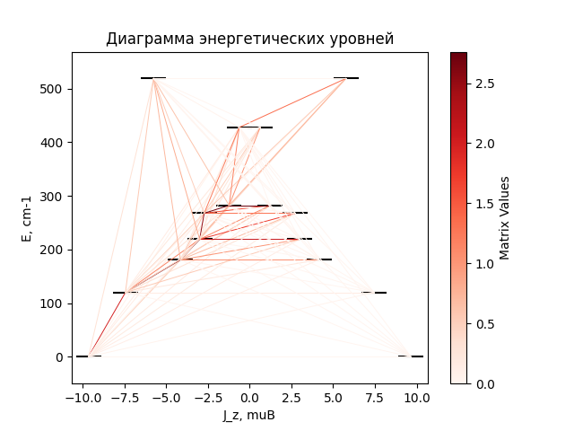

# CF_parameters

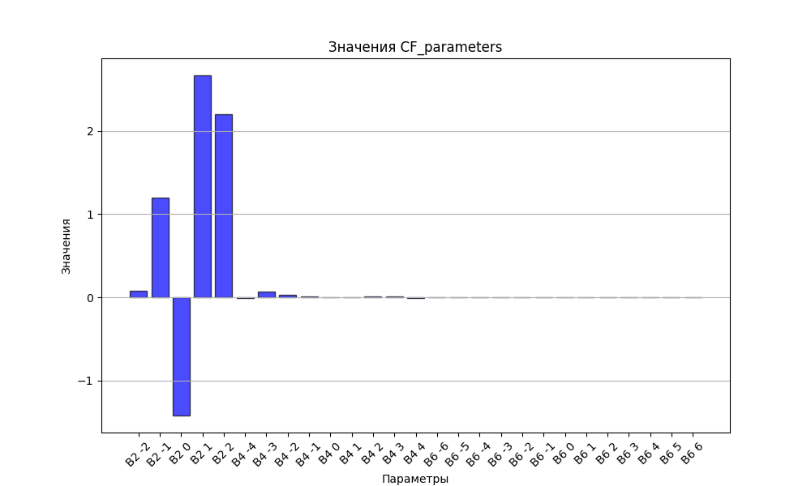

# CHI * T

|  |  |
| --- | --- |
| T | CHI * T |
| 1.0 | 4.5300308 |
| 2.0 | 7.6111102 |
| 3.0 | 9.3043736 |
| 4.0 | 10.2138077 |
| 5.0 | 10.7365081 |
| 6.0 | 11.0624391 |
| 7.0 | 11.2813777 |
| 8.0 | 11.4381958 |
| 9.0 | 11.5568286 |
| 10.0 | 11.6508319 |
| 11.0 | 11.7282935 |
| 12.0 | 11.794259 |
| 13.0 | 11.8519979 |
| 14.0 | 11.9036989 |
| 15.0 | 11.9508676 |
| 16.0 | 11.9945647 |
| 17.0 | 12.0355516 |
| 18.0 | 12.0743838 |
| 19.0 | 12.1114725 |
| 20.0 | 12.1471246 |
| 21.0 | 12.1815719 |
| 22.0 | 12.21499 |
| 23.0 | 12.2475135 |
| 24.0 | 12.2792453 |
| 25.0 | 12.310265 |
| 26.0 | 12.3406343 |
| 27.0 | 12.3704011 |
| 28.0 | 12.3996029 |
| 29.0 | 12.4282696 |
| 30.0 | 12.4564246 |
| 31.0 | 12.484087 |
| 32.0 | 12.5112723 |
| 33.0 | 12.5379933 |
| 34.0 | 12.5642611 |
| 35.0 | 12.5900849 |
| 36.0 | 12.6154731 |
| 37.0 | 12.6404331 |
| 38.0 | 12.6649717 |
| 39.0 | 12.6890953 |
| 40.0 | 12.7128101 |
| 41.0 | 12.7361218 |
| 42.0 | 12.7590362 |
| 43.0 | 12.7815587 |
| 44.0 | 12.8036948 |
| 45.0 | 12.82545 |
| 46.0 | 12.8468294 |
| 47.0 | 12.8678385 |
| 48.0 | 12.8884824 |
| 49.0 | 12.9087665 |
| 50.0 | 12.9286958 |
| 51.0 | 12.9482756 |
| 52.0 | 12.9675109 |
| 53.0 | 12.9864069 |
| 54.0 | 13.0049687 |
| 55.0 | 13.0232012 |
| 56.0 | 13.0411095 |
| 57.0 | 13.0586985 |
| 58.0 | 13.0759731 |
| 59.0 | 13.0929383 |
| 60.0 | 13.1095989 |
| 61.0 | 13.1259597 |
| 62.0 | 13.1420254 |
| 63.0 | 13.1578009 |
| 64.0 | 13.1732907 |
| 65.0 | 13.1884997 |
| 66.0 | 13.2034324 |
| 67.0 | 13.2180933 |
| 68.0 | 13.2324871 |
| 69.0 | 13.2466182 |
| 70.0 | 13.2604912 |
| 71.0 | 13.2741103 |
| 72.0 | 13.2874801 |
| 73.0 | 13.3006048 |
| 74.0 | 13.3134889 |
| 75.0 | 13.3261364 |
| 76.0 | 13.3385517 |
| 77.0 | 13.3507389 |
| 78.0 | 13.3627021 |
| 79.0 | 13.3744455 |
| 80.0 | 13.3859731 |
| 81.0 | 13.3972888 |
| 82.0 | 13.4083966 |
| 83.0 | 13.4193004 |
| 84.0 | 13.430004 |
| 85.0 | 13.4405113 |
| 86.0 | 13.450826 |
| 87.0 | 13.4609517 |
| 88.0 | 13.4708922 |
| 89.0 | 13.480651 |
| 90.0 | 13.4902317 |
| 91.0 | 13.4996377 |
| 92.0 | 13.5088725 |
| 93.0 | 13.5179394 |
| 94.0 | 13.5268419 |
| 95.0 | 13.5355831 |
| 96.0 | 13.5441663 |
| 97.0 | 13.5525946 |
| 98.0 | 13.5608713 |
| 99.0 | 13.5689992 |
| 100.0 | 13.5769815 |
| 101.0 | 13.5848211 |
| 102.0 | 13.5925209 |
| 103.0 | 13.6000837 |
| 104.0 | 13.6075124 |
| 105.0 | 13.6148096 |
| 106.0 | 13.6219781 |
| 107.0 | 13.6290204 |
| 108.0 | 13.6359393 |
| 109.0 | 13.6427371 |
| 110.0 | 13.6494165 |
| 111.0 | 13.6559798 |
| 112.0 | 13.6624295 |
| 113.0 | 13.6687678 |
| 114.0 | 13.6749971 |
| 115.0 | 13.6811196 |
| 116.0 | 13.6871375 |
| 117.0 | 13.6930529 |
| 118.0 | 13.698868 |
| 119.0 | 13.7045848 |
| 120.0 | 13.7102054 |
| 121.0 | 13.7157316 |
| 122.0 | 13.7211655 |
| 123.0 | 13.726509 |
| 124.0 | 13.7317638 |
| 125.0 | 13.7369318 |
| 126.0 | 13.7420148 |
| 127.0 | 13.7470145 |
| 128.0 | 13.7519326 |
| 129.0 | 13.7567708 |
| 130.0 | 13.7615306 |
| 131.0 | 13.7662137 |
| 132.0 | 13.7708215 |
| 133.0 | 13.7753557 |
| 134.0 | 13.7798177 |
| 135.0 | 13.784209 |
| 136.0 | 13.7885309 |
| 137.0 | 13.7927849 |
| 138.0 | 13.7969723 |
| 139.0 | 13.8010944 |
| 140.0 | 13.8051525 |
| 141.0 | 13.809148 |
| 142.0 | 13.8130819 |
| 143.0 | 13.8169556 |
| 144.0 | 13.8207702 |
| 145.0 | 13.8245269 |
| 146.0 | 13.8282268 |
| 147.0 | 13.831871 |
| 148.0 | 13.8354607 |
| 149.0 | 13.8389967 |
| 150.0 | 13.8424802 |
| 151.0 | 13.8459123 |
| 152.0 | 13.8492938 |
| 153.0 | 13.8526257 |
| 154.0 | 13.8559091 |
| 155.0 | 13.8591448 |
| 156.0 | 13.8623336 |
| 157.0 | 13.8654766 |
| 158.0 | 13.8685746 |
| 159.0 | 13.8716283 |
| 160.0 | 13.8746387 |
| 161.0 | 13.8776065 |
| 162.0 | 13.8805326 |
| 163.0 | 13.8834176 |
| 164.0 | 13.8862624 |
| 165.0 | 13.8890678 |
| 166.0 | 13.8918343 |
| 167.0 | 13.8945628 |
| 168.0 | 13.8972539 |
| 169.0 | 13.8999083 |
| 170.0 | 13.9025267 |
| 171.0 | 13.9051097 |
| 172.0 | 13.9076579 |
| 173.0 | 13.910172 |
| 174.0 | 13.9126526 |
| 175.0 | 13.9151003 |
| 176.0 | 13.9175156 |
| 177.0 | 13.9198991 |
| 178.0 | 13.9222515 |
| 179.0 | 13.9245731 |
| 180.0 | 13.9268647 |
| 181.0 | 13.9291266 |
| 182.0 | 13.9313594 |
| 183.0 | 13.9335637 |
| 184.0 | 13.9357398 |
| 185.0 | 13.9378883 |
| 186.0 | 13.9400097 |
| 187.0 | 13.9421044 |
| 188.0 | 13.9441728 |
| 189.0 | 13.9462155 |
| 190.0 | 13.9482328 |
| 191.0 | 13.9502252 |
| 192.0 | 13.952193 |
| 193.0 | 13.9541368 |
| 194.0 | 13.9560569 |
| 195.0 | 13.9579536 |
| 196.0 | 13.9598274 |
| 197.0 | 13.9616787 |
| 198.0 | 13.9635078 |
| 199.0 | 13.9653151 |
| 200.0 | 13.9671009 |
| 201.0 | 13.9688655 |
| 202.0 | 13.9706095 |
| 203.0 | 13.9723329 |
| 204.0 | 13.9740363 |
| 205.0 | 13.9757198 |
| 206.0 | 13.9773839 |
| 207.0 | 13.9790288 |
| 208.0 | 13.9806549 |
| 209.0 | 13.9822623 |
| 210.0 | 13.9838515 |
| 211.0 | 13.9854227 |
| 212.0 | 13.9869762 |
| 213.0 | 13.9885123 |
| 214.0 | 13.9900312 |
| 215.0 | 13.9915331 |
| 216.0 | 13.9930185 |
| 217.0 | 13.9944874 |
| 218.0 | 13.9959403 |
| 219.0 | 13.9973772 |
| 220.0 | 13.9987985 |
| 221.0 | 14.0002043 |
| 222.0 | 14.001595 |
| 223.0 | 14.0029708 |
| 224.0 | 14.0043318 |
| 225.0 | 14.0056782 |
| 226.0 | 14.0070104 |
| 227.0 | 14.0083285 |
| 228.0 | 14.0096328 |
| 229.0 | 14.0109233 |
| 230.0 | 14.0122004 |
| 231.0 | 14.0134643 |
| 232.0 | 14.014715 |
| 233.0 | 14.0159528 |
| 234.0 | 14.017178 |
| 235.0 | 14.0183906 |
| 236.0 | 14.0195909 |
| 237.0 | 14.020779 |
| 238.0 | 14.0219551 |
| 239.0 | 14.0231194 |
| 240.0 | 14.0242721 |
| 241.0 | 14.0254133 |
| 242.0 | 14.0265431 |
| 243.0 | 14.0276618 |
| 244.0 | 14.0287695 |
| 245.0 | 14.0298663 |
| 246.0 | 14.0309524 |
| 247.0 | 14.0320279 |
| 248.0 | 14.0330931 |
| 249.0 | 14.0341479 |
| 250.0 | 14.0351927 |
| 251.0 | 14.0362274 |
| 252.0 | 14.0372523 |
| 253.0 | 14.0382675 |
| 254.0 | 14.0392731 |
| 255.0 | 14.0402693 |
| 256.0 | 14.0412561 |
| 257.0 | 14.0422337 |
| 258.0 | 14.0432023 |
| 259.0 | 14.0441619 |
| 260.0 | 14.0451126 |
| 261.0 | 14.0460546 |
| 262.0 | 14.046988 |
| 263.0 | 14.047913 |
| 264.0 | 14.0488295 |
| 265.0 | 14.0497378 |
| 266.0 | 14.0506379 |
| 267.0 | 14.0515299 |
| 268.0 | 14.0524141 |
| 269.0 | 14.0532903 |
| 270.0 | 14.0541588 |
| 271.0 | 14.0550197 |
| 272.0 | 14.055873 |
| 273.0 | 14.0567188 |
| 274.0 | 14.0575573 |
| 275.0 | 14.0583886 |
| 276.0 | 14.0592127 |
| 277.0 | 14.0600296 |
| 278.0 | 14.0608396 |
| 279.0 | 14.0616427 |
| 280.0 | 14.062439 |
| 281.0 | 14.0632285 |
| 282.0 | 14.0640114 |
| 283.0 | 14.0647878 |
| 284.0 | 14.0655576 |
| 285.0 | 14.066321 |
| 286.0 | 14.0670782 |
| 287.0 | 14.067829 |

# H_B_df

|  |  |  |  |
| --- | --- | --- | --- |
| H(T) | B(T_1) | B(T_2) | B(T_3) |
| 0.0001 | 0.0010495031 | 0.0005272413 | 0.000353154 |
| 0.1 | 1.0281566872 | 0.5245131817 | 0.3523421668 |
| 0.2 | 1.9418091744 | 1.0331339015 | 0.6998775331 |
| 0.3 | 2.6789960315 | 1.5121857866 | 1.0381096734 |
| 0.4 | 3.2364501653 | 1.9517514494 | 1.3631178385 |
| 0.5 | 3.6434874609 | 2.3462117722 | 1.6717435048 |
| 0.6 | 3.9369856551 | 2.6938834058 | 1.9616829283 |
| 0.7 | 4.1491124016 | 2.9961191908 | 2.2314895129 |
| 0.8 | 4.3042017864 | 3.2562598413 | 2.4805040395 |
| 0.9 | 4.4195075269 | 3.478701766 | 2.7087376983 |
| 1.0 | 4.5069220117 | 3.6681967994 | 2.9167328862 |
| 1.1 | 4.5745686902 | 3.8293929959 | 3.1054221874 |
| 1.2 | 4.6280063624 | 3.9665732196 | 3.2759995029 |
| 1.3 | 4.6710693947 | 4.0835346001 | 3.4298109974 |
| 1.4 | 4.706433523 | 4.1835579973 | 3.5682685245 |
| 1.5 | 4.7359915498 | 4.2694292229 | 3.6927848184 |
| 1.6 | 4.7611021547 | 4.3434861848 | 3.804727835 |
| 1.7 | 4.7827553225 | 4.4076759009 | 3.9053908375 |
| 1.8 | 4.8016832005 | 4.4636121776 | 3.9959747496 |
| 1.9 | 4.818435148 | 4.5126291819 | 4.0775796331 |
| 2.0 | 4.8334291395 | 4.5558288269 | 4.1512026505 |
| 2.1 | 4.8469874102 | 4.5941214288 | 4.2177404164 |
| 2.2 | 4.8593614909 | 4.6282599048 | 4.2779941409 |
| 2.3 | 4.8707500159 | 4.6588681609 | 4.3326763902 |
| 2.4 | 4.8813115534 | 4.6864644506 | 4.3824186311 |
| 2.5 | 4.8911739617 | 4.7114804868 | 4.4277789902 |
| 2.6 | 4.9004412959 | 4.7342770228 | 4.4692498517 |
| 2.7 | 4.9091989657 | 4.755156533 | 4.5072650638 |
| 2.8 | 4.9175176284 | 4.7743735244 | 4.5422066216 |
| 2.9 | 4.9254561606 | 4.7921429245 | 4.5744107649 |
| 3.0 | 4.9330639488 | 4.8086469118 | 4.6041734763 |
| 3.1 | 4.9403826715 | 4.8240404847 | 4.6317553938 |
| 3.2 | 4.9474476996 | 4.8384560124 | 4.6573861687 |
| 3.3 | 4.9542892055 | 4.8520069614 | 4.6812683135 |
| 3.4 | 4.9609330496 | 4.8647909552 | 4.703580583 |
| 3.5 | 4.9674014929 | 4.8768922928 | 4.7244809393 |
| 3.6 | 4.9737137761 | 4.8883840289 | 4.7441091433 |
| 3.7 | 4.979886591 | 4.8993296954 | 4.7625890182 |
| 3.8 | 4.9859344692 | 4.9097847325 | 4.7800304225 |
| 3.9 | 4.991870102 | 4.9197976808 | 4.7965309706 |
| 4.0 | 4.9977046076 | 4.9294111777 | 4.812177531 |
| 4.1 | 5.0034477534 | 4.9386627937 | 4.8270475318 |
| 4.2 | 5.0091081435 | 4.9475857347 | 4.8412100985 |
| 4.3 | 5.0146933759 | 4.9562094364 | 4.8547270451 |
| 4.4 | 5.0202101768 | 4.9645600661 | 4.8676537397 |
| 4.5 | 5.0256645136 | 4.9726609499 | 4.8800398586 |
| 4.6 | 5.0310616928 | 4.9805329361 | 4.8919300468 |
| 4.7 | 5.0364064425 | 4.9881947058 | 4.9033644938 |
| 4.8 | 5.0417029841 | 4.9956630397 | 4.9143794389 |
| 4.9 | 5.0469550941 | 5.0029530462 | 4.9250076136 |
| 5.0 | 5.0521661573 | 5.0100783598 | 4.9352786297 |

# WAVE FUNCTIONS

|  |  |  |  |  |  |  |  |  |
| --- | --- | --- | --- | --- | --- | --- | --- | --- |
| Label | +-15/2> | +-13/2> | +-11/2> | +-9/2> | +-7/2> | +-5/2> | +-3/2> | +-1/2> |
| KD1 | 89 | 0 | 10 | 0 | 1 | 0 | 0 | 0 |
| KD2 | 0 | 66 | 2 | 20 | 2 | 6 | 1 | 1 |
| KD3 | 4 | 8 | 20 | 4 | 16 | 7 | 24 | 16 |
| KD4 | 3 | 5 | 26 | 16 | 8 | 10 | 3 | 30 |
| KD5 | 1 | 6 | 8 | 25 | 33 | 5 | 14 | 8 |
| KD6 | 1 | 2 | 5 | 1 | 12 | 47 | 26 | 6 |
| KD7 | 0 | 2 | 4 | 6 | 8 | 15 | 27 | 37 |
| KD8 | 2 | 11 | 24 | 26 | 19 | 10 | 5 | 2 |