# artion1new

# PSEUDOSPIN HAMILTONIAN TENSORS

|  |  |  |
| --- | --- | --- |
| g_x | g_y | g_z |
| 0.00409769257465 | 0.00502729505793 | 19.68556029472632 |
| 0.16048429470708 | 0.28842728716348 | 16.0658209307829 |
| 0.60807355087514 | 0.91482101572981 | 13.72206318695731 |
| 0.65396381681113 | 1.89877512969069 | 9.99494544324905 |
| 4.98707761579746 | 5.3298039285061 | 9.08032237734966 |
| 1.28821585631555 | 1.68805977881532 | 17.68416442247482 |
| 0.0657351652374 | 0.18918687855952 | 18.16752012439055 |
| 0.00924546455928 | 0.01844389860117 | 19.64317369631025 |

# AB INITIO BLOCKING BARRIER

|  |  |  |  |
| --- | --- | --- | --- |
| KD | l+, muB | l-, muB | E, cm-1 |
| 1.0 | -9.8427801 | 9.8427801 | 0.0 |
| 2.0 | -7.9346531 | 7.9346531 | 143.5780037 |
| 3.0 | -6.1162435 | 6.1162435 | 195.1766927 |
| 4.0 | -4.7449114 | 4.7449114 | 254.7154062 |
| 5.0 | -2.6503033 | 2.6503033 | 307.7966268 |
| 6.0 | -2.9642168 | 2.9642168 | 361.6639698 |
| 7.0 | -1.0911637 | 1.0911637 | 435.9524529 |
| 8.0 | -5.5458696 | 5.5458696 | 567.3769985 |

# QTM, ORBACH, MATRIX ELEMENTS

|  |  |  |  |  |  |  |  |
| --- | --- | --- | --- | --- | --- | --- | --- |
| 0 | 1 | 2 | 3 | 4 | 5 | 6 | 7 |
| 0.00152083127443 | 0.01066494003 | 0.0243384911611 | 0.0521299573431 | 0.0625696888726 | 0.0407677605835 | 0.00984999702896 | 0.00154434822432 |
| 0.0 | 0.0757070506893 | 0.11015307132 | 0.138805121837 | 0.162508975072 | 0.106230354831 | 0.123336664528 | 0.0137735783845 |
| 0.0 | 0.0 | 0.271153243313 | 0.34741064692 | 0.393751923704 | 0.239089221848 | 0.417419978886 | 0.0608100033432 |
| 0.0 | 0.0 | 0.0 | 0.446580264757 | 0.699772687483 | 0.58143176191 | 0.764335947862 | 0.0937934450176 |
| 0.0 | 0.0 | 0.0 | 0.0 | 2.3502286677 | 1.4589661639 | 1.08870132652 | 0.358388924432 |
| 0.0 | 0.0 | 0.0 | 0.0 | 0.0 | 0.967194478424 | 0.57806376862 | 0.39374839259 |
| 0.0 | 0.0 | 0.0 | 0.0 | 0.0 | 0.0 | 0.162043240466 | 0.0498800453682 |
| 0.0 | 0.0 | 0.0 | 0.0 | 0.0 | 0.0 | 0.0 | 0.00591384502283 |

# DIRECT MATRIX ELEMENTS

|  |  |  |  |  |  |  |  |
| --- | --- | --- | --- | --- | --- | --- | --- |
| 0 | 1 | 2 | 3 | 4 | 5 | 6 | 7 |
| 3.28092671579 | 1.8157186125 | 0.508438143146 | 0.37120269308 | 0.283453693572 | 0.112253644077 | 0.123172165929 | 0.293906870952 |
| 0.0 | 3.21633938237 | 2.52397751036 | 1.03433953617 | 0.586310545792 | 0.25684825228 | 0.232546573114 | 0.501884858065 |
| 0.0 | 0.0 | 3.45586943994 | 2.94989288209 | 0.698171294681 | 0.483418666987 | 0.329275341667 | 0.599702002558 |
| 0.0 | 0.0 | 0.0 | 2.24509380345 | 3.20329023394 | 0.81326954987 | 0.768114413159 | 0.889054951941 |
| 0.0 | 0.0 | 0.0 | 0.0 | 1.10456308809 | 2.06026026917 | 1.60617280128 | 0.984171413727 |
| 0.0 | 0.0 | 0.0 | 0.0 | 0.0 | 4.57725636905 | 1.04346280824 | 0.325832295743 |
| 0.0 | 0.0 | 0.0 | 0.0 | 0.0 | 0.0 | 4.39247894416 | 1.34751776165 |
| 0.0 | 0.0 | 0.0 | 0.0 | 0.0 | 0.0 | 0.0 | 4.79257996729 |

# Diagram

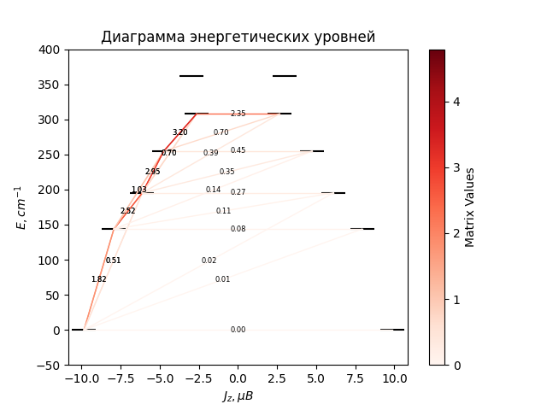

# CF_parameters

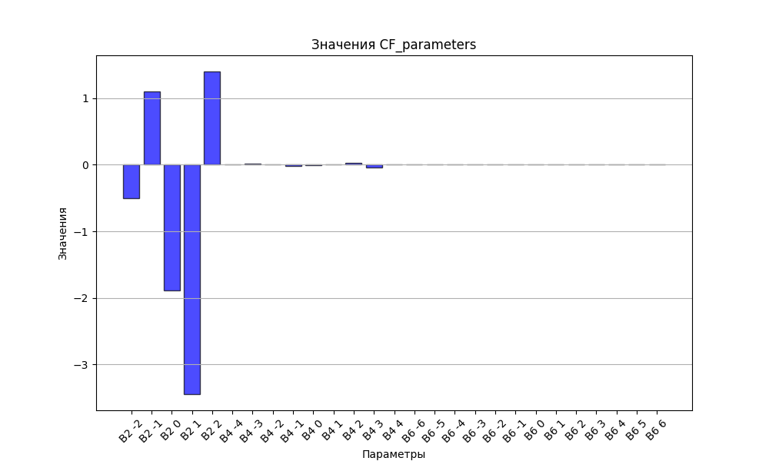

# CHI * T

|  |  |
| --- | --- |
| T | CHI * T |
| 1.0 | 5.1695193 |
| 2.0 | 8.5433951 |
| 3.0 | 10.1497923 |
| 4.0 | 10.9373975 |
| 5.0 | 11.3676137 |
| 6.0 | 11.6276512 |
| 7.0 | 11.7986288 |
| 8.0 | 11.9191118 |
| 9.0 | 12.0090388 |
| 10.0 | 12.0794699 |
| 11.0 | 12.1369092 |
| 12.0 | 12.1853725 |
| 13.0 | 12.2274424 |
| 14.0 | 12.2648385 |
| 15.0 | 12.2987403 |
| 16.0 | 12.3299775 |
| 17.0 | 12.3591469 |
| 18.0 | 12.3866855 |
| 19.0 | 12.4129188 |
| 20.0 | 12.4380921 |
| 21.0 | 12.4623928 |
| 22.0 | 12.485965 |
| 23.0 | 12.5089202 |
| 24.0 | 12.5313457 |
| 25.0 | 12.5533096 |
| 26.0 | 12.5748654 |
| 27.0 | 12.5960552 |
| 28.0 | 12.616912 |
| 29.0 | 12.6374619 |
| 30.0 | 12.6577253 |
| 31.0 | 12.6777183 |
| 32.0 | 12.6974532 |
| 33.0 | 12.71694 |
| 34.0 | 12.736186 |
| 35.0 | 12.7551972 |
| 36.0 | 12.773978 |
| 37.0 | 12.7925319 |
| 38.0 | 12.8108614 |
| 39.0 | 12.8289685 |
| 40.0 | 12.8468549 |
| 41.0 | 12.8645215 |
| 42.0 | 12.8819694 |
| 43.0 | 12.8991994 |
| 44.0 | 12.916212 |
| 45.0 | 12.9330079 |
| 46.0 | 12.9495877 |
| 47.0 | 12.965952 |
| 48.0 | 12.9821013 |
| 49.0 | 12.9980365 |
| 50.0 | 13.0137581 |
| 51.0 | 13.0292671 |
| 52.0 | 13.0445644 |
| 53.0 | 13.059651 |
| 54.0 | 13.0745278 |
| 55.0 | 13.0891962 |
| 56.0 | 13.1036573 |
| 57.0 | 13.1179126 |
| 58.0 | 13.1319633 |
| 59.0 | 13.1458111 |
| 60.0 | 13.1594574 |
| 61.0 | 13.1729041 |
| 62.0 | 13.1861527 |
| 63.0 | 13.1992051 |
| 64.0 | 13.212063 |
| 65.0 | 13.2247286 |
| 66.0 | 13.2372036 |
| 67.0 | 13.2494901 |
| 68.0 | 13.2615901 |
| 69.0 | 13.2735058 |
| 70.0 | 13.2852392 |
| 71.0 | 13.2967925 |
| 72.0 | 13.308168 |
| 73.0 | 13.3193678 |
| 74.0 | 13.3303941 |
| 75.0 | 13.3412493 |
| 76.0 | 13.3519355 |
| 77.0 | 13.3624551 |
| 78.0 | 13.3728104 |
| 79.0 | 13.3830036 |
| 80.0 | 13.3930371 |
| 81.0 | 13.4029131 |
| 82.0 | 13.412634 |
| 83.0 | 13.422202 |
| 84.0 | 13.4316194 |
| 85.0 | 13.4408886 |
| 86.0 | 13.4500117 |
| 87.0 | 13.4589912 |
| 88.0 | 13.4678291 |
| 89.0 | 13.4765277 |
| 90.0 | 13.4850893 |
| 91.0 | 13.4935161 |
| 92.0 | 13.5018102 |
| 93.0 | 13.5099737 |
| 94.0 | 13.518009 |
| 95.0 | 13.525918 |
| 96.0 | 13.5337028 |
| 97.0 | 13.5413656 |
| 98.0 | 13.5489084 |
| 99.0 | 13.5563333 |
| 100.0 | 13.5636421 |
| 101.0 | 13.5708369 |
| 102.0 | 13.5779197 |
| 103.0 | 13.5848924 |
| 104.0 | 13.5917568 |
| 105.0 | 13.5985149 |
| 106.0 | 13.6051685 |
| 107.0 | 13.6117194 |
| 108.0 | 13.6181695 |
| 109.0 | 13.6245204 |
| 110.0 | 13.6307739 |
| 111.0 | 13.6369317 |
| 112.0 | 13.6429955 |
| 113.0 | 13.648967 |
| 114.0 | 13.6548477 |
| 115.0 | 13.6606394 |
| 116.0 | 13.6663435 |
| 117.0 | 13.6719616 |
| 118.0 | 13.6774952 |
| 119.0 | 13.6829459 |
| 120.0 | 13.6883151 |
| 121.0 | 13.6936042 |
| 122.0 | 13.6988147 |
| 123.0 | 13.7039479 |
| 124.0 | 13.7090053 |
| 125.0 | 13.7139881 |
| 126.0 | 13.7188977 |
| 127.0 | 13.7237354 |
| 128.0 | 13.7285024 |
| 129.0 | 13.7332001 |
| 130.0 | 13.7378295 |
| 131.0 | 13.742392 |
| 132.0 | 13.7468887 |
| 133.0 | 13.7513208 |
| 134.0 | 13.7556894 |
| 135.0 | 13.7599956 |
| 136.0 | 13.7642405 |
| 137.0 | 13.7684252 |
| 138.0 | 13.7725507 |
| 139.0 | 13.7766181 |
| 140.0 | 13.7806284 |
| 141.0 | 13.7845826 |
| 142.0 | 13.7884817 |
| 143.0 | 13.7923265 |
| 144.0 | 13.7961181 |
| 145.0 | 13.7998574 |
| 146.0 | 13.8035453 |
| 147.0 | 13.8071826 |
| 148.0 | 13.8107702 |
| 149.0 | 13.8143091 |
| 150.0 | 13.8177999 |
| 151.0 | 13.8212436 |
| 152.0 | 13.8246409 |
| 153.0 | 13.8279927 |
| 154.0 | 13.8312996 |
| 155.0 | 13.8345626 |
| 156.0 | 13.8377822 |
| 157.0 | 13.8409592 |
| 158.0 | 13.8440944 |
| 159.0 | 13.8471885 |
| 160.0 | 13.8502421 |
| 161.0 | 13.8532559 |
| 162.0 | 13.8562306 |
| 163.0 | 13.8591668 |
| 164.0 | 13.8620652 |
| 165.0 | 13.8649264 |
| 166.0 | 13.867751 |
| 167.0 | 13.8705395 |
| 168.0 | 13.8732927 |
| 169.0 | 13.8760111 |
| 170.0 | 13.8786952 |
| 171.0 | 13.8813455 |
| 172.0 | 13.8839628 |
| 173.0 | 13.8865474 |
| 174.0 | 13.8890999 |
| 175.0 | 13.8916209 |
| 176.0 | 13.8941108 |
| 177.0 | 13.8965701 |
| 178.0 | 13.8989993 |
| 179.0 | 13.9013989 |
| 180.0 | 13.9037694 |
| 181.0 | 13.9061113 |
| 182.0 | 13.9084249 |
| 183.0 | 13.9107107 |
| 184.0 | 13.9129692 |
| 185.0 | 13.9152008 |
| 186.0 | 13.9174059 |
| 187.0 | 13.9195849 |
| 188.0 | 13.9217382 |
| 189.0 | 13.9238663 |
| 190.0 | 13.9259695 |
| 191.0 | 13.9280481 |
| 192.0 | 13.9301027 |
| 193.0 | 13.9321335 |
| 194.0 | 13.9341409 |
| 195.0 | 13.9361253 |
| 196.0 | 13.9380869 |
| 197.0 | 13.9400263 |
| 198.0 | 13.9419436 |
| 199.0 | 13.9438392 |
| 200.0 | 13.9457135 |
| 201.0 | 13.9475668 |
| 202.0 | 13.9493993 |
| 203.0 | 13.9512115 |
| 204.0 | 13.9530035 |
| 205.0 | 13.9547757 |
| 206.0 | 13.9565285 |
| 207.0 | 13.9582619 |
| 208.0 | 13.9599765 |
| 209.0 | 13.9616723 |
| 210.0 | 13.9633498 |
| 211.0 | 13.9650091 |
| 212.0 | 13.9666506 |
| 213.0 | 13.9682745 |
| 214.0 | 13.969881 |
| 215.0 | 13.9714704 |
| 216.0 | 13.9730429 |
| 217.0 | 13.9745989 |
| 218.0 | 13.9761384 |
| 219.0 | 13.9776618 |
| 220.0 | 13.9791693 |
| 221.0 | 13.9806611 |
| 222.0 | 13.9821374 |
| 223.0 | 13.9835985 |
| 224.0 | 13.9850445 |
| 225.0 | 13.9864757 |
| 226.0 | 13.9878922 |
| 227.0 | 13.9892944 |
| 228.0 | 13.9906823 |
| 229.0 | 13.9920562 |
| 230.0 | 13.9934163 |
| 231.0 | 13.9947627 |
| 232.0 | 13.9960957 |
| 233.0 | 13.9974154 |
| 234.0 | 13.998722 |
| 235.0 | 14.0000157 |
| 236.0 | 14.0012967 |
| 237.0 | 14.0025651 |
| 238.0 | 14.0038211 |
| 239.0 | 14.0050649 |
| 240.0 | 14.0062967 |
| 241.0 | 14.0075165 |
| 242.0 | 14.0087246 |
| 243.0 | 14.0099211 |
| 244.0 | 14.0111061 |
| 245.0 | 14.0122799 |
| 246.0 | 14.0134426 |
| 247.0 | 14.0145942 |
| 248.0 | 14.0157351 |
| 249.0 | 14.0168652 |
| 250.0 | 14.0179848 |
| 251.0 | 14.0190939 |
| 252.0 | 14.0201928 |
| 253.0 | 14.0212815 |
| 254.0 | 14.0223601 |
| 255.0 | 14.0234289 |
| 256.0 | 14.0244879 |
| 257.0 | 14.0255373 |
| 258.0 | 14.0265772 |
| 259.0 | 14.0276076 |
| 260.0 | 14.0286288 |
| 261.0 | 14.0296408 |
| 262.0 | 14.0306438 |
| 263.0 | 14.0316378 |
| 264.0 | 14.0326231 |
| 265.0 | 14.0335996 |
| 266.0 | 14.0345675 |
| 267.0 | 14.0355269 |
| 268.0 | 14.036478 |
| 269.0 | 14.0374207 |
| 270.0 | 14.0383553 |
| 271.0 | 14.0392818 |
| 272.0 | 14.0402003 |
| 273.0 | 14.041111 |
| 274.0 | 14.0420138 |
| 275.0 | 14.042909 |
| 276.0 | 14.0437965 |
| 277.0 | 14.0446766 |
| 278.0 | 14.0455492 |
| 279.0 | 14.0464146 |
| 280.0 | 14.0472727 |
| 281.0 | 14.0481236 |
| 282.0 | 14.0489675 |
| 283.0 | 14.0498044 |
| 284.0 | 14.0506344 |
| 285.0 | 14.0514576 |
| 286.0 | 14.0522741 |
| 287.0 | 14.0530839 |

# H_B_df

|  |  |  |  |
| --- | --- | --- | --- |
| H(T) | B(T_1) | B(T_2) | B(T_3) |
| 0.0001 | 0.0010880063 | 0.0005457082 | 0.0003649422 |

# WAVE FUNCTIONS

|  |  |  |  |  |  |  |  |  |
| --- | --- | --- | --- | --- | --- | --- | --- | --- |
| Label | +-15/2> | +-13/2> | +-11/2> | +-9/2> | +-7/2> | +-5/2> | +-3/2> | +-1/2> |
| KD1 | 95 | 0 | 4 | 0 | 0 | 0 | 0 | 0 |
| KD2 | 0 | 74 | 3 | 21 | 1 | 0 | 0 | 0 |
| KD3 | 2 | 5 | 44 | 14 | 28 | 6 | 0 | 1 |
| KD4 | 1 | 4 | 19 | 18 | 18 | 27 | 11 | 2 |
| KD5 | 0 | 6 | 2 | 12 | 13 | 12 | 29 | 25 |
| KD6 | 0 | 0 | 4 | 6 | 17 | 34 | 20 | 18 |
| KD7 | 0 | 1 | 3 | 3 | 1 | 6 | 33 | 52 |
| KD8 | 2 | 9 | 20 | 25 | 22 | 15 | 6 | 1 |