# artion2new

# PSEUDOSPIN HAMILTONIAN TENSORS

|  |  |  |
| --- | --- | --- |
| g_x | g_y | g_z |
| 0.00215644776696 | 0.0026992938324 | 19.65044833068541 |
| 0.35499521039719 | 0.48953283265439 | 16.40416022405797 |
| 0.32056912291451 | 0.94376280436661 | 13.87016660438039 |
| 1.34387794433745 | 1.7233192935589 | 9.65950350171573 |
| 8.76195168311287 | 7.14593256235162 | 4.2773169067494 |
| 0.46491098905997 | 0.82761275802581 | 17.03535072368986 |
| 0.080687332308 | 0.14823633724122 | 17.90014158101768 |
| 0.01985186967859 | 0.03514680477801 | 19.45876906150662 |

# AB INITIO BLOCKING BARRIER

|  |  |  |  |
| --- | --- | --- | --- |
| KD | l+, muB | l-, muB | E, cm-1 |
| 1.0 | -9.8252242 | 9.8252242 | 0.0 |
| 2.0 | -7.6243287 | 7.6243287 | 144.2178749 |
| 3.0 | -6.0551221 | 6.0551221 | 188.9771669 |
| 4.0 | -4.6547963 | 4.6547963 | 245.6479797 |
| 5.0 | -2.7203797 | 2.7203797 | 295.6195127 |
| 6.0 | -2.888692 | 2.888692 | 369.5210501 |
| 7.0 | -1.2127482 | 1.2127482 | 442.5548613 |
| 8.0 | -5.6805265 | 5.6805265 | 537.2368118 |

# QTM, ORBACH, MATRIX ELEMENTS

|  |  |  |  |  |  |  |  |
| --- | --- | --- | --- | --- | --- | --- | --- |
| 0 | 1 | 2 | 3 | 4 | 5 | 6 | 7 |
| 0.000809290269231 | 0.0231668595048 | 0.054879505636 | 0.0335016521585 | 0.0506272713456 | 0.0257030301712 | 0.0142010908545 | 0.00166719330983 |
| 0.0 | 0.148516374272 | 0.304499532233 | 0.240102990481 | 0.208410587152 | 0.121438671913 | 0.123670762552 | 0.0227661829738 |
| 0.0 | 0.0 | 0.239343011119 | 0.392071693 | 0.704038946358 | 0.307927526727 | 0.369216736378 | 0.118218880093 |
| 0.0 | 0.0 | 0.0 | 0.526671137589 | 1.07800131765 | 0.752817762048 | 0.65506108737 | 0.146600527285 |
| 0.0 | 0.0 | 0.0 | 0.0 | 2.35855763533 | 1.19009227142 | 0.70987279565 | 0.284605964026 |
| 0.0 | 0.0 | 0.0 | 0.0 | 0.0 | 0.377666209423 | 0.177229412069 | 0.295416774951 |
| 0.0 | 0.0 | 0.0 | 0.0 | 0.0 | 0.0 | 0.159431664332 | 0.0835213779698 |
| 0.0 | 0.0 | 0.0 | 0.0 | 0.0 | 0.0 | 0.0 | 0.0115318573874 |

# DIRECT MATRIX ELEMENTS

|  |  |  |  |  |  |  |  |
| --- | --- | --- | --- | --- | --- | --- | --- |
| 0 | 1 | 2 | 3 | 4 | 5 | 6 | 7 |
| 3.27507472178 | 1.76284159417 | 0.801906962638 | 0.356616587222 | 0.234415607214 | 0.139154157427 | 0.135600332665 | 0.325432537284 |
| 0.0 | 3.68898633512 | 2.50894370592 | 1.12280107716 | 0.686147545889 | 0.168164338048 | 0.223448700868 | 0.570527153456 |
| 0.0 | 0.0 | 3.60668531126 | 3.00038076226 | 0.757551547104 | 0.443295919872 | 0.260026151975 | 0.679649675931 |
| 0.0 | 0.0 | 0.0 | 2.1189970928 | 3.10016925791 | 0.797356963883 | 0.595720784018 | 0.999132005033 |
| 0.0 | 0.0 | 0.0 | 0.0 | 1.68255749225 | 2.17685279532 | 1.55684720686 | 0.926357172546 |
| 0.0 | 0.0 | 0.0 | 0.0 | 0.0 | 4.71678457732 | 1.50710658879 | 0.44111380511 |
| 0.0 | 0.0 | 0.0 | 0.0 | 0.0 | 0.0 | 4.07590218866 | 1.45372243627 |
| 0.0 | 0.0 | 0.0 | 0.0 | 0.0 | 0.0 | 0.0 | 4.80696283028 |

# Diagram

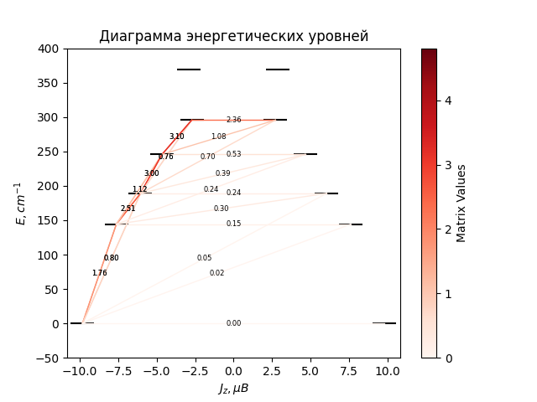

# CF_parameters

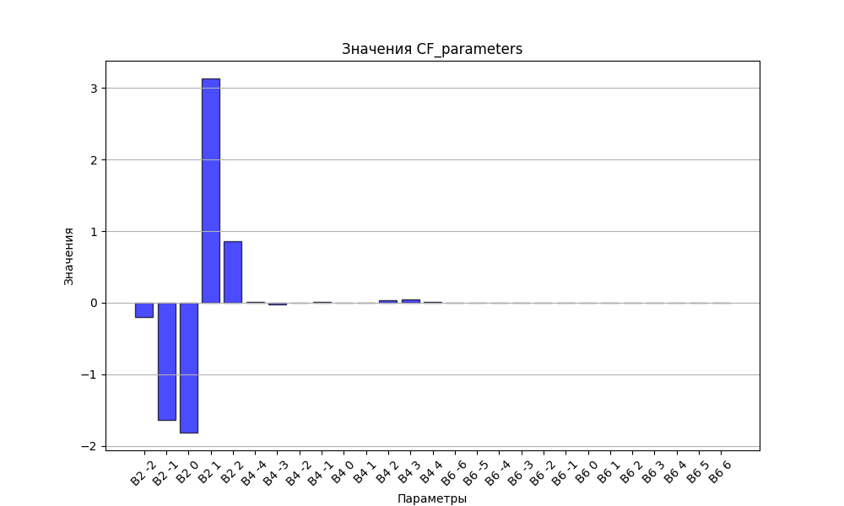

# CHI * T

|  |  |
| --- | --- |
| T | CHI * T |
| 1.0 | 3.816704 |
| 2.0 | 6.951104 |
| 3.0 | 8.9245263 |
| 4.0 | 10.051208 |
| 5.0 | 10.7148438 |
| 6.0 | 11.1302818 |
| 7.0 | 11.4066936 |
| 8.0 | 11.6008863 |
| 9.0 | 11.7439217 |
| 10.0 | 11.853682 |
| 11.0 | 11.9409586 |
| 12.0 | 12.0125399 |
| 13.0 | 12.0728538 |
| 14.0 | 12.1248804 |
| 15.0 | 12.1706815 |
| 16.0 | 12.2117182 |
| 17.0 | 12.2490475 |
| 18.0 | 12.2834487 |
| 19.0 | 12.3155054 |
| 20.0 | 12.3456608 |
| 21.0 | 12.374256 |
| 22.0 | 12.4015558 |
| 23.0 | 12.4277681 |
| 24.0 | 12.4530572 |
| 25.0 | 12.477554 |
| 26.0 | 12.5013633 |
| 27.0 | 12.5245696 |
| 28.0 | 12.5472409 |
| 29.0 | 12.5694329 |
| 30.0 | 12.5911905 |
| 31.0 | 12.6125506 |
| 32.0 | 12.6335435 |
| 33.0 | 12.654194 |
| 34.0 | 12.6745225 |
| 35.0 | 12.6945459 |
| 36.0 | 12.714278 |
| 37.0 | 12.7337305 |
| 38.0 | 12.7529129 |
| 39.0 | 12.7718332 |
| 40.0 | 12.7904982 |
| 41.0 | 12.8089135 |
| 42.0 | 12.8270838 |
| 43.0 | 12.8450132 |
| 44.0 | 12.8627052 |
| 45.0 | 12.8801628 |
| 46.0 | 12.8973886 |
| 47.0 | 12.9143851 |
| 48.0 | 12.9311543 |
| 49.0 | 12.9476982 |
| 50.0 | 12.9640187 |
| 51.0 | 12.9801173 |
| 52.0 | 12.9959958 |
| 53.0 | 13.0116558 |
| 54.0 | 13.0270988 |
| 55.0 | 13.0423264 |
| 56.0 | 13.0573402 |
| 57.0 | 13.0721417 |
| 58.0 | 13.0867327 |
| 59.0 | 13.1011147 |
| 60.0 | 13.1152894 |
| 61.0 | 13.1292586 |
| 62.0 | 13.1430239 |
| 63.0 | 13.1565873 |
| 64.0 | 13.1699506 |
| 65.0 | 13.1831156 |
| 66.0 | 13.1960844 |
| 67.0 | 13.2088588 |
| 68.0 | 13.221441 |
| 69.0 | 13.233833 |
| 70.0 | 13.2460368 |
| 71.0 | 13.2580547 |
| 72.0 | 13.2698888 |
| 73.0 | 13.2815413 |
| 74.0 | 13.2930143 |
| 75.0 | 13.3043102 |
| 76.0 | 13.3154313 |
| 77.0 | 13.3263797 |
| 78.0 | 13.3371578 |
| 79.0 | 13.347768 |
| 80.0 | 13.3582124 |
| 81.0 | 13.3684935 |
| 82.0 | 13.3786136 |
| 83.0 | 13.388575 |
| 84.0 | 13.39838 |
| 85.0 | 13.408031 |
| 86.0 | 13.4175303 |
| 87.0 | 13.4268802 |
| 88.0 | 13.4360831 |
| 89.0 | 13.4451411 |
| 90.0 | 13.4540566 |
| 91.0 | 13.4628319 |
| 92.0 | 13.4714692 |
| 93.0 | 13.4799708 |
| 94.0 | 13.4883388 |
| 95.0 | 13.4965755 |
| 96.0 | 13.504683 |
| 97.0 | 13.5126635 |
| 98.0 | 13.5205192 |
| 99.0 | 13.5282521 |
| 100.0 | 13.5358643 |
| 101.0 | 13.5433578 |
| 102.0 | 13.5507348 |
| 103.0 | 13.5579972 |
| 104.0 | 13.565147 |
| 105.0 | 13.5721862 |
| 106.0 | 13.5791166 |
| 107.0 | 13.5859401 |
| 108.0 | 13.5926588 |
| 109.0 | 13.5992743 |
| 110.0 | 13.6057885 |
| 111.0 | 13.6122031 |
| 112.0 | 13.61852 |
| 113.0 | 13.6247409 |
| 114.0 | 13.6308674 |
| 115.0 | 13.6369013 |
| 116.0 | 13.6428441 |
| 117.0 | 13.6486975 |
| 118.0 | 13.6544631 |
| 119.0 | 13.6601425 |
| 120.0 | 13.6657371 |
| 121.0 | 13.6712485 |
| 122.0 | 13.6766782 |
| 123.0 | 13.6820275 |
| 124.0 | 13.6872981 |
| 125.0 | 13.6924911 |
| 126.0 | 13.6976081 |
| 127.0 | 13.7026503 |
| 128.0 | 13.7076191 |
| 129.0 | 13.7125158 |
| 130.0 | 13.7173417 |
| 131.0 | 13.722098 |
| 132.0 | 13.726786 |
| 133.0 | 13.7314067 |
| 134.0 | 13.7359616 |
| 135.0 | 13.7404516 |
| 136.0 | 13.7448779 |
| 137.0 | 13.7492417 |
| 138.0 | 13.753544 |
| 139.0 | 13.7577859 |
| 140.0 | 13.7619685 |
| 141.0 | 13.7660928 |
| 142.0 | 13.7701598 |
| 143.0 | 13.7741705 |
| 144.0 | 13.7781259 |
| 145.0 | 13.782027 |
| 146.0 | 13.7858745 |
| 147.0 | 13.7896696 |
| 148.0 | 13.7934131 |
| 149.0 | 13.7971058 |
| 150.0 | 13.8007487 |
| 151.0 | 13.8043426 |
| 152.0 | 13.8078882 |
| 153.0 | 13.8113866 |
| 154.0 | 13.8148383 |
| 155.0 | 13.8182443 |
| 156.0 | 13.8216053 |
| 157.0 | 13.824922 |
| 158.0 | 13.8281952 |
| 159.0 | 13.8314256 |
| 160.0 | 13.834614 |
| 161.0 | 13.837761 |
| 162.0 | 13.8408673 |
| 163.0 | 13.8439336 |
| 164.0 | 13.8469605 |
| 165.0 | 13.8499488 |
| 166.0 | 13.8528989 |
| 167.0 | 13.8558117 |
| 168.0 | 13.8586875 |
| 169.0 | 13.8615272 |
| 170.0 | 13.8643312 |
| 171.0 | 13.8671001 |
| 172.0 | 13.8698345 |
| 173.0 | 13.872535 |
| 174.0 | 13.875202 |
| 175.0 | 13.8778362 |
| 176.0 | 13.880438 |
| 177.0 | 13.883008 |
| 178.0 | 13.8855467 |
| 179.0 | 13.8880545 |
| 180.0 | 13.890532 |
| 181.0 | 13.8929796 |
| 182.0 | 13.8953978 |
| 183.0 | 13.8977871 |
| 184.0 | 13.9001478 |
| 185.0 | 13.9024806 |
| 186.0 | 13.9047857 |
| 187.0 | 13.9070636 |
| 188.0 | 13.9093148 |
| 189.0 | 13.9115396 |
| 190.0 | 13.9137385 |
| 191.0 | 13.9159118 |
| 192.0 | 13.9180599 |
| 193.0 | 13.9201833 |
| 194.0 | 13.9222822 |
| 195.0 | 13.9243572 |
| 196.0 | 13.9264084 |
| 197.0 | 13.9284364 |
| 198.0 | 13.9304413 |
| 199.0 | 13.9324237 |
| 200.0 | 13.9343837 |
| 201.0 | 13.9363218 |
| 202.0 | 13.9382383 |
| 203.0 | 13.9401334 |
| 204.0 | 13.9420076 |
| 205.0 | 13.943861 |
| 206.0 | 13.9456941 |
| 207.0 | 13.9475071 |
| 208.0 | 13.9493003 |
| 209.0 | 13.951074 |
| 210.0 | 13.9528284 |
| 211.0 | 13.9545639 |
| 212.0 | 13.9562808 |
| 213.0 | 13.9579792 |
| 214.0 | 13.9596595 |
| 215.0 | 13.9613219 |
| 216.0 | 13.9629667 |
| 217.0 | 13.9645941 |
| 218.0 | 13.9662043 |
| 219.0 | 13.9677977 |
| 220.0 | 13.9693744 |
| 221.0 | 13.9709347 |
| 222.0 | 13.9724788 |
| 223.0 | 13.974007 |
| 224.0 | 13.9755194 |
| 225.0 | 13.9770163 |
| 226.0 | 13.9784979 |
| 227.0 | 13.9799644 |
| 228.0 | 13.981416 |
| 229.0 | 13.9828529 |
| 230.0 | 13.9842754 |
| 231.0 | 13.9856835 |
| 232.0 | 13.9870776 |
| 233.0 | 13.9884578 |
| 234.0 | 13.9898242 |
| 235.0 | 13.9911772 |
| 236.0 | 13.9925168 |
| 237.0 | 13.9938432 |
| 238.0 | 13.9951567 |
| 239.0 | 13.9964573 |
| 240.0 | 13.9977453 |
| 241.0 | 13.9990209 |
| 242.0 | 14.0002841 |
| 243.0 | 14.0015352 |
| 244.0 | 14.0027743 |
| 245.0 | 14.0040016 |
| 246.0 | 14.0052172 |
| 247.0 | 14.0064213 |
| 248.0 | 14.007614 |
| 249.0 | 14.0087955 |
| 250.0 | 14.0099659 |
| 251.0 | 14.0111254 |
| 252.0 | 14.0122741 |
| 253.0 | 14.0134121 |
| 254.0 | 14.0145397 |
| 255.0 | 14.0156569 |
| 256.0 | 14.0167638 |
| 257.0 | 14.0178606 |
| 258.0 | 14.0189474 |
| 259.0 | 14.0200243 |
| 260.0 | 14.0210915 |
| 261.0 | 14.0221492 |
| 262.0 | 14.0231973 |
| 263.0 | 14.024236 |
| 264.0 | 14.0252655 |
| 265.0 | 14.0262858 |
| 266.0 | 14.0272971 |
| 267.0 | 14.0282996 |
| 268.0 | 14.0292932 |
| 269.0 | 14.0302781 |
| 270.0 | 14.0312544 |
| 271.0 | 14.0322222 |
| 272.0 | 14.0331817 |
| 273.0 | 14.0341328 |
| 274.0 | 14.0350759 |
| 275.0 | 14.0360108 |
| 276.0 | 14.0369377 |
| 277.0 | 14.0378568 |
| 278.0 | 14.0387681 |
| 279.0 | 14.0396717 |
| 280.0 | 14.0405677 |
| 281.0 | 14.0414562 |
| 282.0 | 14.0423373 |
| 283.0 | 14.043211 |
| 284.0 | 14.0440775 |
| 285.0 | 14.0449368 |
| 286.0 | 14.0457891 |
| 287.0 | 14.0466344 |

# H_B_df

|  |  |  |  |
| --- | --- | --- | --- |
| H(T) | B(T_1) | B(T_2) | B(T_3) |
| 0.0001 | 0.0010841257 | 0.0005437605 | 0.0003636388 |

# WAVE FUNCTIONS

|  |  |  |  |  |  |  |  |  |
| --- | --- | --- | --- | --- | --- | --- | --- | --- |
| Label | +-15/2> | +-13/2> | +-11/2> | +-9/2> | +-7/2> | +-5/2> | +-3/2> | +-1/2> |
| KD1 | 94 | 0 | 5 | 1 | 0 | 0 | 0 | 0 |
| KD2 | 0 | 64 | 6 | 25 | 3 | 0 | 1 | 1 |
| KD3 | 1 | 18 | 30 | 11 | 31 | 7 | 0 | 3 |
| KD4 | 2 | 0 | 29 | 11 | 10 | 32 | 12 | 4 |
| KD5 | 0 | 6 | 4 | 16 | 13 | 7 | 33 | 22 |
| KD6 | 0 | 1 | 2 | 10 | 21 | 32 | 13 | 21 |
| KD7 | 0 | 1 | 3 | 2 | 2 | 8 | 35 | 48 |
| KD8 | 2 | 11 | 22 | 24 | 20 | 14 | 6 | 1 |