# artion_1

# PSEUDOSPIN HAMILTONIAN TENSORS

|  |  |  |
| --- | --- | --- |
| g_x | g_y | g_z |
| 0.221166687665 | 0.57484992164522 | 18.89852337305834 |
| 0.01383942482363 | 0.61344029307908 | 18.62449187005231 |
| 1.57171263358345 | 3.14095641772227 | 13.76881771076453 |
| 0.53889630190002 | 5.4011349083303 | 10.35990531971742 |
| 1.28377803415003 | 4.75732230958298 | 8.98722168620483 |
| 1.79605003976628 | 5.89564714420093 | 11.54906842712098 |
| 0.16474130033551 | 0.22933196968856 | 19.298466615256 |
| 0.00071246816831 | 0.00149302390704 | 19.93382862661267 |

# AB INITIO BLOCKING BARRIER

|  |  |  |  |
| --- | --- | --- | --- |
| KD | l+, muB | l-, muB | E, cm-1 |
| 1.0 | -9.4492617 | 9.4492617 | 0.0 |
| 2.0 | -1.0646603 | 1.0646603 | 26.9240088 |
| 3.0 | -6.8698525 | 6.8698525 | 73.8802513 |
| 4.0 | -1.9876394 | 1.9876394 | 122.2367139 |
| 5.0 | -2.3980472 | 2.3980472 | 161.4534931 |
| 6.0 | -2.8269033 | 2.8269033 | 185.8586398 |
| 7.0 | -4.0468775 | 4.0468775 | 264.3319044 |
| 8.0 | -5.9581342 | 5.9581342 | 499.0536994 |

# QTM, ORBACH, MATRIX ELEMENTS

|  |  |  |  |  |  |  |  |
| --- | --- | --- | --- | --- | --- | --- | --- |
| 0 | 1 | 2 | 3 | 4 | 5 | 6 | 7 |
| 0.132669434885 | 1.02592486634 | 0.129401898817 | 0.479831055431 | 0.299449710024 | 0.191485915918 | 0.129788653044 | 0.00530109579129 |
| 0.0 | 0.327503331572 | 1.26220813154 | 0.381770012013 | 0.630574834267 | 0.31929679713 | 0.0450977735184 | 0.128527725094 |
| 0.0 | 0.0 | 0.822003725925 | 1.77235069917 | 0.554251736746 | 0.501121777473 | 0.172973391229 | 0.0502864006038 |
| 0.0 | 0.0 | 0.0 | 1.63383159226 | 1.30531792218 | 1.38092237627 | 0.380751947012 | 0.582935264636 |
| 0.0 | 0.0 | 0.0 | 0.0 | 1.78295990909 | 2.05475489621 | 0.874196340514 | 0.439118760977 |
| 0.0 | 0.0 | 0.0 | 0.0 | 0.0 | 1.70863147806 | 1.25253067567 | 0.450584806797 |
| 0.0 | 0.0 | 0.0 | 0.0 | 0.0 | 0.0 | 0.123125619733 | 0.701278783548 |
| 0.0 | 0.0 | 0.0 | 0.0 | 0.0 | 0.0 | 0.0 | 0.000459673118798 |

# DIRECT MATRIX ELEMENTS

|  |  |  |  |  |  |  |  |
| --- | --- | --- | --- | --- | --- | --- | --- |
| 0 | 1 | 2 | 3 | 4 | 5 | 6 | 7 |
| 3.14975389551 | 0.711931212584 | 1.84748014562 | 0.355459315507 | 0.348694897567 | 0.533191936783 | 0.0759581980389 | 0.290912641838 |
| 0.0 | 3.7517608859 | 0.870299690122 | 1.33571286908 | 0.899643721863 | 0.383736942277 | 0.257727702786 | 0.0365283899271 |
| 0.0 | 0.0 | 2.48160196492 | 2.46088287882 | 1.26830776319 | 0.999060744624 | 0.326481825658 | 0.458812964687 |
| 0.0 | 0.0 | 0.0 | 2.17351514736 | 2.56713659552 | 1.13386752519 | 0.718803056073 | 0.417113943695 |
| 0.0 | 0.0 | 0.0 | 0.0 | 1.00385497782 | 2.89679193781 | 1.02705640567 | 0.731743840629 |
| 0.0 | 0.0 | 0.0 | 0.0 | 0.0 | 2.99621265264 | 0.968142993072 | 1.34188223198 |
| 0.0 | 0.0 | 0.0 | 0.0 | 0.0 | 0.0 | 4.84741093992 | 0.0782722698346 |
| 0.0 | 0.0 | 0.0 | 0.0 | 0.0 | 0.0 | 0.0 | 4.93422597575 |

# Diagram

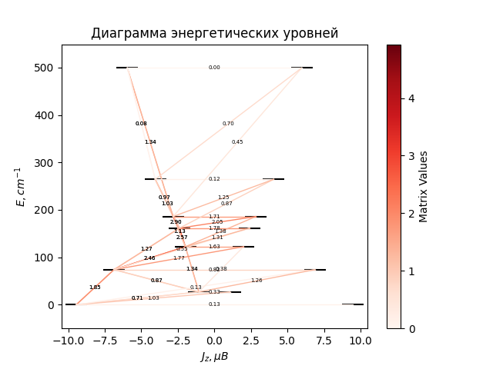

# CF_parameters

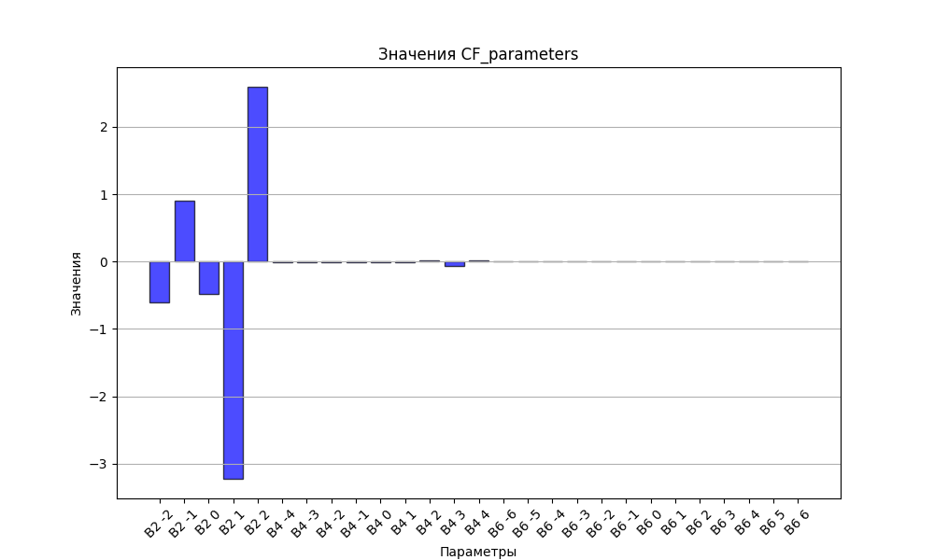

# CHI * T

|  |  |
| --- | --- |
| T | CHI * T |
| 1.0 | 4.9415363 |
| 2.0 | 8.0170608 |
| 3.0 | 9.5249484 |
| 4.0 | 10.3036141 |
| 5.0 | 10.7584723 |
| 6.0 | 11.0571598 |
| 7.0 | 11.2728916 |
| 8.0 | 11.4404303 |
| 9.0 | 11.5776587 |
| 10.0 | 11.6944706 |
| 11.0 | 11.7967089 |
| 12.0 | 11.8880291 |
| 13.0 | 11.9708355 |
| 14.0 | 12.0467789 |
| 15.0 | 12.1170359 |
| 16.0 | 12.1824727 |
| 17.0 | 12.2437463 |
| 18.0 | 12.3013683 |
| 19.0 | 12.355747 |
| 20.0 | 12.4072154 |
| 21.0 | 12.4560509 |
| 22.0 | 12.5024881 |
| 23.0 | 12.5467285 |
| 24.0 | 12.5889474 |
| 25.0 | 12.6292988 |
| 26.0 | 12.6679191 |
| 27.0 | 12.7049299 |
| 28.0 | 12.7404403 |
| 29.0 | 12.7745486 |
| 30.0 | 12.8073436 |
| 31.0 | 12.8389061 |
| 32.0 | 12.8693093 |
| 33.0 | 12.8986202 |
| 34.0 | 12.9269 |
| 35.0 | 12.9542047 |
| 36.0 | 12.9805858 |
| 37.0 | 13.0060907 |
| 38.0 | 13.030763 |
| 39.0 | 13.0546432 |
| 40.0 | 13.0777685 |
| 41.0 | 13.1001737 |
| 42.0 | 13.121891 |
| 43.0 | 13.1429505 |
| 44.0 | 13.1633801 |
| 45.0 | 13.1832061 |
| 46.0 | 13.2024531 |
| 47.0 | 13.2211442 |
| 48.0 | 13.239301 |
| 49.0 | 13.2569442 |
| 50.0 | 13.2740929 |
| 51.0 | 13.2907656 |
| 52.0 | 13.3069795 |
| 53.0 | 13.3227511 |
| 54.0 | 13.338096 |
| 55.0 | 13.3530291 |
| 56.0 | 13.3675647 |
| 57.0 | 13.3817161 |
| 58.0 | 13.3954963 |
| 59.0 | 13.4089178 |
| 60.0 | 13.4219922 |
| 61.0 | 13.4347311 |
| 62.0 | 13.4471452 |
| 63.0 | 13.4592449 |
| 64.0 | 13.4710404 |
| 65.0 | 13.4825412 |
| 66.0 | 13.4937565 |
| 67.0 | 13.5046954 |
| 68.0 | 13.5153664 |
| 69.0 | 13.5257777 |
| 70.0 | 13.5359373 |
| 71.0 | 13.5458529 |
| 72.0 | 13.5555319 |
| 73.0 | 13.5649815 |
| 74.0 | 13.5742085 |
| 75.0 | 13.5832195 |
| 76.0 | 13.5920211 |
| 77.0 | 13.6006194 |
| 78.0 | 13.6090204 |
| 79.0 | 13.6172299 |
| 80.0 | 13.6252535 |
| 81.0 | 13.6330966 |
| 82.0 | 13.6407644 |
| 83.0 | 13.6482619 |
| 84.0 | 13.6555941 |
| 85.0 | 13.6627657 |
| 86.0 | 13.6697813 |
| 87.0 | 13.6766452 |
| 88.0 | 13.6833617 |
| 89.0 | 13.6899351 |
| 90.0 | 13.6963692 |
| 91.0 | 13.7026679 |
| 92.0 | 13.708835 |
| 93.0 | 13.7148742 |
| 94.0 | 13.7207889 |
| 95.0 | 13.7265825 |
| 96.0 | 13.7322584 |
| 97.0 | 13.7378196 |
| 98.0 | 13.7432694 |
| 99.0 | 13.7486106 |
| 100.0 | 13.7538463 |
| 101.0 | 13.758979 |
| 102.0 | 13.7640117 |
| 103.0 | 13.7689469 |
| 104.0 | 13.7737872 |
| 105.0 | 13.778535 |
| 106.0 | 13.7831928 |
| 107.0 | 13.7877628 |
| 108.0 | 13.7922473 |
| 109.0 | 13.7966485 |
| 110.0 | 13.8009685 |
| 111.0 | 13.8052093 |
| 112.0 | 13.8093729 |
| 113.0 | 13.8134614 |
| 114.0 | 13.8174764 |
| 115.0 | 13.8214199 |
| 116.0 | 13.8252935 |
| 117.0 | 13.8290991 |
| 118.0 | 13.8328382 |
| 119.0 | 13.8365125 |
| 120.0 | 13.8401235 |
| 121.0 | 13.8436728 |
| 122.0 | 13.8471618 |
| 123.0 | 13.8505918 |
| 124.0 | 13.8539644 |
| 125.0 | 13.8572809 |
| 126.0 | 13.8605425 |
| 127.0 | 13.8637506 |
| 128.0 | 13.8669063 |
| 129.0 | 13.8700109 |
| 130.0 | 13.8730656 |
| 131.0 | 13.8760714 |
| 132.0 | 13.8790294 |
| 133.0 | 13.8819408 |
| 134.0 | 13.8848066 |
| 135.0 | 13.8876277 |
| 136.0 | 13.8904052 |
| 137.0 | 13.89314 |
| 138.0 | 13.8958331 |
| 139.0 | 13.8984853 |
| 140.0 | 13.9010975 |
| 141.0 | 13.9036706 |
| 142.0 | 13.9062055 |
| 143.0 | 13.9087028 |
| 144.0 | 13.9111635 |
| 145.0 | 13.9135883 |
| 146.0 | 13.9159779 |
| 147.0 | 13.918333 |
| 148.0 | 13.9206544 |
| 149.0 | 13.9229428 |
| 150.0 | 13.9251988 |
| 151.0 | 13.9274232 |
| 152.0 | 13.9296164 |
| 153.0 | 13.9317792 |
| 154.0 | 13.9339121 |
| 155.0 | 13.9360158 |
| 156.0 | 13.9380908 |
| 157.0 | 13.9401378 |
| 158.0 | 13.9421571 |
| 159.0 | 13.9441494 |
| 160.0 | 13.9461152 |
| 161.0 | 13.948055 |
| 162.0 | 13.9499693 |
| 163.0 | 13.9518586 |
| 164.0 | 13.9537234 |
| 165.0 | 13.955564 |
| 166.0 | 13.957381 |
| 167.0 | 13.9591749 |
| 168.0 | 13.9609459 |
| 169.0 | 13.9626946 |
| 170.0 | 13.9644214 |
| 171.0 | 13.9661266 |
| 172.0 | 13.9678107 |
| 173.0 | 13.969474 |
| 174.0 | 13.9711169 |
| 175.0 | 13.9727398 |
| 176.0 | 13.974343 |
| 177.0 | 13.9759268 |
| 178.0 | 13.9774917 |
| 179.0 | 13.9790379 |
| 180.0 | 13.9805658 |
| 181.0 | 13.9820757 |
| 182.0 | 13.9835679 |
| 183.0 | 13.9850426 |
| 184.0 | 13.9865003 |
| 185.0 | 13.9879411 |
| 186.0 | 13.9893654 |
| 187.0 | 13.9907734 |
| 188.0 | 13.9921655 |
| 189.0 | 13.9935418 |
| 190.0 | 13.9949027 |
| 191.0 | 13.9962484 |
| 192.0 | 13.9975792 |
| 193.0 | 13.9988952 |
| 194.0 | 14.0001967 |
| 195.0 | 14.0014841 |
| 196.0 | 14.0027574 |
| 197.0 | 14.0040169 |
| 198.0 | 14.0052629 |
| 199.0 | 14.0064955 |
| 200.0 | 14.007715 |
| 201.0 | 14.0089215 |
| 202.0 | 14.0101154 |
| 203.0 | 14.0112967 |
| 204.0 | 14.0124656 |
| 205.0 | 14.0136225 |
| 206.0 | 14.0147673 |
| 207.0 | 14.0159004 |
| 208.0 | 14.0170219 |
| 209.0 | 14.018132 |
| 210.0 | 14.0192309 |
| 211.0 | 14.0203186 |
| 212.0 | 14.0213955 |
| 213.0 | 14.0224616 |
| 214.0 | 14.0235171 |
| 215.0 | 14.0245622 |
| 216.0 | 14.025597 |
| 217.0 | 14.0266217 |
| 218.0 | 14.0276364 |
| 219.0 | 14.0286413 |
| 220.0 | 14.0296365 |
| 221.0 | 14.0306222 |
| 222.0 | 14.0315984 |
| 223.0 | 14.0325653 |
| 224.0 | 14.0335231 |
| 225.0 | 14.0344719 |
| 226.0 | 14.0354118 |
| 227.0 | 14.036343 |
| 228.0 | 14.0372655 |
| 229.0 | 14.0381794 |
| 230.0 | 14.039085 |
| 231.0 | 14.0399823 |
| 232.0 | 14.0408714 |
| 233.0 | 14.0417525 |
| 234.0 | 14.0426256 |
| 235.0 | 14.0434909 |
| 236.0 | 14.0443484 |
| 237.0 | 14.0451983 |
| 238.0 | 14.0460407 |
| 239.0 | 14.0468757 |
| 240.0 | 14.0477033 |
| 241.0 | 14.0485238 |
| 242.0 | 14.0493371 |
| 243.0 | 14.0501433 |
| 244.0 | 14.0509426 |
| 245.0 | 14.0517351 |
| 246.0 | 14.0525208 |
| 247.0 | 14.0532998 |
| 248.0 | 14.0540723 |
| 249.0 | 14.0548382 |
| 250.0 | 14.0555977 |
| 251.0 | 14.0563509 |
| 252.0 | 14.0570978 |
| 253.0 | 14.0578386 |
| 254.0 | 14.0585733 |
| 255.0 | 14.0593019 |
| 256.0 | 14.0600246 |
| 257.0 | 14.0607414 |
| 258.0 | 14.0614525 |
| 259.0 | 14.0621578 |
| 260.0 | 14.0628575 |
| 261.0 | 14.0635516 |
| 262.0 | 14.0642402 |
| 263.0 | 14.0649233 |
| 264.0 | 14.0656011 |
| 265.0 | 14.0662735 |
| 266.0 | 14.0669408 |
| 267.0 | 14.0676028 |
| 268.0 | 14.0682597 |
| 269.0 | 14.0689116 |
| 270.0 | 14.0695584 |
| 271.0 | 14.0702004 |
| 272.0 | 14.0708374 |
| 273.0 | 14.0714697 |
| 274.0 | 14.0720971 |
| 275.0 | 14.0727199 |
| 276.0 | 14.073338 |
| 277.0 | 14.0739516 |
| 278.0 | 14.0745606 |
| 279.0 | 14.0751651 |
| 280.0 | 14.0757651 |
| 281.0 | 14.0763608 |
| 282.0 | 14.0769522 |
| 283.0 | 14.0775392 |
| 284.0 | 14.0781221 |
| 285.0 | 14.0787007 |
| 286.0 | 14.0792753 |
| 287.0 | 14.0798457 |

# H_B_df

|  |  |  |  |
| --- | --- | --- | --- |
| H(T) | B(T_1) | B(T_2) | B(T_3) |
| 0.0001 | 0.0010141092 | 0.0005137745 | 0.0003469658 |

# WAVE FUNCTIONS

|  |  |  |  |  |  |  |  |  |
| --- | --- | --- | --- | --- | --- | --- | --- | --- |
| Label | +-15/2> | +-13/2> | +-11/2> | +-9/2> | +-7/2> | +-5/2> | +-3/2> | +-1/2> |
| KD0 | 87 | 1 | 8 | 1 | 0 | 1 | 1 | 1 |
| KD1 | 2 | 1 | 0 | 2 | 6 | 13 | 29 | 45 |
| KD1 | 0 | 67 | 3 | 13 | 4 | 2 | 3 | 8 |
| KD2 | 3 | 12 | 16 | 2 | 11 | 16 | 21 | 18 |
| KD2 | 3 | 2 | 26 | 12 | 12 | 11 | 26 | 9 |
| KD3 | 2 | 4 | 14 | 19 | 16 | 29 | 6 | 10 |
| KD3 | 0 | 2 | 8 | 22 | 30 | 19 | 11 | 7 |
| KD4 | 3 | 11 | 23 | 28 | 20 | 9 | 4 | 2 |