# artion_2

# PSEUDOSPIN HAMILTONIAN TENSORS

|  |  |  |
| --- | --- | --- |
| g_x | g_y | g_z |
| 0.01769893674995 | 0.025638182677 | 19.72590705410852 |
| 1.07505690610447 | 1.6184494027323 | 18.1019817250804 |
| 0.49651415156121 | 2.6372489855492 | 13.36024410316719 |
| 1.73780347472755 | 5.45625805810361 | 11.67863490489647 |
| 3.10631421141289 | 4.71233794943104 | 11.70974414494323 |
| 0.84026997369488 | 1.23964793235653 | 16.23652780878204 |
| 0.20124109398085 | 0.44469834280974 | 19.07158012758662 |
| 0.01281724869654 | 0.02842778226643 | 19.84755068370389 |

# AB INITIO BLOCKING BARRIER

|  |  |  |  |
| --- | --- | --- | --- |
| KD | l+, muB | l-, muB | E, cm-1 |
| 1.0 | -9.8629535 | 9.8629535 | 0.0 |
| 2.0 | -4.1396924 | 4.1396924 | 106.7473639 |
| 3.0 | -6.6109645 | 6.6109645 | 139.985573 |
| 4.0 | -2.1766469 | 2.1766469 | 187.1639189 |
| 5.0 | -2.5063289 | 2.5063289 | 214.4981399 |
| 6.0 | -2.8784451 | 2.8784451 | 283.584382 |
| 7.0 | -2.4064327 | 2.4064327 | 358.688267 |
| 8.0 | -6.1039753 | 6.1039753 | 484.9296206 |

# QTM, ORBACH, MATRIX ELEMENTS

|  |  |  |  |  |  |  |  |
| --- | --- | --- | --- | --- | --- | --- | --- |
| 0 | 1 | 2 | 3 | 4 | 5 | 6 | 7 |
| 0.00722285323759 | 0.333649603166 | 0.0879867248931 | 0.346664539212 | 0.218085093308 | 0.0864618758796 | 0.0246428369125 | 0.00214927540193 |
| 0.0 | 0.771963526985 | 1.18391138722 | 0.348350697653 | 0.569275397215 | 0.404543530759 | 0.273773946672 | 0.178116566507 |
| 0.0 | 0.0 | 0.530062675408 | 1.39306764245 | 0.522700337827 | 0.291256880665 | 0.181155208288 | 0.182215594845 |
| 0.0 | 0.0 | 0.0 | 2.23671821737 | 1.64079889081 | 0.897542980928 | 0.535609303385 | 0.849495233322 |
| 0.0 | 0.0 | 0.0 | 0.0 | 2.37572924135 | 1.43329189205 | 0.40592759279 | 0.688650948095 |
| 0.0 | 0.0 | 0.0 | 0.0 | 0.0 | 0.753214161077 | 0.367967356292 | 0.447957113825 |
| 0.0 | 0.0 | 0.0 | 0.0 | 0.0 | 0.0 | 0.24520250819 | 0.228366884822 |
| 0.0 | 0.0 | 0.0 | 0.0 | 0.0 | 0.0 | 0.0 | 0.00844256077504 |

# DIRECT MATRIX ELEMENTS

|  |  |  |  |  |  |  |  |
| --- | --- | --- | --- | --- | --- | --- | --- |
| 0 | 1 | 2 | 3 | 4 | 5 | 6 | 7 |
| 3.28765117568 | 0.784711329683 | 1.63928246106 | 0.346756491482 | 0.303612742368 | 0.105058515202 | 0.0801459210967 | 0.451724722155 |
| 0.0 | 4.24269157025 | 1.87804753888 | 1.35544538807 | 0.500541564141 | 0.203727453057 | 0.059156945228 | 0.13757932044 |
| 0.0 | 0.0 | 2.52400709639 | 2.18459103574 | 1.64869161245 | 0.604567396998 | 0.266122934672 | 0.78252964173 |
| 0.0 | 0.0 | 0.0 | 2.27178957872 | 2.50280199981 | 0.705396601979 | 0.293262992369 | 0.931765832232 |
| 0.0 | 0.0 | 0.0 | 0.0 | 1.53089121737 | 2.19814019291 | 0.610815127023 | 0.945445183067 |
| 0.0 | 0.0 | 0.0 | 0.0 | 0.0 | 3.93684785682 | 2.20569983331 | 0.373379723154 |
| 0.0 | 0.0 | 0.0 | 0.0 | 0.0 | 0.0 | 5.14350342394 | 0.435869972393 |
| 0.0 | 0.0 | 0.0 | 0.0 | 0.0 | 0.0 | 0.0 | 5.63017691983 |

# Diagram

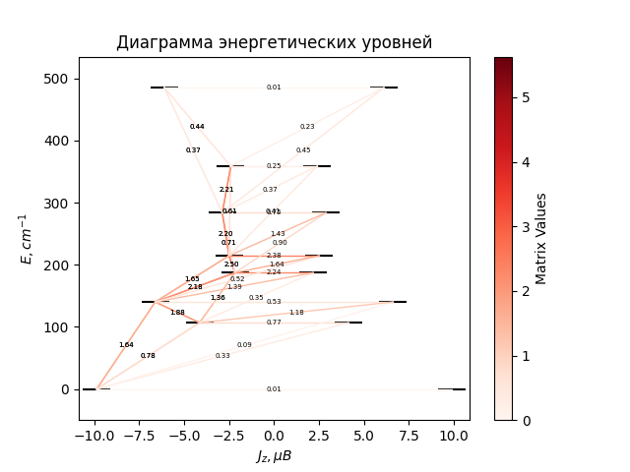

# CF_parameters

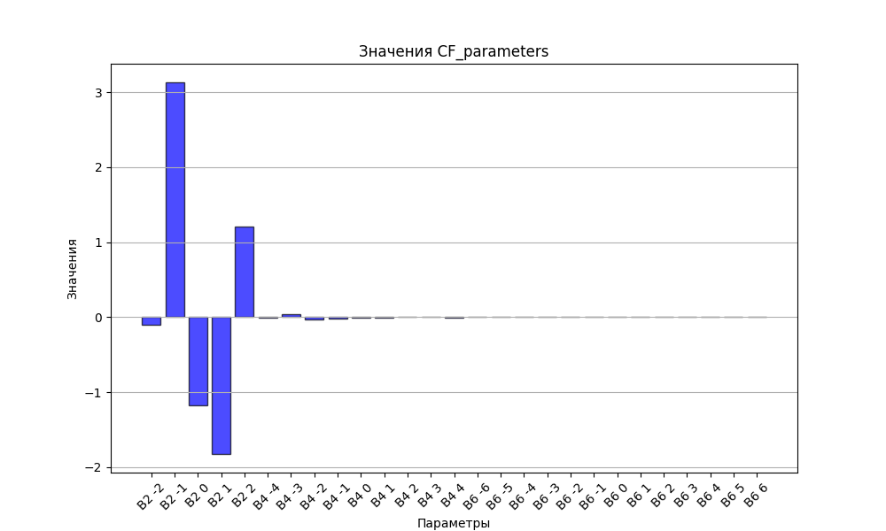

# CHI * T

|  |  |
| --- | --- |
| T | CHI * T |
| 1.0 | 4.4568563 |
| 2.0 | 7.5456214 |
| 3.0 | 9.3806642 |
| 4.0 | 10.4015529 |
| 5.0 | 10.9956073 |
| 6.0 | 11.3657347 |
| 7.0 | 11.6119699 |
| 8.0 | 11.7854973 |
| 9.0 | 11.9140152 |
| 10.0 | 12.01336 |
| 11.0 | 12.0930428 |
| 12.0 | 12.1590258 |
| 13.0 | 12.215187 |
| 14.0 | 12.2641308 |
| 15.0 | 12.3076554 |
| 16.0 | 12.3470321 |
| 17.0 | 12.3831793 |
| 18.0 | 12.416772 |
| 19.0 | 12.4483148 |
| 20.0 | 12.47819 |
| 21.0 | 12.5066909 |
| 22.0 | 12.5340447 |
| 23.0 | 12.5604292 |
| 24.0 | 12.5859848 |
| 25.0 | 12.6108227 |
| 26.0 | 12.6350319 |
| 27.0 | 12.6586838 |
| 28.0 | 12.6818358 |
| 29.0 | 12.7045344 |
| 30.0 | 12.7268171 |
| 31.0 | 12.7487143 |
| 32.0 | 12.7702507 |
| 33.0 | 12.7914463 |
| 34.0 | 12.8123172 |
| 35.0 | 12.8328763 |
| 36.0 | 12.8531342 |
| 37.0 | 12.8730993 |
| 38.0 | 12.8927781 |
| 39.0 | 12.912176 |
| 40.0 | 12.9312973 |
| 41.0 | 12.9501451 |
| 42.0 | 12.9687221 |
| 43.0 | 12.9870304 |
| 44.0 | 13.0050716 |
| 45.0 | 13.022847 |
| 46.0 | 13.0403578 |
| 47.0 | 13.057605 |
| 48.0 | 13.0745894 |
| 49.0 | 13.091312 |
| 50.0 | 13.1077737 |
| 51.0 | 13.1239755 |
| 52.0 | 13.1399184 |
| 53.0 | 13.1556036 |
| 54.0 | 13.1710325 |
| 55.0 | 13.1862064 |
| 56.0 | 13.2011269 |
| 57.0 | 13.2157957 |
| 58.0 | 13.2302147 |
| 59.0 | 13.2443859 |
| 60.0 | 13.2583114 |
| 61.0 | 13.2719937 |
| 62.0 | 13.285435 |
| 63.0 | 13.2986379 |
| 64.0 | 13.3116052 |
| 65.0 | 13.3243396 |
| 66.0 | 13.336844 |
| 67.0 | 13.3491214 |
| 68.0 | 13.3611749 |
| 69.0 | 13.3730076 |
| 70.0 | 13.3846227 |
| 71.0 | 13.3960236 |
| 72.0 | 13.4072135 |
| 73.0 | 13.4181958 |
| 74.0 | 13.428974 |
| 75.0 | 13.4395514 |
| 76.0 | 13.4499315 |
| 77.0 | 13.4601177 |
| 78.0 | 13.4701136 |
| 79.0 | 13.4799226 |
| 80.0 | 13.4895481 |
| 81.0 | 13.4989936 |
| 82.0 | 13.5082625 |
| 83.0 | 13.5173583 |
| 84.0 | 13.5262843 |
| 85.0 | 13.5350438 |
| 86.0 | 13.5436403 |
| 87.0 | 13.5520769 |
| 88.0 | 13.5603569 |
| 89.0 | 13.5684836 |
| 90.0 | 13.5764601 |
| 91.0 | 13.5842896 |
| 92.0 | 13.591975 |
| 93.0 | 13.5995194 |
| 94.0 | 13.6069258 |
| 95.0 | 13.6141972 |
| 96.0 | 13.6213363 |
| 97.0 | 13.6283461 |
| 98.0 | 13.6352292 |
| 99.0 | 13.6419885 |
| 100.0 | 13.6486265 |
| 101.0 | 13.6551459 |
| 102.0 | 13.6615492 |
| 103.0 | 13.667839 |
| 104.0 | 13.6740177 |
| 105.0 | 13.6800877 |
| 106.0 | 13.6860514 |
| 107.0 | 13.691911 |
| 108.0 | 13.6976688 |
| 109.0 | 13.703327 |
| 110.0 | 13.7088878 |
| 111.0 | 13.7143532 |
| 112.0 | 13.7197254 |
| 113.0 | 13.7250063 |
| 114.0 | 13.7301978 |
| 115.0 | 13.735302 |
| 116.0 | 13.7403206 |
| 117.0 | 13.7452555 |
| 118.0 | 13.7501085 |
| 119.0 | 13.7548813 |
| 120.0 | 13.7595757 |
| 121.0 | 13.7641932 |
| 122.0 | 13.7687355 |
| 123.0 | 13.7732042 |
| 124.0 | 13.7776009 |
| 125.0 | 13.781927 |
| 126.0 | 13.786184 |
| 127.0 | 13.7903734 |
| 128.0 | 13.7944965 |
| 129.0 | 13.7985547 |
| 130.0 | 13.8025494 |
| 131.0 | 13.8064819 |
| 132.0 | 13.8103534 |
| 133.0 | 13.8141651 |
| 134.0 | 13.8179184 |
| 135.0 | 13.8216143 |
| 136.0 | 13.825254 |
| 137.0 | 13.8288387 |
| 138.0 | 13.8323695 |
| 139.0 | 13.8358474 |
| 140.0 | 13.8392734 |
| 141.0 | 13.8426487 |
| 142.0 | 13.8459742 |
| 143.0 | 13.8492509 |
| 144.0 | 13.8524797 |
| 145.0 | 13.8556615 |
| 146.0 | 13.8587974 |
| 147.0 | 13.8618881 |
| 148.0 | 13.8649345 |
| 149.0 | 13.8679375 |
| 150.0 | 13.8708979 |
| 151.0 | 13.8738166 |
| 152.0 | 13.8766942 |
| 153.0 | 13.8795317 |
| 154.0 | 13.8823296 |
| 155.0 | 13.8850889 |
| 156.0 | 13.8878101 |
| 157.0 | 13.890494 |
| 158.0 | 13.8931413 |
| 159.0 | 13.8957527 |
| 160.0 | 13.8983288 |
| 161.0 | 13.9008702 |
| 162.0 | 13.9033776 |
| 163.0 | 13.9058517 |
| 164.0 | 13.9082929 |
| 165.0 | 13.9107019 |
| 166.0 | 13.9130793 |
| 167.0 | 13.9154256 |
| 168.0 | 13.9177414 |
| 169.0 | 13.9200273 |
| 170.0 | 13.9222836 |
| 171.0 | 13.924511 |
| 172.0 | 13.92671 |
| 173.0 | 13.9288811 |
| 174.0 | 13.9310246 |
| 175.0 | 13.9331412 |
| 176.0 | 13.9352313 |
| 177.0 | 13.9372953 |
| 178.0 | 13.9393337 |
| 179.0 | 13.9413468 |
| 180.0 | 13.9433352 |
| 181.0 | 13.9452993 |
| 182.0 | 13.9472394 |
| 183.0 | 13.9491559 |
| 184.0 | 13.9510493 |
| 185.0 | 13.9529199 |
| 186.0 | 13.9547681 |
| 187.0 | 13.9565943 |
| 188.0 | 13.9583989 |
| 189.0 | 13.9601821 |
| 190.0 | 13.9619443 |
| 191.0 | 13.9636859 |
| 192.0 | 13.9654072 |
| 193.0 | 13.9671085 |
| 194.0 | 13.9687902 |
| 195.0 | 13.9704525 |
| 196.0 | 13.9720958 |
| 197.0 | 13.9737203 |
| 198.0 | 13.9753264 |
| 199.0 | 13.9769144 |
| 200.0 | 13.9784845 |
| 201.0 | 13.9800369 |
| 202.0 | 13.9815721 |
| 203.0 | 13.9830902 |
| 204.0 | 13.9845916 |
| 205.0 | 13.9860764 |
| 206.0 | 13.9875449 |
| 207.0 | 13.9889974 |
| 208.0 | 13.9904341 |
| 209.0 | 13.9918553 |
| 210.0 | 13.9932611 |
| 211.0 | 13.9946519 |
| 212.0 | 13.9960278 |
| 213.0 | 13.997389 |
| 214.0 | 13.9987359 |
| 215.0 | 14.0000685 |
| 216.0 | 14.0013871 |
| 217.0 | 14.002692 |
| 218.0 | 14.0039832 |
| 219.0 | 14.0052611 |
| 220.0 | 14.0065257 |
| 221.0 | 14.0077774 |
| 222.0 | 14.0090162 |
| 223.0 | 14.0102424 |
| 224.0 | 14.0114562 |
| 225.0 | 14.0126577 |
| 226.0 | 14.013847 |
| 227.0 | 14.0150245 |
| 228.0 | 14.0161902 |
| 229.0 | 14.0173443 |
| 230.0 | 14.0184869 |
| 231.0 | 14.0196183 |
| 232.0 | 14.0207386 |
| 233.0 | 14.0218479 |
| 234.0 | 14.0229464 |
| 235.0 | 14.0240343 |
| 236.0 | 14.0251116 |
| 237.0 | 14.0261786 |
| 238.0 | 14.0272353 |
| 239.0 | 14.028282 |
| 240.0 | 14.0293187 |
| 241.0 | 14.0303457 |
| 242.0 | 14.0313629 |
| 243.0 | 14.0323706 |
| 244.0 | 14.0333688 |
| 245.0 | 14.0343578 |
| 246.0 | 14.0353376 |
| 247.0 | 14.0363083 |
| 248.0 | 14.0372702 |
| 249.0 | 14.0382232 |
| 250.0 | 14.0391675 |
| 251.0 | 14.0401032 |
| 252.0 | 14.0410305 |
| 253.0 | 14.0419494 |
| 254.0 | 14.04286 |
| 255.0 | 14.0437626 |
| 256.0 | 14.0446571 |
| 257.0 | 14.0455436 |
| 258.0 | 14.0464223 |
| 259.0 | 14.0472933 |
| 260.0 | 14.0481567 |
| 261.0 | 14.0490125 |
| 262.0 | 14.0498609 |
| 263.0 | 14.050702 |
| 264.0 | 14.0515357 |
| 265.0 | 14.0523624 |
| 266.0 | 14.053182 |
| 267.0 | 14.0539945 |
| 268.0 | 14.0548002 |
| 269.0 | 14.0555991 |
| 270.0 | 14.0563913 |
| 271.0 | 14.0571768 |
| 272.0 | 14.0579558 |
| 273.0 | 14.0587283 |
| 274.0 | 14.0594944 |
| 275.0 | 14.0602541 |
| 276.0 | 14.0610077 |
| 277.0 | 14.061755 |
| 278.0 | 14.0624963 |
| 279.0 | 14.0632316 |
| 280.0 | 14.0639609 |
| 281.0 | 14.0646843 |
| 282.0 | 14.0654019 |
| 283.0 | 14.0661138 |
| 284.0 | 14.0668201 |
| 285.0 | 14.0675207 |
| 286.0 | 14.0682158 |
| 287.0 | 14.0689054 |

# H_B_df

|  |  |  |  |
| --- | --- | --- | --- |
| H(T) | B(T_1) | B(T_2) | B(T_3) |
| 0.0001 | 0.0010926748 | 0.0005481502 | 0.000366642 |

# WAVE FUNCTIONS

|  |  |  |  |  |  |  |  |  |
| --- | --- | --- | --- | --- | --- | --- | --- | --- |
| Label | +-15/2> | +-13/2> | +-11/2> | +-9/2> | +-7/2> | +-5/2> | +-3/2> | +-1/2> |
| KD0 | 96 | 0 | 2 | 1 | 0 | 0 | 0 | 0 |
| KD1 | 0 | 15 | 8 | 16 | 15 | 19 | 14 | 13 |
| KD1 | 0 | 66 | 6 | 6 | 10 | 2 | 7 | 3 |
| KD2 | 1 | 4 | 27 | 11 | 11 | 10 | 15 | 21 |
| KD2 | 0 | 2 | 27 | 12 | 8 | 21 | 17 | 13 |
| KD3 | 0 | 0 | 4 | 22 | 23 | 9 | 12 | 29 |
| KD3 | 0 | 0 | 0 | 3 | 12 | 31 | 33 | 20 |
| KD4 | 2 | 12 | 26 | 29 | 21 | 8 | 2 | 1 |