# dybpm_molcas

# PSEUDOSPIN HAMILTONIAN TENSORS

|  |  |  |
| --- | --- | --- |
| g_x | g_y | g_z |
| 0.00672627511282 | 0.00879192196096 | 19.4500446488033 |
| 0.21613569501196 | 0.36130633393461 | 15.45331797091058 |
| 0.84096544199914 | 1.01422973400762 | 12.27720377417136 |
| 0.17879264865823 | 1.86886016920162 | 9.14601075784208 |
| 9.85111817767547 | 7.92739818190761 | 2.91765759831264 |
| 0.14210089680312 | 0.19350860802361 | 19.32498311093199 |
| 0.04275659985771 | 0.11007388907809 | 19.1897927589102 |
| 0.00303872705617 | 0.00685948620763 | 19.82016888285875 |

# AB INITIO BLOCKING BARRIER

|  |  |  |  |
| --- | --- | --- | --- |
| KD | l+, muB | l-, muB | E, cm-1 |
| 1.0 | -9.7250223 | 9.7250223 | 0.0 |
| 2.0 | -7.5426317 | 7.5426317 | 137.2102928 |
| 3.0 | -5.8466384 | 5.8466384 | 198.0123527 |
| 4.0 | -4.0108603 | 4.0108603 | 237.1040728 |
| 5.0 | -2.1128505 | 2.1128505 | 261.6901943 |
| 6.0 | -4.4665404 | 4.4665404 | 330.7645596 |
| 7.0 | -0.3624269 | 0.3624269 | 390.7594622 |
| 8.0 | -5.9313599 | 5.9313599 | 535.707958 |

# QTM, ORBACH, MATRIX ELEMENTS

|  |  |  |  |  |  |  |  |
| --- | --- | --- | --- | --- | --- | --- | --- |
| 0 | 1 | 2 | 3 | 4 | 5 | 6 | 7 |
| 0.0025863661787 | 0.0153099291264 | 0.0512248751498 | 0.0737153610894 | 0.0775075232233 | 0.0532815489644 | 0.030822141375 | 0.00375644336765 |
| 0.0 | 0.0999801058855 | 0.259887075972 | 0.246622842408 | 0.294038940906 | 0.0916223117587 | 0.211360040882 | 0.024200256155 |
| 0.0 | 0.0 | 0.3185885039 | 0.662066187749 | 0.735930254871 | 0.185239217602 | 0.586763339508 | 0.115526601278 |
| 0.0 | 0.0 | 0.0 | 0.46181182469 | 1.2731046268 | 0.330856734561 | 0.960694104709 | 0.248680338167 |
| 0.0 | 0.0 | 0.0 | 0.0 | 2.48138977544 | 0.889331872486 | 0.704695751438 | 0.332746169537 |
| 0.0 | 0.0 | 0.0 | 0.0 | 0.0 | 0.103397043367 | 0.225201759513 | 0.342398611216 |
| 0.0 | 0.0 | 0.0 | 0.0 | 0.0 | 0.0 | 0.390165444701 | 0.0292863949266 |
| 0.0 | 0.0 | 0.0 | 0.0 | 0.0 | 0.0 | 0.0 | 0.00205424390548 |

# DIRECT MATRIX ELEMENTS

|  |  |  |  |  |  |  |  |
| --- | --- | --- | --- | --- | --- | --- | --- |
| 0 | 1 | 2 | 3 | 4 | 5 | 6 | 7 |
| 3.24167410813 | 1.95818373014 | 0.549954377259 | 0.319155115606 | 0.375670351879 | 0.217419611766 | 0.119755612115 | 0.360312031887 |
| 0.0 | 3.28276329138 | 2.76076676822 | 0.965684032687 | 0.589726297855 | 0.41249666831 | 0.171440984119 | 0.615696325494 |
| 0.0 | 0.0 | 2.74417710668 | 2.92153816997 | 1.09491928534 | 0.839838135484 | 0.407163475148 | 0.749669877004 |
| 0.0 | 0.0 | 0.0 | 2.12586323212 | 3.06346963768 | 1.44703328176 | 0.514001520064 | 0.912636327216 |
| 0.0 | 0.0 | 0.0 | 0.0 | 1.76886432421 | 1.19823994891 | 1.55178352566 | 1.185840696 |
| 0.0 | 0.0 | 0.0 | 0.0 | 0.0 | 5.47859493383 | 0.564728434582 | 0.0882741727404 |
| 0.0 | 0.0 | 0.0 | 0.0 | 0.0 | 0.0 | 4.39728696539 | 0.985117218947 |
| 0.0 | 0.0 | 0.0 | 0.0 | 0.0 | 0.0 | 0.0 | 5.66569063317 |

# Diagram

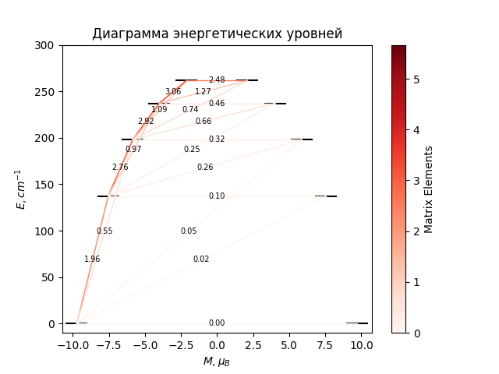

# CF_parameters

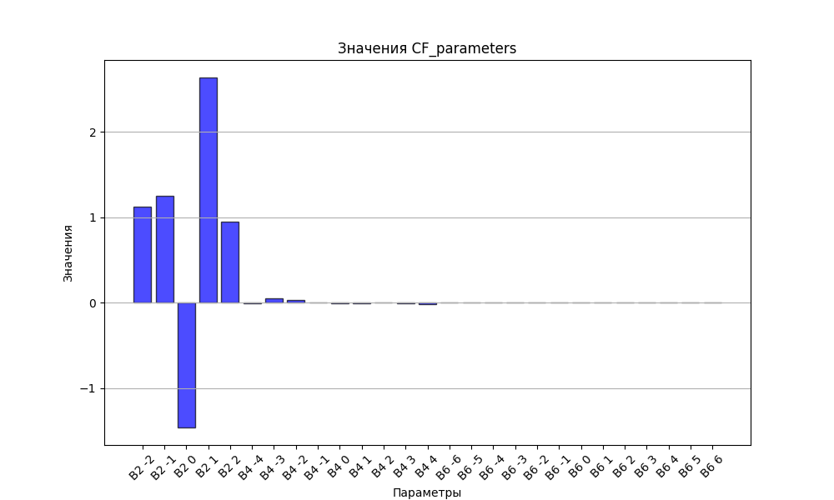

# CHI * T

|  |  |
| --- | --- |
| T | CHI * T |
| 1.0 | 10.8317321 |
| 2.0 | 11.5934481 |
| 3.0 | 11.7686797 |
| 4.0 | 11.8460649 |
| 5.0 | 11.8943066 |
| 6.0 | 11.9309396 |
| 7.0 | 11.9620583 |
| 8.0 | 11.9902275 |
| 9.0 | 12.0166778 |
| 10.0 | 12.0420594 |
| 11.0 | 12.0667418 |
| 12.0 | 12.0909476 |
| 13.0 | 12.1148169 |
| 14.0 | 12.1384416 |
| 15.0 | 12.1618829 |
| 16.0 | 12.1851826 |
| 17.0 | 12.2083687 |
| 18.0 | 12.2314598 |
| 19.0 | 12.2544671 |
| 20.0 | 12.2773965 |
| 21.0 | 12.3002495 |
| 22.0 | 12.3230245 |
| 23.0 | 12.3457171 |
| 24.0 | 12.3683212 |
| 25.0 | 12.3908292 |
| 26.0 | 12.4132322 |
| 27.0 | 12.4355211 |
| 28.0 | 12.4576862 |
| 29.0 | 12.4797177 |
| 30.0 | 12.501606 |
| 31.0 | 12.5233418 |
| 32.0 | 12.5449161 |
| 33.0 | 12.5663203 |
| 34.0 | 12.5875466 |
| 35.0 | 12.6085874 |
| 36.0 | 12.6294361 |
| 37.0 | 12.6500863 |
| 38.0 | 12.6705325 |
| 39.0 | 12.6907697 |
| 40.0 | 12.7107934 |
| 41.0 | 12.7305997 |
| 42.0 | 12.7501851 |
| 43.0 | 12.7695468 |
| 44.0 | 12.7886822 |
| 45.0 | 12.8075893 |
| 46.0 | 12.8262665 |
| 47.0 | 12.8447123 |
| 48.0 | 12.8629259 |
| 49.0 | 12.8809065 |
| 50.0 | 12.8986539 |
| 51.0 | 12.9161679 |
| 52.0 | 12.9334486 |
| 53.0 | 12.9504964 |
| 54.0 | 12.9673118 |
| 55.0 | 12.9838956 |
| 56.0 | 13.0002487 |
| 57.0 | 13.0163722 |
| 58.0 | 13.0322673 |
| 59.0 | 13.0479352 |
| 60.0 | 13.0633776 |
| 61.0 | 13.0785959 |
| 62.0 | 13.0935919 |
| 63.0 | 13.1083673 |
| 64.0 | 13.122924 |
| 65.0 | 13.1372638 |
| 66.0 | 13.1513889 |
| 67.0 | 13.1653012 |
| 68.0 | 13.1790029 |
| 69.0 | 13.1924961 |
| 70.0 | 13.2057831 |
| 71.0 | 13.2188662 |
| 72.0 | 13.2317476 |
| 73.0 | 13.2444296 |
| 74.0 | 13.2569147 |
| 75.0 | 13.2692053 |
| 76.0 | 13.2813037 |
| 77.0 | 13.2932123 |
| 78.0 | 13.3049337 |
| 79.0 | 13.3164702 |
| 80.0 | 13.3278244 |
| 81.0 | 13.3389988 |
| 82.0 | 13.3499957 |
| 83.0 | 13.3608178 |
| 84.0 | 13.3714675 |
| 85.0 | 13.3819472 |
| 86.0 | 13.3922594 |
| 87.0 | 13.4024067 |
| 88.0 | 13.4123915 |
| 89.0 | 13.4222163 |
| 90.0 | 13.4318834 |
| 91.0 | 13.4413953 |
| 92.0 | 13.4507545 |
| 93.0 | 13.4599634 |
| 94.0 | 13.4690242 |
| 95.0 | 13.4779395 |
| 96.0 | 13.4867115 |
| 97.0 | 13.4953426 |
| 98.0 | 13.503835 |
| 99.0 | 13.5121911 |
| 100.0 | 13.5204132 |
| 101.0 | 13.5285033 |
| 102.0 | 13.5364639 |
| 103.0 | 13.544297 |
| 104.0 | 13.5520049 |
| 105.0 | 13.5595896 |
| 106.0 | 13.5670533 |
| 107.0 | 13.574398 |
| 108.0 | 13.5816258 |
| 109.0 | 13.5887387 |
| 110.0 | 13.5957388 |
| 111.0 | 13.602628 |
| 112.0 | 13.6094082 |
| 113.0 | 13.6160814 |
| 114.0 | 13.6226494 |
| 115.0 | 13.6291142 |
| 116.0 | 13.6354774 |
| 117.0 | 13.641741 |
| 118.0 | 13.6479067 |
| 119.0 | 13.6539763 |
| 120.0 | 13.6599514 |
| 121.0 | 13.6658338 |
| 122.0 | 13.671625 |
| 123.0 | 13.6773269 |
| 124.0 | 13.6829408 |
| 125.0 | 13.6884685 |
| 126.0 | 13.6939115 |
| 127.0 | 13.6992712 |
| 128.0 | 13.7045493 |
| 129.0 | 13.7097471 |
| 130.0 | 13.7148661 |
| 131.0 | 13.7199077 |
| 132.0 | 13.7248733 |
| 133.0 | 13.7297644 |
| 134.0 | 13.7345821 |
| 135.0 | 13.7393279 |
| 136.0 | 13.744003 |
| 137.0 | 13.7486087 |
| 138.0 | 13.7531462 |
| 139.0 | 13.7576169 |
| 140.0 | 13.7620218 |
| 141.0 | 13.7663621 |
| 142.0 | 13.770639 |
| 143.0 | 13.7748537 |
| 144.0 | 13.7790071 |
| 145.0 | 13.7831006 |
| 146.0 | 13.787135 |
| 147.0 | 13.7911115 |
| 148.0 | 13.795031 |
| 149.0 | 13.7988946 |
| 150.0 | 13.8027033 |
| 151.0 | 13.8064581 |
| 152.0 | 13.8101598 |
| 153.0 | 13.8138095 |
| 154.0 | 13.817408 |
| 155.0 | 13.8209563 |
| 156.0 | 13.8244551 |
| 157.0 | 13.8279055 |
| 158.0 | 13.8313082 |
| 159.0 | 13.8346641 |
| 160.0 | 13.8379739 |
| 161.0 | 13.8412385 |
| 162.0 | 13.8444586 |
| 163.0 | 13.8476351 |
| 164.0 | 13.8507687 |
| 165.0 | 13.85386 |
| 166.0 | 13.8569099 |
| 167.0 | 13.8599191 |
| 168.0 | 13.8628881 |
| 169.0 | 13.8658178 |
| 170.0 | 13.8687088 |
| 171.0 | 13.8715618 |
| 172.0 | 13.8743773 |
| 173.0 | 13.877156 |
| 174.0 | 13.8798986 |
| 175.0 | 13.8826056 |
| 176.0 | 13.8852777 |
| 177.0 | 13.8879154 |
| 178.0 | 13.8905193 |
| 179.0 | 13.89309 |
| 180.0 | 13.8956279 |
| 181.0 | 13.8981337 |
| 182.0 | 13.9006079 |
| 183.0 | 13.903051 |
| 184.0 | 13.9054635 |
| 185.0 | 13.9078458 |
| 186.0 | 13.9101986 |
| 187.0 | 13.9125223 |
| 188.0 | 13.9148173 |
| 189.0 | 13.9170842 |
| 190.0 | 13.9193232 |
| 191.0 | 13.9215351 |
| 192.0 | 13.92372 |
| 193.0 | 13.9258786 |
| 194.0 | 13.9280111 |
| 195.0 | 13.9301181 |
| 196.0 | 13.9321998 |
| 197.0 | 13.9342568 |
| 198.0 | 13.9362894 |
| 199.0 | 13.938298 |
| 200.0 | 13.940283 |
| 201.0 | 13.9422447 |
| 202.0 | 13.9441835 |
| 203.0 | 13.9460997 |
| 204.0 | 13.9479938 |
| 205.0 | 13.949866 |
| 206.0 | 13.9517167 |
| 207.0 | 13.9535462 |
| 208.0 | 13.9553548 |
| 209.0 | 13.9571429 |
| 210.0 | 13.9589108 |
| 211.0 | 13.9606587 |
| 212.0 | 13.962387 |
| 213.0 | 13.964096 |
| 214.0 | 13.965786 |
| 215.0 | 13.9674572 |
| 216.0 | 13.9691099 |
| 217.0 | 13.9707445 |
| 218.0 | 13.9723611 |
| 219.0 | 13.9739601 |
| 220.0 | 13.9755417 |
| 221.0 | 13.9771061 |
| 222.0 | 13.9786536 |
| 223.0 | 13.9801845 |
| 224.0 | 13.9816991 |
| 225.0 | 13.9831974 |
| 226.0 | 13.9846798 |
| 227.0 | 13.9861466 |
| 228.0 | 13.9875979 |
| 229.0 | 13.9890339 |
| 230.0 | 13.9904549 |
| 231.0 | 13.9918611 |
| 232.0 | 13.9932527 |
| 233.0 | 13.9946299 |
| 234.0 | 13.9959929 |
| 235.0 | 13.997342 |
| 236.0 | 13.9986772 |
| 237.0 | 13.9999989 |
| 238.0 | 14.0013071 |
| 239.0 | 14.0026022 |
| 240.0 | 14.0038842 |
| 241.0 | 14.0051534 |
| 242.0 | 14.0064099 |
| 243.0 | 14.0076539 |
| 244.0 | 14.0088855 |
| 245.0 | 14.0101051 |
| 246.0 | 14.0113126 |
| 247.0 | 14.0125083 |
| 248.0 | 14.0136924 |
| 249.0 | 14.0148649 |
| 250.0 | 14.0160261 |
| 251.0 | 14.0171761 |
| 252.0 | 14.0183151 |
| 253.0 | 14.0194432 |
| 254.0 | 14.0205605 |
| 255.0 | 14.0216672 |
| 256.0 | 14.0227634 |
| 257.0 | 14.0238494 |
| 258.0 | 14.0249251 |
| 259.0 | 14.0259908 |
| 260.0 | 14.0270466 |
| 261.0 | 14.0280925 |
| 262.0 | 14.0291288 |
| 263.0 | 14.0301556 |
| 264.0 | 14.031173 |
| 265.0 | 14.0321811 |
| 266.0 | 14.03318 |
| 267.0 | 14.0341698 |
| 268.0 | 14.0351507 |
| 269.0 | 14.0361228 |
| 270.0 | 14.0370862 |
| 271.0 | 14.038041 |
| 272.0 | 14.0389874 |
| 273.0 | 14.0399253 |
| 274.0 | 14.040855 |
| 275.0 | 14.0417765 |
| 276.0 | 14.0426899 |
| 277.0 | 14.0435954 |
| 278.0 | 14.044493 |
| 279.0 | 14.0453828 |
| 280.0 | 14.046265 |
| 281.0 | 14.0471396 |
| 282.0 | 14.0480068 |
| 283.0 | 14.0488665 |
| 284.0 | 14.049719 |
| 285.0 | 14.0505642 |
| 286.0 | 14.0514023 |
| 287.0 | 14.0522334 |

# H_B_df

|  |  |  |  |
| --- | --- | --- | --- |
| H(T) | B(T_1) | B(T_2) | B(T_3) |
| 0.0001 | 0.0011185886 | 0.0007099291 | 0.0004275825 |

# WAVE FUNCTIONS

|  |  |  |  |  |  |  |  |  |
| --- | --- | --- | --- | --- | --- | --- | --- | --- |
| Label | +-15/2> | +-13/2> | +-11/2> | +-9/2> | +-7/2> | +-5/2> | +-3/2> | +-1/2> |
| KD1 | 91 | 0 | 8 | 0 | 0 | 0 | 0 | 0 |
| KD2 | 0 | 64 | 1 | 30 | 2 | 1 | 1 | 1 |
| KD3 | 4 | 8 | 37 | 2 | 40 | 4 | 1 | 5 |
| KD4 | 1 | 4 | 15 | 15 | 5 | 36 | 14 | 10 |
| KD5 | 0 | 7 | 2 | 6 | 7 | 15 | 37 | 27 |
| KD6 | 1 | 4 | 12 | 19 | 24 | 23 | 10 | 7 |
| KD7 | 0 | 1 | 1 | 2 | 3 | 10 | 33 | 50 |
| KD8 | 2 | 12 | 24 | 26 | 19 | 11 | 4 | 1 |