# eg23p_single_aniso.log

# PSEUDOSPIN HAMILTONIAN TENSORS

|  |  |  |  |
| --- | --- | --- | --- |
| KD | g_x | g_y | g_z |
| 1.0 | 0.01057279232228 | 0.01565030450798 | 19.13829400963081 |
| 2.0 | 0.19108435488364 | 0.25544396114559 | 15.60120079298806 |
| 3.0 | 0.19811490356388 | 0.37315780295276 | 12.5783965919305 |
| 4.0 | 4.4887371658789 | 6.26199956531217 | 8.31444975397781 |
| 5.0 | 2.71686778321279 | 3.34781251014984 | 12.56926045828683 |
| 6.0 | 0.53746812899573 | 0.74599219684912 | 18.58112860511386 |
| 7.0 | 0.02738673385885 | 0.0565795713081 | 19.04654383910049 |
| 8.0 | 0.00497225943939 | 0.01127738299084 | 19.70268734176997 |

# AB INITIO BLOCKING BARRIER

|  |  |  |  |
| --- | --- | --- | --- |
| KD | l+, muB | l-, muB | E, cm-1 |
| 1.0 | -9.569147 | 9.569147 | 0.0 |
| 2.0 | -7.523984 | 7.523984 | 115.0529549 |
| 3.0 | -5.4868753 | 5.4868753 | 184.4942976 |
| 4.0 | -3.8319522 | 3.8319522 | 224.3044518 |
| 5.0 | -1.7544177 | 1.7544177 | 263.7262632 |
| 6.0 | -3.0857275 | 3.0857275 | 313.3562701 |
| 7.0 | -0.2540974 | 0.2540974 | 402.5516994 |
| 8.0 | -5.8794623 | 5.8794623 | 546.3255697 |

# QTM, ORBACH, MTRIX ELEMENTS

|  |  |  |  |  |  |  |  |
| --- | --- | --- | --- | --- | --- | --- | --- |
| 1+ | 2+ | 3+ | 4+ | 5+ | 6+ | 7+ | 8+ |
| 0.00437051613815 | 0.0181927074061 | 0.0523523670315 | 0.0618722319064 | 0.171460088164 | 0.127274980858 | 0.134335222586 | 0.00550652830928 |
| 0.0 | 0.0764168725659 | 0.133134479735 | 0.129099864874 | 0.315770582381 | 0.259863907903 | 0.212074162318 | 0.0192013179841 |
| 0.0 | 0.0 | 0.10330873496 | 0.596186531755 | 0.475477279813 | 0.289936806771 | 0.260198139963 | 0.0812423587907 |
| 0.0 | 0.0 | 0.0 | 1.87275909911 | 1.5380914768 | 0.625094039879 | 0.251851775722 | 0.168310952782 |
| 0.0 | 0.0 | 0.0 | 0.0 | 2.31495599979 | 1.57530172144 | 1.51645543386 | 0.41367604334 |
| 0.0 | 0.0 | 0.0 | 0.0 | 0.0 | 0.453097484319 | 0.374436283091 | 0.632650444594 |
| 0.0 | 0.0 | 0.0 | 0.0 | 0.0 | 0.0 | 0.263081302841 | 1.16120662529 |
| 0.0 | 0.0 | 0.0 | 0.0 | 0.0 | 0.0 | 0.0 | 0.00345599040376 |

# DIRECT MTRIX ELEMENTS

|  |  |  |  |  |  |  |  |
| --- | --- | --- | --- | --- | --- | --- | --- |
| 0 | 1 | 2 | 3 | 4 | 5 | 6 | 7 |
| 3.18971566827 | 2.0325199114 | 0.613076964875 | 0.36253746419 | 0.326656577454 | 0.14089973604 | 0.0491091422358 | 0.320440952255 |
| 0.0 | 3.4349225725 | 2.70725931951 | 0.847200165406 | 0.689199501709 | 0.349674114131 | 0.176133007872 | 0.551924384206 |
| 0.0 | 0.0 | 3.1829182403 | 3.16691537216 | 0.998057545804 | 0.687709756933 | 0.40315009896 | 0.713109224239 |
| 0.0 | 0.0 | 0.0 | 1.7818220134 | 2.64246069957 | 1.11716490223 | 0.623829289603 | 0.760755770697 |
| 0.0 | 0.0 | 0.0 | 0.0 | 1.67153077364 | 1.32170874628 | 0.94601079916 | 1.07464953119 |
| 0.0 | 0.0 | 0.0 | 0.0 | 0.0 | 5.0769078736 | 0.663281189778 | 0.113978814245 |
| 0.0 | 0.0 | 0.0 | 0.0 | 0.0 | 0.0 | 4.14277349764 | 0.0411114305387 |
| 0.0 | 0.0 | 0.0 | 0.0 | 0.0 | 0.0 | 0.0 | 5.48623627347 |

# Energy_diagram

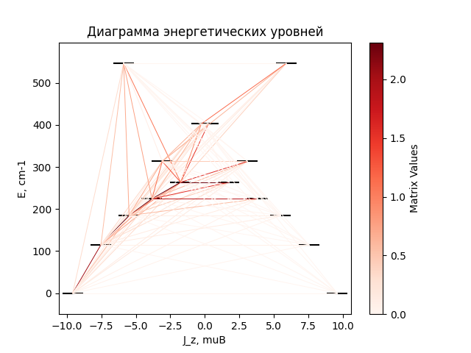

# CF_parameters

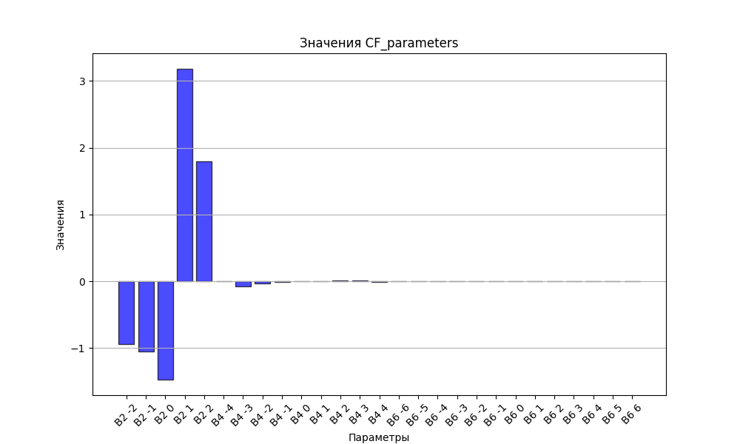

# CHI * T

|  |  |
| --- | --- |
| T | CHI * T |
| 1.0 | 4.5609257 |
| 2.0 | 7.5703495 |
| 3.0 | 9.2065585 |
| 4.0 | 10.0803747 |
| 5.0 | 10.5818189 |
| 6.0 | 10.8948779 |
| 7.0 | 11.1058485 |
| 8.0 | 11.257672 |
| 9.0 | 11.3731895 |
| 10.0 | 11.4653126 |
| 11.0 | 11.5417346 |
| 12.0 | 11.60725 |
| 13.0 | 11.6649628 |
| 14.0 | 11.7169487 |
| 15.0 | 11.7646342 |
| 16.0 | 11.8090224 |
| 17.0 | 11.8508318 |
| 18.0 | 11.8905853 |
| 19.0 | 11.9286682 |
| 20.0 | 11.9653671 |
| 21.0 | 12.000897 |
| 22.0 | 12.0354202 |
| 23.0 | 12.0690597 |
| 24.0 | 12.1019092 |
| 25.0 | 12.1340406 |
| 26.0 | 12.165509 |
| 27.0 | 12.196357 |
| 28.0 | 12.2266176 |
| 29.0 | 12.2563168 |
| 30.0 | 12.2854753 |
| 31.0 | 12.3141096 |
| 32.0 | 12.3422334 |
| 33.0 | 12.3698579 |
| 34.0 | 12.3969929 |
| 35.0 | 12.4236469 |
| 36.0 | 12.4498278 |
| 37.0 | 12.4755426 |
| 38.0 | 12.5007982 |
| 39.0 | 12.5256008 |
| 40.0 | 12.549957 |
| 41.0 | 12.5738729 |
| 42.0 | 12.5973546 |
| 43.0 | 12.6204083 |
| 44.0 | 12.6430402 |
| 45.0 | 12.6652564 |
| 46.0 | 12.6870632 |
| 47.0 | 12.7084666 |
| 48.0 | 12.729473 |
| 49.0 | 12.7500886 |
| 50.0 | 12.7703196 |
| 51.0 | 12.7901722 |
| 52.0 | 12.8096527 |
| 53.0 | 12.8287672 |
| 54.0 | 12.847522 |
| 55.0 | 12.8659232 |
| 56.0 | 12.883977 |
| 57.0 | 12.9016894 |
| 58.0 | 12.9190665 |
| 59.0 | 12.9361142 |
| 60.0 | 12.9528386 |
| 61.0 | 12.9692454 |
| 62.0 | 12.9853406 |
| 63.0 | 13.0011298 |
| 64.0 | 13.0166189 |
| 65.0 | 13.0318133 |
| 66.0 | 13.0467187 |
| 67.0 | 13.0613407 |
| 68.0 | 13.0756845 |
| 69.0 | 13.0897556 |
| 70.0 | 13.1035592 |
| 71.0 | 13.1171006 |
| 72.0 | 13.1303849 |
| 73.0 | 13.1434171 |
| 74.0 | 13.1562022 |
| 75.0 | 13.1687452 |
| 76.0 | 13.1810509 |
| 77.0 | 13.193124 |
| 78.0 | 13.2049692 |
| 79.0 | 13.2165911 |
| 80.0 | 13.2279942 |
| 81.0 | 13.2391831 |
| 82.0 | 13.250162 |
| 83.0 | 13.2609352 |
| 84.0 | 13.2715071 |
| 85.0 | 13.2818816 |
| 86.0 | 13.292063 |
| 87.0 | 13.3020552 |
| 88.0 | 13.3118621 |
| 89.0 | 13.3214876 |
| 90.0 | 13.3309354 |
| 91.0 | 13.3402094 |
| 92.0 | 13.349313 |
| 93.0 | 13.3582499 |
| 94.0 | 13.3670236 |
| 95.0 | 13.3756375 |
| 96.0 | 13.3840949 |
| 97.0 | 13.3923992 |
| 98.0 | 13.4005535 |
| 99.0 | 13.4085611 |
| 100.0 | 13.416425 |
| 101.0 | 13.4241482 |
| 102.0 | 13.4317337 |
| 103.0 | 13.4391845 |
| 104.0 | 13.4465033 |
| 105.0 | 13.4536929 |
| 106.0 | 13.4607561 |
| 107.0 | 13.4676955 |
| 108.0 | 13.4745137 |
| 109.0 | 13.4812133 |
| 110.0 | 13.4877967 |
| 111.0 | 13.4942665 |
| 112.0 | 13.5006249 |
| 113.0 | 13.5068743 |
| 114.0 | 13.5130171 |
| 115.0 | 13.5190553 |
| 116.0 | 13.5249913 |
| 117.0 | 13.5308271 |
| 118.0 | 13.5365648 |
| 119.0 | 13.5422064 |
| 120.0 | 13.547754 |
| 121.0 | 13.5532095 |
| 122.0 | 13.5585747 |
| 123.0 | 13.5638517 |
| 124.0 | 13.569042 |
| 125.0 | 13.5741477 |
| 126.0 | 13.5791702 |
| 127.0 | 13.5841115 |
| 128.0 | 13.5889731 |
| 129.0 | 13.5937566 |
| 130.0 | 13.5984636 |
| 131.0 | 13.6030958 |
| 132.0 | 13.6076545 |
| 133.0 | 13.6121412 |
| 134.0 | 13.6165575 |
| 135.0 | 13.6209047 |
| 136.0 | 13.6251842 |
| 137.0 | 13.6293973 |
| 138.0 | 13.6335453 |
| 139.0 | 13.6376296 |
| 140.0 | 13.6416514 |
| 141.0 | 13.645612 |
| 142.0 | 13.6495124 |
| 143.0 | 13.653354 |
| 144.0 | 13.6571378 |
| 145.0 | 13.6608649 |
| 146.0 | 13.6645365 |
| 147.0 | 13.6681537 |
| 148.0 | 13.6717174 |
| 149.0 | 13.6752288 |
| 150.0 | 13.6786887 |
| 151.0 | 13.6820983 |
| 152.0 | 13.6854583 |
| 153.0 | 13.6887699 |
| 154.0 | 13.6920338 |
| 155.0 | 13.695251 |
| 156.0 | 13.6984224 |
| 157.0 | 13.7015488 |
| 158.0 | 13.704631 |
| 159.0 | 13.7076699 |
| 160.0 | 13.7106663 |
| 161.0 | 13.7136209 |
| 162.0 | 13.7165345 |
| 163.0 | 13.7194079 |
| 164.0 | 13.7222418 |
| 165.0 | 13.7250369 |
| 166.0 | 13.7277939 |
| 167.0 | 13.7305135 |
| 168.0 | 13.7331964 |
| 169.0 | 13.7358432 |
| 170.0 | 13.7384545 |
| 171.0 | 13.7410311 |
| 172.0 | 13.7435734 |
| 173.0 | 13.7460822 |
| 174.0 | 13.748558 |
| 175.0 | 13.7510014 |
| 176.0 | 13.7534129 |
| 177.0 | 13.7557931 |
| 178.0 | 13.7581425 |
| 179.0 | 13.7604617 |
| 180.0 | 13.7627512 |
| 181.0 | 13.7650115 |
| 182.0 | 13.7672431 |
| 183.0 | 13.7694465 |
| 184.0 | 13.7716221 |
| 185.0 | 13.7737705 |
| 186.0 | 13.775892 |
| 187.0 | 13.7779872 |
| 188.0 | 13.7800565 |
| 189.0 | 13.7821003 |
| 190.0 | 13.784119 |
| 191.0 | 13.786113 |
| 192.0 | 13.7880828 |
| 193.0 | 13.7900288 |
| 194.0 | 13.7919512 |
| 195.0 | 13.7938506 |
| 196.0 | 13.7957273 |
| 197.0 | 13.7975817 |
| 198.0 | 13.7994141 |
| 199.0 | 13.8012248 |
| 200.0 | 13.8030143 |
| 201.0 | 13.8047828 |
| 202.0 | 13.8065307 |
| 203.0 | 13.8082583 |
| 204.0 | 13.8099659 |
| 205.0 | 13.8116539 |
| 206.0 | 13.8133226 |
| 207.0 | 13.8149722 |
| 208.0 | 13.8166031 |
| 209.0 | 13.8182155 |
| 210.0 | 13.8198097 |
| 211.0 | 13.8213861 |
| 212.0 | 13.8229448 |
| 213.0 | 13.8244862 |
| 214.0 | 13.8260105 |
| 215.0 | 13.8275179 |
| 216.0 | 13.8290088 |
| 217.0 | 13.8304834 |
| 218.0 | 13.8319419 |
| 219.0 | 13.8333846 |
| 220.0 | 13.8348116 |
| 221.0 | 13.8362233 |
| 222.0 | 13.8376199 |
| 223.0 | 13.8390015 |
| 224.0 | 13.8403684 |
| 225.0 | 13.8417209 |
| 226.0 | 13.8430591 |
| 227.0 | 13.8443832 |
| 228.0 | 13.8456934 |
| 229.0 | 13.84699 |
| 230.0 | 13.8482732 |
| 231.0 | 13.8495431 |
| 232.0 | 13.8507999 |
| 233.0 | 13.8520438 |
| 234.0 | 13.8532749 |
| 235.0 | 13.8544936 |
| 236.0 | 13.8556999 |
| 237.0 | 13.8568941 |
| 238.0 | 13.8580762 |
| 239.0 | 13.8592465 |
| 240.0 | 13.8604051 |
| 241.0 | 13.8615522 |
| 242.0 | 13.862688 |
| 243.0 | 13.8638126 |
| 244.0 | 13.8649261 |
| 245.0 | 13.8660287 |
| 246.0 | 13.8671206 |
| 247.0 | 13.8682019 |
| 248.0 | 13.8692728 |
| 249.0 | 13.8703334 |
| 250.0 | 13.8713838 |
| 251.0 | 13.8724241 |
| 252.0 | 13.8734546 |
| 253.0 | 13.8744753 |
| 254.0 | 13.8754863 |
| 255.0 | 13.8764879 |
| 256.0 | 13.8774801 |
| 257.0 | 13.878463 |
| 258.0 | 13.8794368 |
| 259.0 | 13.8804016 |
| 260.0 | 13.8813575 |
| 261.0 | 13.8823046 |
| 262.0 | 13.883243 |
| 263.0 | 13.8841729 |
| 264.0 | 13.8850944 |
| 265.0 | 13.8860075 |
| 266.0 | 13.8869124 |
| 267.0 | 13.8878092 |
| 268.0 | 13.888698 |
| 269.0 | 13.8895788 |
| 270.0 | 13.8904519 |
| 271.0 | 13.8913172 |
| 272.0 | 13.8921749 |
| 273.0 | 13.8930251 |
| 274.0 | 13.8938679 |
| 275.0 | 13.8947033 |
| 276.0 | 13.8955315 |
| 277.0 | 13.8963526 |
| 278.0 | 13.8971666 |
| 279.0 | 13.8979736 |
| 280.0 | 13.8987737 |
| 281.0 | 13.899567 |
| 282.0 | 13.9003536 |
| 283.0 | 13.9011336 |
| 284.0 | 13.901907 |
| 285.0 | 13.9026739 |
| 286.0 | 13.9034345 |
| 287.0 | 13.9041887 |

# H_B_df

|  |  |  |  |
| --- | --- | --- | --- |
| H(T) | B(T_1) | B(T_2) | B(T_3) |
| 0.0001 | 0.0010303882 | 0.0005178228 | 0.0003469677 |
| 0.1 | 1.0098158482 | 0.515194681 | 0.3461856444 |
| 0.2 | 1.9090648142 | 1.0150709063 | 0.6877397426 |
| 0.3 | 2.6371925792 | 1.4864094301 | 1.020324437 |
| 0.4 | 3.1900389527 | 1.9195621035 | 1.340147341 |
| 0.5 | 3.5953180555 | 2.3089837078 | 1.644139926 |
| 0.6 | 3.8885929634 | 2.6529109373 | 1.930047938 |
| 0.7 | 4.1012111335 | 2.9525239256 | 2.1964368747 |
| 0.8 | 4.2570654385 | 3.2109540764 | 2.4426288849 |
| 0.9 | 4.3731961379 | 3.4323913364 | 2.6685941042 |
| 1.0 | 4.4614034527 | 3.621405688 | 2.8748197592 |
| 1.1 | 4.5297782814 | 3.7824962663 | 3.062176372 |
| 1.2 | 4.583874 | 3.919830047 | 3.2317945116 |
| 1.3 | 4.6275305736 | 4.0371173376 | 3.3849596785 |
| 1.4 | 4.663432808 | 4.1375758844 | 3.5230281733 |
| 1.5 | 4.6934827574 | 4.2239467931 | 3.6473635432 |
| 1.6 | 4.7190472856 | 4.2985370706 | 3.7592913222 |
| 1.7 | 4.7411231713 | 4.363272922 | 3.8600689472 |
| 1.8 | 4.7604480313 | 4.4197545608 | 3.9508676046 |
| 1.9 | 4.7775755692 | 4.4693076348 | 4.0327630316 |
| 2.0 | 4.792927202 | 4.5130290417 | 4.1067327459 |
| 2.1 | 4.806827905 | 4.5518264561 | 4.1736576799 |
| 2.2 | 4.8195314114 | 4.5864517271 | 4.2343266597 |
| 2.3 | 4.8312381498 | 4.617528706 | 4.2894425776 |
| 2.4 | 4.842108172 | 4.6455762179 | 4.3396294279 |
| 2.5 | 4.852270582 | 4.6710269094 | 4.3854396354 |
| 2.6 | 4.8618304975 | 4.6942426542 | 4.4273612954 |
| 2.7 | 4.8708742461 | 4.715527117 | 4.4658250852 |
| 2.8 | 4.8794732882 | 4.7351359922 | 4.5012107061 |
| 2.9 | 4.8876872092 | 4.753285347 | 4.5338527885 |
| 3.0 | 4.8955660259 | 4.770158426 | 4.5640462338 |
| 3.1 | 4.9031519803 | 4.7859112087 | 4.5920510032 |
| 3.2 | 4.9104809491 | 4.8006769558 | 4.6180963776 |
| 3.3 | 4.9175835595 | 4.8145699378 | 4.6423847281 |
| 3.4 | 4.9244860805 | 4.8276884982 | 4.6650948369 |
| 3.5 | 4.9312111413 | 4.8401175793 | 4.6863848146 |
| 3.6 | 4.9377783127 | 4.8519308086 | 4.7063946559 |
| 3.7 | 4.9442045827 | 4.863192228 | 4.7252484744 |
| 3.8 | 4.9505047474 | 4.8739577316 | 4.7430564551 |
| 3.9 | 4.9566917341 | 4.8842762646 | 4.7599165583 |
| 4.0 | 4.9627768699 | 4.8941908254 | 4.775916006 |
| 4.1 | 4.9687701072 | 4.9037393075 | 4.7911325789 |
| 4.2 | 4.9746802121 | 4.9129552066 | 4.8056357477 |
| 4.3 | 4.9805149244 | 4.9218682192 | 4.8194876598 |
| 4.4 | 4.9862810927 | 4.9305047484 | 4.8327440022 |
| 4.5 | 4.99198479 | 4.9388883336 | 4.8454547539 |
| 4.6 | 4.9976314122 | 4.9470400175 | 4.8576648448 |
| 4.7 | 5.0032257625 | 4.954978659 | 4.8694147322 |
| 4.8 | 5.0087721246 | 4.9627212011 | 4.8807409054 |
| 4.9 | 5.0142743251 | 4.9702829025 | 4.8916763288 |
| 5.0 | 5.0197357881 | 4.9776775358 | 4.9022508307 |

# WAVE FUNCTIONS

|  |  |  |  |  |  |  |  |  |
| --- | --- | --- | --- | --- | --- | --- | --- | --- |
| Label | +-15/2> | +-13/2> | +-11/2> | +-9/2> | +-7/2> | +-5/2> | +-3/2> | +-1/2> |
| KD1 | 87 | 0 | 12 | 0 | 0 | 0 | 0 | 0 |
| KD2 | 1 | 65 | 4 | 23 | 2 | 3 | 2 | 0 |
| KD3 | 5 | 12 | 29 | 7 | 25 | 5 | 11 | 8 |
| KD4 | 2 | 2 | 21 | 21 | 5 | 18 | 6 | 25 |
| KD5 | 1 | 5 | 4 | 12 | 25 | 16 | 26 | 10 |
| KD6 | 0 | 2 | 4 | 9 | 20 | 34 | 20 | 10 |
| KD7 | 0 | 1 | 3 | 4 | 5 | 13 | 30 | 44 |
| KD8 | 3 | 12 | 24 | 26 | 18 | 10 | 5 | 2 |