# eg24_single_aniso.log

# PSEUDOSPIN HAMILTONIAN TENSORS

|  |  |  |  |
| --- | --- | --- | --- |
| KD | g_x | g_y | g_z |
| 1.0 | 0.01504900519739 | 0.02209652215101 | 19.43820827055352 |
| 2.0 | 0.513663393222 | 0.78942004936985 | 15.86152769094238 |
| 3.0 | 2.31577155137548 | 4.45177884046125 | 10.28685857091234 |
| 4.0 | 2.85932542761713 | 5.48779619800192 | 10.27089090038596 |
| 5.0 | 1.261871827981 | 1.54302327450705 | 13.63332832648664 |
| 6.0 | 0.05703295745032 | 0.0787642640323 | 18.79133626146638 |
| 7.0 | 0.07518686214028 | 0.11623377250761 | 19.20600690490416 |
| 8.0 | 0.01384046913082 | 0.0293794552859 | 19.69341639372754 |

# AB INITIO BLOCKING BARRIER

|  |  |  |  |
| --- | --- | --- | --- |
| KD | l+, muB | l-, muB | E, cm-1 |
| 1.0 | -9.7191041 | 9.7191041 | 0.0 |
| 2.0 | -7.872181 | 7.872181 | 130.5406108 |
| 3.0 | -4.9699253 | 4.9699253 | 206.3767665 |
| 4.0 | -1.7562642 | 1.7562642 | 236.5468573 |
| 5.0 | -0.8233277 | 0.8233277 | 279.4709328 |
| 6.0 | -3.3425122 | 3.3425122 | 328.6323424 |
| 7.0 | -0.3439519 | 0.3439519 | 420.5214442 |
| 8.0 | -5.6050453 | 5.6050453 | 563.146445 |

# QTM, ORBACH, MTRIX ELEMENTS

|  |  |  |  |  |  |  |  |
| --- | --- | --- | --- | --- | --- | --- | --- |
| 1+ | 2+ | 3+ | 4+ | 5+ | 6+ | 7+ | 8+ |
| 0.00619092122455 | 0.0311561107714 | 0.115205279484 | 0.208468739288 | 0.166862689684 | 0.123075758906 | 0.0972194792388 | 0.00642560488186 |
| 0.0 | 0.218135076879 | 0.37023133591 | 0.605205753665 | 0.369002405378 | 0.262805987397 | 0.15749335207 | 0.0186134207169 |
| 0.0 | 0.0 | 1.17671847418 | 1.46610705476 | 0.852412816062 | 0.576963156276 | 0.300168862688 | 0.191552287924 |
| 0.0 | 0.0 | 0.0 | 2.52293504765 | 2.23084925383 | 0.445726557883 | 0.333085135671 | 0.520312869319 |
| 0.0 | 0.0 | 0.0 | 0.0 | 2.16995958517 | 1.57054609969 | 1.69616730823 | 0.47600417855 |
| 0.0 | 0.0 | 0.0 | 0.0 | 0.0 | 0.0441209707182 | 0.0672219891634 | 0.787236545623 |
| 0.0 | 0.0 | 0.0 | 0.0 | 0.0 | 0.0 | 0.569824689961 | 0.967774625685 |
| 0.0 | 0.0 | 0.0 | 0.0 | 0.0 | 0.0 | 0.0 | 0.00942787580787 |

# DIRECT MTRIX ELEMENTS

|  |  |  |  |  |  |  |  |
| --- | --- | --- | --- | --- | --- | --- | --- |
| 0 | 1 | 2 | 3 | 4 | 5 | 6 | 7 |
| 3.23970137843 | 1.87752904344 | 0.448150738762 | 0.0882907036701 | 0.285694082831 | 0.144906281955 | 0.0645271586937 | 0.262383193626 |
| 0.0 | 3.0598195556 | 2.53382634663 | 0.563213773238 | 0.55950305377 | 0.375279859501 | 0.209618698072 | 0.476168503782 |
| 0.0 | 0.0 | 2.10033245917 | 2.90922873419 | 1.21857971199 | 0.803149323816 | 0.391434071532 | 0.574076119414 |
| 0.0 | 0.0 | 0.0 | 1.25126877989 | 1.4428248078 | 1.01130292761 | 0.774982610195 | 0.420403712853 |
| 0.0 | 0.0 | 0.0 | 0.0 | 2.00311600766 | 0.748735918921 | 0.854477598138 | 1.16481757123 |
| 0.0 | 0.0 | 0.0 | 0.0 | 0.0 | 4.83447210687 | 0.68539666115 | 0.0064949195114 |
| 0.0 | 0.0 | 0.0 | 0.0 | 0.0 | 0.0 | 4.59750461564 | 0.108167382684 |
| 0.0 | 0.0 | 0.0 | 0.0 | 0.0 | 0.0 | 0.0 | 4.83848475867 |

# Energy_diagram

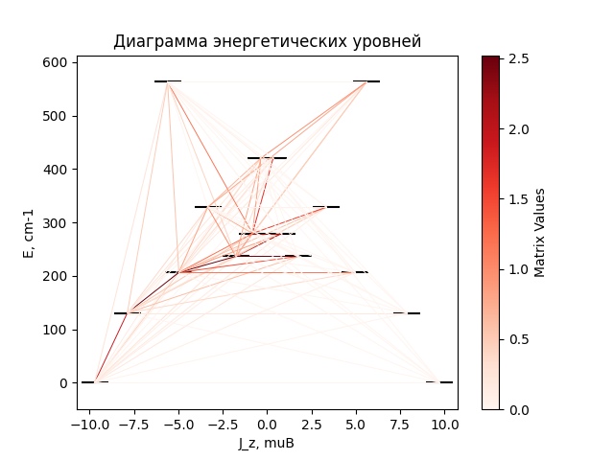

# CF_parameters

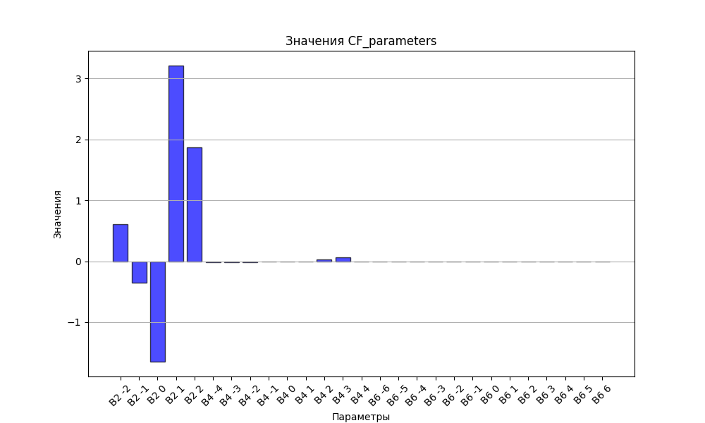

# CHI * T

|  |  |
| --- | --- |
| T | CHI * T |
| 1.0 | 4.8599847 |
| 2.0 | 8.1058004 |
| 3.0 | 9.7270991 |
| 4.0 | 10.5508425 |
| 5.0 | 11.0104231 |
| 6.0 | 11.2920397 |
| 7.0 | 11.4790804 |
| 8.0 | 11.6119787 |
| 9.0 | 11.7119027 |
| 10.0 | 11.7906938 |
| 11.0 | 11.8553569 |
| 12.0 | 11.9102351 |
| 13.0 | 11.9581306 |
| 14.0 | 12.0009132 |
| 15.0 | 12.039867 |
| 16.0 | 12.0758959 |
| 17.0 | 12.1096489 |
| 18.0 | 12.1416007 |
| 19.0 | 12.1721031 |
| 20.0 | 12.2014198 |
| 21.0 | 12.2297505 |
| 22.0 | 12.2572473 |
| 23.0 | 12.2840269 |
| 24.0 | 12.3101788 |
| 25.0 | 12.3357722 |
| 26.0 | 12.3608606 |
| 27.0 | 12.3854854 |
| 28.0 | 12.4096787 |
| 29.0 | 12.4334654 |
| 30.0 | 12.4568652 |
| 31.0 | 12.4798931 |
| 32.0 | 12.5025613 |
| 33.0 | 12.5248794 |
| 34.0 | 12.5468551 |
| 35.0 | 12.5684949 |
| 36.0 | 12.5898043 |
| 37.0 | 12.6107878 |
| 38.0 | 12.6314496 |
| 39.0 | 12.6517936 |
| 40.0 | 12.6718234 |
| 41.0 | 12.6915423 |
| 42.0 | 12.7109538 |
| 43.0 | 12.7300611 |
| 44.0 | 12.7488676 |
| 45.0 | 12.7673766 |
| 46.0 | 12.7855916 |
| 47.0 | 12.8035158 |
| 48.0 | 12.8211529 |
| 49.0 | 12.8385062 |
| 50.0 | 12.8555794 |
| 51.0 | 12.872376 |
| 52.0 | 12.8888997 |
| 53.0 | 12.905154 |
| 54.0 | 12.9211426 |
| 55.0 | 12.9368691 |
| 56.0 | 12.9523373 |
| 57.0 | 12.9675508 |
| 58.0 | 12.9825133 |
| 59.0 | 12.9972284 |
| 60.0 | 13.0116998 |
| 61.0 | 13.0259311 |
| 62.0 | 13.0399259 |
| 63.0 | 13.0536878 |
| 64.0 | 13.0672203 |
| 65.0 | 13.0805271 |
| 66.0 | 13.0936116 |
| 67.0 | 13.1064773 |
| 68.0 | 13.1191277 |
| 69.0 | 13.1315662 |
| 70.0 | 13.1437961 |
| 71.0 | 13.1558209 |
| 72.0 | 13.1676438 |
| 73.0 | 13.1792682 |
| 74.0 | 13.1906973 |
| 75.0 | 13.2019343 |
| 76.0 | 13.2129824 |
| 77.0 | 13.2238447 |
| 78.0 | 13.2345244 |
| 79.0 | 13.2450245 |
| 80.0 | 13.255348 |
| 81.0 | 13.2654981 |
| 82.0 | 13.2754775 |
| 83.0 | 13.2852893 |
| 84.0 | 13.2949364 |
| 85.0 | 13.3044215 |
| 86.0 | 13.3137476 |
| 87.0 | 13.3229173 |
| 88.0 | 13.3319335 |
| 89.0 | 13.3407988 |
| 90.0 | 13.3495158 |
| 91.0 | 13.3580873 |
| 92.0 | 13.3665159 |
| 93.0 | 13.3748039 |
| 94.0 | 13.3829541 |
| 95.0 | 13.3909688 |
| 96.0 | 13.3988505 |
| 97.0 | 13.4066017 |
| 98.0 | 13.4142246 |
| 99.0 | 13.4217216 |
| 100.0 | 13.429095 |
| 101.0 | 13.4363471 |
| 102.0 | 13.44348 |
| 103.0 | 13.4504961 |
| 104.0 | 13.4573973 |
| 105.0 | 13.4641859 |
| 106.0 | 13.4708639 |
| 107.0 | 13.4774333 |
| 108.0 | 13.4838962 |
| 109.0 | 13.4902546 |
| 110.0 | 13.4965103 |
| 111.0 | 13.5026653 |
| 112.0 | 13.5087215 |
| 113.0 | 13.5146806 |
| 114.0 | 13.5205446 |
| 115.0 | 13.5263152 |
| 116.0 | 13.531994 |
| 117.0 | 13.5375829 |
| 118.0 | 13.5430835 |
| 119.0 | 13.5484975 |
| 120.0 | 13.5538264 |
| 121.0 | 13.5590719 |
| 122.0 | 13.5642355 |
| 123.0 | 13.5693187 |
| 124.0 | 13.5743231 |
| 125.0 | 13.57925 |
| 126.0 | 13.5841011 |
| 127.0 | 13.5888775 |
| 128.0 | 13.5935809 |
| 129.0 | 13.5982124 |
| 130.0 | 13.6027735 |
| 131.0 | 13.6072654 |
| 132.0 | 13.6116894 |
| 133.0 | 13.6160468 |
| 134.0 | 13.6203389 |
| 135.0 | 13.6245667 |
| 136.0 | 13.6287315 |
| 137.0 | 13.6328345 |
| 138.0 | 13.6368768 |
| 139.0 | 13.6408595 |
| 140.0 | 13.6447837 |
| 141.0 | 13.6486505 |
| 142.0 | 13.6524609 |
| 143.0 | 13.6562159 |
| 144.0 | 13.6599166 |
| 145.0 | 13.6635639 |
| 146.0 | 13.6671588 |
| 147.0 | 13.6707023 |
| 148.0 | 13.6741952 |
| 149.0 | 13.6776386 |
| 150.0 | 13.6810332 |
| 151.0 | 13.6843799 |
| 152.0 | 13.6876797 |
| 153.0 | 13.6909333 |
| 154.0 | 13.6941415 |
| 155.0 | 13.6973053 |
| 156.0 | 13.7004253 |
| 157.0 | 13.7035023 |
| 158.0 | 13.7065371 |
| 159.0 | 13.7095304 |
| 160.0 | 13.712483 |
| 161.0 | 13.7153955 |
| 162.0 | 13.7182688 |
| 163.0 | 13.7211033 |
| 164.0 | 13.7238999 |
| 165.0 | 13.7266592 |
| 166.0 | 13.7293818 |
| 167.0 | 13.7320683 |
| 168.0 | 13.7347194 |
| 169.0 | 13.7373357 |
| 170.0 | 13.7399177 |
| 171.0 | 13.7424661 |
| 172.0 | 13.7449815 |
| 173.0 | 13.7474643 |
| 174.0 | 13.7499151 |
| 175.0 | 13.7523345 |
| 176.0 | 13.754723 |
| 177.0 | 13.7570811 |
| 178.0 | 13.7594094 |
| 179.0 | 13.7617082 |
| 180.0 | 13.7639782 |
| 181.0 | 13.7662197 |
| 182.0 | 13.7684333 |
| 183.0 | 13.7706194 |
| 184.0 | 13.7727784 |
| 185.0 | 13.7749109 |
| 186.0 | 13.7770171 |
| 187.0 | 13.7790976 |
| 188.0 | 13.7811528 |
| 189.0 | 13.7831831 |
| 190.0 | 13.7851889 |
| 191.0 | 13.7871705 |
| 192.0 | 13.7891284 |
| 193.0 | 13.7910629 |
| 194.0 | 13.7929745 |
| 195.0 | 13.7948634 |
| 196.0 | 13.79673 |
| 197.0 | 13.7985747 |
| 198.0 | 13.8003979 |
| 199.0 | 13.8021998 |
| 200.0 | 13.8039808 |
| 201.0 | 13.8057412 |
| 202.0 | 13.8074813 |
| 203.0 | 13.8092015 |
| 204.0 | 13.8109021 |
| 205.0 | 13.8125833 |
| 206.0 | 13.8142454 |
| 207.0 | 13.8158888 |
| 208.0 | 13.8175137 |
| 209.0 | 13.8191205 |
| 210.0 | 13.8207093 |
| 211.0 | 13.8222805 |
| 212.0 | 13.8238342 |
| 213.0 | 13.8253709 |
| 214.0 | 13.8268907 |
| 215.0 | 13.8283939 |
| 216.0 | 13.8298807 |
| 217.0 | 13.8313514 |
| 218.0 | 13.8328062 |
| 219.0 | 13.8342453 |
| 220.0 | 13.835669 |
| 221.0 | 13.8370775 |
| 222.0 | 13.8384711 |
| 223.0 | 13.8398498 |
| 224.0 | 13.841214 |
| 225.0 | 13.8425639 |
| 226.0 | 13.8438997 |
| 227.0 | 13.8452215 |
| 228.0 | 13.8465295 |
| 229.0 | 13.8478241 |
| 230.0 | 13.8491053 |
| 231.0 | 13.8503733 |
| 232.0 | 13.8516284 |
| 233.0 | 13.8528706 |
| 234.0 | 13.8541003 |
| 235.0 | 13.8553176 |
| 236.0 | 13.8565225 |
| 237.0 | 13.8577154 |
| 238.0 | 13.8588964 |
| 239.0 | 13.8600656 |
| 240.0 | 13.8612232 |
| 241.0 | 13.8623694 |
| 242.0 | 13.8635043 |
| 243.0 | 13.8646281 |
| 244.0 | 13.8657409 |
| 245.0 | 13.8668429 |
| 246.0 | 13.8679342 |
| 247.0 | 13.869015 |
| 248.0 | 13.8700854 |
| 249.0 | 13.8711455 |
| 250.0 | 13.8721956 |
| 251.0 | 13.8732356 |
| 252.0 | 13.8742658 |
| 253.0 | 13.8752863 |
| 254.0 | 13.8762971 |
| 255.0 | 13.8772986 |
| 256.0 | 13.8782906 |
| 257.0 | 13.8792735 |
| 258.0 | 13.8802473 |
| 259.0 | 13.8812121 |
| 260.0 | 13.882168 |
| 261.0 | 13.8831152 |
| 262.0 | 13.8840537 |
| 263.0 | 13.8849838 |
| 264.0 | 13.8859054 |
| 265.0 | 13.8868187 |
| 266.0 | 13.8877238 |
| 267.0 | 13.8886209 |
| 268.0 | 13.8895099 |
| 269.0 | 13.890391 |
| 270.0 | 13.8912644 |
| 271.0 | 13.89213 |
| 272.0 | 13.8929881 |
| 273.0 | 13.8938387 |
| 274.0 | 13.8946818 |
| 275.0 | 13.8955177 |
| 276.0 | 13.8963463 |
| 277.0 | 13.8971677 |
| 278.0 | 13.8979822 |
| 279.0 | 13.8987896 |
| 280.0 | 13.8995902 |
| 281.0 | 13.900384 |
| 282.0 | 13.9011711 |
| 283.0 | 13.9019516 |
| 284.0 | 13.9027255 |
| 285.0 | 13.903493 |
| 286.0 | 13.904254 |
| 287.0 | 13.9050088 |

# H_B_df

|  |  |  |  |
| --- | --- | --- | --- |
| H(T) | B(T_1) | B(T_2) | B(T_3) |
| 0.0001 | 0.001061567 | 0.0005328105 | 0.0003565584 |
| 0.1 | 1.0396944982 | 0.5300145658 | 0.3557263507 |
| 0.2 | 1.962215017 | 1.0437471312 | 0.7065271861 |
| 0.3 | 2.7046656919 | 1.5272123048 | 1.0477988604 |
| 0.4 | 3.264405005 | 1.97031269 | 1.3755341782 |
| 0.5 | 3.671838303 | 2.3673825245 | 1.6865144882 |
| 0.6 | 3.9647260896 | 2.7167959392 | 1.9784035979 |
| 0.7 | 4.1757809462 | 3.020025111 | 2.2497478882 |
| 0.8 | 4.3296271254 | 3.2805535925 | 2.4999018683 |
| 0.9 | 4.4436571782 | 3.5029175465 | 2.7289054559 |
| 1.0 | 4.5298226022 | 3.6919910913 | 2.9373390745 |
| 1.1 | 4.596267265 | 3.8525218324 | 3.1261777193 |
| 1.2 | 4.6485531108 | 3.9888696788 | 3.296658299 |
| 1.3 | 4.6905108721 | 4.1048891754 | 3.4501679594 |
| 1.4 | 4.7248107013 | 4.2039026972 | 3.5881559103 |
| 1.5 | 4.7533398874 | 4.2887253006 | 3.7120678206 |
| 1.6 | 4.77745236 | 4.3617149876 | 3.8232999375 |
| 1.7 | 4.7981342266 | 4.4248322188 | 3.9231693249 |
| 1.8 | 4.8161145139 | 4.4796995106 | 4.0128965877 |
| 1.9 | 4.8319400445 | 4.5276564339 | 4.0935978257 |
| 2.0 | 4.8460266784 | 4.5698080399 | 4.1662831044 |
| 2.1 | 4.8586948309 | 4.6070662608 | 4.2318592988 |
| 2.2 | 4.870194418 | 4.640184633 | 4.2911356877 |
| 2.3 | 4.8807226062 | 4.66978705 | 4.3448311119 |
| 2.4 | 4.8904366072 | 4.6963913722 | 4.393581862 |
| 2.5 | 4.8994630157 | 4.7204287063 | 4.4379497247 |
| 2.6 | 4.9079047071 | 4.7422590992 | 4.47842982 |
| 2.7 | 4.9158459916 | 4.7621842888 | 4.5154580039 |
| 2.8 | 4.9233565073 | 4.78045806 | 4.5494177097 |
| 2.9 | 4.9304941915 | 4.7972946576 | 4.5806461745 |
| 3.0 | 4.9373075713 | 4.8128756293 | 4.6094400394 |
| 3.1 | 4.9438375449 | 4.8273553994 | 4.6360603432 |
| 3.2 | 4.9501187799 | 4.840865819 | 4.6607369449 |
| 3.3 | 4.9561808199 | 4.8535198894 | 4.6836724213 |
| 3.4 | 4.9620489661 | 4.8654148166 | 4.705045488 |
| 3.5 | 4.9677449868 | 4.8766345243 | 4.7250139944 |
| 3.6 | 4.9732876909 | 4.8872517281 | 4.7437175387 |
| 3.7 | 4.9786933947 | 4.8973296521 | 4.7612797485 |
| 3.8 | 4.9839763046 | 4.9069234548 | 4.7778102685 |
| 3.9 | 4.9891488336 | 4.9160814169 | 4.7934064896 |
| 4.0 | 4.994221862 | 4.9248459345 | 4.8081550552 |
| 4.1 | 4.9992049562 | 4.9332543513 | 4.8221331715 |
| 4.2 | 5.0041065513 | 4.9413396599 | 4.8354097487 |
| 4.3 | 5.0089341046 | 4.9491310927 | 4.8480463949 |
| 4.4 | 5.0136942263 | 4.9566546234 | 4.8600982827 |
| 4.5 | 5.0183927891 | 4.9639333918 | 4.8716149041 |
| 4.6 | 5.0230350233 | 4.9709880673 | 4.8826407309 |
| 4.7 | 5.0276255962 | 4.9778371582 | 4.8932157911 |
| 4.8 | 5.0321686825 | 4.9844972781 | 4.9033761729 |
| 4.9 | 5.0366680228 | 4.9909833742 | 4.913154467 |
| 5.0 | 5.0411269758 | 4.9973089245 | 4.9225801537 |

# WAVE FUNCTIONS

|  |  |  |  |  |  |  |  |  |
| --- | --- | --- | --- | --- | --- | --- | --- | --- |
| Label | +-15/2> | +-13/2> | +-11/2> | +-9/2> | +-7/2> | +-5/2> | +-3/2> | +-1/2> |
| KD1 | 93 | 0 | 6 | 0 | 0 | 0 | 0 | 0 |
| KD2 | 0 | 78 | 3 | 15 | 1 | 2 | 1 | 0 |
| KD3 | 3 | 2 | 40 | 7 | 24 | 2 | 14 | 8 |
| KD4 | 0 | 3 | 12 | 15 | 4 | 21 | 10 | 34 |
| KD5 | 1 | 5 | 9 | 17 | 17 | 19 | 24 | 8 |
| KD6 | 0 | 2 | 6 | 14 | 26 | 29 | 16 | 6 |
| KD7 | 0 | 1 | 2 | 5 | 6 | 15 | 30 | 41 |
| KD8 | 2 | 9 | 21 | 27 | 23 | 13 | 5 | 1 |