# Dyhf4.log report

# PSEUDOSPIN HAMILTONIAN TENSORS

|  |  |  |  |
| --- | --- | --- | --- |
| KD | g_x | g_y | g_z |
| 1.0 | 0.00331355219312 | 0.00829568121891 | 19.52428985955491 |
| 2.0 | 0.29043258675536 | 0.53491980676383 | 15.6812153937424 |
| 3.0 | 1.208503106073 | 1.58292163520739 | 15.67824079061241 |
| 4.0 | 4.89450320417512 | 6.38443297610024 | 8.57438243885668 |
| 5.0 | 1.43149383019222 | 1.82495507012608 | 15.30072945107844 |
| 6.0 | 0.03737646679733 | 0.07063002854337 | 18.85768385897292 |
| 7.0 | 0.01625302842543 | 0.16655764626863 | 18.8450821557688 |
| 8.0 | 0.04796883009176 | 0.14559473138299 | 19.44774581518576 |

# AB INITIO BLOCKING BARRIER

|  |  |  |  |
| --- | --- | --- | --- |
| KD | l+, muB | l-, muB | E, cm-1 |
| 1.0 | -9.7621449 | 9.7621449 | 0.0 |
| 2.0 | -7.7471608 | 7.7471608 | 171.3397068 |
| 3.0 | -1.6918732 | 1.6918732 | 223.4034583 |
| 4.0 | -3.1277728 | 3.1277728 | 257.0417903 |
| 5.0 | -2.6903261 | 2.6903261 | 283.7378168 |
| 6.0 | -5.5703092 | 5.5703092 | 347.7984783 |
| 7.0 | -1.0430432 | 1.0430432 | 416.9934699 |
| 8.0 | -6.0559332 | 6.0559332 | 485.6376563 |

# QTM, ORBACH, MTRIX ELEMENTS

|  |  |  |  |  |  |  |  |
| --- | --- | --- | --- | --- | --- | --- | --- |
| 1+ | 2+ | 3+ | 4+ | 5+ | 6+ | 7+ | 8+ |
| 0.00193487223626 | 0.0217435338919 | 0.143939405727 | 0.0954396727409 | 0.0391677322548 | 0.0340889629644 | 0.0369989965711 | 0.0104216482399 |
| 0.0 | 0.139740233409 | 0.387454576781 | 0.316228425899 | 0.232484013134 | 0.0858757591556 | 0.181962706518 | 0.0681293697808 |
| 0.0 | 0.0 | 1.35512706808 | 1.07759114372 | 0.673824316723 | 0.15317447828 | 0.68389788295 | 0.747188407832 |
| 0.0 | 0.0 | 0.0 | 2.29741701887 | 1.57895246827 | 0.204455002743 | 0.895818316794 | 0.380497064051 |
| 0.0 | 0.0 | 0.0 | 0.0 | 1.05115299643 | 0.16790907131 | 0.339894682968 | 0.190804893417 |
| 0.0 | 0.0 | 0.0 | 0.0 | 0.0 | 0.0227510690912 | 0.156326772785 | 0.23461054429 |
| 0.0 | 0.0 | 0.0 | 0.0 | 0.0 | 0.0 | 0.19582868376 | 0.14311966557 |
| 0.0 | 0.0 | 0.0 | 0.0 | 0.0 | 0.0 | 0.0 | 0.0378591251099 |

# DIRECT MTRIX ELEMENTS

|  |  |  |  |  |  |  |  |
| --- | --- | --- | --- | --- | --- | --- | --- |
| 0 | 1 | 2 | 3 | 4 | 5 | 6 | 7 |
| 3.25404830993 | 1.94914204274 | 0.371371338201 | 0.269150811081 | 0.233802214198 | 0.290084124901 | 0.11248851413 | 0.443360032863 |
| 0.0 | 3.11850905061 | 1.62570149134 | 1.95467582852 | 1.11616461162 | 0.823419399033 | 0.392195772151 | 0.862362980546 |
| 0.0 | 0.0 | 3.87960990304 | 2.55522418916 | 1.26677282644 | 0.874433087209 | 0.19265567824 | 0.556741086674 |
| 0.0 | 0.0 | 0.0 | 1.3631660623 | 2.0252163388 | 0.891940521636 | 1.2149777149 | 1.06429749087 |
| 0.0 | 0.0 | 0.0 | 0.0 | 4.11380528168 | 1.93556547006 | 1.14023210659 | 0.378848231754 |
| 0.0 | 0.0 | 0.0 | 0.0 | 0.0 | 4.80691166421 | 0.594811478275 | 0.101460648293 |
| 0.0 | 0.0 | 0.0 | 0.0 | 0.0 | 0.0 | 3.4806604621 | 1.51195026882 |
| 0.0 | 0.0 | 0.0 | 0.0 | 0.0 | 0.0 | 0.0 | 5.50301059776 |

# Energy_diagram

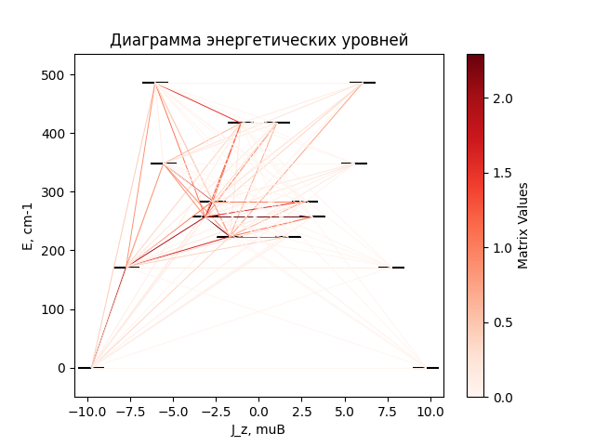

# CF_parameters

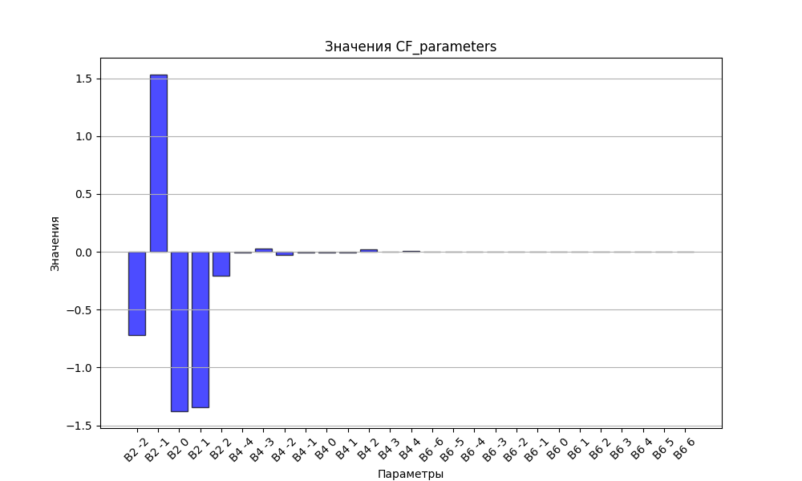

# CHI * T

|  |  |
| --- | --- |
| T | CHI * T |
| 1.0 | 4.7013617 |
| 2.0 | 7.82781 |
| 3.0 | 9.5231489 |
| 4.0 | 10.4249024 |
| 5.0 | 10.9378167 |
| 6.0 | 11.2535062 |
| 7.0 | 11.462133 |
| 8.0 | 11.6086595 |
| 9.0 | 11.7170372 |
| 10.0 | 11.8008197 |
| 11.0 | 11.8680887 |
| 12.0 | 11.9238848 |
| 13.0 | 11.9714742 |
| 14.0 | 12.0130448 |
| 15.0 | 12.0501046 |
| 16.0 | 12.0837188 |
| 17.0 | 12.114657 |
| 18.0 | 12.1434856 |
| 19.0 | 12.1706284 |
| 20.0 | 12.1964075 |
| 21.0 | 12.2210708 |
| 22.0 | 12.244811 |
| 23.0 | 12.2677796 |
| 24.0 | 12.2900965 |
| 25.0 | 12.3118572 |
| 26.0 | 12.3331383 |
| 27.0 | 12.3540013 |
| 28.0 | 12.374496 |
| 29.0 | 12.3946627 |
| 30.0 | 12.4145338 |
| 31.0 | 12.4341359 |
| 32.0 | 12.4534904 |
| 33.0 | 12.4726147 |
| 34.0 | 12.4915228 |
| 35.0 | 12.5102262 |
| 36.0 | 12.5287341 |
| 37.0 | 12.5470539 |
| 38.0 | 12.5651917 |
| 39.0 | 12.5831524 |
| 40.0 | 12.6009398 |
| 41.0 | 12.6185572 |
| 42.0 | 12.636007 |
| 43.0 | 12.6532914 |
| 44.0 | 12.6704122 |
| 45.0 | 12.6873706 |
| 46.0 | 12.7041679 |
| 47.0 | 12.720805 |
| 48.0 | 12.737283 |
| 49.0 | 12.7536025 |
| 50.0 | 12.7697642 |
| 51.0 | 12.7857688 |
| 52.0 | 12.8016169 |
| 53.0 | 12.8173091 |
| 54.0 | 12.832846 |
| 55.0 | 12.8482282 |
| 56.0 | 12.8634563 |
| 57.0 | 12.8785308 |
| 58.0 | 12.8934524 |
| 59.0 | 12.9082216 |
| 60.0 | 12.9228392 |
| 61.0 | 12.9373056 |
| 62.0 | 12.9516217 |
| 63.0 | 12.965788 |
| 64.0 | 12.9798052 |
| 65.0 | 12.993674 |
| 66.0 | 13.0073951 |
| 67.0 | 13.0209692 |
| 68.0 | 13.034397 |
| 69.0 | 13.0476792 |
| 70.0 | 13.0608167 |
| 71.0 | 13.07381 |
| 72.0 | 13.08666 |
| 73.0 | 13.0993675 |
| 74.0 | 13.1119332 |
| 75.0 | 13.1243578 |
| 76.0 | 13.1366423 |
| 77.0 | 13.1487874 |
| 78.0 | 13.1607939 |
| 79.0 | 13.1726626 |
| 80.0 | 13.1843944 |
| 81.0 | 13.1959902 |
| 82.0 | 13.2074507 |
| 83.0 | 13.2187768 |
| 84.0 | 13.2299695 |
| 85.0 | 13.2410296 |
| 86.0 | 13.2519579 |
| 87.0 | 13.2627556 |
| 88.0 | 13.2734234 |
| 89.0 | 13.2839622 |
| 90.0 | 13.2943731 |
| 91.0 | 13.3046571 |
| 92.0 | 13.3148149 |
| 93.0 | 13.3248478 |
| 94.0 | 13.3347566 |
| 95.0 | 13.3445423 |
| 96.0 | 13.354206 |
| 97.0 | 13.3637488 |
| 98.0 | 13.3731715 |
| 99.0 | 13.3824754 |
| 100.0 | 13.3916614 |
| 101.0 | 13.4007306 |
| 102.0 | 13.409684 |
| 103.0 | 13.4185229 |
| 104.0 | 13.4272482 |
| 105.0 | 13.4358611 |
| 106.0 | 13.4443626 |
| 107.0 | 13.4527539 |
| 108.0 | 13.4610361 |
| 109.0 | 13.4692103 |
| 110.0 | 13.4772776 |
| 111.0 | 13.4852393 |
| 112.0 | 13.4930963 |
| 113.0 | 13.5008498 |
| 114.0 | 13.5085011 |
| 115.0 | 13.5160512 |
| 116.0 | 13.5235012 |
| 117.0 | 13.5308523 |
| 118.0 | 13.5381057 |
| 119.0 | 13.5452625 |
| 120.0 | 13.5523238 |
| 121.0 | 13.5592908 |
| 122.0 | 13.5661646 |
| 123.0 | 13.5729464 |
| 124.0 | 13.5796372 |
| 125.0 | 13.5862383 |
| 126.0 | 13.5927507 |
| 127.0 | 13.5991755 |
| 128.0 | 13.6055139 |
| 129.0 | 13.611767 |
| 130.0 | 13.6179358 |
| 131.0 | 13.6240216 |
| 132.0 | 13.6300253 |
| 133.0 | 13.635948 |
| 134.0 | 13.6417909 |
| 135.0 | 13.647555 |
| 136.0 | 13.6532414 |
| 137.0 | 13.6588511 |
| 138.0 | 13.6643852 |
| 139.0 | 13.6698446 |
| 140.0 | 13.6752305 |
| 141.0 | 13.6805439 |
| 142.0 | 13.6857857 |
| 143.0 | 13.690957 |
| 144.0 | 13.6960588 |
| 145.0 | 13.701092 |
| 146.0 | 13.7060576 |
| 147.0 | 13.7109566 |
| 148.0 | 13.7157899 |
| 149.0 | 13.7205585 |
| 150.0 | 13.7252633 |
| 151.0 | 13.7299052 |
| 152.0 | 13.7344852 |
| 153.0 | 13.7390041 |
| 154.0 | 13.7434628 |
| 155.0 | 13.7478622 |
| 156.0 | 13.7522032 |
| 157.0 | 13.7564867 |
| 158.0 | 13.7607134 |
| 159.0 | 13.7648842 |
| 160.0 | 13.769 |
| 161.0 | 13.7730615 |
| 162.0 | 13.7770696 |
| 163.0 | 13.781025 |
| 164.0 | 13.7849286 |
| 165.0 | 13.7887811 |
| 166.0 | 13.7925833 |
| 167.0 | 13.7963359 |
| 168.0 | 13.8000396 |
| 169.0 | 13.8036953 |
| 170.0 | 13.8073036 |
| 171.0 | 13.8108652 |
| 172.0 | 13.8143808 |
| 173.0 | 13.8178512 |
| 174.0 | 13.821277 |
| 175.0 | 13.8246588 |
| 176.0 | 13.8279974 |
| 177.0 | 13.8312933 |
| 178.0 | 13.8345473 |
| 179.0 | 13.8377599 |
| 180.0 | 13.8409319 |
| 181.0 | 13.8440637 |
| 182.0 | 13.8471559 |
| 183.0 | 13.8502093 |
| 184.0 | 13.8532244 |
| 185.0 | 13.8562017 |
| 186.0 | 13.8591418 |
| 187.0 | 13.8620454 |
| 188.0 | 13.8649128 |
| 189.0 | 13.8677447 |
| 190.0 | 13.8705416 |
| 191.0 | 13.8733041 |
| 192.0 | 13.8760325 |
| 193.0 | 13.8787276 |
| 194.0 | 13.8813897 |
| 195.0 | 13.8840193 |
| 196.0 | 13.886617 |
| 197.0 | 13.8891832 |
| 198.0 | 13.8917183 |
| 199.0 | 13.8942229 |
| 200.0 | 13.8966974 |
| 201.0 | 13.8991423 |
| 202.0 | 13.9015579 |
| 203.0 | 13.9039447 |
| 204.0 | 13.9063032 |
| 205.0 | 13.9086338 |
| 206.0 | 13.9109368 |
| 207.0 | 13.9132127 |
| 208.0 | 13.9154619 |
| 209.0 | 13.9176848 |
| 210.0 | 13.9198817 |
| 211.0 | 13.9220531 |
| 212.0 | 13.9241993 |
| 213.0 | 13.9263207 |
| 214.0 | 13.9284177 |
| 215.0 | 13.9304905 |
| 216.0 | 13.9325396 |
| 217.0 | 13.9345653 |
| 218.0 | 13.936568 |
| 219.0 | 13.9385479 |
| 220.0 | 13.9405055 |
| 221.0 | 13.9424409 |
| 222.0 | 13.9443547 |
| 223.0 | 13.946247 |
| 224.0 | 13.9481181 |
| 225.0 | 13.9499685 |
| 226.0 | 13.9517983 |
| 227.0 | 13.9536078 |
| 228.0 | 13.9553975 |
| 229.0 | 13.9571675 |
| 230.0 | 13.958918 |
| 231.0 | 13.9606495 |
| 232.0 | 13.9623622 |
| 233.0 | 13.9640563 |
| 234.0 | 13.9657321 |
| 235.0 | 13.9673898 |
| 236.0 | 13.9690297 |
| 237.0 | 13.9706521 |
| 238.0 | 13.9722572 |
| 239.0 | 13.9738453 |
| 240.0 | 13.9754165 |
| 241.0 | 13.9769711 |
| 242.0 | 13.9785094 |
| 243.0 | 13.9800316 |
| 244.0 | 13.9815378 |
| 245.0 | 13.9830284 |
| 246.0 | 13.9845035 |
| 247.0 | 13.9859633 |
| 248.0 | 13.9874081 |
| 249.0 | 13.9888381 |
| 250.0 | 13.9902534 |
| 251.0 | 13.9916543 |
| 252.0 | 13.9930409 |
| 253.0 | 13.9944135 |
| 254.0 | 13.9957722 |
| 255.0 | 13.9971173 |
| 256.0 | 13.9984489 |
| 257.0 | 13.9997671 |
| 258.0 | 14.0010723 |
| 259.0 | 14.0023645 |
| 260.0 | 14.0036439 |
| 261.0 | 14.0049107 |
| 262.0 | 14.0061651 |
| 263.0 | 14.0074072 |
| 264.0 | 14.0086371 |
| 265.0 | 14.0098552 |
| 266.0 | 14.0110614 |
| 267.0 | 14.012256 |
| 268.0 | 14.0134391 |
| 269.0 | 14.0146109 |
| 270.0 | 14.0157715 |
| 271.0 | 14.0169211 |
| 272.0 | 14.0180597 |
| 273.0 | 14.0191876 |
| 274.0 | 14.0203049 |
| 275.0 | 14.0214117 |
| 276.0 | 14.0225082 |
| 277.0 | 14.0235945 |
| 278.0 | 14.0246706 |
| 279.0 | 14.0257369 |
| 280.0 | 14.0267933 |
| 281.0 | 14.02784 |
| 282.0 | 14.0288771 |
| 283.0 | 14.0299047 |
| 284.0 | 14.0309231 |
| 285.0 | 14.0319322 |
| 286.0 | 14.0329322 |
| 287.0 | 14.0339233 |

# H_B_df

|  |  |  |  |
| --- | --- | --- | --- |
| H(T) | B(T_1) | B(T_2) | B(T_3) |
| 0.0001 | 0.0011262256 | 0.0007144403 | 0.0004299341 |
| 0.1 | 1.1003495229 | 0.707735189 | 0.4284731765 |
| 0.2 | 2.0637799714 | 1.3773090607 | 0.8483492151 |
| 0.3 | 2.8223448255 | 1.9796860045 | 1.2518348091 |
| 0.4 | 3.3802580498 | 2.4995173718 | 1.6325773758 |
| 0.5 | 3.7769074639 | 2.9342327189 | 1.9860275234 |
| 0.6 | 4.0562509953 | 3.2900050727 | 2.3095070165 |
| 0.7 | 4.2541492307 | 3.5773722363 | 2.6020371843 |
| 0.8 | 4.3964406135 | 3.8080047964 | 2.8640207246 |
| 0.9 | 4.5007654671 | 3.9928591479 | 3.0968699948 |
| 1.0 | 4.5789222884 | 4.1413754168 | 3.3026516089 |
| 1.1 | 4.6387781769 | 4.261296377 | 3.4837872504 |
| 1.2 | 4.6856132618 | 4.3587906383 | 3.6428252058 |
| 1.3 | 4.7230139088 | 4.4386905647 | 3.7822804115 |
| 1.4 | 4.7534525732 | 4.50474769 | 3.9045323042 |
| 1.5 | 4.778661901 | 4.5598632492 | 4.0117671104 |
| 1.6 | 4.7998768078 | 4.6062801171 | 4.1059518854 |
| 1.7 | 4.8179924237 | 4.6457357912 | 4.1888297717 |
| 1.8 | 4.8336683188 | 4.6795813112 | 4.2619284522 |
| 1.9 | 4.847398185 | 4.7088723782 | 4.3265760493 |
| 2.0 | 4.8595570827 | 4.734438631 | 4.3839205679 |
| 2.1 | 4.8704339384 | 4.7569361255 | 4.4349503668 |
| 2.2 | 4.8802542251 | 4.7768870669 | 4.480514125 |
| 2.3 | 4.8891960162 | 4.7947099282 | 4.5213394489 |
| 2.4 | 4.8974015092 | 4.8107423459 | 4.5580497023 |
| 2.5 | 4.9049854077 | 4.8252585903 | 4.5911789234 |
| 2.6 | 4.9120410989 | 4.8384829548 | 4.6211848566 |
| 2.7 | 4.9186452607 | 4.8506000708 | 4.6484602214 |
| 2.8 | 4.9248613404 | 4.8617628949 | 4.6733423842 |
| 2.9 | 4.9307422089 | 4.8720989288 | 4.6961216157 |
| 3.0 | 4.9363322082 | 4.8817150918 | 4.7170481138 |
| 3.1 | 4.9416687466 | 4.8907015577 | 4.7363379619 |
| 3.2 | 4.9467835529 | 4.8991347962 | 4.7541781752 |
| 3.3 | 4.9517036717 | 4.907079996 | 4.7707309717 |
| 3.4 | 4.9564522596 | 4.914593007 | 4.7861373854 |
| 3.5 | 4.9610492265 | 4.9217219062 | 4.800520323 |
| 3.6 | 4.9655117569 | 4.9285082656 | 4.8139871532 |
| 3.7 | 4.969854736 | 4.9349881873 | 4.8266318992 |
| 3.8 | 4.9740911001 | 4.9411931494 | 4.8385371 |
| 3.9 | 4.9782321261 | 4.9471507039 | 4.8497753908 |
| 4.0 | 4.9822876734 | 4.9528850537 | 4.860410848 |
| 4.1 | 4.9862663851 | 4.9584175327 | 4.8705001344 |
| 4.2 | 4.9901758579 | 4.9637670062 | 4.8800934782 |
| 4.3 | 4.9940227848 | 4.9689502076 | 4.889235509 |
| 4.4 | 4.9978130761 | 4.9739820224 | 4.8979659749 |
| 4.5 | 5.0015519628 | 4.9788757277 | 4.9063203573 |
| 4.6 | 5.0052440846 | 4.9836431967 | 4.9143304012 |
| 4.7 | 5.0088935645 | 4.9882950729 | 4.9220245709 |
| 4.8 | 5.0125040743 | 4.9928409189 | 4.9294284443 |
| 4.9 | 5.0160788899 | 4.9972893454 | 4.9365650544 |
| 5.0 | 5.0196209391 | 5.0016481213 | 4.9434551849 |

# WAVE FUNCTIONS

|  |  |  |  |  |  |  |  |  |
| --- | --- | --- | --- | --- | --- | --- | --- | --- |
| Label | +-15/2> | +-13/2> | +-11/2> | +-9/2> | +-7/2> | +-5/2> | +-3/2> | +-1/2> |
| KD1 | 92 | 0 | 8 | 0 | 0 | 0 | 0 | 0 |
| KD2 | 0 | 71 | 1 | 25 | 2 | 0 | 1 | 1 |
| KD3 | 1 | 3 | 7 | 2 | 14 | 14 | 23 | 35 |
| KD4 | 2 | 2 | 22 | 1 | 32 | 18 | 19 | 4 |
| KD5 | 1 | 2 | 15 | 7 | 4 | 30 | 20 | 21 |
| KD6 | 1 | 7 | 20 | 32 | 24 | 10 | 4 | 2 |
| KD7 | 0 | 1 | 3 | 6 | 4 | 17 | 32 | 37 |
| KD8 | 3 | 13 | 25 | 27 | 21 | 10 | 2 | 1 |