**TIC-TAC-TOE USING TCP/IP SOCKET CONNECTION**

A COURSE PROJECT REPORT

By

**KSHITIZ RAJ (RA2011003010422)**

**SHIVAM SINGH RATHORE (RA2011003010423)**

**HIMANSHU KUMAR (RA2011003010430)**

**ANKIT CHATURVEDI (RA2011003010433)**

Under the guidance of   
**Dr. R. Subash***In partial fulfilment for the Course*

of

18CSC302J - COMPUTER NETWORKS

in Department of Computing Technologies



**FACULTY OF ENGINEERING AND TECHNOLOGY SRM INSTITUTE OF SCIENCE AND TECHNOLOGY**

**Kattankulathur, Chenpalpattu District**

NOVEMBER 2022

**SRM INSTITUTE OF SCIENCE AND TECHNOLOGY**

**(Under Section 3 of UGC Act, 1956)**

**BONAFIDE CERTIFICATE**

Certified that this mini project report "**TicTacToe using Socket Server**" is the bonafide work of **Kshitiz Raj (RA2011003010422), Shivam Singh Rathore (RA2011003010423), Himanshu Kumar (RA2011003010430)** and **Ankit Chaturvedi (RA2011003010433)** who carried out the project work under my supervision.

# SIGNATURE

**Dr. R. Subash**

# Assosiate professor

**Department of Computing Technologies**

SRM Institute of Science and Technology

# ABSTRACT

This is a simple game of tic-tac-toe developed in Python. It allows two players to play with one another on different command lines through networking. The server starts the game by first running server.py, waiting for the client to connect by then running client.py. Once they’re connected, the game itself starts. The server starts as "X" and goes first, and the client is "O."

The players choose the square they would like to use with coordinates; both "A1" and "1A" would be accepted, for example. The game proceeds, with the players taking turns until one wins or the game is a draw. The host, then the client, is asked whether they'd like a rematch. If both agree, the game starts anew.

Socket programming is a way of connecting two nodes on a network to communicate with each other. One socket(node) listens on a particular port at an IP, while the other socket reaches out to the other to form a connection. The server forms the listener socket while the client reaches out to the server

# ACKNOWLEDGEMENT

We express our heartfelt thanks to our honourable **Vice Chancellor Dr.C.MUTHAMIZHCHELVAN**, for being the beacon in all our endeavours.

We would like to express my warmth of gratitude to our **Registrar Dr. S. Ponnusamy,** for his encouragement

We express our profound gratitude to our **Dean (College of Engineering and Technology) Dr. T. V.Gopal,** for bringing out novelty in all executions.

We would like to express our heartfelt thanks to the Chairperson, School of Computing **Dr. Revathi Venkataraman,** for imparting confidence to complete my course project

We wish to express my sincere thanks to **Course Audit Professor Dr. Annapurani Panaiyappan, Professor and Head, Department of Networking and Communications** and **Course Coordinators** for their constant encouragement and support.

We are highly thankful to our Course project Faculty **Dr. R. Subash, Assistant professor, Department of Computing Technologies,** for hisassistance, timely suggestions and guidance throughout the duration of this course project.

We extend my gratitude to our **HoD Dr. Pushpa Latha Professor And Head of Computing Technologies** and my Departmental colleagues for their Support.

Finally, we thank our parents and friends near and dear ones who directly and indirectly contributed to the successful completion of our project. Above all, I thank the almighty for showering his blessings on me to complete my Course project.

**TABLE OF CONTENTS**

## CHAPTERS CONTENTS PAGE NO.

* + - 1. **ABSTRACT**
      2. **INTRODUCTION**
      3. **REQUIREMENT ANALYSIS**
      4. **ARCHITECTURE & DESIGN**
      5. **RESULTS AND DISCUSSION**
      6. **IMPLEMENTATION**
      7. **CONCLUSION & FUTURE ENHANCEMENT**
      8. **REFERENCES**

1. **INTRODUCTION**
   1. **Scenario Description**

We had to implement a game server for the online tic-tac-toe game. The tic-tac-toe game is played on a 3 × 3 board with two types of players “X” and “O”. Each player takes a turn to play (place a stone anywhere on the board that is still available), with the “X” always making the first move. The game is won by having three consecutive stones horizontally, vertically, or diagonally on the board. The server should support the basic functionality of a typical Internet game server. .

The employees in the organisation will be able to use the server without any restriction since they are directly routed to the same network via the company router. The departments can also intercommunicate with one another without any restriction.

The public internet users will only know the public address of the company router to connect to the server. They can communicate with each other since they are on a public network. However, they cannot know the private addresses of the company devices.

1. **REQUIREMENTS** 
   1. **Requirement Analysis**

From the given scenario, we draw the following requirements:

1. Identifying the appropriate hardware which would be used.

2. Users on the internet should be able to access only HTTPS on the Tic-TacToe server.

3. Users on the internet should have access only to the public IP address of the server and not the private IP address.

4. The users in the organization should have full access to the server.

5. TCP/IP Network design with IP addressing

6. Features and configuration required on the hardware with an explanation

We need to configure a network design keeping the following requirements in mind.

* 1. **Hardware Requirement**

From the given scenario, we draw the following requirements:

For Host XYZ(Private Network):

Hardware Required:

1x Server – PT Primary Server

1x Router (For address 10.0.0.1)

1x End Devices:

For Public Network:

Hardware Required:

1x End Devices(Public Network PCs)

1. **ARCHITECTURE AND DESIGN**
   1. **Network Architecture:**

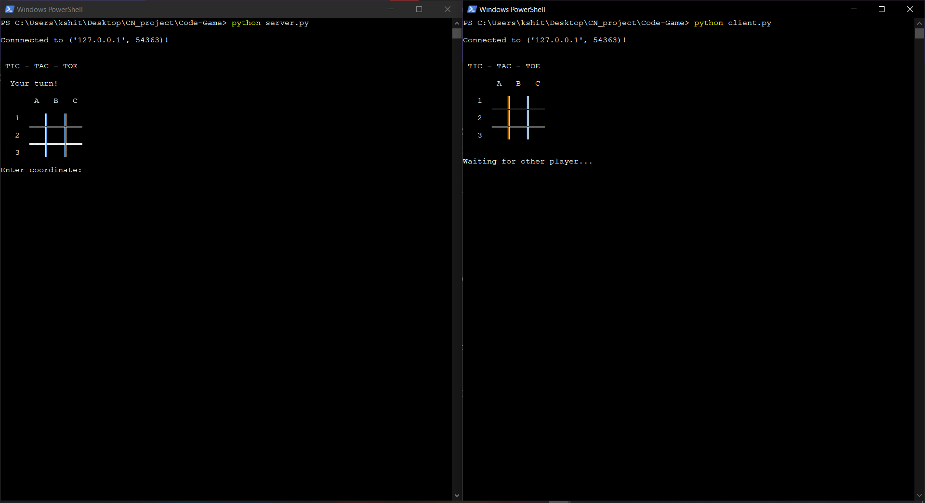

The architecture consists of three major networks:

* Host Network
* Client Network

These networks are interconnected with each other to varying degrees.

1. **IMPLEMENTATION**
   1. **TCP/IP PROTOCOL**

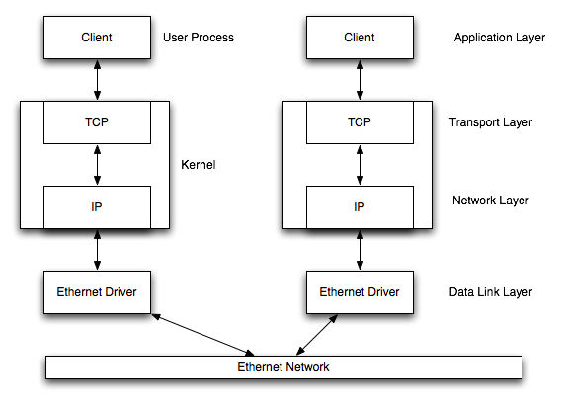

The client and Server are connected via TCP/IP protocol using the host address and port address. After connecting, Server makes the first move in the TIC-TAC-TOE. The input can be of any form like “1a”, “a1”, “1A” or “A1”. The server starts as "X" and goes first, and the client is "O". After each move the server checks if there is any situation where either Server or client has won the game or there is a draw if none is found then the server asks for the next coordinate from the following Server/client and the process repeats until a decision is made then both server and client are asked for a rematch if both agree then the game restarts.

There can be a case when the user may give a coordinate that had been marked already then the server warns the user and asks for a coordinate again.

1. **RESULTS AND DISCUSSION**
   1. **Connection Check**

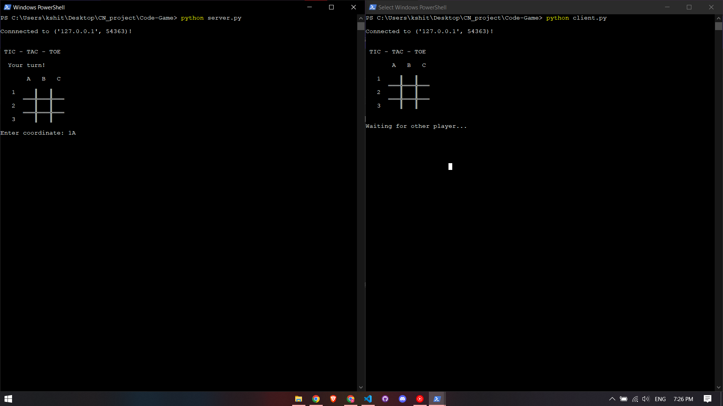

* 1. **Check for results:**

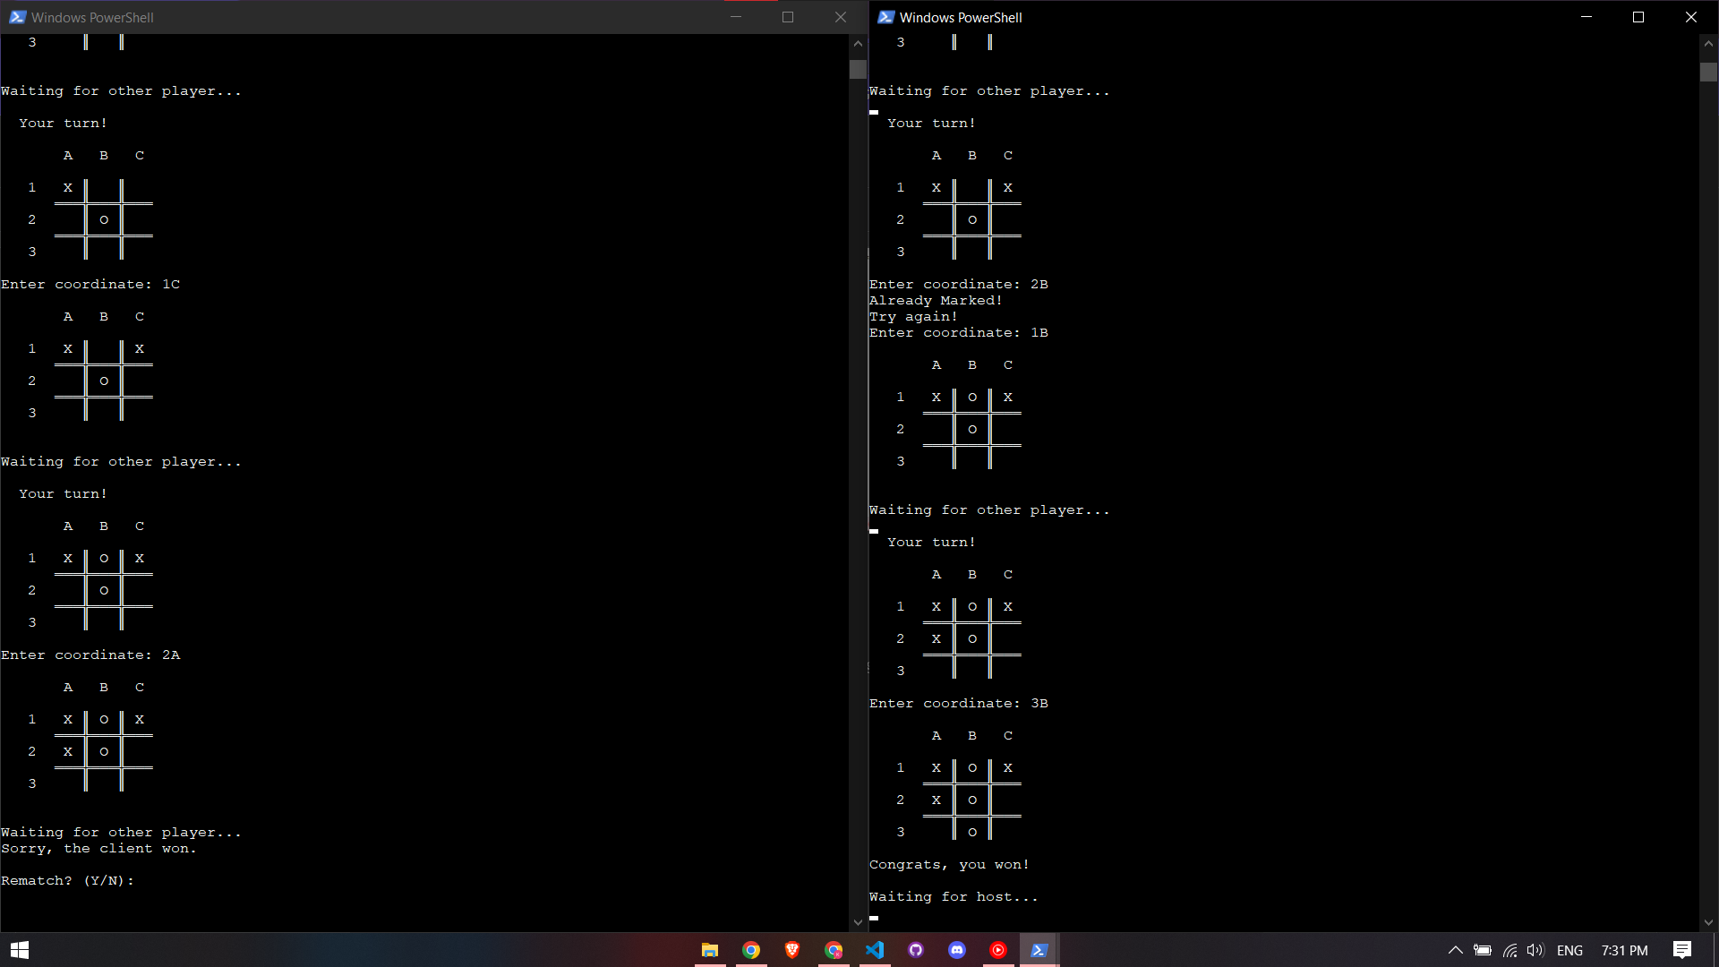

* 1. **Check for repeated symbols:**

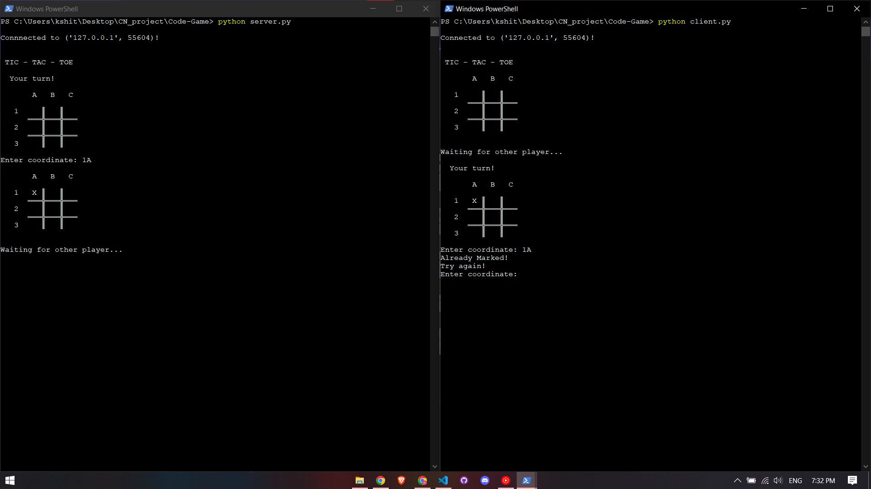

1. **CONCLUSION AND FUTURE ENHANCEMENT**

The Mini Project on Tic-Tac-Toe using TCP/IP socket was made successfully.

In Future, we can deploy the project on the web so that it can be accessed across the world. Instead of the host playing the game we can implement Artificial intelligence to play the game with the user where the user will be first asked for difficulty level and then plays accordingly.

We can make a user interface for the project that displays rules, selects difficulty and many more.

**REFERENCES**

* <https://en.wikipedia.org/wiki/Tic-tac-toe>
* <https://www.geeksforgeeks.org/tcp-ip-model/>
* <https://www.geeksforgeeks.org/socket-programming-python/>
* <https://www.wikihow.com/Play-Tic-Tac-Toe/>
* https://www.ibm.com/docs/en/aix/7.2?topic=protocol-tcpip-protocols/