23-Jun-2017

**WS 2.0**

**Implementation**

Migration Strategy - SG & HK Retail

Document Details

|  |  |
| --- | --- |
| Information | Details |
| Project Name | Enable – WS 2.0 |
| Project Code | 16000683 |
| Document Type | Migration Strategy Document |
| Document Status | Draft |
| Date of Approval | <Approval Date> |
| Current Version No. | 0.1 |
| Author(s) | Druva Mallikarjuna |

Revision History

|  |  |  |  |
| --- | --- | --- | --- |
| Version No | Date | Description | Made By |
| 0.1 | 22-Jun-2017 | Initial Draft | Druva Mallikarjuna |
|  |  |  |  |
|  |  |  |  |
|  |  |  |  |

# 

**Sign-Off and Reviewing Parties**

|  |  |  |  |
| --- | --- | --- | --- |
| S/N | Name | Role | Action Required |
|  |  |  |  |
|  |  |  |  |

**Confidentiality Statement**

All the information contained in this document and/or any other related media is strictly confidential and must not be disclosed to any other party without prior written consent from SCB.

**Acronyms**

|  |  |
| --- | --- |
| **ACRONYM** | **Description** |
| TAP | Triple A Plus |
| CAT | Conversion Acceptance Testing |
| CIT | Conversion Integration Testing |
| WM | Wealth Management |
| TDS | Temenos Data Source |
| RB | Retail Banking |
| WS | Work Stream |
| CA | Corporate Action |
| IRS | Interest Rate Swaps |
| Target System | Wealth suite – T24 |
| ACCU / DECU | Accumulator / Decumulator |
| PCI / DCI | Premium Currency Investment / Dual Currency Investment |
| FIM | Financial Intermediary |
| SY | Structured Products Module |
| DM tool | Temenos Data Migration tool |
| A&L | Asset and Liability |
| P&L | Profit and Loss |
| PCI | Premium currency investment |
| EDP | Electronic Dealing Platform |
| eBBS | Core Banking system for SG Retail |
| Hogan | Core Banking system for HK Retail |
| Fin IQ | Structured products – Order capture and Lifecycle Management system |
| UTS | Funds trading system for SG and HK region |
| TPS | Treasury product system for HK region |
| Strauss | Equities trading system for SG region |
| MESI | Multi Entity Single Instance |
| TTI | T24 TAP Integration |
| OAT | Operational Acceptance Test |
| ETL | Extract, Transform and Load |
| ICM | Individual Client master platform for Retail |
| ELN | Equity asset type note based product |
| ELI | Equity asset type deposit linked investment product |
| CB system | Core Banking - eBBS and Hogan for SG and HK region |
| TP system | Transaction processing system |

Contents

1. Introduction 5

1.1 Document Purpose 5

1.2 Programme Overview 5

2. Migration Strategy 6

2.1 Overview 6

2.2 Migration Activities 7

2.2.1 Planning 8

2.2.2 Analysis and Design 8

2.2.2.1 Retail Scope 9

2.2.2.2 Migration In-Scope 11

2.2.2.3 Migration Out-Scope 15

2.2.3 Build 17

2.2.4 Data Validation 17

2.2.4.1 Technical Validation (CIT) 17

2.2.4.2 Functional and Business Validation (CAT) 17

2.2.5 Mock / Trial Migration 17

2.2.6 Cut-over Preparation and Execution 18

2.3 Migration Window 18

2.4 Methods of Data Migration 18

2.4.1 Automated Data Migration 18

2.4.2 Manual Data Migration 19

2.5 Migration Upload Tools 19

2.6 Environment requirements 20

2.7 Classification of Data Objects 20

2.7.1 Bank Setup /Business Parameter Data 20

2.7.2 Static Data 20

2.7.3 Transactional and Financial Data 20

3. Migration approach 21

3.1 Data Migration Scope 21

3.1.1 Functional scope 21

3.1.2 Master for Client Referential Data 21

3.2 Migration detailed strategy 22

3.2.1 Customer 22

3.2.2 Account 23

3.2.3 Portfolios / Investment account 24

3.2.4 Financial Instruments 25

3.2.5 Financial Migration 27

3.2.6 Credit Risk 29

3.2.7 Interest and Rates 31

3.2.8 Fees, Commission and Charges 32

3.2.9 Security positions 32

3.2.10 Deals and Contracts 34

3.2.10.1 Forex 34

3.2.10.2 Structure Products 35

3.2.11 Corporate Actions and Events 36

3.3 Checks and Controls 37

3.4 Nomenclature 38

3.5 Mapping Approach 38

3.6 Dependencies and Constraints 39

3.7 Assumptions 39

3.8 Data Protection and Access control 40

3.9 Deliverables / Output 40

3.10 Clarifications 41

3.11 Out of scope activities 42

3.12 Review Inputs 43

# Introduction

## Document Purpose

The Purpose of the document is to describe the overall migration strategy for Retail (SG & HK) 2.0 Implementation. The Strategy document covers including migration approach, tools & techniques, methods of migration, In-Scope/Out-Scope items and functional approach.

## Programme Overview

Standard Chartered Bank (“SCB”) Wealth Management (“WM”) has three strategic objectives based on five-year financial plan to double the AUM, what we have communicated to investors and discussion with our customer segment colleagues – principally across Retail and PvB segments. Three strategic objectives are to:

1. Achieve Scale in growing our AUM and income
2. Strengthen competitive advantage of our wealth management proposition
3. Deploy a standard and scalable wealth management platform

Current application landscape is very fragmented and it cannot be scalable to support the business model that we would like to achieve the above three objectives. It requires a unified system that supports the enhanced business model across PvB and Retail locations

The initiative has been confirmed as a global transformation program (“Enable Program”) to deliver a standardized, front-to-back WM platform serving customers within Retail and WM segments. The Global WM platform transformation is made up by two major components – Core and Digital initiatives. As part of Enable program, Temenos Wealth suite (Triple A plus (TAP) and T24) is chosen for front-end and core banking platform.

Below is the approved plan for WS 2.0

* Tranche I – PvB and Retail for Singapore and Hong Kong Location
* Tranche II – PvB and Retail for UAE and India
* Tranche III – Other locations (TBD)

# Migration Strategy

## Overview

The objective of this document is to provide a detailed overview of migrating data into the new Temenos platform. Wealth suite - T24 will be implemented in multiple locations with single instance Architecture model (MESI).

Project (WS 2.0) implementation scope will cover back office capabilities and will require data from multiple source systems across Private, Wealth and Retail Core Banking platforms.

The purpose of Data Migration is to provide required data for the Wealth suite - T24 Platform to be used by end users to support business operations. The terminology data migration summarizes all transformation related activities Including data analysis, mapping, migration development, transformation/conversion and testing.

It is essential to have an understanding on source system Data model, Object structures, landscape and its functions. This will enable the project team to arrive with migration strategy to migrate data from multiple source systems into the target system. The below figure represents the high-level migration activities that would be delivered in-line with project deliverables.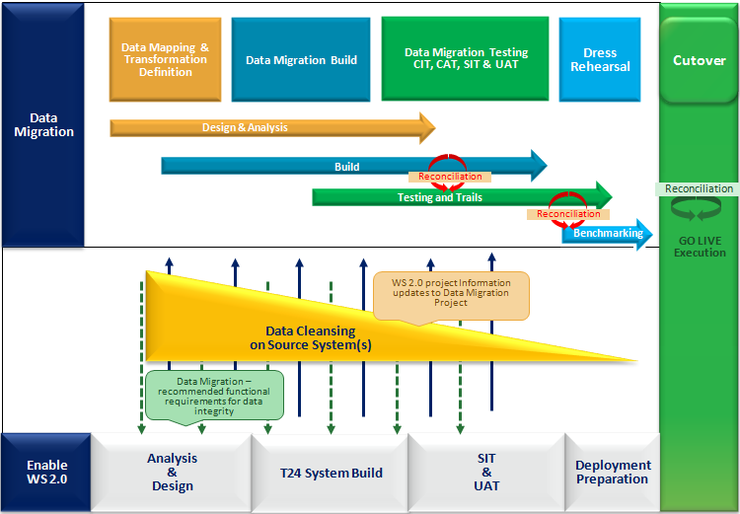

Figure: Approach for data migration

The figure above describes on a high-level approach for data migration and highlights the main steps to be considered and executed.

This document covers the Migration strategy / approach for all the applications delivered in the Base Product T24. Any enhancement that arises for core and local changes during the project cycle then its relevant migration approach will be taken up for GAP migration analysis. The delivery of GAPs migration will follow the release schedule setup by the project for GAPs.

## Migration Activities

Migration activities will contain different phases in migration: Planning, Analysis & Design, Build, Test and Mock Migration. Below diagram explains the different activities under its respective phases

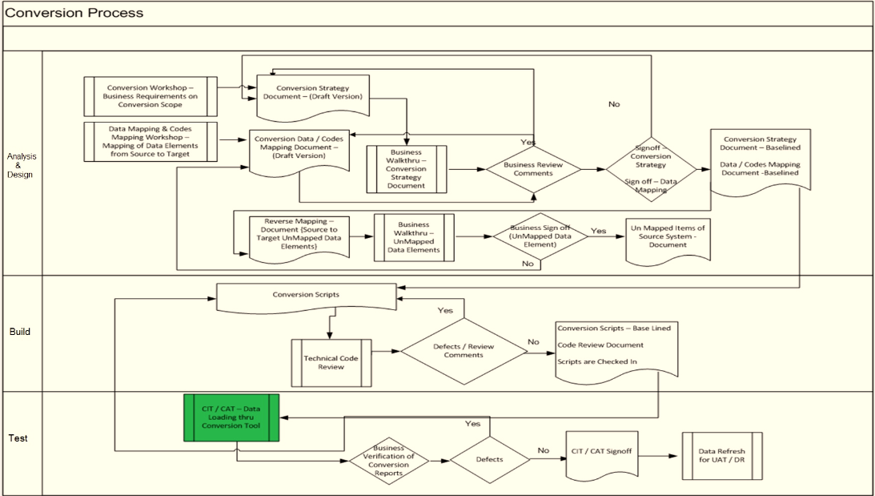

Figure: Migration Activities

### Planning

High level migration plan will be drafted based on the overall project plan for 2.0 and in line with the project deliverables for each location and segment

TBD

### Analysis and Design

The migration team will perform high-level system study on the existing Retail application landscape. Based on the High-Level system study, migration team will come up with the in-scope application for migration in to Wealth suite - T24 platform. Once the in-scope application list is finalized, a detailed system study will be performed on the source systems involved for migration.

By analysing the functionality being implemented, the enable team will identify data that is required in Wealth suite - T24. Once both the legacy and target data analysis are complete, they will be brought together for assessment and the proposed migration inventory will be updated and approved. The dependencies, sequencing, and estimated volumes and runtimes will be established for each migration.

For each migration execution, procedures will be understood and data mapping document will be completed. These design and data mapping will include extract criteria that must be applied in the source system and upload method used in target system. Migration team will own the design for Transformation, Migration and Reconciliation approach in the target system

Reverse mapping will be accomplished in target system during mapping phase to ensure the un-mapped data fields are identified and reported. This procedure will ensure end-to-end data mapping is covered from source to the target system.

#### Retail Scope

Below table lists the Applications and Products scoped for Retail migration in Singapore loaction

|  |  |  |  |
| --- | --- | --- | --- |
| **Source System** | **Products and Description** | **In-Scope** | **Remarks** |
| TAP | * Initial load for Relationship * Portfolio / Investment Accounts * Positions | Yes | Relationship details for Wealth related clients from all TP and CB systems are setup in TAP as part of WS 1.0 and 1.2 Implementation |
| ICM | * Relationship additional data | Yes | Simplified platform for multiple core systems and TP systems in Retail to access customer static related data |
| eBBS | * Relationship additional data | Yes | If ICM is not available within project delivery timelines, then eBBS will be referred for Relationship additional data |
| eBBS / TP System | * Financial Balances | Yes | Balances for Takeover account for contract migration and ISAC accounts |
| TDS | * Instrument master for Security products * Instrument master for Structured Products | Yes | After 1.2 implementation, TDS will be the master for instrument setup |
| Speed | * Limits * Collaterals | Yes | Speed maintains the consolidated Limit details for Wealth clients |
| UTS | Open trades for below products:   * Mutual Funds * Bonds * Structured notes | Yes |  |
| FinIQ | Open trades for below products:   * Premium Currency Investments * Equity linked notes * Equity linked Investments | Yes |  |
| EDP / Murex | Open Forex deals:   * Forex Spot * Forex Forward | Yes |  |
| Strauss | * Open trades for Equity products | No | Out of scope for 2.0 |

*TP System – UTS, FinIQ, EDP, Murex

**Figure: Retail Application Scope – SG**

Below table lists the Applications and Products scoped for Retail migration in Hongkong loaction

|  |  |  |  |
| --- | --- | --- | --- |
| **Source System** | **Products and Description** | **In-Scope** | **Remarks** |
| TAP | * Initial load for Relationship * Portfolio / Investment Accounts * Positions | Yes | Relationship details for Wealth related clients from all TP and CB systems are setup in TAP as part of WS 1.0 and 1.2 Implementation |
| ICM | * Relationship additional data | Yes | Simplified platform for multiple core systems and TP systems in Retail to access customer static related data |
| Hogan | * Relationship additional data | Yes | If ICM is not available within project delivery timelines, then Hogan will be referred for Relationship additional data |
| Hogan / TP System | * Financial Balances | Yes | Balances for Takeover account for contract migration and ISAC accounts |
| TDS | * Instrument master for Security products * Instrument master for Structured Products | Yes | After 1.2 implementation, TDS will be the master for instrument setup |
| Speed | * Limits * Collateral | Yes | Speed maintains the consolidated Limit details for Wealth clients |
| UTS | * Open trades for Funds Product | Yes |  |
| TPS | Open trades for below products   * Bonds * I Bonds * Structured Notes * Equity-linked Investments | Yes |  |
| FinIQ | Migrate Open trades for below products   * Premium Currency Investments * Equity linked notes * Equity linked Investments | Yes |  |
| EDP / Murex | Open Forex deals:   * Forex Spot * Forex Forward | Yes |  |
| T24R08 (HKOE) | * Open trades for Equity products | No | Out of scope for 2.0 |

*TP System – UTS, TPS, FinIQ, EDP, Murex

**Figure: Retail Application Scope - HK**

#### Migration In-Scope

Based on the high-level analysis and project system study, the following list of In-scope and items identified for Retail WS 2.0 Migration for SG and HK region

|  |  |  |  |  |  |  |  |
| --- | --- | --- | --- | --- | --- | --- | --- |
|  |  |  | **Retail Source system  - Singapore** |  | **Retail Target - Wealth Suite T24** | |  |
| **Sl No** | **Work stream** | **Classification / Product** | **Applications** | **Method** | **Target Module** | **Target Tables** | **Description** |
| 1 | Relationship Management/Client setup & Master file | Relationship | TAP | Migration | EB | CUSTOMER | Migrate Initial load for Relationship from TAP |
| 2 | Relationship | eBBS / ICM | Migration | EB | CUSTOMER | Additional attributes from eBBS or ICM |
| 3 | Broker, Depository and Issuer | TBC | Migration | EB | CUSTOMER | Migrate Broker, Depo and Issuer |
| 4 | Customer Static | eBBs | Migration | EB | CUSTOMER.SECURITY CUSTOMER.CHARGE | 1. Set Default security profile for all Relationship as Customer. 2. Set security profile for all Broker and Depository 3. Update Customer charge to set the depository group for Depository customers |
| 5 | Portfolio Management/Portfolio overview | Internal Accounts:  Client settlement accounts (CSA) Inter system account (ISAC) Suspense accounts | eBBs | Migration | AC | ACCOUNT | 1. The CSA would be multiple Omnibus accounts handling all settlements in different currencies. It would be linked to the Customer and not to a portfolio 2. Entry to ISAC is triggered in T24 as corresponding entry in CBS during order booking |
| 6 | Portfolio / Investment accounts | TAP | Migration | SC | SEC.ACC.MASTER | Creation of Memo portfolios without linking an account to a portfolio |
| 7 | Relationship Management/Client setup & Master file | Address migration | eBBs | Migration | EB | DE.ADDRESS | Delivery address setup for transactional advice |
| 8 | Address product migration | eBBs | Migration | EB | DE.PRODUCT | Delivery setup product wise for transactional advice |
| 9 | Masterfile/Product and Instruments | Financial Instruments | TDS | Migration | SC / SY | SECURITY.MASTER SY.MASTER | Instrument data will be sourced from TDS. |
| 10 | Finance/Accounting | Financial Balances for   Takeover account | TBC | Migration | FT | FUNDS.TRANSFER | Take over balances for contracts an deals |
| 11 | Risk & Lending/Credit risk & Lending | Limits | CB Speed | Migration | LI | LIMITS | Migration of Limits from CB Speed |
| 12 | Collaterals | CB Speed | Migration | LI | COLLATERAL.RIGHT COLLATERAL | Migration of collateral from CB Speed |

|  |  |  |  |  |  |  |  |
| --- | --- | --- | --- | --- | --- | --- | --- |
| **Sl No** | **Work stream** | **Classification / Product** | **Applications** | **Method** | **Target Module** | **Target Tables** | **Description** |
| 13 | Product E2E/Product Lifecycle | Currency rates | eBBS | Migration | EB | CURRENCY FORWARD.RATES | Currency and forward rate setup prior to the migration |
| 14 | Settlement & Fulfilment /Transaction Settlement | Positions | TAP  CB Speed | Migration | SC | SECURITY.TRANSFER SC.BLOCK.SEC.POS | 1. Settled position will be Migrated from TAP  2. Position blocking data is available in both CB Speed and TAP. Additional attributes is sourced from speed |
| 15 | **UTS:** Mutual Funds  Bonds Structured notes   **FinIQ:** Equity linked notes Equity linked Investments | UTS Fin IQ | Migration | SC | SEC.TRADE | Unsettled trades for Bonds, Mutual funds, structured notes, ELN and ELI |
| 16 | Premium currency investment | FIN IQ | Migration | SY | SY.DCI | PCI transaction migrated from Fin IQ. |
| 17 | Settlement & Fulfilment /Cash Booking | Forex spot and forward | EDP / Murex | Migration | FX | FOREX | Forex deals are migrated from EDP system |
| 18 | Settlement & Fulfilment /Corporate Actions | **UTS:** Mutual Funds  Bonds Structured notes  **FinIQ:** Equity linked notes Equity linked Investments | UTS Fin IQ | Migration | CA | DIARY ENTITLEMENT | Coupon payments, Dividends, Interest payment, and Pay out migrated from TP systems |

|  |  |  |  |  |  |  |  |
| --- | --- | --- | --- | --- | --- | --- | --- |
|  |  |  | **Retail Source system Honkong** |  | **Retail Target - Wealth Suite T24** | |  |
| **Sl No** | **Work stream** | **Classification / Product** | **Applications** | **Method** | **Target Module** | **Target Tables** | **Description** |
| 1 | Relationship Management/Client setup & Master file | Relationship | TAP | Migration | EB | CUSTOMER | Migrate Initial load for Relationship from TAP |
| 2 | Relationship | Hogan / ICM | Migration | EB | CUSTOMER | Additional attributes from Hogan or ICM |
| 3 | Broker, Depository and Issuer | TBC | Migration | EB | CUSTOMER | Migrate Broker, Depo and Issuer from Hogan |
| 4 | Customer Static | Hogan | Migration | EB | CUSTOMER.SECURITY CUSTOMER.CHARGE | 1. Set Default security profile for all Relationship as Customer. 2. Set security profile for all Broker and Depository 3. Update Customer charge to set the depository group for Depository customers |
| 5 | Portfolio Management/Portfolio overview | Internal Account:  Client settlement accounts (CSA) Inter system account (ISAC) Suspense accounts | Hogan | Migration | AC | ACCOUNT | 1. The CSA would be multiple Omnibus accounts handling all settlements in different currencies. It would be linked to the Customer and not to a portfolio 2. Entry to ISAC is triggered in T24 as corresponding entry in CBS during order booking |
| 6 | Portfolio / Investment accounts | TAP | Migration | SC | SEC.ACC.MASTER | Creation of Memo portfolios without linking an account to a portfolio |
| 7 | Relationship Management/Client setup & Master file | Address migration | Hogan | Migration | EB | DE.ADDRESS | Delivery address setup for transactional advice |
| 8 | Address product migration | Hogan | Migration | EB | DE.PRODUCT | Delivery setup product wise for transactional advice |
| 9 | Masterfile/Product and Instruments | Financial Instruments | TDS | Migration | SC / SY | SECURITY.MASTER SY.MASTER | Instrument data will be sourced from TDS. |
| 10 | Finance/Accounting | Financial Balances for  Takeover account | TBC | Migration | FT | FUNDS.TRANSFER | Take over balance for contracts and deals |
| 11 | Risk & Lending/Credit risk & Lending | Limits | CB Speed | Migration | LI | LIMITS | Migration of Limits from CB Speed |
| 12 | Collaterals | CB Speed | Migration | LI | COLLATERAL.RIGHT COLLATERAL | Migration of collateral from CB Speed |

|  |  |  |  |  |  |  |  |
| --- | --- | --- | --- | --- | --- | --- | --- |
| **Sl No** | **Work stream** | **Classification / Product** | **Applications** | **Method** | **Target Module** | **Target Tables** | **Description** |
| 13 | Product E2E/Product Lifecycle | Currency rates | Hogan | Migration | EB | CURRENCY FORWARD.RATES | Currency and forward rate setup prior to the migration |
| 14 | Settlement & Fulfilment /Transaction Settlement | Portfolio Positions | TAP  CB Speed | Migration | SC | SECURITY.TRANSFER SC.BLOCK.SEC.POS | 1. Settled position will be Migrated from TAP  2. Position blocking data is available in both CB Speed and TAP. Additional attributes is sourced from speed |
| 15 | **TPS:** Bonds and I Bonds Structured Notes  Equity-linked Investments **UTS:** Mutual Funds **FinIQ:** Equity linked notes Equity linked Investments | TPS UTS Fin IQ | Migration | SC | SEC.TRADE | Unsettled trades for Bonds, Mutual funds, structured notes, ELN and ELI |
| 16 | Premium currency investment | FIN IQ | Migration | SY | SY.DCI | PCI transaction migrated from Fin IQ. |
| 17 | Settlement & Fulfilment /Cash Booking | Forex spot and forward | EDP / Murex | Migration | FX | FOREX | Forex deals are migrated from EDP system |
| 18 | Settlement & Fulfilment /Corporate Actions | **TPS:** Bonds I Bonds Structured Notes  Equity-linked Investments  **UTS:** Mutual Funds  **FinIQ:** Equity linked notes Equity linked Investments | TPS UTS Fin IQ | Migration | CA | DIARY ENTITLEMENT | Coupon payments, Dividends, Interest payment, Pay out migrated from UTS |

#### Migration Out-Scope

Based on the high-level analysis and project system study, the following list of Out-scope items identified for Retail WS 2.0 Migration for SG and HK region

|  |  |  |  |  |  |  |  |
| --- | --- | --- | --- | --- | --- | --- | --- |
|  |  |  | **Source System Singapore** |  | **Wealth Suite - T24** | |  |
| **Sl No** | **Workstream** | **Classification / Product** | **Applications** | **Method** | **Target Module** | **Target Tables** | **Description** |
| 1 | Relationship Management/Client setup & Master file | Customer Static | eBBs | NA | EB | DX.CUSTOMER | Derivative profile is out of scope for Retail |
| 2 | Portfolio Management/Portfolio overview | Client Account | eBBs | NA | AC | ACCOUNT | CASA will be continued to maintain in CB system |
| 3 | Nostro and Internal account | eBBs | NA | AC | ACCOUNT | Nostro and Internal account will be continued to maintain in CB system |
| 4 | Agency setup | eBBs | NA | EB | AGENCY NOSTRO.ACCOUNT | Agency and Nostro setup |
| 5 | Delivery Address | eBBs | NA | SW | DE.PRODUCT DE.ADDRESS | Delivery product and address is not required since T24 will replace only the TP systems |
| 6 | Product E2E/Product Lifecycle | Account Interest conditions | eBBs | NA | AC | ACCOUNT.CREDIT.INTEREST ACCOUNT.DEBIT.INTEREST | CASA will be continued to be created and maintained in CBS. Migration of account interest rate is out of scope |
| 7 | Basic and Periodic Interest rates | eBBS | NA | EB | BASIC.INTEREST PERIODIC.INTEREST | Loans and Deposits is out of scope; hence interest setup is Not applicable |
| 8 | Finance/Accounting | Financial Balances for Nostro, Client, Internal account and P&L | eBBs | NA | FT | FUNDS.TRANSFER | Out of scope for Retail migration |
| 9 | Settlement & Fulfilment /Transaction Settlement | Guarantees | eBBS | NA | MD | MD.DEAL | Out of scope for Retail migration |
| 10 | Derivatives - FX and EQ OTC options | NA | NA | DX | DX.TRADE | NA for Retail |
| 11 | Structured Products - Accu / Decu | NA | NA | SY | SY.ACCU.DECU | NA for Retail |
| 12 | Structured Products - FX Target Fwd | NA | NA | SY | SY.FX.FORWARDS | NA for Retail |
| 13 | Interest Rate Derivatives | NA | NA | SW | SWAPS | NA for Retail |
| 14 | Settlement & Fulfilment /Cash Booking | Term / Time deposits | eBBS | NA | AA | AA.ARRANGEMENT.ACTIVITY | Out of scope for Retail migration |
| 15 | Loans | eBBS | NA | AA | AA.ARRANGEMENT.ACTIVITY | Out of scope for Retail migration |
| 16 | Non Deliverable forwards | NA | NA | FX | ND.DEAL | NA for Retail |

|  |  |  |  |  |  |  |  |
| --- | --- | --- | --- | --- | --- | --- | --- |
|  |  |  | **Source System  Hong Kong** |  | **Wealth Suite - T24** | |  |
| **Sl No** | **Workstream** | **Classification / Product** | **HK** | **Method** | **Target Module** | **Target Tables** | **Description** |
| 1 | Relationship Management/Client setup & Master file | Customer Static | Hogan | NA | EB | DX.CUSTOMER | Derivative profile is out of scope for Retail |
| 2 | Portfolio Management/Portfolio overview | Client Account | Hogan | NA | AC | ACCOUNT | CASA will be continued to maintain in CB system |
| 3 | Nostro and Internal accounts | Hogan | NA | AC | ACCOUNT | Nostro and Bank Internal account will be continued to maintain in CB system |
| 4 | Agency setup | Hogan | NA | EB | AGENCY NOSTRO.ACCOUNT | Agency and Nostro setup |
| 5 | Delivery Address | Hogan | NA | SW | DE.PRODUCT DE.ADDRESS | Delivery product and address is not required since T24 will replace only the TP systems |
| 6 | Product E2E/Product Lifecycle | Account Interest conditions | Hogan | NA | AC | ACCOUNT.CREDIT.INTEREST ACCOUNT.DEBIT.INTEREST | CASA will be continued to be created and maintained in CBS. Migration of account interest rate is out of scope |
| 7 | Basic and Periodic Interest rates | Hogan | NA | EB | BASIC.INTEREST PERIODIC.INTEREST | Loans and Deposits is out of scope; hence interest setup is Not applicable |
| 8 | Finance/Accounting | Financial Balances for Nostro, Client, Internal account and P&L | Hogan | NA | FT | FUNDS.TRANSFER | Out of scope for Retail migration |
| 10 | Settlement & Fulfilment /Transaction Settlement | Guarantees | Hogan | NA | MD | MD.DEAL | Out of scope for Retail migration |
| 11 | Derivatives - FX and EQ OTC options | NA | NA | DX | DX.TRADE | NA for Retail |
| 12 | Structured Products - Accu / Decu | NA | NA | SY | SY.ACCU.DECU | NA for Retail |
| 13 | Structured Products - FX Target Fwd. | NA | NA | SY | SY.FX.FORWARDS | NA for Retail |
| 14 | Interest Rate Derivatives | NA | NA | SW | SWAPS | NA for Retail |
| 15 | Settlement & Fulfilment /Cash Booking | Term / Time deposits | Hogan | NA | AA | AA.ARRANGEMENT.ACTIVITY | Out of scope for Retail migration |
| 16 | Loans | Hogan | NA | AA | AA.ARRANGEMENT.ACTIVITY | Out of scope for Retail migration |
| 17 | Non-Deliverable forwards | NA | NA | FX | ND.DEAL | NA for Retail |

### Build

The build phase includes developing the scripts for source data extraction, target data upload and data reconciliation. These scripts are built in such a way to reuse the capabilities and reduce the dependency within the build solution

**Source**: The procedure logic in the extract script in the source system is built in line with data mapping sheet designed during the mapping phase. The extract program must control the scope of records by exact definition of selection criteria as defined in design document.

**Target**: Standard Temenos Data Migration Upload tool will be used for the Load in the target system and the upload configuration/scripts are built based on data mapping defined during the design and mapping phase.

**Reconciliation**: Standard Temenos Data extraction tool will be used for extracting the data from the target system. Auto comparison report and detailed verification report are produced for reconciliation by consuming the data extracted in the source and target system

### Data Validation

Data validation after a data-migration is essential to make sure that the data has been transferred and converted correctly as expected from Business point of view. For this reason, data validation is most critical success factors in a large Wealth suite - T24 implementation. The below validation should be performed during implementation and cut-over to ensure the integrity of data.

#### Technical Validation (CIT)

All the migration process will be validated during the Conversion integration testing. Technical validation will be performed to ensure that the migration processes (Mapping, Conversion and Upload) are implemented correctly. Following are the objective of CIT testing

* Data mapping integrity check
* Validate source file formatting
* Validation of transformation of data
* Baseline source extraction and target upload tools
* Recon reports baseline

#### Functional and Business Validation (CAT)

The involvement of Business during CAT phase is to ensure that the migrated data meets the original design and processed correctly in the target system. This involves the actual execution of T24 transactions using the migrated data and this will identify any downstream processing issues at the early stage

Following are the objectives of CAT testing

* Validate the migrated data at field level
* Validate the functionality of each module on the migrated data
* Recon reports verification

### Mock / Trial Migration

One of the factor for successful data migration depends on the intensity and careful execution of the “mock tests/ trail run”. The data migration programs should be tested as early and extensively as possible with production like test data both regarding quantity and quality. Mock test will ensure technical consistency between extracted and migrated data. The following aspects will be taken care during the Mock phase:

* 1. Sequencing and dependencies of cut over activities
  2. Target system can process the migrated data (validation related to field control rules)
  3. Verify run times. Identify tasks on critical path and length of critical path.
  4. Identify technical shortfalls and workarounds.
  5. Identify issues and risks
  6. Verify the data migration upload performance in the target system
  7. To meet migration benchmark timing to fit within the cut-over timeline

The defects resolved during the mock cycle will be tracked and closed in Jira. The migration elements (script / data) amended to resolve the defects will be packaged and released in the mock environments through incremental method. The migration elements version control will be tracked as part of release management process until the completion of final run.

The migration success rates must trend towards 100% by the final mock and mock migration will be considered as complete when all processes are executed end-to-end successfully. Tasks, run-times and dependencies will be reported to the cutover team to include this information in the cutover planning

### Cut-over Preparation and Execution

The migration team will play a key role during Go live and coordinate all migration related activities. The following deliverables are part of the Cut-Over Preparation for migration:

* Migration Cutover plan
* Migration communication Plan
* Stakeholder management
* Migration data validation/verification
* Decision matrix for Go/No-go decision

Dress Rehearsals will be organized to execute the cutover plan with the same resources who will execute the activities on the Migration day. Below mentioned are the Logistics and Infrastructure required during the cut-over phase:

* Contact information and telephone numbers
* Collaboration tool(s)
* Backup Plans/Rollback plan
* Access to location(s), security and facility management
* Meeting rooms and the setup of the meeting rooms
* Emergency plans for outage of key applications and loss of availability
* Command center setup

## Migration Window

The production cut-over will take place in a limited timeframe (‘Migration Window’) and it is migration teams responsibility to make sure all the migration cut-over tasks are executed within the window. The duration of individual steps which need to be executed during migration cycles must be tracked for each test and mock phases. Based on these measures the migration team will take relevant action to align with the Go-Live window.

Factors that must be considered for cut-over window:

* Volume and quality of the data to be loaded.
* Data dependencies which determines objects that can be loaded in parallel to reduce the overall load time.
* The efficiency of the database engine and how it has been configured for the migration.
* The degree of manual intervention in the migration process.
* The time it takes to reconcile individual loads before proceeding with the next step in the migration.
* The time it takes to get the business checks done and sign-off that the migration has been successful.

## Methods of Data Migration

### Automated Data Migration

Automated data migration assumes that data will be downloaded, converted and loaded in the target system by fully automated migration programs and tools. On a high level, each data migration will be conducted in four main parts.

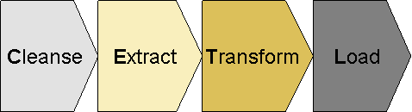

Figure: CETL Approach

* **C: Cleanse**  
  Cleansing comprises the analysis of source system data quality by Business team to identify potential data issues. This issue detection is mainly driven by the future system business rules and. This exercise will generate a list of cleansing candidates (for example, removal of duplicates, filling of empty fields,) to decide if data must be corrected in the source system.

* **E: Extract**  
  Extract programs are used to get data out of the source system by BAU team. Normally it is suggested to extract the data in flat or csv file format.

* **T: Transform**  
  Transformation means mapping of source data structure to target structure. This could be 1:1, n:m mappings via mapping tables but as well complex migration, transformation rules and mapping routines.
* **L: Load**  
  Load represents the transform and upload of migration data into the target system.

### Manual Data Migration

Manual data migration is applicable for very complex products (Eg Structured products), where effort to prepare automatic migration might be higher, than manual effort. Any data exceptions on the day of Cut-over will be also treated as a manual migration activity.

## Migration Upload Tools

The data upload into the target Wealth suite - T24 systems should be accomplished using T24™ Data Migration tool. It covers the following functionalities.

* Uses the inbuilt Standard OFS (Open Financial Services) module to perform the Load.
* Validates the data prior to upload.
* Accepts data in flat and csv format.
* Required less manual intervention as mapping is onetime setup.
* Performs all standard T24 validations and includes any special cases to perform local validations
* Stop/Resume options in case the Server/T24//Database connectivity is lost in the middle of the load.
* Exception Handling is done to report any erroneous data present in the Data file.

## Environment requirements

The migration team requires access to the T24 environment to execute the migration related activities and upload data into the target system. The table below provides a list of requirements to support the Migration team:

|  |  |  |  |
| --- | --- | --- | --- |
| Env Name | Description / Purpose of Environment | Project Phase | Cluster/Configuration |
| CD1 | - Conversion Development | Development Phase | T24, T24-Browser, TAP, TTI, TDS, TCIB |
| - Recon tool preparation |
| CIT1 | - Conversion Integration Test (CIT) | SIT / UAT | T24, T24-Browser, TAP, TTI, TDS, TCIB |
| - Trial Run *(Followed by CIT completion)* |
| CAT1 | - Conversion Acceptance Test (CAT) | SIT / UAT / DR support * | T24, T24-Browser, TAP, TTI, TDS, TCIB |
| - Master Conversion Environment (Flush out data to SIT / UAT) |

## Classification of Data Objects

Data migration distinguishes between different types of data and their definitions are outlined in the following section.

### Bank Setup /Business Parameter Data

Data migration requires a functional and operational Wealth suite - T24 system with complete configuration for the areas in scope for migration. The actual configuration activity is not in scope with Data Migration team. It is within the scope of the Bank setup team and it is a prerequisite for the build, test and execution of the data migration.

In a situation when Business parameter data are required to tweak for migration activity and re-instate to its original state during the cut-over window then migration team will handle such scenario by having two set of solution packages given below and the deployment activities will be listed and tracked in migration run book

1. Solution package to change the parameter data for Migration
2. Solution package to re-instate the parameter data to its original state

### Static Data

Static data migration is in ownership of the data migration team and data describes business objects which are often referred in day to day business operations. Examples would be Customer and Account. Static data tends to be created once and is maintained over a long timeframe which is not frequently updated and is used by many business activities. Static data will be sourced from multiple source system to migrate data into the target system

### Transactional and Financial Data

Transactional and Financial data migration is in ownership of the data migration team; the data is sourced from multiple source system to migrate the data into the target system. These data are created in target system to maintain customer financial deals and positions.

To migrate data into the target system, it requires the data in flat or csv file format with delimited values. Detailed requirements of data format will be listed during the Data mapping phase

# Migration approach

## Data Migration Scope

### Functional scope

The following slide provides the Functional scope for Retail WS 2.0 Migration

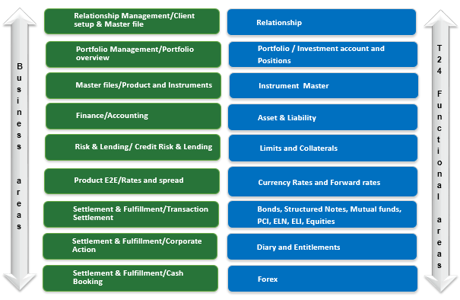

Figure: Functional Scope

### Master for Client Referential Data

The table below provides the view

|  |  |  |  |  |
| --- | --- | --- | --- | --- |
| **Referential Data** | **Systems** | | **After 1.2** | **After 2.0** |
| **SG** | **HK** |
| **Relationship** | eBBS | Hogan | Master for all Customers | Master for all Customers |
| Wealth Suite – T24 | Wealth Suite – T24 | NA | Slave for all Customers |
| **Portfolios / Investment Accounts** | TAP | TAP | Master for all Portfolios | Master for all Portfolios |
| Wealth Suite – T24 | Wealth Suite – T24 | NA | Slave for all portfolios |
| **Instruments** | TDS | TDS | Master for all instruments | Master for all instruments |
| Wealth Suite – T24 | Wealth Suite – T24 | NA | Slave for all instruments |
| **Client Accounts** | eBBS | Hogan | Master for all Client accounts | Master for all client accounts |
| Wealth suite – T24 | Wealth suite – T24 | NA | NA |

## Migration detailed strategy

### Customer

Individual Client Master (ICM) is a simplified platform for multiple systems (core banking systems, transaction processing systems) to access static information related to Individual Retail Customers. If ICM is not available within project delivery timelines, then eBBS and Hogan will provide the data service on behalf of ICM

Option to get the customer attributes from ICM will be kept open as it helps to provide single customer source point for WS 2.0 migration.

As part of 1.0 and 1.2 retail implementation, the Relationship details of all Wealth related clients are setup in TAP using the interface established with ODS. In ODS these Relationship masters are created based on the existing BAU Relation Master data from the core banking systems (eBBS / Hogan) and the Investment Account holding patterns maintained in TP systems

Below table lists the Pre-requisite for Customer section migration:

|  |  |  |
| --- | --- | --- |
| **Sl No** | **Application** | **Migration Pre-requisites** |
| 1 | CUSTOMER | CONDITION.PRIORITY COUNTRY CUSTOMER.STATUS DEPT.ACCT.OFFICER INDUSTRY LANGUAGE SECTOR TARGET |
| 2 | CUSTOMER.SECURITY | CUSTOMER |
| 3 | CUSTOMER.CHARGE | CUSTOMER |

WS 2.0 migration for Retail Customer will follow below mentioned strategy:

* Initial load of Relationship for SG region will be migrated from TAP and additional attributes from eBBS / ICM into Wealth suite – T24
* Initial load of Relationship for HK region will be migrated from TAP and additional attributes from Hogan / ICM into Wealth suite - T24
* Customer sensitive information like name and address will not be mapped from respective source systems. Sensitive information is mandatory (E.g. Name and address) in Wealth suite - T24 and alternate logic will be built to populate sensitive client data based on agreement with BRM team
* Customer level group charges and statement frequency will be updated automatically when customer is migrated based on group condition setup in Wealth suite - T24
* Depository group in Customer charge application is updated as part of migration activity
* Broker and Depository profiles will be migrated As-Is from eBBS / Hogan
* eBBS / Hogan does not have securities profile for Relationship, Broker and Depository. As part of migration activity default security profile will be set for all customers migrated in SG and HK region
* Static data related to Derivatives profile is out of scope for Retail migration
* Any cleansing for the redundant data need to be analysed by Business team for the migrated Broker and Depository from eBBS / Hogan

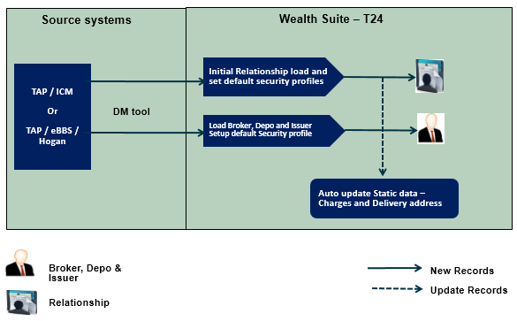

Figure: Customer Migration approach

### Account

eBBS and Hogan is core banking system which is currently managing CASA, Deposits, and Structured deposits. As part of WS 2.0 design solution it is decided to retain eBBS and Hogan as core banking system and Wealth suite – T24 will take over the functionality of transaction processing from its respective TP systems.

CASA will continue to be created and maintained in eBBS / Hogan. Client settlement account (CSA) would handle all the settlements in different currencies linked to the customers and they will be created by product and currency in Wealth suite – T24

Inter system account (ISAC) are created in Wealth suite – T24 which acts as corresponding account to eBBS / Hogan during the order generation and settlement process. At the end of the day the net balances of ISAC in Wealth suite - T24 should tally with ISAC entries raised in core banking system.

Creation and setting up of CSA and ISAC in Wealth suite – T24 is part of Bank setup activity, below table provides the Account classification for Retail Migration.

|  |  |  |  |  |  |
| --- | --- | --- | --- | --- | --- |
| **Sl. No** | **Classification** | **Description** | **Retail Source system** | **Region** | **Migration / Setup** |
| 1 | Internal | Inter settlement account (ISAC)  Client settlement account (CSA)  Suspense accounts | eBBS | SG | Setup |
| Hogan | HK | Setup |
| 2 | Takeover | Takeover suspense | NA | SG and HK | Setup |

Below table lists the Pre-requisite for Account section migration:

|  |  |  |
| --- | --- | --- |
| **Sl No** | **Application migration** | **Migration Pre-requisites** |
| 1 | ACCOUNT | ACCOUNT.CLASS ALT.ACCT.PARAMETER ACCOUNT.PARAMETER ACCT.GROUP.CONDITION ACCT.GEN.CONDITION CONDITION.PRIORITY CURRENCY CURRENCY.MARKET POSTING.RESTRICT STMT.GEN.CONDITION |

WS 2.0 will follow below mentioned strategy for Account migration:

* Account migration for Client, Nostro, Bank Internal account is out of scope for SG and HK region
* Above mentioned accounts will be continued to maintain in eBBS and Hogan system
* Migration takeover account list will be discussed and finalised between migration and business team before migrating into Wealth suite – T24
* Creation of Internal account mentioned in account classification table above will be migrated into Wealth suite – T24 based on the list of internal account agreed with Business team

### Portfolios / Investment account

Portfolio is grouping of financial assets holding such as stocks, bonds, and structured products. As part of WS 1.2 implementation the portfolios are created in TAP based on the investment account relation from the Trade processing and Core Banking system (eBBS & Hogan).

In TAP a portfolio is created for the unique Relationship from ODS and this portfolio will have the related ISA / Investment account details tagged from the current TP systems, this interface will be enhanced to bring in the delta Relationship data (Non-Priority clients with wealth investments) to TAP along with the additional attributes scoped in for 1.2 implementation to create portfolios in TAP

All Retail clients will have memo portfolios created without linking to the Client account in Wealth suite-T24. Whenever a security trade is triggered in target system the customer account will be replaced with Bank internal settlement account as mentioned in Account section migration.

Below table lists the Pre-requisites for portfolio migration

|  |  |  |
| --- | --- | --- |
| **Sl No** | **Application** | **Migration Pre-requisites** |
| 1 | SEC.ACC.MASTER | CUSTOMER CUSTOMER.SECURITY ACCOUNT  MANAGED.ACCOUNT |

WS 2.0 migration for Portfolios will follow below mentioned strategy:

* By default, all Retail clients will be flagged to memo portfolio in Wealth Suite – T24
* Data required for client portfolio creation will be sourced from TAP
* Some of the key attributes to migrate Client portfolio are reference currency, valuation currency, managed account, safekeeping frequency and advisory charge frequency
* Retail client who have availed for Wealth Lending facilities, the portfolio will be flagged as a Margin Lending portfolios in Wealth suite – T24 and client will avail the margin based on the collateral value defined for the portfolio
* The pre-requisites for migrating portfolio is handled in customer migration section
* Broker portfolio creation will be part of Bank setup activity
* Portfolio statement frequency are maintained in TAP and when the client portfolio statements are generated it will be sent to Spring Watch

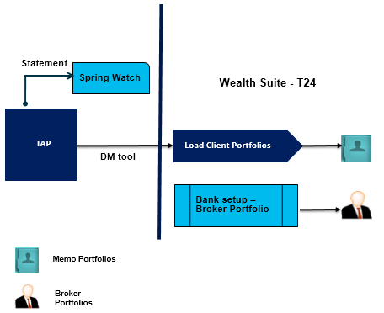

**Figure: Portfolio Migration approach**

### Financial Instruments

Financial instruments encompass all the assets and contracts that can be traded in the exchange or over the counter and can be held in portfolios as an asset or liability. Identified financial instruments for Retail include:

|  |  |  |
| --- | --- | --- |
| **Asset Classification** | **Product Type** | **Product Sub Type** |
| Cash | Cash & Cash Equivalents | CASA |
| Term Deposits, SMCD |
| Equity | Equities & Other Exchange-traded products | ADR |
| Common Shares |
| ETFs |
| REITs |
| Rights |
| Stapled Security |
| Warrants |
| Structured Investments | Non-Principal Protected |
| PCI |
| Principal Protected |
| Structured Deposits |
| Fixed Income | Fixed Income/Bonds | Bonds |
| Certificate of Deposit |
| Commercial Paper |
| Contingent Convertible |
| Convertible Bonds |
| FIXED DEPOSIT |
| Alt Investments | FUNDS | Closed-ended |
| Fund of hedge funds |
| Hedge Fund - FOHF |
| Mutual Fund |
| Structured Products | ELI/N |
| Non-Principal Protected |
| Principal Protected |

Temenos Data source (TDS) is decided as source system for all the financial instruments.As part of WS 1.2 implementation a golden copy of instrument master is formed and setup into TDS and all the market feeds will be updated in in TDS.

In WS 2.0 the similar approach will be followed to source the instrument data from TDS. Instruments will be classified for Securities and Structured products while setting up the contract master in Wealth suite – T24.

* All the instruments will be sourced from TDS based on the classification listed in below table in this section
* When the instruments are sourced into Wealth suite - T24, one-to-one existence will occur with Securities and Structured Products instruments
* Data Migration for financial instruments is out of scope as the data will be interfaced from TDS, any incremental data or changes specific to WS 2.0 will be scoped in migration
* SECURITY.MASTER and SY. MASTER are the contract master files for Securities and Structured products respectively
* Structured product master setup is part of bank setup activity and Derivative master setup is not applicable for Retail migration
* Below table lists the classification for setting the instruments in Wealth suite – T24

|  |  |  |  |  |
| --- | --- | --- | --- | --- |
| **Sl No** | **Transaction system** | **Product Classification** | **Target Module** | **Target Instrument setup** |
| 1 | Fin IQ | Premium Currency investment | Structure Products | SY. MASTER |
| 2 | TPS  UTS  Fin IQ | **UTS:**  Structured Notes  Mutual Funds  Bonds  **TPS:**  Bonds  I Bonds  Structured Notes  Equity-linked Investment  **FinIQ:**  Equity linked notes  Equity linked Investments | Securities | SECURITY.MASTER |

**Figure: Instrument Classification**

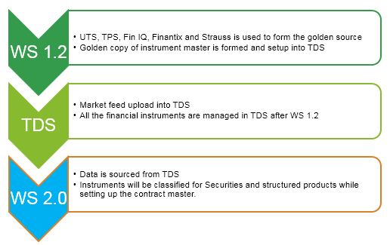

**Figure: Data sourcing for financial instruments**

### Financial Migration

As part of WS 2.0 Wealth implementation, it is decided to retain eBBS / Hogan as Core Banking system and Wealth suite – T24 will replace the TP systems for processing the security trades for the instruments listed in section 3.2.4. All the existing cash booking activities for the Client accounts will be retained in eBBS / Hogan.

Below table lists the Pre-requisites for Financial migration

|  |  |  |
| --- | --- | --- |
| **Sl No** | **Application** | **Migration Pre-requisites** |
| 1 | FUNDS.TRANSFER | FT.TXN.TYPE. CONDITION ACCOUNT |

WS 2.0 migration for financial migration will follow below mentioned strategy:

**Asset and Liability migration**

* All the contract balances (Forex, SY) and Open trades will be booked via its respective applications in Wealth suite - T24, the detailed migration of contract balances will be discussed later in the section **3.2.10** below.
* Migrating balances for Client account, Nostro accounts and Bank Internal account is not applicable for Retail migration

**Profit and Loss migration**

* All the income received and expenses incurred in eBBs and Hogan for Transaction related charges, Client accruals and fee accruals will be retained in eBBs and Hogan. Hence the P&L migration for income received and expense incurred is out of scope for Retail WS 2.0
* If there are any transaction related charges for open contracts and trades in TP systems they will be migrated As-Is through the respective T24 applications (Ex: Forex, Security trade and Structured Products)

**Migration Take over account**

* Take over account is used as substitute account for migrating the contract and account balances.
* The takeover account will be categorized by module, currency and entity.
* The Source GL balance would be booked on the equivalent take-over account prior to the migration of financial data. Post migration the take-over account balance for all currencies should be zero.
* These scenarios will be agreed with Business team in-order to create the number of take over accounts and to check and reconcile them at the end of migration.

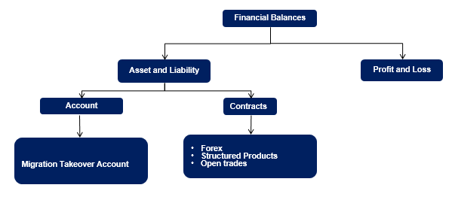

**Figure: Retail - Financial migration chart**

### Credit Risk

SPEED is integrated software, developed to monitor credit facilities and collaterals information. SPEED consolidates all acceptable collaterals and credit facilities currently booked in various TP systems and Core Banking systems.

SPEED application has been implemented in 17 countries and is currently receiving all the collaterals and facilities data from Core Banking System (eBBS and Hogan) and various TP systems (UTS, TPS, STRAUSS, RLS and E-Investment) daily. For countries that do not have any source system, the collaterals and facilities are manually handled in SPEED by the Business users.

Below table lists the pre-requisites for Credit risk migration:

|  |  |  |
| --- | --- | --- |
| **Sl No** | **Application** | **Migration Pre-requisites** |
| 1 | LIMITS | LIMIT.PARAMETER LIMIT.REFERENCE |
| 2 | COLLATERAL.RIGHT | COLLATERAL.TYPE COLLATERAL.CODE LIMITS |
| 3 | COLLATERAL | LIMITS COLLATERAL.RIGHT |

WS 2.0 migration for Credit Risk will follow below mentioned strategy

**Limits**

* New limit products will be replaced with existing limit products due to the change in Business rules for WS 2.0 implementation and these factors will be considered while migrating limits into Wealth suite – T24
* Portfolio pledging activity in Retail is currently done at the individual position level, this requires transformation in Wealth suite – T24 when we migrate the limits and collaterals. Transformation rules will be defined based on the solution obtained from the project team
* Limits with expiry date greater than Cut-over date and outstanding expired limits in SPEED is scoped for Retail migration
* Expiry dates is set to cut-over date for outstanding expired limit when migrated into Wealth suite – T24
* Key attributes for Limit migration are currency, approval date, expiry date, limit approved amount, fixed and variable indicator
* All secured limits will have its respective contract and portfolio linked to the limit structure in wealth suite – T24
* When Limits are migrated into Wealth suite – T24; the limit products that belong to term loan, overdraft, investment cash and structured products will belong to single global limit product (10000)

|  |  |  |  |
| --- | --- | --- | --- |
| **Relationship** | **Limit product** | **To-Be** | **Global Limit** |
| 190184-1 | 18100 (Term Loan) | 190184.0018100.01 | 190184.0010000.01 |
| 190184-1 | 10100 (Overdraft) | 190184.0010100.01 |
| 190184-1 | 18200 (Ins TL limit) | 190184.0018200.01 |
| 190184-1 | 10300 (Ins OD limit) | 190184.0010300.01 |

**Figure: Limit structure**

**Collateral**

* Collateral expiry date greater than cut-over date is migrated from SPEED into Wealth suite – T24
* Key attributes for collateral migration are value date, expiry date, review frequency date and collateral type
* When limit and collateral is migrated, they will be secured by bringing all the collateral ownership and collateral information from SPEED
* Only the approved limit amount is migrated and the available limit is updated automatically in Wealth suite – T24 when customer deals are migrated and linked into its respective limit and collateral.
* In case of non-revolving limit the unutilised limit amount in eBBS / Hogan will be considered as approved limit amount for the customer contracts which are closed or partially settled

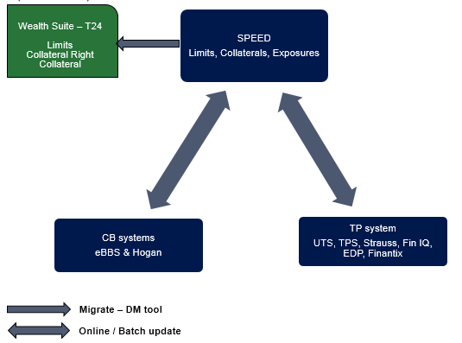

**Figure: Credit Risk Migration approach**

### Interest and Rates

This section explains setting up the Group and Individual Account Interest conditions, Currency Rates, Market price, Fixed and variable interest rates

WS 2.0 migration for Interest and Rates will follow below mentioned strategy

**Auto Migration:**

* Client accounts are retained in eBBS / Hogan and hence setting up the interest conditions for individual accounts is not applicable in Retail migration

**Bank Setup:**

* Account group conditions for Nostro and Internal accounts are bank setup activity
* Basic Interest and Periodic interest setup is not applicable for Retail migration since the Loans and Deposits products will be continue to operate in eBBS / Hogan
* Currency exchange rates are pre-requisites for migration to ensure all the currency exchange rates are updated in Wealth suite - T24 prior to the migration
* Forward rates are pre-requisite for Forex deal migration and they must be available in Wealth suite – T24 prior to the migration of Forex and Non-deliverable forward
* Currency and Forward rates setup is part of Bank setup activity
* Market price related to Securities, and Structure Products instruments is required to update in Wealth suite - T24 prior to the migration

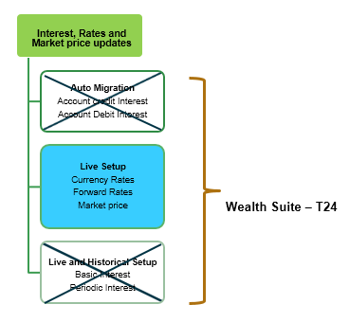

**Figure: Interest and Rates Migration**

### Fees, Commission and Charges

When contracts are migrated from CB (eBBS and Hogan) and TP systems (TPS, UTS, Fin IQ) into Wealth suite – T24, the commission and charges will be waived for contracts which are already booked and transacted in their respective TP systems.

**Customer fees**

All the customer related fee accruals will be continued to maintain in eBBS and Hogan. Hence the migration of fee accruals and posting in Wealth suite – T24 is out of scope for Retail migration

**Commission and charge setup**

Commission and charge parameter setup belongs to Bank setup team and they are out of scope for migration activity. Migration team will get the list of commission and charge details if they are required to trigger while migrating the contracts and deals.

### Security positions

Initial Security Position is the holding of the customer in various financial instruments during the point of migration cut-over date. Position data are available within the T24-POSITION module and data is maintained for each Portfolio and for each Asset segments.

Below table lists the pre-requisites for Security positions and trade migration

|  |  |  |
| --- | --- | --- |
| **Sl No** | **Application migration** | **Migration Pre-requisites** |
| 1 | SECURITY.TRANSFER | SC.TRANS.NAME SC.TRANS.TYPE PRICE.TYPE SEC.ACC.MASTER SECURITY.MASTER CURRENCY  SC. SETT.INSTRUCT |
| 2 | SEC.TRADE |
| 3 | SC.BLOCK.SEC.POS | SEC.ACC.MASTER SECURITY.MASTER SECURITY.POSITION |

Scope for building the portfolio positions in Wealth suite – T24 for its respective security products are listed below:

|  |  |  |  |  |  |
| --- | --- | --- | --- | --- | --- |
|  |  | **Retail Source details** | | **Retail Target details** | |
| **Security Products** | **Activity** | **SG** | **HK** | **Target Module** | **Target Tables** |
| **TPS:**  Bonds  I Bonds  Structured Notes  Equity-linked Investments  **UTS:**  Mutual Funds  Bonds  Structured Notes  **FinIQ:**  Equity linked notes  Equity linked Investments | Portfolio Positions Blocked Positions | TAP  Speed | TAP  Speed | SC | SECURITY.TRANSFER SC.BLOCK.SEC.POS |
| Unsettled trade | UTS  Fin IQ | TPS  UTS (Funds)  Fin IQ | SC | SEC.TRADE |

WS 2.0 migration for Securities products will follow below mentioned strategy

**Portfolio Positions**

* As part of WS 1.2 all the portfolio positions are mastered and centralised in TAP based on trade date and positions are segregated based on portfolio number, security number and Depository
* Positions will be extracted from TAP as on cut-over date and migrated into Wealth suite – T24 using security transfer application by setting the instruction “Free of payment” to update the positions without invoking the financial entries
* Key attributes to migrate the positions are transaction type, trade currency, depository, value date, customer security account details, Broker side details and nominal values etc.
* Trade date and Value date will be marked as cutover date to migrate the positions for security products.
* Security instruments which contains accruals and coupon payments for Bond type instruments, the accrual interest start date in Wealth suite – T24 will be the last coupon payment date
* Dummy Broker will be used while migrating the positions and the broker positions are not maintained currently in TAP system

**Blocked Positions**

* In current BAU all the portfolio positions blocked in TP systems are mastered and centralised in SPEED on daily basis through batch feed
* Blocked positions will be migrated from SPEED into wealth suite – T24 as on migration cut-over date
* Key attributes to migrate blocked positions are Client portfolio number, nominal to be blocked, and block dates

**Open trades**

* Unsettled trades from TP systems will be migrated using security trade application in Wealth suite – T24
* Client account will be replaced with designated settlement account when migrated into Wealth suite – T24
* Key attributes to migrate open trades are nominal, trade date, value date, customer and broker details
* When Open trades are set to actual settlement, the trade and commission details will be migrated As-Is from the TP systems and during the value date the trade settlement will be cleared through customer settlement account in Wealth suite – T24
* Once the trades are settled the Client account entries will be generated in eBBS / Hogan and settled portfolio positions will be moved into TAP
* Source system primary key will be retained as alternate key in the target system; the old reference key can be used for the settlement activities between eBBS / Hogan and Wealth suite – T24
* Key attributes to migrate open trades from TP systems into Wealth suite – T24 are security code, depository details, trade and value date, nominal details, customer and broker details

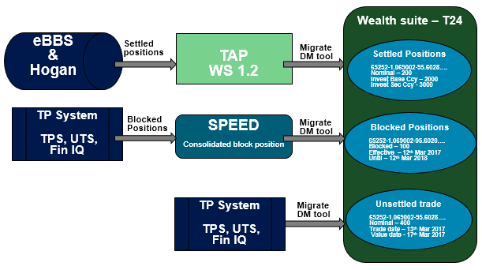

**Figure: Securities module Migration**

### Deals and Contracts

#### Forex

Electronic Dealing platform (AGCAPITAL) is customized to support Forex deal processing and it is activated in SG and HK region for Retail wealth suite. Services offered in EDP are Order Management, transaction enquiry, Live market pricing and business rule handling

Below table lists the pre-requisites for Forex migration

|  |  |  |
| --- | --- | --- |
| **Sl No** | **Application** | **Migration Pre-requisites** |
| 1 | FOREX | CURRENCY FORWARD.RATES REGION HOLIDAY |

As part of WS 2.0 Wealth suite - T24 Forex module will replace EDP to manage the Forex life cycle and below approach is followed to migrate the Forex deals

* Forex migration scope includes migrating the Forex deals with value date greater than cut-over date for the deal types spot and forward
* Forex deals which are having the value date equivalent to the cut-over date to be settled and closed in the source system
* Key attributes like Deal amount, forward rates, spot rates, client details, Buy / Sell date and currency are source from EDP / Murex
* Value date buy and Value date sell in Wealth suite – T24 will hold the similar value dates present in the EDP
* Client account will be replaced with designated settlement account in Wealth suite – T24 for all the forex deals
* Any forex forward deals with value date less then cut-over day + 2 days will be booked as spot deals in Wealth suite – T24

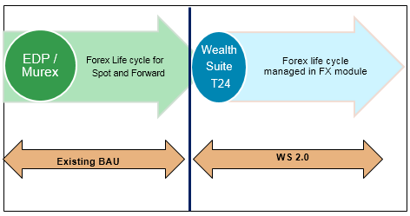

**Figure: Forex life cycle Migration**

#### Structure Products

Structure products include Premium Currency Investment (PCI) and it is a short-term investment product that gives the opportunity to earn potentially higher returns on investment in the currency markets and it allows selecting a base currency and an alternate currency for the investment.

Below table lists the pre-requisites for Structure products migration:

|  |  |  |
| --- | --- | --- |
| **Sl No** | **Application** | **Migration Pre-requisites** |
| 1 | SY.DCI | SY. PARAMETER  SY. MASTER  SY. PRODUCT.VARIANT  SY. PRODUCT.DEFINITION  SC. SETT.INSTRUCT |

As part of WS 2.0, Structure product (SY) module is used to migrate below mentioned products

**Premium currency investment:**

* All outstanding PCI contracts with maturity date greater than cut-over date in Fin IQ is scoped in migration
* PCI product is currently captured and managed in Fin IQ for Retail wealth suite
* PCI trades are involved between customer and counterparty and bank in effect acts as an agent which does not hold any positions
* Some of the Key attributes required from the source system to create PCI trades are trade currency, delivery currency, spot price, strike price, Deposit interest rate, principal amount, value date and maturity date
* Financial entries for deposit amount will be posted to the counterparty and during the principle redemption it will be passed back to the customer account in Wealth suite – T24
* Take over account will be used as drawdown account during the migration and replaced later to customer settlement account once the deals are authorised

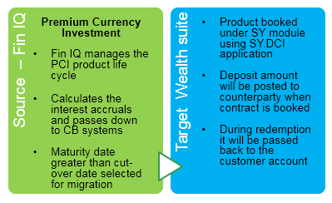

**Figure: Structure Products Migration**

### Corporate Actions and Events

Corporate action events are currently booked in TP system (UTS, TPS, FIN IQ) and settled in CB (eBBS / Hogan) systems for SG and HK region respectively. The scope of migration includes diary events with Execution date or the record date greater than cut-over date along with partially settled diary events in TP systems.

Below table lists the pre-requisites for corporate action migration:

|  |  |  |
| --- | --- | --- |
| **Sl No** | **Application** | **Migration Pre-requisites** |
| 1 | DIARY | DIARY.TYPE  SEC.ACC.MASTER  SECURITY.MASTER  CUSTOMER  ACCOUNT |
| 2 | ENTITLEMENT | DIARY.TYPE  DIARY |

Scope for Corporate action events for its respective security products are listed below:

|  |  |  |  |  |  |
| --- | --- | --- | --- | --- | --- |
|  |  | **Retail Source details** | | **Retail Target details** | |
| **Security Products** | **CA Events** | **SG** | **HK** | **Target Module** | **Target Table** |
| **TPS:**  Bonds  I Bonds  Structured Notes  Equity-linked Investments  **UTS:**  Mutual Funds  Bonds  Structured Notes  **FinIQ:**  Equity linked notes  Equity linked Investments | Coupon payments Dividends  Interest payment Pay out | UTS  Fin IQ | TPS  UTS  Fin IQ | SC | DIARY |

As part of WS 2.0 below migration approach is followed for corporate actions events

**Future dated settlements**

* Diary records with execution date greater than cut-over date in SG region is scoped for migration
* Diary records with record date greater than cut-over date in HK region is scoped for migration
* Some of the key attributes required from the TP systems to migrate Diary records are execution date, record date, pay date, value date, depository, security number and diary event type
* There are no financial entries raised when Diary records are migrated and hence the source data will be brought As Is into Wealth suite - T24
* Diary record primary key in TP system will be retained as alternate key in Wealth suite - T24 in-order to ensure the target system holds the source system reference key for the settlement events
* Post migration during the execution / record date the entitlements will be created in Wealth suite – T24 and client settlement account will be credited as part of Diary event flow.
* Wealth suite – T24 will create entitlements on the execution date and settlement entries are passed into eBBS / Hogan as part of BAU activity

**Back dated settlements**

* Diary records with execution date prior to the cut-over date is scoped in migration
* For diary events, which are yet to trigger the settlement in TP systems will be migrated in similar approach as explained under future dated settlements section
* Diary events which are partially settled will involve two-step process, first migrate the Diary Events As-Is into Wealth suite – T24 and then delete the unauthorised entitlements events which are already settled in TP systems
* Diary record primary key will be retained as in Wealth suite – T24 alternate key for the settlement purpose

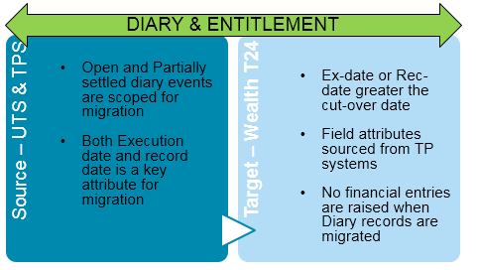

**Figure: Corporate Action Migration**

## Checks and Controls

Wealth suite - T24 generates Print and SWIFT advices during the migration and it also updates Wealth suite - TAP via B2F events. In-order to prevent such events in Wealth suite – T24 below table lists the checks and controls to adhere during the migration.

|  |  |  |  |  |
| --- | --- | --- | --- | --- |
| **Sl No** | **Migration** | **Suppress Print advices** | **Suppress SWIFT advices** | **Suppress B2F events to TAP** |
| 1 | Customer | NA | NA | ✓ |
| 2 | Account | NA | NA | ✓ |
| 3 | Portfolio | ✓ | NA | ✓ |
| 4 | Limits | NA | NA | NA |
| 5 | Collateral | NA | NA | NA |
| 6 | Structure Products | ✓ | ✓ | NA |
| 7 | Forex | ✓ | NA | NA |
| 8 | Diary and Entitlement | ✓ | NA | NA |
| 9 | Agency and Nostro setup | NA | NA | NA |
| 10 | Portfolio Positions | NA | NA | ✓ |
| 11 | Open Security trades | ✓ | ✓ | ✓ |
| 12 | Financial Balances | ✓ | ✓ | ✓ |
| 13 | Financial Instruments | NA | NA | ✓ |

**Figure: Checks and Controls**

## Nomenclature

It is necessary to retain the source system primary key in Wealth suite - T24 for all applications during the migration. Below table defines the strategy to retain the source system primary key has target system primary key or alternate key field value in Wealth suite – T24

|  |  |  |  |
| --- | --- | --- | --- |
|  |  | **TARGET** | |
| **Sl No** | **Application** | **Retain primary key from source system** | **Store source primary key in alternate field** |
| 1 | Customer | ✓ | NA |
| 2 | Account (Nostro and Bank Internal) | ✗ | ✓ |
| 3 | Portfolio | ✗ | ✓ |
| 4 | Limits | ✗ | ✓ |
| 5 | Collateral | ✗ | ✓ |
| 6 | Structure Products | ✗ | ✓ |
| 7 | Forex | ✗ | ✓ |
| 8 | Diary and Entitlement | ✗ | ✓ |
| 9 | Agency and Nostro setup | ✗ | NA |
| 10 | Portfolio Positions | ✗ | NA |
| 11 | Open Security trades | ✗ | ✓ |
| 12 | Financial Balances | NA | NA |
| 13 | Financial Instruments | TBC | NA |

**Figure: Primary key storage in Wealth suite – T24**

## Mapping Approach

Temenos standard mapping approach will be followed to map the Mandatory and Optional fields across the system. T24 core tables to map are listed during the migration strategy which serves the purpose to scope the number of applications to migrate.

However, decision to be made to adopt T24 functionality and minimize customization. If some entities or data do not exist in Wealth suite – T24, it will be treated as a GAP and a validation will be required to perform the customization to support the business continuity.

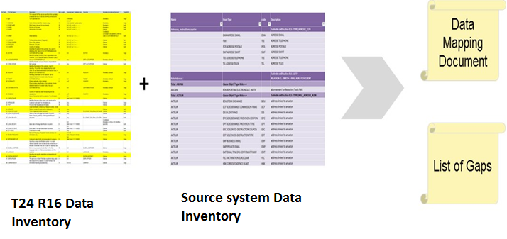

Figure: Data Mapping and Gap identification

## Dependencies and Constraints

|  |  |  |  |
| --- | --- | --- | --- |
| **#** | **Phase** | **Activity** | **Project Dependencies** |
| **1** | **Analyse** | Data Inventory | BAU, BA, Solution Architect and Target Operating Model involvement |
| **2** | **Design** | Data Mapping | Signed-off Functional requirements for L1, L2, L3 gaps |
| **3** | **Build** | Migration build | Functional and operational Wealth suite – T24 system with complete configuration for the areas in scope for migration |
| **4** | **Test** | CIT, CAT, Trial Run | Environment team and Business team |
| **5** | **Deploy** | Dress Rehearsals | Enable Project deployment, environment and Business team |

## Assumptions

The migration activities and responsibilities of the migration team are based on a set of assumptions which are outlined in the following table.

|  |  |
| --- | --- |
| ID# | Assumptions |
| 1 | Migration environment will be provided by Infrastructure team. System set-up activities like parameterizations / configuration will be done by Bank setup team. |
| 2 | Migration Team will provide input for data cleansing through data profiling (Data Defect List) but not conduct the cleansing of data. Activities will be done by Business Users. Ownership of data correction will stay with Business team. |
| 3 | Onshore Migration Team will get access to production like data for mock migrations and dress rehearsals. |

## Data Protection and Access control

The following steps are involved to protect the production cut-data while migrating from source systems into the target system during CIT / CAT for WS 2.0 migration

1. Production cut-data of various source systems (Like eBBS, Hogan, TPS, UTS and Fin IQ) is required during CIT, CAT and Trial migration phase for WS 2.0 migration
2. Approval must be obtained from CIO / CTM’s and Business owners from the respective country (SG / HK) in-order to make use of the production cut-data for the migration activity
3. CIT and CAT plan will be enclosed along with the list of Bank IDs who requires accessing the production data in the source and target migration environment
4. Copy of Production data will be restored in the source migration environment. Necessary checks and control is placed to ensure the credentials rights are restricted to read only access for the Project and Business team (For the Bank IDs shared during CIO / CTM’s approval)
5. Source project team will extract the data from the source migration environment and place the extracted files in the source directory. Source files will be pushed to the target environment directory through secured file transfer protocol
6. Source project team is provided with the directory / folder access rights in source and target environment
7. Target project team is provided with the directory / folder access rights in the target migration environment
8. Write access control to upload the data by reading the flat files in the target system is given to the designated migration users for the required applications in Wealth suite.
9. Post loading and high level reconciliation matching between source and target system the write access control will be removed
10. Business team is provided with read only access rights in Wealth suite for validating the migrated data
11. Customer sensitive information will not be uploaded in the target system and internal logic is built to populate the customer sensitive information in the target system. Hence masking of customer sensitive data is not applicable in Wealth suite.
12. Conversion reports will be extracted from wealth suite and placed in the reconciliation directory / folder with access rights controls for the designated Business users
13. Housekeeping activities in target migration environment will be performed to delete the source data files once the Business sign-off is obtained
14. The source migration environment restored with the production cut-data will be dropped for the next iteration (CIT / CAT) cycle
15. The target migration environment will be dropped once the SIT / UAT Business sign-off is obtained

## Deliverables / Output

|  |  |
| --- | --- |
| **Migration Activities** | **Deliverables / Output** |
| Planning | 1. Migration Strategy & Approach 2. Plan 3. Resource Plan |
| Analyse | 1. Data Dictionary 2. Data Mapping |
| Design | 1. Reconciliation/Validation Design 2. Mock Migration Plan |
| Build | 1. Technical design Migration 2. Implementation of Migration and Reconciliation components 3. Unit Test |
| Test – CIT and CAT | 1. Test Plan and Execution 2. Data Defect List 3. Provision of data for SIT and UAT |
| Test – Mock Migration | 1. Mock Migration Execution 2. Data defect list |
| Cut-over Preparation and Execution | 1. Dress Rehearsals Execution 2. Go- Live Support |

## Clarifications

Below are the clarifications identified during the migration strategy which requires to be addressed

|  |  |  |  |
| --- | --- | --- | --- |
| No. | Clarifications | Closure comments | Priority |
| 1 | Do we need to set default profile for Derivatives? Currently only PCI product is in scope for Retail migration which uses SY module |  | Low |
| 2 | Do we require to setup the delivery address and delivery product in Wealth suite – T24 for retail customers? |  | Medium |
| 3 | Is it required to migrate Bank Internal and Nostro accounts from TP or CB systems? To re-visit the account classification list for the Retail migration |  | Medium |
| 4 | Retail client with Wealth Lending facilities and accounts would be directly linked to the portfolio. How these scenarios can be handled when Clients accounts are not migrated in Wealth suite – T24 |  | Medium |
| 5 | Do we get all the LIMIT data from SPEED or should we consider to migrate from eBBS / Hogan? |  | Medium |
| 6 | Portfolio pledging activity in Retail is currently done at the individual position level. Transformation rules to be obtained from the Project team |  | Medium |
| 7 | Business to validate the Financial Instruments listed under section 3.2.4 |  | Medium |
| 8 | Is it required to migrated the balances for Nostro, Internal account and P&L? Linked to the clarification point 2 |  | Medium |
| 9 | Business to verify the Limit product listed in section 3.2.6 for Retail migration. |  | Medium |
| 10 | How are OD limits handled for Retail migration and it has dependency with Client Account to complete the Limit creation |  | Medium |
| 11 | Are there any customer fee accruals to migrate into Wealth suite? If Yes, please provide the fees list and how the accruals are maintained in TP systems (UTS and TPS)? |  | Medium |
| 12 | Are there any customer level charge and fee setup in TP and CB systems?  Do they have to be considered for migration while setting up CUSTOMER.CHARGE and while migrating unsettled trades? |  | Medium |
| 13 | Need details on EDP flow for the Forex deals in Retail and attributes currently available in EDP for the migration |  | Medium |
| 14 | Need details on Fin IQ flow for the PCI products and attributes currently available in Fin IQ for the migration |  | Medium |
| 15 | Need details on TPS / UTS flow into eBBS / Hogan and attributes currently available for the migration. Also, to validate the product list available under section 3.2.9 |  | Medium |
| 16 | Required details on types of Diary events in Retail and also record date execution for Diary events for HK |  | Low |
| 17 | Is record date considered for the Diary event execution in TP systems (TPS, UTS and FinIQ) |  | Low |
| 18 | Is BANCA in Scope for 2.0 Retail migration |  | Low |
| 19 | Should the UTS Omnibus account for PvB mapped with Target system |  | Low |
| 20 | EDP/OMF/SSW - No need to consider as it is for Order booking system - To check if any migration impact |  | Low |
| 21 | SSW referring INFO HUB for product catalog - To get clarity - If any migration scope |  | Low |
| 22 | Financial balance – Source system to be confirmed |  | Low |
| 23 | Should the Income received and Expense incurred (Existing P&L balances) be taken over to T24-Weathsuite from TP systems or eBBs / Hogan |  | Low |

## Out of scope activities

|  |  |
| --- | --- |
| **#** | **Objects** |
| 1 | Group condition setup and Product Parameterisation |
| 2 | Tax condition setup, Fees and Commission setup, Broker settlement instructions |
| 3 | Static data setup related system tables in Wealth suite – T24 |
| 4 | Transaction and Settlement Deal types setup |
| 5 | Financial Ledger setup |
| 6 | Integration with target system to push the data through TTI |
| 7 | User profile and Security management setup |
| 8 | Unauthorised Static data (E.g. Customer, Account, Portfolios) |
| 9 | Currency rates, forward rates, Market Price, Interest rates setup |
| 10 | Financial related reports will be generated in PSGL system and T24 sends the daily transaction details to PSGL. Sending transaction details to PSGL is out of scope for migration team. |

## Review Inputs