31-Jul-2017

**WS 2.0**

**Implementation**

Migration Strategy - SG & HK PvB

Document Details

|  |  |
| --- | --- |
| Information | Details |
| Project Name | Enable – WS 2.0 |
| Project Code | 16000683 |
| Document Type | Migration Strategy Document |
| Document Status | Final |
| Date of Approval | 11th Aug 2017 |
| Current Version No. | 0.8 |
| Author(s) | Druva Mallikarjuna, Mithin Jones |

Revision History

|  |  |  |  |
| --- | --- | --- | --- |
| Version No | Date | Description | Made By |
| 0.1 | 19-May-2017 | Initial Draft | Druva Mallikarjuna, Mithin Jones |
| 0.2 | 29 May 2017 | Revised Strategy for section 1.1 to 2.9 | Druva Mallikarjuna, Mithin Jones |
| 0.3 | 1 Jun 2017 | Revised Strategy for section 1.1 to 2.9 | Druva Mallikarjuna, Mithin Jones |
| 0.4 | 2 Jun 2017 | Revised Strategy for section 3.3.1 to 3.3.11 | Druva Mallikarjuna, Mithin Jones |
| 0.5 | 5 Jun 2017 | Updates based on review comments – To change the flow diagrams and Migration approach | Druva Mallikarjuna, Mithin Jones |
| 0.6 | 13Jun 2017 | Updates made after internal review with migration team | Druva Mallikarjuna, Mithin Jones |
| 0.7 | 14 Jul 2017 | Review feedback updated in the strategy document for the walkthrough session held with SA, BA, BAU and Temenos | Druva Mallikarjuna, Mithin Jones |
| 0.8 | 31 Jul 2017 | Review feedback updated for the comments provided during the walkthrough with BRM team | Druva Mallikarjuna, Mithin Jones |

# 

**Sign-Off and Reviewing Parties**

|  |  |  |  |
| --- | --- | --- | --- |
| S/N | Name | Role | Action Required |
| 1 | Steven Glover | Head, Requirements Management, Back-Office | Approve |
| 2 | Douglas Teo | Head, Requirements Management, Front-Office | Approve |
| 3 | Ravi Singhania | Business Project Management, 2.0 | Approve |
| 1 | Rangan Narasimhan | Head, Business Analysis | Review |
| 2 | Massimo Zaros | Head Solution Architecture | Review |
| 3 | Sri Ganesh Lakshminarayanan | 2.0 Program Manager | Review |
| 4 | Vikram Suri | 2.0 Project Manager | Review |
| 5 | Pankaj Adurkar | Bank Setup Lead / Head, Infra & Config | Review |
| 6 | Leinert, Christian | Lead BRM | Review |
| 7 | Anand Jagadeeshwaran | Lead BRM | Review |
| 8 | Pascal Pong | Lead BRM | Review |
| 9 | Savio Barbosa | Lead BRM | Review |
| 10 | Martelly, Bernard | Lead BRM | Review |
| 11 | Andrew Pnwee | Functional Specialist, BRM | Review |
| 12 | Milen Vergov | Functional Specialist, BRM | Review |
| 13 | Ong, Beng Imm | Functional Specialist, BRM | Review |
| 14 | Sandeep Patel | Senior Project Finance Manager | Review |

**Confidentiality Statement**

All the information contained in this document and/or any other related media is strictly confidential and must not be disclosed to any other party without prior written consent from SCB.

**Acronyms**

|  |  |
| --- | --- |
| **ACRONYM** | **Description** |
| TAP | Triple A Plus |
| PvB | Private Banking |
| CAT | Conversion Acceptance Testing |
| CIT | Conversion Integration Testing |
| WM | Wealth Management |
| TDS | Temenos Data Source |
| RB | Retail Banking |
| WS | Work Stream |
| CA | Corporate Action |
| IRS | Interest Rate Swaps |
| Target System | Wealth suite - T24 |
| ACCU / DECU | Accumulator / Decumulator |
| DCI | Dual Currency Investment |
| FIM | Financial Intermediary |
| SY | Structured Products |
| DM tool | Temenos Data Migration tool |
| A&L | Asset and Liability |
| P&L | Profit and Loss |
| PCI | Premium currency investment |
| EDP | Electronic Dealing Platform – Forex Order capture platform |
| PvB Opics | Forex Transaction Processing system |
| Murex | FX Derivatives and IRS transaction processing system |
| Fin IQ | Structured products – Order capture and Lifecycle Management system |
| Sophis | Trade processing system for Equities Derivatives and Structured products |
| MESI | Multi Entity Single Instance |
| TTI | T24 TAP Integration |
| OAT | Operational Acceptance Test |
| ETL | Extract, Transform and Load |
| UTS | Unit trust system |

Contents

1. Introduction 5

1.1 Document Purpose 5

1.2 Programme Overview 6

2. Migration Strategy 6

2.1 Overview 6

2.2 Migration Activities 7

2.2.1 Planning 8

2.2.2 Analysis and Design 9

2.2.2.1 Migration In-Scope 9

2.2.3 Build 12

2.2.4 Data Validation 12

2.2.4.1 Technical Validation (CIT) 12

2.2.4.2 Functional and Business Validation (CAT) 12

2.2.5 Mock / Trial Migration 13

2.2.6 Cut-over Preparation and Execution 13

2.3 Migration Window 13

2.4 Methods of Data Migration 14

2.4.1 Automated Data Migration 14

2.4.2 Manual Data Migration 14

2.5 Migration Upload Tool 14

2.6 Environment requirements 15

2.7 Classification of Data Objects 15

2.7.1 Bank Setup /Business Parameter Data 15

2.7.2 Static Data 15

2.7.3 Transactional and Financial Data 16

3. Migration approach 16

3.1 Data Migration Scope 16

3.1.1 Master for Client Referential Data 17

3.2 Migration detailed strategy 17

3.2.1 Customer 17

3.2.2 Account 18

3.2.3 Portfolios 20

3.2.4 Financial Instruments 21

3.2.5 Financial Migration 24

3.2.6 Credit Risk 26

3.2.7 Interest and Rates 28

3.2.8 Fees, Commission and Charges 29

3.2.9 Security Positions 30

3.2.10 Deals and Contracts 31

3.2.10.1 Loans, Deposits, and Miscellaneous deals 31

3.2.10.2 Forex and Non-deliverable forwards 34

3.2.10.3 Interest Rate Swaps 35

3.2.10.4 Derivatives 36

3.2.10.5 Structure Products 38

3.2.11 Corporate Actions and Events 39

3.3 Checks and Controls 41

3.4 Data volume and Methods 42

3.5 Nomenclature 42

3.6 Mapping Approach 43

3.7 Dependencies 44

3.8 Assumptions 44

3.9 Upstream / Downstream 44

3.10 Data Protection and Access control 45

3.11 Deliverables / Output 46

3.12 Clarifications / Open points 46

3.13 Out of scope activities 48

3.14 Reviewer feedback 49

# Introduction

## Document Purpose

The Purpose of the document is to describe the overall migration strategy for PvB (SG & HK) 2.0 Implementation. The Strategy document covers including migration approach, tools & techniques, methods of migration, In-Scope/Out-Scope items and functional approach.

## Programme Overview

Standard Chartered Bank (“SCB”) Wealth Management (“WM”) has three strategic objectives based on five-year financial plan to double the AUM, what we have communicated to investors and discussion with our customer segment colleagues – principally across Retail Banking and PvB segments. Three strategic objectives are to:

1. Achieve Scale in growing our AUM and income
2. Strengthen competitive advantage of our wealth management proposition
3. Deploy a standard and scalable wealth management platform

Current application landscape is very fragmented and it cannot be scalable to support the business model that we would like to achieve the above three objectives. It requires a unified system that supports the enhanced business model across PvB and Retail locations

The initiative has been confirmed as a global transformation program (“Enable Program”) to deliver a standardized, front-to-back WM platform serving customers within PvB and WM segments. The Global WM platform transformation is made up by two major components – Core and Digital initiatives. As part of Enable program, Temenos Wealth suite (Triple A plus (TAP) and T24) is chosen for front-end and core banking platform.

Below is the approved plan for WS 2.0

* Tranche I – PvB and Retail for Singapore and Hong Kong Location
* Tranche II – PvB and Retail for UAE and India
* Tranche III – Other locations (TBD)

# Migration Strategy

## Overview

The objective of this document is to provide a detailed overview of migrating data into the new Temenos platform. Wealth suite - T24 will be implemented in multiple locations with single instance Architecture model (MESI).

Project (WS 2.0) implementation scope will cover back office capabilities and will require data from multiple source systems across Private, Wealth and Retail Core Banking platforms.

The purpose of Data Migration is to provide required data for the Wealth suite - T24 Platform to be used by end users to support business operations. The terminology data migration summarizes all transformation related activities Including data analysis, mapping, migration development, transformation/conversion and testing.

It is essential to have an understanding on source system Data model, Object structures, landscape and its functions. This will enable the project team to arrive with migration strategy to migrate data from multiple source systems into the target system. The below figure represents the high-level migration activities that would be delivered in-line with project deliverables.

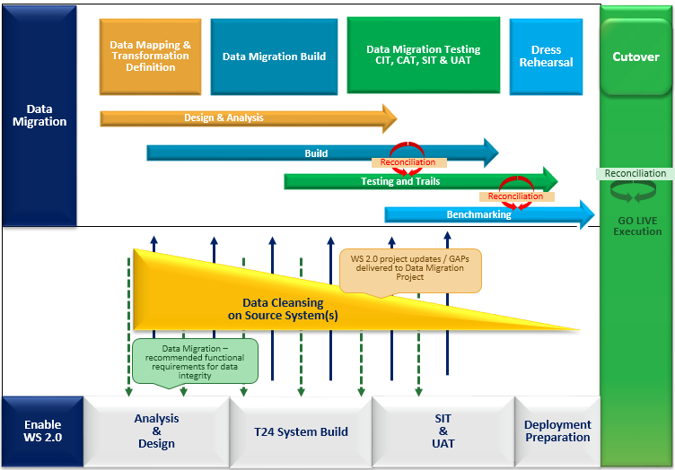

Figure: Overview for data migration activities in-line with project activities

This document covers the Migration strategy / approach for all the applications delivered in the Base Product T24. Any enhancement that arises for core and local changes during the project cycle then its relevant migration approach will be taken up for GAP migration analysis. The delivery of GAPs migration will follow the release schedule setup by the project for GAPs.

## Migration Activities

Migration activities will contain different phases in migration: Planning, Analysis & Design, Build, Test and Mock Migration. Below diagram explains the different activities under its respective phases

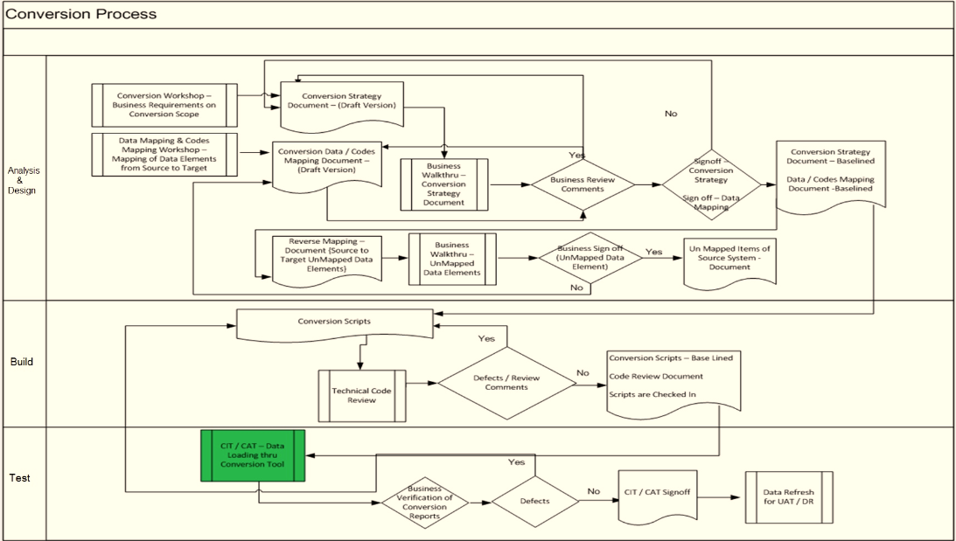

Figure: Migration Activities

### Planning

Below high level migration plan has been drafted based on the overall project plan for 2.0 and in line with the project deliverables for each location and segment

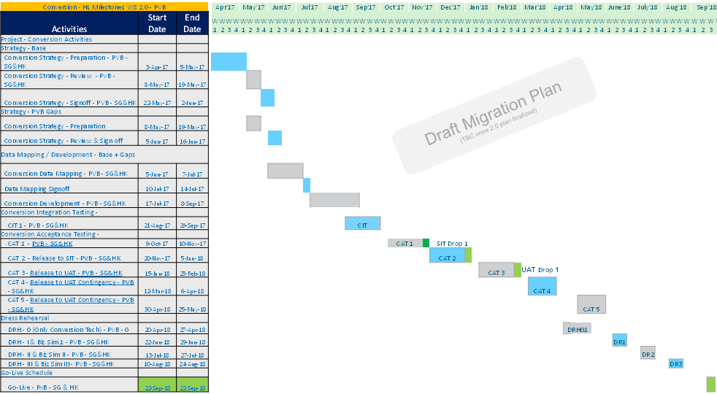

### Analysis and Design

The migration team will perform high-level system study on the existing PvB and Wealth application landscape. Based on the High-Level system study, migration team will come up with the in-scope application for migration in to Wealth suite - T24 platform. Once the in-scope application list is finalized, a detailed system study will be performed on the source systems involved for migration.

### 2.2.2.1 Migration In-Scope

Based on the high-level analysis and project system study, the following list of In-scope items identified for PvB WS 2.0 Migration

|  |  |  |  |  |  |  |  |
| --- | --- | --- | --- | --- | --- | --- | --- |
| **Business Streams** | **Functional streams** | **Migration Source** | | | **Migration Target** | | |
| **System** | **Module** | **Module Description** | **System** | **Module** | **Module Description** |
| Client Setup and Master file | Customer | T24 R08  Cupid | CUSTOMER CIF CUSTOMER (Broker, Custodian, Counterparty) CUSTOMER.CHARGE CUSTOMER.SECURITY DE.PRODUCT DE.ADDRESS | . Relationship / CIF . Broker, Custodian and Counterparty  . Customer Charge Profile . Definition of Customer profile for Securities . Customer wise Delivery product definition . Customer wise Delivery Address Definition (Reference to cupid) | T24-Wealth Suite | CUSTOMER CIF CUSTOMER (Broker, Custodian, Counterparty) CUSTOMER.CHARGE CUSTOMER.SECURITY DX.CUSTOMER DE.PRODUCT DE.ADDRESS | . Relationship / CIF . Broker, Custodian and Counterparty  . Customer Charge Profile . Definition of Customer profile for Securities . Definition of Customer profile for Derivatives . Customer wise Delivery product definition . Customer wise Delivery Address Definition (Reference to cupid) |
| Account | T24 R08 | ACCOUNT AGENCY NOSTRO.ACCOUNT DE.PRODUCT DE.ADDRESS | . Static Data creation for CASA, Nostro, Vostro, Bank Internal  . Agency Definition . Nostro Definition . Account wise Delivery product definition . Account wise Delivery Address Definition (Reference to cupid) | T24-Wealth Suite | ACCOUNT AGENCY NOSTRO.ACCOUNT DE.PRODUCT DE.ADDRESS | . Static Data creation for CASA, Nostro, Vostro, Bank Internal . Agency Definition . Nostro Definition . Account wise Delivery product definition . Account wise Delivery Address Definition (Reference to cupid) |
| Master Files / Instruments | Financial Instruments | TDS | ASSETS (Securities, Derivatives, Structured Products) | . Instrument Master Definition for Securities, Derivatives and Structured products | T24-Wealth Suite | SECURITY.MASTER DX.CONTRACT.MASTER SY.MASTER | . Instrument Master Definition for securities product . Instrument Master Definition for Derivatives product . Instrument Master Definition for Structured product |
| Portfolio Management / Overview | Portfolio | T24 R08 | SEC.ACC.MASTER | . Portfolio Definition for CIF . Portfolio Definition for broker and counterparty | T24-Wealth Suite | SEC.ACC.MASTER | . Portfolio Definition for CIF . Portfolio Definition for broker and counterparty |
| Security Positions / Pending trades | T24 R08 | SECURITY.POSITION SC.BLOCK.SEC.POS SEC.TRADE | . Customer positions . Position blocking . Security trades (pending for settlement) | T24-Wealth Suite | SECURITY.POSITION SC.BLOCK.SEC.POS SEC.TRADE | . Customer positions . Position blocking . Security trades (pending for settlement) |

|  |  |  |  |  |  |  |  |
| --- | --- | --- | --- | --- | --- | --- | --- |
| **Business Streams** | **Functional streams** | **Migration Source** | | | **Migration Target** | | |
| **System** | **Module** | **Module Description** | **System** | **Module** | **Module Description** |
| Settlement & Fulfilment / Transaction Settlement / Corporate Action / Cash Booking | Derivatives | MUREX SOPHIS T24 R08 | SECURITY.POSITION MD.DEAL | . Outstanding Derivatives captures as positions . Margin blocks captured as Miscellaneous deals | T24-Wealth Suite | DX.TRADE | . Capture FX and EQ OTC Derivatives |
| Structured products | PvB OPICS SOPHIS T24 R08 FIN IQ | SECURITY.POSITION | . Outstanding Structured Products captured as positions for:   . PCI  . Accu / Decu,  . FX forwards | T24-Wealth Suite | SY.DCI SY.ACCU.DECU SY.FX.FORWARDS | . Contracts booked for PCI products . Contracts booked for ACCU/DECU products . Contracts booked for Target Redemption forwards products |
| Corporate actions | T24 R08 | SC.PRE.DIARY DIARY ENTITLEMENTS | . Pre-Diary for CA Notification events . Future dated Diary events . Entitlements for the partially settled CA Events | T24-Wealth Suite | SC.PRE.DIARY DIARY ENTITLEMENTS | . Pre-Diary for CA Notification events . Future dated Diary events . Entitlements for the partially settled CA Events |
| Interest rate swaps | T24 R08 MUREX | SECURITY.POSITION | . Asset side captured as position for swaps | T24-Wealth Suite | SWAPS | . Capture Asset and Lability interest rates swap contracts |
| Loans, Deposits and Miscellaneous | T24 R08 | LOANS.AND.DEPOSITS MM.MONEY.MARKET MD.DEAL | . Outstanding customer Loans . Outstanding customer Deposits . Customer Guarantees | T24-Wealth Suite | LOANS.AND.DEPOSITS/AA MM.MONEY.MARKET/AA MD.DEAL | . Outstanding customer Loans . Outstanding customer Deposits . Customer Guarantees |
| Forex | PvB OPICS MUREX T24 R08 | MD.DEAL SECURITY.POSITION | . Outstanding Forex deals (Spot, Forward, Swaps) captured as miscellaneous deals . Outstanding Non-deliverable forwards captured in positions | T24-Wealth Suite | FOREX ND.DEAL | . Used for trading with the Foreign exchange market . Used for Non-Deliverable currency trading |
| Finance / Accounting | Financial Migration | T24 R08 | PROFIT and LOSS ASSET and LIABILITY | . Income received & Receivable, Expenses incurred and payable  . Accounts and Contracts Balances | T24-Wealth Suite | PROFIT and LOSS ASSET and LIABILITY | . Income received & Receivable, Expenses incurred and payable  . Accounts and Contracts Balances |
| Product E2E | Interest and Rates | T24 R08 | ACCOUNT.CREDIT.INTEREST ACCOUNT.DEBIT.INTEREST | . Account credit interest setup . Account debit interest setup | T24-Wealth Suite | ACCOUNT.CREDIT.INTEREST ACCOUNT.DEBIT.INTEREST | . Account credit interest setup . Account debit interest setup |
| Fees, Commission and Charges | T24 R08 | SAFEKEEPING FEES ADVISORY FEES HOLD MAIL FEES | . Fees commission and Charges setup | T24-Wealth Suite | SAFEKEEPING FEES ADVISORY FEES HOLD MAIL FEES | . Fees commission and Charges setup |

By analysing the functionality being implemented, the enable team will identify data that is required in Wealth suite - T24. Once both the legacy and target data analysis are complete, they will be brought together for assessment and the proposed migration inventory will be updated and approved. The dependencies, sequencing, and estimated volumes and runtimes will be established for each migration.

For each migration execution, procedures will be understood and data mapping document will be completed. These design and data mapping will include extract criteria that must be applied in the source system and upload method used in target system. Migration team will own the design for Transformation, Migration and Reconciliation approach in the target system

For the above listed In-scope items, Reverse mapping will be accomplished in target system during mapping phase to ensure the un-mapped data fields are identified and reported. This procedure will ensure end-to-end data mapping is covered from source to the target system.

### Build

The build phase includes developing the scripts for source data extraction, target data upload and data reconciliation. These scripts are built in such a way to reuse the capabilities and reduce the dependency within the build solution

**Source**: The procedure logic in the extract script in the source system is built in line with data mapping sheet designed during the mapping phase. The extract program must control the scope of records by exact definition of selection criteria as defined in design document.

**Target**: Standard Temenos Data Migration Upload tool will be used for the Load in the target system and the upload configuration/scripts are built based on data mapping defined during the design and mapping phase.

**Reconciliation**: Standard Temenos Data extraction tool will be used for extracting the data from the target system. Auto comparison report and detailed verification report are produced for reconciliation by consuming the data extracted in the source and target system

### Data Validation

Data validation after a data-migration is essential to make sure that the data has been transferred and converted correctly as expected from Business point of view. For this reason, data validation is most critical success factors in a large Wealth suite - T24 implementation. The below validation should be performed during implementation and cut-over to ensure the integrity of data.

#### Technical Validation (CIT)

All the migration process will be validated during the Conversion integration testing. Technical validation will be performed to ensure that the migration processes (Mapping, Conversion and Upload) are implemented correctly. Following are the objective of CIT testing

* Data mapping integrity check
* Validate source file formatting
* Validation of transformation of data
* Baseline source extraction and target upload tools
* Recon reports baseline

#### Functional and Business Validation (CAT)

The involvement of Business during CAT phase is to ensure that the migrated data meets the original design and processed correctly in the target system. This involves the actual execution of T24 transactions using the migrated data and this will identify any downstream processing issues at the early stage

Following are the objectives of CAT testing

* Validate the migrated data at field level
* Validate the functionality of each module on the migrated data
* Recon reports verification

### Mock / Trial Migration

One of the factor for successful data migration depends on the intensity and careful execution of the “mock tests/ trail run”. The data migration programs should be tested as early and extensively as possible with production like test data both regarding quantity and quality. Mock test will ensure technical consistency between extracted and migrated data. The following aspects will be taken care during the Mock phase:

* 1. Sequencing and dependencies of cut over activities
  2. Target system can process the migrated data (validation related to field control rules)
  3. Verify run times. Identify tasks on critical path and length of critical path.
  4. Identify technical shortfalls and workarounds.
  5. Identify issues and risks
  6. Verify the data migration upload performance in the target system
  7. To meet migration benchmark timing to fit within the cut-over timeline

The defects resolved during the mock cycle will be tracked and closed in Jira. The migration elements (script / data) amended to resolve the defects will be packaged and released in the mock environments through incremental method. The migration elements version control will be tracked as part of release management process until the completion of final run.

The migration success rates must trend towards 100% by the final mock and mock migration will be considered as complete when all processes are executed end-to-end successfully. Tasks, run-times and dependencies will be reported to the cutover team to include this information in the cutover planning

### Cut-over Preparation and Execution

The migration team will play a key role during Go live and coordinate all migration related activities. The following deliverables are part of the Cut-Over Preparation for migration:

* Migration Cutover plan
* Migration communication Plan
* Stakeholder management
* Migration data validation/verification
* Decision matrix for Go/No-go decision

Dress Rehearsals will be organized to execute the cutover plan with the same resources who will execute the activities on the Migration day. Below mentioned are the Logistics and Infrastructure required during the cut-over phase:

* Contact information and telephone numbers
* Collaboration tool(s)
* Backup Plans/Rollback plan
* Access to location(s), security and facility management
* Meeting rooms and the setup of the meeting rooms
* Emergency plans for outage of key applications and loss of availability
* Command center setup

## Migration Window

The production cut-over will take place in a limited timeframe (‘Migration Window’) and it is migration teams responsibility to make sure all the migration cut-over tasks are executed within the window. The duration of individual steps which need to be executed during migration cycles must be tracked for each test and mock phases. Based on these measures the migration team will take relevant action to align with the Go-Live window.

Factors that must be considered for cut-over window:

* Volume and quality of the data to be loaded.
* Data dependencies which determines objects that can be loaded in parallel to reduce the overall load time.
* The efficiency of the database engine and how it has been configured for the migration.
* The degree of manual intervention in the migration process.
* The time it takes to reconcile individual loads before proceeding with the next step in the migration.
* The time it takes to get the business checks done and sign-off that the migration has been successful.

## Methods of Data Migration

There are several mechanisms by which data can be imported into the target system as listed below in this section. Standard approach is Bulk data migration and for any exception cases it will be discussed in each respective section in this document.

### Automated Data Migration

Automated data migration assumes that data will be extracted, converted and loaded in the target system by fully automated migration programs and tools. On a high level, each data migration will be conducted in four main parts.

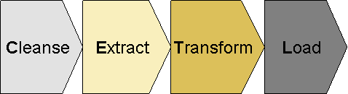

Figure: CETL Approach

* **C: Cleanse**  
  Cleansing comprises the analysis of source system data quality by Business team to identify potential data issues. This issue detection is mainly driven by the future system business rules. This exercise will generate a list of cleansing candidates (for example, removal of duplicates, filling of empty fields,) to decide if data must be corrected in the source system.

The Data Cleansing activities will be considered to improve the data quality. The cleansing activity will be divided in two cycles:

* A first cycle during the design and mapping phase to clean up known issues or foreseeable problems.
* A second cycle during the test phase to clean up exceptions coming out of CIT, CAT and Mock conversion.

* **E: Extract**  
  Extract programs are used to get data out of the source system by BAU team. Normally it is suggested to extract the data in flat or csv file format.

* **T: Transform**  
  Transformation means mapping of source data structure to target structure. This could be 1:1, n:m mappings via mapping tables but as well complex migration, transformation rules and mapping routines.
* **L: Load**  
  Load represents the transform and upload of migration data into the target system.

### Manual Data Migration

Manual data migration is applicable for very complex products (Eg Structured products), where effort to prepare automatic migration might be higher than manual effort. Any data exceptions on the day of Cut-over will be also treated as a manual migration activity.

## Migration Upload Tool

The data upload into the target Wealth suite - T24 systems should be accomplished using T24™ Data Migration tool. It covers the following functionalities.

* Uses the inbuilt Standard OFS (Open Financial Services) module to perform the Load.
* Validates the data prior to upload.
* Accepts data in flat and csv format.
* Required less manual intervention as mapping is onetime setup.
* Performs all standard T24 validations and includes any special cases to perform local validations
* Stop/Resume options in case the Server/T24//Database connectivity is lost in the middle of the load.
* Exception Handling is done to report any erroneous data present in the Data file.

## Environment requirements

The migration team requires access to the T24 environment to execute the migration related activities and upload data into the target system.

The table below provides a list of requirements to support the Migration team:

|  |  |  |  |
| --- | --- | --- | --- |
| Env Name | Description / Purpose of Environment | Project Phase | Cluster/Configuration |
| CD1 | - Conversion Development | Development Phase | T24, T24-Browser, TAP, TTI, TDS, TCIB |
| - Recon tool preparation |
| CIT1 | - Conversion Integration Test (CIT) | SIT / UAT | T24, T24-Browser, TAP, TTI, TDS, TCIB |
| - Trial Run *(Followed by CIT completion)* |
| CAT1 | - Conversion Acceptance Test (CAT) | SIT / UAT / DR support * | T24, T24-Browser, TAP, TTI, TDS, TCIB |
| - Master Conversion Environment (Flush out data to SIT / UAT) |

## Classification of Data Objects

Data migration distinguishes between different types of data and their definitions are outlined in the following section.

### Bank Setup /Business Parameter Data

Data migration requires a functional and operational Wealth suite - T24 system with complete configuration for the areas in scope for migration. The actual configuration activity is not in scope with Data Migration team. It is within the scope of the Bank setup team and it is a prerequisite for the build, test and execution of the data migration.

In a situation when Business parameter data are required to tweak for migration activity and re-instate to its original state during the cut-over window then migration team will handle such scenario by having two set of solution packages given below and the deployment activities will be listed and tracked in migration run book

1. Solution package to change the parameter data for Migration
2. Solution package to re-instate the parameter data to its original state

### Static Data

Static data migration is in ownership of the data migration team and data describes business objects which are often referred in day to day business operations. Examples would be Customer and Account. Static data tends to be created once and is maintained over a long timeframe which is not frequently updated and is used by many business activities. Static data will be sourced from multiple source system to migrate data into the target system

### Transactional and Financial Data

Transactional and Financial data migration is in ownership of the data migration team; the data is sourced from multiple source system to migrate the data into the target system. These data are created in target system to maintain customer financial deals and positions.

To migrate data into the target system, it requires the data in flat or csv file format with delimited values. Detailed requirements of data format will be listed during the Data mapping phase

# Migration approach

## Data Migration Scope

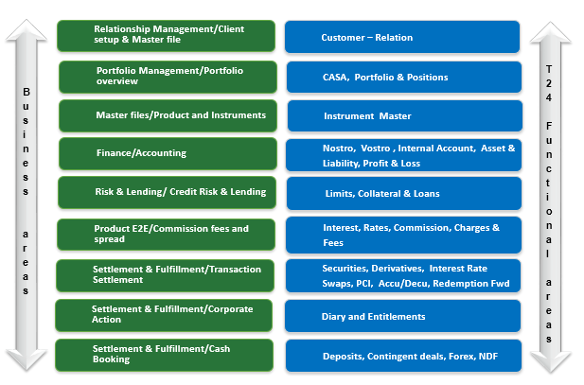

Figure: Functional Scope

### Master for Client Referential Data

The table below provides the view

|  |  |  |  |
| --- | --- | --- | --- |
| **Referential Data** | **Systems** | **After 1.2** | **After 2.0** |
| **Customer** | Temenos T24 | T24 R08 Slave for Relation (CIF) | Wealth suite - T24 Slave for Relation (CIF) |
| CUPID | Cupid is master for Party and Relation | Cupid is master for Party and Relation |
| **Portfolios** | Temenos T24 | T24 R08 Master for all Portfolios | Wealth suite - T24 Master for all Portfolios |
| TAP | TAP slave for all portfolios | TAP slave for all portfolios |
| **Instruments** | Temenos T24 | T24 R08 Slave for all instruments | Wealth suite - T24 Slave for all instruments |
| TDS | TDS Master for all instruments | TDS Master for all instruments |
| **CASA accounts** | Temenos T24 | T24 R08 Master for all CASA accounts | Wealth suite - T24 Master for all CASA accounts |
| TAP | TAP Slave for CASA account | TAP Slave for CASA account |

## Migration detailed strategy

### Customer

As part of WS1.2 implementation it will be made available to have relationship information from Cupid and T24 R08 to establish Client relationship setup in TAP WS1.2 application. Customer risk rating and other suitability related data are setup at the relationship level in TAP by sourcing the data from T24 R08 and Cupid. All the relationship linked to the portfolios was scoped in WS1.2 migration.

Below table lists the Pre-requisite for Customer section migration:

|  |  |  |
| --- | --- | --- |
| **Sl No** | **Application** | **Migration Pre-requisites** |
| 1 | CUSTOMER | CONDITION.PRIORITY COUNTRY CUSTOMER.STATUS DEPT.ACCT.OFFICER INDUSTRY LANGUAGE SECTOR TARGET |
| 2 | CUSTOMER.SECURITY DX.CUSTOMER | CUSTOMER |
| 3 | CUSTOMER.CHARGE | CUSTOMER |

WS 2.0 migration for Customer will follow below mentioned strategy:

* Migrating Party from Cupid into Wealth Suite – T24 is out of scope for PvB WS 2.0
* Initial load for Relation (CIF) will be migrated from T24 R08 into Wealth suite - T24
* Additional attributes for Relation will be migrated from Cupid
* Relation sensitive information like name and address will not be mapped from respective source systems. Sensitive information is mandatory in Wealth suite - T24 and alternate logic will be built to populate the name and address field values during the migration
* Customer level group charge will be updated automatically when customer is migrated into Wealth suite - T24 based on the condition group setup and customer statement frequency will be updated from T24 R08
* Depository group in Customer charge application is updated as part of migration activity
* All Broker, Depository and Issuer customer profile will be migrated As-Is from T24 R08
* Static data related to Securities for CIF, Broker and Depository will be migrated As-Is from T24 R08
* Static data related to Derivatives will be migrated for all existing customers in T24 R08
* Any cleansing for the redundant data needs to be analysed by Business team for the migrated Broker, Depository and Issuer from T24 R08

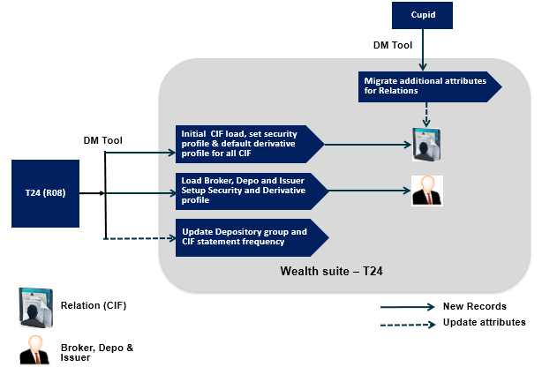

Figure: Customer Migration approach

### Account

As part of WS1.2 implementation all the customer and Nostro accounts will be mastered in T24 R08, below table provides the Account classification and Products identified in T24 R08

|  |  |  |
| --- | --- | --- |
| **Sl. No** | **Product Description** | **Classification** |
| 1 | Demand Account IB, Demand Account IB AC – AC, Saving Account  Demand Account NIB AC -AC, Collateral Hedging Settlement Account | CASA |
| 2 | Bony Melon, Clear stream, Payment Nostro, Bony Brussels, Securities service Singapore, Citibank NA HK, SCB Hong Kong, OPICS, Bony Mellon NY  Securities Services Malaysia, SCB London Nostro, Securities Services Honkong, Clear stream custody settle Suspense, Securities Services Indonesia, Securities Services Taiwan | Nostro |
| 3 | Demand Account NIB | Vostro |
| 4 | Suspense CR General, Suspense Bulk FT, Suspense past due, Brokerage payable, Payment netting suspense, Suspense data capture, IDT-Cheque(In&OUT), IDT-SIT(In&OUT), Intercompany A/C, Reserve swap Debit,  Forex forward reserve, Investment In consolidated subs, Suspense data capture, Suspense bulk FT, Suspense CR and DR FX, referred clearing checks, FX Forward revaluation, Exchange A/L Forwards, Suspense CR LD/MM, Profit Loss Close, Reserve Forward Credit, Suspense CR General  Suspense CR and DR FX | Bank Internal |
| 5 | Migration Takeover Account | Migration |

Below table lists the Pre-requisite for Account section migration:

|  |  |  |
| --- | --- | --- |
| **Sl No** | **Application migration** | **Migration Pre-requisites** |
| 1 | ACCOUNT | ACCOUNT.CLASS ALT.ACCT.PARAMETER ACCOUNT.PARAMETER ACCT.GROUP.CONDITION ACCT.GEN.CONDITION CONDITION.PRIORITY CURRENCY CURRENCY.MARKET POSTING.RESTRICT STMT.GEN.CONDITION |
| 2 | AGENCY | DE.BIC.PARAMETER DE.BIC CUSTOMER |
| 3 | NOSTRO.ACCOUNT | ACCOUNT CURRENCY |
| 4 | DE.PRODUCT | COMPANY DE.CARRIER DE.INTERFACE DE.MESSAGE CUSTOMER ACCOUNT |
| 5 | DE.ADDRRESS | DE.PRODUCT CUSTOMER ACCOUNT |

WS 2.0 will follow below mentioned strategy for Account migration:

* Above mentioned classifications are factored while migrating the accounts into Wealth suite - T24
* All the client accounts that are not closed in T24 R08 are scoped in migration. CASA account will be migrated from T24 R08 into Wealth Suite – T24
* Migration of segregated / sub accounts from T24 R08 will be taken into the consideration when the design solution is finalised in the target system wealth suite – T24
* Nostro Account, Bank Internal accounts, Agency and Nostro setup for all the counterparties will be migrated As-Is from T24 R08
* All Open account and customer delivery products for print and swift carrier will be migrated As-Is from T24 R08 into Wealth suite – T24
* Message status, priority and carrier address are some of the key attributes required to migrate customer delivery product
* Migration takeover account list will be discussed and finalised between migration and business team, Creation of take over account will be part of bank setup team.
* Account statement frequency will be updated automatically in Wealth suite - T24 from the statement frequency definition at the group level.
* All the customer account statements are generated in TAP based on statement frequency which are setup and available in TAP system as part of WS1.2 implementation.

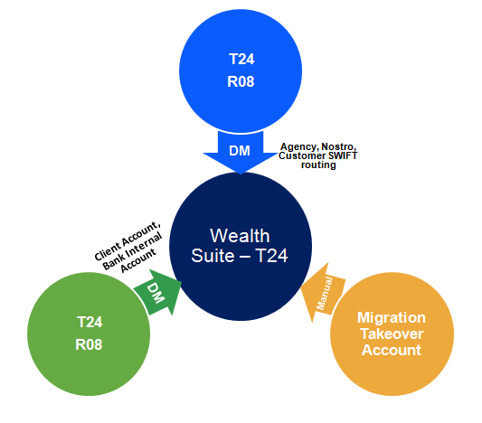

Figure: Account Migration approach

* Attached excel contains the Account category mapping between T24 R08 and Wealth suite – T24. The attached list will be re-visited during the mapping phase.



### Portfolios

Portfolio is grouping of financial assets holding such as stocks, bonds, structured products, cash products including mutual funds, Hedge funds and Private Equities.

Currently the Portfolio setup is available in TAP and T24 R08. Each portfolio setup is done as per relationship definition established for the Client. As part of WS 1.2 implementation data is sourced into TAP from T24 R08 portfolio module and all the active portfolios were scoped in the migration.

Below table lists the Pre-requisites for portfolio migration

|  |  |  |
| --- | --- | --- |
| **Sl No** | **Application** | **Migration Pre-requisites** |
| 1 | SEC.ACC.MASTER | CUSTOMER CUSTOMER.SECURITY ACCOUNT  MANAGED.ACCOUNT |

WS 2.0 migration for Portfolios will follow below mentioned strategy:

* All the active customer portfolios available in T24 R08 will be migrated into Wealth Suite – T24
* Reference currency, valuation currency, managed account, client account, safekeeping charge account, safekeeping charge frequency and advisory charge frequency are the key attributes to migrate customer portfolios into Wealth suite – T24
* The pre-requisites for migrating portfolio is handled in customer migration section
* Broker, Depository and Issuer portfolio will be migrated As-Is from T24 R08
* Portfolio statement frequency setup and generation will be handled in TAP and sent to Spring Watch

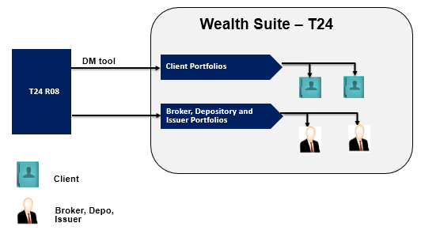

**Figure: Portfolio Migration approach**

### Financial Instruments

Financial instruments encompass all the assets and contracts that can be traded in the exchange or over the counter and can be held in portfolios as an asset or liability. Identified financial instruments include:

1. Equities and Other exchange trade products
2. Bonds
3. Mutual Funds / Hedge funds / Private Equity / CD wraps / discretionary
4. Structured notes, structure investments and alternative investments
5. Derivatives
6. Liabilities
7. CASA
8. Term Deposits
9. Guarantees

Temenos Data source (TDS) is decided as source system for all the financial instruments. As part of WS 1.2 implementation a golden copy of instrument master is formed and setup into TDS and all the market feed updates will happen in TDS.

Below table lists the Pre-requisites for financial instrument migration

|  |  |  |
| --- | --- | --- |
| **Sl No** | **Application** | **Migration Pre-requisites** |
| 1 | SECURITY.MASTER | PRICE.TYPE SUB.ASSET.TYPE CURRENCY COUPON.TAX.CODE ALT.SEC.PARAMETER |
| 2 | SY. MASTER | SY. PARAMETER |
| 3 | DX.CONTRACT.MASTER | SECURITY.MASTER DX.EXCHANGE.MASTER DX.PRICE.SET DX.PRICE.SOURCE DX.OPTION.TYPE DX.CONTRACT.CLASS SUB.ASSET.TYPE |

In WS 2.0 the similar approach will be followed to source the instrument data from TDS, instruments will be classified for Securities and Derivatives while setting up the contract master in Wealth suite - T24.

* All the instruments will be sourced from TDS based on the classification listed in below table in this section
* When the instruments are sourced into Wealth suite - T24, one-to-one existence will occur with Securities and Derivatives Products instruments
* Data Migration for financial instruments is out of scope as the data will be interfaced from TDS, any incremental data or changes specific to WS 2.0 will be scoped in migration
* SECURITY.MASTER and DX. CONTRACT.MASTER are the contract master files for Securities and Derivatives products respectively
* SY. MASTER is contract master file for structured products and it will be a Bank setup activity depending on the parameter data required to configure the master table
* Attached excel contains the Financial instruments mapping between T24 R08 and Wealth suite – T24. The attached list will be re-visited and verified during the mapping phase



* Below table lists the classification for setting the instruments

|  |  |  |  |  |
| --- | --- | --- | --- | --- |
| **Sl No** | **Asset types** | **Products classification** | **Target Module** | **Target Instrument setup** |
| 1 | Currency Derivatives, Calls and Puts | FX Barrier Option – Buy FX Barrier Option - Sell FX Option - Buy FX Option - Sell Buy Eq Call Buy Eq Put Sell Eq Call Sell Eq Put | Derivatives | DX.CONTRACT.MASTER |
| 2 | Premium Currency investment, Commodity linked structure investment, Currency Derivatives, Calls and Puts | FX Target Redemption FWDs Buy Eq Leveraged AQ Buy Eq Leveraged DQ Buy Eq Non-Leveraged AQ Buy Eq Non-Leveraged DQ | Structure Products | SY. MASTER |
| 3 | Bonds, Shares, American Deposit receipt shares, Preferred shares, Right of subscription, Approved MF, Exchange traded funds, Currency Option, Certificate of deposit, US treasury bills/notes, Floating rate notes, Assignment of Securities, Wrap funds, Structure deposits, Third part structure note, Approved Hedge fund, Hedge funds not sponsored, Approved – UCITS funds, On shore funds, SCB premium funds, Private equity funds, Non approved funds, Non approved MF, Approved Money market funds, Bonds with pool factor, Third party equity link loans, Fixed maturity plan – Funds, SCB structure notes, SCB equity linked notes, Accumulator notes | Bonds Shares Equities Warrants Hedge Funds  Certificate of Deposits Notes Other Funds | Securities | SECURITY.MASTER |

**Figure: Instrument Classification**

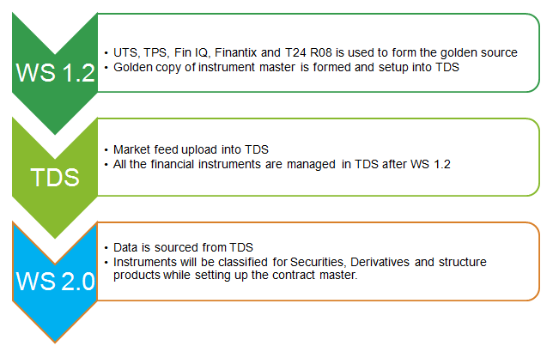

**Figure: Data sourcing for financial instruments**

### Financial Migration

Financial Migration will include migration of balances for Client Accounts, Profit and Loss, Take over Account, Bank Internal Accounts and Nostro Accounts. Funds Transfer and Data Capture application is used to migrate the balances.

Below table lists the Pre-requisites for Financial migration

|  |  |  |
| --- | --- | --- |
| **Sl No** | **Application** | **Migration Pre-requisites** |
| 1 | FUNDS.TRANSFER | FT.TXN.TYPE.CONDITION ACCOUNT  CONSILATED.COND  RE.STAT.REP.LINE  RE.STAT.REPORT.HEAD |
| 2 | IC.ADJUST.ACCRUAL | ACCOUNT |
| 3 | DATA.CAPTURE | CATEGORY TRANSACTION ACCOUNT  CONSILATED.COND  RE.STAT.REP.LINE  RE.STAT.REPORT.HEAD |

WS 2.0 migration for Balance migration will follow below mentioned strategy

**Asset and Liability migration covers:**

* Client Account, Nostro Account and Bank Internal Account closing balances in T24 R08 will be migrated as Opening working balance in Wealth suite - T24 using Funds transfer application
* When Account balances are migrated into Wealth suite – T24, the source system account product balance consolidation will be In-line with Asset and Liability accounting key defined in the target system.
* If there are any accrued balances for CASA in T24 R08 then accrued balance for each Client account in wealth suite – T24 will be captured using adjust accruals table as part of migration activity
* When the account capitalises in Wealth suite – T24 it will combine the source system accrual figure captured in adjustment accruals table during the cut-over along with the new accruals in the target system
* Key attributes to migrate accrued portion from source system are accrued interest amount till the cut-over date and client account number which will have the credit or debit during the capitalisation
* Contract Balances (Like loans, deposits, Swaps, Derivatives and Structured products etc...) will be migrated through the respective application in Wealth suite - T24, the detailed migration of contract balances will be discussed later in the ***section 3.2.10*** below***.***

**Profit and Loss migration covers:**

* P&L balance mapping keys from source to target system will be verified with BRM / BA team before the respective P&L balances are considered for migration in Wealth suite - T24
* All the income received and expenses incurred will be migrated as balances to the respective P&L category using Data capture application
* Below table lists the Profit and Loss consolidation key in T24 R08 and similar structure will be retained in Wealth suite – T24 for all the P&L keys

|  |  |
| --- | --- |
| **Key** | **Description** |
| Category | PL classification |
| Product code | Product classification |
| Sector | Customer sector code |
| Residence | Customer residence |
| Department | Account officer code involved in P&L entries |
| Cost centre | Customer cost centre |
| Affiliate code | Customer affiliate code |

* P&L code with negative balance will be considered has expenses incurred in source system and these balances will be migrated in wealth suite – T24 by debiting the P&L code and crediting takeover suspense
* P&L code with positive balance will be considered has income received in the source system and these balances will be migrated in wealth suite – T24 by crediting the P&L code and debiting takeover suspense
* Some of the key attributes required for migrating P&L balances are category, product, account number, transaction code, debit / credit indicator and cost centre
* All the income receivable and expense payable will be built through the respective application migration for Loans, Deposits and Client accruals

**Migration Take over account**

* Take over account is used as substitute account for migrating the A&L and P&L balances.
* Takeover account will be used to avoid the double booking of customer accounts to migrate transactions without affecting the Customer account, since these balances would have debited / credited the Customer account in the source system.
* The takeover account will be categorized by module, currency and entity.
* The Source GL balance would be booked on the equivalent take-over account prior to the migration of financial data. Post migration the take-over account balance for all currencies should be zero.
* These scenarios will be agreed with Business team in-order to create the number of take over accounts and to check and reconcile them at the end of migration.

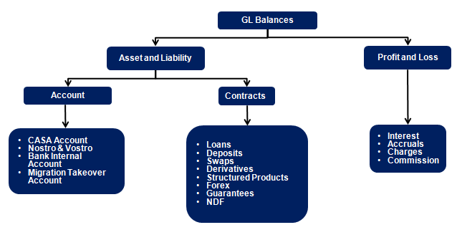

**Figure: Financial Migration Scope**

### Credit Risk

All Limits with expiry date greater than Cut-over date is scoped in the migration. Expired limits which are outstanding will also be migrated by setting the expiry date as migration date. Both Global Limit and Sub product limits will be scoped in Migration.

Below table lists the pre-requisites for Credit risk migration:

|  |  |  |
| --- | --- | --- |
| **Sl No** | **Application** | **Migration Pre-requisites** |
| 1 | LIMITS | LIMIT.PARAMETER LIMIT.REFERENCE |
| 2 | COLLATERAL.RIGHT | COLLATERAL.TYPE COLLATERAL.CODE LIMITS |
| 3 | COLLATERAL | LIMITS COLLATERAL.RIGHT |

WS 2.0 migration for Credit Risk will follow below mentioned strategy

* New limit products will be replaced with existing product in T24 R08 due to the change in Business rules and operations. These factors will be considered during transformation to have the new limit structure
* All limits with expiry date greater than cut-over date will be migrated from T24 R08, also the outstanding expired limits is considered for migration by setting the expiry dates to migration date
* Only the approved limit amount is migrated and the available limit is updated when the customer deals are migrated into Wealth suite – T24
* In case of non-revolving limit the unutilised limit amount in T24 R08 will be considered as approved limit amount for the customer contracts which are closed or partially settled
* Once the limit is migrated they will be secured by bringing all the collateral ownership and collateral information from T24 R08 into Wealth suite - T24
* Secured limits will be linked with deal and portfolio once the deal migration is complete
* When Limits are migrated into Wealth suite - T24, limit will require a transformation based on RISK classifications and limit product given below

|  |  |  |  |  |
| --- | --- | --- | --- | --- |
| **Global (To-be)** | **As-Is Risk Class** | **Product** | **Sub Product** | **Description** |
| Class I | 1 | 100 |  | OVERDRAFT |
| 4000 |  | PLACEMENTS |
| 8300 |  | LC+GTEE |
|  | 8340 | GUARANTEES |
|  | 8350 | STANDBY L/C |
| 8500 |  | INITIAL MARGIN |
|  | 8510 | AQ/DQ INITIAL MARGIN |
| Class II | 2 | 100 |  | OVERDRAFT |
| 4000 |  | PLACEMENTS |
| Class II | 12 | 100 |  | OVERDRAFT |
| 4000 |  | PLACEMENTS |
| Class III | 3 | 4000 |  | PLACEMENTS |
| 8300 |  | LC+GTEE |
|  | 8340 | GUARANTEES |
|  | 8350 | STANDBY L/C |
| Class III | 13 | 4000 |  | PLACEMENTS |
| 8300 |  | LC+GTEE |
|  | 8340 | GUARANTEES |
|  | 8350 | STANDBY L/C |
| Class IV | 4 | 7000 |  | CFX ACCOUNTS |
| Class V | 11 | 100 |  | OVERDRAFT |
| 4000 |  | PLACEMENTS |
| 8300 |  | LC+GTEE |
|  | 8340 | GUARANTEES |
|  | 8350 | STANDBY L/C |

**Figure: Limit structure**

* Attached sheet contains the WealthSuite-T24 limit product list and it will be re-visited during mapping phase to form the limit reference key and field attributes for migration.



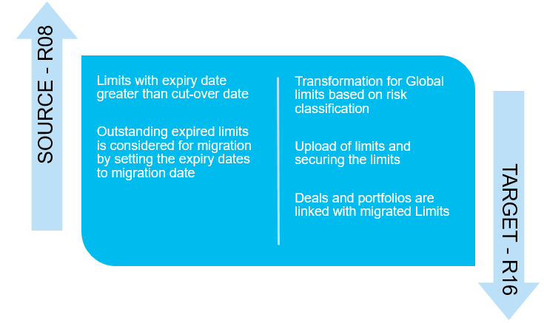

**Figure: Credit Risk Migration approach**

### Interest and Rates

This section explains migrating and setting up Interest and Rates at the group level and at the individual level for Customer Account and Products

Below table lists the pre-requisites for Account interest migration

|  |  |  |
| --- | --- | --- |
| **Sl No** | **Application** | **Migration Pre-requisites** |
| 1 | ACCOUNT.CREDIT.INTEREST | ACCOUNT |
| 2 | ACCOUNT.DEBIT.INTEREST |

WS 2.0 migration for Interest and Rates will follow below mentioned strategy

**Auto Migration:**

* Individual Account conditions for debit and credit interest is scoped in migration, the interest conditions at the individual account level will be migrated from T24 R08 into Wealth suite - T24
* All the Account interest condition present in T24 R08 will migrated from the last capitalisation date

**Bank Setup:**

* Account group conditions are parameter setup and they will not be scoped in migration and it will be handled by the bank setup team.
* Basic Interest and Periodic interest setup is a Bank setup activity for all product groups and currencies
* Historical data for the Basic Interest and Periodic Interest is required to setup in Wealth suite – T24 from the last capitalisation date for all the respective products present in T24 R08
* Currency exchange rates are pre-requisites for migration to ensure all the currency exchange rates are updated in Wealth suite - T24 prior to the migration
* Forward rates are pre-requisite for Forex deal migration and they must be available in Wealth suite – T24 prior to the migration of Forex and Non-deliverable forward
* Market price related to Securities, Derivatives and Structure Products instruments is required to update in Wealth suite - T24 prior to the migration

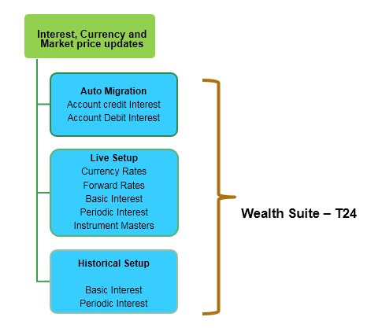

**Figure: Interest and Rates Migration approach**

### Fees, Commission and Charges

System table related to commission, charges and fees setup is in scope of Bank setup team and any activity related to brining the accrued fees balance for the portfolios will be handled as part of migration activity

When contracts are migrated from T24 R08 into the Wealth suite - T24, the commission and charges will be waived for the contracts which are already booked and transacted in their respective source system.

**Portfolio fees**

In current BAU, the portfolio fees (safekeeping, advisory fees etc.,) are posted manually by the operation team. The charge frequency is currently set to post quarterly by debiting the customer account. WS 2.0 migration for portfolio fees will follow below mentioned strategy

* If the cut-over event does not occur during the quarter end, then accrued portfolio fees will be considered for the migration in Wealth suite – T24.
* It is expected to provide the portfolio fee accruals till the cut-over date in-order to migrate the accrued fees into Wealth suite – T24
* The posting of fees will be handled through forward dated transfer with processing date set to the next charge date (Quarter end)
* During the quarter end of day run, Wealth suite - T24 will debit the customer account for the migrated accrued fees.
* Any new accruals and fee posting from the cut-over date will be handled in Wealth suite – T24 though parameter setup

**Commission and charge setup**

All the commission and charge parameter setup belongs to Bank setup team and they are out of scope for migration activity. Migration team will get the list of commission and charge type if they are required to trigger while migrating the contracts and deals.

Below table list the parameter tables related Commission and charge setup

|  |  |  |
| --- | --- | --- |
| **Sl No** | **Parameter list** | **Description** |
| 1 | SCPM.CHARGE.PARAMETER | Portfolio management charge parameter which define the rules for calculating charges and commissions. |
| 2 | SCPM.GROUP.CONDITION | Portfolio management group conditions |
| 3 | SCPM.GEN.CONDITION | Portfolio management general conditions |
| 4 | SCSK.GROUP.CONDITION | Safekeeping group conditions |
| 5 | SCSK.GEN.CONDITION | Safekeeping general conditions |
| 6 | SCSF.CHARGE.PARAMETER | Safekeeping charge parameter which define the rules for calculating charges and commissions. |
| 7 | SAFECUSTODY.VALUES | Safe custody charges and Management fee structures to be levied on each portfolio |
| 8 | FT.COMMISSION.TYPE | Conditions related to all types of commission |
| 9 | FT.CHARGE.TYPE | Conditions related to all types of charges |
| 10 | CONDITION.PRIORITY | Condition priority for each application |
| 11 | DX.COMMISSION | Derivatives fees and commission |

### Security Positions

Initial Security Position is the holding of the customer in various financial instruments during the point of cutover. Position data are available within the T24-POSITION module and data is maintained for each Portfolio and for each Asset segments

Below table lists the pre-requisites for Security positions and trade migration

|  |  |  |
| --- | --- | --- |
| **Sl No** | **Application migration** | **Migration Pre-requisites** |
| 1 | SECURITY.TRANSFER | SC.TRANS.NAME SC.TRANS.TYPE PRICE.TYPE SEC.ACC.MASTER SECURITY.MASTER CURRENCY  SC.SETT.INSTRUCT |
| 2 | SEC.TRADE |
| 3 | SC.BLOCK.SEC.POS | SEC.ACC.MASTER SECURITY.MASTER SECURITY.POSITION |

WS 2.0 migration for Securities products will follow below mentioned strategy

**Positions and Blocking**

* Migration scope for building the portfolio positions in Wealth suite - T24 for its respective security Products are listed under the Section ***Financial Instruments (Security Master)***
* Positions are segregated based on portfolio number, Security instruments and Depository in T24 R08
* All the active portfolio settled positions will be extracted from T24 R08 as on migration date.
* All settled positions will be migrated using Security transfer application by setting the instruction “Free of payment” to update the positions without invoking the financial entries in Wealth suite - T24
* Trade date and Value date will be marked as cutover date to migrate the portfolio positions
* Security instruments which contains accruals and coupon payments, the accrual interest start date will be taken from last coupon payment date or the trade start date
* Broker number 5000 for SG and HK region is used while migrating the portfolio position under Security Transfer application in Wealth suite - T24
* Blocked portfolio positions will be migrated from T24 R08 into Wealth suite – T24
* Transaction type will be set to block while blocking the security positions. Security account, block date and block until date are some of the key attributes required to block the security positions
* Broker position are not maintained in T24 R08 and it is not required to migrate the Broker positions

**Open Trades**

* All the value dated trades which are set to actual settlement with value date greater than cut-over date will be migrated using security trade application into Wealth suite - T24.
* Settlement of these trades will happen post cut-over date as part of BAU when it reaches the value date in wealth suite – T24 via Security settlement application
* When Open trades are set to actual settlement, the trade and commission details will be migrated As Is from T24 R08 and during the settlement date customer account will be reflected financial entries
* Key attributes to migrate open trades are nominal, trade date, value date, customer and broker details
* Source system primary key will be retained as target system primary key; the old reference key can be used for the settlement activities in Wealth suite – T24

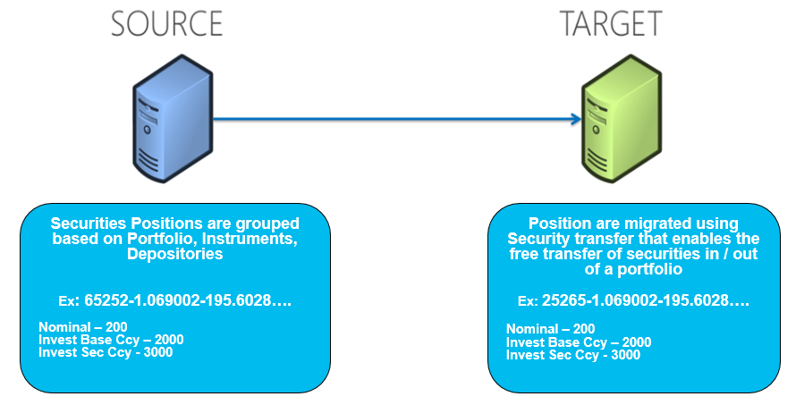

**Figure: Securities Positions Migration**

### Deals and Contracts

#### Loans, Deposits, and Miscellaneous deals

Products covered under this section is currently available in LD, MM and MD modules in T24 R08, these products will be fit into the target module when they are migrated into Wealth suite - T24.

Below table represents the product scoped for migration

|  |  |  |  |
| --- | --- | --- | --- |
| **Product** | **Description** | **Source Module** | **Target Module** |
| 21050 | Time loans | LD | AA |
| 21054 | Real Estate loans | LD | AA |
| 21060 | Term loans | LD | AA |
| 21073 | Special Loan Non-earning | LD | AA |
| 21010 | Fixed deposits | MM | AA |
| GTEER | Guarantees Received | MD | MD |
| SGREL | Guarantees Received RE collateral | MD | MD |
| SIPRC | Single insurance premium | MD | MD |
| CCTPI | Credit allocation CTP | MD | MD |
| IGTER | INTL GTEE Fixed pledge issued | MD | MD |
| SBLCI | Stand by LC | MD | MD |
| SBLCR | Stand by LC received | MD | MD |
| SHIPG | Guarantees Issued | MD | MD |
| HKREL | Guarantees received Re collateral | MD | MD |

Below table represents the product which are currently booked in MD module in T24 R08 and they will be moved to its respective target module in Wealth suite - T24

|  |  |  |  |  |
| --- | --- | --- | --- | --- |
| **Product** | **Description** | **Source Module** | **Target Module** |  |
| OPXFX | FOREX SPOT / FORWARD | MD | FX |  |
| IMLIB | DERIVATIVES INIT MARGIN BLOCK/  IM CURRENCY DERIVATIVE | MD | DX |  |

Below table lists the pre-requisites for Loans, Deposits and Miscellaneous deals migration

|  |  |  |
| --- | --- | --- |
| **Sl No** | **Application** | **Migration Pre-requisites** |
| 1 | AA. ARRANGEMENT.ACTIVITY (Loans) | AA. ACTIVITY  AA. ACTIVITY.CLASS  AA. ACTIVITY.HISTORY  AA. ARRANGEMENT  AA. PRD.CAT.REPORTING  AA. PRODUCT  AA. PRODUCT.CATALOG  AA. PRODUCT.GROUP  AA. PRODUCT.LINE  AA. PROPERTY.CLASS  AC. BALANCE.TYPE  ACCOUNT.CLASS |
| 2 | AA. ARRANGEMENT.ACTIVITY (Deposits) | HOLIDAY |
| 3 | MD.DEAL | MD.PARAMETER |

WS 2.0 migration will follow below mentioned strategy

**Loans**

* Loans Contracts is booked in AA module with start date as the cut-over date and accrued interest amount in T24 R08 from last capitalisation date till the cut-over date
* Having loan start date with cut-over date will increase the COB performance and eliminates setting the product conditions from last capitalisation date
* Original loan tenure, Original start date, Original loan amount, loan reference will be migrated from source system into Wealth suite - T24.
* Loans Schedules is scoped as part of contract migration by defining the schedule property classes
* Interest calculation in Wealth suite – T24 for the Loans will start from the cut-over date and interest accrual amount calculated in T24 R08 till the cut-over date will be migrated into the target system
* Outstanding Principle will be migrated using LENDING-TAKEOVER-ARRANGEMENT using take over suspense account, once the loan contract is authorised the drawdown account will be replaced with Customer account through Settlement update activity
* Any accruals and principal re-payment will be captured using capture balance activity during the migration
* There are no Past dues linked to the debt loans in the source system and hence past dues are out of scope for WS 2.0 migration

**Deposits**

* Fixed Deposits is booked in AA module with start date as the as the cut-over date and accrued interest amount in T24 R08 from last capitalisation date till the cut-over date
* Source system deposit reference number can be stored as an alternate key in Wealth suite - T24.
* Interest calculation in Wealth suite – T24 for the Deposits will start from the cut-over date and interest accrual amount calculated in T24 R08 till the cut-over date will be migrated into the target system
* Drawdown account will be defaulted to migration take over account and later drawdown account will be replaced with customer account as part of migration
* Auto rollover deposits will have additional attributes to migrate like Auto rollover flag, rollover term, rollover interest rate and final maturity date. Deposits set with auto rollover at the contract level will rollover automatically on the maturity date in Wealth suite – T24

**Miscellaneous deals**

* Miscellaneous contingent deals that are required to record Guarantee type transactions on the banks’ books is migrated to MD module
* All the active deals which are maturing after cut-over date will be scoped for migration
* Contract dates will be retained As Is from the source system when they are migrated into Wealth suite - T24
* Principal amount from the source system will be taken as contract amount

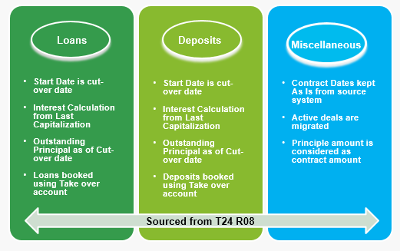

**Figure: Loans, Deposits and Guarantees Migration**

#### Forex and Non-deliverable forwards

In current BAU, EDP is used for Order capture and PvB Opics for processing the Forex deals (Spot, Forward, Swaps). Once the order is generated and has reached the value date the forex deals are settled T24 R08. Non-deliverable forwards deals are currently managed in Murex and booked in T24 R08 using Security transfer application

Below is the current BAU to manage Forex life cycle:

1. Forex spot deals are processed in PvB Opics and customer accounts are settled in T24 R08 through funds transfer application when the Forex deals are matured
2. Forex Forward deals are processed in PvB Opics and updated into T24 R08 as miscellaneous deals. On the maturity date the accounting entries are generated in T24 R08 using Funds transfer application by using PvB Opics suspense account and Forex customer account
3. Forex Swap; Spot and forward leg will follow the similar process mentioned in above first and second points respectively
4. Non-deliverable forwards are booked as positions using Security transfer application in T24 R08 and each deal are linked one-to-one with the security master instruments.

Below table lists the pre-requisites for Forex and Non-deliverable forward migration

|  |  |  |
| --- | --- | --- |
| **Sl No** | **Application** | **Migration Pre-requisites** |
| 1 | FOREX | CURRENCY FORWARD.RATES REGION HOLIDAY |
| 2 | ND.DEAL | ND.PARAMETER |

As part of WS 2.0 Wealth suite - T24 Forex module will replace PvB Opics to manage the Forex life cycle, below migration approach is followed to bring Forex related deals into Wealth suite – T24 from T24 R08 / PvB Opics

**Forex (Spot / Fwd / Swaps)**

* Migration scope includes to migrate Forex deal type spot, forward and swap which are due to mature on the cut-over date
* Outstanding forex spot deals will be migrated from PvB Opics into Wealth suite – T24
* Outstanding forex forward deals will be migrated from T24 R08, all miscellaneous deals will be extracted with deal sub type OPXFX and with maturity date greater than cut-over date
* Deal amount, forward rates, spot rates, client details, Buy / Sell date and Buy / Sell currency are some of the key attributes obtained from the source system
* Value date buy and Value date sell will hold the settlement date and they are obtained from the source system
* Counterparty limits will be linked to Forex deals during the migration based on limit product setup

**Non-Deliverable forwards**

* For NDF deals migration, Security instrument with sub asset type 292 (Currency Derivative) and product type FXNDF with maturity date greater than cutover will be scoped for migration
* Non-deliverable forward deals will be migrated into Wealth suite - T24 as Vanilla deals using FX module and the fixing date is obtained from the source system
* Client details, Buy / Sell indicator, deal currency, settlement currency, deal amount, notional rate, value date and settlement date are some of the key attributes obtained from the source system
* If there is no fixing date in the source system, then Wealth suite - T24 calculates the fixing date based on the settlement days of the corresponding fixing currency
* Migrating Non-deliverable forwards into Wealth suite – T24 is scoped for manual migration considering the data volume in live system as mentioned under section 3.4

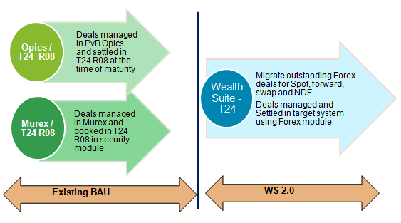

**Figure: Forex life cycle Migration**

#### Interest Rate Swaps

Interest rate swap is subjected to fixed and floating rate connected to either Asset side or Liability side. These Contracts are booked with sub asset type Interest Rate Derivatives (187) and Product type IRSWAPFIX

In current BAU the outstanding portion is maintained as notional principle and the fixed leg is booked in Security transfer application. Floating leg is not maintained in T24 R08 and it is booked in Murex system and hence the floating side data will be extracted from Murex to book the IRS deals in Wealth suite - T24

Below table lists the pre-requisites for Interest rate swap migration:

|  |  |  |
| --- | --- | --- |
| **Sl No** | **Application** | **Migration Pre-requisites** |
| 1 | SWAPS | SWAP.PARAMETER SWAP.ACTIVITY |

As part of WS 2.0 Temenos Swap module will be used to manage IRS life cycle, below migration approach is followed to bring IRS product into Wealth suite - T24

* Security instrument with sub asset type 187 (Interest rate derivatives), product type IRSWAPFIX and maturity date greater than cutover will be scoped for migration
* Input file to bifurcate Asset and Liability side via indicator “+” and “-”
* New floating keys will be defined in Wealth suite - T24 to migrate floating side of IRS deal
* Transformation is required in Wealth suite - T24 to arrive following data

1. Set next interest payment date for fixed and floating side
2. Set the interest rate as zero from the contract start date
3. Set the source system interest rate from the migration cut-over date or the last fixing date

* Key attributes like customer details, value date and maturity date, notional principle, currency, fixed rate, floating rate and payment schedule can be obtained from the source system [Murex & T24 R08]
* Migrating Interest rate swap product into Wealth suite – T24 is scoped for manual migration considering the data volume in live system as mentioned under section 3.4

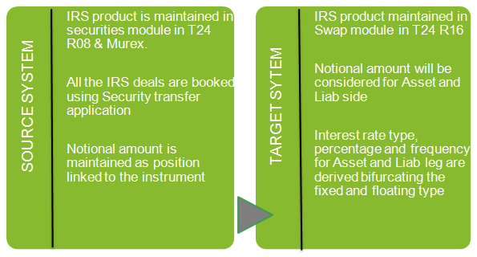

**Figure: Interest rate swaps Migration**

#### Derivatives

As part of WS 2.0 implementation TAP is used for order entry and Wealth suite - T24 will be used for transaction processing. In the current BAU FX Derivative product life cycle is maintained in Murex and Equities Derivatives product life cycle is maintained in Sophis. These systems are interfaced with T24 R08 for cash settlement and physical delivery of positions

In current BAU, the derivative contracts master details are held in security master and when the derivative contract is live in T24 R08 it creates security position holding the contract details in the form of portfolio positions. During the time of expiry / exercise, based on the customer choice the contract based positions linked to the security master is liquidated and the respective cash /security position is updated.

All the active live positions linked to the Derivatives (option) asset type in T24 R08 will be converted and migrated into Derivative contracts in Wealth suite – T24. In the new system, the options contracts are booked and exercised using Derivative module.

Below table lists the pre-requisites for Derivatives migration:

|  |  |  |
| --- | --- | --- |
| **Sl No** | **Application** | **Migration Pre-requisites** |
| 1 | DX.TRADE | REGION HOLIDAY DX.EXCHANGE.MASTER DX.CONTRACT.MASTER SECURITY.MASTER NOSTRO.ACCOUNT  SC.SETT.INSTRUCT |

Scope for WS 2.0 migration includes migrating FX/EQ OTC options and below strategy is followed

* All active positions and pending trades with sub asset type 292 (FX Options and Barriers), 135 (EQ Buy-Call/Put & Sell-Call/Put) will be scoped for migration
* Key attributes such as Deal currency, Delivery currency, Buy / Sell options, strike price, deal amount, value date, maturity date and premium price will be extracted from the source system
* If any of the required data for migration is not available in T24 R08, then Murex and Sophis will be referred to get the relevant data.
* Derivative trading limit (1300) will be sourced from Murex prior to the creation of Derivative contracts
* Trading limit will be attached to Primary and Secondary customer while migrating Derivative contracts in Wealth suite – T24
* Derivative customer and Derivative master setup for instruments is covered in Customer and Financial Instruments section
* Options are based on Primary and Secondary participants. For clients, they are input as the primary participant with the Bank counterparty being the secondary participant.
* In the instance of a counterparty trade, bank would be setup as primary participant and the counterparty as secondary participant

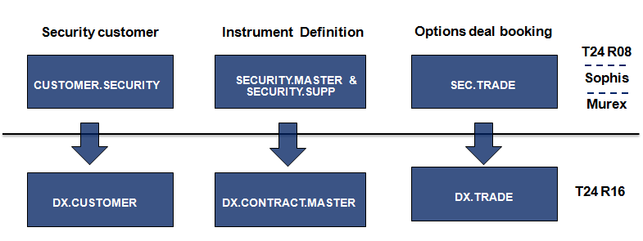

**Figure: Derivatives Migration**

#### Structure Products

Structure products include Dual Currency Investment (DCI/PCI), Accumulator and Decumulator, FX Target Redemption Forwards.

Dual Currency Investment is a short-term investment product that gives the opportunity to earn potentially higher returns on investment in the currency markets and it allows selecting a base currency and an alternate currency for the investment.

Accumulators are financial derivative products sold by an issuer to investors that require the issuer to sell shares at a predetermined strike price, this allows the investor to "accumulate" holdings in the [underlying](https://en.wikipedia.org/wiki/Underlying) [security](https://en.wikipedia.org/wiki/Security_(finance)) over the term of the contract. Accumulator typically last for a year or less and terminate early ("knock-out") if the stock price goes above a threshold ("barrier").

The basic idea of an accumulator contract is that the buyer speculates a certain price range (the range between the strike and the knock out price) within the contract period, Buyer holds an obligation to buy the shares at the strike price and issuer holds an obligation to sell shares at the strike price.

Decumulator is reverse of Accumulator and Investors buy Decumulator on the expectation that a certain stock will trade within a specific price range during the term of the contract. This range is bound by the strike price and a barrier price (usually a knock-out that triggers termination if the underlying price goes below a threshold).

Below table lists the pre-requisites for Structure products migration:

|  |  |  |
| --- | --- | --- |
| **Sl No** | **Application** | **Migration Pre-requisites** |
| 1 | SY.ACCU.DECU | SY.PARAMETER  SY. MASTER  SY.PRODUCT.VARIANT  SY. PRODUCT.DEFINITION  SC.SETT.INSTRUCT |
| 2 | SY.DCI |
| 3 | SY.FX.FORWARDS |

As part of WS 2.0, Structure product (SY) module is used to migrate below mentioned products

**Premium currency investment:**

* PCI is currently captured as security trade in T24 R08 and PvB Opics manages the product life cycle
* All active and pending trade with sub asset type 182 (Premium currency investment) and 210 (Commodity linked structure investment) will be scoped in migration for PCI contracts
* Key attributes for PCI deposit like principal amount and interest rate will be fetched from PvB Opics
* PCI trades are involved between customer and counterparty and bank in effect acts as an agent which does not hold any positions
* Financial entries such as deposit amount will be posted to counterparty and during the principle redemption it will be passed back to the customer account in Wealth suite – T24
* Take over account will be used as drawdown account during the migration and then will be replaced with customer account once the deals are authorised
* Key attributes required from the source system to create PCI trade are trade currency, delivery currency, spot price, strike price, Deposit interest rate, principal amount, value date and maturity date

**Accumulator / Decumulator:**

* All active and pending trade with sub asset type 135 (Calls and Puts), product type (BELA, BELD, BENLA, BENLD) will be scoped in migration for Accumulator / Decumulator contracts
* Key attributes required from the source system are product type, value date, maturity date, contract currency, principle amount, strike price, knockout price, daily units, fixing frequency and premium price
* The required data for migrating ACCU / DECU will be obtained from Sophis and T24 R08
* Accu / Decu trades are involved between customer and counterparty, the underlying option trade will not be created as the bank (dealer book) is not a party to the transaction
* Premium portion will be waived during the migration since it is already captured in the source system
* Migrating Accu / Decu product into Wealth suite – T24 is scoped for manual migration considering the data volume in live system as mentioned under section 3.4

**Target Redemption Forwards:**

* All active and pending trade with sub asset type 292 (Target Redemption forwards) is scoped for migration
* Target Redemption trades are involved between customer and counterparty; the underlying option trade will not be created as the bank (dealer book) is not a party to the transaction
* Premium portion will be waived during the migration since it is already captured in the source system
* Key attributes required from the source system to create Target Redemption forward trade are Currency bought, currency sold, value date, maturity date, spot price, strike price for call & Put options, notional amount for Call & Put options, fixing frequencies and option style
* The required data for migrating this product will be obtained from Fin-IQ and T24 R08

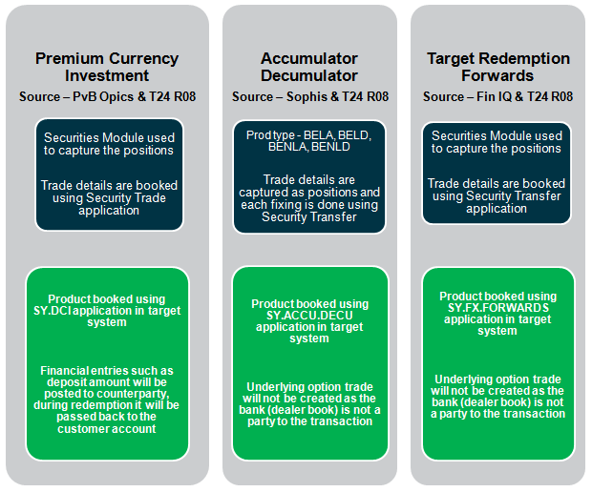

**Figure: Structure Products Migration**

### Corporate Actions and Events

Corporate action events are currently booked in T24 R08 and the scope of the migration includes diary events with execution date greater than cut-over date and backdated diary events which are unsettled during the time of cut-over.

Below table describes the corporate action events and types along with the migration scenarios to consider for the future dated and backdated diary events settlements in Wealth suite – T24

|  |  |  |  |  |
| --- | --- | --- | --- | --- |
|  |  | **Future dated  Settlements** | **Back dated  Settlements** | |
| **Corporate Events** | **Types** | **Execution date greater the Cut-over date** | **Partially Unsettled events at Depot level** | **Partially unsettled events at Portfolio level** |
| Mandatory | Final maturity, Early Redemption, Reverse stock split, Cash dividend | ✓ | ✓ | ✗ |
| Client Options | Dividend re-investment, Warrant exercise, Conversion | ✓ | ✓ | ✓ |

Below table lists the pre-requisites for corporate action migration:

|  |  |  |
| --- | --- | --- |
| **Sl No** | **Application** | **Migration Pre-requisites** |
| 1 | DIARY | DIARY.TYPE  SEC.ACC.MASTER  SECURITY.MASTER  CUSTOMER  ACCOUNT |
| 2 | ENTITLEMENT | DIARY.TYPE  DIARY |
| 3 | SC.PRE.DIARY | DIARY.TYPE |

As part of WS 2.0, below migration approach is followed for corporate actions events

**Future dated settlements**

* Diary records with execution date greater the migration cut-over date is scoped for migration
* All the mandatory and additional fields will be sourced from T24 R08 while migrating into Wealth suite - T24
* Diary record primary key from T24 R08 will be retained as target system primary key in Wealth suite - T24. The purpose to retain T24 R08 primary key is to allow the target system to continue support the settlement events using source reference key in Wealth suite – T24
* There are no financial entries raised when Diary records are migrated and hence the source data will be brought As Is into Wealth suite - T24
* All Pre-diaries in unauthorised status will be migrated As-Is from T24 R08. These pre-diaries will be placed in unauthorised queue in wealth suite – T24 and it will continue to support the updation / amendment through MT564 (Corporate action notification event)
* Some of the key attributes to migrate Diary records are execution date, pay date, value date, depository, security number and diary event type

**Back dated settlements**

* Diary records with execution date prior to cut-over date and diary status flag indicating to unauthorised is scoped for migration
* Diary events which are yet to trigger the settlement in T24 R08 will be migrated in similar approach as explained under future dated settlements section
* Diary events which are partially settled will involve two-step process, first migrate the Diary Events As-Is into Wealth suite – T24 and then delete the unauthorised entitlements events which are settled in T24 R08
* Diary record primary key will be retained in Wealth suite – T24 for the settlement purpose

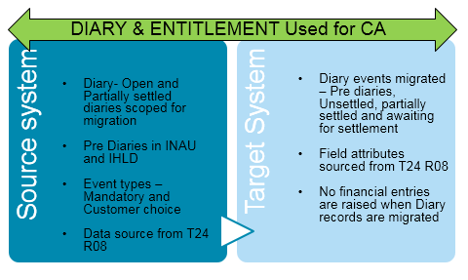

**Figure: Corporate Action Migration**

## Checks and Controls

Wealth suite - T24 generates Print and SWIFT advices during the migration and it also possess the functionality to update Wealth suite - TAP via B2F events. In-order to prevent the triggering of such events from Wealth suite – T24 below table lists the checks and controls to adhere during the migration.

|  |  |  |  |  |
| --- | --- | --- | --- | --- |
| **Sl No** | **Migration** | **Suppress Print advices** | **Suppress SWIFT advices** | **Suppress B2F events to TAP** |
| 1 | Customer | NA | NA | ✓ |
| 2 | Account | NA | NA | ✓ |
| 3 | Portfolio | ✓ | NA | ✓ |
| 4 | Limits | NA | NA | NA |
| 5 | Collateral | NA | NA | NA |
| 6 | Loans | ✓ | NA | NA |
| 7 | Money market deposits | ✓ | NA | NA |
| 8 | Miscellaneous deals | ✓ | NA | NA |
| 9 | Derivatives | ✓ | ✓ | NA |
| 10 | Structure Products | ✓ | ✓ | NA |
| 11 | Forex | ✓ | NA | NA |
| 12 | Non Deliverable forwards | ✓ | ✓ | NA |
| 13 | Diary and Entitlement | ✓ | NA | NA |
| 14 | Swaps | ✓ | ✓ | NA |
| 15 | Agency and Nostro setup | NA | NA | NA |
| 16 | Portfolio Positions | NA | NA | ✓ |
| 17 | Open Security trades | ✓ | ✓ | ✓ |
| 18 | Financial Balances | ✓ | ✓ | ✓ |
| 19 | Financial Instruments | NA | NA | ✓ |

**Figure: Checks and Controls**

## Data volume and Methods

Below table lists the data volumes for Singapore and Honkong region along with proposed migration method for each application in WS 2.0 PvB migration

|  |  |  |  |  |
| --- | --- | --- | --- | --- |
| **Sl No** | **Application** | **Data Volume** |  | **Migration  methods** |
| **SG** | **HK** |
| 1 | Customer | 15092 | 9360 | Auto |
| 2 | Account | 39086 | 33290 | Auto |
| 3 | Portfolio | 15759 | 9145 | Auto |
| 4 | Limits | 14773 | 8762 | Auto |
| 5 | Collateral | 4867 | 6868 | Auto |
| 6 | Loans | 24064 | 28081 | Auto |
| 7 | Money market deposits | 2658 | 2748 | Auto |
| 8 | Miscellaneous deals | 1710 | 972 | Auto |
| 9 | Derivatives | 2197 | 630 | Auto |
| 10 | SY – PCI | 641 | | Auto |
| 11 | SY - Accu / Decu | 139 | | Manual |
| 12 | SY - Target Redemption | 467 | | Auto |
| 13 | Forex | 159 | 94 | Auto |
| 14 | Non Deliverable forwards | 55 | 23 | Manual |
| 15 | Diary and Entitlement | 142 | 64 | Auto |
| 16 | Swaps | 31 | 18 | Manual |
| 17 | Agency and Nostro setup | 684 | 452 | Auto |
| 18 | Portfolio Positions | 32879 | 28326 | Auto |
| 19 | Open Security trades | 555 | 622 | Auto |
| 20 | Financial Balances | NA | NA | Auto |
| 21 | Financial Instruments | 11963 | | Auto |

**Figure: Migration volumes and method**

## Nomenclature

It is necessary to retain the source system primary key in Wealth suite - T24 for all applications during the migration. Below table defines the strategy to retain the source system primary key as target primary key and option to store the source system primary key as an alternate field value in Wealth suite – T24

|  |  |  |  |
| --- | --- | --- | --- |
|  |  | **TARGET** | |
| **Sl No** | **Application** | **Retain primary key from source system** | **Store source primary key in alternate field** |
| 1 | Customer | ✓ | NA |
| 2 | Account | ✓ | NA |
| 3 | Portfolio | ✓ | NA |
| 4 | Limits | ✗ | ✓ |
| 5 | Collateral | ✗ | ✓ |
| 6 | Loans | ✗ | ✓ |
| 7 | Money market deposits | ✗ | ✓ |
| 8 | Miscellaneous deals | ✗ | ✓ |
| 9 | Derivatives | ✗ | ✓ |
| 10 | Structure Products | ✗ | ✓ |
| 11 | Forex | ✗ | ✓ |
| 12 | Non-Deliverable forwards | ✗ | ✓ |
| 13 | Diary and Entitlement | ✓ | NA |
| 14 | Swaps | ✗ | ✓ |
| 15 | Agency and Nostro setup | ✓ | NA |
| 16 | Portfolio Positions | ✗ | NA |
| 17 | Open Security trades | ✓ | NA |
| 18 | Financial Balances | NA | NA |
| 19 | Financial Instruments | TBC | NA |

**Figure: Primary key storage in Wealth suite – T24**

## Mapping Approach

Temenos standard mapping approach will be followed to map the Mandatory and Optional fields across the system. T24 core tables to map are listed during the migration strategy which serves the purpose to scope the number of applications to migrate. Attached sheet lists the number of applications scoped for PvB WS 2.0 migration

However, decision to be made to adopt T24 functionality and minimize customization. If some entities or data do not exist in Wealth suite - T24, it will be treated as a GAP and a validation will be required to perform the customization to support business continuity

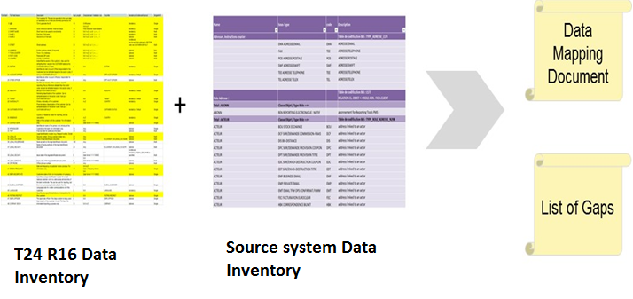

Figure: Data Mapping and Gap identification

## Dependencies

|  |  |  |  |
| --- | --- | --- | --- |
| **#** | **Phase** | **Activity** | **Project Dependencies** |
| **1** | **Analyse** | Data Inventory | BAU, BA, Solution Architect and Target Operating Model involvement |
| **2** | **Design** | Data Mapping | Signed-off Functional requirements for L1, L2, L3 gaps |
| **3** | **Build** | Migration build | Functional and operational Wealth suite - T24 system with complete configuration for the areas in scope for migration |
| **4** | **Test** | CIT, CAT, Trial Run | Environment team and Business team |
| **5** | **Deploy** | Dress Rehearsals | Enable Project deployment, environment and Business team |

## Assumptions

The migration activities and responsibilities of the migration team are based on a set of assumptions which are outlined in the following table.

|  |  |
| --- | --- |
| ID# | Assumptions |
| 1 | Migration environment will be provided by Infrastructure team. System set-up activities like parameterizations / configuration will be done by Bank setup team. |
| 2 | Migration Team will provide input for data cleansing through data profiling (Data Defect List) but not conduct the cleansing of data. Activities will be done by Business Users. Ownership of data correction will stay with Business team. |
| 3 | Onshore Migration Team will get access to production like data for mock migrations and dress rehearsals. |

## Upstream / Downstream

Below table lists the Upstream and downstream system impact during the cut-over for the migrated data, the detailed level of analysis at the attribute level will be performed during the mapping phase to highlight impact on the migrated data in Wealth suite – T24

|  |  |  |  |  |
| --- | --- | --- | --- | --- |
| **Sl No** | **System Name** | **Description** | **Upstream / Downstream** | **Purpose** |
| 1 | WS (TAP) | Enable Front Office | Both | Triple A Plus is an advanced Portfolio management application that calculates performance of the client portfolios. It is the single-entry order capture platform for all the investment product. |
| 2 | WS (TDS) | Enable Product Master | Upstream | As part of WS 1.2 implementation a golden copy of instrument master is formed and setup into TDS. All the market feed updates will happen in TDS and will flow into Wealth suite - T24 |
| 3 | TLM | Reconciliation | Downstream | Investment transactions booked in Wealth suite - T24 needs to be reconciled with Execution platforms, Custodians using TLM. |
| 4 | SCStar | Swift Connectivity engine | Both | Wealth suite - T24 will send/receive swift messages for securities order processing, trade settlement, trade confirmation matching, corporate actions through SC Star  In the target system, Mutual Funds orders will be captured in Wealth suite - T24 (replacing UTS funds capability) and sent to Vestima+ through SCStar |
| 5 | PSGL | Finance engine | Downstream | PSGL feeds would be impacted when Wealth suite - T24 takes over on the cut-over date and all finance related entries will be fed into PSGL. Source system product balance consolidation will be In-line with A&L and P&L accounting rule defined in the target system |

## Data Protection and Access control

The following steps are involved to protect the production cut-data while migrating from source systems into the target system during CIT / CAT for WS 2.0 migration

1. Production cut-data of various source systems (Like T24 R08, PvB Opics, Murex, Sophis and Fin IQ) is required during CIT, CAT and Trial migration phase for WS 2.0 migration
2. Approval must be obtained from CIO / CTM’s and Business owners from the respective country (SG / HK) in-order to make use of the production cut-data for the migration activity
3. CIT and CAT plan will be enclosed along with the list of Bank IDs who requires accessing the production data in the source and target migration environment
4. Copy of Production data will be restored in the source migration environment. Necessary checks and control is placed to ensure the credentials rights are restricted to read only access for the Project and Business team (For the Bank IDs shared during CIO / CTM’s approval)
5. Source project team will extract the data from the source migration environment and place the extracted files in the source directory. Source files will be pushed to the target environment directory through secured file transfer protocol
6. Source project team is provided with the directory / folder access rights in source and target environment
7. Target project team is provided with the directory / folder access rights in the target migration environment
8. Write access control to upload the data by reading the flat files in the target system is given to the designated migration users for the required applications in Wealth suite.
9. Post loading and high level reconciliation matching between source and target system the write access control will be removed
10. Business team is provided with read only access rights in Wealth suite for validating the migrated data
11. Customer sensitive information will not be uploaded in the target system and internal logic is built to populate the customer sensitive information in the target system. Hence masking of customer sensitive data is not applicable in Wealth suite.
12. Conversion reports will be extracted from wealth suite and placed in the reconciliation directory / folder with access rights controls for the designated Business users
13. Housekeeping activities in target migration environment will be performed to delete the source data files once the Business sign-off is obtained
14. The source migration environment restored with the production cut-data will be dropped for the next iteration (CIT / CAT) cycle
15. The target migration environment will be dropped once the SIT / UAT Business sign-off is obtained

## Deliverables / Output

|  |  |
| --- | --- |
| **Migration Activities** | **Deliverables / Output** |
| Planning | 1. Migration Strategy & Approach 2. Plan 3. Resource Plan |
| Analyse | 1. Data Dictionary 2. Data Mapping |
| Design | 1. Reconciliation/Validation Design 2. Mock Migration Plan |
| Build | 1. Technical design Migration 2. Implementation of Migration and Reconciliation components 3. Unit Test |
| Test – CIT and CAT | 1. Test Plan and Execution 2. Data Defect List 3. Provision of data for SIT and UAT |
| Test – Mock Migration | 1. Mock Migration Execution 2. Data defect list |
| Cut-over Preparation and Execution | 1. Dress Rehearsals Execution 2. Go- Live Support |

## Clarifications / Open points

Below is the clarification list identified during the migration strategy for PvB WS 2.0:

|  |  |  |  |  |
| --- | --- | --- | --- | --- |
| No. | Clarification | Closure comments | Priority | Status |
| 1 | Discretionary Portfolio Management | In-Progress. Awaiting for Temenos PRD solution document to understand the core changes | Medium | Open |
| 2 | Banca insurance – Needs solution approach for migrating the Banca Insurance functionalities into T24. | Awaiting solution approach as well as Temenos PRD solution document to finalize the migration approach | Low | Open |
| 3 | All-in-Portfolio setup and relevant changes / cleansing for Migration | Awaiting information on All-in-Portfolio setup. Migration approach will be finalized once the All-in-on-Portfolio solution approach is finalized | Low | Open |
| 4 | Should we migrate Party details from source into Wealth suite - T24 | Only Relation (CIF) is considered for migration and migrating party is out of scope | Low | Closed |
| 5 | Extraction criteria for Client Account migration (CASA) from TAP | All Open accounts will be migrated | Low | Closed |
| 5 | GL and PL balance migration, review with Finance team for Financial migration | This activity will be taken during design and mapping phase to arrive on Financial migration | Medium | Closed |
| 6 | Own book/Bank customer and portfolio for Migration - Existing system do not have own book concept and how it is handled moving forward with DX and SY module | Specific customer number and portfolio will be created and allocated for DX and SY module to complete the trade | Low | Closed |
| 7 | Should we consider Trade dated or Value dated position for Security position migration?  To Discuss the Migration approach for pending trades | Trade dated position is considered for positions migration and pending trades will be migrated using SEC.TRADE application | Medium | Closed |
| 8 | How about the interest amount (accrued) from last coupon date in T24- R08?  Should we consider the accruals while migrating portfolio positions for Bond instruments? | Interest amount accrued from last coupon date will be calculated in Wealth suite – T24 while migrating the positions for Security Bond Instruments | Medium | Closed |
| 9 | Broker is required to migrate the portfolio positions in the new system. Can we use the dummy broker for migration purpose? | Broker created (5000) in T24 R08 specified for migration will be used for WS 2.0 migration | Low | Closed |
| 10 | Principle early repayment and Principle Increase/Decrease for LD and MM.  Is this process allowed in the current BAU? | There are principle early repayments, increase and decrease done in T24 R08. But the volume is very less and it can be handled manually depending on volume in T24 R08 | Low | Closed |
| 11 | Considering the volume of NDF, is it recommended to migrate manually or do you need Auto migration? | Manual migration will be opted as the volume of NDF deals are around seventy | Low | Closed |
| 12 | Current BAU process for Forex deals (Spot/Fwd/Swap/NDF). To discuss on data sourcing from T24 R08 and PvB Opics | Detailed study of data sourcing will be performed during mapping phase | Medium | Closed |
| 13 | Current BAU for Interest Rate Swap.  We noticed floating side was missing in T24 R08. Can we source the data from Murex (Both Asset & Liability side)? | Manual migration will be opted as the volume of IRS is less in current BAU | Medium | Closed |
| 14 | To discuss the Cutover approach for Corporate action events | This activity is taken under technical demo activity for WS 2.0 migration | Medium | Open |
| 15 | SY – To discuss the data sourcing for ACCU / DECU Product from Sophis’ | Detailed study of data sourcing will be performed during mapping phase | Medium | Closed |
| 16 | SY – Deposits details for PCI product. To discuss data sourcing from PvB Opics | Detailed study of data sourcing will be performed during mapping phase | Medium | Closed |
| 17 | SY – Trade details for FX forwards product (Target Redemption Forwards). To discuss on data sourcing | Detailed study of data sourcing will be performed during mapping phase | Medium | Closed |
| 18 | LI – Should we migrate expired limits with no outstanding | Not required and they are out of scope | Low | Closed |
| 19 | Signature Portfolio handling which is a L2 solution. Waiting for the high-level solution to include it in Strategy document under section 3.2.3 | Based on L2 solution from Temenos, the migration of signature portfolio will be handled during the mapping and development phase | Medium | Closed |
| 20 | Customer status code in T24 R08 is not sync with Cupid. Clarified that this must be taken up while mapping from Cupid | It will be handled during mapping phase | Medium | Closed |
| 21 | Historical data migration for closed deals in source system. This was raised in BRM walkthrough and will be kept as open point | On case to case basis historical migration will be done based on requirement from BRM | Medium | Closed |

## Out of scope activities

|  |  |
| --- | --- |
| **#** | **Objects** |
| 1 | Core & Local enhancements. Any migration requirements for Core and local enhancements will be taken up during the GAPS migration analysis therefore it is out of scope for this document. |
| 2 | Group condition setup and Product Parameterisation |
| 3 | Tax condition setup, Fees and Commission setup, Broker settlement instructions |
| 4 | Static data setup related system tables in Wealth suite - T24 |
| 5 | Transaction and Settlement Deal types setup |
| 6 | Financial Ledger setup |
| 7 | Satellite Integration, Interface data, TTI interface |
| 8 | User profile and Security management setup |
| 9 | Unauthorised Static data (E.g. Customer, Account, Portfolios) |
| 10 | Currency setup, forward rates, Market Price (excluding cutover day rates, prices), Interest rates setup |
| 11 | Financial related reports will be generated in PSGL system and T24 sends the daily transaction details to PSGL. Sending transaction details to PSGL is out of scope for migration team. |
| 12 | Loan cancellation penalty fees (52415) is set in T24 R08 and this will be triggered when the loan contracts are cancelled, P&L amortization for such scenarios is not applicable in migration |
| 13 | Historical rates for Currency is not required while migrating contracts, deals, positions and open trades. Required currency rates will be extracted from the source system. Hence currency historical migration is out of scope |
| 14 | Client output is not part of migration activity and they will be suppressed |

## Reviewer feedback

This section refers to review feedback collected in the walkthrough sessions with BAU, BA, BRM and SA team. The review inputs are incorporated in the strategy document and relevant closure comments are updated in the attached excel document.

