19-Jun-2017

**WS 2.0**

**Implementation**

Migration Strategy - SG & HK PvB

Document Details

|  |  |
| --- | --- |
| Information | Details |
| Project Name | Enable – WS 2.0 |
| Project Code | 16000683 |
| Document Type | Migration Strategy Document |
| Document Status | Draft |
| Date of Approval | <Approval Date> |
| Current Version No. | 0.7 |
| Author(s) | Druva Mallikarjuna, Mithin Jones |

Revision History

|  |  |  |  |
| --- | --- | --- | --- |
| Version No | Date | Description | Made By |
| 0.1 | 19-May-2017 | Initial Draft | Druva Mallikarjuna, Mithin Jones |
| 0.2 | 29 May 2017 | Revised Strategy for section 1.1 to 2.9 | Druva Mallikarjuna, Mithin Jones |
| 0.3 | 1 Jun 2017 | Revised Strategy for section 1.1 to 2.9 | Druva Mallikarjuna, Mithin Jones |
| 0.4 | 2 Jun 2017 | Revised Strategy for section 3.3.1 to 3.3.11 | Druva Mallikarjuna, Mithin Jones |
| 0.5 | 5 Jun 2017 | Updates based on review comments – To change the flow diagrams and Migration approach | Druva Mallikarjuna, Mithin Jones |
| 0.6 | 13Jun 2017 | Updates made after internal review with migration team | Druva Mallikarjuna, Mithin Jones |
| 0.7 | 14 Jul 2017 | Review feedback updated walkthrough session held with SA and BA team | Druva Mallikarjuna, Mithin Jones |

# 

**Sign-Off and Reviewing Parties**

|  |  |  |  |
| --- | --- | --- | --- |
| S/N | Name | Role | Action Required |
|  |  |  |  |
|  |  |  |  |

**Confidentiality Statement**

All the information contained in this document and/or any other related media is strictly confidential and must not be disclosed to any other party without prior written consent from SCB.

**Acronyms**

|  |  |
| --- | --- |
| **ACRONYM** | **Description** |
| TAP | Triple A Plus |
| PvB | Private Banking |
| CAT | Conversion Acceptance Testing |
| CIT | Conversion Integration Testing |
| WM | Wealth Management |
| TDS | Temenos Data Source |
| RB | Retail Banking |
| WS | Work Stream |
| CA | Corporate Action |
| IRS | Interest Rate Swaps |
| Target System | Wealth suite - T24 |
| ACCU / DECU | Accumulator / Decumulator |
| DCI | Dual Currency Investment |
| FIM | Financial Intermediary |
| SY | Structured Products |
| DM tool | Temenos Data Migration tool |
| A&L | Asset and Liability |
| P&L | Profit and Loss |
| PCI | Premium currency investment |
| EDP | Electronic Dealing Platform – Forex Order capture platform |
| PvB Opics | Forex Transaction Processing system |
| Murex | FX Derivatives and IRS transaction processing system |
| Fin IQ | Structured products – Order capture and Lifecycle Management system |
| Sophis | Trade processing system for Equities Derivatives and Structured products |
| MESI | Multi Entity Single Instance |
| TTI | T24 TAP Integration |
| OAT | Operational Acceptance Test |
| ETL | Extract, Transform and Load |

Contents

1. Introduction 5

1.1 Document Purpose 5

1.2 Programme Overview 6

2. Migration Strategy 6

2.1 Overview 6

2.2 Migration Activities 8

2.2.1 Planning 9

2.2.2 Analysis and Design 9

2.2.3 Build 9

2.2.4 Mock / Trial Migration 9

2.2.5 Cut-over Preparation and Execution 10

2.3 Migration Window 11

2.4 Classification of Data Objects 11

2.4.1 Bank Setup /Business Parameter Data 11

2.4.2 Static Data 11

2.4.3 Transactional and Financial Data 11

2.5 Methods of Data Migration 12

2.5.1 Automated Data Migration 12

2.5.1.1 Bulk Data Migration 12

2.5.1.2 Wealth Suite data Integration (TAP & TDS -> T24) 13

2.5.2 Manual Data Migration 13

2.6 TEMENOS T24 Upload Methods 13

2.7 Data Validation 13

2.7.1 Technical Validation (CIT) 13

2.7.2 Functional and Business Validation (CAT) 14

2.8 Standard principles 14

2.9 Environment requirements 15

3. Migration approach 16

3.1 Data Migration Scope 16

3.1.1 Functional scope 16

3.1.2 Master for Client Referential Data 17

3.2 Migration detailed strategy 17

3.2.1 Customer 17

3.2.2 Account 18

3.2.3 Portfolios 19

3.2.4 Financial Instruments 20

3.2.5 Financial Migration 22

3.2.6 Credit Risk 23

3.2.7 Interest and Rates 25

3.2.8 Commission and Charges 25

3.2.9 Security Positions 26

3.2.10 Deals and Contracts 27

3.2.10.1 Loans, Deposits, and Miscellaneous deals 27

3.2.10.2 Forex and Non-deliverable forwards 28

3.2.10.3 Interest Rate Swaps 29

3.2.10.4 Derivatives 30

3.2.10.5 Structure Products 31

3.2.11 Corporate Actions and Events 33

3.3 Migration Pre-requisites 34

3.4 Checks and Controls 35

3.5 Data volume and Methods 36

3.6 Nomenclature 36

3.7 Mapping Approach 37

3.8 Dependencies 38

3.9 Assumptions 38

3.10 High Level Plan 38

3.11 Deliverables / Output 39

3.12 Clarifications 40

3.13 Out of scope activities 41

3.14 Reviewer feedback 42

# Introduction

## Document Purpose

The purpose of this document is to describe the overall Migration Strategy for enable 2.0. The strategy will contain migration approach, tools and techniques used for migrating the data into the target system. Broadly the data migration will be covered through automated data migration approach and depending on the nature of data; it would also be migrated through manual approach. This broadly explains the process for migrating the data in to the target system in the given timeline. In addition, the document outlines the measures to assure correctness and completeness of the migration and the quality of the migrated data.

The current version of the document will include the specific approach for Private Banking including scope, high level planning and resources.

## Programme Overview

Standard Chartered Bank (“SCB”) Wealth Management (“WM”) has three strategic objectives based on five-year financial plan to double the AUM, what we have communicated to investors and discussion with our customer segment colleagues – principally across Retail Banking and PvB segments. Three strategic objectives are to:

1. Achieve Scale in growing our AUM and income
2. Strengthen competitive advantage of our wealth management proposition
3. Deploy a standard and scalable wealth management platform

Current application landscape is very fragmented and it cannot be scalable to support the business model that we would like to achieve the above three objectives. It requires a unified system that supports the enhanced business model across PvB and Retail locations

The initiative has been confirmed as a global transformation program (“Enable Program”) to deliver a standardized, front-to-back WM platform serving customers within PvB and WM segments. The Global WM platform transformation is made up by two major components – Core and Digital initiatives. As part of Enable program, Temenos Wealth suite (Triple A plus (TAP) and T24) is chosen for front-end and core banking platform.

Below is the approved plan for WS 2.0

* Tranche I – PvB and Retail for Singapore and Hong Kong Location
* Tranche II – PvB and Retail for UAE and India
* Tranche III – Other locations (TBD)

# Migration Strategy

## Overview

The objective of this document is to provide a detailed overview of migrating data into the new Temenos platform. Wealth suite - T24 will be implemented in multiple locations with single instance Architecture model (MESI).

Project (WS 2.0) implementation scope will cover back end capabilities and will require data from multiple source systems across Private, Wealth and Retail Core Banking platforms.

The purpose of Data Migration is to provide required data for the Wealth suite - T24 Platform to be used by end users to support business operations. This is done by migrating the data from source systems into the Wealth suite - T24 entities. The terminology data migration summarizes all transformation related activities Including data analysis, mapping, migration development and testing etc.

It is essential to have an understanding on source system Data model, Object structures, landscape and its functions. This will enable the project team to arrive with migration strategy to migrate data from multiple source systems into the target system. The overall approach to data migration is based on the Temenos Delivery Methodology which provides a comprehensive list of methods to complete the migration.

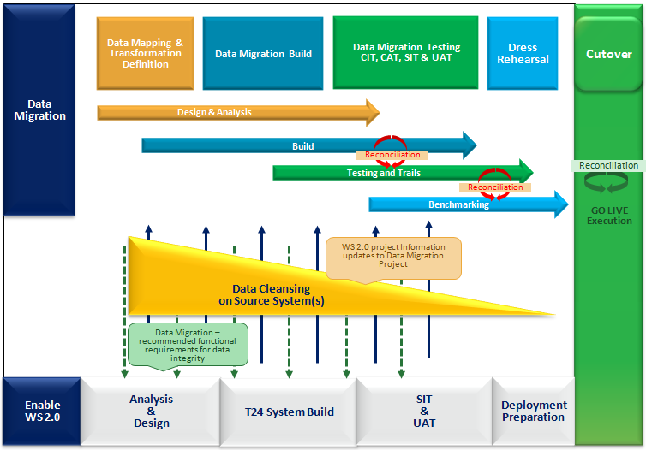

Figure: Approach for data migration

The figure above describes on a high-level approach for data migration and highlights the main steps to be considered and executed.

## Migration Activities

Migration activities will contain different phases in migration: Planning, Analysis & Design, Build, Test and Mock Migration. Below diagram explains the different activities under its respective phases

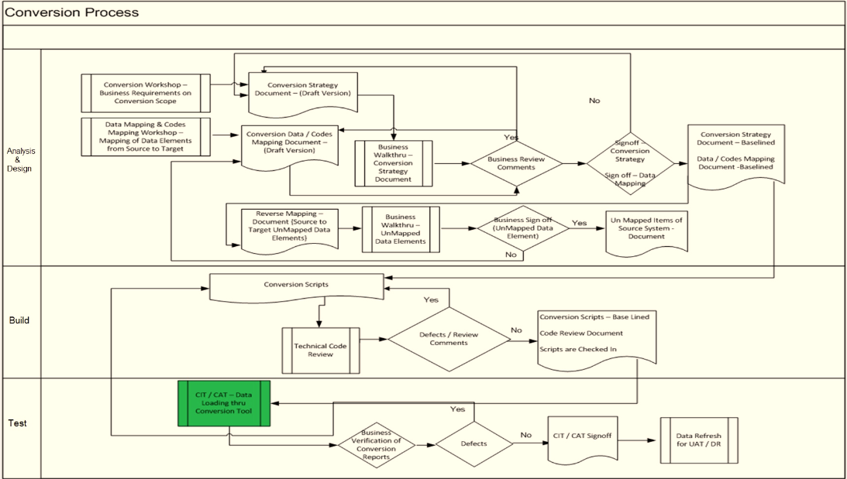

Figure: Migration Activities

Migration rules and logic are to be centralised as far as possible for the following reasons:

1. Improved transparency and control since all migration rules are in one place
2. Synergies between different source systems have to be handled such a way the data should be unique for migration and will be worked out during data mapping phase
3. Basic functionality can be standardised, for example load error reporting and summary result.
4. Gain a deep insight and understanding in the logical T24 data model.
5. All migration components (Migration, Transformation, recon) must be successfully unit tested during Conversion Integration Testing (CIT).
6. Each change of requirements to the migration rules is tracked and documented by the data migration team lead. Implementation of changes and retest of changed rules is performed by the developer and reported to the data migration team lead.

### Planning

The planning phase comprises the creation of a migration related project plan including deliverables, resources and estimates. The plan will include input and output dependencies to other work streams, duration effort and role assignments.

A High-level migration plan will be created based on the overall project plan and in-line with the location/segment Go-live plan as described under the High level plan section (***3.6***)

### Analysis and Design

Migration will be identified as given below.

1. The migration team will perform high-level system study on the existing PvB and Wealth system landscape and based on the High-Level system study, migration team will come up with the in-scope application for migration in to Wealth suite - T24 platform. Once the in-scope application list is finalized, a detailed system study will be performed on the source systems involved for migration.
2. By analysing the functionality being implemented, the enable team will identify data that is required in Wealth suite - T24 . Once both the legacy and target data analysis are complete, they will be brought together for assessment and the proposed migration inventory will be updated and approved. The dependencies, sequencing, and estimated volumes and runtimes will be established for each migration.
3. For each migration execution, procedures will be understood and data mapping document will be completed. These design and data mapping will include extract criteria that must be applied in the source system and upload method used in target system. Migration team will own the design for Transformation, Migration and Reconciliation approach in the target system
4. Reverse mapping will be accomplished in target system during mapping phase to ensure the un-mapped data fields are identified and reported. This procedure will ensure end-to-end data mapping is covered from source to the target system.

### Build

Wherever possible the translation of data element values will be performed outside the Wealth suite - T24 system which maximizes the reuse capabilities and reducing the dependency with build solution from data translation rules required for each unique source system or file. The development of the migration programs takes place in the corresponding source systems for the extract procedures and in the target Wealth suite - T24 platform for the upload procedures.

The procedure logic in the extract program in the source system is build in line with data mapping sheet designed during the mapping phase. The extract program must control the scope of records by exact definition of selection criteria as defined in design document.

Standard Temenos Data Migration Upload tool will be used for the Load in the target system and the upload configuration/scripts are built based on data mapping defined during the design and mapping phase.

Unit test is executed by the developers belonging to the data migration team. It is executed within the T24 development test system. Objective is to ensure accurate Migration of the respective mapping designs for the extract and upload programs.

### Mock / Trial Migration

Mock test must ensure technical consistency between extracted and migrated data. The following aspects will be taken care during mock phase:

* 1. Sequencing and dependencies of cut over activities
  2. Target system is able to process the migrated data (validation related to field control rules)
  3. Check data quality of extracts and identify cleansing needs
  4. Verify run times. Identify tasks on critical path and length of critical path.
  5. Identify technical shortfalls and workarounds.
  6. Verify the data migration upload performance in the target system
  7. To meet migration benchmark timing to fit within the cut-over timeline

The success of the data migration depends primarily on the intensity and careful execution of the mock tests. The data migration programs should be tested as early and extensively as possible with production like test data both regarding quantity and quality.

During mock testing, the status of migrations planned versus executed should be documented, along with the number of records successfully loaded. The migration success rates must trend towards 100% by the final mock . Issues will be tracked in Jira to ensure they are resolved from one mock migration to the next.

Mock migration data cleansing metrics will be reported for the key areas of concern. The migration team produces an audit for a data scenario and cleansing requirement to the business team for cleansing progress from one mock migration to the next.

A mock migration will be considered complete when all processes are executed end-to-end successfully. Tasks, run-times and dependencies will be reported to the cutover team to include this information in the cutover planning.

### Cut-over Preparation and Execution

The migration team will play a key role during Go live and centrally manage and coordinate all migration related activities. The following deliverables are part of the Cut-Over Preparation for migration:

* Migration / Cutover plan
* Logistics Processes and Infrastructure
* Communication Plan
* Maintenance and Support Plan
* Migration data validation/verification
* Decision matrix for Go/No-go decision

A comprehensive migration or cutover plan will be developed for each release, pulling together a schedule of tasks and dependencies across the following:

* Migration activities: Source system extracts, cleansing routines, load programs, validations
* Manual configuration activities: manual setting up data
* Live system impacts: interface/workflow stoppage, user lock outs, and restart/validation of live system activities
* Interface handling: using interfaces to exchange mass volumes of data; sending initial data loads to downstream systems
* Setting up/verifying migration user IDs
* Interim processes required between cutover phases
* Communications: broadcasts regarding system downtime/start up; communications to interface partners, vendors, customers, and employees
* Migration data validation/verification
* Go/No-go milestones
* System back-ups at key milestones

Dress Rehearsals will be organized to execute the cutover plan with the same resources who will execute the activities on the Migration day. Below mentioned are the Logistics and Infrastructure required during the cut-over phase:

* Contact information and telephone numbers
* Collaboration tool(s)
* Backup Plans/Rollback plan
* Access to location(s), security and facility management
* Meeting rooms and the setup of the meeting rooms
* Emergency plans for outage of key applications and loss of availability
* Command center setup

## Migration Window

The production Migration for each release will take place in a limited timeframe (‘Migration Window’). The estimation of the window size is the responsibility of the migration team. The duration of individual steps which need to be executed during migration cycles must be tracked for each test and mockphases. Based on these measures the migration team will provide estimated timeframe required for Go Live .

Factors that must be considered while arriving with the timeframe:

* Volume and quality of the data to be loaded.
* Data dependencies which determines objects that can be loaded in parallel to reduce the overall load time.
* The efficiency of the database engine and how it has been configured for the migration. For example, dropping indexes during loading and rebuilding them once the data is loaded to optimise the distribution of physical writes to disk.
* The degree of manual intervention in the migration process.
* The time it takes to reconcile individual loads before proceeding with the next step in the migration.
* The time it takes to get the sign-off that the migration has been successful (based on reconciliation controls and SME input) and data can be released for production use.

## Classification of Data Objects

Data migration distinguishes between different types of data and their definitions are outlined in the following section.

### Bank Setup /Business Parameter Data

Data migration requires a functional and operational Wealth suite - T24 system with complete configuration for the areas in scope for migration. The actual configuration activity is not in scope with Data Migration team. It is within the scope of the Bank setup team and it is a prerequisite for the build, test and execution of the data migration.

In a situation when Business parameter data are required to tweak for migration activity and re-instate to its original state during the cut-over window then migration team will handle such scenario by having two set of solution packages given below and the deployment activities will be listed and tracked in migration run book

1. Solution package to change the parameter data for Migration
2. Solution package to re-instate the parameter data to its original state

### Static Data

Static data migration is in ownership of the data migration team and data describes business objects which are often referred in day to day business operations. Examples would be Customer and Account. Static data tends to be created once and is maintained over a long timeframe which is not frequently updated and is used by many business activities. Static data will be sourced from multiple source system to migrate data into the target system

### Transactional and Financial Data

Transactional and Financial data migration is in ownership of the data migration team; the data is sourced from multiple source system to migrate the data into the target system. These data are created in target system to maintain customer financial deals and positions.

To migrate data into the target system, it requires the data in flat or csv file format with delimited values. Detailed requirements of data format will be listed during the Data mapping phase

## Methods of Data Migration

There are several mechanisms by which data can be imported into the target system as listed below in this section. Standard approach is Bulk data migration and for any exception cases it will be discussed in each respective section in this document.

### Automated Data Migration

Automated data migration assumes that data will be downloaded, converted and loaded in the target system by fully automated migration programs and tools. On a high level, each data migration will be conducted in four main parts.

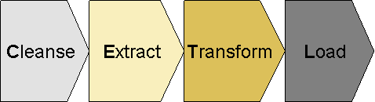

Figure: CETL Approach

* **C: Cleanse**  
  Cleansing comprises the analysis of source system data quality by Business team to identify potential data issues. This issue detection is mainly driven by the future system business rules and. This exercise will generate a list of cleansing candidates (for example, removal of duplicates, filling of empty fields,) to decide if data must be corrected in the source system.

* **E: Extract**  
  Extract programs are used to get data out of the source system by BAU team. Normally it is suggested to extract the data in flat or csv file format.

* **T: Transform**  
  Transformation means mapping of source data structure to target structure. This could be 1:1, n:m mappings via mapping tables but as well complex migration, transformation rules and mapping routines.
* **L: Load**  
  Load represents the transform and upload of migration data into the target system.

We differentiate between two different kinds of automated data migration as given below:

#### Bulk Data Migration

Bulk data migration is used when large volumes of data are migrated from source system into the target system

ETL (Extract, Transform, and Load) Migrations are fully automated migrations triggered in Batches. These migrations require a middleware tool catering for the extract, transformation and upload of the data from the source into the target system. These tools are called ETL systems. Those ETL systems provide comprehensive tools to read data out of a source system and to transform data into the target systems.

The transformation comprises 1:1 or n:m source to target field mappings and complex transformation rules and routines. The ETL Migration is typical used when:

* Huge volume of transformation is required
* Complex transformation rules in place
* Multiple source systems in scope for data migration
* High secure processes must be in place due to data and business requirements.

#### Wealth Suite data Integration (TAP & TDS -> T24)

As a guiding principle, existing interfaces should be reused in migration context to avoid duplication of effort. Thus, the architecture of the interfaces in scope during migration must cater for a delta and an initial transfer mode.

As part WS 2.0 migration the target system will be integrated through various source system (Like TTI, TDS) layers to get the customer, account, portfolio and instrument data into the target system. Interface integration activity is not in scope with the data migration team

### Manual Data Migration

Manual data migration is applicable for very complex products (Eg Structured products), where effort to prepare automatic migration might be higher, than manual effort. Any data exceptions on the day of Cut-over will be also treated as a manual migration activity.

## TEMENOS T24 Upload Methods

The data upload into the target Wealth suite - T24 systems should be accomplished using T24™ Data Migration tool. It covers the following functionalities.

* Uses the Standard OFS (Open Financial Services) module to perform the Load.
* Validations done on the data, prior to update.
* Accepts data in flat and csv format.
* Required less manual intervention during mapping of the incoming file to T24 applications which is a onetime setup.
* Performs all standard T24 validations and includes any special cases to perform local validations
* Supports scaling, using the multi-threading capabilities.
* Stop/Resume options in case the Server/T24//Database connectivity is lost in the middle of the load.
* Exception Handling is done to report any erroneous data present in the Data file. This report also includes detailed description of the error that is raised during the load.

## Data Validation

Data validation after a data-migration is essential to make sure that the data has been transferred and converted correctly as expected from Business point of view. For this reason, data validation is most critical success factors in a large Wealth suite - T24 implementation. Multiple levels of validation should be performed in both the test and live systems in this programme.

### Technical Validation (CIT)

All the migration process will be checked during the Conversion integration testing. Technical validation will be performed when the data records are extracted from multiple source systems to ensure the file transfer protocol and data formats are appropriate to perform the transformation and load in the target system.

When the data is transformed and mapped into the target system, this verifies the integrity of the file records and data elements loaded as per the mapping rules defined in data mapping sheet.

### Functional and Business Validation (CAT)

The involvement of Business during CAT phase is to ensure that the migrated data meets the original design and data is processed correctly in the target system. This involves the actual execution of T24 transactions using the migrated data and this will identify any downstream processing issues at the early stage

Business users are expected to validate the various functional aspects as defined in the data mapping sheet. The final step of the validation is end user verification to ensure the actual data element values are correctly placed and mapped in the target system.

The principles of Validations and Reconciliations during migration are outlined in the figure below:

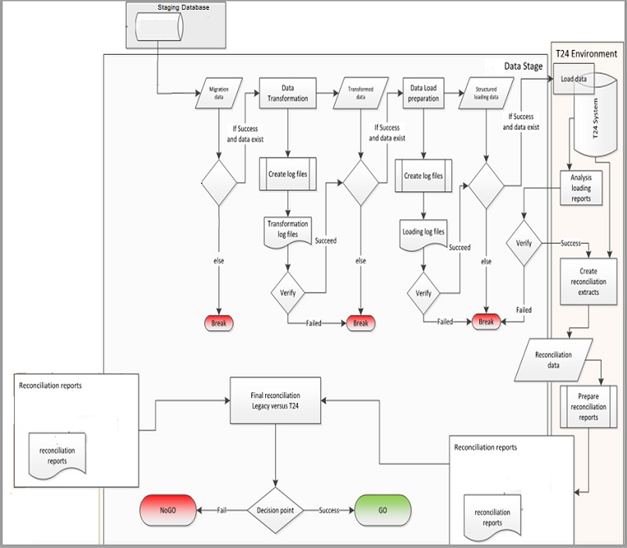

Figure: Data Validation / Reconciliation Architecture

## Standard principles

The following principles apply for enable 2.0 Data Migration:

1. As far as possible the migration data to be kept clean, accurate and complete
   1. Business will ensure the quality, accuracy and completeness of data before it is made available to migration team for the data upload.
   2. Prior to data migration, all data must be signed-off by data owner and business users.
2. Avoiding failures
   1. Migration tools and procedure must be fully tested prior to actual migration. This will be accomplished through Conversion Integration test, Conversion Acceptance test, and Trial migration.
   2. Proper testing is crucial to prevent mismatch in the production system after the data upload.
3. Sequencing of migration activities
   1. Master data and parameter setup are critical pre-requisite component to start migration activities. It is important to ensure that the correct sequencing (viz.. Bank setup, Business parameter data, Client static data, financial data and transactional data) should be followed for successful data migration.
4. Cutover window and business impact is minimized
   1. Final migration and cutover must be done as efficiently as possible to minimize business impact
   2. Wherever possible Delta approaches (i.e. incremental) can be chosen to minimize the migration activities during Cut Over which divides the migration window into Static and Financial data migration
   3. Check points must be in place throughout the cutover period to allow the project to measure progress of the activities leading up to final cutover.
5. Data migration team will reuse the existing assets or experts as much as possible.
   1. Wherever possible interfaces (Like TTI, TDS etc...) will be used for initial data load into the target system. Requirements for initial data load will be considered during the design phase.
   2. New migration programs will only be built where interfaces are unavailable or insufficient.
6. The data migration team will use only standard data upload mechanisms supported by Wealth suite - T24.
7. Data migration tests (CIT and CAT) and functional tests will be performed with production like data (volume and quality). For those activities, sensitive data must be scrambled wherever necessary during extraction
8. Any Data cleansing requirements evolved from data migration activity will be analysed and reported to the business team for them to perform the cleansing activities
9. Data migration testing requires several trail runs prior to Go-live with full production data load. This is essential to assess the run times, the extent of the data cleansing necessity, and the final data migration procedures.
10. Within a mock test the cutover will be tested with production like data from data consistency point of view. After the configuration is frozen the final mock tests begins and upon signoff in Operational Acceptance test (OAT) the same steps will be executed during Go Live
11. As a best practice the migration of pending operational processes (Like Pending transaction, Clearing, etc...) in the source system will be avoided. Migration team would suggest that the pending processes should be closed in the source system and these scenarios will be discussed below under the “***Migration approach***” section wherever applicable
12. As a best practice, spreadsheets are not used while migrating the data from source to target system and it is recommended to provide the migration data in delimited format.
13. Migrate and store the source system transaction reference for all T24 contracts and deals
14. Migration activity run book will be created and maintained all through the project till go-live cutover

## Environment requirements

The migration team requires access to the T24 environment to execute the migration related activities and upload data into the target system and two new environments.

The table below provides a list of requirements to support the Migration team:

|  |  |  |  |
| --- | --- | --- | --- |
| **#** | **Environment** | **Purpose** | **Phase** |
| 1 | Development | Migration Development and Recon script preparation | Build |
| 2 | Conversion Integration Test (CIT) | Trail runs followed by CIT completion | Test – CIT |
| 3 | Conversion Acceptance Test (CAT) | Master Conversion Environment ( Flush out data to SIT / UAT) | SIT / UAT / DR support |

# Migration approach

## Data Migration Scope

### Functional scope

The following slide provides the Functional scope for PvB WS 2.0 Migration

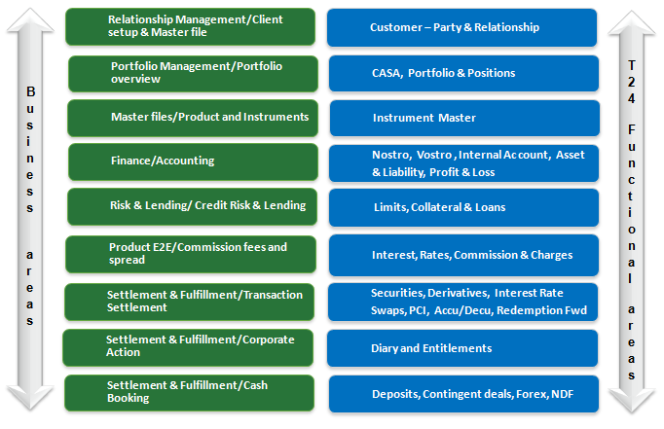

Figure: Functional Scope

### Master for Client Referential Data

The table below provides the view

|  |  |  |  |
| --- | --- | --- | --- |
| **Referential Data** | **Systems** | **After 1.2** | **After 2.0** |
| **Customer** | Temenos T24 | T24 R08 Slave for all Customers | Wealth suite - T24 Slave for all Customers |
| CUPID | Cupid is master for all Customers | Cupid is master for all Customers |
| **Portfolios** | Temenos T24 | T24 R08 Master for all Portfolios | Wealth suite - T24 Master for all Portfolios |
| TAP | TAP slave for all portfolios | TAP slave for all portfolios |
| **Instruments** | Temenos T24 | T24 R08 Slave for all instruments | Wealth suite - T24 Slave for all instruments |
| TDS | TDS Master for all instruments | TDS Master for all instruments |
| **CASA accounts** | Temenos T24 | T24 R08 Master for all CASA accounts | Wealth suite - T24 Master for all CASA accounts |
| TAP | TAP Slave for CASA account | TAP Slave for CASA account |

## Migration detailed strategy

### Customer

As part of WS1.2 implementation it will be made available to have both party and relationship information from Cupid and T24 R08 to establish Client relationship setup in TAP WS1.2 application.

Customer risk rating and other suitability related data are setup at the relationship level in TAP by sourcing the data from T24 R08 and Cupid. All the relationship linked to the portfolios was scoped in WS1.2 migration.

WS 2.0 migration for Customer will follow below mentioned strategy:

* TAP will be interfaced via TTI to create all the Customer Relation data (CIF) in Wealth suite - T24
* Additional attributes to Relation will be migrated from Cupid
* Additional attributes like mnemonic, sector and gender for Relation will be migrated from T24 R08
* Customer sensitive information like name and address for Relation will not be mapped from respective source systems. Sensitive information are mandatory in Wealth suite - T24 and alternate logic will be built to populate the name and address field values for each party and relationship
* Customer static setup related to statements will be migrated from T24 R08 into Wealth suite - T24
* Customer level group charge will be updated automatically when customer is migrated into Wealth suite - T24 based on the condition group charges setup.
* Broker, Depositories and Issuer configuration is part of Bank setup

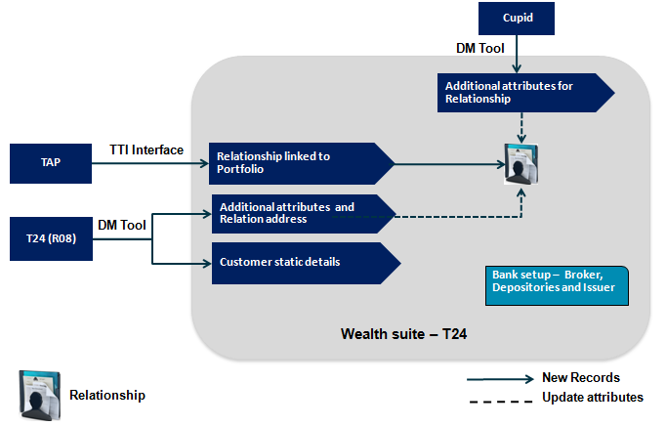

Figure: Customer Migration approach

### Account

As part of WS1.2 implementation all the customer and Nostro accounts will be mastered in T24 R08, Below table provides the Account classification and Products identified in T24 R08

|  |  |  |
| --- | --- | --- |
| **Sl. No** | **Product Description** | **Classification** |
| 1 | Demand Account IB, Demand Account IB AC – AC, Saving Account  Demand Account NIB AC -AC, Collateral Hedging Settlement Account | CASA |
| 2 | Bony Melon, Clear stream, Payment Nostro, Bony Brussels, Securities service Singapore, Citibank NA HK, SCB Hong Kong, OPICS, Bony Mellon NY  Securities Services Malaysia, SCB London Nostro, Securities Services Hongkong, Clear stream custody settle Suspense, Securities Services Indonesia, Securities Services Taiwan | Nostro |
| 3 | Demand Account NIB | Vostro |
| 4 | Suspense CR General, Suspense Bulk FT, Suspense past due, Brokerage payable, Payment netting suspense, Suspense data capture, IDT-Cheque(In&OUT), IDT-SIT(In&OUT), Intercompany A/C, Reserve swap Debit,  Forex forward reserve, Investment In consolidated subs, Suspense data capture, Suspense bulk FT, Suspense CR and DR FX, Referred clearing checks, FX Forward revaluation, Exchange A/L Forwards, Suspense CR LD/MM, Profit Loss Close, Reserve Forward Credit, Suspense CR General  Suspense CR and DR FX | Bank Internal |
| 5 | Migration Takeover Account | Migration |

WS 2.0 will follow below mentioned strategy for Account migration:

* Above mentioned classifications is factored while migrating the accounts into Wealth suite - T24
* All the client accounts that are not closed in TAP is scoped for migration
* Client Account will be sourced from TAP via TTI Interface
* Additional attributes for Client Account will be migrated from T24 R08
* Nostro Account, Bank Internal accounts, Nostro Agency will be migrated As Is from T24 R08
* Migration takeover account list will be discussed and finalised between migration and business team, Creation of take over account will be part of bank setup team.
* Account statement frequency will be updated automatically in Wealth suite - T24 from the statement definition at the group level. All the customer account statements are generated based on statement frequency which are setup and available in TAP system as part of WS1.2 implementation.

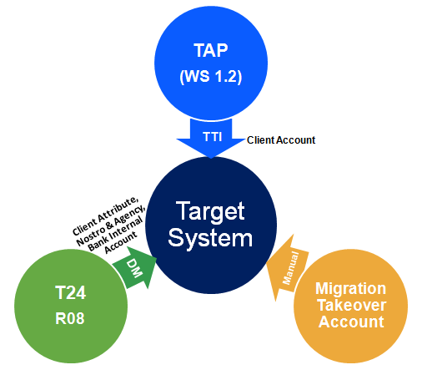

Figure: Account Migration approach

* Attached excel contains the Account category mapping between T24 R08 and Wealth suite – T24. The attached list will be re-visited during the mapping phase.



### Portfolios

Portfolio is grouping of financial assets holding such as stocks, bonds, structured products, cash products including mutual funds, Hedge funds and Private Equities.

Currently the Portfolio setup is available in TAP and T24 R08. Each portfolio setup is done as per relationship definition established for the Client. As part of WS 1.2 implementation data is sourced into TAP from T24 R08 portfolio module and all the active portfolios were scoped in the migration.

WS 2.0 migration for Portfolios will follow below mentioned strategy:

* TAP will be interfaced via TTI and the existing portfolios from TAP will be integrated into Wealth suite - T24
* Additional attributes for portfolios will be migrated from T24 R08
* Bank related portfolios are available in TAP and they will be included along with customer portfolios migration
* Portfolio statement frequency setup and generation will be handled in TAP and sent to Spring Watch

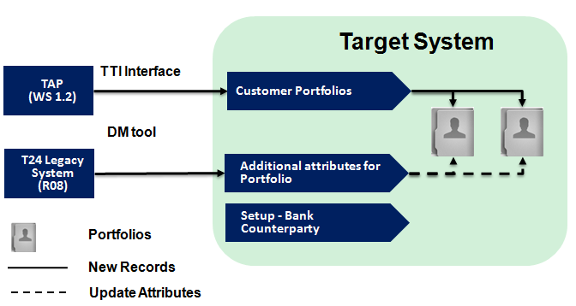

**Figure: Portfolio Migration approach**

### Financial Instruments

Financial instruments encompass all the assets and contracts that can be traded in the exchange or over the counter and can be held in portfolios as an asset or liability. Identified financial instruments include:

1. Equities and Other exchange trade products
2. Bonds
3. Mutual Funds / Hedge funds / Private Equity / CD wraps / discretionary
4. Structured notes, structure investments and alternative investments
5. Derivatives
6. Liabilities
7. CASA
8. Term Deposits
9. Guarantees

Temenos Data source (TDS) is decided as source system for all the financial instruments. As part of WS 1.2 implementation a golden copy of instrument master is formed and setup into TDS and all the market feed updates will happen in TDS.

In WS 2.0 the similar approach will be followed to source the instrument data from TDS, instruments will be classified for Securities and Derivatives while setting up the contract master in Wealth suite - T24.

* All the instruments will be sourced from TDS based on the classification listed in below table in this section
* When the instruments are sourced into Wealth suite - T24, one-to-one existence will occur with Securities, Derivatives and Structure Products instruments
* Data Migration for financial instruments is out of scope as the data will be interfaced from TDS, any incremental data or changes specific to WS 2.0 will be scoped in migration
* Attached excel contains the Financial instruments mapping between T24 R08 and Wealth suite – T24. The attached list will be re-visited and verified during the mapping phase



* Below table lists the classification for setting the instruments

|  |  |  |  |  |
| --- | --- | --- | --- | --- |
| **Sl No** | **Asset types** | **Products classification** | **Target Module** | **Target Instrument setup** |
| 1 | Currency Derivatives, Calls and Puts | FX Barrier Option – Buy FX Barrier Option - Sell FX Option - Buy FX Option - Sell Buy Eq Call Buy Eq Put Sell Eq Call Sell Eq Put | Derivatives | DX.CONTRACT.MASTER |
| 2 | Premium Currency investment, Commodity liked structure investment, Currency Derivatives, Calls and Puts | FX Target Redemption FWDs Buy Eq Leveraged AQ Buy Eq Leveraged DQ Buy Eq Non-Leveraged AQ Buy Eq Non-Leveraged DQ | Structure Products | DX.CONTRACT.MASTER |
| 3 | Bonds, Shares, American Deposit receipt shares, Preferred shares, Right of subscription, Approved MF, Exchange traded funds, Currency Option, Certificate of deposit, US treasury bills/notes, Floating rate notes, Assignment of Securities, Wrap funds, Structure deposits, Third part structure note, Approved Hedge fund, Hedge funds not sponsored, Approved – UCITS funds, On shore funds, SCB premium funds, Private equity funds, Non approved funds, Non approved MF, Approved Money market funds, Bonds with pool factor, Third party equity link loans, Fixed maturity plan – Funds, SCB structure notes, SCB equity linked notes, Accumulator notes | Bonds Shares Equities Warrants Hedge Funds  Certificate of Deposits Notes Other Funds | Securities | SECURITY.MASTER |

**Figure: Instrument Classification**

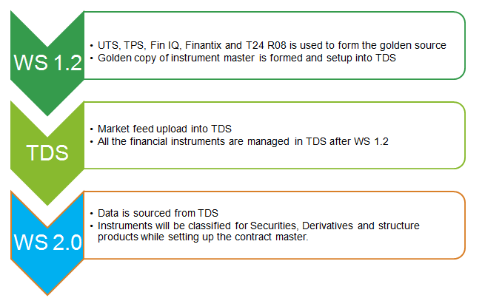

**Figure: Data sourcing for financial instruments**

### Financial Migration

Financial Migration will include migration of balances for Client Accounts, Profit and Loss, Take over Account, Bank Internal Accounts and Nostro Accounts. Funds Transfer and Data Capture application will be made used to migrate the balances.

WS 2.0 migration for Balance migration will follow below mentioned strategy

**Asset and Liability migration covers:**

* Client Account, Nostro Account and Bank Internal Account closing balances in T24 R08 will be migrated as Opening working balance in Wealth suite - T24 using Funds transfer application
* If there are any accrued balances for CASA in T24 R08 then the accrued portion will be captured as part of migration activity in Wealth suite – T24. The posting of accruals during the capitalisation date can be handled manually as part BAU
* Contract Balances(Loans, Deposits, Forex, Swaps, Derivatives and Structured products)will be migrated through the respective application in Wealth suite - T24

The detailed migration of contract balances will be discussed in the ***section 3.2.10*** below***.***

**Profit and Loss migration covers:**

* P&L balance mapping keys from source to target system will be verified with BRM / BA team before the respective P&L balances are considered for migration in Wealth suite - T24
* All the income received and expenses incurred will be migrated as balances to the respective P&L category.
* All the income receivable and expense payable will be built through the respective contract migration.

**Migration Take over account**

* Take over account is used as substitute account for migrating the A&L and P&L balances.
* Takeover account will be used to avoid the double booking of customer accounts to migrate transactions without affecting the Customer account, since these balances would have debited / credited the Customer account in the source system.
* The takeover account will be categorized by module, currency and entity.
* The Source GL balance would be booked on the equivalent take-over account prior to the migration of financial data. Post migration the take-over account balance for all currencies should be zero.
* These scenarios will be agreed with Business team in-order to create the number of take over accounts and to check and reconcile them at the end of migration.

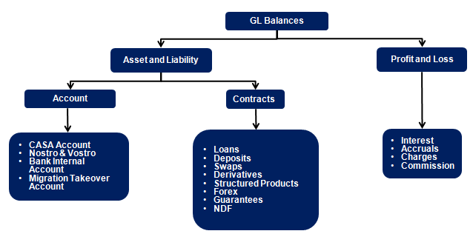

**Figure: Financial Migration Scope**

### Credit Risk

All Limits with expiry date greater than Cut-over date is scoped in the migration. Expired limits which are outstanding will also be migrated by setting the expiry date as migration date. Both Global Limit and Sub product limits will be scoped in Migration.

Below are the existing Limit products maintained in T24 R08 and scoped for migration

|  |  |  |
| --- | --- | --- |
| **Product** | **Description** | **Limit check** |
| 8510 | AQ/DQ Initial Margin | Y |
| 8500 | Initial margin | Y |
| 8350 | Stand-By LC | Y |
| 10000 | Shared product limit | Y |
| 4000 | Loans | Y |
| 8340 | Guarantees | Y |
| 100 | Overdraft | Y |
| 8300 | LC+GTEE | Y |

WS 2.0 migration for Credit Risk will follow below mentioned strategy

* New limit products will be replaced with existing product in T24 R08 due to the change in Business rules and operations. These factors will be considered during transformation to have the new limit structure
* All limits with expiry date greater than cut-over date will be migrated from T24 R08, also the outstanding expired limits is considered for migration by setting the expiry dates to migration date
* Only the approved limit amount is migrated and the available limit is updated when the customer deals are migrated into Wealth suite – T24
* In case of non-revolving limit the unutilised limit amount in T24 R08 will be considered as approved limit amount during the migration.
* Once the limit is migrated they will be secured by bringing all the collateral ownership and collateral information from T24 R08 into Wealth suite - T24
* Secured limits will be linked with deal and portfolio once the deal migration is complete
* When Limits are migrated into the Wealth suite - T24, global limit will require a transformation based on RISK classifications given below

|  |  |  |
| --- | --- | --- |
| **As IS** | **RISK.CLASS** | **To BE** |
| NNNNNN.0010000.01 | 3 | NNNNNN.0030000.01 |
| NNNNNN.0014000.01 | 3 | NNNNNN.0034000.01 |
| NNNNNN.0010000.02 | 1 | NNNNNN.0010000.01 |
| NNNNNN.0014000.02 | 1 | NNNNNN.0014000.01 |

**Figure: Limit structure**

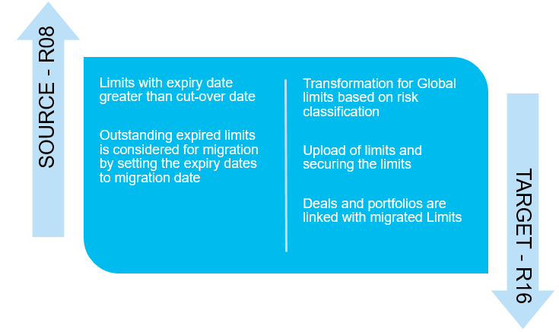

**Figure: Credit Risk Migration approach**

### Interest and Rates

This section explains migrating and setting up Interest and Rates at the group level and at the individual level for Customer Account and Products

WS 2.0 migration for Interest and Rates will follow below mentioned strategy

**Auto Migration:**

* Individual Account conditions for debit and credit interest is scoped in migration, the interest conditions at the individual account level will be migrated from T24 R08 into Wealth suite - T24

**Bank Setup:**

* Account group conditions are parameter setup and they will not be scoped in migration and it will be handled by bank setup team.
* Basic and Periodic interest setup is Bank setup for all product group and currencies
* Currency exchange rates are pre-requisites for migration to ensure all the currency exchange rates are up to date in T24 system.
* Forward rates are pre-requisite for Forex deals migration and they must be available in the system prior to migrating the Forex and Non-deliverable forward deals
* Market price related to Securities, Derivatives and Structure Products instruments will be updated in Wealth suite - T24 by Bank setup team

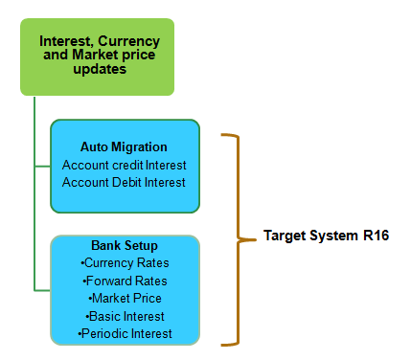

**Figure: Interest and Rates Migration approach**

### Commission and Charges

When contracts are migrated from T24 R08 into the Wealth suite - T24, the commission and charges will be waived for the contracts which are booked and transacted in their respective source system.

There are specific cases while migrating pending / unsettled security trades which will require triggering commission and charges during the migration. Also the portfolio related charges (Like Management fees and safe custody fees) will be accrued in Wealth suite - T24 from the last portfolio charge date in T24 R08 as part of migration activity.

All the commission and charge parameter setup belongs to Bank setup team and they are out of scope for migration activity. Migration team will get the list of commission and charges if they are required to populate at the contract level during the migration.

### Security Positions

Initial Security Position is the holding of the customer in various financial instruments during the point of cutover. Position data are available within the T24-POSITION module and data is maintained for each Portfolio and for each Asset segments

WS 2.0 migration for Securities products will follow below mentioned strategy

* Migration scope for building the portfolio positions in Wealth suite - T24 for its respective security Products are listed under the Section ***Financial Instruments (Security Master)***
* Positions are segregated based on portfolio number, Security instruments and Depository in T24 R08
* All the active portfolio settled positions will be extracted from T24 R08 as on migration date.
* All settled positions will be migrated using Security transfer application by setting the instruction “Free of payment” to update the positions without invoking the financial entries in Wealth suite - T24
* Trade date and Value date will be marked as cutover date to migrate the portfolio positions
* Security instruments which contains accruals and coupon payments, the accrual interest start date will be taken from last coupon payment date or the trade start date

* All open trades will be migrated separately using security trade application to bring the unsettled customer positions into Wealth suite - T24. Settlement of these trades will happen post cut-over date as part of BAU
* Dummy Broker will be used while migrating position using Security Transfer application in Wealth suite - T24
* Broker position are not maintained in the source system T24 R08

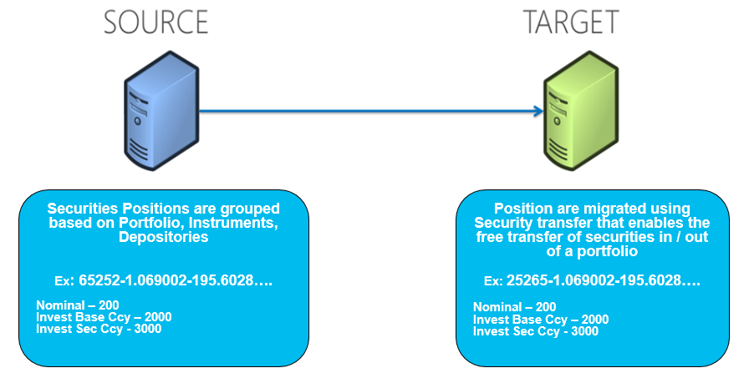

**Figure: Securities Positions Migration**

### Deals and Contracts

#### Loans, Deposits, and Miscellaneous deals

Products covered under this section is currently available in LD, MM and MD modules in T24 R08, these products will be fit into the same module when they are migrated into Wealth suite - T24.

Below table represents the product scoped for migration

|  |  |  |
| --- | --- | --- |
| **Product** | **Description** | **Indicator** |
| 21050 | Time loans | LD |
| 21054 | Real Estate loans | LD |
| 21060 | Term loans | LD |
| 21073 | Special Loan Non-earning | LD |
| 21010 | Fixed deposits | MM |
| GTEER | Guarantees Received | MD |
| SGREL | Guarantees Received RE collateral | MD |
| SIPRC | Single insurance premium | MD |
| CCTPI | Credit allocation CTP | MD |
| IGTER | INTL GTEE Fixed pledge issued | MD |

Below table represents the product which are currently booked in MD module in T24 R08 and they will be moved to its respective target module in Wealth suite - T24

|  |  |  |
| --- | --- | --- |
| **Product** | **Description** | **Target Module** |
| OPXFX | FOREX SPOT / FORWARD | FX |
| IMLIB | DERIVATIVES INIT MARGIN BLOCK/  IM CURRENCY DERIVATIVE | DX |

WS 2.0 migration will follow below mentioned strategy

**Loans**

* Loans Contracts is booked in LD module with start date as the last capitalisation date
* Details on loan start date and outstanding principal in Wealth suite - T24 will be picked as the last capitalisation date in the source system.
* Loan tenure, principal amount, schedules, repayments, interests will be available in Wealth suite - T24 as of the last capitalisation date in Wealth suite – T24
* It will be a potential gap to store the Original loan tenure, Original loan amount, Loan reference, historical interest rate and repayment details in Wealth suite - T24.
* Interest calculation for the Loans will start from last interest capitalisation day and accruals for the current period will be calculated in Wealth suite - T24 from previous Capitalisation date
* Take over account will be used as drawdown account to bring the outstanding principal, once the loans contract is authorised the drawdown account will be replaced with Customer account
* Loans Schedules is also scoped as part of contract migration through transformation approach
* There are no Past dues linked to the debt loans in the source system and hence past dues are out of scope for WS 2.0 migration
* Partial repayment and Principle Increase/Decrease scenarios will be considered during migration

**Deposits**

* Fixed Deposits is booked in MM module with start date as the last capitalisation date and outstanding principal will be taken as contract amount
* Source system deposit reference number can be stored as an alternate key in Wealth suite - T24.
* Fixed deposits interest rate are migrated from source system, Interest calculation for deposits will start from last capitalisation day meaning the accruals for the current period will be calculated from the last interest Capitalisation date
* Drawdown account will be defaulted to migration take over account and later drawdown account will be replaced with customer account as part of migration

**Miscellaneous deals**

* Miscellaneous contingent deals that are required to record Guarantee type transactions on the banks’ books is migrated to MD module
* All the active deals which are maturing after cut-over date will be scoped for migration
* Contract dates will be retained As Is from the source system when they are migrated into Wealth suite - T24
* Principal amount from the source system will be taken as contract amount

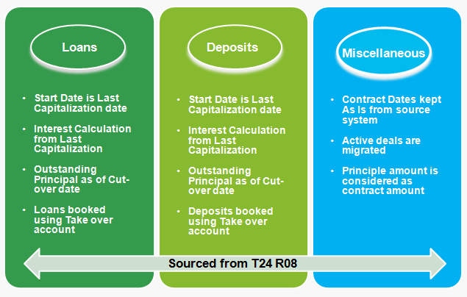

**Figure: Loans, Deposits and Guarantees Migration**

#### Forex and Non-deliverable forwards

EDP is used for Order capture and PvB Opics for deal processing (Spot, Forward, Swap and NDF). Once the order is generated the deal information is updated in T24 R08.

Below is the current BAU to manage Forex life cycle in PvB

1. FX Spot deals are processed in PvB Opics and updated into T24 R08 through funds transfer application to reflect the customer position and they will not require to migrate into Wealth suite - T24 (Covered as part of Customer balance migration)
2. FX Forward deals are processed in PvB Opics and updated into T24 R08 as miscellaneous deals. On the maturity date the accounting entries are generated using Funds transfer application by using PvB Opics suspense account and FX customer account
3. FX Swap; Spot leg and forward leg will follow the similar process mentioned in first and second point respectively
4. Non-deliverable forwards are booked as positions using Security transfer application and they are linked one-to-one with the security instruments.

As part of WS 2.0 Wealth suite - T24 FX module will replace PvB Opics to manage the Forex life cycle, below migration approach is followed to bring Forex related deals from T24 R08 and PvB Opics

* It is required to migrate Forex forward, Swap (Forward leg) and NDF into the new system
* For Forex deal migration, MD deals will be extracted from the source system with deal sub type OPXFX and maturity date greater than cut-over date
  1. All the forex forward deals will be scoped for migration into Wealth suite - T24
  2. Deal amount, forward rates, spot rates, client details, Buy / Sell date and currency are obtained from the source system
  3. Value date buy and Value date sell will hold the maturity date obtained from the source system
* For NDF deals migration, Security instrument with sub asset type 292 (Currency Derivative), product type FXNDF and maturity date greater than cutover will be scoped for migration
  1. Non deliverable forward deals will be migrated into Wealth suite - T24 as Vanilla deals using ND module and the fixing date is obtained from the source system
  2. Client details, Buy / Sell indicator, deal currency, settlement currency, deal amount, notional rate, value date and settlement date are obtained from the source system
  3. If there is no fixing date in the source system, then Wealth suite - T24 calculates the fixing date based on the settlement days of corresponding fixing currency

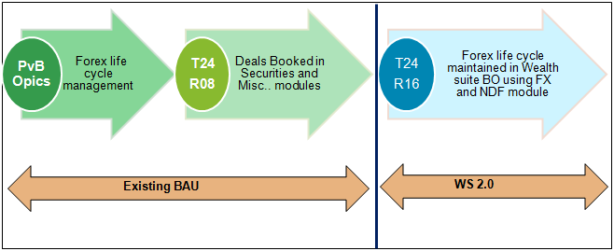

**Figure: Forex life cycle Migration**

#### Interest Rate Swaps

Interest rate swap is subjected to fixed and floating rate connected to either Asset side or Liability side. These Contracts are booked with sub asset type Interest Rate Derivatives (187) and Product type IRSWAPFIX

In current BAU the outstanding portion is maintained as notional principle and the fixed leg is booked in Security transfer application. Floating leg is not maintained in T24 R08 and it is booked in Murex system and hence the floating side data will be extracted from Murex to book the IRS deals in Wealth suite - T24

As part of WS 2.0 Temenos Swap module will be used to manage IRS life cycle, below migration approach is followed to bring IRS product into Wealth suite - T24

* Security instrument with sub asset type 187 (Interest rate derivatives), product type IRSWAPFIX and maturity date greater than cutover will be scoped for migration
* Input file to bifurcate Asset and Liability side via indicator “+” and “-”
* New floating keys will be defined in Wealth suite - T24 to migrate floating side of IRS deal
* Transformation is required in Wealth suite - T24 to arrive following data

1. Set next interest payment date for fixed and floating side
2. Set the interest rate as zero from the contract start date
3. Set the source system interest rate from the migration cut-over date or the last fixing date

* Key attributes like customer details, value date and maturity date, notional principle, currency, fixed rate, floating rate and payment schedule can be obtained from the source system [Murex & T24 R08]

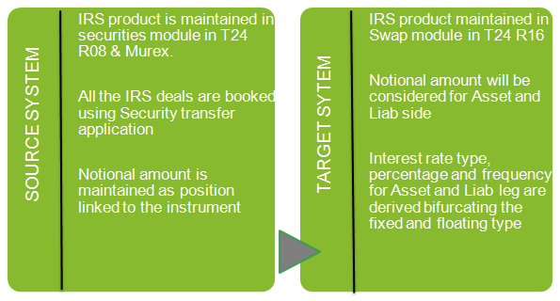

**Figure: Interest rate swaps Migration**

#### Derivatives

As part of WS 2.0 implementation TAP is used for order entry and Wealth suite - T24 will be used for transaction processing. In the current BAU FX Derivative product life cycle is maintained in Murex and Equities Derivatives product life cycle is maintained in Sophis. These systems are interfaced with T24 R08 for cash settlement and physical delivery of positions

Scope for WS 2.0 migration includes migrating FX/EQ OTC options and below strategy is followed

* All active positions and pending trades with sub asset type 292 (FX Options and Barriers), 135 (EQ Buy-Call/Put & Sell-Call/Put) will be scoped for migration
* Key attributes such as Deal currency, Delivery currency, Buy / Sell options, strike price, deal amount, value date, maturity date and premium price will be extracted from the source system
* If any of the required data for migration is not available in T24 R08, then Murex and Sophis will be referred to get the relevant data.
* Derivative customer and Derivative master setup for instruments is covered in Customer and Financial Instruments section
* Options are based on Primary and Secondary participants. For clients, they are input as the primary participant with the Bank counterparty being the secondary participant.
* In the instance of a counterparty trade, bank would be setup as primary participant and the counterparty as secondary participant

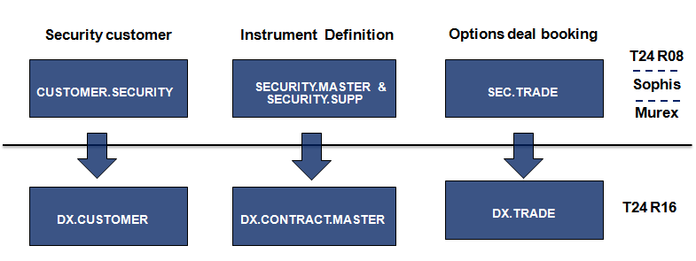

**Figure: Derivatives Migration**

#### Structure Products

Structure products include Dual Currency Investment (DCI/PCI), Accumulator and Decumulator, FX Target Redemption Forwards.

Dual Currency Investment is a short-term investment product that gives the opportunity to earn potentially higher returns on investment in the currency markets and it allows selecting a base currency and an alternate currency for the investment.

Accumulators are financial derivative products sold by an issuer to investors that require the issuer to sell shares at a predetermined strike price, this allows the investor to "accumulate" holdings in the [underlying](https://en.wikipedia.org/wiki/Underlying) [security](https://en.wikipedia.org/wiki/Security_(finance)) over the term of the contract. Accumulator typically last for a year or less and terminate early ("knock-out") if the stock price goes above a threshold ("barrier").

The basic idea of an accumulator contract is that the buyer speculates a certain price range (the range between the strike and the knock out price) within the contract period, Buyer holds an obligation to buy the shares at the strike price and issuer holds an obligation to sell shares at the strike price.

Decumulator is reverse of Accumulator and Investors buy Decumulator on the expectation that a certain stock will trade within a specific price range during the term of the contract. This range is bound by the strike price and a barrier price (usually a knock-out that triggers termination if the underlying price goes below a threshold).

As part of WS 2.0, Structure product (SY) module is used to migrate below mentioned products

**PCI / DCI:**

* All active positions and pending trade with sub asset type 182 (Premium currency investment) will be scoped in migration for DCI contracts
* PCI is currently captured as security trade in T24 R08 and Fin IQ manages the product life cycle
* Deposit details are stored in PvB Opics, key attributes for PCI deposit like principal amount and interest rate will be fetched from PvB Opics
* In Wealth suite - T24 the SY module creates MM and DX as underlying contract for PCI product
* Key attributes required from the source system to create PCI trade are trade currency, delivery currency, spot price, strike price, Deposit interest rate, principal amount, value date and maturity date

**Accumulator / Decumulator:**

* All active positions and pending trade with sub asset type 135 (Calls and Puts), product type (BELA, BELD, BENLA, BENLD) will be scoped in migration for Accumulator / Decumulator contracts
* In Wealth suite - T24 the SY module creates DX as a underlying contract
* Key attributes required from the source system to are product type, value date, maturity date, contract currency, principle amount, strike price, knockout price, daily units, fixing frequency and premium price
* The required data for migrating ACCU / DECU will be obtained from Sophis and T24 R08

**Target Redemption Forwards:**

* All active positions and pending trade with sub asset type 292 (FX Target Redemption forwards) will be scoped for migration
* In Wealth suite - T24 the SY module creates two DX contracts as underlying for CALL and PUT options
* Key attributes required from the source system to create Target Redemption forward trade are Currency bought, currency sold, value date, maturity date, spot price, strike price for call & Put options, notional amount for Call & Put options, fixing frequencies and option style
* The required data for migrating this product will be obtained from Fin-IQ and T24 R08

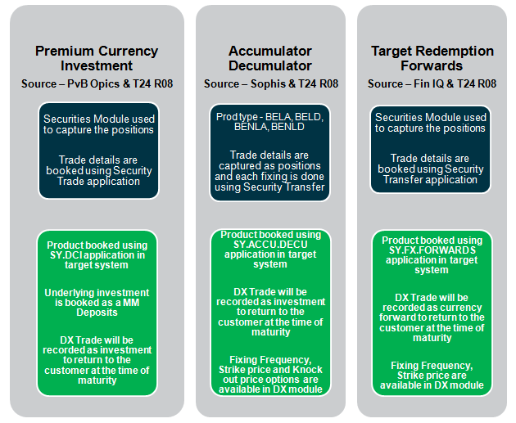

**Figure: Structure Products Migration**

### Corporate Actions and Events

SCB has three types of corporate action events and below table describes the types of events

|  |  |
| --- | --- |
| **Corporate Events** | **Types** |
| Mandatory | Final maturity, Early Redemption, Reverse stock split, Cash dividend |
| Mandatory with choice | Dividend re-investment, Warrant exercise, Conversion |
| Voluntary | Annual General Meeting, Rights issue, Repurchase offer bid |

Corporate action events are currently booked in T24 R08 system and the scope of migration includes diary events with Execution date greater than cut-over date and partially settled diary events.

As part of WS 2.0, below migration approach is followed for corporate actions events

* Diary records with Ex-date greater the migration cut-over date and partially settled events is scoped for migration
* All the mandatory and additional fields will be sourced from T24 R08 while migrating into Wealth suite - T24
* Diary record primary key from T24 R08 will be migrated and retained as Target system primary key in Wealth suite - T24. The purpose to retain T24 R08 primary key in Wealth suite – T24 is mainly for the target system to continue to support the corporate action events that are triggered via SWIFT network
* No financial entries are raised when Diary records are migrated and hence the source data will be brought As Is into Wealth suite - T24

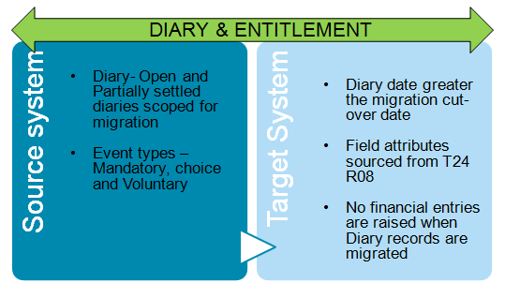

**Figure: Corporate Action Migration**

## Migration Pre-requisites

Below table lists the Pre-requisite to be completed by Bank setup team for PvB WS 2.0 migration

|  |  |  |
| --- | --- | --- |
| **Sl No** | **Application** | **Migration Pre-requisites** |
| 1 | CUSTOMER | CONDITION.PRIORITY COUNTRY CUSTOMER.STATUS DEPT.ACCT.OFFICER INDUSTRY LANGUAGE SECTOR TARGET |
| 2 | ACCOUNT | ACCOUNT.CLASS ALT.ACCT.PARAMETER ACCOUNT.PARAMETER ACCT.GROUP.CONDITION ACCT.GEN.CONDITION CONDITION.PRIORITY CURRENCY CURRENCY.MARKET POSTING.RESTRICT STMT.GEN.CONDITION |
| 3 | LIMITS | LIMIT.PARAMETER LIMIT.REFERENCE |
| 4 | COLLATERAL | COLLATERAL.TYPE COLLATERAL.CODE |
| 5 | LD.LOANS.AND.DEPOSITS | LD.TXN.CODES LD.TXN.TYPE.CONDITION BASIC.RATE.TEXT BASIC.INTEREST PERIODIC.INTEREST |
| 6 | MM.MONEY.MARKET | HOLIDAY |
| 7 | MD.DEAL | MD.PARAMETER |
| 8 | DX.TRADE | REGION HOLIDAY DX.EXCHANGE.MASTER DX.CONTRACT.MASTER SECURITY.MASTER |
| 9 | SY.ACCU.DECU | SY.PARAMETER |
| 10 | SY.DCI |
| 11 | SY.FX.FORWARDS |
| 12 | FOREX | CURRENCY FORWARD.RATES REGION HOLIDAY |
| 13 | ND.DEAL | ND.PARAMETER |
| 14 | DIARY | DIARY.TYPE |
| 15 | SWAPS | SWAP.PARAMETER SWAP.ACTIVITY |
| 16 | AGENCY | DE.BIC.PARAMETER DE.BIC |
| 17 | NOSTRO.ACCOUNT | NA |

**Figure: Migration Pre-requisites**

## Checks and Controls

Wealth suite - T24 generates Print and SWIFT advices during the migration and it also possess the functionality to update Wealth suite - TAP via B2F events. In order to prevent the triggering of such events from Wealth suite – T24 below table lists the checks and controls to adhere during the migration.

|  |  |  |  |  |
| --- | --- | --- | --- | --- |
| **Sl No** | **Migration** | **Suppress Print advices** | **Suppress SWIFT advices** | **Suppress B2F events to TAP** |
| 1 | Customer | NA | NA | ✓ |
| 2 | Account | NA | NA | ✓ |
| 3 | Portfolio | ✓ | NA | ✓ |
| 4 | Limits | NA | NA | NA |
| 5 | Collateral | NA | NA | NA |
| 6 | Loans | ✓ | NA | NA |
| 7 | Money market deposits | ✓ | NA | NA |
| 8 | Miscellaneous deals | ✓ | NA | NA |
| 9 | Derivatives | ✓ | ✓ | NA |
| 10 | Structure Products | ✓ | ✓ | NA |
| 11 | Forex | ✓ | NA | NA |
| 12 | Non Deliverable forwards | ✓ | ✓ | NA |
| 13 | Diary and Entitlement | ✓ | NA | NA |
| 14 | Swaps | ✓ | ✓ | NA |
| 15 | Agency and Nostro setup | NA | NA | NA |
| 16 | Portfolio Positions | NA | NA | ✓ |
| 17 | Open Security trades | ✓ | ✓ | ✓ |
| 18 | Financial Balances | ✓ | ✓ | ✓ |
| 19 | Financial Instruments | NA | NA | ✓ |

**Figure: Checks and Controls**

## Data volume and Methods

Below table lists the data volumes for Singapore and Honkong region along with proposed migration method for each application in WS 2.0 PvB migration

|  |  |  |  |  |
| --- | --- | --- | --- | --- |
| **Sl No** | **Application** | **Data Volume** |  | **Migration  methods** |
| **SG** | **HK** |
| 1 | Customer | 15092 | 9360 | Auto |
| 2 | Account | 39086 | 33290 | Auto |
| 3 | Portfolio | 15759 | 9145 | Auto |
| 4 | Limits | 14773 | 8762 | Auto |
| 5 | Collateral | 4867 | 6868 | Auto |
| 6 | Loans | 24064 | 28081 | Auto |
| 7 | Money market deposits | 2658 | 2748 | Auto |
| 8 | Miscellaneous deals | 1710 | 972 | Auto |
| 9 | Derivatives | 2197 | 630 | Auto |
| 10 | SY - PCI | 641 | | Auto |
| 11 | SY - Accu / Decu | 139 | | Manual |
| 12 | SY - Target Redemption | 467 | | Auto |
| 13 | Forex | 159 | 94 | Auto |
| 14 | Non Deliverable forwards | 55 | 23 | Manual |
| 15 | Diary and Entitlement | 142 | 64 | Auto |
| 16 | Swaps | 31 | 18 | Manual |
| 17 | Agency and Nostro setup | 684 | 452 | Auto |
| 18 | Portfolio Positions | 32879 | 28326 | Auto |
| 19 | Open Security trades | 555 | 622 | Auto |
| 20 | Financial Balances | NA | NA | Auto |
| 21 | Financial Instruments | 11963 | | Auto |

**Figure: Migration volumes and method**

## Nomenclature

It is necessary to retain the source system primary key in Wealth suite - T24 for all applications during the migration. Below table defines the strategy to retain the source system primary key as target primary key and option to store the source system primary key as an alternate field value in Wealth suite – T24

|  |  |  |  |
| --- | --- | --- | --- |
|  |  | **TARGET** | |
| **Sl No** | **Application** | **Retain primary key from source system** | **Store source primary key in alternate field** |
| 1 | Customer | ✓ | NA |
| 2 | Account | ✓ | NA |
| 3 | Portfolio | ✓ | NA |
| 4 | Limits | ✗ | ✓ |
| 5 | Collateral | ✗ | ✓ |
| 6 | Loans | ✗ | ✓ |
| 7 | Money market deposits | ✗ | ✓ |
| 8 | Miscellaneous deals | ✗ | ✓ |
| 9 | Derivatives | ✗ | ✓ |
| 10 | Structure Products | ✗ | ✓ |
| 11 | Forex | ✗ | ✓ |
| 12 | Non Deliverable forwards | ✗ | ✓ |
| 13 | Diary and Entitlement | ✓ | NA |
| 14 | Swaps | ✗ | ✓ |
| 15 | Agency and Nostro setup | ✓ | NA |
| 16 | Portfolio Positions | ✓ | NA |
| 17 | Open Security trades | ✓ | NA |
| 18 | Financial Balances | NA | NA |
| 19 | Financial Instruments | ✓ | NA |

**Figure: Primary key storage in Wealth suite – T24**

## Mapping Approach

Temenos standard mapping approach will be followed to map the Mandatory and Optional fields across the system. T24 core tables to map are listed during the migration strategy which serves the purpose to scope the number of applications to migrate. Attached sheet lists the number of applications scoped for PvB WS 2.0 migration



However, decision to be made to adopt T24 functionality and minimize customization. If some entities or data do not exist in Wealth suite - T24, it will be treated as a GAP and a validation will be required to perform the customization to support business continuity

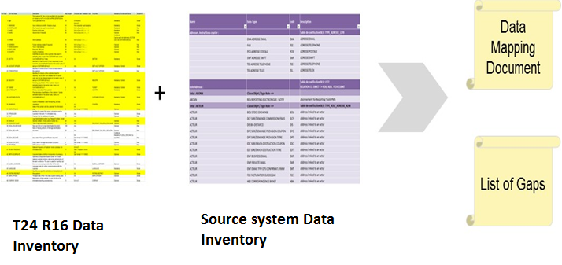

Figure: Data Mapping and Gap identification

## Dependencies

|  |  |  |  |
| --- | --- | --- | --- |
| **#** | **Phase** | **Activity** | **Project Dependencies** |
| **1** | **Analyse** | Data Inventory | BAU, BA, Solution Architect and Target Operating Model involvement |
| **2** | **Design** | Data Mapping | Signed-off Functional requirements for L1, L2, L3 gaps |
| **3** | **Build** | Migration build | Functional and operational Wealth suite - T24 system with complete configuration for the areas in scope for migration |
| **4** | **Test** | CIT, CAT, Trial Run | Environment team and Business team |
| **5** | **Deploy** | Dress Rehearsals | Enable Project deployment, environment and Business team |

## Assumptions

The migration activities and responsibilities of the migration team are based on a set of assumptions which are outlined in the following table.

|  |  |
| --- | --- |
| ID# | Assumptions |
| 1 | Migration environment will be provided by Infrastructure team. System set-up activities like parameterizations / configuration will be done by Bank setup team. |
| 2 | Migration Team will provide input for data cleansing through data profiling (Data Defect List) but not conduct the cleansing of data. Activities will be done by Business Users. Ownership of data correction will stay with Business team. |
| 3 | Onshore Migration Team will get access to production like data for mock migrations and dress rehearsals. |

## High Level Plan

The below plan provides a high-level plan for the client migration schedule.

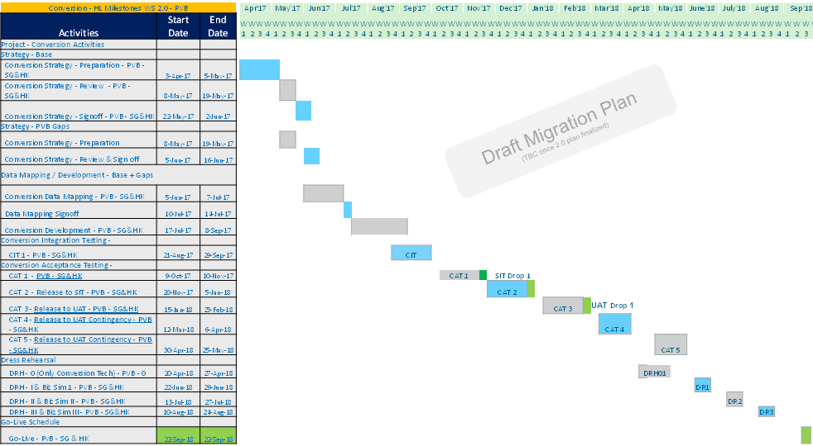

## Deliverables / Output

|  |  |
| --- | --- |
| **Migration Activities** | **Deliverables / Output** |
| Planning | 1. Migration Strategy & Approach 2. Plan 3. Resource Plan |
| Analyse | 1. Data Dictionary 2. Data Mapping |
| Design | 1. Reconciliation/Validation Design 2. Mock Migration Plan |
| Build | 1. Technical design Migration 2. Implementation of Migration and Reconciliation components 3. Unit Test |
| Test – CIT and CAT | 1. Test Plan and Execution 2. Data Defect List 3. Provision of data for SIT and UAT |
| Test – Mock Migration | 1. Mock Migration Execution 2. Data defect list |
| Cut-over Preparation and Execution | 1. Dress Rehearsals Execution 2. Go- Live Support |

## Clarifications

Below is the clarification list identified during the migration strategy for PvB WS 2.0:

|  |  |  |  |  |
| --- | --- | --- | --- | --- |
| No. | Clarification | Closure comments | Priority | Status |
| 1 | Should we migrate Party details from source into Wealth suite - T24 | Only Relation (CIF) is considered for migration and migrating party is out of scope | Low | Closed |
| 2 | Extraction criteria for Client Account migration (CASA) from TAP | All Open accounts will be migrated | Low | Closed |
| 3 | GL and PL balance migration, review with Finance team for Financial migration | This activity will be taken during design and mapping phase to arrive on Financial migration | Medium | Closed |
| 4 | Own book/Bank customer and portfolio for Migration - Existing system do not have own book concept and how it is handled moving forward with DX and SY module | Specific customer number and portfolio will be created and allocated for DX and SY module to complete the trade | Low | Closed |
| 5 | Should we consider Trade dated or Value dated position for Security position migration?  To Discuss the Migration approach for pending trades | Trade dated position is considered for positions migration and pending trades will be migrated using SEC.TRADE application | Medium | Closed |
| 6 | How about the interest amount (accrued) from last coupon date in T24- R08?  Should we consider the accruals while migrating portfolio positions for Bond instruments? | Interest amount accrued from last coupon date will be calculated in Wealth suite – T24 while migrating the positions for Security Bond Instruments | Medium | Closed |
| 7 | Broker is required to migrate the portfolio positions in the new system. Can we use the dummy broker for migration purpose? | Dummy broker created in T24 R08 specified for migration will be used or a new one will be created for WS 2.0 migration | Low | Closed |
| 8 | Principle early repayment and Principle Increase/Decrease for LD and MM.  Is this process allowed in the current BAU? | There are principle early repayments, increase and decrease done in T24 R08. But the volume is very less and it can be handled manually depending on volume in T24 R08 | Low | Closed |
| 9 | Considering the volume of NDF, is it recommended to migrate manually or do you need Auto migration? | Manual migration will be opted as the volume of NDF deals are around seventy | Low | Closed |
| 10 | Current BAU process for Forex deals (Spot/Fwd/Swap/NDF). To discuss on data sourcing from T24 R08 and PvB Opics | Detailed study of data sourcing will be performed during mapping phase | Medium | Closed |
| 11 | Current BAU for Interest Rate Swap.  We noticed floating side was missing in T24 R08. Can we source the data from Murex (Both Asset & Liab side)? | Manual migration will be opted as the volume of IRS is less in current BAU | Medium | Closed |
| 12 | To discuss the Cutover approach for Corporate action events | This activity is taken under technical demo activity for WS 2.0 migration | Medium | Open |
| 13 | SY – To discuss the data sourcing for ACCU / DECU Product from Sophis’ | Detailed study of data sourcing will be performed during mapping phase | Medium | Closed |
| 14 | SY – Deposits details for PCI product. To discuss data sourcing from PvB Opics | Detailed study of data sourcing will be performed during mapping phase | Medium | Closed |
| 15 | SY – Trade details for FX forwards product (Target Redemption Forwards). To discuss on data sourcing | Detailed study of data sourcing will be performed during mapping phase | Medium | Closed |
| 16 | LI – Should we migrate expired limits with no outstanding | Not required and they are out of scope | Low | Closed |

## Out of scope activities

|  |  |
| --- | --- |
| **#** | **Objects** |
| 1 | Group condition setup and Product Parameterisation |
| 2 | Tax condition setup, Fees and Commission setup, Broker settlement instructions |
| 3 | Static data setup related system tables in Wealth suite - T24 |
| 4 | Transaction and Settlement Deal types setup |
| 5 | Financial Ledger setup |
| 6 | Integration with target system to push the data through TTI |
| 7 | User profile and Security management setup |
| 8 | Unauthorised Static data (E.g. Customer, Account, Portfolios) |
| 9 | Currency rates, forward rates, Market Price, Interest rates setup |

## Reviewer feedback

