

**Wealth Suite BackOffice Packaging & Deployment**

|  |  |  |
| --- | --- | --- |
| Project ID |  |  |
| Project Name | enable Program – RCiM |  |
| Document Status | Draft v0.1 |  |
| Author | AJAAYKANNAN V.R. |  |

Template Version: 2016-v3f

**Table of Contents**

1 Document Presentation 4

1.1 Document Purpose 4

1.2 Programme Overview 4

2 Wealth Suite BackOffice Packaging & Deployment 5

2.1 GIT Connection via DesignStudio T24 5

2.2 Source Package 6

2.3 Data Package & Deployment 7

2.4 Integration Framework Package 10

2.5 Temenos Web Service packaging 14

**Tables**

**No table of figures entries found.**

**Figures**

**No table of figures entries found.**

**Acronyms**

|  |  |
| --- | --- |
| **ACRONYM** | **Description** |
| T24 | Temenos Wealth Suite Back Office T24 |
| TTI | T24 – Triple A Plus Interface |
| IF | Integration Framework |
| TWS | Temenos Web Service |

# Document Presentation

## Document Purpose

This document defines the high-level approach of Bank Setup approach to configure & maintain Wealth Suite system.

* Wealth Suite Parameter & Configuration Approach
* Create approach to seamless update on Wealth Suite system without any breakage
* Approach to validate with complete system to reduce the impact on the Wealth Suite system
* Bank Setup Tools & Techniques

## Programme Overview

Standard Chartered Bank (“SCB”) Wealth Management (“WM”) has three strategic objectives based on five-year financial plan to double the AUM, what we have communicated to investors and discussion with our customer segment colleagues – principally across Retail and PvB segments.

Three strategic objectives are to:

1. Achieve Scale in growing our AUM and income
2. Strengthen competitive advantage of our wealth management proposition
3. Deploy a standard and scalable wealth management platform

Current application landscape is very fragmented and it cannot be scalable to support the business model that we would like to achieve the above three objectives. It requires a unified system that supports the enhanced business model across PvB and Retail locations.

The initiative has been confirmed as a global transformation program (“Enable Program”) to deliver a standardized, front-to-back WM platform serving customers within Retail and WM segments. The Global WM platform transformation is made up by two major components – Core and Digital initiatives. As part of Enable program, Temenos Wealth suite (Triple A plus (TAP) and T24) is chosen for front-end and core banking platform.

# Wealth Suite BackOffice Packaging & Deployment

## GIT Connection via DesignStudio T24

To connect GIT with Design Studio T24

Select the Repository & branch to clone

Repository - t24-source

Branch – feature/ws2.0

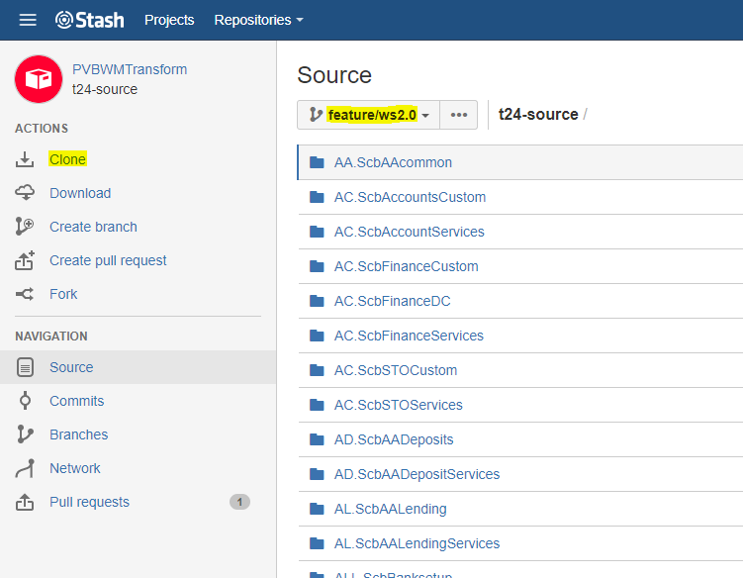

Copy the clone url in IDE.

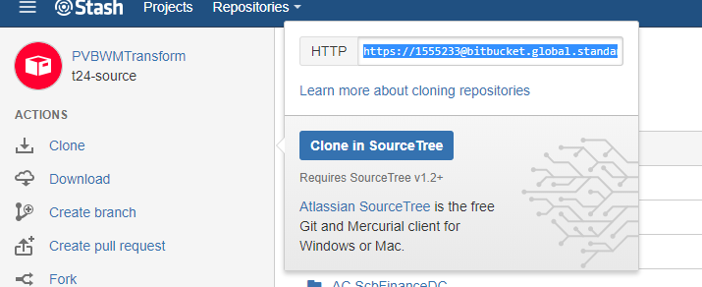

Clone the repository by providing URL & password for GIT

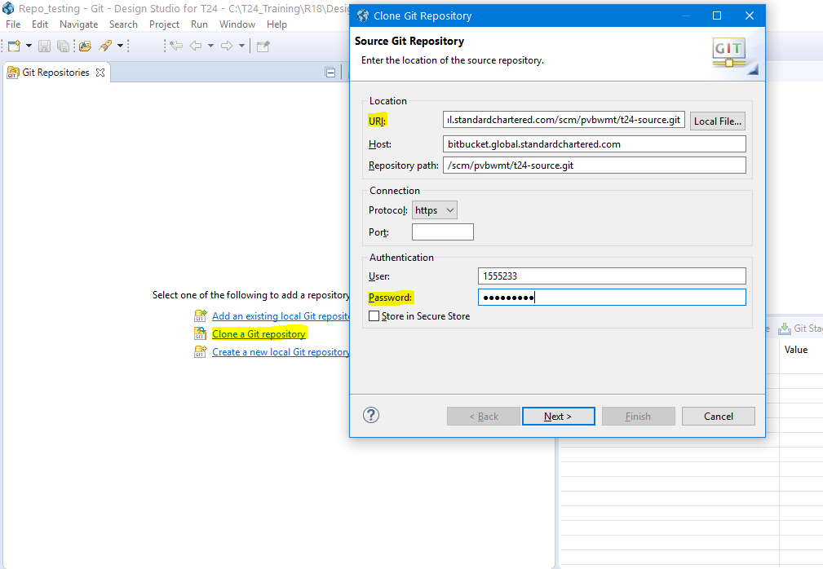

Required repository clone branch could be selected in the next page & select destination folder in local machine to finish the clone.

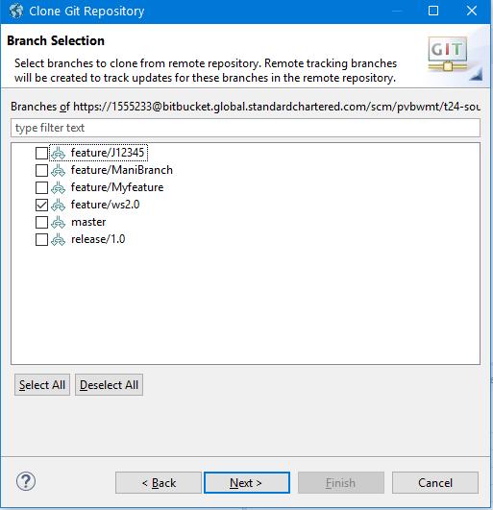 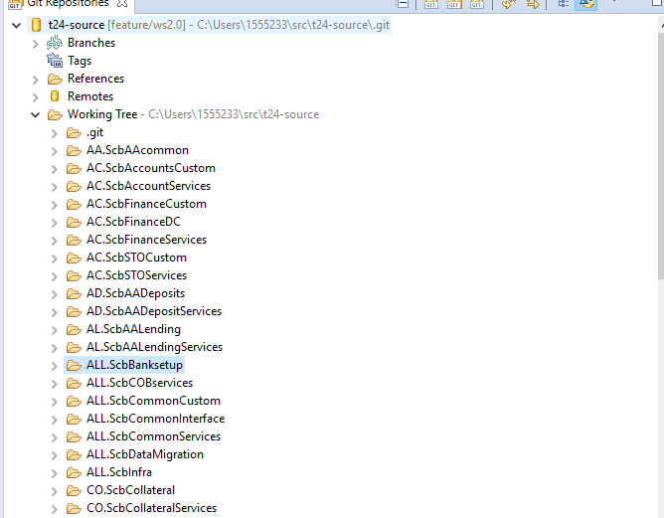

## Source Package

Modified folders should be copied to TAFJ project. Right Click on each folder to compile & generate the respective jars

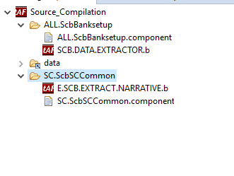 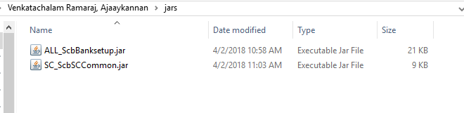

Generated jar files will be replaced in the destination environment

## Data Package & Deployment

Setting filter option in Data Packager

Right Click on Launch T24 Package(TAFJ) & Run As -> Run Configuration

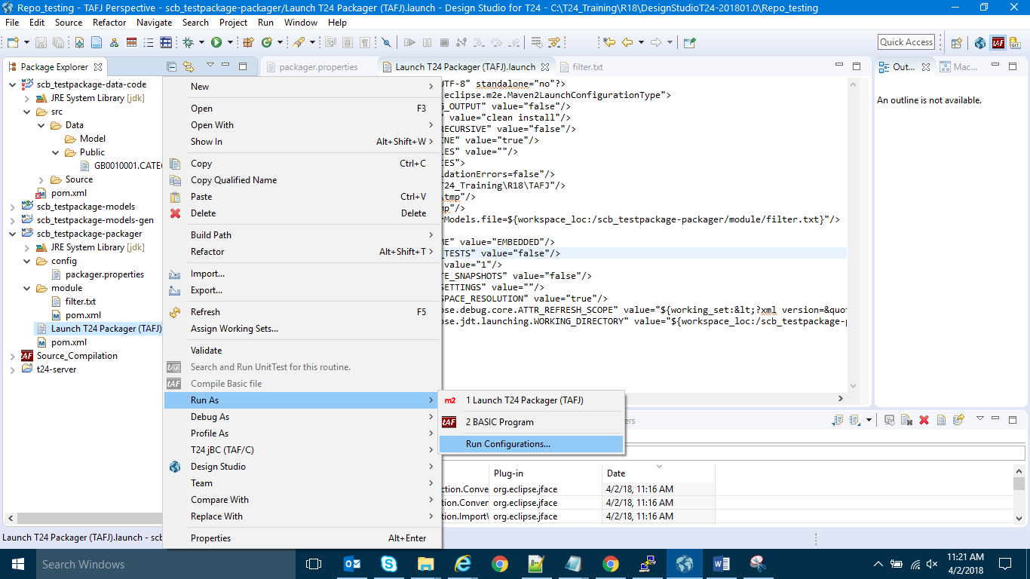

If filter property is not available Add the parameter as mentioned below:

**Name:** ds.gen.filteredModels.file

**Value:** ${workspace_loc:/<project-package>/module/<filter_fileName>}

**Name:** ds.delta.package.filter.file

**Value:** ${workspace_loc: /<project-package>/module/<filter_fileName>}

Update project-package & filter_fileName value accordingly.

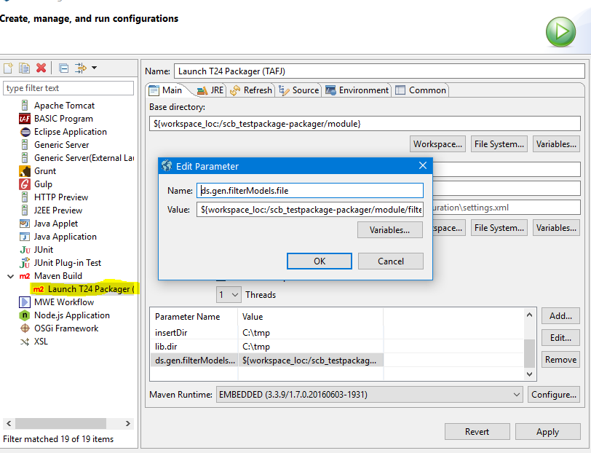

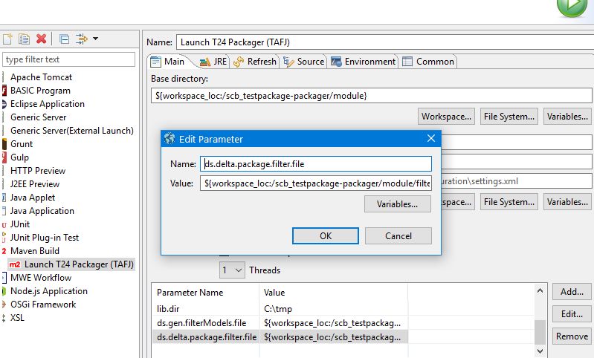

After saving the configuration you could see the settings update in Launch T24 Packager

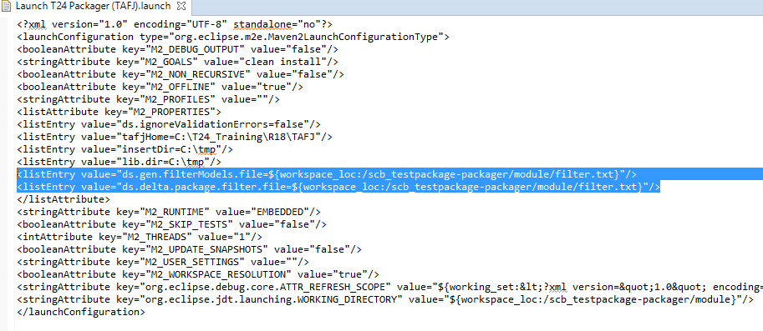

In the filter file add the components that needs to be packaged.

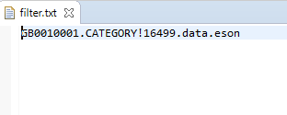

**Creating Package**

Right Click on Launch T24 Package(TAFJ) & Run As -> Launch T24 Package (TAFJ)

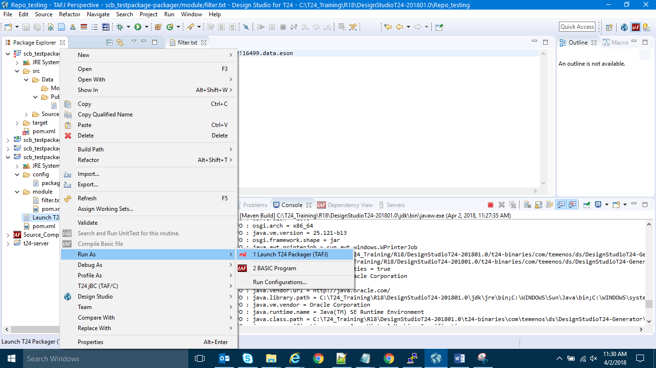

If the package is success you could see the below message.

T24 data jar package folder will be generated in packager\target folder

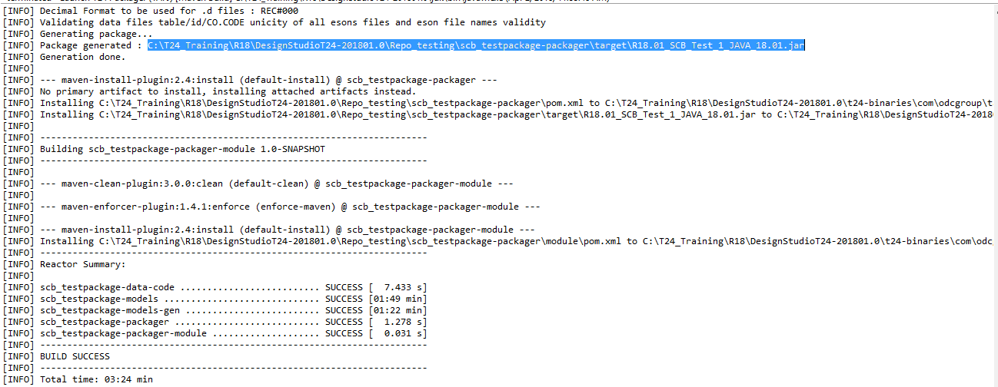

Deploying the package

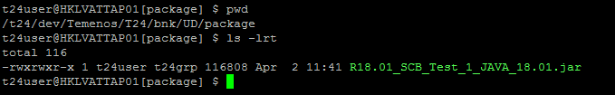

**User Creation for TAFJ DBTools login**

**tUserMgnt --Add -u rcim -p 123456Ab#**



**Note: If the package directory is not available in the environment, please create it using DBTools**

JQL CREATE-FILE package TYPE=UD

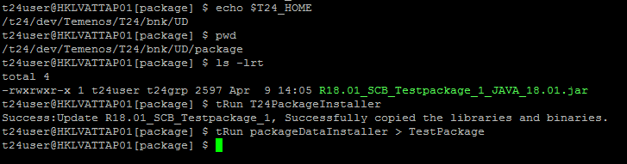

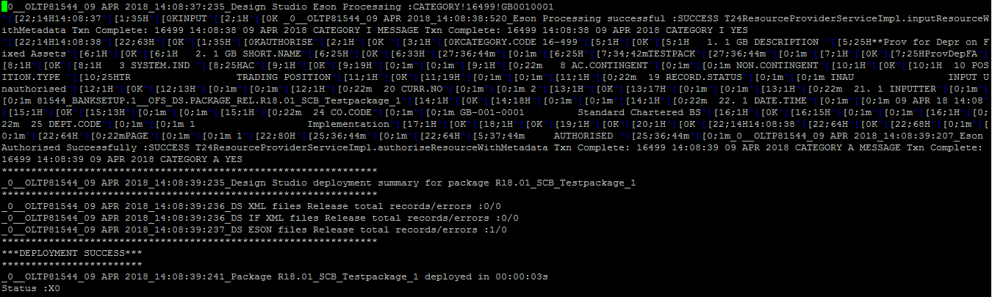

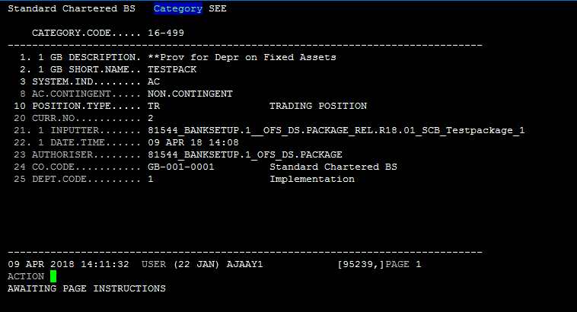

**Sample error log as below:**

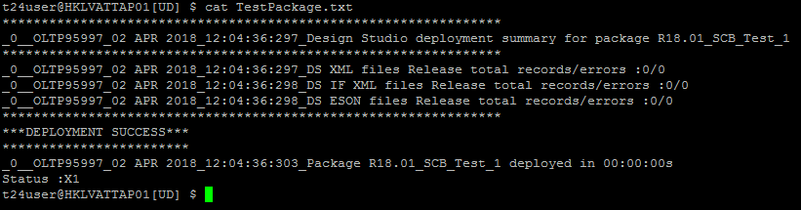

## Integration Framework Package

Create new IF project.

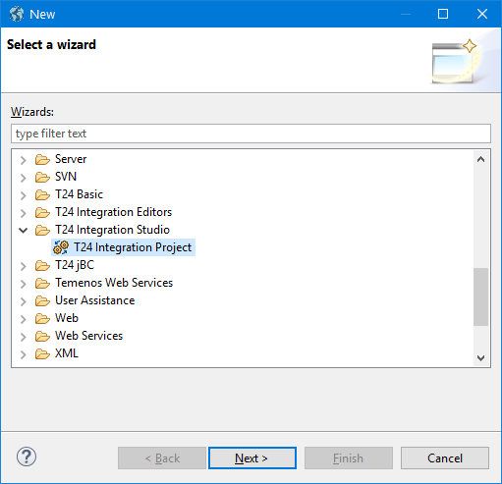

copy or create the respective events & flow.

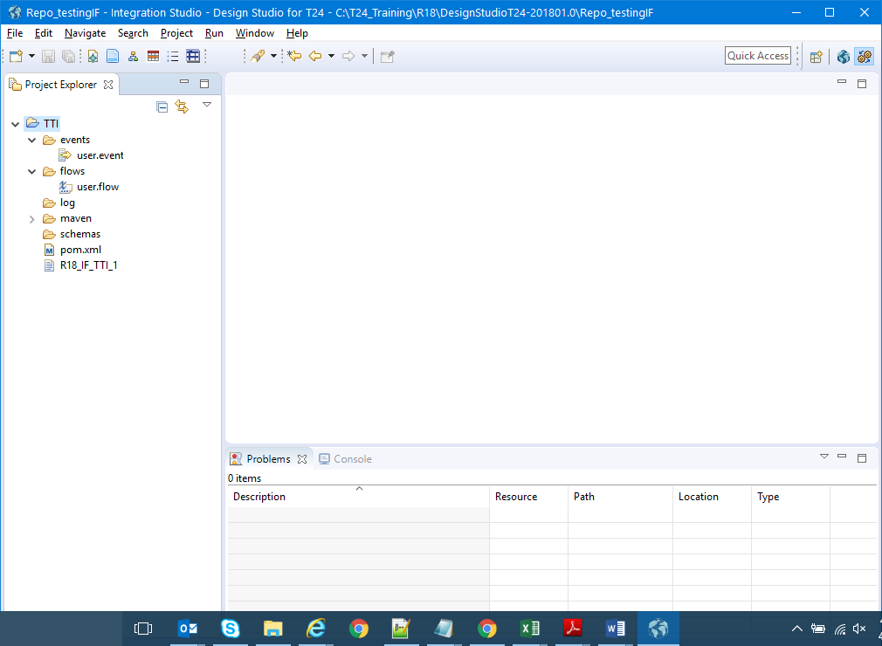

Right click on project & select Run As -> Run Configuration

Apply the below settings save the configuration & click on Run to create the package

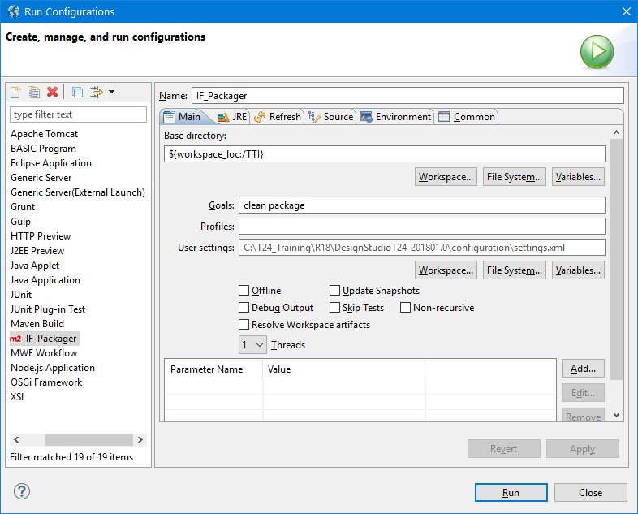

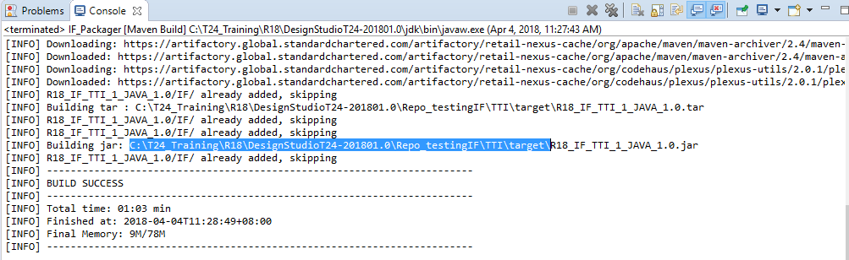

**Note: Dependent Maven jar files repository path is available in DS_HOME/configuration/settings.xml**

**Deploy TTI Package in T24**

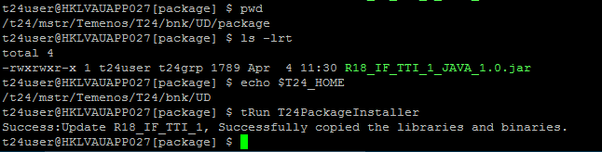

To install only specific flow please use the below option

tRun packageDataInstaller -IF:install=”<flow_name>”

for multiple flows give multiple values with comma separator

tRun packageDataInstaller -IF:install=”<flow 1>,<flow 2>,…<flow n>”

To update the existing flow please use the below option

tRun packageDataInstaller -IF:update=”<flow_name>”

for multiple flows give multiple values with comma separator

tRun packageDataInstaller -IF:update=”<flow 1>,<flow 2>,…<flow n>”

to Install all flows install / update the package without -IF option

tRun packageDataInstaller



Check the status of the deployment

Success – X0

Failure – X1

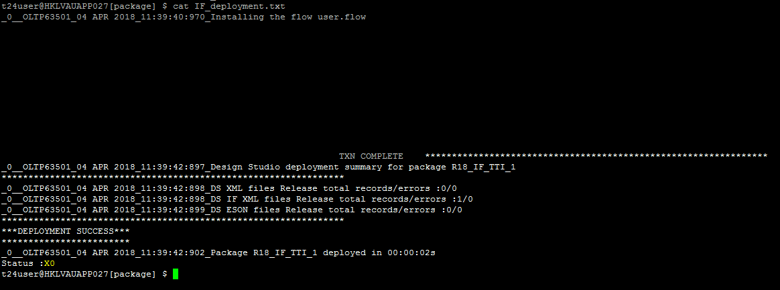

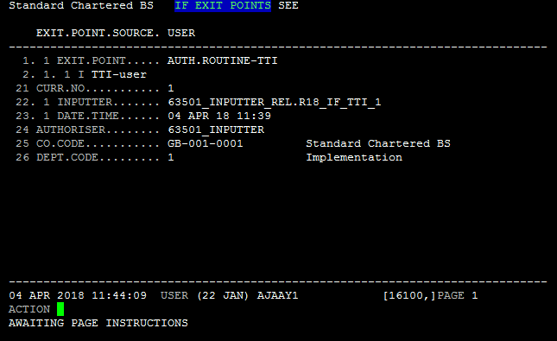

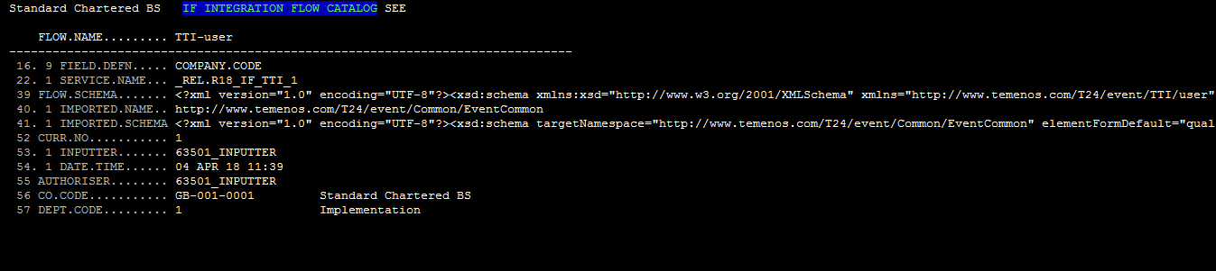

## Temenos Web Service packaging

Import the TWS project components from GIT & create the package

Right Click on TWS project select Export -> War file

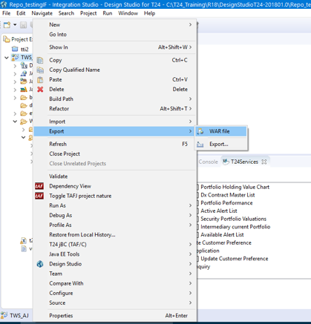

Deploy the generated war file to jboss deployments.