ThreadScheduler

## R Code for ThreadScheduling Probability

There are Two Processcor cores each capable of running 2 threads. A stress test is required to be performed in the design on a FPGA platform. A selection of tests are picked at random from a pool of tests.

The expectation was that the tests would run without any hitch over a number of iterations or tries, the hypothesis being that the probability of occurance of 3 slave mode tests scheduled without a corresponding master is very slim.

In reality, it was otherwise

This R program plots the probability of the test Success abd Test Fail over given number of tries and proves that it does not take many tries to end up with a failure

#This program attempts to get the plot of sucessful runs over number of tries  
library(dplyr)  
library(RSQLite)  
library(tidyr)  
library(ggplot2)  
library(readr)  
library(stringr)  
library(scales)  
library(mixtools)

## Details

Here is how the test is set up

* There are 4 tests A, B, C, and D
  + Further more, test A can run in Master or slave modes - M or S
* There are 2 cores with two threads each
* Each thread is named t0, t1, t2 and t3
* 4 instances of each test is picked at random and scheduled
* 4 instances of each of the tests, A,B, C and D create a pool of 16 tests to choose from
* For all practical purposes, the total pool of tests can be thought of as
  + MSSS
  + BBBB
  + CCCC
  + DDDD
* There are 4 threads to schedule from this pool of tests
* Only if M is scheduled in t0, S can run sucessfully
  + e.g MSSS runs successfully -> q3
    - MSSX runs successfully
    - MSXS runs successfully ->q2
    - MXSS runs successfully
    - MSXX runs successfully
    - MXSX runs successfully ->q1
    - MXXS runs successfully
    - MXXX runs successfully ->q0
    - XXXX runs successfully ->qx # Probability
* Example
  + A in slave mode (S) can be picked picked with a probability of 4/16 into t1
  + A in slave mode (S) can be picked picked with a probability of 3/15 into t2
  + A in slave mode (S) can be picked picked with a probability of 2/14 into t3
  + A in Master mode (M) can be picked picked with a probability of 1/13 into t0
  + Let q3 be the probability of a successful thread scheduling

#### Let us set up the Probability of the other cases enumerated above

q3 <- (1/13) * (4/16) * (3/15) * (2/14)  
  
q2 <- 3 * (2/13) * (4/16) * (3 /15)* (12/14)  
  
q1 <- 3 * (3/13) * 3 * (4/16) * (12/15) * (11/14)  
  
q0 <- (4/13) * (12/16) * (11/15) * (10/14)  
  
qx <- (12/16) * (11/15) * (10/14) * (9/13)

#### total probability of a sucessful run in 1 try

q <- q3 + q2 + q1 + q0 + qx  
q

## [1] 0.7395604

#### probability of failure in 1st try

1-q

## [1] 0.2604396

#### Probability of failure in 2 trys

q * ( 1-q)

## [1] 0.1926108

#### Probability of failure in 3 trys

q*q *( 1-q)

## [1] 0.1424473

#### probability of failure in 4096th try

q^4095 * ( 1-q)

## [1] 0

#### Probability of success in 4096 tries

P <- q^4096  
P

## [1] 0

#### Probability of failure in 4096 tries

F <- 1-P  
F

## [1] 1

#### Define a function

# gives success probability in xth tries  
sched_success <- function (x, q) { q^(x)}  
  
# gives success probability in xth tries  
sched_fail <- function (x, q) { 1 - (q^(x))}  
  
# create a vector of   
tries <- c(seq(1,20, by = 1))

#### print y pass

y_pass <- sapply(tries, sched_success,q)  
y_pass

## [1] 0.739560440 0.546949644 0.404502319 0.299153913 0.221242399  
## [6] 0.163622126 0.121008451 0.089493064 0.066185529 0.048948199  
## [11] 0.036200152 0.026772200 0.019799660 0.014643045 0.010829417  
## [16] 0.008009008 0.005923146 0.004380524 0.003239662 0.002395926

#### print y fail

y_fail <- sapply(tries, sched_fail,q)  
y_fail

## [1] 0.2604396 0.4530504 0.5954977 0.7008461 0.7787576 0.8363779 0.8789915  
## [8] 0.9105069 0.9338145 0.9510518 0.9637998 0.9732278 0.9802003 0.9853570  
## [15] 0.9891706 0.9919910 0.9940769 0.9956195 0.9967603 0.9976041

# Plot

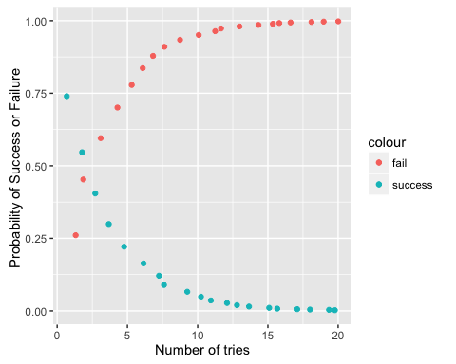

Note that the echo = FALSE parameter was added to the code chunk to prevent printing of the R code that generated the plot.