# Course Introduction and syllabus

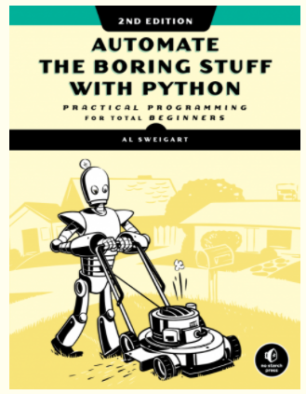

<https://automatetheboringstuff.com/>

# 

# 

## What we’ll learn

* Automate tasks on computers by writing simple Python programs.
* Write programs that can do text pattern recognition with "regular expressions".
* Programmatically generate and update Excel spreadsheets.
* Parse PDFs and Word documents.
* Crawl web sites and pull information from online sources.
* Write programs that send out email notifications.
* Use Python's debugging tools to quickly figure out bugs in your code.
* Programmatically control the mouse and keyboard to click and type for you.

Source: <https://www.udemy.com/course/automate/learn/lecture/3309062?start=0#overview>

## Installations:

**Python:** [**https://www.python.org/**](https://www.python.org/)

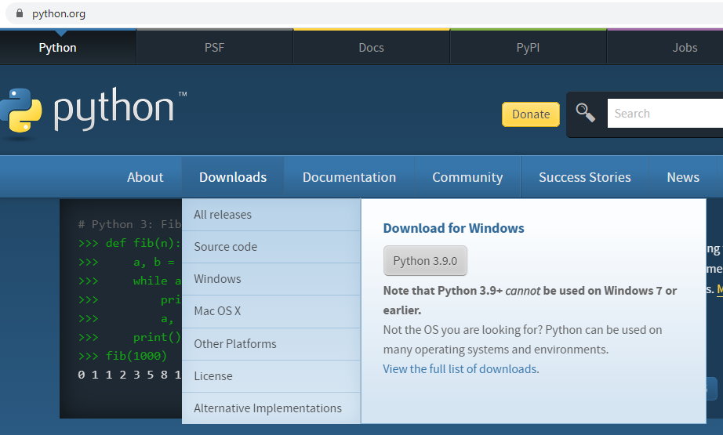

**Python Interpreter or IDE:**

* Built in**:** IDLE (used in this course)
* Third party: <https://codewith.mu/>, <https://www.jetbrains.com/pycharm/>, many others

# Basics

## **Expressions, Statements (one line codes)**

* Start IDLE
* Lets get familiar with
  + Shell, scripts
  + Expressions
  + Data types
  + Variables

**Exercise:** Open IDLE and print Hello Word on the shell terminal.

**Exercise:** Find 30 time 345.4 on the terminal

**Exercise:** Do ¾ + 5 in the terminal

**Exericse:** Do 1+ 2/3 in the terminal

**Exericse:** Do (1+2)/3 in the terminal

**Exericse:** Try to add a string and a number

**Excercise:** What do you think will happen if I type

|  |
| --- |
| 'Python' + 20 |

**Excercise:** What do you think will happen if I type

|  |
| --- |
| 'Python' + 'is cool' |

This is called **string concatenation**

**Exercise:** Try this expression

|  |
| --- |
| "India" *3 |

**Exercise:** Try running

|  |
| --- |
| "hello"/5 |

**Exercise**: Guess the output and verify

|  |
| --- |
| 'What' + '?'*10 |

### **Variables:**

Saving values in computer memory so that we don’t have to type or calculate again and again.

|  |
| --- |
| fName = "Ajit" print(name) |

|  |
| --- |
| lName = name + "Kumar" fullName = fName + " " + lName |

print(fullName)

**Exercise:** Try and evaluate these lines of explain what is happening

|  |
| --- |
| a = 10 print (a) a = 20 *# variables can be reused* print(a) |

**Exercise: Try this. Explain the output of this line**

|  |
| --- |
| a = 10 a = a + 23  print(a) |

**Recap:**

* Where to start programming in Python?

* IDLE
* Interactive shell
* File editor
* Data type:
  + 4 is an **int** datatype
  + 4.0 is a **float** datatype
  + “Hello” or “4” is a **string** datatype
* Expressions/statements: Any single line command we run on shell
  + print(“hello world”)
* Variables:
  + a = 3.0, etc
  + b = “coding is boring”

## 

## **Writing codes in File Editor and Running:**

Multiple commands are passed to computer in one shot. The lines will be executed on line at a time.

**Exercise:** Create a new python file, type the code below and run.

|  |
| --- |
| print( "Hello file editor") |

**Exercise:** Create a new python file, type the code below and run.

|  |
| --- |
| a = 20  b = 30  X = a + b  print(x) |

**Exercise:** Create a new python file, type the code below and run.

|  |
| --- |
| print("Hello. I can double any number. Type any number of your choice:") number = input() print("You printed: ", number) print("Its double is:", 2*number) |

Noting something weird? Guess the reason and try to fix it. Feel free to use Google.

**Exercise:** Create a new python file, type the code below and run.

|  |
| --- |
| print("I can count how many characters are there in your name. What is your name?") name = input() length = len(name) print("you have ", length, " characters in your name") |

**Exercise:** In the codes, add some human readable comments but which will be ignored by python. Why do we need comments?

**New functions learned: (play around with it)**

int(), str(),

**Exercise:** Write a program, which asks the user for their age, and prints out how old they will be after 5 years.

# Program Flow Control

## What if scenarios

**Exercise:** Write a program which

* Asks user to input his/her name and sex
* The greets with a hello “Mr. X” or “Mrs. X” depending on the response

**Exercise:** Write a program which

* Asks user to input an number
* The program checks if the number is even or odd.
* Prints out different message in each case.

**Exercise:** Write a program which

* Ask user to input an email address.
* Checks if the input is a valid email address or not. (By looking for “@” character )
* Throughs out some warning kind of message if it is not a valid email address.

**Exercise:** Write a program which asks user to create password which must be

* Of 8 < lenth < 16
* Must have at least one of these special characters: @, !
* Check if the password is valid
* Throughs out some warning kind of message if it is not valid

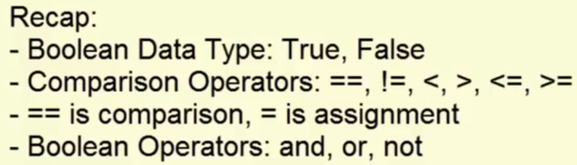

## 

## Repeat an action over and over again

* **for** loop
* **while** loop

**Exercise:** Type and run this code in a new file. Explain line by line

|  |
| --- |
| name = '' while name != 'Ajit':  print("who is the best coder in the world?")  name = input() print("Yes you are right. ", name, " is the best coder in the world") |

**Exercise:** Type and run this code in a new file. Explain line by line

|  |
| --- |
| number = 1 while (number %2) != 0:  number = input("enter an even number:")  number = int(number) print("ok") |

**Exercise:** Write a for-loop program for printing which prints out each letter of the given string in a separate line.

|  |
| --- |
| text = "Hello for loop" n = len(text) for i in range(n):  print(text[i]) |

**Exercise:** Repeat the above exercise to print every alternate characters.

**Exercise:** Repeat the above exercise to print and print each character

* And stop if the program hits a **space** character (if any)

### break & continue

**Exercise:** Study these codes and try to guess the use of **break** and **continue** keywords.

|  |
| --- |
| text = "Hello for loop" for c in text:  if c == ' ':  break  print(c) |

|  |
| --- |
| text = "Hello for loop" for c in text:  if c == ' ':  continue  print(c) |

**Exercise:** Write a progam to find the sum of first n numbers

|  |
| --- |
| n = 100  total = 0 for i in range(1,n+1):  total = total + (i)  print("Sum of first ", n, "natural number = ", total) |

**Exercise:** Modify the above program to find the square, cube, square roots, etc of first n numbers.

# Functions

Functions are pre-written codes which we can use repeatedly by simply calling their name.

## Python’s built in standard functions

We don’t need to import anything to use these.

We have already seen some examples of fucntions

|  |
| --- |
| int(); str(); print() |

**Exercise:** File opening, reading and writing

* Create a text file, say demo.txt.
* Write two three meaningless lines in it.
* In the same folder, create an empty file **fileReading.py**
* Write code in fileReading.py which will read the data from demo.txt and print in IDLE shell.

|  |
| --- |
| f = open("demo.txt", "r") *# "r" for reading, "w" for overwriting,*  *# "" for appending*  fileContent = f.read() print(fileContent) |

**Exercise:** Add something more to this file

|  |
| --- |
| f = open("demo.txt", "a") f.write("hello how are you?\n") f.close() |

**Exercise** Run the above code without "\n"

For some functions which are **pre-installed.** We need to **import** them

**Exercise:** Import **math** module

|  |
| --- |
| import math print(math.pi) |

|  |
| --- |
| import math x = ???? *# find square root of 2* |

## Third-party module:

**Need to install** and **then import**

**PANDAS**

**Exercise:** Try to run this code which reads and excel file in the current folder.

Install pandas

|  |
| --- |
| **pip install pandas** |

Run this code to read an excel file in the current directory.

|  |
| --- |
| import pandas as pd df = pd.read_excel("testxl.xlsx") |

**Exercise:** print only the **name** column on the screen

**Exercise:** Create a new columns, twicing the marks and save as a new file.

## 

## Writing our own functions

**Exercise:** Guess the output

|  |
| --- |
| def myPrint():  print("ha ha ha")  print("hi hi hi")  print("ho ho ho")   myPrint() |

**Exercise:** Guess the output

|  |
| --- |
| def myPrint_n_Times(n):  for i in range(n):  print("pak pak")   myPrint_n_Times(10) |

**Exercise:** Guess the output

|  |
| --- |
| myPrint_n_Times() |

**Exercise:** Guess the output

|  |
| --- |
| myPrint_n_Times(10, 20) |

**Exercise:** Guess the output

|  |
| --- |
| def get_n_th_character(s,n):  return s[n]   c = get_n_th_character("India", 2) print(c) |

**Exercise:** Write a function which accepts a string as input, and returns the **first** character of the string

|  |
| --- |
| def get_1st_character(s):  return *# your code here*  print(get_1st_character("love")) |

**Exercise:** Modify the above code to get the last character of the input string.

## Global and local scopes

**Example:**

|  |
| --- |
| x = 0 *# global variable* def testGlobal():  x = 3 *# local variable*  print(x)  testGlobal() print(x) |

**Example**

|  |
| --- |
| x = 0 def testFun():  y = 3    testFun() print(y) *# error* |

**Example**

|  |
| --- |
| x = 0 def testFun():  x = x + 1 *# error* testFun() |

**Example:**

|  |
| --- |
| x = 0 def testFun():  global x  x = x + 1 *# error*   testFun() print(x) |

## Exceptional Handling

A way to let the program continue even if some error happened

Example:

|  |
| --- |
| y = '3'  try:  print("x" + y)  print("all seems ok")  except:  print("some error happened")  *# then rerun with y = 3* |

**Exercise: Guess the number**

|  |
| --- |
| *# This is a guess the number game. import random secretNumber = random.randint(1, 20) print('I am thinking of a number between 1 and 20.') # Ask the player to guess 6 times. """  YOUR CODE HERE  """* |

**Exercise: The Collatz Sequence**

Write a function named collatz() that has one parameter named number. If number is even, then collatz() should print number // 2 and return this value. If number is odd, then collatz() should print and return 3 * number + 1.

Then write a program that lets the user type in an integer and that keeps calling collatz() on that number until the function returns the value 1.

(Amazingly enough, this sequence actually works for any integer—sooner or later, using this sequence, you’ll arrive at 1! Even mathematicians aren’t sure why. Your program is exploring what’s called the Collatz sequence, sometimes called “**the simplest impossible math problem**.”)

# Lists

Variables which contains one or more other objects.

|  |
| --- |
| pets = ['cat', 'dog', 'cow', 'horse'] morePets = ['chicken', 'goat'] |

|  |
| --- |
| *# list concatenation* allPets = pets + morePets |



|  |
| --- |
| *# gets items from list* allPets[2] *# 3rd entry*  allPets[1:3] *# sublist* allPets[-1] *# last list*   *# check if an item is in the list* print('goat' in allPets) print('snake' in allPets) |

|  |
| --- |
| *# for loop with list* pets = ['cat', 'dog', 'horse', 'goat', 'chicken']  *# loop over list* for p in pets:  print(p) |

|  |
| --- |
| *# or this with index* for i, p in enumerate(pets):  print(i,p) |

|  |
| --- |
| *# list of numbers* x = list(range(1,100, 2)) |

**List methods**

|  |
| --- |
| pets = ['cat', 'dog', 'horse', 'goat', 'chicken']   *# position of 'cat'* i = pets.index('cat')  print(i) |

|  |
| --- |
| *# position of something that does not exist* i = pets.index('snake')  print(i) |

|  |
| --- |
| *# other useful method* *# insert()* *# append()* *# remove()* |

|  |
| --- |
| spam = [2,3,-1,2.4,6.2,-2] spam.sort() print(spam) |

|  |
| --- |
| pets.sort() print(pets) |

|  |
| --- |
| pets.sort(reverse=True) print(pets) |

# 

# Dictionary

|  |
| --- |
| *#Create and print a dictionary:*  thisdict = {  "brand": "Ford",  "model": "Mustang",  "year": 1964 }  print(thisdict) |

**Exercise:**

* Get an excel sheet from https://https://data.gov.in/
* Read the sheet in your python program
* Convert the data into a dictionary

# 

# Regular Expressions

Pattern matching, advanced search, eg.

* Find all phone numbers in a page
* Find all email addresss

|  |
| --- |
| *# read file content and*  f = open("resources/sampleText.txt", "r")  fileContent = f.read() |

|  |
| --- |
| *# import regex module* import re |

|  |
| --- |
| *# suppose we are searching for all 4 digit numbers* numberRegEx = re.compile(r'\d\d\d\d')  *# find first 4 digit number* mo = numberRegEx.search(fileContent) *#print(mo.group())*   *# find all 4 digit number* mo = numberRegEx.findall(fileContent) *#print(mo)* |

|  |
| --- |
| *# exericse : find all dates dd/mm/yyyy in the sample text* dateRegEx = re.compile(r'\d\d/\d\d/\d\d\d\d') mo = dateRegEx.findall(fileContent) *#print(mo)* |

|  |
| --- |
| *## group within match* dateRegEx = re.compile(r'(\d\d)/(\d\d)/(\d\d\d\d)') mo = dateRegEx.findall(fileContent) *##print(mo)* |

|  |
| --- |
| *## piping* *## group within match* dateRegEx = re.compile(r'\d\d/\d\d/(2020|2019)') mo = dateRegEx.search(fileContent) *#print(mo.group())* |

|  |
| --- |
| *# match non-fixed length pattern* *#? zero or one appearence* cRegEx = re.compile(r'a?b') mo = cRegEx.search("bcd") *#print(mo.group())* |

|  |
| --- |
| phoneNumberRegEx = re.compile(r'(\+91|0)?(\d\d\d\d\d\d\d\d\d\d)') mo = phoneNumberRegEx.findall("blah blah +918285906156 pak pak 08285906157 quaq quad 9068900900") *#print(mo)* |

|  |
| --- |
| *#+ 1 more times* wordRegEx = re.compile(r'[a-zA-Z]+') mo = wordRegEx.findall("156 pak Padak 08285906157 quaq quad 9068900900") *#print(mo)* |

|  |
| --- |
| numRegEx = re.compile(r'\d+') mo = numRegEx.findall("156 pak Padak 08285906157 quaq quad 9068900900") *#print(mo)* |

|  |
| --- |
| *#* zero or more* numRegEx = re.compile(r'Can I call you\?*') mo = numRegEx.findall("blah blah bla Can I call you???") *#print(mo)* |

|  |
| --- |
| *# {n} exact number of match* phoneNumberRegEx = re.compile(r'(\+91|0)?(\d{10})') mo = phoneNumberRegEx.findall("blah blah +918285906156 pak pak 08285906157 quaq quad 9068900900") *#print(mo)* |

|  |
| --- |
| *# {m,n} m to n repeatting* phoneNumberRegEx = re.compile(r'\d{3,6}') mo = phoneNumberRegEx.findall("blah blah 18 pak pak 0828 quaq quad 906890") *#print(mo)* |

|  |
| --- |
| *# {m,n} m to n repeatting - non-greedy match with ?* phoneNumberRegEx = re.compile(r'\d{3,6}?') mo = phoneNumberRegEx.findall("blah blah 18 pak pak 0828 quaq quad 906890") *#print(mo)* |

**Character class**

\d : is a shorthand character class that matches digits.

\w: matches "word characters" (letters, numbers, and the underscore).

\s : matches whitespace characters (space, tab, newline).

**The uppercase shorthand character classes**

\D, \W, and \S match charaters that are not digits, word characters, and whitespace.

You can make your own character classes with square brackets: [aeiou]

^caret makes it a negative character class, matching anything not in the brackets:

[^aeiou]

|  |
| --- |
| *#^xyz begins with* *# xyz$ ends with xyz* |

|  |
| --- |
| *# dot* *# . : anything except newline* atRegEx = re.compile(r'.*\.pdf') mo = atRegEx.findall(fileContent) *#print(mo)* |

**Exercise:**

|  |
| --- |
| *#Find all email addresses* |

**Exercise:**

|  |
| --- |
| *#Find all hyperlinks: https://* |

**Multiline search**

re.DOTALL

|  |
| --- |
| atRegEx = re.compile(r'.*', re.DOTALL) mo = atRegEx.search("i hate this\n non sense") *#print(mo.group())* |

**ignore cases (capital/small)**

re.I

|  |
| --- |
| *#atRegEx = re.compile(r'.*', re.I)* |

**Exericse**

Find and replace all numbers with **

|  |
| --- |
| phoneNumberRegEx = re.compile(r'(\+91|0)?(\d{10})') textInput = "blah blah +918285906156 pak pak 08285906157 quaq quad 9068900900" newText = phoneNumberRegEx.sub('**',textInput) print(newText) |

**Exericse**

|  |
| --- |
| *# Find and replace all emails with \*\** |

**Exercise**

# google re.VERBOSE

# File handling

Exercise:

Read a file, replace some string using a reg-ex, write the new string in a new file

# Request module

|  |
| --- |
| *# downloading files from the web* *# request is not there built in* *# pip install request in command prompt* |

|  |
| --- |
| import requests res = requests.get("https://krajit.github.io/") print(res.status_code) *# 200 means ok* print(res.text) *# the downloaded file* |

|  |
| --- |
| *# save the downloaded text in a file* open("dump.html","w").write(res.text) |

|  |
| --- |
| *# recommended way to write* dumpFile = open("dumpFile.html","wb") for chunk in res.iter_content(1000000):  dumpFile.write(chunk)  dumpFile.close() |

# Go back to learning about dictionary

# Go back to reading, writing, editing excel files using pandas.

# Semi-final- exercise:

**Objective:** Nifty200 has 200 hundred stocks listed in it. Write a program to extract price history for all 200 stocks. Rank them according to lowest to highest return.

Helpful resource:

* <https://github.com/ranaroussi/yfinance>
* <https://towardsdatascience.com/free-stock-data-for-python-using-yahoo-finance-api-9dafd96cad2e>

# 

# Import module

Create a file myModule.py

|  |
| --- |
| def helloModule():  print ("hello hi how are you?")   x = 2  agents = {  "007": "James Bond",  "008": "Superman",  "009": "Doga"   } |

You can use the code written in another file by the **import** keyword.

|  |
| --- |
| import myModule  myModule.helloModule()  print(myModule.x)  print(myModule.agents) |

We can rename a module after importing for convenience

|  |
| --- |
| import myModule as mm  mm.helloModule()  print(mm.x)  print(mm.agents) |

We can import only part of a module.

|  |
| --- |
| *# partial import of a module* from myModule import helloModule as hm hm() |

**Exercise:**

Create a few module of your own imagination and use it in another code file.

# Class - Object Oriented Programming in Python

Python is an object oriented programming language. Almost everything in Python is an object, with its properties and methods.

|  |
| --- |
| class Person:  def __init__(self, name, age):  self.name = name  self.age = age p1 = Person("John", 36) print(p1.name) print(p1.age) |

Lets add a **method**

|  |
| --- |
| **class Person:  def __init__(self, name, age):  self.name = name  self.age = age  self.bankBalance = 0    def tellaboutYourself(self):  print("Hello my name is " + self.name)    def takeMoney(self,x):  self.bankBalance = self.bankBalance + x  p1 = Person("John", 36) p1.tellaboutYourself() p1.bankBalance  p1.takeMoney(100)** |

**Exercise:**

Add more members in the **Person** class like, weight, sex, birth place, school, etc

**Exercise:**

Add more methodss in the **Person** class like, which prints out your school name, etc

* E.g. take money and increase the bank balance

# 

# Class inheritence

|  |
| --- |
| *# do nothing* class Agent(Person):  pass x07 = Agent('ajit',38) |

# add more members

|  |
| --- |
| class Agent(Person):  def __init__(self, name, age, department):  super().__init__(name, age)  self.dept = department    x07 = Agent('ajit',38,'hacking') |

**Exercise:**

Create a child of the **Agent** class.

**Exercise:**

Create more classes and child classes like

**Exercise:**

Separate your **class** files in a separate module. Use it in another file by calling the **import** keyword.