Feature Selection DEMO using Matlab
By Ph.D. Dimitrios Ververidis and Ass. Prof. Constantine Kotropoulos

The DEMO of feature selection Graphical User Interface is capable of loading a pattern x features matrix and selecting the subset of features that maximizes Correct Classification Rate (CCR).

The DEMO includes 5 feature selection algorithms:
- Sequential Forward Selection (SFS)
- Sequential Floating Forward Selection (SFFS)
- Sequential Backward Selection (SBS)
- Sequential Floating Backward Selection (SFBS)
- ReliefF

Two CCR estimation methods:
- Cross-validation
- Resubstitution

After selecting the best feature subset, the classifier obtained can be used for classifying any pattern.

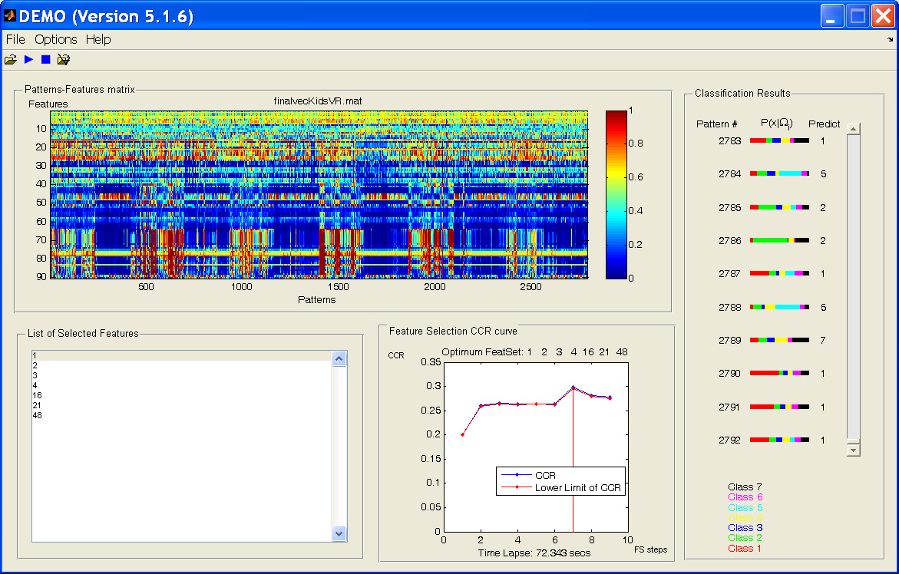
Figure 1: Upper panel is the pattern x feature matrix
Lower panel left are the features selected
Lower panel right is the CCR curve during feature selection steps
Right panel is the classification results of some patterns.

This software was developed using Matlab 7.5 and Windows XP.

Updates: 5.1.4 Named as zero version is the first public available version
5.1.5 A binary format also available with mcc command.
5.1.6 I have added a help menu with our accepted publication
5.1.7 Supports up to seven classes.
5.1.8 Help menu includes the readme file, …

In order to run the DEMO:

In order to run the demo:
- A PC with Windows XP is needed.
- Use Matlab7.5 or later to run DEMO.m

1) Select the ‘finalvec.mat’ dataset (patterns x [features+1] matrix) from 'PatTargMatrices' folder. The last column of ‘finalvec.mat’ are the targets.
2) Press the run button on the panel. It is the second one.
3) After the selection of the optimum feature set, select a set of patterns for classification using the open folder button (last button). It can be the same data-set that was used for training the feature selection algorithm

And the God be with you.

Copyright: D. Ververidis and C.Kotropoulos
AIIA Lab, Thessaloniki, Greece,
jimver@aiia.csd.auth.gr
costas@aiia.csd.auth.gr

References

[1] D. Ververidis and C. Kotropoulos, "Fast and accurate feature subset selection applied into speech emotion recognition," Els. Signal Process., vol. 88, issue 12, pp. 2956-2970, 2008.
[2] D. Ververidis and C. Kotropoulos, "Optimum feature subset selection with respect to the information loss of the Mahalanobis distance in high dimensions," major revision submitted to PAMI, 2009.
[3] Pascal Getreuer and Didier Clamond matlab implementation of Corless, Gonnet, Hare, Jeffrey, Knuth, "On the Lambert W Function", Advances in Computational Mathematics, vol. 5, 1996, pp. 329-359.
[4] R. Kohavi, G. John, Wrappers for feature subset selection, Artificial Intelligence, vol. 97, 1997, pp. 273–324.
[5] P. Pudil, J. Novovicova, J. Kittler, Floating search methods in feature selection, Pattern Rec. Letters, vol. 15, 1994, pp. 1119–1125.

