

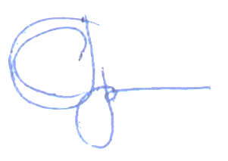 Manuscript copyright

Gulay Stanislav Leonidovich

MULTI-OBJECTIVE OPTIMIZATION

ELECTRICAL MACHINE DESIGNS BASED ON

NON-DOMINANT SORTING ALGORITHMS

05.09.05 — Theoretical electrical engineering

ABSTRACT

of thesis for the degree PhD

Saint Petersburg

2022

Thesis is done in the Federal State Autonomous Educational Institution of Higher Education "Peter the Great St. Petersburg Polytechnic University" at the "Higher School of High Voltage Power Engineering" at the "Institute of Power Engineering"

|  |  |
| --- | --- |
| Scientific supervisor: | Korovkin Nikolay Vladimirovich  Doctor of Technical Sciences, Professor |
| Official opponents: | Dovgun Valery Petrovich  Doctor of Technical Sciences, Professor of the Federal State Autonomous Educational Institution of Higher Education "Siberian Federal University", Professor, Head of the Scientific and Educational Laboratory of Information Systems in Power Engineering.  Kadi-Ogly Evgeny Fedorovich  Candidate of Technical Sciences, Director of Energy Equipment of Limited Liability Company "Turbine Technologies AAEM" (LLC "AAEM"). |
| External Reviewer: Federal State Budgetary Educational Institution of Higher Education National Research University "MPEI", Moscow. (Federal State Budgetary Educational Institution of Higher Education "National Research University "MPEI"), Moscow. | |

Thesis Defense will be held 25/05/2022 at 12:00 p.m. at a meeting of the Dissertation Committee U.05.09.05 of the Federal State Educational Institution of Higher Professional Education "SPbPU" at: 195251, St. Petersburg, Polytechnicheskaya st., 29, Main Academic Building, Aud. 176. Thesis can be found in the fundamental library and on the website of the Federal State Educational Institution of Higher Professional Education "SPbPU": http://www.spbstu.ru

The abstract is sent on “___” April 2022.

|  |  |  |
| --- | --- | --- |
| Academic Secretary  of Dissertation Council U.05.09.05,  Candidate of Technical Sciences, Associate Professor |  | Tatyana Gennadyevna Minevich |

1. GENERAL OVERVIEW OF WORK

Relevance of the research topic. One of the central problems, solved at designing and construction of electric machines is connected with repeated calculation of dependences between the basic parameters, given in the form of system of formulas, empirical coefficients and graphic dependences with the purpose of search of optimum parameters by the solution of this system of equations.

As it is known, the account of complementary interaction of parameters on target functions at designing of electric machines is the difficult multivariate task demanding multi-objective optimization. The choice of optimum parameters is complicated by complexity of algorithm of calculation of the electric machine by formulas of designing, and necessity to consider cost of the machine, reliability and manufacturability of design. This is the reason why the optimum electrical machine options are selected based on the extensive use of computing machines, the skills and intuition of the designer, and operating experience.

Objective of the dissertation. To create a design methodology for competitive hydro-generators in the power engineering market, based on multi-objective optimization, to approve this methodology to improve the reference design of a hydro-generator, and to analyses and summarize the results obtained. In order to achieve the goal, the following was required:

1. selection and justification of a set of optimality criteria for hydro-generator design;
2. development, justification and software implementation of computationally effective parametrized model;
3. development and approbation of the method, comparison of results of its usage with available designs;
4. development of method of construction of Pareto set in space of optimality criteria for reference design of hydro-generator;
5. obtaining of dependences of parameters for individual cluster structural groups for reference hydro-generator.

Research objectives:

1. to select a number of criteria for optimality of hydro-generator design;
2. develop a software implementation of a parameterized model;
3. to develop multi-objective optimization methodology;
4. to develop a methodology of constructing a Pareto set in the optimality criteria space;
5. to determine the dependencies of parameters for particular cluster structural groups on the basis of correlation analysis;
6. to estimate perspectivity of the technique and to define the expedient place of its use in process of hydro-generators designing.

Objects of research: design of generator for hydropower plants, finite element model of generator, methods of multi-objective optimization and genetic algorithm.

Subjects of research: multi-objective optimization of hydro-generator design model, formation of cluster structures, correlation and regression analysis based on obtained data.

Scientific novelty:

1. a parametrized two-dimensional finite element model of hydro-generator is developed, allowing to determine the selected optimality criteria;
2. methodology of calculation of losses in active steel of stator core and rotor poles caused by hysteresis and eddy currents was developed. It differs from traditionally used methodology by discretization of calculation area, taking into account saturation of separate parts of magnetic circuit of generator and division of losses according to Bertotti formulation;
3. methodology for calculation of distortion coefficient of sinusoidal line voltage curve and inductive resistances has been developed;
4. developed a set of optimality criteria for constructing a Pareto set, reflecting economic performance and key technical parameters;
5. the set of program script files, realizing proposed MOO method and FEM calculation with characteristic parameters (50'000÷150'000 finite elements, discretization in time - 200 steps for one period and calculation time of one problem - 20÷40 minutes) was developed;
6. the dependencies of parameters for particular cluster structural groups based on the correlation analysis have been obtained, which can be used to reduce computational complexity, to reduce CPU time, to create regression models and to explore other methods of multi-objective optimization.

Theoretical significance of the research: new approach to optimization of rotating electric machine design has been proposed, tested for hydro-generators and possibility of effective algorithmic implementation of the new approach on modern computers has been confirmed.

Practical significance of the research: a set of optimality criteria is created, substantiated and tested. A set of software scenario files for implementation of MOO, integration with FEM computational module, formation of Pareto set, its clustering, correlation and regression analysis was created. In contrast to existing approaches the possibility of optimization of hydro-generator parameters on the basis of the method taking into account complementary interactions of target functions is realized for the first time. Implementation of the method is carried out on a modern computer. Designs of generators surpassing parameters of reference machine are obtained. For model A: mass of stator core is 3% less, rotor current 2% less, steel losses 1% less; model B: mass of stator core is 1.5% less, rotor current 1.5% less, steel losses 1% less, - 3% less; model C: rotor current 2% less, steel losses 7% less and distortion sinusoidal curve of stator's line voltage THD less by 36%.

Key points made for protection:

1. a set of optimality criteria for hydro-generator design, reflecting economic indicators and main technical parameters is proposed, substantiated and tested;
2. parameterized two-dimensional finite-element model of a hydro-generator, allowing determining target functions, is developed. Vector of model design parameters includes 13 geometric dimensions (total number of varying parameters for different models is 29);
3. the methodology of calculation of losses in stator core active steel and rotor poles from hysteresis and eddy currents was developed for optimization algorithm. In the framework of FEM software, the loss partition model defined by Bertotti equation is selected;
4. for reliable comparison the method of calculation of distortion coefficient of sinusoidal curve of linear voltage and inductive resistances is developed;
5. the multi-objective optimization algorithm was adapted to the optimization problems of the electrical machines;
6. the set of program script files realizing proposed MOO method and FEM calculation was developed, which allowed to automate the process of calculation of magnetic fields and target functions;
7. on the basis of correlation analysis of separate cluster structural groups dependences of hydro-generator parameters were obtained that may serve as a basis for reduction of total calculation time, creation of regression models or investigation of other methods of multi-objective optimization.

The thesis corresponds to the specialty 05.09.05 - theoretical electrical engineering. The scientific results obtained in the work correspond to item 1 "Experimental and computational research of weak and strong electromagnetic fields in electrical, electric power, electrophysical, information, control and biological systems", item 2 "Experimental and computational research of electric, electronic and magnetic circuits" of the passport of specialty.

Probation of the work: the report on the topic of the thesis was made at an international conference (St. Petersburg), the material in the form of an article in English was published in the journal IOP Conference Series: Materials Science and Engineering.

Publications: 4 theses have been published on the topic of the thesis.

Author's personal contribution: the statements submitted for defense were received by the author personally.

Organizations, factories interested in the results of the work: JSC "Power machines".

Numerical definition: number of computational cases for one model is 40'000 at ~ 50'000÷150'000 of finite elements with time discretization of 200 steps. Single computation time is 20÷40 min.

Software realization: The comprehensive platform ANSYS Electronics Desktop with the Maxwell calculation module and The MathWorks MATLAB.

Structure and summary of the distance: The thesis consists of 132 pages and consists of an introduction, three chapters, a conclusion, a list of references (104 titles), a list of abbreviations and terms, a glossary of terms and applications. The work contains 65 figures and 11 tables.

1. SUMMARY OF WORK

The introduction substantiates the relevance of the thesis work, formulates the goal and argues the scientific novelty of the research, presents the scientific significance of the results obtained, and presents the main provisions to be defended.

The first chapter gives a brief analysis of the known models, methods and algorithms of multi-objective optimization. Metaheuristic methods, which include evolutionary methods, are considered to be the main tool for finding a global extremum. Strictly speaking, these methods do not guarantee finding a global optimum; however, there is a high probability that either it or a solution close enough to it will be identified.

One of the promising evolutionary methods is the improved genetic algorithm NSGA-II for non-dominant sorting. This algorithm is one of the most used, as it allows us to optimize complex functions and is very fast. Literature analysis shows that the application of NSGA-II algorithm is effective in optimizing the design of electrical machines and distributed power systems.

It is also noted its significant drawback, like most evolutionary algorithms based on Pareto-dominance, associated with the complexity of solving MOO problems with more than three criteria: not representative of the Pareto set approximation and reduced selection pressure. Despite the above drawback, the set of optimality criteria chosen in solving MOO problems of electrical machines does not exceed four and does not contribute significantly to the approximation of the Pareto set. NSGA-II is chosen as the main optimization algorithm for our MOO problem.

In the second chapter a number of target functions are proposed, justified and tested, selected according to the criteria of minimum manufacturing costs and maximum efficiency:

* stator, rotor and damping rod steel losses in no-load operation at nominal stator voltage (hereinafter referred to as "iron losses");
* stator line voltage sinusoidal distortion factor ;
* rotor winding current ;
* short circuit ratio and/or synchronous inductance along the longitudinal axis ;
* super-transient inductive resistance along the longitudinal axis ;
* mass of stator core .

To determine these parameters, it is necessary to use different types of tasks (the exception is the mass of stator core, which is not related to the task type). For the first three, it is appropriate to use unsteady magnetic field at rated rotor speed ; for the latter, it is appropriate to use magnetostatic field.

A parameterized two-dimensional finite-element model of the hydro-generator has been developed. In this paper, the vector of design parameters includes 13 geometric dimensions: outer and inner diameters of stator core (and ); stator active steel length ; stator slot height and width ( and ); air gap size between rotor and stator ; width, height and radius of curvature of the rotor pole tip ( and ); width of the rotor pole core ; diameter, radius of location and width of slot of damper rods (, and ). Their initial values as well as geometric parameters uniquely defining two-dimensional model of hydro-generator (total number of possible varying parameters is 29) are found by classical methodology. Figure 1 shows the parametrized model of the hydro-generator, with the main varying dimensions marked.

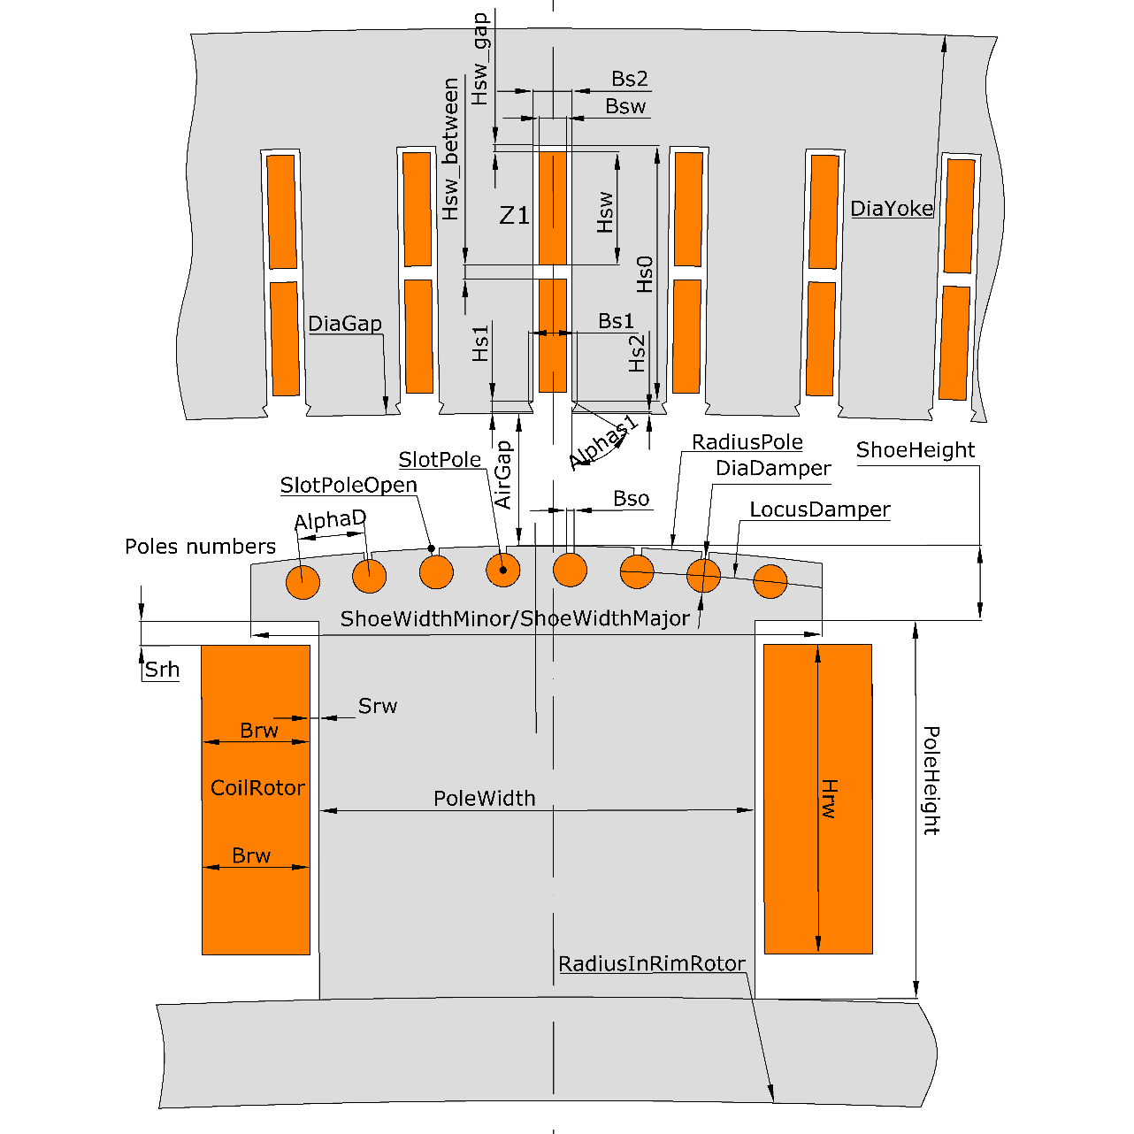

Figure 1 - Parametrized two-dimensional hydro-generator model

A number of assumptions are used to simplify the construction, formulation and calculation:

* the magnetic field is plane-parallel and does not vary along the length of the model;
* we consider only one component of the vector magnetic potential (in the direction along the length of the model) is considered;
* properties of the magnetic cores are modelled based on the basic magnetization curve of the steel;
* the cores of the magnetic cores along the length of the model are assumed to be homogeneous;
* electric insulation of elementary conductors of stator winding and rotor coils is not considered. The stator winding cores and rotor coils are modelled as monolithic;
* case electric insulation of stator and rotor windings, stator fiberglass wedges are assumed to be non-magnetic and non-conductive;
* magnetic field does not extend beyond the stator core;
* no eddy currents are induced in magnetic system except for rotor damper winding;
* the geometry of the model is determined by the nominal dimensions of the parts or assemblies.

The FEM software has chosen a model for separating the steel losses in the stator core and rotor poles from hysteresis and eddy currents, determined by the Bertotti equation:

, Wm-3

- specific hysteresis loss at maximum induction and frequency , Wm-3

- specific losses from eddy currents, Wm-3;

- specific additional losses, Wm-3;

- coefficient of losses from hysteresis, Wm-3T-2s;

- coefficient of losses from eddy currents, Wm-3T-2s2;

- coefficient of additional losses, Wm-3T-1.5s1.5.

For comparison, a model that takes into account spatial and temporal characteristics of the magnetic field is also presented. It is known that pulsating magnetic flux exists only in the stator tooth while the rest of the stator is circular or elliptical. The proportionality factor is used to distinguish between pulsating and rotating magnetic fields. Obviously, the pulsating field prevails in the stator slots, while the rest of the stator is rotating from almost circular to elliptical . To illustrate the above, figure 2 shows the distribution of and the change in over the period .

The phenomenological validity of the steel loss model, which takes into account the rotating magnetic field, is higher than the Bertotti model. However, the comparative analysis of application of two models of iron losses for thirteen hydro-generators in a range of rated capacities from 9 to 640 MW and review of literature testifies that application of model on the basis of Bertotti equation, differing high speed and sufficient accuracy, is acceptable: the average sum of square deviations of model by Bertotti is 16%, by - 14%, by classical method - 38%.

Validation of the numerical calculation models has been carried out for thirteen hydro-generators. The main results of the calculations are presented in Table 1.

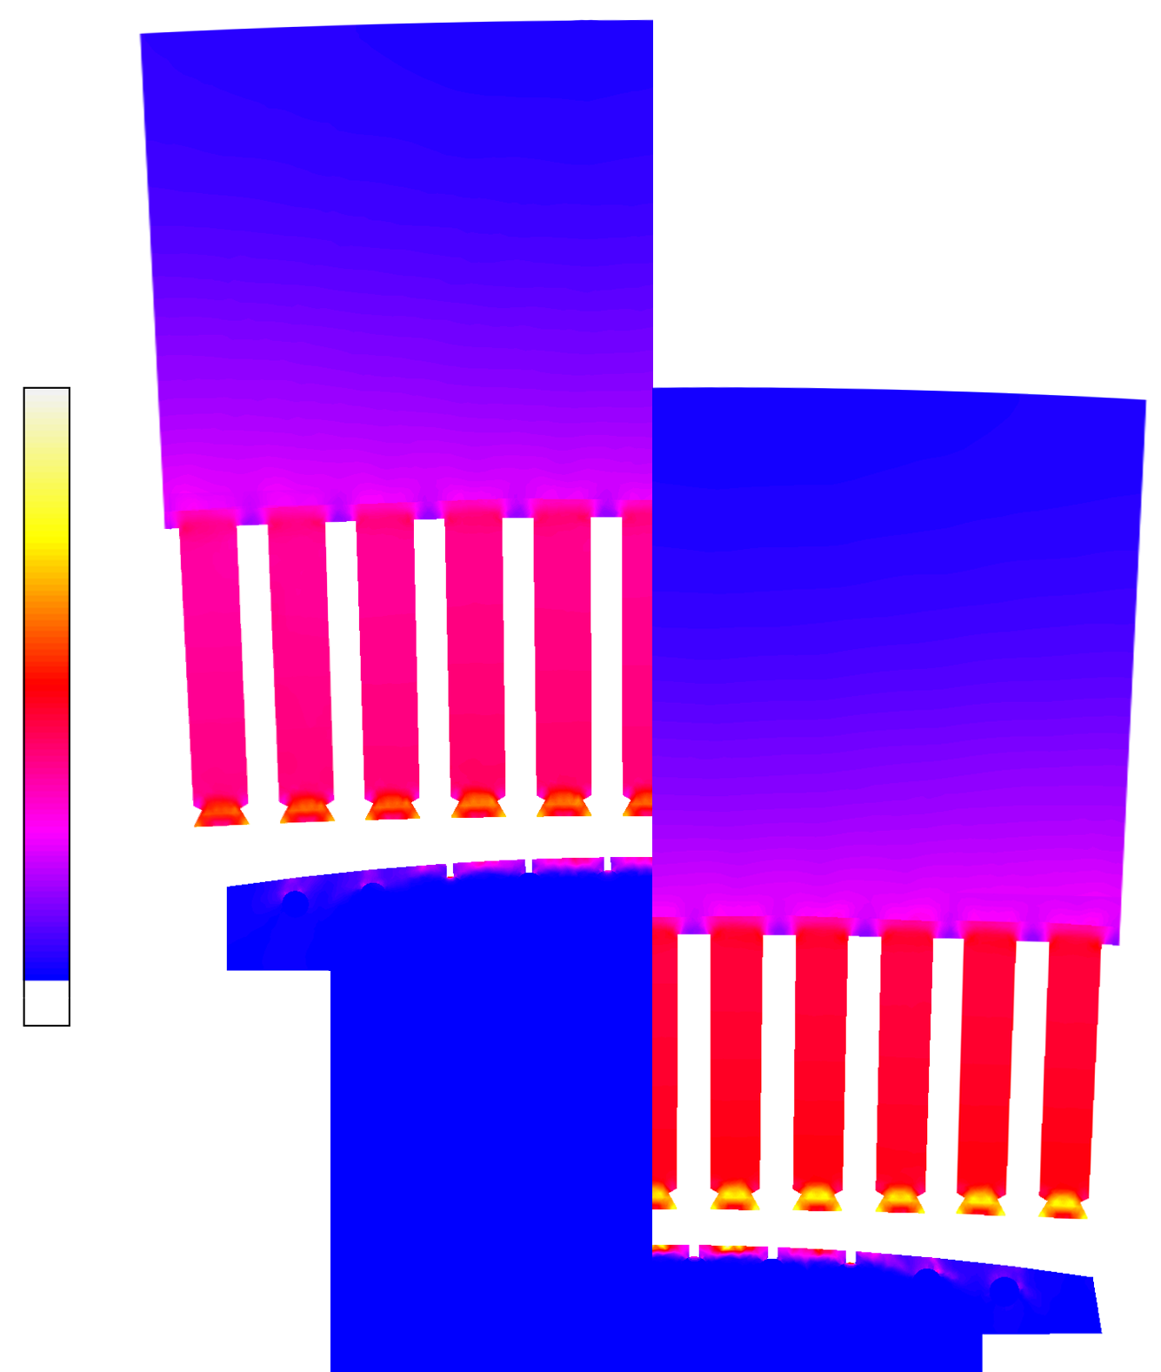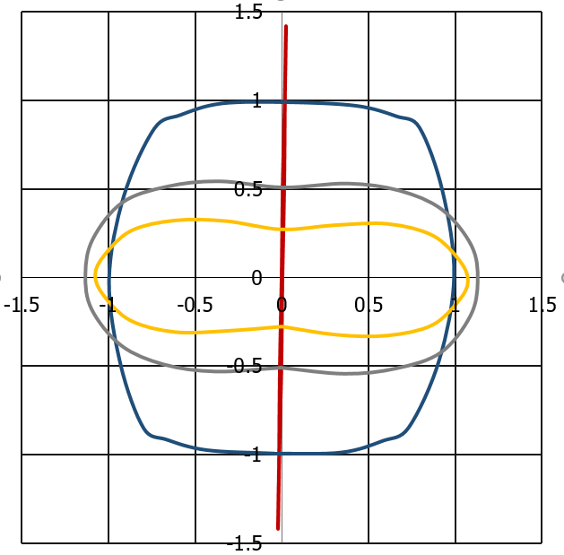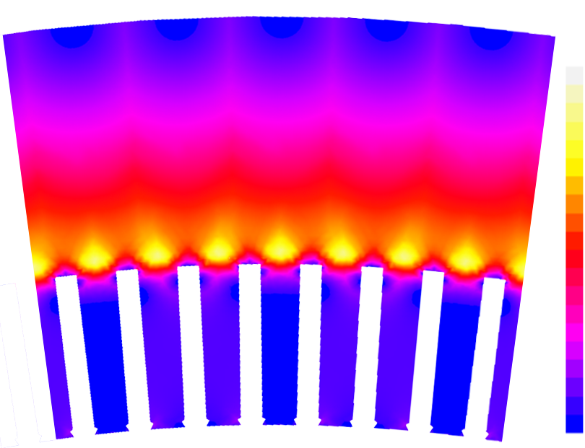

1.0

0.9

0.8

0.7

0.6

0.5

0.4

0.3

0.2

0.1

0

, p.u.

Y

X

**—** – point №1;

**—** – point №2;

**—** – point №3;

**—** – point №4

1.

Вy, Т

Вx, Т

4.

3.

2.

Figure 2 - Distribution of proportionality factor (left) and change in at four points over T=0.02 s in no-load mode at rated voltage of Baksan hydropower plant

Table 1 — Basic data on hydro-generators

|  |  |  |  |  |  |  |  |  |  |  |  |  |  |  |  |  |  |  |  |  |  |  |  |  |  |  |  |  |
| --- | --- | --- | --- | --- | --- | --- | --- | --- | --- | --- | --- | --- | --- | --- | --- | --- | --- | --- | --- | --- | --- | --- | --- | --- | --- | --- | --- | --- |
| Station  Parameters | | | | | Sao Joao | Sayana-Shusenskaya | | Baksan | | La Eska | | | Saratovskaya | Djerdap | | Rybinskaya | | | | Nizhnekamskaya | | Volzhskaya | Punta-Negro | Nuoja | | Plyavinas | | Kigi |
| Active power, МW | | | | | 39.69 | 640 | | 9 | | 375 | | | 54 | 190 | | 65 | | | | 78 | | 125.5 | 31.45 | 34.2 | | 96.6 | | 45.9 |
| Rotation speed,  1/min | | | | | 138.46 | 142.86 | | 500 | | 150 | | | 75 | 71.43 | | 62.5 | | | | 57.69 | | 68.18 | 300 | 136.36 | | 88.24 | | 375 |
| Frequency, Hz | | | | | 60 | 50 | | 50 | | 60 | | | 50 | 50 | | 50 | | | | 50 | | 50 | 50 | 50 | | 50 | | 50 |
| Stator voltage, kV | | | | | 13.8 | 15.75 | | 6.3 | | 17 | | | 10.5 | 15.75 | | 13.8 | | | | 13.8 | | 13.8 | 13.8 | 10.5 | | 13.8 | | 13.8 |
| Type of stator  assembly | | | | | S | R | | R | | S | | | S | R | | R | | | | R | | R | R | S | | R | | S |
| Iron losses | | | | | | | | | | | | | | | | | | | | | | | | | | | | |
|  | | | kW | 180 | | | 1103 | | 38 | 1527 | | 225 | | | 565 | 217 | | | 282 | | | 567 | 124 | 127 | 366 | | 178 | |
|  | | | 199 | | | 1278 | | 67 | 1215 | | 222 | | | 673 | 379 | | | 446 | | | 680 | 150 | 160 | 430 | | 212 | |
|  | | | 161 | | | 1135 | | 41 | 1252 | | 202 | | | 554 | 265 | | | 342 | | | 508 | 103 | 144 | 273 | | 130 | |
|  | | | 148 | | | 1133 | | 40 | 1303 | | 202 | | | 540 | 271 | | | 337 | | | 514 | 115 | 146 | 306 | | 145 | |
|  | | | % | 11 | | | 16 | | 78 | -20 | | -1 | | | 19 | 74 | | | 58 | | | 20 | 21 | 26 | -18 | | -19 | |
|  | | | -10 | | | 3 | | 9 | -17 | | -9 | | | -2 | 22 | | | 21 | | | -10 | -17 | 14 | -25 | | -26 | |
|  | | | -18 | | | 3 | | 7 | -15 | | -9 | | | -4 | 25 | | | 20 | | | -9 | -8 | 15 | -16 | | -18 | |
| Electromagnetic parameters | | | | | | | | | | | | | | | | | | | | | | | | | | | | |
| Test |  | % | | - | | | 0.850 | 0.970 | | | 0.350 | | 0.860 | | - | | - | 1.300 | | | 0.400 | | 0.450 | 0.640 | - | | 0.450 | |
|  | p.u. | | 1.040 | | | 1.803 | 1.000 | | | 0.920 | | 1.180 | | 1.380 | | 0.760 | 0.760 | | | 0.650 | | 1.080 | 0.855 | 1.076 | | 1.095 | |
|  | А | | 560 | | | 1520 | 350 | | | 972 | | 600 | | 897 | | 740 | 770 | | | 1305 | | 530 | 750 | 687 | | 412 | |
| FEM |  | % | | 0.312 | | | 0.544 | 0.721 | | | 0.261 | | 0.593 | | 0.800 | | 0.392 | 0.987 | | | 0.178 | | 0.393 | 0.550 | 0.395 | | 0.344 | |
|  | p.u. | | 1.029 | | | 1.590 | 1.020 | | | 0.805 | | 1.150 | | 1.236 | | 0.713 | 0.757 | | | 0.602 | | 1.057 | 0.928 | 0.992 | | 1.063 | |
|  | % | | -1 | | | -12 | 2 | | | -13 | | -3 | | -10 | | -6 | -1 | | | -7 | | -2 | 9 | -16 | | -3 | |
|  | А | | 535 | | | 1544 | 334 | | | 1119 | | 565 | | 960 | | 770 | 788 | | | 1235 | | 520 | 635 | 760 | | 425 | |
|  | % | | -4 | | | 2 | -5 | | | 15 | | -6 | | 7 | | 4 | 2 | | | -5 | | -2 | -15 | 11 | | 3 | |
| Analytical  calculation |  | p.u. | | 1.070 | | | 1.600 | 1.000 | | | 0.800 | | 1.150 | | 1.230 | | 0.780 | 0.740 | | | 0.590 | | 1.100 | 0.867 | 1.070 | | 1.050 | |
|  | % | | 3 | | | -11 | 0 | | | -13 | | -3 | | -11 | | 3 | -3 | | | -9 | | 2 | 1 | -1 | | -4 | |
|  | А | | 620 | | | 1490 | 385 | | | 1000 | | 670 | | 965 | | 825 | 774 | | | 1120 | | 560 | 730 | 830 | | 435 | |
|  | % | | 11 | | | -2 | 10 | | | 3 | | 12 | | 8 | | 11 | 1 | | | -14 | | 6 | -3 | 21 | | 6 | |

*Note: Two types of stator core assembly are indicated, namely S - the stator core is assembled from sectors and R - the stator core assembly is made without joints, the so-called "ring".*

In the third chapter the calculation of three problems for forty generations with the number of individuals in the population of one thousand: Sayano-Shushenskaya HPP — model A, Baksan HPP — model B and La-Eska HPP — model C was performed. It is noted that the criteria move to steady-state values in the last generations of the calculation.

To speed up the solution, a parallel calculation process using one processor core for each task has been applied. The computation time using a 24-core processor was about two weeks for each model. However, an unsolved problem was the performance of parallel calculation on cluster computers. The main difficulty is the lack of a clear toolkit for generating parallel MATLAB and ANSYS Electronics Desktop threads.

Populations of the first, second and last generations are presented. It is evident that arbitrary choice of geometrical parameters typical for the first generations does not lead to the desirable result: in figure 3 populations of the first and the last generations of model B are presented. The results of numerical calculation of a reference hydraulic generator designed by classical method and operated at the Customer site are taken as basic values. The point corresponding to the reference generator is highlighted in white in the figures, with projections on the planes. The projections on the approximating surface of the Pareto set limit the area with hydro-generator designs that are superior to the reference generator according to the selected criteria.

The selection of a single solution from the Pareto set is made by the decision maker and is based on a subjective evaluation of the quality criteria and the relationship between them. In the general case, having only a set of possible solutions and a set of criteria within a multicriteria problem model, no decision maker can make a reasonable and single Pareto-optimal choice, as it is necessary to extend the choice model by involving additional information about the preferences of the decision maker. This issue is not addressed in this paper.

At the same time, we have obtained generator designs superior to the reference machines. For model A: mass of stator core is 3% less, rotor current 2% less, steel loss 1%; model B: mass of stator core 1.5% less, rotor current 1.5% less, steel loss 1% less, 3% less; model C: rotor current 2% less, iron loss 7% less and 36%.

Iron

losses, p.u.

Iron

losses, p.u.

|  |  |
| --- | --- |
| Rotor  current, p.u.  Mass of stator  core, p.u. | Mass of stator  core, p.u.  Rotor current, p.u. |
| Figure 3 - Pareto set of the first (left) and the last (right) generation of model B | |

Clustering of the last ten generations by k-means method with selection of the number of clusters by the Kalinsky-Harabash variance criterion was performed. While the Pareto set is obtained by optimization, the individual groups are clustered by clustering, and the area of greatest interest is highlighted. The detection and removal of outliers by the median absolute deviation method with bandwidth assignment is also performed [1, 99].

A formalization of the term "golden mean" (in all models corresponding to cluster No.1, Figure 4) in relation to the reference oscillator is considered. This cluster is characterized by intermediate geometric sizes of adjacent groups. It is expedient to form boundary conditions for geometric parameters at the stage of calculation of first generations and the basis of the region of interest, which significantly reduces the volume of necessary calculations.

Detection of multicollinearity by variance inflation coefficients, standardized regression coefficients, Balsley method, regression trees and random forest together with correlation analysis allows to determine a set of main predictors of regression models.

Iron losses, p.u.

Δ, p.u.

|  |  |
| --- | --- |
| Stator core  mass, p.u.  Rotor current, p.u.  — cluster No.1  — cluster No.2  — cluster No.3 | parameter  — кластер №1  — кластер №2  — кластер №3  параметр |
| Figure 4 - Clustering of the last ten generations of target functions of model B by k-means method (left) and distribution of parameters across clusters (right). The black dots are remote outliers | |

Before the regression analysis, optimal set selection was carried out on the example of model B, cluster No.1. The parameters are found to be mutually certain ("deterministic") and there is no significant contribution from part of the predictors, which may indicate both overfitting of the models, but most likely a strict dependence of predictors and factors on the set of Pareto-optimal solutions.

A comparative analysis was performed for three regression models: linear, quadratic and random forest. The selection of informative predictors, the consideration of possible interactions between them, the absence of the need to explicitly specify the form of the relationship between the response and the factor variables, and the high coefficient of determination show the efficiency and ease of use of the random forest regression model. Figure 5 to the right shows the relative importance of random forest regression predictors. The importance of the parameters and on mass of stator core and steel losses has the maximum value, as does on rotor current and steel losses. Figure 5 on the left shows the results predicted from three regression models for the rotor current criterion with five predictors . The analysis of Table 2 and Figure 5 on the left shows that the random forest regression is the best regression model of the three presented and the most robust to a reduction in the independent variables. The determinism of the results and the absence of a significant contribution from part of the predictors indicates the strict dependence of the predictors and factors on the Pareto-optimal set of solutions. To check the adequacy of the model, the standard deviation and the coefficient of determination were used.

Table 2 - Standard deviation and coefficient of determination of different regressions

|  |  |  |  |  |  |  |
| --- | --- | --- | --- | --- | --- | --- |
| Set of predictors | MLR | | MPR | | Random forest | |
|  |  |  |  |  |  |
| Mass of stator core | | | | | | |
|  | 0.146 | 0.979 | 0.060 | 0.996 | 0.018 | 0.999 |
|  | 0.137 | 0.981 | 0.040 | 0.998 | 0.003 | 1.000 |
|  | 0.131 | 0.983 | 0.039 | 0.999 | 0.003 | 1.000 |
| whole set | 0.126 | 0.984 | 0.030 | 0.999 | 0.001 | 1.000 |
| Iron losses | | | | | | |
|  | 0.235 | 0.945 | 0.067 | 0.996 | 0.014 | 0.999 |
|  | 0.233 | 0.946 | 0.063 | 0.996 | 0.009 | 0.999 |
| whole set | 0.215 | 0.955 | 0.035 | 0.999 | 0.006 | 1.000 |
| Rotor current | | | | | | |
|  | 0.273 | 0.926 | 0.192 | 0.941 | 0.060 | 0.996 |
|  | 0.239 | 0.943 | 0.128 | 0.984 | 0.010 | 0.999 |
| whole set | 0.229 | 0.949 | 0.093 | 0.991 | 0.007 | 1.000 |

|  |  |
| --- | --- |
| Predicted data, p.u.    Initial data, p.u.  — MLR  — MPR  — Random forest | Relative importance, p.u.    parameter  — mass of stator core, =1,000;  — iron losses, =0,999;  — rotor current, =0,999.  Параметры |
| Figure 1 - Distribution of raw data and data determined by the three regression models for rotor current (black line - ideal model) - left; relative importance of random forest predictors for model B, cluster 1 - right | |

In order to test the adequacy of the regression model, a population consisting of generators exceeding the baseline with coordinates {1; 1; 1} by all criteria in the number of 120 was generated. It is worth noting that the number of generators after NSGA-II satisfying this condition is only three, Figure 6.1. Figure 6.2 shows the population of 120 generators, where each after regression model optimization is below the reference; Figure 6.3 shows the result of checking the previous population with an average error of 1%. Generator designs are obtained that exceed the parameters of the reference machine. The mass of stator core is 2.8% (1.5% - previous NSGA-II value), the rotor current is 1.8% (1.5%), steel losses are 3.5% (1%), - 3.5% (3%).

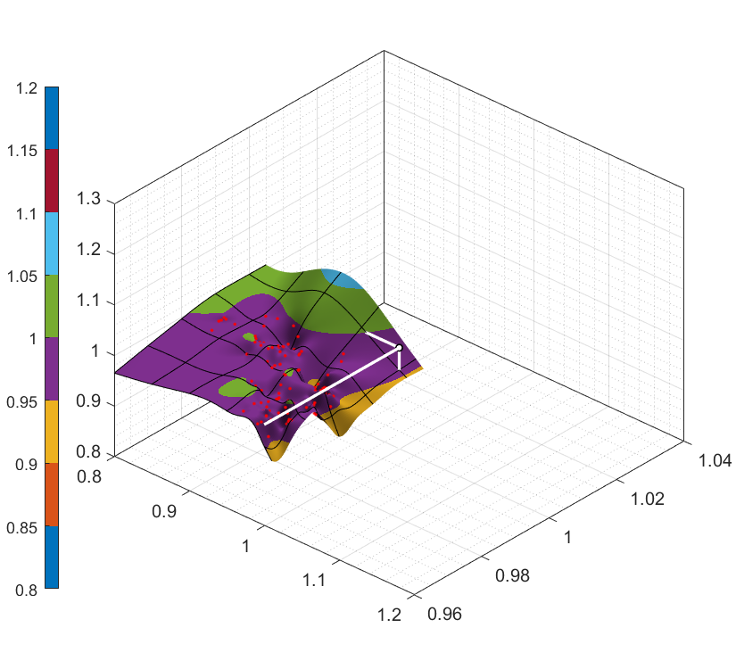

Mass of stator core, p.u.

Rotor current, p.u.

Rotor current, p.u.

Mass of stator core, p.u.

**3**

**2**

**1**

Iron

losses, p.u.

Iron

losses, p.u.

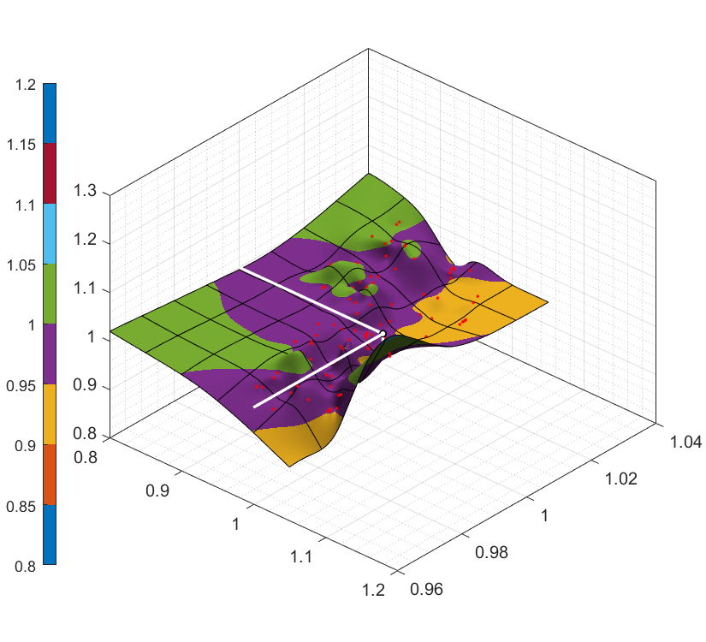

Rotor current, p.u.

Mass of stator core, p.u.

Iron

losses, p.u.

Figure 2 - 1 - Pareto set of the last ten generations of model B; 2 - Pareto set of the regression model with generators surpassing the baseline for all criteria; 3 - Pareto test set of Figure 2**Ошибка! Источник ссылки не найден.**.2.

The main steps of data preparation and regression model selection are identified:

* cluster analysis of multiple Pareto-optimal solutions and selection of a suitable cluster;
* removing outliers by median absolute deviations;
* correlation analysis and normality analysis of scatter plots;
* detection of multicollinearity by variance inflation coefficients, standardized regression coefficients, Balsley method, regression trees and random forest
* selecting the optimal set of predictors and selecting the appropriate regression model;
* assessment of model quality by standard deviation and determination coefficients;
* predicting unknown values of dependent variables.

The described stages of the method for solving a multifactorial design problem allow you to generate not just a few variants for solving the problem, but to define a multidimensional set of Pareto-optimal solutions. Regression analysis and determination of regression functions of cluster groups based on random forest allows to obtain correct and compact models of dependent variables. A flowchart describing the actions of the constructor is presented in Figure 7.

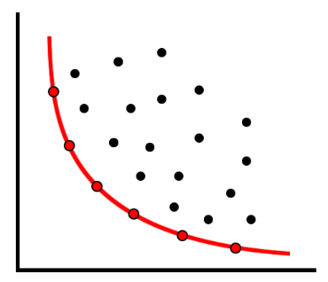

time of operation

Initial data

MOO

weeks -months

minutes

Clustering

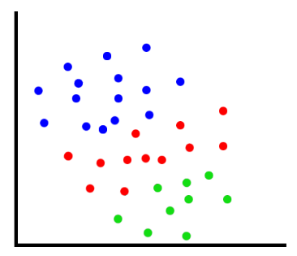

Correlation analysis

Regression analysis

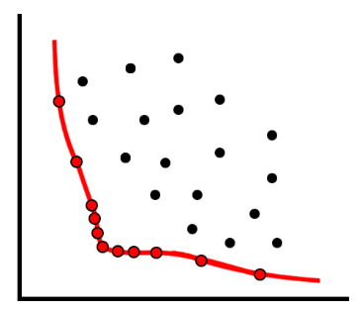

minutes -hours

MOO

hours -days

Test adequacy of model

end

Figure 3 - Schematic diagram of the design methodology and time allocation

1. conclusion

In the dissertation work a new algorithm for solving the problem of optimization analysis of electric machines on the example of hydro-generators is considered. The developed method and complex of multi-objective optimization programs provides decision maker with the effective tool which allows constructing set of Pareto-optimal solutions, substantiating chosen variant, reducing labour input in evaluation of different variants.

The following main results were obtained:

1. A number of target functions of optimality of hydro-generators design by criterion of minimum production costs and maximum coefficient of efficiency is selected;
2. Software implementation of parameterized 2D finite element model of a hydro-generator in the complex platform ANSYS Electronics Desktop with computational module Maxwell using script files of the interpreted programming language Microsoft Visual Basic Script Edition was developed;
3. Technique of multi-objective optimization on the basis of evolutional algorithm of non-dominant sorting NSGA-II with parallel process of calculation based on MATLAB software package was developed;
4. Technique for constructing Pareto set in optimality criteria space was developed;
5. The dependence of parameters of individual cluster structural groups on the basis of correlation analysis was determined;
6. Perspectivity of the method is estimated and its application in hydro-generators designing process is determined.

For further development of the proposed method, it seems necessary to investigate and formalize other factors within the framework of the model. Such factors can form either additional optimality criteria or supplement limitations of combinatorial optimization problem.

1. LIST OF THE AUTHOR'S PUBLICATIONS
2. S. Gulay and D. Verkhovtsev. "On optimization hydro-generator parameters by NSGA-II," IOP Conference Series: Materials Science and Engineering, 2019.
3. N.V. Korovkin, S.L. Gulay, D.A. Verkhovtsev. "Optimization of hydro-generator parameters," IZVESTIA RAN. ENERGY 2019, No. 4, pp. 1-9.
4. A.A. Lyamin, S.L. Gulay, D.A. Verkhovtsev, and S.D. Chishko. "By a method for visualization of polyharmonic vibrations of structures," Electric Stations 2020, no.8, pp.43-46.
5. A.A. Lyamin, S.L. Gulai, D.A. Verkhovtsev, and S.D. Chishko “Application of the method of visualization of polyharmonic vibration structures," Power Technology and Engineering Vol. 54, No. 6, March, 2021.