FINAL PROJECT REPORT
DAIICT Swiss Bank
Banking Management System

Course: IT113 – 2025 (GROUP- 2)
GROUP MEMBERS
- MUSTANSIR CHHATARIYA 202501013
- AADYA SHAH 202501014
- MERJA DESHIK 202501015
- KARMUR DHRUV 202501017
- MEHTA HARIOM 202501018
- PARTH PANDYA 202501020
- CHAUHAN DHVANIT 202501021
- HET THAKKAR 202501022
- JOSHI MAUNIL 202501023

Project Overview
This project implements a complete Banking Management System using the C programming language and Raylib GUI. It includes separate modules for Login, User Dashboard, Staff Dashboard, and Admin Dashboard. Each module handles distinct responsibilities and communicates through text/CSV data files. The project supports money transfers, loan applications, complaint systems, ratings, account creation, staff actions, and administrative approval workflows. All operations use file-driven storage and update logs to maintain data persistence.

Functionalities Implemented

Login Module (login.c)
- Unified login portal for Users, Staff, and Admin.
- Password hidden and textbox validation.
- Successful login launches respective EXE modules.
- Credential verification using users.txt, staff.txt, admin.txt.

User Dashboard (userinterface.c)
A. Account Management
- View profile, change PIN (with old PIN verification).
- Block/unblock card.
- Transfer money with confirmation and name-checking.
- View transaction statements.
B. Loan System
- Apply for loans with automatic Loan ID generation.
- Select loan types using GUI buttons.
- View loan status (Pending/Approved/Rejected).
- EMI & FD calculator included.
C. Care System
- File complaints, update them, or view responses.
- Rate service and provide feedback.

Staff Menu (staffinterface.c)
A. Account Operations
- Create new customer accounts with autogenerated card numbers.
- Deposit/withdraw money.
- Reset PIN.
- Updates both accounts.csv and users.txt.
B. Complaint Handling
- View pending/resolved complaints.
- Respond to complaints (auto-logs actions).
- Maintain changelog.csv.

Admin Dashboard (admininterface.c)
A. Account Controls
- View, search, delete accounts.
- Freeze/unfreeze accounts and sync users.txt.
B. Loan Handling
- Approve or reject loan applications.
- Backup system using loan_backup.txt before updates.
C. Staff Operations
- Create staff accounts.
- View/search staff profiles.
- View staff changelog.
D. Care Analytics
- View all complaints.
- View all ratings.

Screenshots
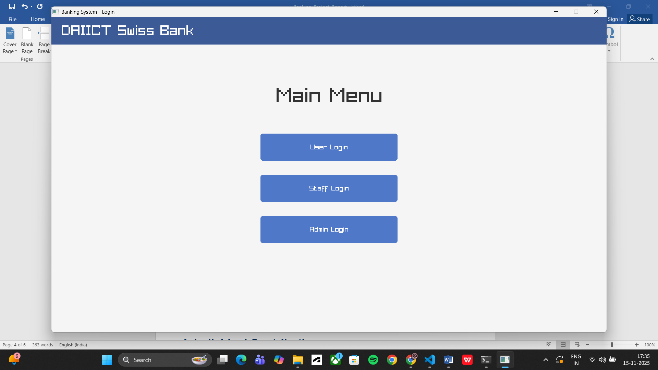
- Login Screen

- User Dashboard
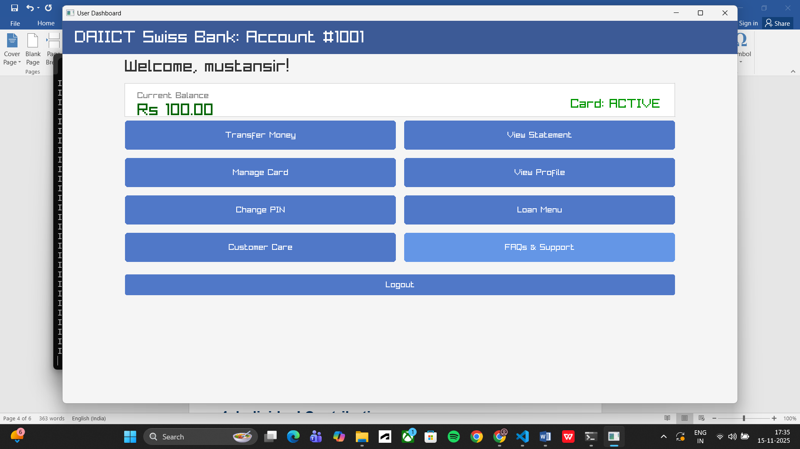
- Staff Menu
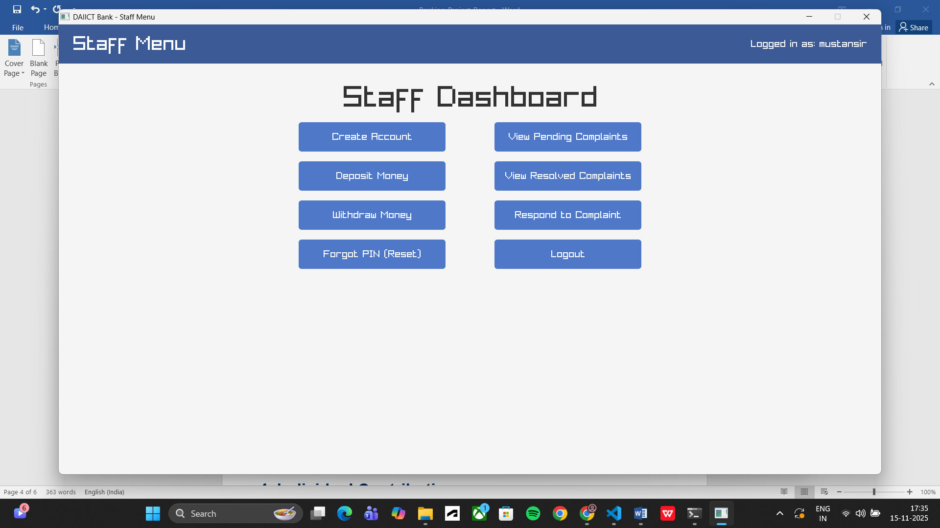
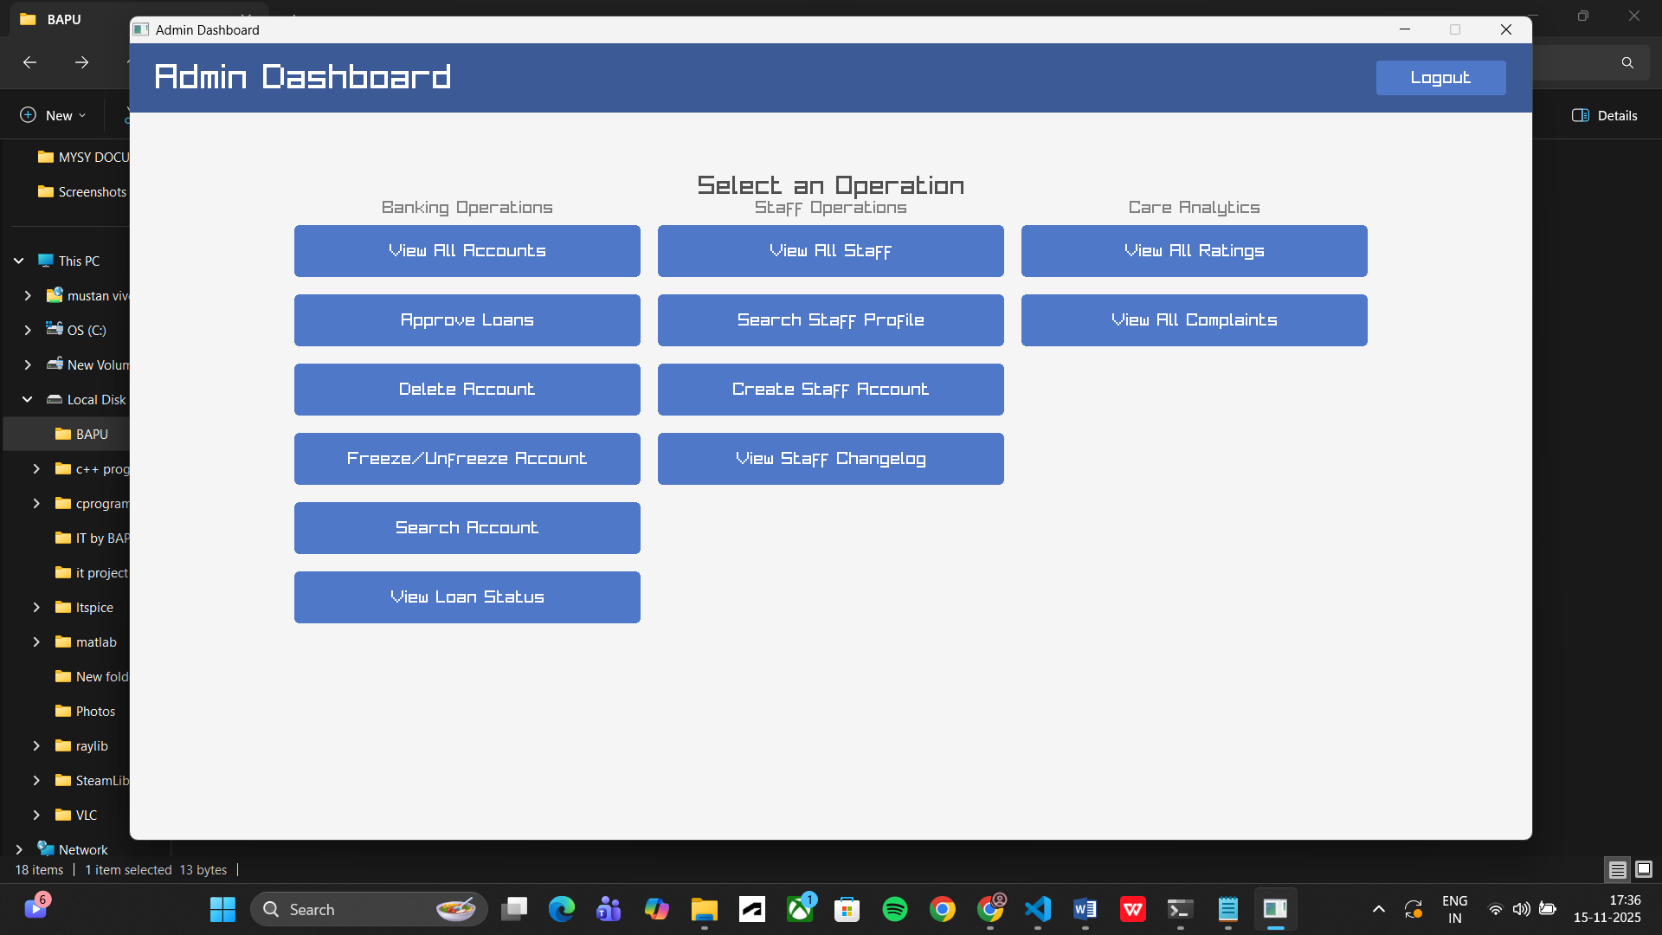
- Admin Dashboard

Individual Contribution
- Mustansir :- I have implemented the user interface and login page using raylib library. I had also encrypted the admin interface, user interface and staff interface file so that no one can directly open the .exe file of the program ,they can only access using login page only after entering correct username and password and also solved solved many file handling errors,many logical error in program in which the program was unable to read and write the loan file correct at real time solved that too. Some GUI related errors too solved in after clicking a specific button nothing was showing solved that too, also solved the backslash error in which at first when backlash was pressed once whole username gets backlashed but now that error is solved too. I have make contribution in making the code of transfer money in user interface ,withdraw and deposit money in staff interface.
- Aadya :- I have contributed my part in the loan managament part .File handling ,debugging and contributed in developing the logic behind the various functions developed. Also developed the data synchronizzation process necessary to ensure consistent, real-time visibility of loan statuses across the user and the admin interface.
- Dhruv:- I have completed a portion of the loan management system. In that segment, I included all six loan types: gold loan, car loan, education, home, and others. Additionally, I developed three other sections: loan details, FD section, and EMI calculator. I wrote all of this independently. In the loan section, I set different interest rates for each type of loan. I also handled file-handling by my-own.
- Hariom :- My part is about Customer care and Feedback System. With the help of AI, I made the code and then edited accordingly diffrent types of Structures and Functions that we had in our Project. By File Handling ,I store these Data of users which will be shown to staff / admin for complaint resolution .
- Parth:- I and Hariom made the customer care systen,
Features:
User features:
User can....
1. register complaints using 6 options and text description
2. view complaints thrpugh their account number by sscanf and then finding that account.
3. update the pending complaints, by modifying, storing to temp, then replacing.
4. rate the service with feedback
5. display FAQ, using printf
Staff features:
Staff can...
1. view pending and resolved complaints
2. respond to complaints and update pending status to resolved.
Admin features:
Admin can....
1. view statistics of ratings using arrays
2. view compaint statisics using variables
3. access all staff featuers
- Maunil:- I contributed to the development of several user features in the Banking Management System. My work included the functionalities such as Create Account,Block/Unblock Card, View Profile, and View Statement within the terminal-based version of the project.
Although the majority of the GUI integration was handled by Het and Mustansir, I contributed by identifying some of the issues between the GUI layer and the previously developed terminal functionalities.
- Deshik:-
I contributed to the development of the Admin Feature and Staff Feature in the Banking Management System. My work mainly focused on implementing and refining the core administrative functionalities, which included view all staff,search staff profile,create staff account,view staff changelog, Approve Loans, and View Loan Status as described in the documentation
I also worked on organizing and managing the interactions between the admin interface and the underlying data files. This included maintaining and updating external files such as accounts, staff, admin, and ensuring proper file handling for operations like loan approval and account freezing/unfreezing
Admin Feature
. My role also involved helping structure the Admin Dashboard workflow, ensuring correct loading of UI components, reading and updating CSV/TXT files, and maintaining smooth navigation across admin screens until logout

- Dhvanit:- Terminal-Based Version:
• Implemented the Change PIN functionality under User features.
• Implemented the Forgot PIN feature under Staff features.
• Made the Check PIN function.
• Handled all the file operations required for securely updating and verifying PIN data.

GUI Version:
• Created the corresponding GUI functions for these features.
• Assisted Het and Mustansir with integration and debugging during the transition from terminal-based code to the GUI-based system.
- Het:- As a contributor to the Banking Management System, my work spanned both backend administrative functionalities and frontend GUI development. I engineered several critical admin features, including account listing, deletion, status management (freeze/unfreeze), and search capabilities. For data management, I implemented file handling protocols to ensure all transactions and status changes were accurately stored and retrieved from accounts.csv and user.txt.

In the graphical user interface, I constructed the Admin and Staff interfaces using the Raylib library, successfully resolving various UI defects such as text and button overlapping to enhance usability. Furthermore, I strengthened the user-facing application by integrating new logic. This included enhancing the "Transfer Money" feature to require dual verification of both the account number and the recipient's name. Additionally, I implemented a key business rule in the "Apply Loan" module, restricting users from acquiring more than two active loans simultaneously.

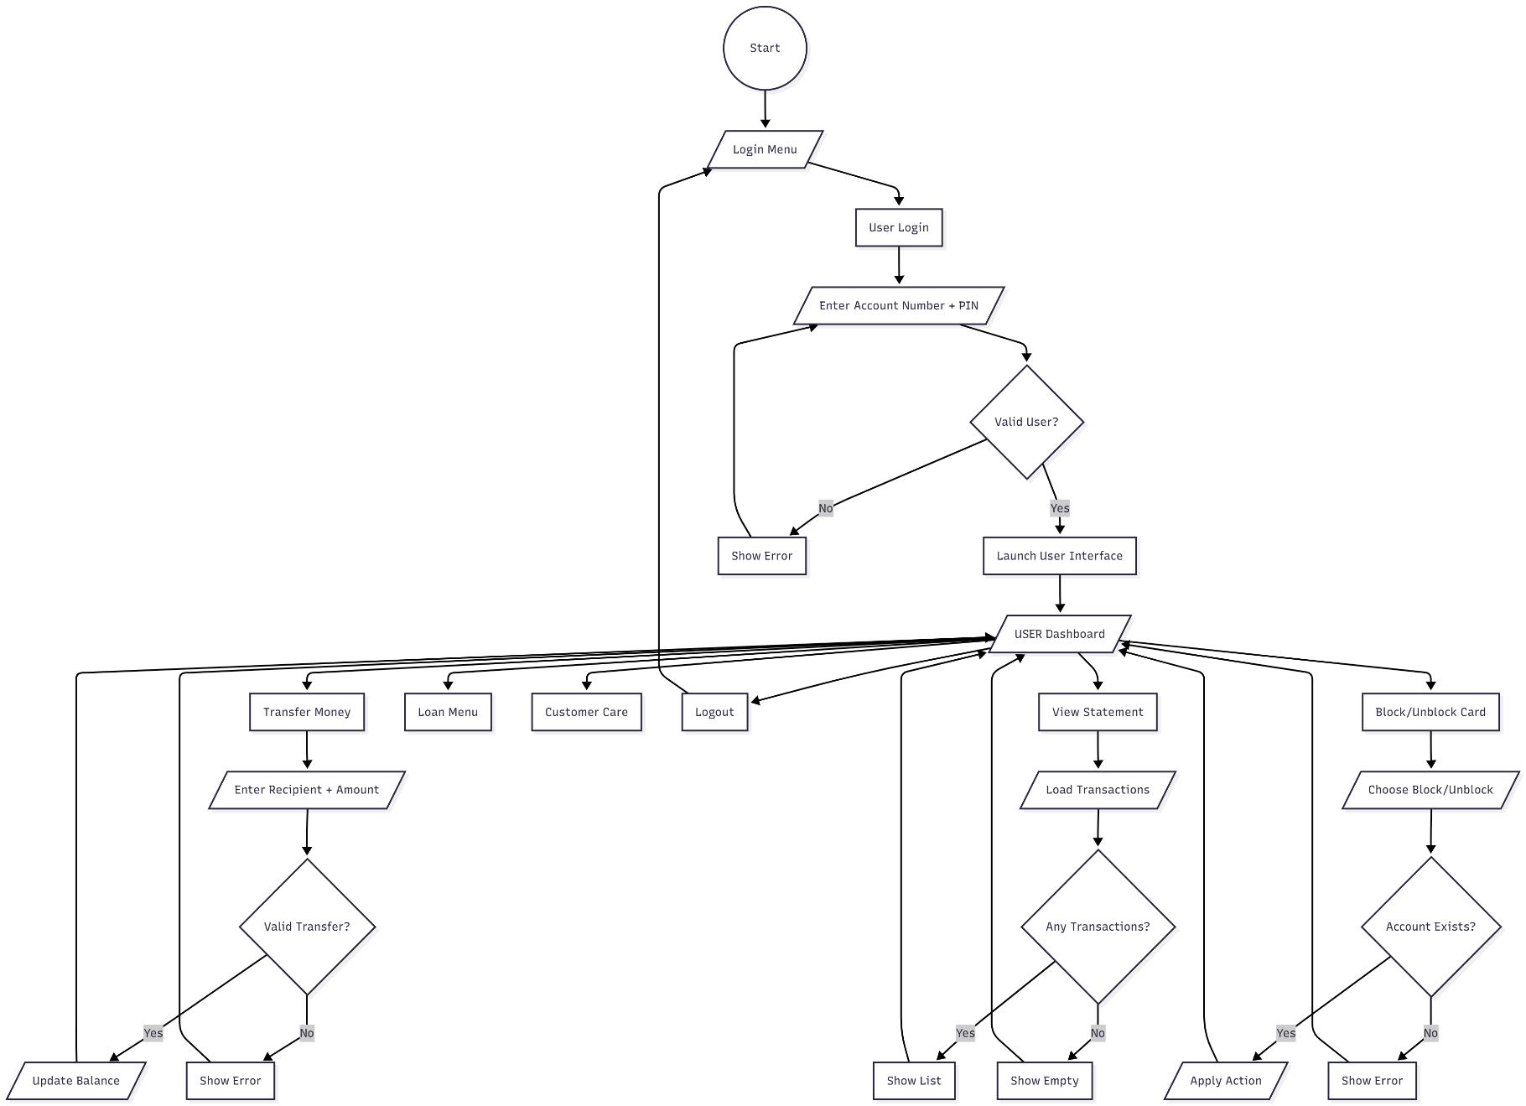
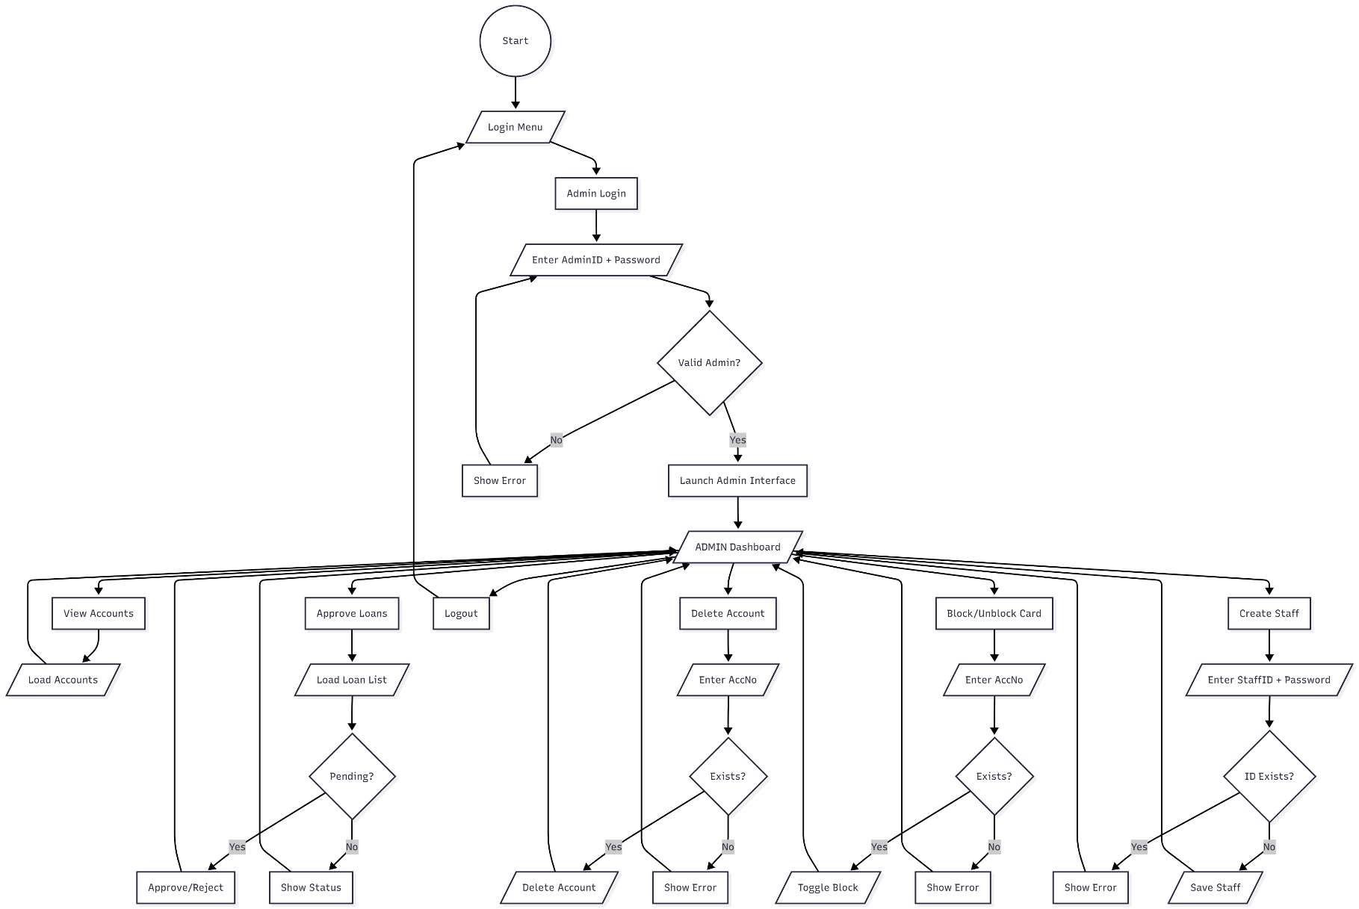
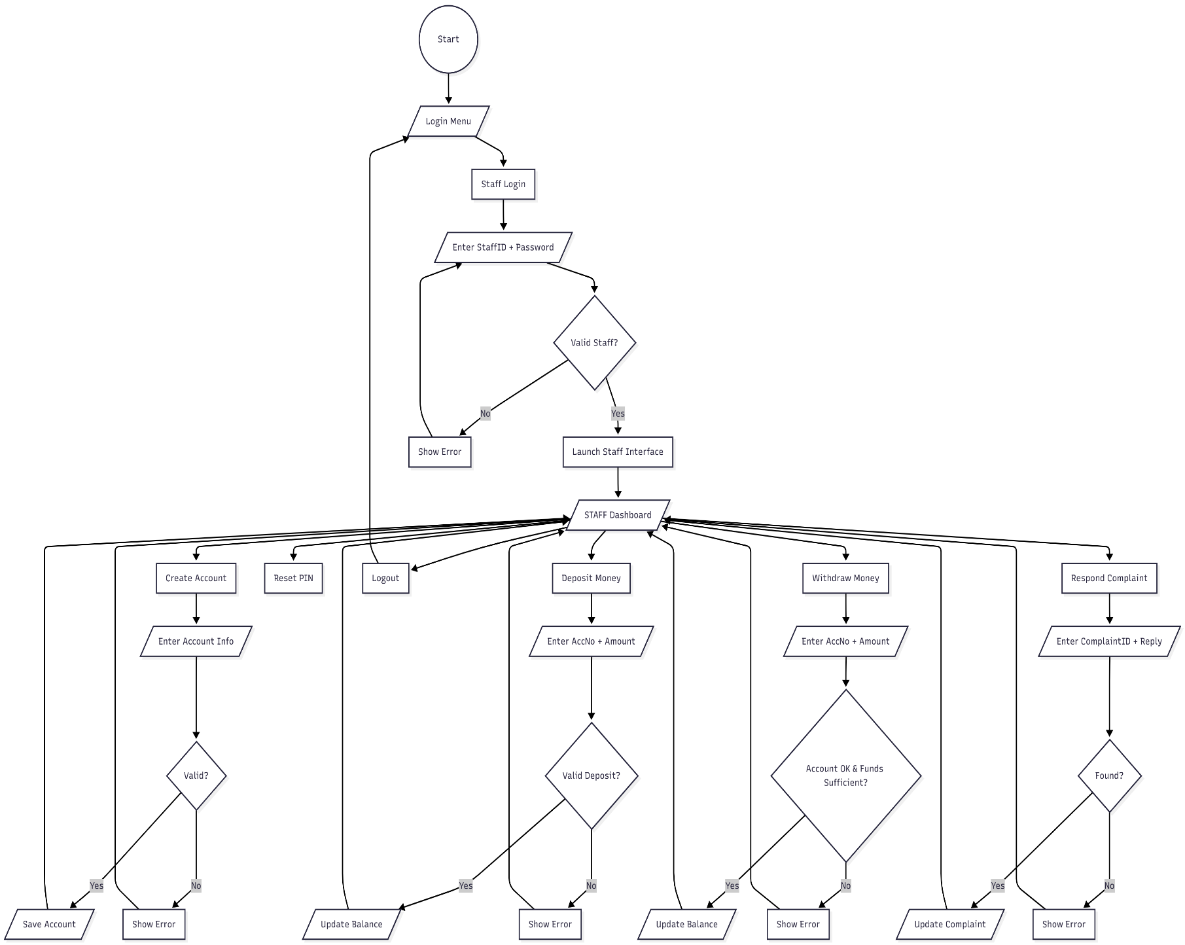

Conclusion
The Banking Management System was successfully implemented with fully functional modules for Users, Staff, and Admin. The project demonstrates structured GUI design, modular programming, and complete file-based data management. All functionalities were thoroughly tested and verified.

