**HTML Source code**

<!DOCTYPE HTML>

<TITLE> My Practice Web Page</TITLE>

<BODY>

<div data-role="page" id="home">

<div data-role="header" data-theme="d" >

<h1> Googleservices</h1>

</div>

<div data-role="content" data-theme="a">

<p><a href="#Service" data-role="button"> Weather information</a> </p>

<p><a href="#Map" data-role="button">google maps </a></p>

</div>

<div data-role="footer" data-theme="d">

<h1> google services <h1>

</div>

</div>

<div data-role="page" id="Service">

<div data-role="header" data-theme="d" >

<h1> Weather information </h1>

<a data-rel="back" data-icon="home">Home </a>

<a data-rel="refresh" data-icon="refresh">Refresh</a>

</div>

<div data-role="content" id="map">

</div>

</div>

<div data-role="page" id="Map">

<div data-role="content" data-theme= "b">

<h1> google maps </h1>

<a data-rel="back" data-icon="home">Home</a>

<a data-rel="reload" data-icon="refresh"> Refresh </a>

</div>

<div data-role="content" id="map">

</div>

</div>

<script src="https://maps.googleapis.com/maps/api/js?v=3.exp&sensor=true"></script>

Css

#map{

width: 450px;

height: 450px;

}

**JQUERY source code**

var map;

var elevator;

var myOptions = {

zoom: 6,

mapTypeId: 'terrain'

};

map = new google.maps.Map($('#map')[0], myOptions);

var markers = [];

// Try HTML5 geolocation

if(navigator.geolocation) {

navigator.geolocation.getCurrentPosition(function(position) {

var pos = new google.maps.LatLng(position.coords.latitude,

position.coords.longitude);

var infowindow = new google.maps.InfoWindow({

map: map,

position: pos,

content: 'Location found using HTML5.'

});

map.setCenter(pos);

}, function() {

handleNoGeolocation(true);

});

} else {

// Browser doesn't support Geolocation

handleNoGeolocation(false);

}

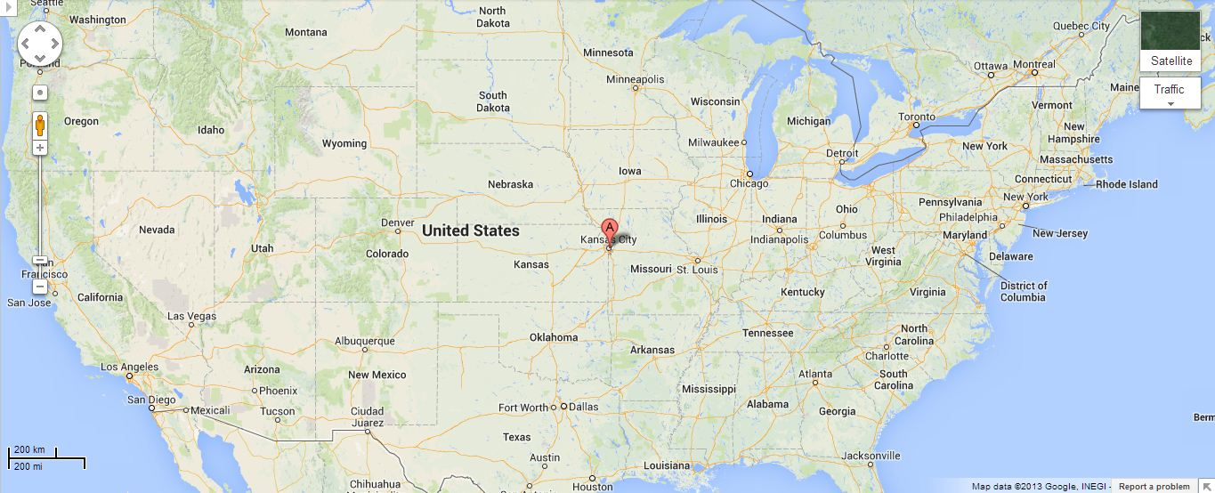

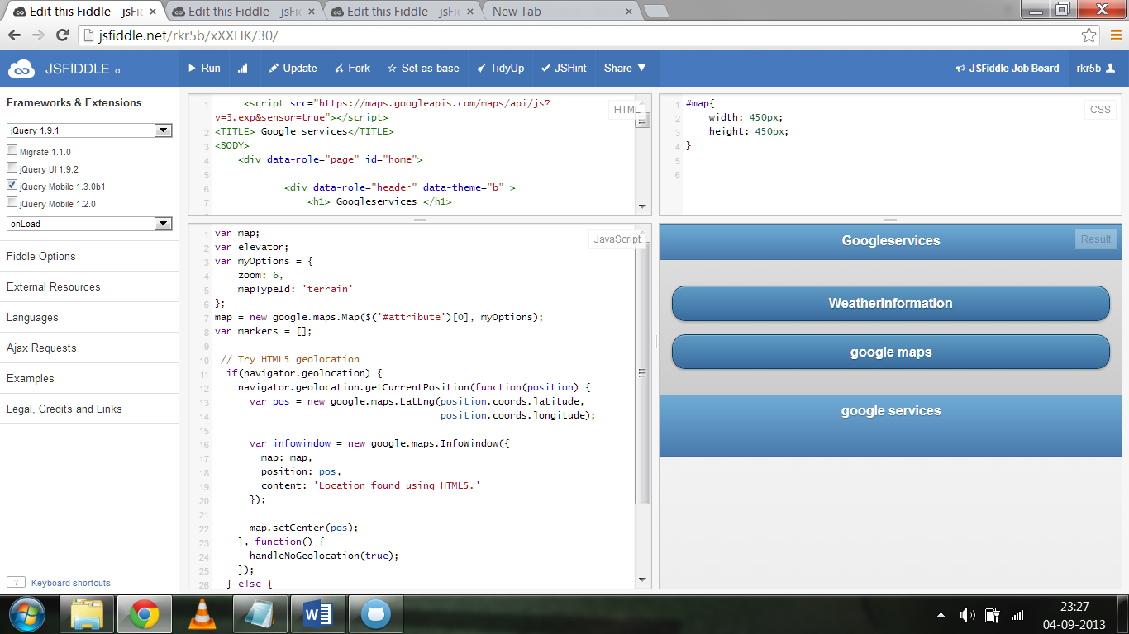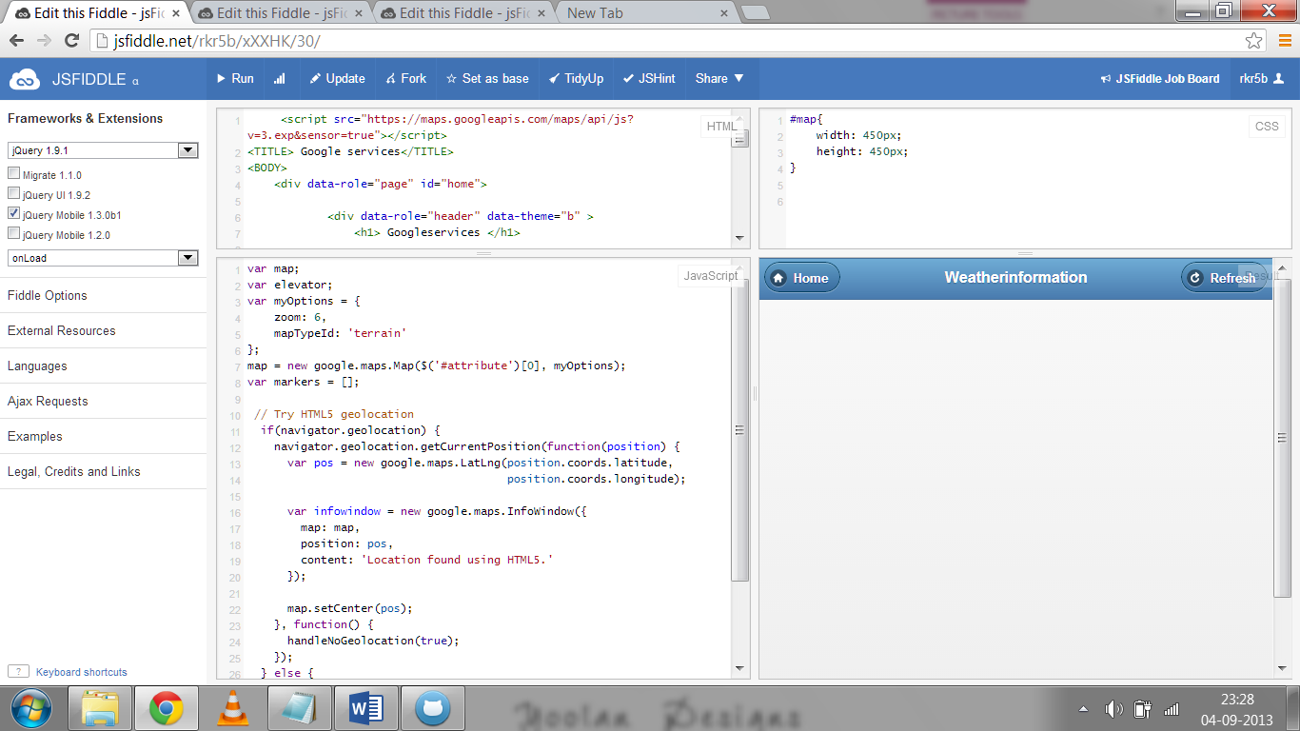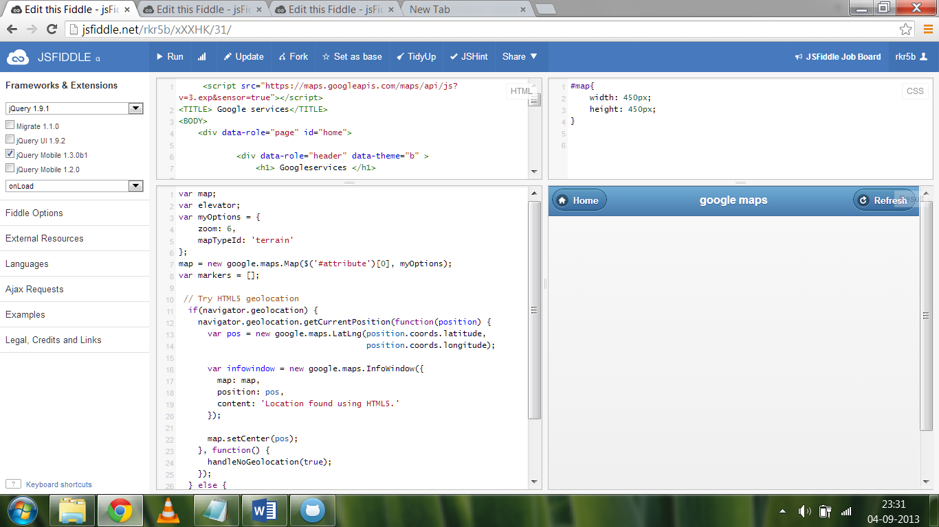

In this application I developed an application which will be used to find geographical locations of any area and we can also find weather information of a particular area. For developing this application I used HTML,JQUERY.CSS