**SOAP:**

**Web.config**

<?xml version="1.0"?>

<!--

For more information on how to configure your ASP.NET application, please visit

http://go.microsoft.com/fwlink/?LinkId=169433

-->

<configuration>

<connectionStrings>

<add name="ApplicationServices" connectionString="data source=.\SQLEXPRESS;Integrated Security=SSPI;AttachDBFilename=|DataDirectory|\aspnetdb.mdf;User Instance=true" providerName="System.Data.SqlClient"/>

</connectionStrings>

<system.web>

<compilation debug="true" targetFramework="4.0"/>

<authentication mode="Forms">

<forms loginUrl="~/Account/Login.aspx" timeout="2880"/>

</authentication>

<membership>

<providers>

<clear/>

<add name="AspNetSqlMembershipProvider" type="System.Web.Security.SqlMembershipProvider" connectionStringName="ApplicationServices" enablePasswordRetrieval="false" enablePasswordReset="true" requiresQuestionAndAnswer="false" requiresUniqueEmail="false" maxInvalidPasswordAttempts="5" minRequiredPasswordLength="6" minRequiredNonalphanumericCharacters="0" passwordAttemptWindow="10" applicationName="/"/>

</providers>

</membership>

<profile>

<providers>

<clear/>

<add name="AspNetSqlProfileProvider" type="System.Web.Profile.SqlProfileProvider" connectionStringName="ApplicationServices" applicationName="/"/>

</providers>

</profile>

<roleManager enabled="false">

<providers>

<clear/>

<add name="AspNetSqlRoleProvider" type="System.Web.Security.SqlRoleProvider" connectionStringName="ApplicationServices" applicationName="/"/>

<add name="AspNetWindowsTokenRoleProvider" type="System.Web.Security.WindowsTokenRoleProvider" applicationName="/"/>

</providers>

</roleManager>

</system.web>

<system.webServer>

<modules runAllManagedModulesForAllRequests="true"/>

</system.webServer>

</configuration>

using System;

using System.Collections.Generic;

using System.Linq;

using System.Web;

using System.Web.Services;

/// <summary>

/// Summary description for WebService

/// </summary>

[WebService(Namespace = "http://tempuri.org/")]

[WebServiceBinding(ConformsTo = WsiProfiles.BasicProfile1_1)]

// To allow this Web Service to be called from script, using ASP.NET AJAX, uncomment the following line.

// [System.Web.Script.Services.ScriptService]

public class WebService : System.Web.Services.WebService {

public WebService () {

//Uncomment the following line if using designed components

//InitializeComponent();

}

[WebMethod]

public int Addition(int a, int b)

{

return a + b;

}

[WebMethod]

public int Subtraction(int a, int b)

{

return a - b;

}

[WebMethod]

public int Multiplication(int a, int b)

{

return a * b;

}

[WebMethod]

public int Division(int a, int b)

{

return a / b;

}

}

using System;

using System.Collections.Generic;

using System.Linq;

using System.Web;

using System.Web.Services;

/// <summary>

/// Summary description for WebService

/// </summary>

[WebService(Namespace = "http://tempuri.org/")]

[WebServiceBinding(ConformsTo = WsiProfiles.BasicProfile1_1)]

// To allow this Web Service to be called from script, using ASP.NET AJAX, uncomment the following line.

// [System.Web.Script.Services.ScriptService]

public class WebService : System.Web.Services.WebService {

public WebService () {

//Uncomment the following line if using designed components

//InitializeComponent();

}

[WebMethod]

public int Addition(int a, int b)

{

return a + b;

}

[WebMethod]

public int Subtraction(int a, int b)

{

return a - b;

}

[WebMethod]

public int Multiplication(int a, int b)

{

return a * b;

}

[WebMethod]

public int Division(int a, int b)

{

return a / b;

}

}

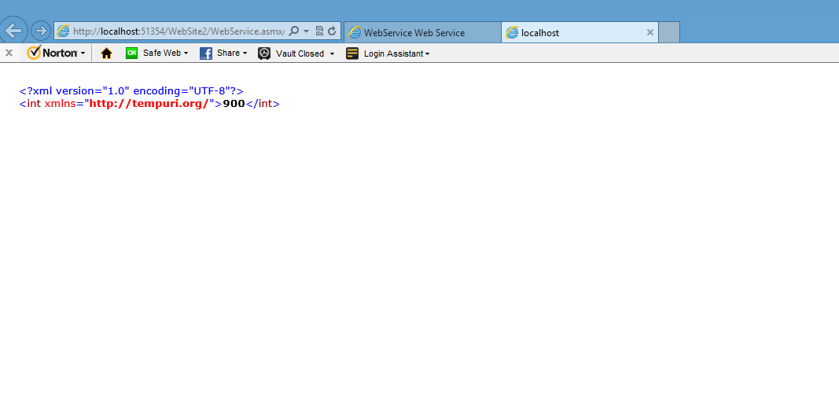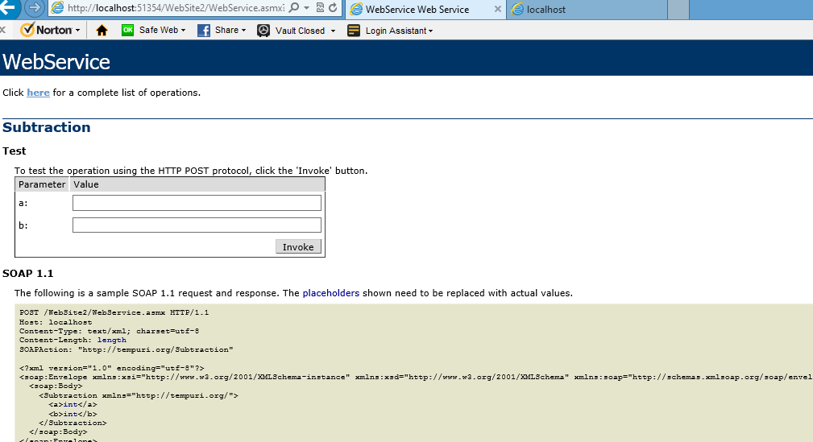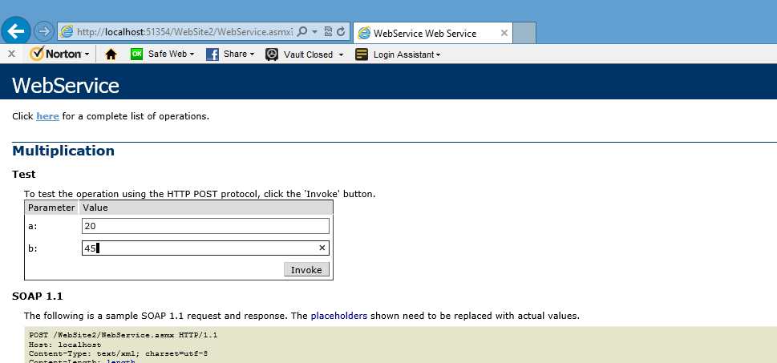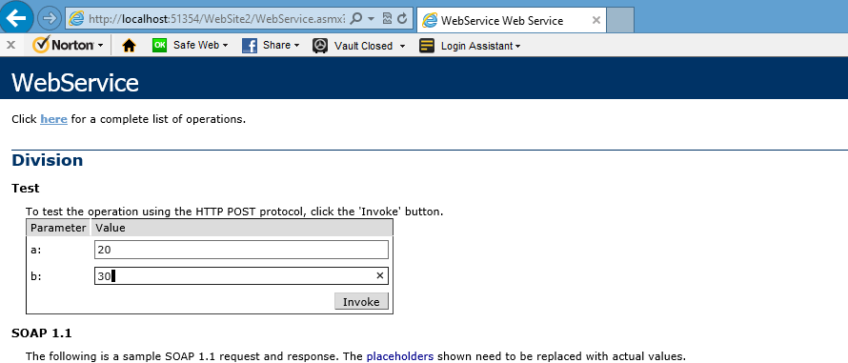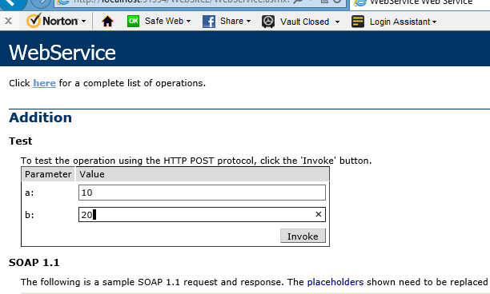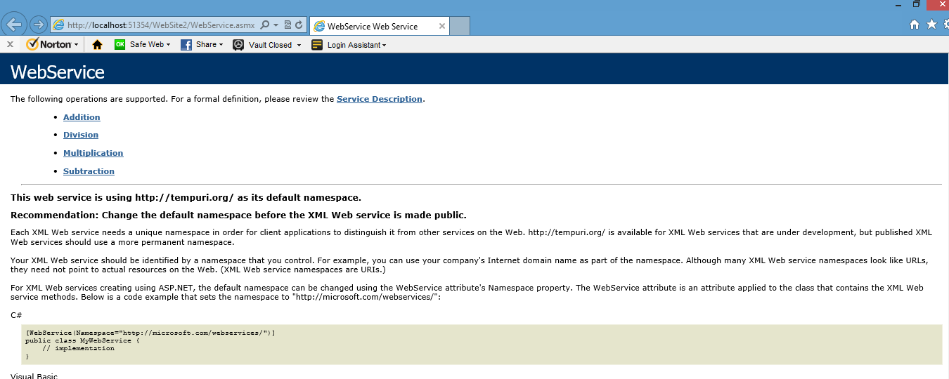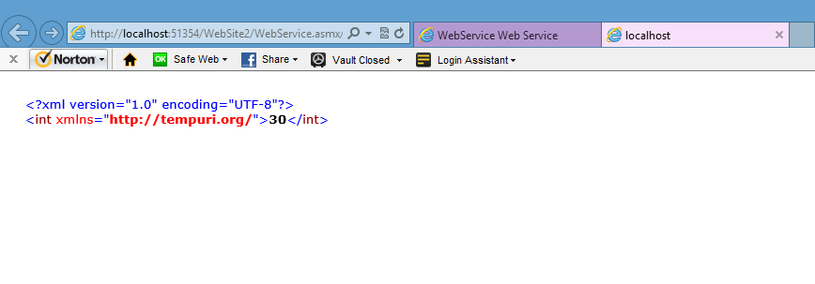re