
KRAKIN’T
Token-Sale: Light Paper
Version 1.0

Network: Ethereum

Address: 0x0463D4fBe3823bdE3278d5BAC8Cf19f608d1e648
https://github.com/krakintgithub/solidity/tree/master/market

Document Date: December 2020, Version 1.0
Authors: Krakin’t Team

Web: http://www.krakint.com

Introduction
∙ The Krakin’t (pre)sale model that lets you earn Ethereum. This is done by spreading 2% of deposited Ethereum to all token holders that held Ethereum within the Krakin't (pre)sale contract.  ∙ This (pre)sale model lasts forever, and allows you to get your Ethereum back, at any time. However, the 4% fee is applied for any Ethereum deposit. More tokens get purchased, more expensive it is to make the next purchase. More tokens get exchanged back to Ethereum, the price of Krakin't token becomes cheaper.  ∙ The (pre)sale model is meant to encourage the Krakin't token trading and mining. Furthermore, it is meant to attract serious investors and lower the risk of a token purchase, to a bare minimum. The (pre)sale model also creates arbitrage with exchanges and maintains the supply and a demand by burning and minting mechanism. |  | Krakin’t (Pre)sale Doodle

Contract Main functions
How does making Ethereum work by purchasing Krakin’t?
A brief explanation on how the earnings are calculated:
- Take 4% from the Ethereum deposit when tokens are purchased
- Allocate 2% to Krakin't
- Allocate 2% to everyone
- Mint the tokens with a 4% reduction
Allocating 2% to everyone works by adding it to a total sum of allocated Ethereum. This sum is simply divided by the number of circulating (and generated by the contract) tokens, in respect to amount of tokens that user wants to withdraw.
A simple formula becomes:

Where:
- a is Amount of minted KRK tokens, per user, that are still circulating with a contract.
- b is Total amount of available Ethereum (in Wei) spread to all investors as 2% fee.
- c is Total amount of tokens that were minted by all users and are circulating with a contract.

Unfortunately, there is no instant solution, and the only possible solution relies on the long-term promises. The only thing that we can instantly accomplish is lowering the risk of purchasing a token by allowing people to get their money back, with a small fee applied. As soon as the purchase is made, 4% fee is applied. Krakin’t allocates half for itself and saves the other half for the investors. Their earnings depend on how many tokens they previously purchased. Given the fees and low risk, if an investor wants to spend 1 whole Ethereum on a purchase, they will need to make a deposit of 25 Ethereum. This is how we are filtering the serious investors from those who are looking to make a quick money at the expense of the project. The 2% that Krakin’t allocates for itself is meant for liquidity that certain exchanges require. Therefore, to allocate the right amount for the exchanges, we need a total volume of approximately $500K USD or more. This amount is also to be used as an indicator that the project is ripe and that the success on the exchanges is imminent. Once the purchase is made, the best strategy is to put the Krakin’t token into a miner, mine as many tokens as needed, and then simply get your Ethereum back from the (pre)sale contract. Furthermore, you can sell Krakin’t token on the exchanges to cover the 4% expenses. With a bit of a luck, you can earn KRK tokens as well as Ethereum, and without any losses.
How is token price calculated ?
Since Solidity language is limited when it comes to mathematics, instead of using a single curve formula, we are using 10 linear formulas to regulate the price of a token within the frame of this contract. Each line represents a new stage and a steeper slope. There are 10 stages in total.

To calculate the price, assume:

x is Circulating KRK tokens (that is, generated by the contract)
f(x) is price

Then, apply these formulas:

stage 1, less than 0.5mil KRK:
f(x) = 1.9998×10^-7 x + 0.0001

stage 2, greater than 0.5mil KRK, less than 1mil KRK:
f(x) = 4.22202×10^-7 x - 0.111011

stage 3, greater than 1mil KRK, less than 1.5mil KRK:
f(x) = 6.72202×10^-7 x - 0.361011

stage 4, greater than 1.5mil KRK, less than 2mil KRK:
f(x) = 9.57917×10^-7 x - 0.789583

stage 5, greater than 2mil KRK, less than 2.5mil KRK:
f(x) = 1.29125×10^-6 x - 1.45625

stage 6, greater than 2.5mil KRK, less than 3mil KRK:
f(x) = 1.69125×10^-6 x - 2.45625

stage 7, greater than 3mil KRK, less than 3.5mil KRK:
f(x) = 2.19125×10^-6 x - 3.95625

stage 8, greater than 3.5mil KRK, less than 4mil KRK:
f(x) = 2.85792×10^-6 x - 6.28958

stage 9, greater than 4mil KRK, less than 4.5mil KRK:
f(x) = 3.8579×10^-6 x - 10.2895

stage 10, greater than 4.5mil KRK:
f(x) = 5.8579×10^-6 x - 19.2895

For example, if there were 51000.00 KRK tokens that are circulating and generated by the contract, it means that the price is:
f(x) = 1.9998×10^-7 x + 0.0001 = 0.01029898 (ETH/KRK)

Let us assume that you want to deposit 1.2 Ethereum to a contract. Therefore, we will calculate this as:

1. Take away 4% from 1.2 to get 1.152 ETH
2. Then calculate the amount of tokens by 1.152 / 0.01029898 = 111.85573717
3. Now, here is something else to consider. In order to increase the yield, we multiply 111.85573717 by 1000/(stage number).

Therefore, you will get 111855.73717 KRK tokens.

The number of minted tokens by the contract then increases by the 51000 KRK + 111855.73717 KRK, so the next purchase for 1.2 Ethereum gives fewer tokens.
Please keep in mind, since we are using Solidity and no decimals (just big integers), the price is always going to be the best estimate lacking a certain precision. A small loss of precision happens while transforming everything to big integers that include 18 decimals in calculation. This is a reason why the contract line formulas and the ones presented in this document are different. Nevertheless, they represent the same numbers and a logic.

Accessing from the www.krakint.com
To access the sale, please go to a main-page and select “Token” from the upper-right corner.
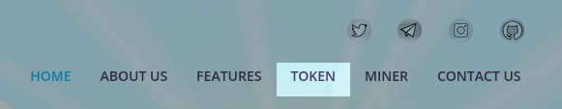

Next, click on the “Purchase Token” button, and decentralized application will pop-up.

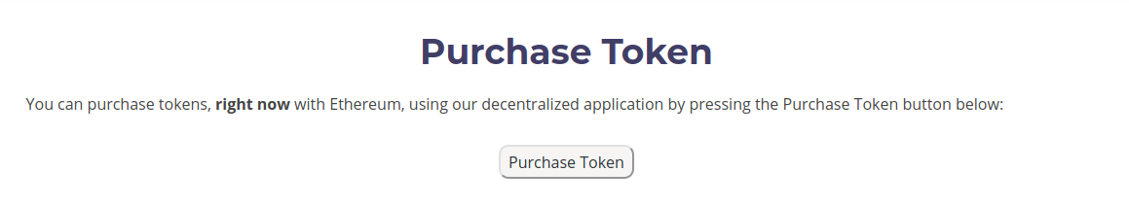

Contract Main functions
No Metamask installed
If you have no Metamask installed, you will see the following:
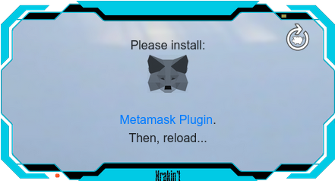

You can click on the “Metamask Plugin” to open a new tab and install Metamask. Simply click on the circular arrow (reload icon), top-right corner, when done.

Metamask is not connected
If you have installed Metamask but not connected or logged-in the browser add-on, you will see the following:
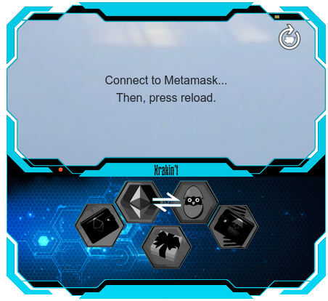

Simply connect to Metamask (it usually pops-up) and press the circular arrow, top-right corner.

NOTE: sometimes it may happen that you are connected but still see this screen. Wait a few seconds, and then press the circular arrow, top-right corner.

Metamask connected
Once everything is connected properly, you will see the first and the last letters of your private key and a message asking you to click on any hexagonal buttons. As you hover over the hexagonal buttons, the small screen will tell you what each button is for.

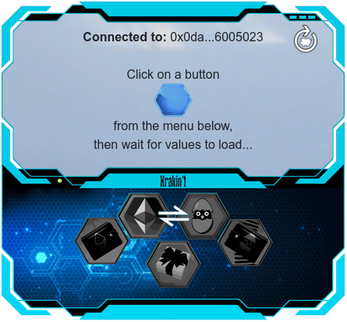

ETH to KRK
This is where you make the Krakin’t token purchase.
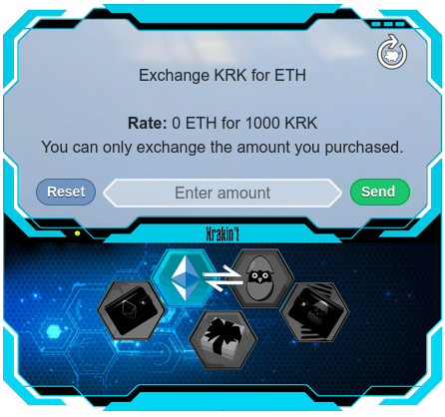

Simply enter the amount of ETH you wish to deposit, and press the “Send” button.
Please note, the Rate may display 0 ETH. If it does, it means that you don’t have any Ethereum deposited or that your exchange rate is too low (the numbers are truncated).

KRK to ETH
This is how you get your money back.
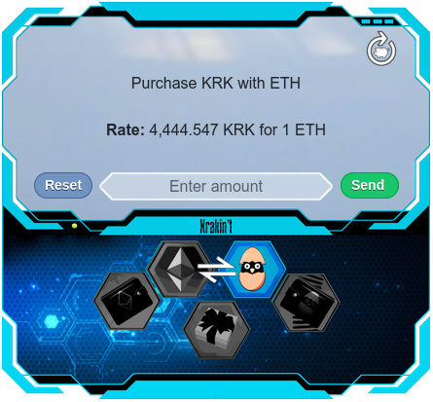

Interface also tells you how many KRK tokens you will get if you deposit 1 ETH.
ETH Statistics
This gives you the overview of the ETH flow through the contract. If all numbers are 0, please wait, the interface is communicating with ETH network…

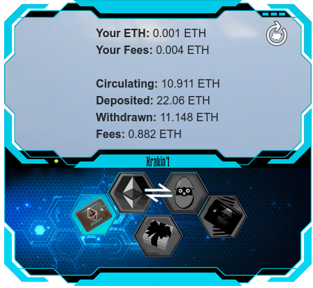

- Your ETH tells you how much ETH has been deposited by you.
- Your Fees tells you how much ETH you spent on fees (in total). This excludes the GAS prices.
- Circulating tells you how much ETH is on hold by the contract.
- Deposited tells you how much ETH was deposited since the contract deployment.
- Withdrawn tells you how much ETH was withdrawn since the contract deployment.

- Fees tells you how much ETH was spent on fees, by everyone, since the contract deployment. 1/2 of it goes to Krakin’t and 1/2 of it is spread to all investors that hold ETH on a contract.

KRK Statistics
This tells you the current state of KRK affairs within the contract. If you see 0 as the KRK amount, it means that you either have made no purchase or that the number got truncated. The Available KRK tells you how many KRK tokens you can exchange to ETH.
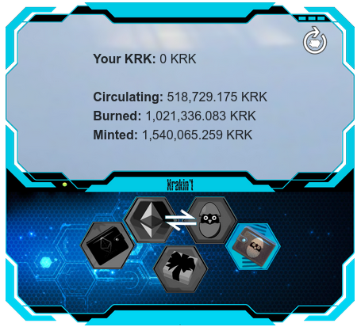

- Your KRK tells you how many KRK you can exchange to ETH (number is truncated).
- Circulating tells you how many KRK tokens can be exchanged back to ETH.
- Burned tells you how many tokens were exchanged to ETH.
- Minted tells you how many tokens were purchased (not circulating).

Earnings and Rewards
This is a fun part of the purchase contract. It tells you how much ETH you have earned. Unfortunately, Krakin’t account has not made any earnings (on purpose) that can be demonstrated. As you can see, we only have 0.001 ETH on hold.
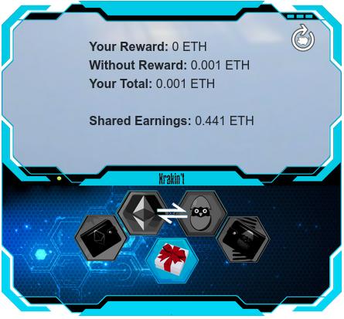

- Your reward tells you how much ETH you have earned, if you exchanged all of your KRK tokens back to ETH.
- Without Reward simply tells you how much ETH you have on hold
- Your Total is a sum of a reward and the ETH you hold
- Shared Earnings is the amount of ETH that is given to all investors

Conclusion
We sincerely hope that you will enjoy using our decentralized applications and make some money while trading with Krakin’t. We also hope that you will have no losses and mainly the gains. Nevertheless, Krakin’t is not just about trading. It is about projects and learning about the amazing and developing world around us.

