
KRAKIN’T
Token White Paper
Version 0.1

Network: Ethereum

Address: 0x7C131Ab459b874b82f19cdc1254fB66840D021B6
Symbol: KRK

Document Date: September 2020, Version 0.1
Authors: Krakin’t Team

Web: http://www.krakint.com

Introduction
∙ Name Krakin’t comes from the association between the incubation and the egg-shell getting cracked. Krakin’t, pronounced as “Crackin’ it” (ˈkrækɪn ɪt), is a company with an aim to become one of the leading project incubators by providing the means for the projects and ideas to become supported by the venture capitalists across the world.  ∙ We believe that the current project incubators are becoming outdated and unsynchronized with the rapidly developing technologies. Our approach includes innovative, sustainable and user-friendly technology, including blockchain, smart contracts, and distributed distributed ledger systems for digital assets.  ∙ Main goal of Krakin’t is to provide the means for any project or idea to become incubated while avoiding the complicated processes associated with the centralized project incubators. |  | Krakin’t Logo

Project Incubators
The main function of the project incubators is to provide the means for the startups to mature into a functioning company. In the early days, this implied providing the means such as the equipment and the office space. Today, the main function of the project incubators is to educate people regarding the business they want to run, provide important connections to other people and companies, as well as the financial means to turn any startup into a mature business. As the time and evolution of the available technology progressed, the need for space as well as the startup equipment is becoming less important. The most important aspects are the finances and the business connections. Personal computers are cheap and the need for the office space is less relevant. This kind of change brings a new set of problems where Krakin't can be applied as a solution. Krakin’t offers a platform for the founders of new and small companies and ideas, where they can discuss their business and get more information about the market and technology. Nevertheless, this Light Paper will cover only the Token part of Krakin’t. Please refer to the Krakin’t Labs Light Paper to find out more.

Why is Krakin’t Tokenized ?
Sometimes it happens that small-companies issue a token or a crypto-currency (coin) only to benefit from a decentralized market exchange. In many cases, a token is not needed to support their products and everything can be done using the native and decentralized platforms or networks such as Ethereum. The problem with such an approach is that, except their idea and a proof of a concept, they're not backed by anything tangible, and therefore their Tokens may be useless. However, Krakin’t is tokenized on Ethereum to bring the most-secure solutions while helping the projects and ideas incubate. The native platforms and networks such as Ethereum can be too general and cannot be customized to fit the specific business needs without issuing the smart contracts and tokens. Therefore, Krakin’t has introduced a token feature that fits the business need and which is unique in design. The main use of the Krakin’t tokens is to create new programs and services for the users, which then is distributed while the value can be collected when needed. Instead of depending on the Ethereum updates, Krakin’t token is a mutable. This means that we can alter the source-code to fit the business model at any time. Krakin’t is simply using the Ethereum infallibility to scale the security. Furthermore, Krakin’t token is also currency, and therefore has the power to shape the projects and ideas at their early stage of a development.

What does Krakin’t Token Solve ?
Please note, some of the mentioned solutions are not strictly confined to a token, but to Krakin’t project as a whole. On the other hand, only the most important solutions that are related to Krakin’t token are mentioned.

Need for Globalization
With the great flow of the Internet information and decreasing hardware prices, the location of a startup is becoming less relevant. The only relevance are the laws that govern the country or area where startups are based. This implies that decentralized authority such as Krakin’t is required so that startups (which do not rely on the physical constraints) can grow without interference. For this reason, Krakin’t has developed a mutable token as a part of the Ethereum decentralized system to be able to accommodate the need for globalization and undisturbed development of the startups. At the same time, with the increasing number of startups and the increasing use of blockchain solutions, Krakin’t can provide a solution to reduce the need for intermediaries and allow faster growth. Krakin’t is a decentralized project aiming at providing a decentralized, scalable and efficient decentralized platform for distributed applications with a focus on innovation in the real time environment, through a novel model of a transaction creation.

Cultural and the Social Biases
One of the main indicators for the potential success of a project that current business incubator models use is the project culture and a social impact. However, this becomes an issue once the startup is not physically bound to a certain area and culture. Internet culture is a concept which supervenes the cultures associated with the physical regions. However, as such, it is not always a good indicator whether the startup will become a success. For example, the Internet trolls may ruin a startup business simply by providing the bad and falsified data. Furthermore, they may also do it to take over the existing projects and lower the competition. For this reason, Krakin’t is providing a solution that does not require any culture or social channels in order to function. This solution, however, is beyond the Token frame of a reference and is discussed in a Krakin’t Labs Light Paper.

Management and Gate-Keeping
Any company, even a decentralized project incubator, needs to be managed. However, this may contradict the purpose of a decentralization structure, since management represents a centralized authority. Perhaps in future this will become automated, but for now, we need the human agents to do the management. Currently, the project incubators are managed by evaluating the startups and managing the risks. As a result, we have project incubators that have a very low number of startups that are accepted for the project incubation. Krakin’t Token offers a solution that increases the number of accepted startups and avoids a centralized management. These details are covered in the Krakin’t Labs white-paper.

Scalability with Interoperability
One of the main issues with blockchain technologies is scalability. Scalability issue simply means that once the project and demand grows, the underlying technology is not able to support a demand. Krakin’t has solved this by making an immutable token, which gives Krakin’t the power to expand onto multiple blockchains, use the private blockchains, and also use the centralized technologies to help the increasing demands. This means that Krakin’t can use the interoperability in order to solve the scalability issue, while token still remains on the Ethereum network.

Token amount not Reflecting Demand vs Price
One of the problems with the token economy running on the token exchanges is that the number of available tokens does not reflect demand for a token. As a solution, Krakin’t is offering a miner that works by applying the proof of a burn. Any tokens that are not used can be placed into a miner contract, and removed from the current supply. Furthermore, by using the miner contract, users can create more tokens when they are needed to be placed on the market (this mechanism is explained in the Miner Light Paper). This is how supply and demand are regulated. As a consequence, token price is becoming more stable and gives a better precision and predictability in regards to a supply and a demand.

Lost wallets, Bad Exchanges and Hacked Accounts
By taking full control of a token (provided the right credentials and the background information), Krakin’t Token has the option to take tokens away from the fraudulent accounts as well as the lost wallets, and give them back to their rightful owner. This is something that Ethereum cannot do and represents a big problem.

Poorly Regulated Token Inflation
A centralized authority that prints the money may be a suspect to corruption. Krakin’t miner is solving this by buffering the tokens within the miner contract, so when the tokens are retrieved from a contract, the user may introduce new tokens. Therefore, the inflation is completely automated, regulated by demand, and as simple as possible.

High Electricity Fees and Expensive Mining Hardware
One of the problems associated with the proof of work concept is that higher mining difficulty requires more electricity. Furthermore, hardware easily becomes obsolete as the mining difficulty increases. To solve these issues, Krakin’t is simply piggy-backing the Ethereum network by calculating the mined blocks. This way, we don’t need any electricity or hardware to mine Krakin’t. Furthermore, more tokens are burned, greater the rewards. In this sense, time does become money, while the mining difficulty is regulated by the amount of the burned Krakin’t tokens. More investment means higher yields. This mechanism is explained in the Miner Light Paper.

Fail-safe Hacking Mechanism
Yes, there are ways to hack Ethereum contracts. For example, Re-Entrancy attack is one. If any of this ever happens to Krakin’t, we can simply disconnect the main contract from the other components, fix the components, undo the financial damage (if any) and reconnect to fixed components. This is a beauty of having the mutable contract.

Fail-safe Token Ownership
Sometimes, it can happen that the contract owner machines are sniffed for the private keys. The usual contract coding standard does not provide a fail-safe mechanism to undo this. Even if the token owner's private keys fall into the wrong hands, there is a master-key that can undo the whole damage. The master-key is a key that is never used and is kept somewhere safe.

Mutable Token Red Flags
These are some facts that may surround any mutable token. Before investing into any mutable token, please be aware of some of the facts and red flags listed in this white-paper.

Everything can be controlled
Contract owner has full control of how the mutable token is managed. This can easily lead to minting tokens rather than mining, and can also include taking tokens away from people’s accounts. Furthermore, even if none of these worst-case scenarios happen, you should always know who the contract owners are. In this case, trusted centralized authority must exist and Krakin’t, in this manner, is not a trust-less Token. Furthermore, such a design is dangerous as it may lead to the unwanted FUD and Internet trolling against Krakin’t.

Agents Running a Mutable Token are Just... Companies
Given the complete authority over the token, agents running the token are centralized. It does not matter whether the community is reaching a consensus or whether a single agent is maintaining a token. The point is, the boundary of whatever runs the token (unless the strong A.I. that doesn’t exist at the moment) is finite and can be defined as a cluster. This implies that the agent is centralized and therefore just another company running the project. The same applies to Krakin’t.

Centralized Authorities can be Corrupted
Corruption can happen in many different ways, and it mainly represents taking advantage of something or someone at disadvantage of some group of people or another person. It does not have to be directly associated with the Krakin’t developers or founders. For example, assume that Krakin’t becomes popular one day and sold for a very good price. Once sold, the red-flag becomes evident when the private keys are given together with the company. The new management has the power to do whatever they want and to corrupt Krakin’t the way they want to corrupt.

Need for trust cannot be avoided
Although mutable tokens can be placed on trust-less networks, it does not mean that the token itself is trust-less. Since the centralized authority has the full control over the token, it means that the trust must be earned and that the need for trust cannot be avoided.

Structure of a Krakin’t token
Since the main purpose of the Krakin’t Token is to evolve beyond its original design, we have solved the mutability by adjusting the Proxy Design Pattern. The Krakin’t design pattern is specific to a Krakin’t token, and the proxy pattern has only paved a way to having a final design.
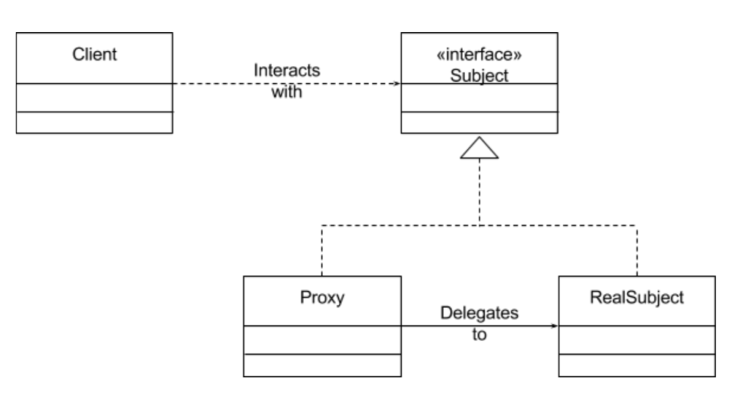

The most common way of representing the Proxy Design Pattern
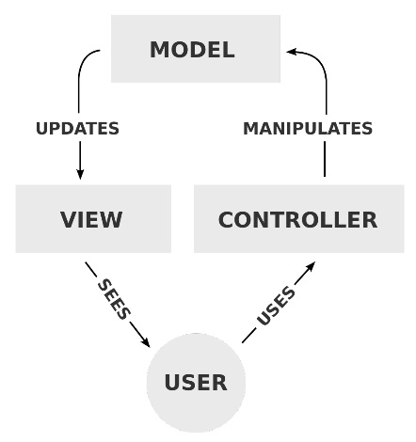
Proxy design pattern has an interface which communicates with a mutable Proxy function or class that is connected to an immutable RealSubject function or class. The problem here is that we need to directly communicate with the RealSubject. Krakin’t has analyzed the simplest token source-code and came up with the two atomic functions: Approve and Transfer. This means that we are talking with the RealSubject and offload everything else within a proxy contract. MVC (Model View Controller) pattern has inspired the design further. The MVC architectural design pattern was then adjusted to become the micro framework that Krakin’t will use to update and evolve the Krakin’t token. Although we are wasting more Ethereum GAS than necessary, we would be compromising the architecture and security otherwise. The solution is to do a token wrapper, however, pros and cons will not be discussed in the Light Paper.

MVC pattern, commonly used in development frameworks
In this sense, the Controller is equivalent to the Token contract, Model is equivalent to a Router contract, and View is equivalent to a Core contract. Nevertheless, the MVC design did not quite meet the Krakin’t needs, and was transformed into this micro-framework architecture:
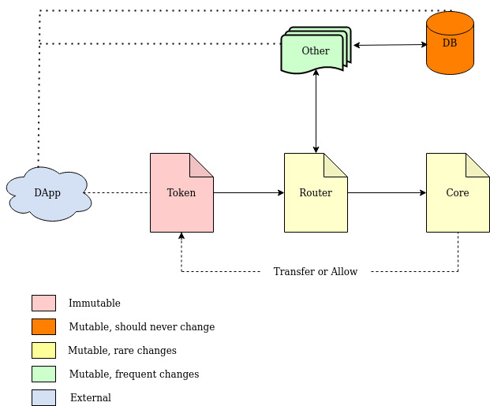

Technical details

Router Contract and Components

Contract address: 0x7C131Ab459b874b82f19cdc1254fB66840D021B6
Symbol: KRK
This is the only immutable part of a token design, and Krakin’t has added more power so it can be fully controlled. The reason is simple, and it is because we cannot predict why we will need such power. Sometimes it is better to be allowed to do anything we want then to be restricted by the contract that is set in stone. We hope that Krakin’t will evolve and that such power and flexibility will prove to be essential.

How does it work?
It mainly works by generating two arrays. One is the address array (addresseArr) and the other is the array of uint256 values (uintArr). Then, we simply pass those arrays to a Router while defining what kind of a function we want the Router to execute (as a string variable). These are the functions that must exist within any token.

Source code
For more details regarding the functions, please visit:
https://github.com/krakintgithub/solidity/tree/master/token/token

Router Contract and Components
Router is mutable and is expected to change over time. The change is done by deploying a new contract and telling the Token and the Core components the newly deployed contract address. Once the new address is set, the old contracts (although cannot be removed) become obsolete. Nevertheless, it is possible to branch-off the Krakin’t token into another token using the old and deployed source-code. However, the Token contract will always remain unique.

How does it work?
There are two main components. One is the component that is strictly associated with the main Token contract. Within this component, we are routing to the Core function depending on the string and the addressArr as well as uintArr passed from the Token contract. The if-then is used to choose the appropriate Core function call. The second part of the Router contract belongs to external application calls or other contract calls. For example, we have the miner contract executing the mint and the burn functions, which are communicated with the Core contract. Therefore, the Router is the place where the Token contract, external applications and other contracts meet to execute the Token contract via the Core contract.

Source code
For more details regarding the functions, please visit:
https://github.com/krakintgithub/solidity/tree/master/token/router

Core Contract and Components

Core is mutable and is expected to change over time. The change is done by deploying a new contract and telling the Token and the Router components the newly deployed contract address. Once the new address is set, the old contracts (although cannot be removed) become obsolete. Nevertheless, it is possible to branch-off the Krakin’t token into another token using the old and deployed source-code. However, the Token contract will always remain unique.

How does it work?
There are two main components. One is the component that is strictly associated with the main Token contract. Within this component, we are calling the Token contract, depending on the string and the addressArr as well as uintArr passed from the Router contract. The if-then is used to choose the appropriate Token function call. The second part of the Core contract belongs to external application calls or other contract calls. For example, we have the miner contract executing the mint and the burn functions, which are communicated via the Router contract. Therefore, the Core is the place where all the extra logic happens, before calling the atomic functions that exist within the Token contract. External applications and other contracts can also execute the Core functions via the Router contract.

Source code
For more details regarding the functions, please visit:
https://github.com/krakintgithub/solidity/tree/master/token/core

Other design possibilities
There are different ways we can implement the mutability onto block-chain. For example, we can combine the Router and the Core contract into one big contract. This would save some Ethereum GAS and make transfers cheaper. Nevertheless, it would make the code messy and more complicated to work with. Furthermore, we could also introduce the token wrapper, and simply transfer the wrapped token instead of the actual Krakin’t token. This would save the GAS prices up to 3 times by calling one contract instead of three. However, with Ethereum 2.0, the current design will not be an issue, and we should not have to worry about the GAS prices at all.

Final words and remarks
Since this white-paper is meant for wider audiences, it is simple to read and understand. Nevertheless, should you like to be more technical, please visit all the mentioned GitHub links, and see the source-code. Each function is well-documented and explained. Furthermore, you are encouraged to browse any other information or details, or simply ask questions on the official social channels.

