
KRAKIN’T
Solo-Miner: Light Paper
Version 0.1

Network: Ethereum

Address: 0xE91c47806D720a8C0A8A87473E6788d30EB1D8F0
https://github.com/krakintgithub/solidity/tree/master/miner

Document Date: October 2020, Version 0.1
Authors: Krakin’t Team

Web: http://www.krakint.com

Introduction
∙ Although we are using the word miner, the Krakin’t miner is very similar to staking. While mining implies something to be found, we are simply using the time-reference and collective staking to calculate the rewards.  ∙ Since we are relying on the Ethereum miners to mine the data-blocks, we are using the word “miner”. As a result, we can mine Krakin’t tokens without any electricity or special hardware, since Ethereum does all the hard-work for us.  ∙ Furthermore, we are applying the proof-of-burn concept to have a clear presentation between the market demands, circulating tokens, and the token market prices. Simply, we don’t circulate tokens that are idle, while we inflate the supply automatically and by demand. In this sense, Krakin’t is neither a stable-coin, inflationary nor deflationary. It is simply a precise-coin. |  | Krakin’t Miner Doodle

What Makes it Unique ?
Some of the networks, such as the Bitcoin network, work by applying the proof-of-work. This means that in order for the network to progress the ledger, computing needs to be performed too. The keyword here is the word “proof”. With decentralized nodes, we can compute whether the proof is true or false, and as a consequence, have the safest and most reliable networks. Ethereum gives us such network-strengths, and it allows us to apply our own creations indulging in its safety. Since all of the necessary proofs exist with the Ethereum network, Krakin’t miner does not need to apply any proof mechanism. Nevertheless, we can substitute the word “work” with anything we want, and build any mechanism around it. To have a profit-oriented network built with Ethereum, the only work that needs to be performed is inserting the Krakin’t tokens into a miner, and letting the miner do everything else.
We have narrowed-down the miner to just two main transactions; one is destroying (or burning) the tokens, and other is creating (or minting) the same tokens. With Ethereum safety, to reward miners, we can simply keep a track of who did what... and when. With the passing time, we can simply reward the accounts for having the tokens burned with the miner. Except for the burning part, this is equivalent to staking.

Furthermore, we can also reward all miners as soon as someone deposits and burns more Krakin’t tokens. By doing this, we have created a network of miners which is balancing the burning impact. Furthermore, if someone wants to mint their tokens back, they can do it by increasing the current supply of tokens. If demand is too high, miners will create new tokens, and inflate the circulating supply by the needed amount. As a result, we have a mechanism that balances the token price by giving us a clear picture of a demand versus the circulating supply.
As already mentioned, Krakin’t miner is profit-oriented, which can mean several things at once. The main goal of this miner is to have a fair system to everyone’s advantage. We have realized that halving mechanism (such as Bitcoin halving) gives unfair advantages to early miners. For this reason, we have made mining a constant, where the mining power is correlated with an investment. On the other hand, people with more money would have unfair advantages simply by disposing more tokens. Nevertheless, with a controlled supply and using the proof-of-burn, those with smaller amounts of tokens can trade them to earn the purchasing power. Therefore, fairness is an emergence from the balanced mechanism rather than direct interactions with the miner.

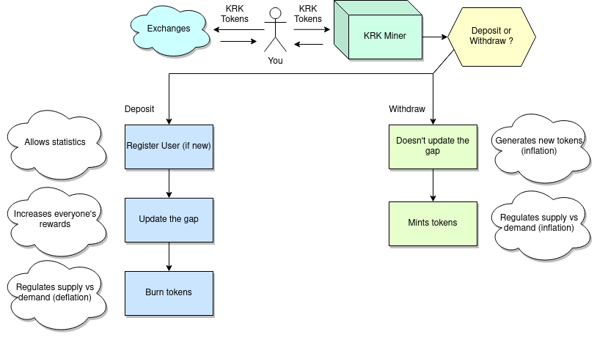
High-level description of a Krakin’t miner interaction

How are things calculated ?
With Krakin’t miner, time is money and money is the mining power. There are two ways the rewards are calculated, and both are very simple and are applied together, at once.

First way is by calculating the gap using the proof-of-burn:
Gap = (Total supply) - (Current supply)

When the user deposits their tokens, we simply calculate the ratio of a gap they own:
Reward = (Deposited Tokens) / (Gap)
The gap widens when tokens are burned by the miner, and then we memorize the burned tokens (per miner). Since the gap widens and since everyone has their share of the gap, their rewards increase too. This is how we are balancing the burning impact. If too many tokens are burned, then some of the miners will most likely mint new tokens to sell them, and therefore decrease the impact.

Second way is by memorizing the Ethereum block number at the time the miner deposit occurred. For Krakin’t miner, the block-number is simply a time-stamp. We simply calculate the ratio of deposited tokens per constant and multiply it by the block number difference.
Reward = [(Deposited Tokens)*((Current Block) – (Memorized Block))]/(constant)

Now, we want to be able to deposit more tokens or withdraw a certain amount but without interfering with the mining process. This is simply done by calculating the total reward that would have been withdrawn and then adding (if deposit) or subtracting (if withdraw) the amount of tokens that we need to interact with. Then, the new amount is silently re-introduced to the miner.
All of these calculations are very simple, and the reason is mainly the inability of Solidity to keep decimals, negative numbers, and therefore limiting the ways we can model the mining process. Nevertheless, a more centralized approach is used with the Krakin’t Labs, which is a group-mining equivalent. Furthermore, all the numbers are big integers and we keep them as the numerator and a denominator ratio to do a division at the very end.

Simplified User Interface
Although the mining contract can do much more, we have boiled down the mining and the user-interface to two simple functions. One is a deposit, other is withdraw. For this, we need just two fields and two (or just one) submit button.

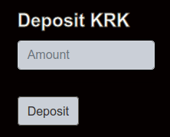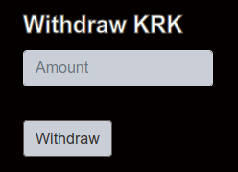
Simplified interaction with the Krakin’t miner
The calls to a contract are called every 6 seconds, and the total that can be withdrawn is displayed per new block. For the Krakin’t team (which has deposited 1 million of tokens for the purpose of setting up the miner and exchanges), this is what the interface displays:
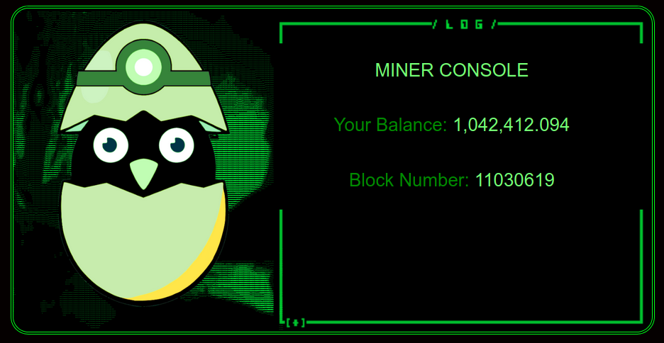
Krakin’t Miner, simplified interface that automatically displays the earnings
Therefore, the Krakin’t miner can be accessed by anyone and used by anyone, regardless their technical skills. Nevertheless, since we do need a third-party plugin to accompany the interface, the learning curve may be a bit steep for the complete beginners.

Things UI doesn’t Cover
Krakin’t miner is more than the simplified interface, and here is a list of things that we can do with the contract:
- See the miners as Ethereum addresses
- See the total amount of burned tokens
- See the total amount of the minted tokens
- See the number of miners
- See the earnings per miner
- See the last block per miner (when the last interaction happened)
- Burn tokens without mining (not recommended! for internal use only)

Furthermore, here are some of the tings that the contract owner (Krakin’t) can do:
- Adjust the total supply
- Adjust the current supply
- Stop/Start the miner
- Adjust the mining constant (rate at which new tokens are approved)
- Adjust the inflation constant
All of these extra features allow us to generate the statistical analysis and reports that are periodically published. Nevertheless, Krakin’t will not adjust any of the numbers, unless necessary, since they are the global variables which determine the earnings of every miner.

CONCLUSION
The purpose of the Light-Paper is to be as simple and up to a point as possible. Nevertheless, the source-code is open to anyone and every function and a variable are documented as a Readme.md.
Please see the GitHub link:
https://github.com/krakintgithub/solidity/tree/master/miner

We hope that you will enjoy the simple interface and the miner which uses no electricity and no hardware to work, except the working Internet connection to access it when necessary. With Krakin’t miner, all you need to keep your private keys safe, and/or exist.

