Embedded Robot Arm Position Control
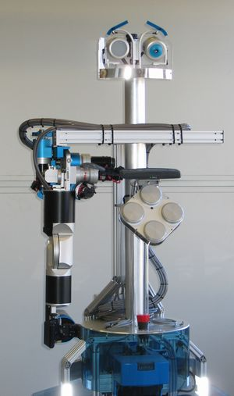
Kurzbeschreibung / short description
The project’s objective is to state a kinematic system model of a robot arm and
to derive a closed-loop controller in order to position the arm.

Typ / type | Semester Project (2 work packages)
Partner
Zeitdauer / period | Summer 2007
Student(en) /  student(s) | Marc Rauer <rauerm@ethz.ch>  Fritz Stoeckli <stfritz@ethz.ch>
Betreuung intern /  internal supervisor | Roland Phillipsen <philippsen@mavt.ethz.ch>  Ralf Kaestner <kaestner@mavt.ethz.ch>
Betreuung extern /
external supervisor

Stichworte / key words
Robot Arm, Position Control, Inverse Kinematic Model, RoboX

Umfeld / context
This project aims for the ready-to-run implementation of a position controller operating the BlueBotics Embedded Robot Arm (ERA-5/1, see http://www.bluebotics.ch for details).
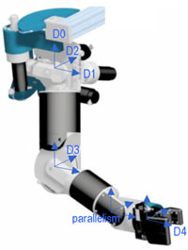
The arm possesses 5 degrees of freedom (DOFs) and is based on a serial mechanism with the motors concentrated at the shoulder for a small inertia. 3 DOFs apply to the shoulder, 1 DOF to the elbow, and another DOF to the wrist for roll movements of the gripper. The gripper itself is equipped with 12 infrared presence detection sensors.
The project’s objective is to state an inverse kinematic system model of the robot arm and to derive a closed-loop controller in order to position the arm. Initially, the gripper’s pose (x y z yaw roll) shall serve as the controller’s reference value. In a second step, the solution might then be extended to smoothly follow gripper pose trajectories. We ask for a POSIX-conform C or C++ implementation consisting of a driver layer and a control layer. The kinematic system model may be stated in Matlab/Simulink or by means of an equivalent framework.
The solution furthermore has to account for the following system constraints. For safety reasons, the actuating motors are limited in speed and torque. Control signals are transmitted via slow serial connections, thus placing an upper bound on the system’s control input rate. Also, the arm is not equipped with any force or torque sensors.
Axis | Description | Range | Speed
D0 | rotation about vertical axis | -30°/+90° | 65°/sec
D1 | rotation about horizontal axis | 0°/+90° | 72°/sec
D2 | rotation about horizontal axis perpendicular to D1 | -20°/+90° | 75°/sec
D3 | rotation about axis parallel to D2 | 0°/+120° | 75°/sec
D4 | rotation about horizontal axis | ±160° | 180°/sec

Overall dimensions | 230 mm from shoulder to elbow  330 mm from elbow to gripper
Payload | 1 Kg / 10 N
Actuators | Standard DC motors
Controller | Each axis can be controlled either in position, speed or torque
Communication | 1 RS232 link for arm movements control  1 RS232 link for gripper sensors
Weight | 2,7Kg - Mobile part  10Kg - Complete arm  3KG - Controller + cables
Power supply | 24V, max 400W
Security | Dedicated emergency stop cable with emergency button

Arbeitspakete / work packages
- Kinematic system model of the robot arm
- Closed-loop position controller
Rahmenbedigung / Formal Requirements
A work schedule has to be established and presented to the supervisors before March 23, 2007.
An intermediate presentation (about 10 minutes presentation and 10 minutes discussion) about your work will take place on Mai 2, 2007. The goal of the presentation is to give a brief summary of the work done, to propose a precise plan for the continuation of the project, and to discuss about the main directions of the project.
A report followed by a summary of one page, has to be handed in to the responsible supervisor with 3 copies on Friday, June 22, 2007 before noon. A preliminary version has to be handed in one week before the final submission (June 15, 2007). The report has to describe the full work performed during the whole project. All documents, including the report (original data and as a PDF file), the summary as a PDF file, and the final presentation have to be saved in a CD-ROM and handed over to the supervisors by the final presentation, at the latest.
A final presentation of 30 minutes (about 20 minutes of presentation and demonstration and 10 minutes of questioning) will take place on June 22, 2007.
The project is judged according to ASL evaluation sheet that is handed out by the responsible supervisor.

Responsible Professor | Responsible Supervisor
Signature | Signature
Name | Name
Zurich, March 19, 2007

Notes
The internet provides abounded information about how to write a scientific report and how to make a presentation. The report and presentation should be done according these common guidelines and the instructions from your supervisors. We recommend reading the following instructions before you start with your work:

Writing Guidelines for Engineering and Science Students
http://www.writing.eng.vt.edu/

Prof. Bernstein’s Student Guides
http://aerospace.engin.umich.edu/people/faculty/bernstein/guide.html

Style and format of your report should follow common practice and according the instructions of your supervisors. However, the ETH template is used preferably for the presentation.
We recommend you to use Microsoft Office, OpenOffice or LaTex to create your report and presentation.

Report:
Podlubny and Kassayova, Authoring Scientific and Technical Documents with Microsoft Word 2000, International Science Publishing, January 2001.

Oetiker et al., The Not So Short Introduction to LaTex 2e, May 2006.
http://www.ctan.org/tex-archive/info/lshort/english/lshort.pdf

Latex Editor http://www.toolscenter.org/ or http://www.lyx.org/

Presentation:
Tufte, PowerPoint is Evil, WIRED, September 2003.
http://www.wired.com/wired/archive/11.09/ppt2.html

The LaTeX Beamer Class
http://latex-beamer.sourceforge.net/

