Flight Reservation System

Software Requirements Specification (SRS)

Table of Contents
Table of Contents II
Revision History IV
1. Introduction 1
1.1 Purpose 1
1.2 Document Conventions 1
1.2.1 Abbreviations 1
1.2.2 Symbols 2
1.3 Intended Audience 2
1.4 Project Scope 2
1.5 References 2
2. Overall Description 2
2.1 Product Features 3
2.1.1 Secured Login 3
2.1.2 Inserting new reservations 3
2.1.3 Confirmations 3
2.1.4 Updating existing reservations. 3
2.1.5 Removing existing reservations. 3
2.1.6 Search capabilities. 3
2.1.7 Reporting 3
2.1.8 Database 3
2.2 Known Bugs 4
2.3 Operating Environment 4
2.4 User Documentation 4
2.5 Assumptions and Dependencies 4
3. Requirements 4
3.1 Login 4
3.1.1 Description 5
3.1.2 Functional Requirements 5
3.1.3 Login – Graphical User Interface 7
3.2 Flight Reservation 7
3.2.1 Description 7
3.2.2 Flight Reservation – Graphical User Interface 10
3.2.3 Functional Requirements 19
3.3 New Order Process 20
3.3.1 Description 20
3.3.2 Functional Requirements 21
3.3.3 Error Messages 24
4. User Challenge 26
4.1 Fax Preview 26
4.1.1 Gui Defaults 26
4.2 Menu 28
4.2.1 Functionality 28
4.3 Fax Order No. <n> 29
4.3.1 Functionality 29
4.4 About Flight Reservations System 30
4.4.1 Gui Defaults 30
4.5 Open Order Process 31
4.5.1 Description 31
4.5.2 Functional Requirements 32
4.5.3 Functional Requirements 34
4.6 Deleting an Order Process 34
4.7 Reporting 34
4.7.1 Description 35
4.7.2 Graphical User Interface Defaults 35

Revision History
Name | Date | Revision Description | Version
Pavan | 28/06/2014 | Reviewed | 1.0

Introduction
A Software Requirements Specification is a complete description of the behavior of the system to be developed. It includes a set of use cases that describe all of the interactions that users will have with the software.
Use Cases are also known as Functional Requirements. In addition to use cases, the SRS also contains nonfunctional requirements.

Purpose
This document contains the tests requirements for the FR Project.

Document Conventions

Abbreviations
AUT | Application Under Test
GUI | Graphical User Interface
UI | User Interface
LIB | Library folder contains QTP library functions
MTM | Multi Test Manager Tool.
QFL | File Extension (QTP File Library )
VBS | File Extension ( VBScript )
N/A | Not Available
DP | Descriptive Programming
OR | Object Repository
SOR | Shared Object Repository
OO | Object Oriented
OOP | Object Oriented Programming
OOT | Object Oriented Testing
STD | Software Test Documentation
PK | Primary Key ( Database relationships )
FK | Foreign key ( Database relationships )

Symbols
Exclamation | 
Question | 
Information
Critical | 

Intended Audience
This project is for "First Steps" members that want to learn how to practically learn how to use QTP as well as intermediate and expert users that want to review different methodology methods, code tricks and implementations.
Product Manager
Project Manager
Development Team
QA Team
Others

Project Scope
This document defines at a functional level the business activities that are encompassed by the system and the rules that apply to them. The scope of the detailed analysis project phase specifies that this document will include.

- Classification of requirements according to their functional areas.
- A description of each process in the system, including their inputs, outputs, and data transformation rules.

References
- Business Requirement Specifiation

Overall Description

Product Features

Secured Login
The system supports a secured login user/password.
Insert a new flight reservation.

Inserting new reservations
The application is able to insert new flight reservations according a future date requested, destinations and flight selections.

Confirmations
The application is send fax confirmations to clients, about new, updates and cancelled flights.

Updating existing reservations.
The application is able to update any data from an existing reservation.

Removing existing reservations.
The application is able to cancel any existing reservation.

Search capabilities.
The application supports a searching mechanism by order number customer name and/or date of flight

Reporting
The application supports graphical and text reports of reservations.

Database
The Flight Reservation database is a MS-Access file ( .mdb ).
The database has 2 tables
- Flights table
  - [PK] Flight_Number – Integer
  - Departure_Initials – String( size = 3 )
  - Departure – String( size = 30 )
  - Day_Of_Week – String( size = 9 )
  - Arrival_Initials – String( size = 3 )
  - Arrival – String( size = 30 )
  - Departure_Time – String( size = 8 )
  - Arrival_Time – String( size = 8 )
  - Airlines – String( size = 5 )
  - Seats_Available – Integer
  - Ticket_Price - Currency
- Orders table
  - [PK] Order_Number – Long Integer
  - Customer_Name – String( size = 20 )
  - Departure_Date – Date
  - [FK] Flight_Number – Integer
  - Tickets_Ordered – Byte
  - Class – String ( size = 1 )
  - Agents_Name - String ( size = 10 )
  - Send_Signature_With_Order – String ( size = 1 → Y/N )

Known Bugs
NA

Operating Environment
Windows XP/2008/7/2012

User Documentation
NA

Assumptions and Dependencies
NA

Requirements
This part of the requirements document serves to present the "big picture" of the application. Here you lay out the objectives of the application.

Login

Description
The Login dialog, logs to the Flight Reservation application. A shortcut to the application demo can be found in
Start → Sample Applications → Flight.
The user must provide an Agent Name that must be at least 4 characters long and the Password is always "Mercury". Clicking the OK button will access the application if requested information is correct.
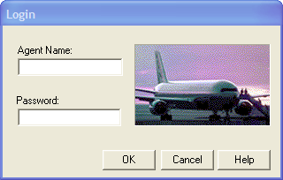
Figure 1 - Login Dialog

Functional Requirements

Req0001
Req0001a - User activates the Flight Application executable file from installation directory plus "\samples\flight\app\flightxx.exe"
Req0001b - immediately afterwards the Dialog "Login" should be displayed.

Req0003
User press OK without entering any information.
Req0003a – Popup dialog is displayed.
Req0003b – Popup title "Flight Reservations"
Req0003c – message type: Exclamation
Req0003d – message text "please enter agent name"

Req0004
The agent name must be at least 4 characters long.
Req0004a - Popup dialog displayed: True.
Req0004b – Popup title: "Flight Reservations"
Req0004c – message type: Exclamation
Req0004d – message text "Agent name must be at least 4 characters long."

Req0005
The password must be at least 4 characters long.
Req0005a - Popup dialog is displayed.
Req0005b – Popup title "Flight Reservations"
Req0005c – message type: Exclamation.
Req0005d – message text: "Password must be at least 4 characters long"

Req0006
The field “Password” should not be empty.
Req0006a - Popup dialog is displayed.
Req0006b – Popup title "Flight Reservations"
Req0006c – message type: Critical
Req0006d – message text "Please enter password"

Req0007
Wrong “Password” field will trigger a critical popup message
Req0006a – Popup dialog is displayed.
Req0006b – Popup title "Flight Reservations"
Req0006c – message type: Critical
Req0006d – message text: "Incorrect password. Please try again"

Req0008
Pressing "Cancel" at any time should close immediately the "Login" dialog

Req0009
After 4 bad attempts to login (bad password) the application will trigger an information message and closed.
Req0009a – Popup dialog is displayed.
Req0009b – Popup title "Flight Reservations"
Req0009c – message type: Exclamation
Req0009d – message text: "Login unsuccessful. Please try again later."
Req0009e – Application is closed.

Login – Graphical User Interface

Req0002
User activates the application the first time.
Req0002a - Label "Agent Name" visible: True.
Req0002b - Textbox "Agent Name" text: "", enabled: True, focused : True.
Req0002c - Label "Password" visible: True.
Req0002d - Textbox "Password" enabled: True, text: "".
Req0002e - Button "OK" enabled: True.
Req0002f - Button "Cancel" enabled: True.
Req0002g - Button '"Help" enabled: True.
Req0002h Image Logo:

Figure 2 - Login Image

Flight Reservation

Description
By inserting a valid and future date, and selecting a base and destination city, the user can choose a flight; order 1 to 10 tickets on 3 different classes. A client can receive a fax confirmation.
The user must provide a future valid Flight Date and must select a Fly From city and a Fly To city.
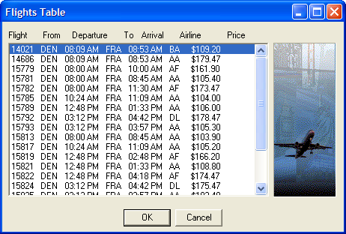
Figure 3 - Flights Table
The system will monitor from this point the price-per-ticket and the total amount to pay.
In addition the user can select 1 to 10 tickets and a flight class.
The information is inserted to a database, and a successful or failure message should be displayed in the transaction progress bar.
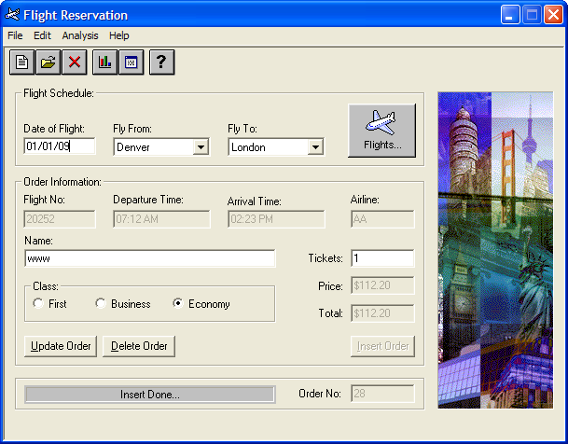
Figure 4 - Flights Reservation Window
In addition the user can get fax confirmation with an optional agent signature.
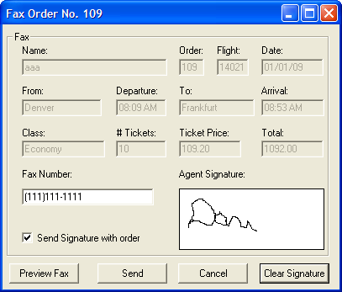
Figure 5 – Fax Order No. <n>

Flight Reservation – Graphical User Interface

The Toolbar

Figure 6 – Flight Reservation Toolbar

Req0010
Req0010a – Button "New Order"
- enabled: True
- icon:
Req0010b – Button "Open Order"
- enabled: True
- icon is:
Req0010c – Button "Delete Order"
- enabled: False
- icon is:
Req0010d – Button "Graphs"
- enabled: True,
- con is:
Req0010e – Button "Reports"
- enabled: True
- icon is:
Req0010f – Button "Help"
- enabled: True
- icon is:

Flight Schedule Frame
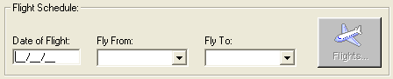
Figure 7 – Flight Schedule Frame

Req0011
Req0011a – "Date of Flight"
- enabled: True
- text: ""
- formattedText: "__/__/__"
- mask: "99/99/99"
- focused: True
Req0011b – "Flight From"
- enabled: True
- selection: ""
Req0011c – "Flight To"
- enabled: True
- selection: ""
Req0011d – "Flights"
- enabled: False

Order Information Frame
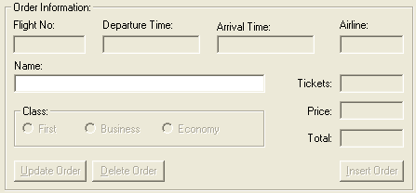
Figure 8 – Order Information Frame

Req0012
Req0012a – "Flight No." text: ""
Req0012b – "Departure Time" text: ""
Req0012c – "Arrival Time" text: ""
Req0012d – "Airline" text: ""
Req0012e – "Name", text: ""
Req0012f – "Tickets" text: ""
Req0012g – "Price", text: ""
Req0012h – "Total" text: ""
Req0012i – "Insert Order"
- Enabled: False
Req0012j – "Delete Order"
- Enabled: False
Req0012k – "Update Order"
- Enabled: False
Req0012l – "Business"
- enabled: False
Req0012m – "Economy"
- enabled: False
Req0012n – "First"
- enabled: False

Menu Defaults

Req0013
Req0013a – "File"
- Exists: True
- Enabled: True
- Index: 1
- Label: "File"
- SubMenuCount: 4
Req0013b – "Edit"
- Exists: True,
- Enabled: True
- Index: 2
- Label: "Edit"
- SubMenuCount: 3
Req0013c – "Analysis"
- Exists: True
- Enabled: True
- Index: 3
- Label: "Analysis"
- SubMenuCount: 2
Req0013d – "Help"
- Exists: True
- Enabled: True
- Index: 4
- Label: "Help"
- SubMenuCount: 2
Req0013e – "New Order"
- Exists: True
- Enabled: True
- Label: "New Order"
- HasSubMenu: False
Req0013f – "Open Order"
- Exists: True
- Enabled: True
- Label: "Open Order..."
- HasSubMenu: False
Req0013g – "Fax Order"
- Exists: True
- Enabled: False
- Label: "Fax Order…"
- HasSubMenu: False
Req0013h – "Exit"
- Exists: True
- Enabled: True
- Label: "Exit"
- HasSubMenu: False
Req0013i – "Copy" Exists: True
Req0013j – "Cut" Exists: True
Req0013k – "Paste" Exists: True
Req0013l – "Reports"
- Exists: True
- Enabled: True
- Label: "Reports…"
- HasSubMenu: False
Req0013m – "Graphs"
- Exists: True
- Enabled: True
- Label: "Graphs…"
- HasSubMenu: False
Req0013n – "Contents"
- Exists: True
- Enabled: True
- Label: "Contents"
- HasSubMenu: False
Req0013o – "About"
- Exists: True
- Enabled: True
- Label: "About…"
- HasSubMenu: False

Summary Defaults
Figure 9 – Summary Frame

Req0014
Req0014a – "Order No." text: ""
Req0014b – Progress bar text: ""

Window Image

Req0015

Figure 10 – Window Image

Flights Table Dialog
Figure 11 – Order Information Frame

Req0016
Req0016a – List
- enabled: True
- columns count: 7
Req0016b – Columns
- "Flight"
- "From"
- "To"
- "Departure"
- "Arrival"
- "Airline"
- "Price"
Req0016c – Button "OK"
- enabled: True
Req0016d – Button "Cancel
- enabled: True
Req0016e – Image :

Figure 12 – Flights Table Image

Send Fax - Defaults
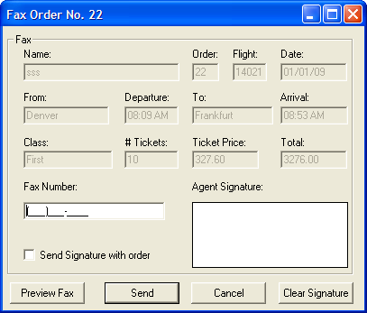
Figure 13 – Fax Order No. <n> Dialog

Req0018
Information match:
Req0018a – Dialog
- text: "Fax Order No. <num>"
- Ispopupwindow: True
Req0018b – Name
- text: <Name>
- Order: text: <Order>
- Flight: text: <Flight>
- Date: text: <Date>,
- From: text: <Fly From>
- Departure text: <Departure Time>
- To: text: <Flight To>
- Arrival: text: <Arrival Time>,
- Class: text: <Class>
- # Tickets text: <Tickets>,
- Ticket Price: <Price>
- Total text: <Total>
Req0018c – Fax Number;
- enabled: True
- format: "(###)###-####"
- FormattedText: "(___)___-____"
- mask: (999)999-9999; text: ""
- focused: True
Req0018c – Send Signature with order; enabled: True, checked: OFF
Req0018d– Agent Signature bitmap:

Req0018e – Preview Fax button
- enabled: True
Req0018f – Send button
- enabled: True
Req0018g – Cancel button
- enabled: True
Req0018h – Clear Signature button
- enabled: True

Functional Requirements

Toolbar Functionality

Req0020
If Data displayed, selecting "New" button, should clear the form. However if information updated without saving changes:
Req0020a – Popup dialog is displayed.
Req0020b – Popup title "Flight Reservations"
Req0020c – message type: Question.
Req0020d – message text: "The information has changed. Save changes?"

Req0021
Toolbar "Open Order" will display the Dialog "Open Order".
Req0021 - Open Order dialog exist: True

Req0022
Toolbar "Delete" will be enabled only after open an order.
Req0022 – open an order "Delete" enabled: True

Req0023
Toolbar "Graphs" will open the dialog "Graph"
Req0023 – Graph dialog
- exist: True

Req0024
Toolbar "Reports" will open "report.txt" notepad file.
Req0024 – Reports text file
- exist: True

Req0025
Toolbar "Help" will open the window "Flight Reservation Help Version.*"
Req0025 – Flight Reservation Help Version .*
- exist: True

New Order Process

Description
See Description

Functional Requirements

Req0035
Only valid departures cities must be in list "Fly Form" and "Fly To"
Req0035a – Fly From
- all items: < all items >
Req0035b – Fly To
- all items: < all items >

Req0036
After selecting "Fly From" The "Fly To" field
Req0035a – Fly To
- items count : < FlyFrom >.count - 1
Req0035b – Fly To;
- < FlyFrom > value is not in the "all items"

Req0037
Only after selecting "Fly From" the access to Flights Table will be available.
Req0037a – Button "Flights"
- enabled: True.
Req0037b – icon
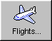

Req0038
All items are ordered by Flight.
Req0038a – List
- items count: <items count>
- all items: <all items>
- selected: <item 0>

Req0039
After selecting a flight from "Flights Table"
Req0039a – "Name"
- focused: True
Req0039b – "Tickets"
- enabled: True
- Text: "1"
Req0039c – "Economy"
- enabled: True
- checked: "ON"
Req0039d – "Flight No."
- text: <OrderNo>
Req0039e – "Departure Time"
- text: <DepartureTime>
Req0039f – "Arrival Time"
- text: <ArrivalTime>
Req0039g – "Airline"
- text: <Airline>
Req0039h – "Price"
- text: <Price>
Req0039i – "Total"
- text: <Price> * <Tickets>

Req0040
After typing a name, tickets or selecting a class
Req0040a – "Insert Order"
- enabled: True
Req0040b – "Total"
- text: <Price> * <Tickets>

Req0041
After pressing "Insert Order"
Req0041a – Application temporally disabled "Flight Reservation
- enabled: False
Req0041b – "Insert Order"
- enabled: True
Req0040c – "Update Order"
- enabled: False
Req0041d – "Delete Order"
- enabled: False
Req0041e – "Order No."
- text: <last order no> + 1
Req0041f – "Send Fax" menu item
- enabled: True
Req0041g – toolbar "Delete"
- enabled: True
Req0041h – toolbar button "Delete"
- image:
Req0041i – progress bar message
- text: "Insert Done…"
Req0041j – new record was added to Orders table in database. Fields values must be consists.
- "Order_Number",
- "Customer_Name",
- "Departue_Date",
- "Flight_Number"
- "Tickets_Ordered", "Class"
- "Agents_Name"

Req0042
After pressing "Send"
Req0042a – Message "Dialing..."
Req0042b – Message "Connecting..."
Req0042c – Message "Sending Fax..."
Req0042d – dialog "Fax Order No. <x>
- Exists: False
Req0042e – progress bar message
- text: "Fax Sent Successfully…"
Req0042f – record <n> Field "Send Signature" must be consists.

Req0043
After pressing "Send"
Req0043a – dialog "Fax Preview
- Exists: False
Req0043b – Message "Dialing..."
Req0043c – Message "Connecting..."
Req0043d – Message "Sending Fax..."
Req0043e – progress bar message
- text: "Fax Sent Successfully…"
Req0043f – record <n> Field "Send Signature" must be consists.

Error Messages

Req0044
User types an invalid month.
Req0044a – Popup dialog is displayed.
Req0044b – Popup title: "Flight Reservations"
Req0044c – message type: Exclamation
Req0044d – message text: "Invalid month Entered.The month must be greater than 01 and less than 12."

Req0045
User types an invalid day
Req0045a – Popup dialog is displayed.
Req0045b – Popup title: "Flight Reservations"
Req0045c – message type: Exclamation
Req0045d – message text: "Invalid day Entered. The date should be valid for the given month."

Req0046
User type an invalid year (valid 2007-2038).
Req0046a – Popup dialog is displayed.
Req0046b – Popup title: "Flight Reservations"
Req0046c – message type: Exclamation
Req0046d – message text: "Invalid year Entered.
The year must be greater than 2007 and less than 2038.

Req0047
Valid dates are Today()+1, User type an old acceptable date.
Req0047a – Popup dialog is displayed.
Req0047b – Popup title: "Flight Reservations"
Req0047c – message type: Information
Req0047d – message text: "Valid flight dates are after <Today>"

Req0048
User select "Fly From" without "Date of Flight"
Req0048a – Popup dialog is displayed.
Req0048b – Popup title: "Flight Reservations"
Req0048c – message type: Information
Req0048d – message text: "Please enter a flight date"

Req0049
User select "Fly To" without "Fly From"
Req0049a – Popup dialog is displayed.
Req0049b – Popup title: "Flight Reservations"
Req0049c – message type: Information
Req0049d – message text: "Please enter a fly 'from' city."

Req0050
Valid number of tickets between 1 and 10, The user types an amount greater than 10.
Req0050a – Popup dialog is displayed.
Req0050b – Popup title: "Flight Reservations"
Req0050c – message type: Critical
Req0050d – message text: "Only ten tickets may be ordered at one time"

User Challenge
This part of the requirements document is for students that want to go forward and complete the whole project.

Fax Preview

Gui Defaults
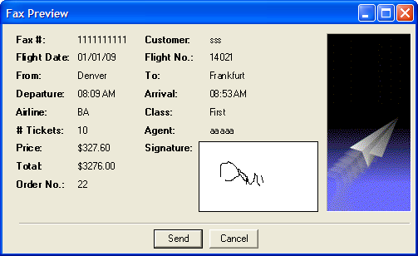
Figure 14 – Fax Preview Dialog

Req0019
Information match:
Req0019a – Dialog; Ispopupwindow: True
Req0019b – Fax # = < faxNo >
Req0019c – Customer = < customer >
Req0019d – Flight Date = < flightDate>
Req0019e – Flight No. = < flightNo >
Req0019f – From = < flyFrom >
Req0019g – To = < flyTo >
Req0019h – Departure = < departure >
Req0019i – Arrival = < arrival >
Req0019j – Airline = < airline >
Req0019k – Class = < class >
Req0019l – # Tickets = < tickets >
Req0019m – Agent = < agent >
Req0019n – Price = < price >
Req0019o – Total = < total >
Req0019p – Order No. = < orderNo >
Req0019q – Button "send"
- enabled" True
Req0019r – Button "Cancel"
- enabled: True
Req0019s – image :

Figure 15 – Fax Preview Image

Menu

Functionality

Req0026
If Data displayed, selecting "File; New" menu item, should clear the form. However if information updated without saving changes:
Req0026a – Popup dialog is displayed.
Req0026b – Popup title "Flight Reservations"
Req0026c – message type: Question.
Req0026d – message text: "The information has changed. Save changes?"

Req0027
If Data displayed, selecting "File; New" menu item, should clear the form. However if information updated without saving changes:
Req0026a – Popup dialog is displayed.
Req0026b – Popup title "Flight Reservations"
Req0026c – message type: Question.
Req0026d – message text: "The information has changed. Save changes?"

Req0028
Toolbar "Open Order" will display the Dialog "Open Order".
However if information updated without saving changes:
Req0026a – Open Order dialog exist:
Req0026b – Popup dialog is displayed.
Req0026c – Popup title "Flight Reservations"
Req0026d – message type: Question.
Req0026e – message text: "The information has changed. Save changes?"

Req0029
If "File; Fax Order" is enabled it should open the "Fax Order No. x" Dialog, where "x" is the currently opened reservation.
Req0029a – "Fax Order No. x"
- exist: True
Req0029b – "x"; currently opened reservation. < orderNo >

Req0030
Menu item "File; Exit" should close application

Req0031
Menu item "Analysis; Graphs" will open the dialog "Graph"
- Graph dialog exist: True

Req0032
Menu item "Analysis; Reports" will open "report.txt" notepad file.
- Reports text file exist: True

Req0033
Menu item "Help; Contents" will open the window "Flight Reservation Help Version.*"
Flight Reservation Help Version .*
- exist: True

Req0034
Menu item "Help; About" will open the dialog "About Flight Reservation System"
About Flight Reservation System
- exist: True

Fax Order No. <n>

Functionality

Req0051
Click on "Cancel" button will close dialog.
Req0041 – "Fax Order No. <x>"; Exists: False

Req0052
Clear Signature Button will erase the signature.
Req0042 – Agent Signature; bitmap:

Req0053
User Clicks Send or Preview Fax with empty fax number or less than 10 digits.
Req0043a – Popup dialog is displayed.
Req0043b – Popup title "Flight Reservations"
Req0043c – message type: Critical
Req0043d – message text "Please complete the fax number."

Req0054
User Clicks Send or Preview Fax with checked field "Send Signature with order" and without signature.
Req0043a – Popup dialog is displayed.
Req0043b – Popup title "Flight Reservations"
Req0043c – message type: Critical
Req0043d – message text "Please sign the fax."

About Flight Reservations System

Gui Defaults

Req0055
Req0055a – Button "OK"
- enabled: True
Req0055b – Static "Version" text: "Version 4.0"
Req0055a – Icon: 
Req0055a – image

Figure 16 – About Image

Open Order Process

Description
When the Flight Reservation Main window is displayed, the agent is able to open an existing order for review, update or delete an existing order.
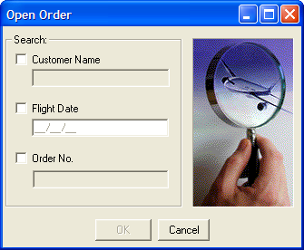
Figure 17 – Open Order Dialog
By entering an Order No Or a Customer Name Or a Flight Date Or a combination of Customer Name and Flight Date, the relevant order will open.
Opening an order by Order No. will open the order directly if it exists.
Opening an order by Customer Name and/Or Flight Date will open a dialog "Search Results" if more than one matches the description.
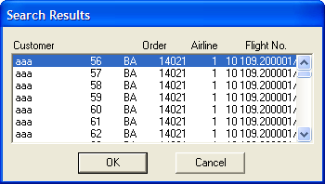
Figure 18 – Search Results Dialog

Functional Requirements

Req0056
Req0056a - Check only "Customer Name" option.
"Customer Name" field
- enabled: True
- focused: True
"Flight Date" field
- enabled: True
"Order No" option
- enabled: False
"Order No" field
- enabled: False
Req0056b - Check "Order No" option
"Order No" field
- enabled: True
- focused: True
"Flight Date" field
- enabled: False
"Flight Date" option
- enabled: False
"Customer Name" option
- enabled: False
"Customer Name" field
- enabled: False
Req0056c - Check only "Flight Date" option
"Flight Date" field
- enabled: True
- focused: True
"Customer Name" field
- enabled: False
"Customer Name" option
- enabled: True
"Order No" option
- enabled: False
"Order No" field
- enabled: False
Req0056d - Check "Customer Name" and then "Flight Date" options
"Flight Date" field
- enabled: True
- focused: True
"Customer Name" field
- enabled: True
"Order No" option
- enabled: False
"Order No" field
- enabled: False

Req0057
Pressing "Cancel" close the dialog

Functional Requirements

Req0058
Trying to open a non-existing order No. will display a critical message
Req0058a – Popup dialog is displayed.
Req0058b – Popup title "Flight Reservations"
Req0058c – message type: Critical
Req0058d – message text "Order Number < OrderNo > does not exist"

Req0059
Trying to open a non-existing Customer Name will display a critical message
Req0059a – Popup dialog is displayed.
Req0059b – Popup title "Flight Reservations"
Req0059c – message type: Critical
Req0059d – message text "No order found. Please try again"

Req0060
Trying to open a non-existing "Flight Date" will display a critical message
Req0060a – Popup dialog is displayed.
Req0060b – Popup title "Flight Reservations"
Req0060c – message type: Critical
Req0060d – message text "No order found. Please try again"

Deleting an Order Process
Make your own requirements for this process

Reporting

Description
The flight application supports two report mechanism
- Textual Report
- Graphical Report
Both are available from the menu and toolbar.
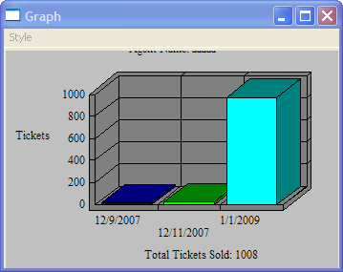
Figure 19 – Graphical Report Dialog

Graphical User Interface Defaults

Req0061
Req0061a – Dialog
- ispopupwindow: True
Req0061b – "Style"
- Exists: True
- Enabled: True
- Index: 1
- Label: "File"
- SubMenuCount: 4
Req0061c – "Style; 2D Bar"
- Exists: True
- Enabled: True
- Label: "2D Bar Graph"
- HasSubMenu: False
Req0061d – "Style; 3D Bar"
- Exists: True
- Enabled: True
- Label: "3D Bar Graph"
- HasSubMenu: False
Req0061e – "Style; 3D Bar"
- Exists: True
- Enabled: True
- Label: "3D Pie Graph"
- HasSubMenu: False
Req0061f – "Agent Name: <AgentName>
Req0061g – "Total Tickets Sold: <TotalTickets>

