Design:

Reports

reports.html

Billing

bill.html

Manage Doctors

doctor.html

Manage Patients

patientslist.html

Appointments

Appointment.html

Dashboard

Index.html

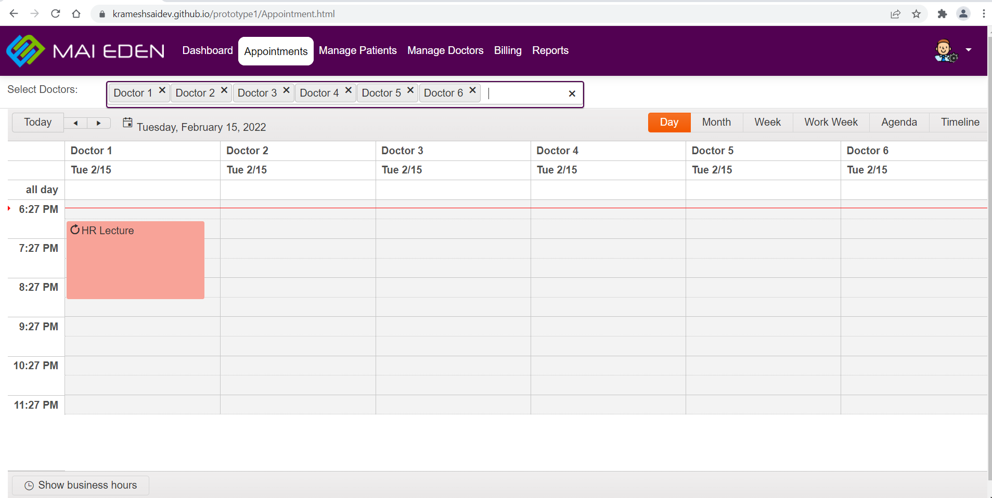

Colors:

Highlighter



Background (white)

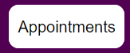

Header



Font family: “Roboto”,sans-serif

Icons:

    

Icons folder path

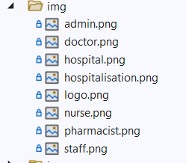

Buttons: [Bootstrap]



<button type="button" class="btn btn-primary">Primary</button>

<button type="button" class="btn btn-secondary">Secondary</button>

<button type="button" class="btn btn-success">Success</button>

<button type="button" class="btn btn-danger">Danger</button>

<button type="button" class="btn btn-warning">Warning</button>

<button type="button" class="btn btn-info">Info</button>

<button type="button" class="btn btn-light">Light</button>

<button type="button" class="btn btn-dark">Dark</button>

Material Design Buttons:

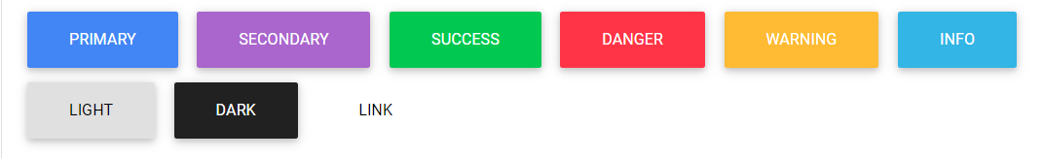

<button type="button" class="btn btn-primary">Primary</button>

<button type="button" class="btn btn-secondary">Secondary</button>

<button type="button" class="btn btn-success">Success</button>

<button type="button" class="btn btn-danger">Danger</button>

<button type="button" class="btn btn-warning">Warning</button>

<button type="button" class="btn btn-info">Info</button>

<button type="button" class="btn btn-light">Light</button>

<button type="button" class="btn btn-dark">Dark</button>

<button type="button" class="btn btn-link">Link</button>