Installing WSUS, Automated Windows System Deployment, Formatting Requirements
In assignment 3, I installed a Windows Update role on my domain controller. After that I downloaded and set up the Microsoft Deployment toolkit. My biggest challenge was resetting my computer because I was hacked. For some reason I had a lot of issues getting my virtual machines connected to the internet.
I messed up the configuration when first downloading the WSUS, I restarted the system before letting it finish installing and couldn’t go back to fix it.
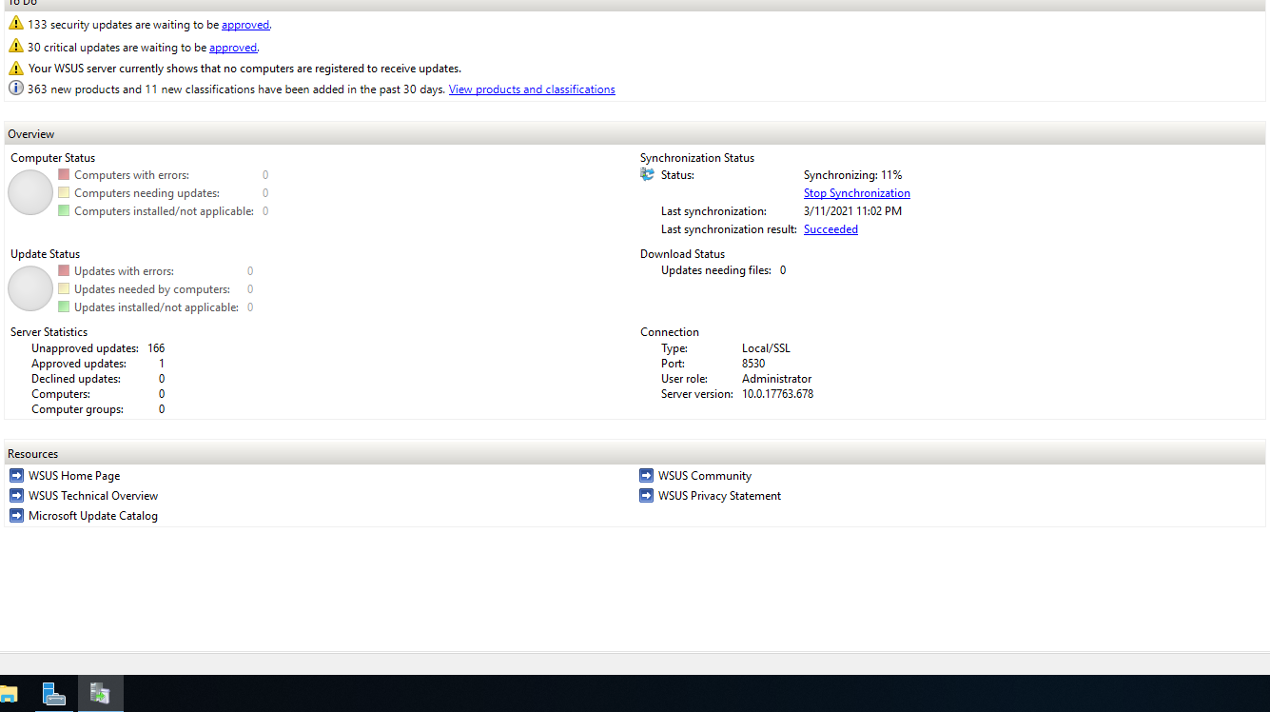

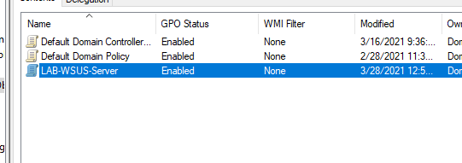
Add the server to the domain.

Downloading MDT from Microsoft was difficult because I could not access webpages even though I was connected to the internet, I spent a bit of time trying to troubleshoot this, but after downloading this file this way, I know that maybe I shouldn’t be able to get on the internet. I changed my VMware gateway address, and this seemed to help me get on the internet.
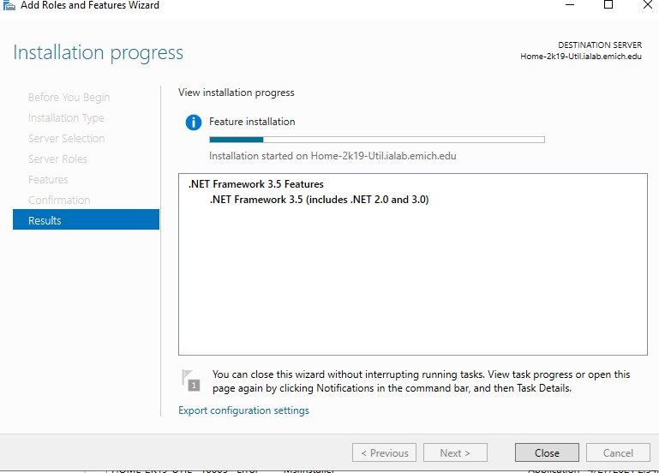
I attempted to install the deployment service.
I was having trouble with the deployment install; it was saying it didn’t recognize the path. I finally went to the command line and changed my default hostname because that’s what I was having issues with.
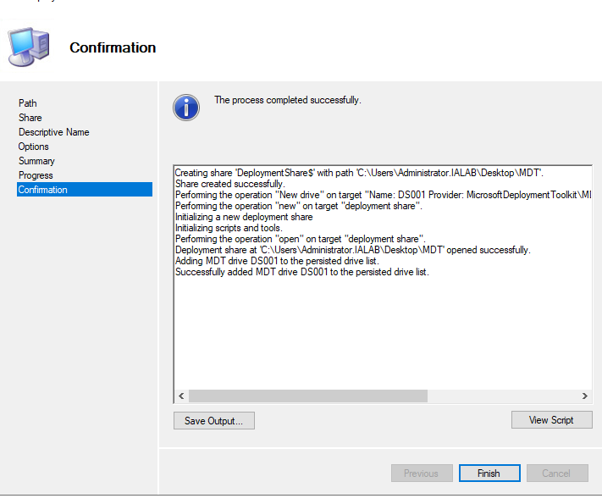
Finally got it to let me download MDT/
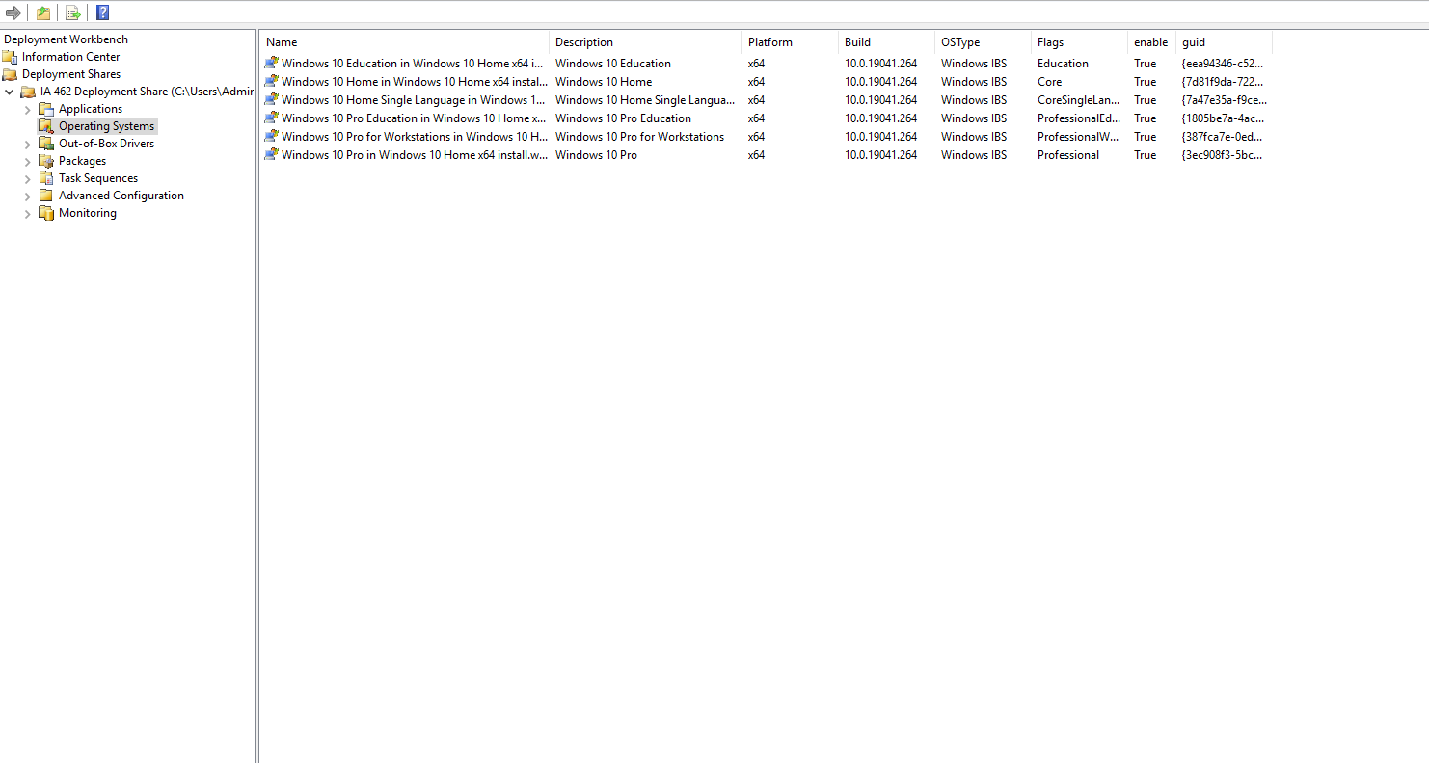
Downloaded OS to workbench and deleted the unnecessary OSs.
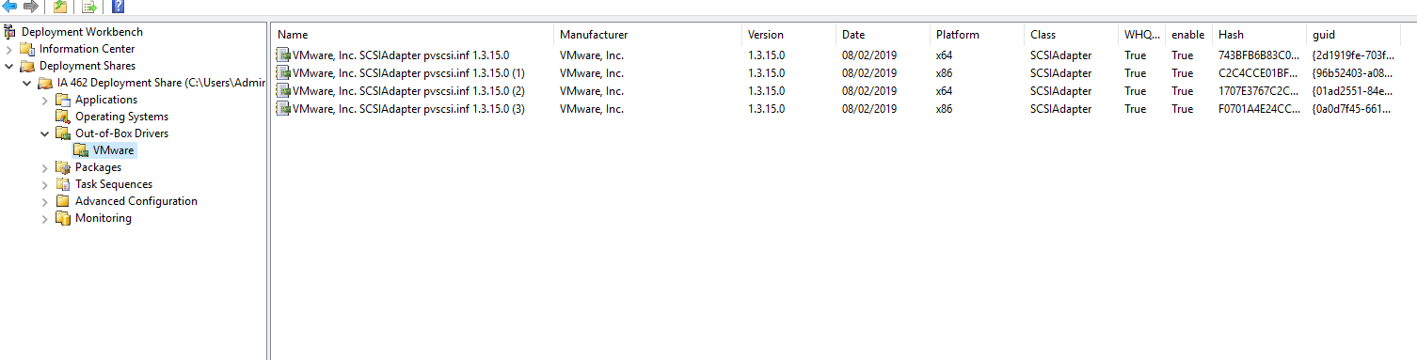
Copied drivers from host vmware.
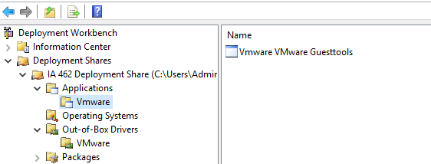
Copied vmware tools
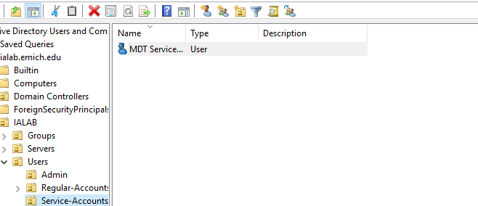
Created Service Account
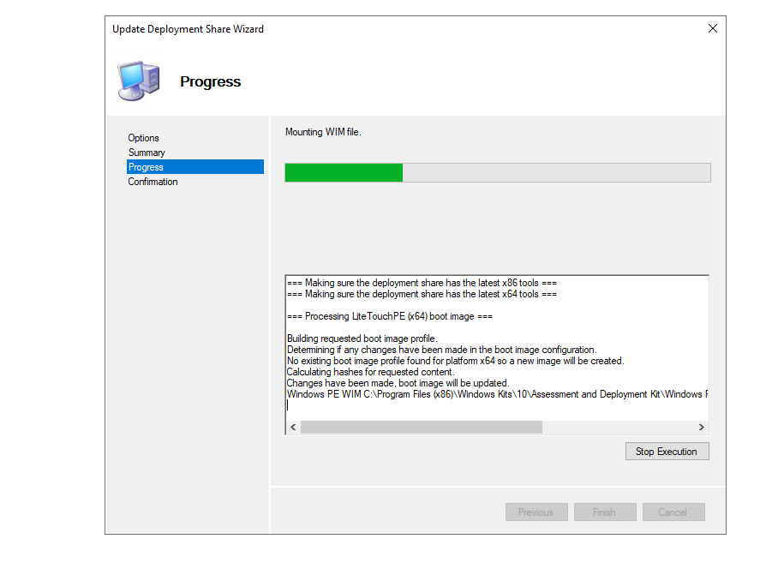
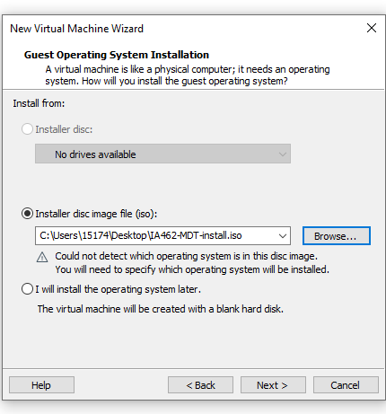
I was having trouble finding the connection to my domain controller on the MDT properties.
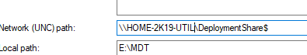
I had issues at the end, I couldn’t get the domain to communicate with MDT. Will reset configurations on the domain controller to see if this helps.

