Outlet line direction

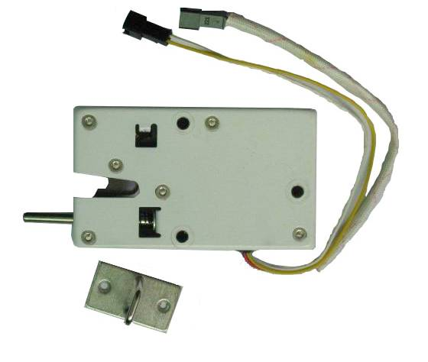
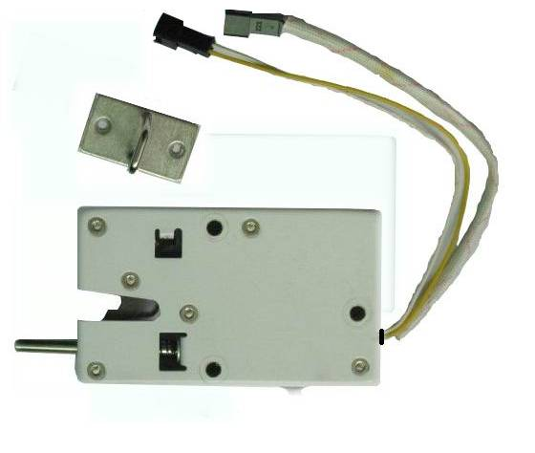
Special production according to customer and proposed to maintain the original factory produced.

