Proportions Test (MSM vs IDU)

October 21, 2015

### Mortality Analysis for the period 2003 to 2014

#### *HIV Mortality Analysis*

In order to explore HIV Mortality in Puerto Rico, we conducted a crude analysis using the data from the HIV Surveillance System for 2003 to 2014. The trend in HIV mortality can be seeing in figure 1:

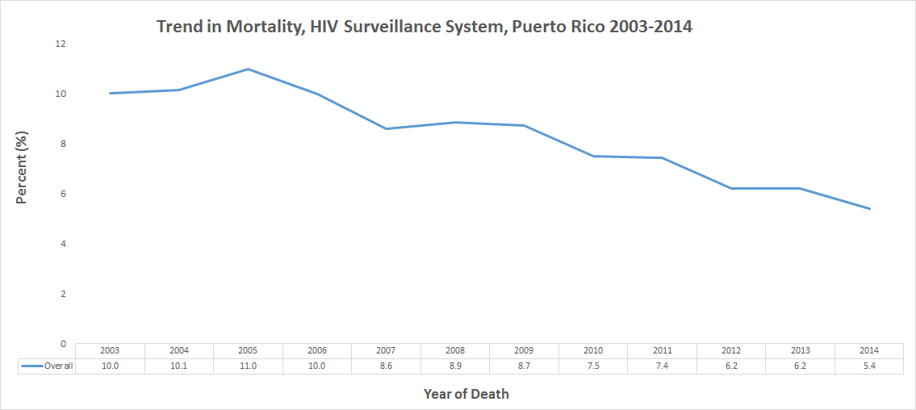

Figure 1 shows the crude HIV mortality trend in Puerto Rico for the period 2003-2014. This preliminar analysis shows a decreasing HIV trend of 4.6% (10.0% in 2003 compared with 5.6% in 2014) in Puerto Rico. In figure 2 we stratified by mode of transmission (Men who have Sex with Men, Injection Drugs Users and Heterosexual Contact):  
  
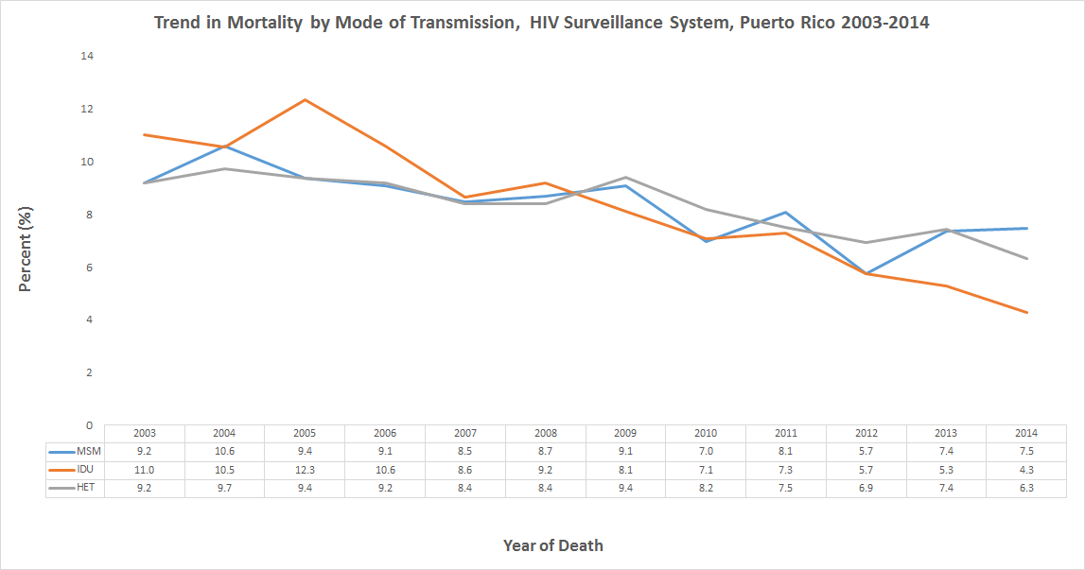

Figure 2 also shows a decreasing trend in HIV in Puerto Rico. In the IDU group, we can see a decrease of almost 7% which might explain the reason why the overall mortality is also decreasing.

#### *Comparing deaths of Men who have Sex with Men (MSM) and Injected Drugs Users (IDU)*

In order to compare deaths among MSM and IDU, we calculate the absolute difference between years (according to the CDC mathematical model) and verify whether there was a significant difference between these groups. The raw file can be accessed [here.](https://github.com/kramus/proptest/blob/master/propt3.csv)   
The structure of the data is as follows:

## year 2004 2005 2006 2007 2008 2009 2010 2011 2012 2013 2014  
## type case   
## msm yes 14 12 3 6 2 4 21 11 23 16 1  
## no 91 105 93 90 84 86 90 69 80 57 73  
## idu yes 17 66 64 72 20 39 38 7 57 17 36  
## no 405 388 454 390 318 338 299 261 268 211 194

The absolute differences of MSM and IDU cases for 2004-2014 are:

## ------------------  
## year MSM IDU   
## ------ ----- -----  
## 2004 0.154 0.042  
##   
## 2005 0.114 0.17   
##   
## 2006 0.032 0.141  
##   
## 2007 0.067 0.185  
##   
## 2008 0.024 0.063  
##   
## 2009 0.047 0.115  
##   
## 2010 0.233 0.127  
##   
## 2011 0.159 0.027  
##   
## 2012 0.288 0.213  
##   
## 2013 0.281 0.081  
##   
## 2014 0.014 0.186  
## ------------------

To perform the analysis we used a function to divide the dataset by year to calculate whether there was a difference between cases of HIV for MSM and IDU by specific years. The p-values were:

|  |  |
| --- | --- |
| Year | p_value |
| 2004 | 0.0007 |
| 2005 | 0.2931 |
| 2006 | 0.0129 |
| 2007 | 0.0252 |
| 2008 | 0.2750 |
| 2009 | 0.1244 |
| 2010 | 0.0570 |
| 2011 | 0.0004 |
| 2012 | 0.3462 |
| 2013 | 0.0013 |
| 2014 | 0.0022 |
|  |  |

We can see that for years 2005, 2008, 2009, 2010 and 2012 the results were not statistically significant (0.2931, 0.275, 0.1244, 0.057, 0.3462 respectively). Further investigation will be needed in order to have a better insight of the behavior of HIV mortality in Puerto Rico.