PrettyCSV
User Guide
Turn any CSV file into a clean, readable table, format it your way, and export it as CSV, JSON, Excel or Zephyr Scale.
Everything runs inside your web browser. Your data is never uploaded anywhere.

1. Launch PrettyCSV
PrettyCSV is a single file, so there is nothing to install.
- Go to github.com/kranmal/PrettyCSV in your browser.
- Click index.html, then click the Download raw file button (the download arrow, top right of the file view). Save it somewhere easy to find, such as your Desktop.
- Double-click the saved index.html file. It opens in your default browser (Chrome, Edge, Safari or Firefox).
- You should see the start screen below. You are ready to go.
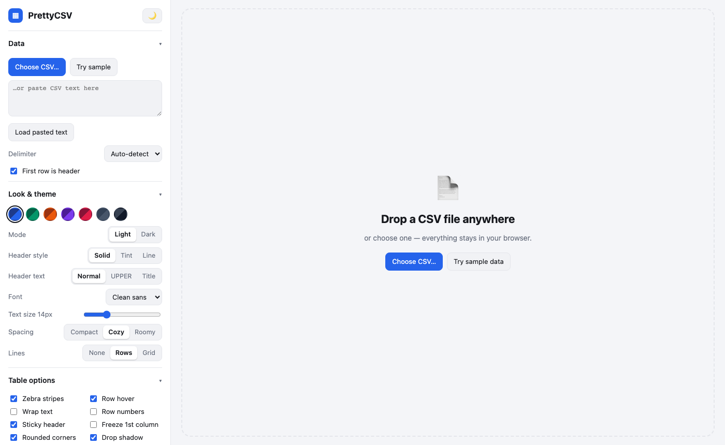
The PrettyCSV start screen: settings on the left, drop zone on the right.
Tip: Bookmark the page or keep the file on your Desktop. It works offline, and your style choices are remembered next time you open it.

2. Load your CSV
Pick whichever way is easiest:
- Drag and drop a .csv file anywhere on the page.
- Choose CSV… to browse for a file.
- Paste CSV text into the box on the left, then click Load pasted text.
- Try sample to explore the tool with demo data first.
Your data appears as a formatted table straight away. PrettyCSV detects the delimiter (comma, semicolon, tab or pipe) and whether each column holds text, numbers or dates.
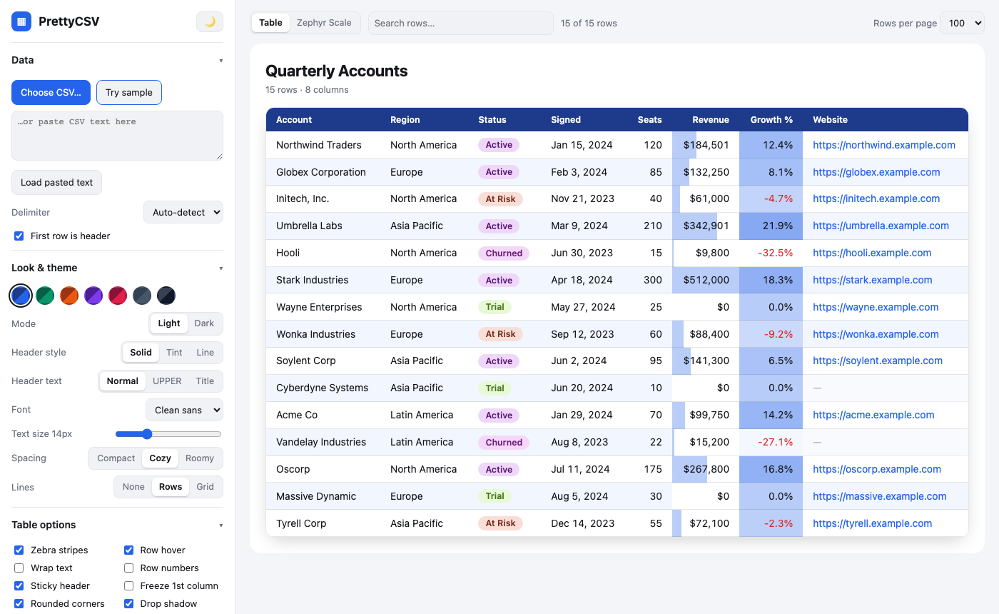
Sample data loaded: dates, currency, percentages, status badges and clickable links.
Tip: If columns look wrong, change Delimiter in the Data section. Untick First row is header if your file has no header row.

3. Search and sort
- Type in the Search rows… box at the top. Only matching rows stay, and matches are highlighted.
- Click a column heading to sort ascending (▲). Click again for descending (▼). Click a third time to remove the sort.
- Use Rows per page (top right) to show 25, 100, 500 or all rows. Prev and Next buttons appear for large files.
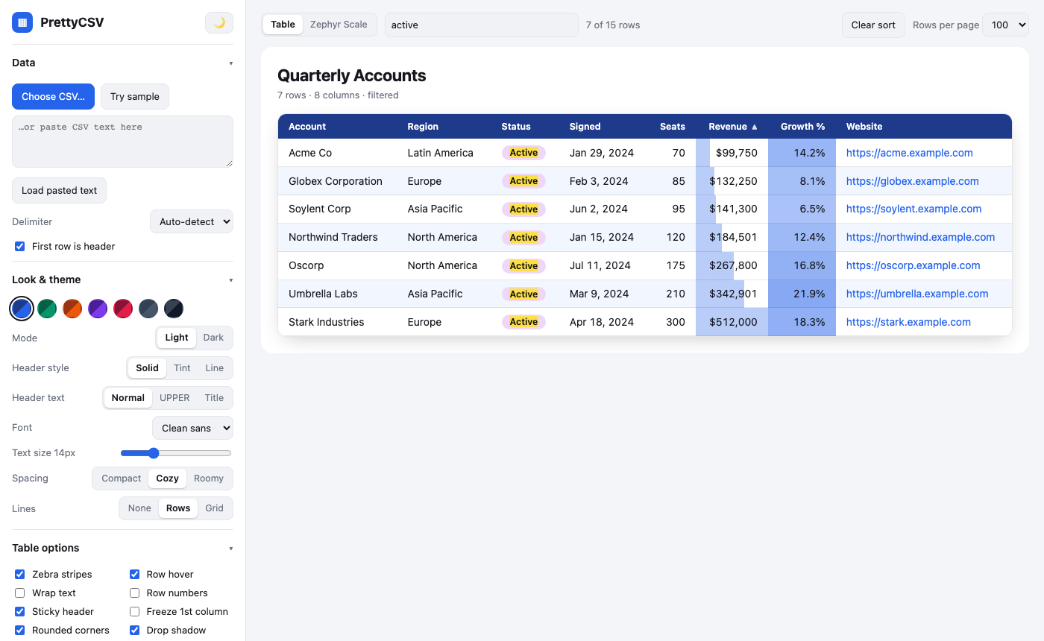
Searching for “active” and sorting by the Signed column.

4. Make it pretty
The Look & theme section of the left panel changes the whole appearance instantly.
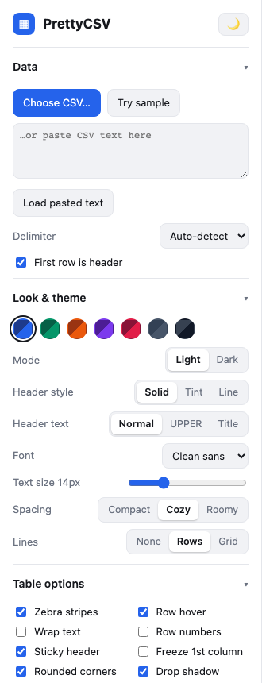
The Look & theme controls.
Control | What it does
Colour swatches | Seven colour themes. Pick one to recolour the headers, accents, bars and badges.
Mode | Light or Dark. You can also use the ☀️ / 🌙 button at the top of the left panel.
Header style | Solid (coloured bar), Tint (soft colour) or Line (underline only).
Header text | Normal, UPPERCASE or Title Case.
Font | Clean sans, Serif, Monospace or Rounded.
Text size | Slide to make the table text smaller or larger.
Spacing | Compact, Cozy or Roomy row height.
Lines | No lines, row lines, or a full grid.

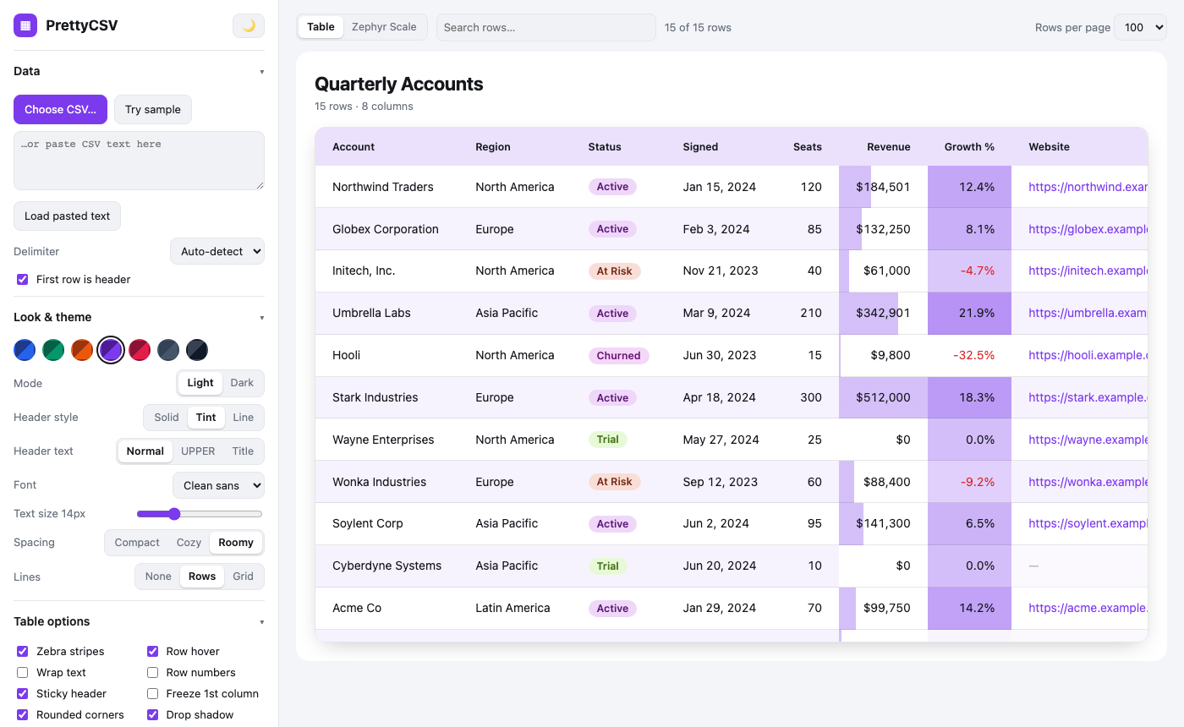
Purple theme with a Tint header and Roomy spacing.
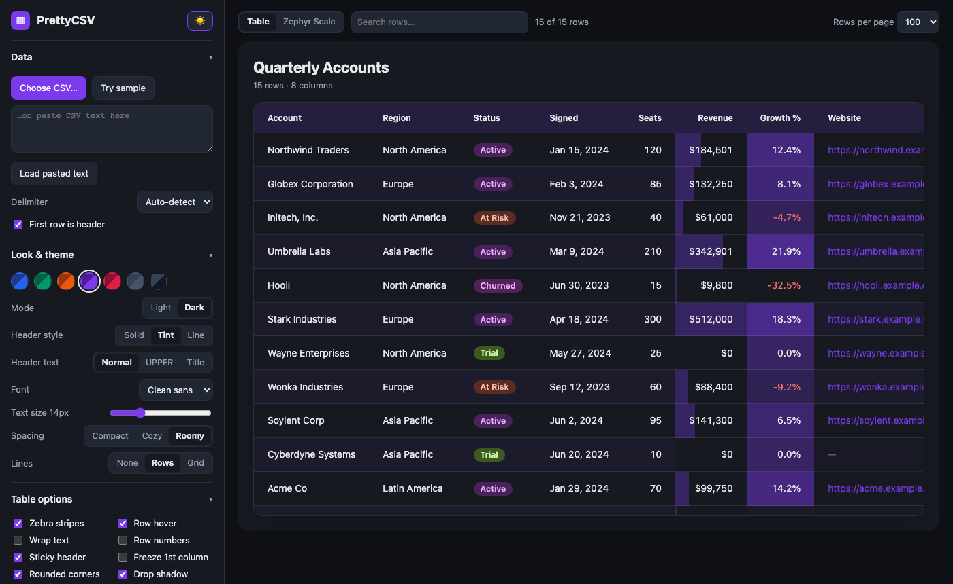
The same table in dark mode.

5. Table options
Below the look controls are tick boxes that switch table features on and off.
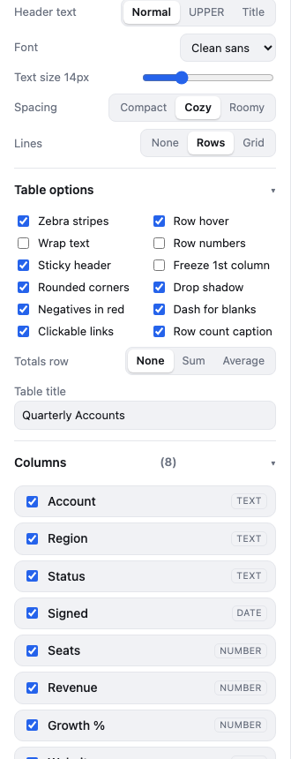
Table options and totals row.
- Zebra stripes / Row hover: make long tables easier to follow.
- Wrap text: show long text over several lines instead of cutting it off.
- Row numbers, Sticky header, Freeze 1st column: keep your place when scrolling.
- Rounded corners, Drop shadow: polish the table frame.
- Negatives in red, Dash for blanks, Clickable links: tidy up the data itself.
- Row count caption and Table title: add a heading above the table. The title fills in from the file name; type your own to replace it.
- Totals row: add a Sum or Average row under every number column.

6. Format individual columns
Scroll down the left panel to the Columns section. Every column has its own settings.
- Click a column name to open its settings.
- Change what you need (see the table below). The table updates immediately.
- Untick the box beside a column name to hide it. It stays hidden in exports too.
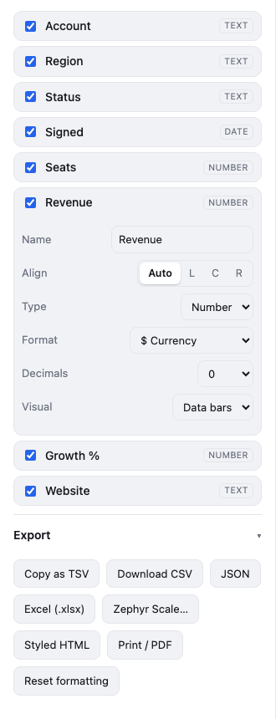
The Revenue column set to $ Currency, 0 decimals, with data bars.
Setting | Options
Name | Rename the column heading.
Align | Auto, Left, Centre or Right.
Type | Text, Number or Date. Change it if PrettyCSV guessed wrong.
Format (numbers) | Number with commas, $ € £ currency, percent, fraction ×100 as percent, or compact (1.2K).
Format (dates) | Oct 24, 2026 · Saturday, October 24, 2026 · 2026-10-24 · 10/24/2026.
Format (text) | As is, UPPERCASE, lowercase or Title Case.
Decimals | Auto, or 0 to 4 decimal places.
Visual | Data bars or Heat map for numbers; coloured Badges for text such as statuses.

7. Zephyr Scale view
If your CSV holds test cases, PrettyCSV can show it the way Zephyr Scale would after an import: one card per test case with its details and a table of test steps.
- Load your file, then click Zephyr Scale in the toolbar at the top (or Zephyr Scale… in the Export section).
- Check the column mapping. PrettyCSV matches your column headings to Zephyr fields automatically. Change any match using the drop-downs, and pick a default Status and Priority for blanks.
- Click Show Zephyr Scale view.
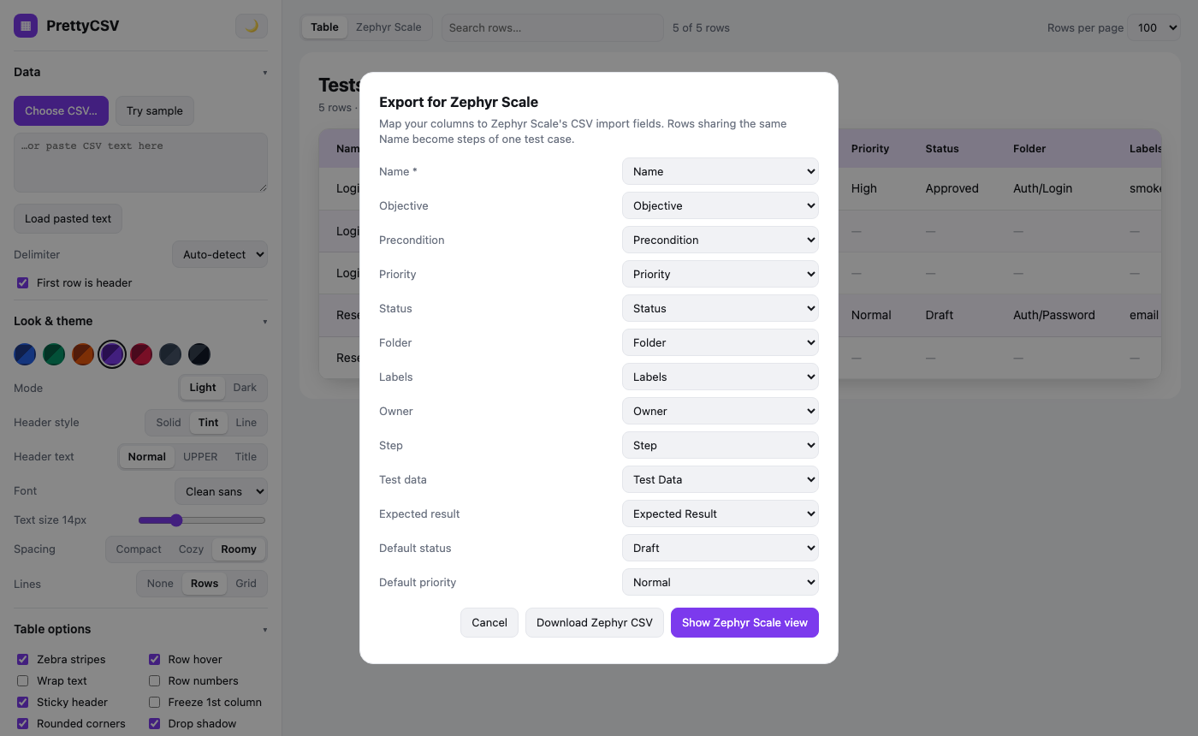
Mapping your columns to Zephyr Scale fields.
Rows that share the same Name are treated as steps of one test case, so only the first row needs the objective, priority, folder and so on.
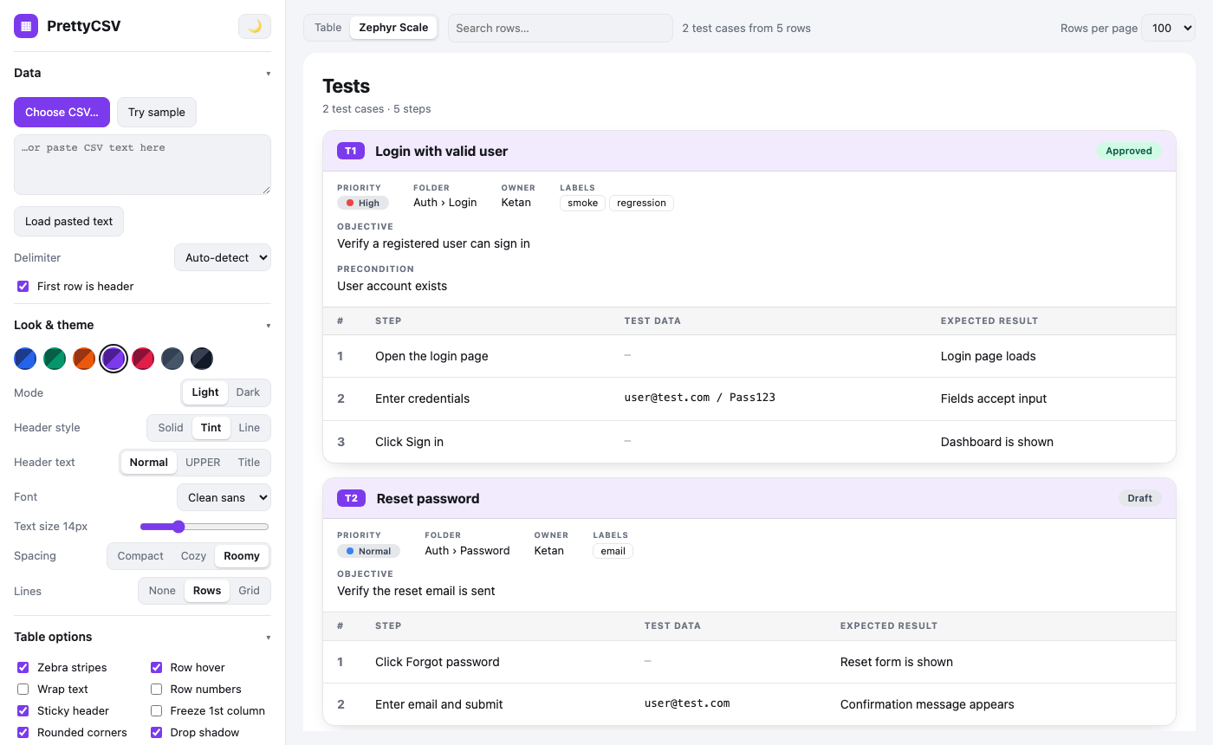
The Zephyr Scale view: test cases with status, priority, folder, labels and steps.
Click Table in the toolbar at any time to go back to the normal table. In the mapping window, Download Zephyr CSV saves a file ready to import into Zephyr Scale.
Zephyr field | Typical CSV column name
Name (required) | Name, Title, Summary, Test case
Objective / Precondition | Objective, Description / Precondition, Prerequisite
Priority / Status | Priority, Severity / Status
Folder / Labels / Owner | Folder, Suite, Module / Labels, Tags / Owner, Assignee
Step / Test data / Expected result | Step, Action / Test Data, Input / Expected Result, Outcome

8. Export your work
Everything in the Export section uses what you currently see: your search, sort, hidden columns and renamed headings.
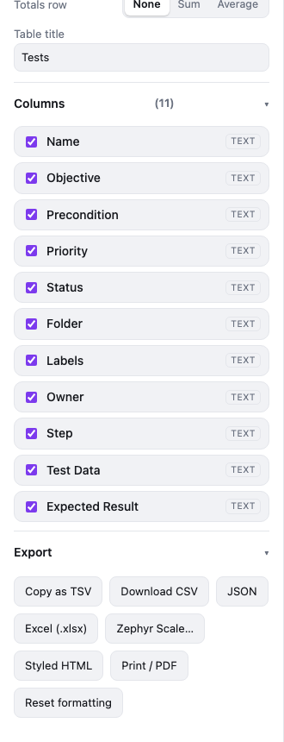
The Export buttons.
Button | What you get
Copy as TSV | Copies the table to the clipboard. Paste straight into Excel or Google Sheets.
Download CSV | A clean CSV file.
JSON | A JSON file with real numbers, ISO dates and null for blanks.
Excel (.xlsx) | A real Excel workbook with a coloured header row, frozen header, filters and sized columns. Numbers and dates are stored as numbers and dates.
Zephyr Scale… | Opens the mapping window, then downloads a Zephyr Scale import CSV.
Styled HTML | A single web page that keeps your colours and styling. Good for emailing or sharing.
Print / PDF | Opens your browser print dialog. Choose “Save as PDF” to make a PDF of the table.
Reset formatting | Puts all look and table options back to their defaults.

9. Quick troubleshooting
Problem | Fix
Everything is in one column | Set Delimiter to the right character (comma, semicolon, tab or pipe).
The first data row became the heading, or vice versa | Tick or untick First row is header.
A number column is shown as text (or the reverse) | Open the column and change Type.
Zip codes or IDs lost their leading zeros | Set the column Type to Text. Values such as 00123 are kept as text automatically.
My settings disappeared | Settings are stored in your browser. Private windows or cleared site data reset them.
Large file is slow | Keep Rows per page at 100 or 500 rather than All.

PrettyCSV is open source: github.com/kranmal/PrettyCSV

