QA Agent Team
Set-up guide: from nothing to your first test run, step by step
This guide walks you through setting up the QA Agent Team so you can start website tests from a normal Claude desktop chat. There are 7 short steps and a first test run. Each step shows exactly what to type and what you should see. It takes about 10 minutes, plus the time the first test run takes.
You do not need to be technical. If you can copy and paste, you can do this. Wherever you see a grey box with a green bar, that is something to copy into Terminal.

The big picture
Here is the whole journey. Each box below is one step in this guide.
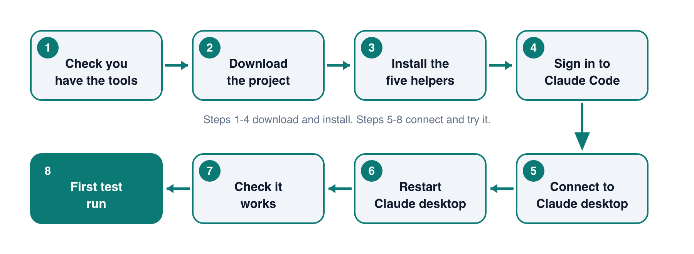
The seven steps, in order

How to read this guide
You will see | What it means
DO THIS | An action for you to take.
A grey box with a green bar | Text to copy and paste into Terminal, then press Return.
You should see: (green) | What the screen should look like if it worked.
If it doesn’t work: (yellow) | The most common problem and how to fix it.

What is Terminal? It is a Mac app where you type commands. To open it, press Cmd + Space, type Terminal and press Return. You will use it in several steps. You can keep the same window open the whole time.
About the screenshots. The Terminal pictures show what each command prints, with your own username in place of “you”. The dashboard picture is a real screenshot of the finished tool. The chat picture is an illustration of the kind of reply to expect, so your wording may differ.

Step 1: Check you have what you need
You need four things on your Mac. Most people already have the first two.
Thing | How to check it
Claude desktop | You can open it and are signed in.
Claude Code | Type claude --version in Terminal. A version number means you have it.
Node.js 18 or newer | Type node --version in Terminal. It should show v18 or higher.
Git | Type git --version in Terminal. A version number means you have it.

DO THIS Open Terminal and paste these three lines, one at a time, pressing Return after each:
node --version
claude --version
git --version
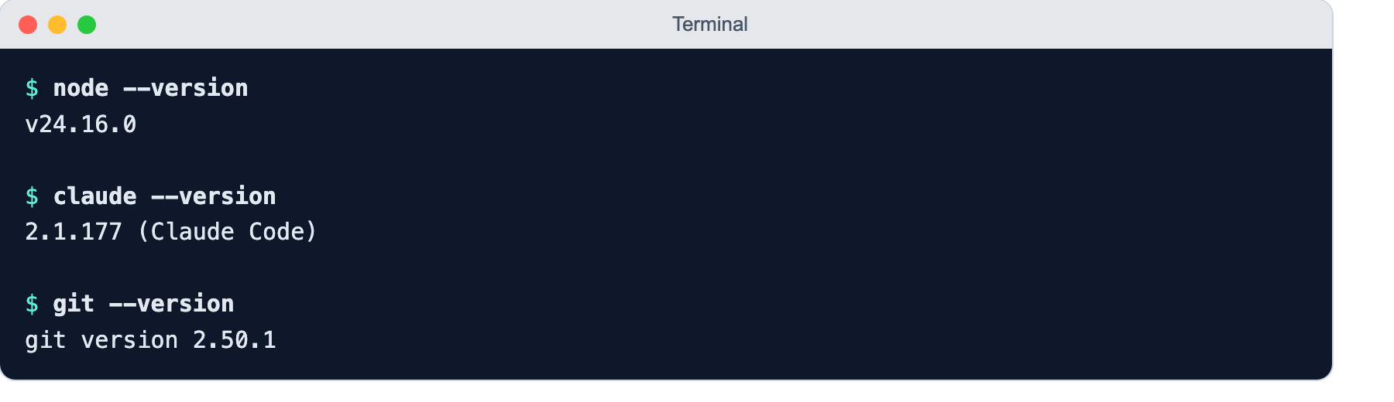
Each command should print a version number
You should see: A version number after each command, like the picture above. The exact numbers will differ.
If it doesn’t work: If you see “command not found”, that tool is missing. Install Node.js from nodejs.org, Git from git-scm.com (or by typing git in Terminal and following the prompt), and Claude Code by following the instructions on claude.com/claude-code. Then try again.

Step 2: Download the project
This copies the QA Agent Team to your Mac. Choose a folder where it can stay, such as your home folder. Do not delete or move it later, because Claude desktop will point at it.
DO THIS In Terminal, paste these two lines, one at a time:
git clone https://github.com/kranmal/qa-agent-team.git
cd qa-agent-team
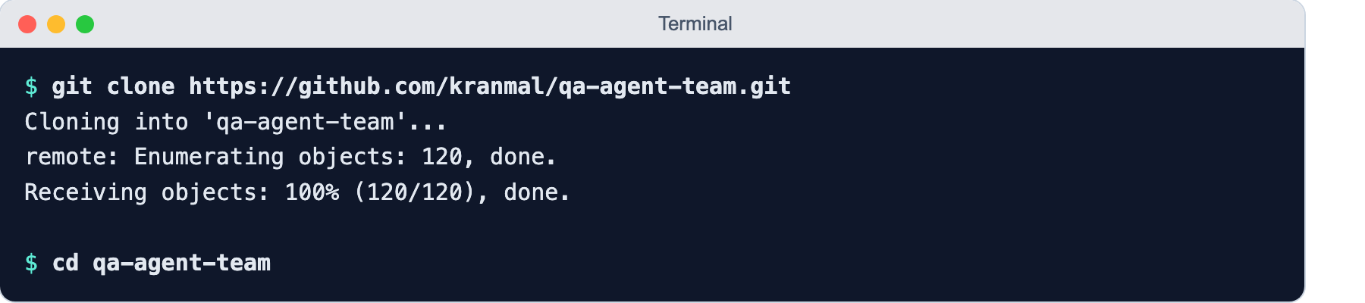
Downloading the project
You should see: Some lines about “Cloning”, and then your cursor on a new line. Nothing else appears after cd.
If it doesn’t work: If it says “destination path already exists”, you downloaded it before. Just type: cd qa-agent-team
Tip: Stay in this same Terminal window for the next steps. It is now “inside” the project folder, which is where the next commands expect to run.

Step 3: Install the five helpers
The QA Agent Team is five helpers. This step copies them where Claude Code can find them. You only ever do this once.
DO THIS Paste this line and press Return:
./install.sh
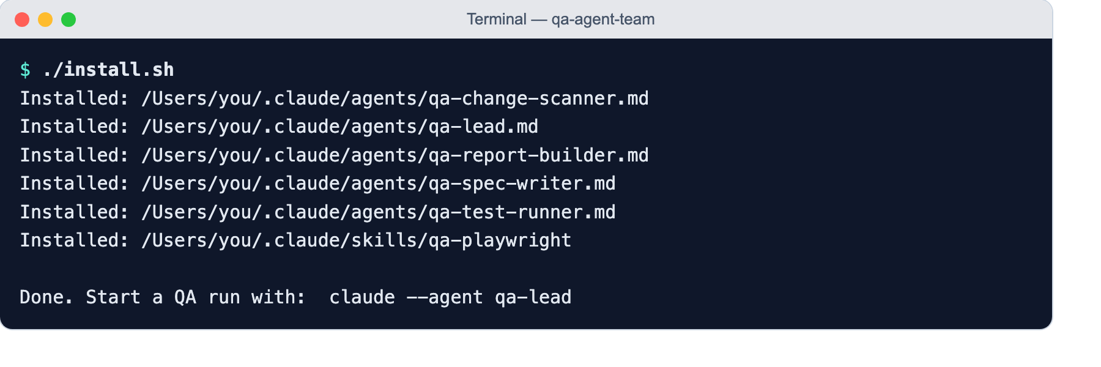
The helpers being installed
You should see: Six lines starting with “Installed:”, then “Done.” at the end.
If it doesn’t work: If you see “Exists, skipping”, the helpers are already installed. That is fine. If you see “Permission denied”, type chmod +x install.sh and try again.

Step 4: Sign in to Claude Code
Claude desktop and Claude Code are two separate programs, and each needs its own sign-in. The QA tests run through Claude Code, so it must be signed in even if the desktop app already is. Skipping this is the number one reason a first run fails.
DO THIS Paste this line and press Return:
claude auth login
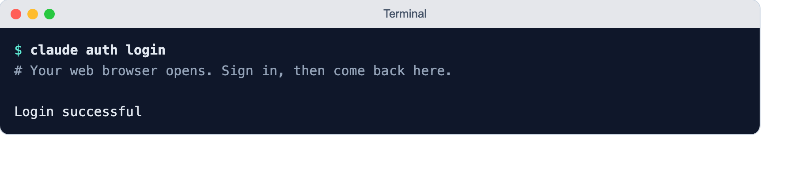
Signing in to Claude Code
Your web browser will open. Sign in with the same account you use for Claude, approve the request, then return to Terminal.
You should see: The words “Login successful”.
If it doesn’t work: To check later whether you are signed in, type claude auth status. It shows “loggedIn”: true when you are.

Step 5: Connect it to Claude desktop
Now we tell Claude desktop about the QA Agent Team. This adds one entry to Claude desktop’s settings file. The command saves a backup of your old settings first, so nothing is lost.
DO THIS Paste this line and press Return:
node interface/setup.mjs --write
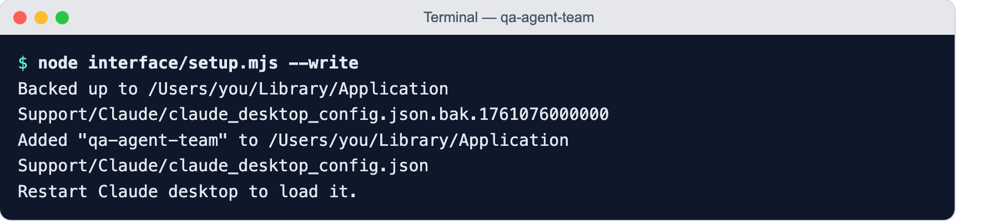
Adding the QA Agent Team to Claude desktop
You should see: A “Backed up to…” line, then “Added “qa-agent-team”…”. If you had no settings file before, there will be no backup line.
Tip: Curious what this changes first? Run node interface/setup.mjs without --write. It only prints the entry and changes nothing.
If it doesn’t work: If it says the settings file is “not valid JSON”, the file was already broken. Nothing was changed. Ask Claude to help fix it, then run the command again.

Step 6: Restart Claude desktop completely
Claude desktop only reads its settings when it starts. Closing the window is not enough: the app keeps running in the background.
DO THIS Click on Claude desktop, then press Cmd + Q to quit it fully. Then open Claude desktop again from your Applications folder or Dock.
You should see: The app closes completely (its icon disappears from the Dock, or loses the small dot under it), then opens fresh.
If it doesn’t work: If you are not sure it quit, right-click the Claude icon in the Dock and choose Quit.

Step 7: Check it works
Now let’s make sure Claude can see the new tools. This does not start a test. It only asks for the address of the dashboard.
DO THIS In a new Claude desktop chat, type: Open the QA dashboard
You should see: Claude replies with an address, http://127.0.0.1:4747. Paste it into your web browser. You should see the QA Agent Team dashboard, as in the picture below. It will be empty if you have not run anything yet.
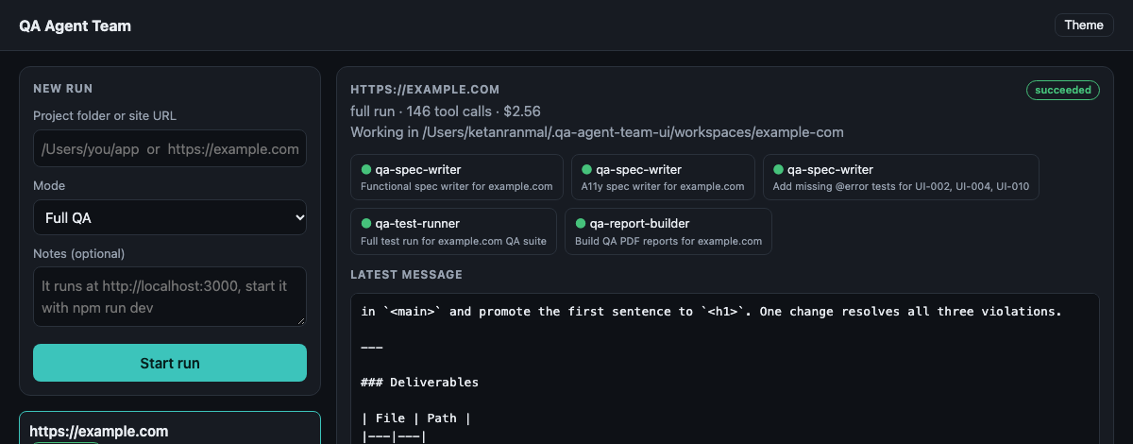
The dashboard. Start a run from the “New run” box on the left
The dashboard has three parts: a box on the left to start a run, a list of your runs under it, and, on the right, details of the run you select.
If it doesn’t work: If Claude says it has no QA tools, go back to Step 6 and quit with Cmd + Q (not just close the window). If it still does not work, repeat Step 5 and then Step 6.
Setup is finished. Everything from here is about using it.

Step 8: Your first test run
Let’s test a safe example website. example.com is a public practice page that is fine to test.
DO THIS In a Claude desktop chat, type: Run QA on https://example.com
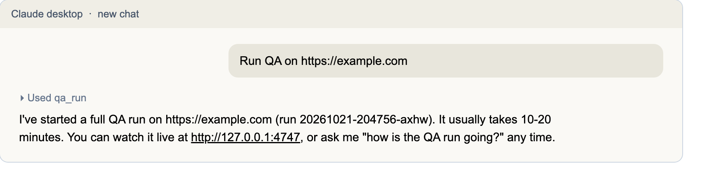
Illustration: Claude starts the run and tells you where to watch it
Claude starts the run in the background and replies straight away. You do not have to keep the chat open. The run keeps going even if you close it.
Watching progress. Open http://127.0.0.1:4747, or ask Claude: “How is the QA run going?”. A small example site like this takes about 10 to 20 minutes.
What you see on the dashboard | What it means
Green dots next to helper names | Those helpers have finished their part.
A blue dot | That helper is working right now.
“Latest message” box | The most recent update from the team lead, in plain words.
“succeeded” badge (top right) | The run is finished. Your reports are ready.
“failed” badge | Something went wrong. Read the red Error box. It is almost always a sign-in problem (Step 4).

Tip: Runs use your Claude usage. The example.com run cost about $2.56. Bigger sites cost more. The dashboard shows the cost when a run finishes.
If it doesn’t work: If starting the run stops at once with “Claude Code CLI is not logged in”, repeat Step 4. If it says the qa-lead agent is not installed, repeat Step 3.

Step 9: Find your reports
When the run says “succeeded”, scroll down on the dashboard to the “Outputs” box. Click any file name to open it in your browser.
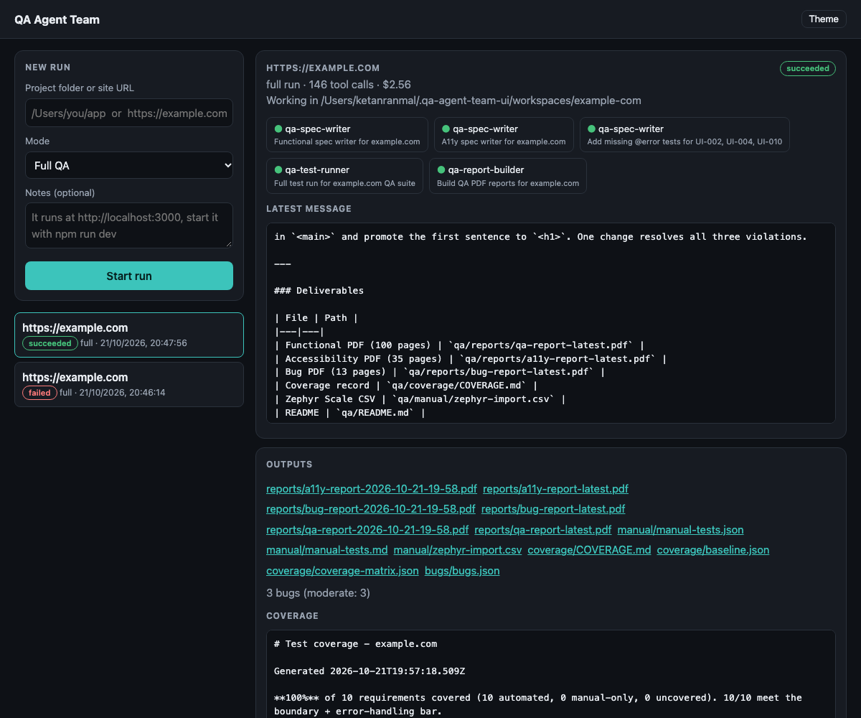
A finished run. Reports are listed under Outputs, with a coverage summary below
Open this one | To see
reports/bug-report-latest.pdf | The problems found, how to reproduce each, and screenshots. Start here.
reports/qa-report-latest.pdf | The full test report with coverage and results.
reports/a11y-report-latest.pdf | Accessibility problems, for people who use screen readers or the keyboard.
manual/zephyr-import.csv | Manual tests, ready to import into Zephyr Scale.

You can also ask Claude. Type “Show me the QA reports”. It lists every file and where it is saved. Reports are kept on your Mac in the folder shown next to “Working in” at the top of the run.

Everyday cheat sheet
Once set up, these are the only things you will ever need.
Say this in Claude desktop | What happens
Run QA on https://your-site.com | Starts a full test run on a website.
Run QA on /Users/me/my-app | Starts a run on a project folder on your Mac.
How is the QA run going? | Shows progress.
Show me the QA reports | Lists the report files.
Stop the QA run | Cancels a run that is in progress.
Scan for changes and update the tests | Quicker, cheaper run after your site changes.
Open the QA dashboard | Gives you the dashboard address.

Quick fixes
Problem | Fix
Claude has no QA tools | Run node interface/setup.mjs --write again, then quit Claude desktop with Cmd + Q and reopen it.
“not logged in” | Run claude auth login in Terminal.
“qa-lead agent not installed” | Run ./install.sh from the qa-agent-team folder.
Dashboard page will not open | Ask Claude to “Open the QA dashboard”. It gives the correct address.
You moved or deleted the qa-agent-team folder | Move it back, or run Step 5 again from the new place, then redo Step 6.
Tests failed in the report | Normal. Real bugs are meant to fail. Open the bug report first.

